Documentation

Presented by – Rupinder Singh

Introduction – This assignment is all about video rental system for a video rental shop where they can store the details of their customers, movies and can also store the data of the customers to whom they have rented the movie.

The Video Rental System start with welcome form where the two buttons are present in the middle of the form. One is for the Registration and second is for Login. There is one more button on the bottom of the form that is for exit, if user do not want to login or register then he/she can close the form by pressing the exit button.

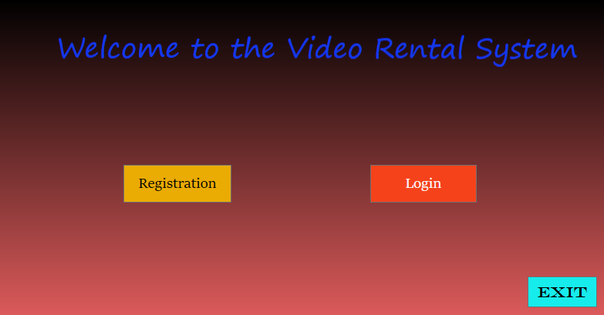

If the user do not have an account then he/she can register their account here and after pressing submit button, the login form will be open. If the user went to this form by mistakenly then they just need to press login button for login page.

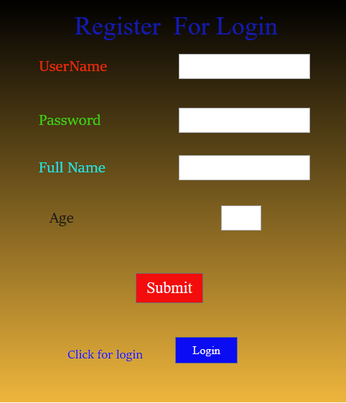

The user can easily login here by write their username and password. If the person do not have an account, they just need to press register button for registeration form.

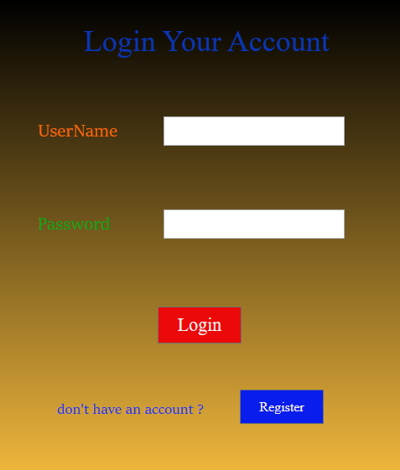

When the user try to login their account, if their username and password match the stored data the next form (video rental system) will be opened otherwise this message will pop up.

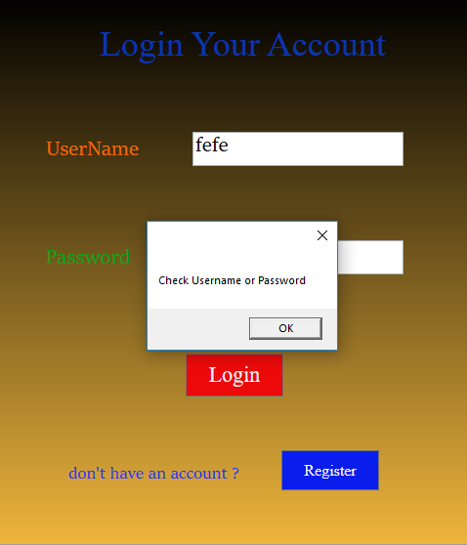

After login the next window will open where the customer, movies, rental tabs are present. The user can add, update and delete the data from these tabs.

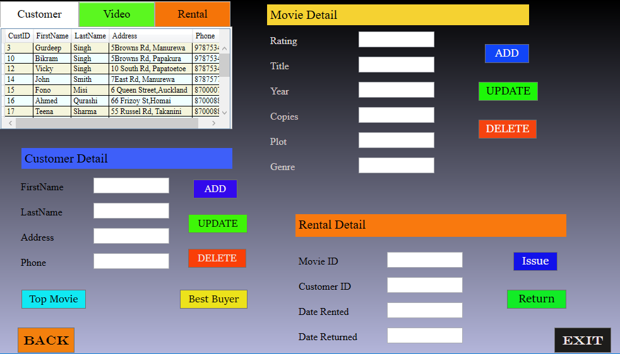

The user wants to add customer then just fill the data in customer detail boxes and press the add button. The data will be stored in

database and message will pop up.

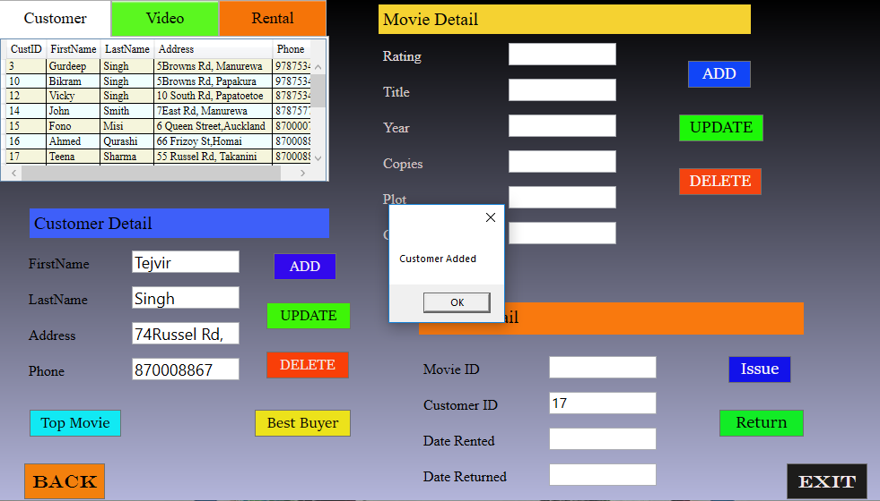

For any making any change or for deleting the customer, user need to double click on the customer and the data will be shown in the text boxes.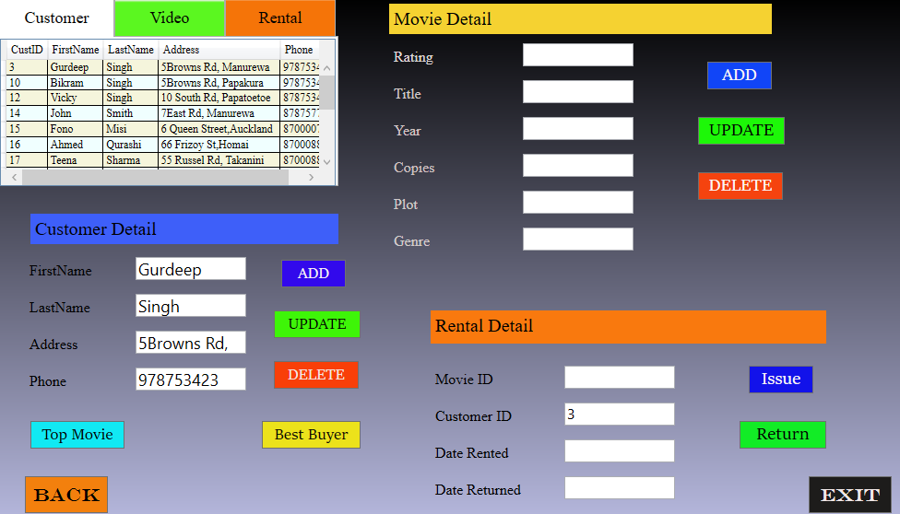

After making changes in customer column this message will pop up for successful update.

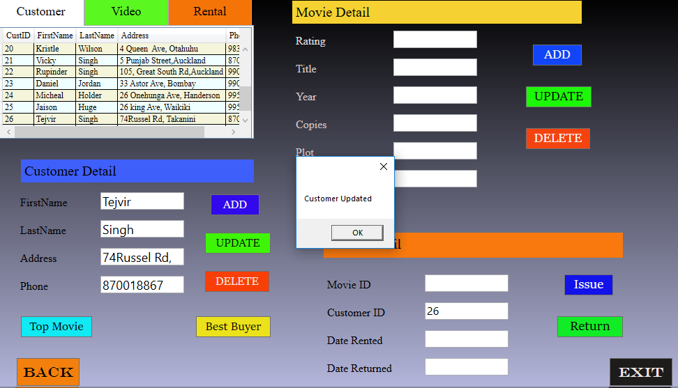

If the user does not want to keep the customer then they will select the customer row and press the delete button. The message will pop up for surety of the deletion for customer.

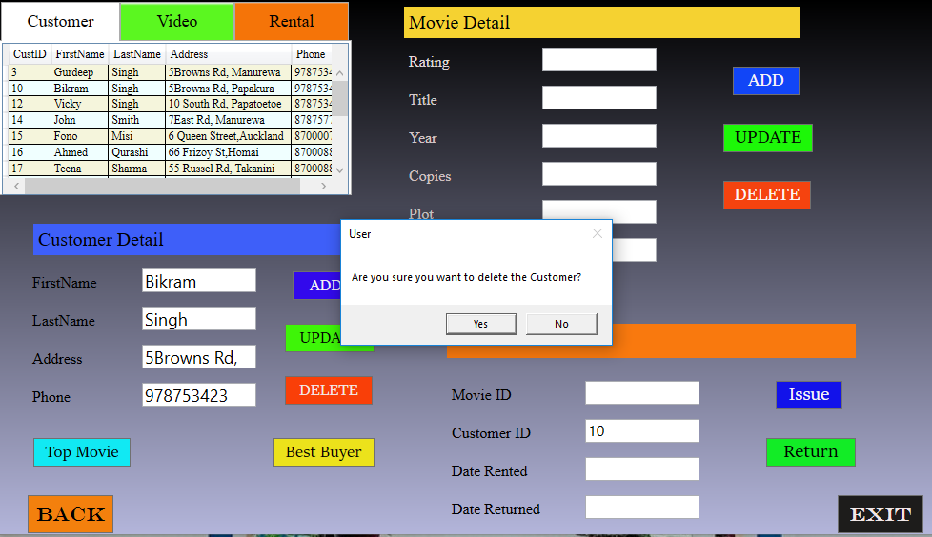

This message will open if the customer is still renting the movie but you are going to delete it.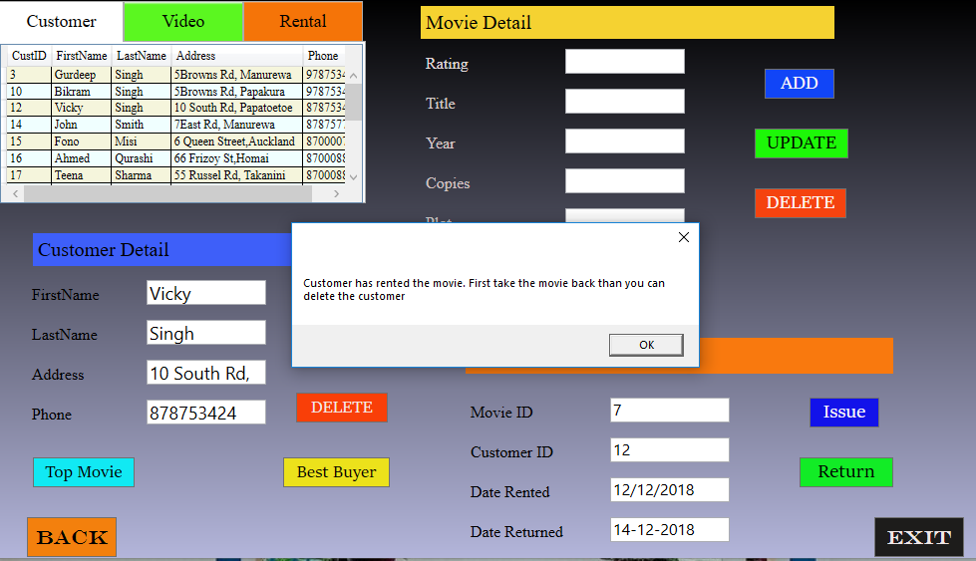

For adding new movie in the table user need to fill the movie details and press the add button. The movie will be added and message will be pop up.

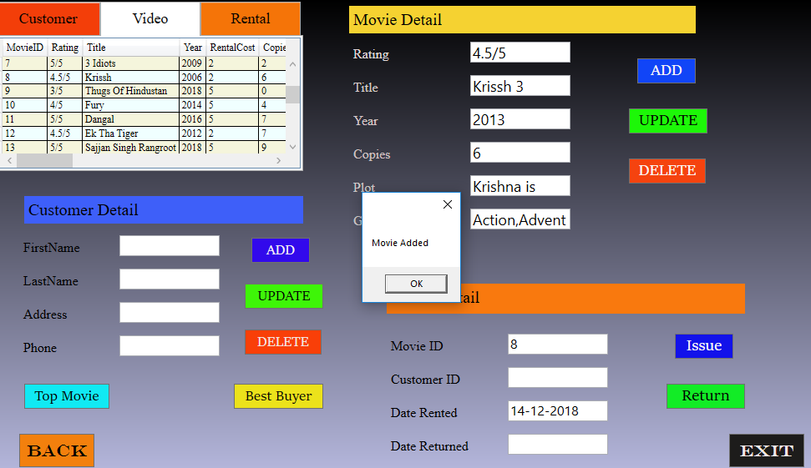

For any making any change or for deleting the customer, user need to double click on the movie and the data will be shown in the text boxes

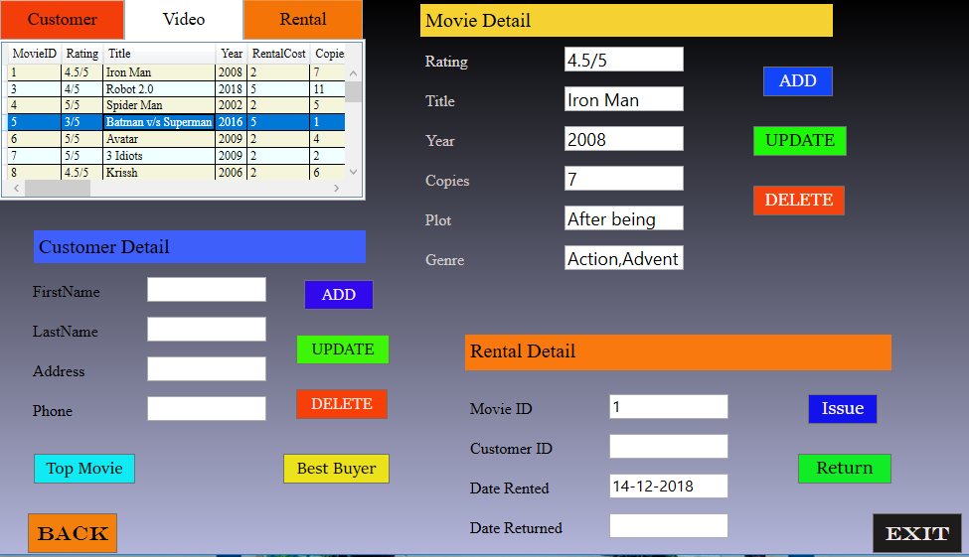

After making changes in customer column this message will pop up for successful update.

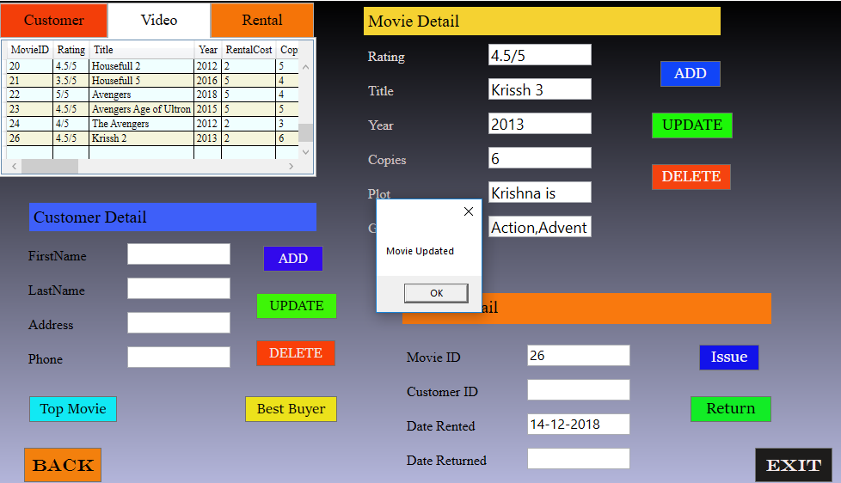

If the users do not want to keep the movie more the they can delete the movie by pressing delete button and the movie deleted message will be shown.

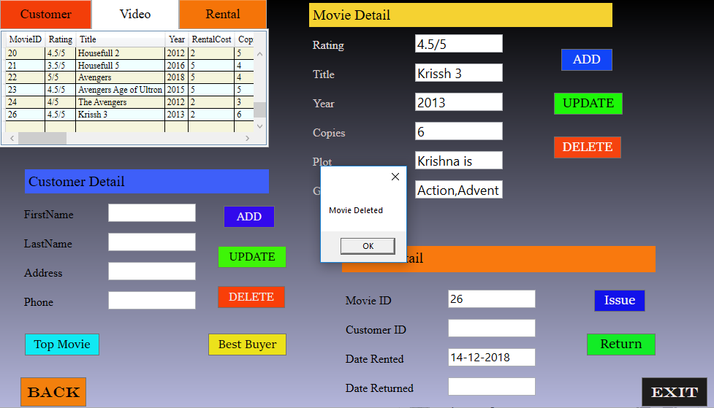

If the user going to delete the movie from the data but the customer have not return the movie back, then this message will pop up.

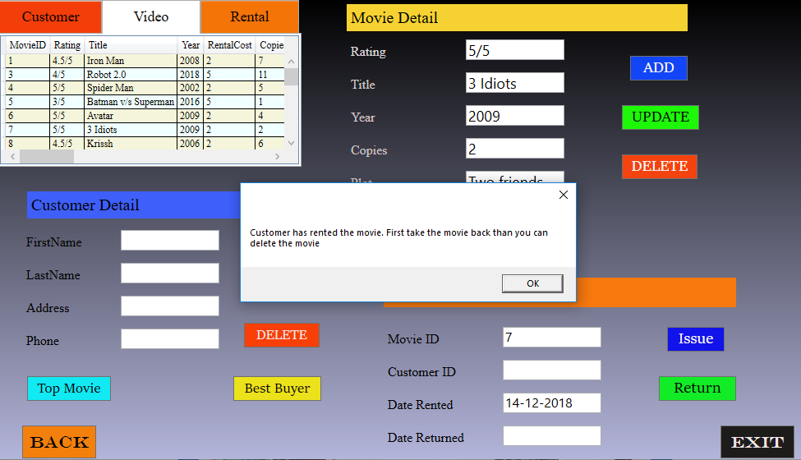

Before issue the movie user will select the customer to whom they are giving the movie and select that movie which they are giving for rent.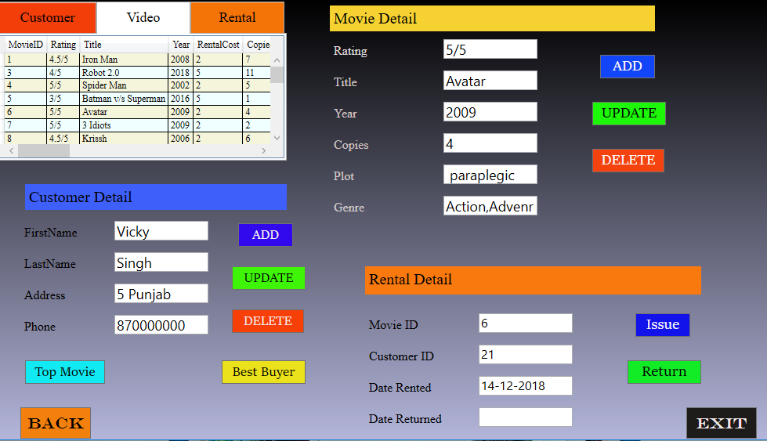

After selecting specific customer and movie, the user just need to press the issue button. The return date 1900-01-01 means value is zero (the box is blank until movie return).

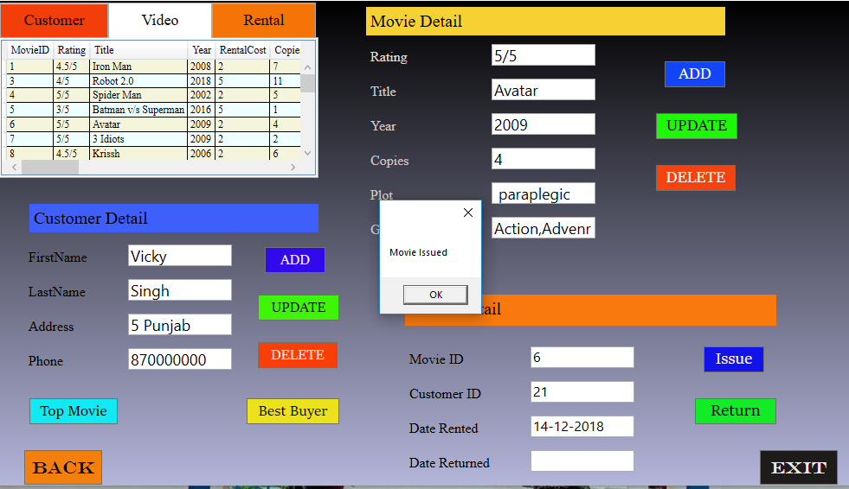

When the customer going to return the movie, the cost will be automatically calculated from rent date to return date and the total cost will be shown on screen through pop up message.

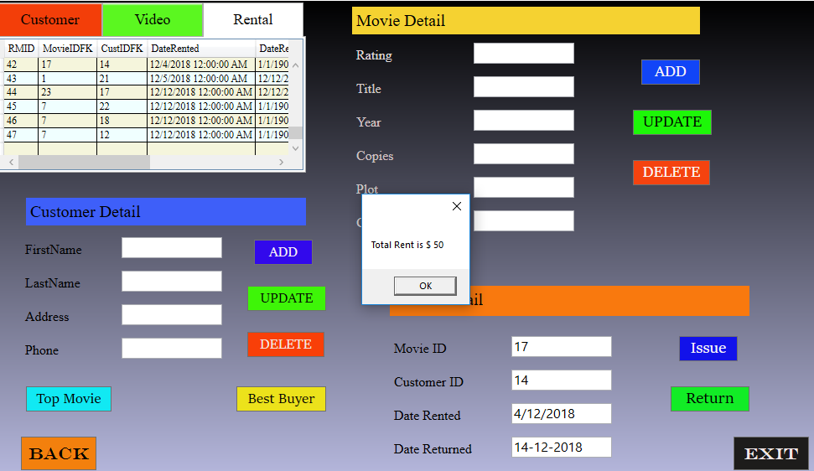

If the user going to select movie which already returned then this message will be shown on screen.

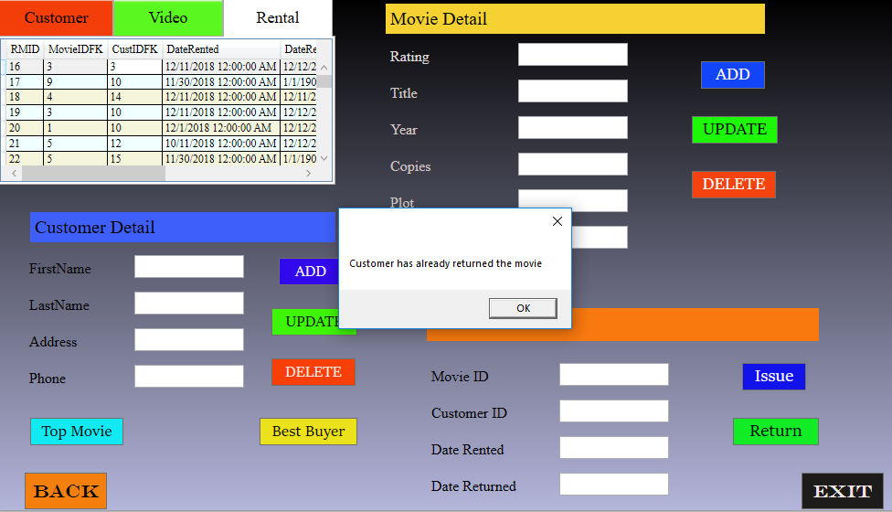

If the user wants to know their top rented movie, they just need to click top movie button which will calculate the data of most rented movie. It will also count that for how many times this movie is rented. After that the data will be shown on screen through pop up message.

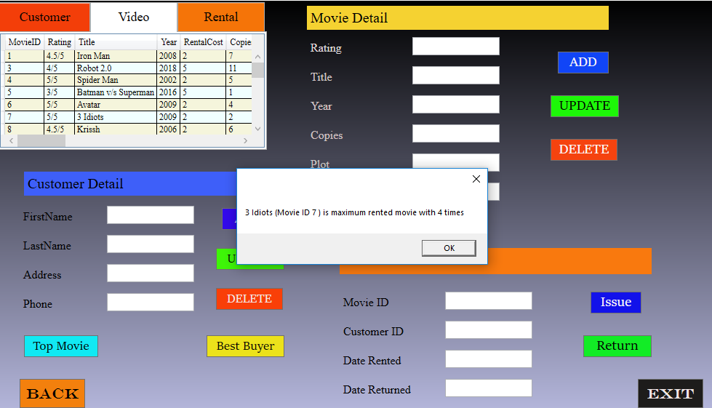

There is one more button on screen which can get the data of best buyer, like which customer rented the movies and will also provide the data of how times.

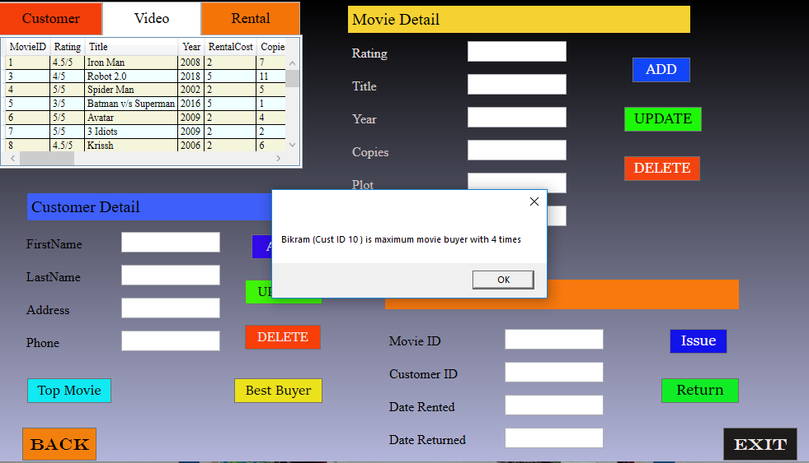

If the user wants to leave the form, they just need to press the exit button for existing the form.