Lc_ biangulation—ignore unless 1,2 or 3

Construct two dictionaries

1. Uid= keys, values= date, many to one
2. Uid=keys, value= coordinate pairs

Github desktop_ if no repository go to file and add new repository

.format has a tuple and quotes {} have the index to the tuple

R – read,, use fileobkj

fileObj are intermediate and not variables..

don’t appear in the variables,,

newFile: as a variabl,, overwrites if run again, using ‘a’ command appends,, writes at the bottom,, ‘w’ with same name overwrites

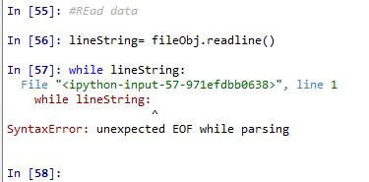

User inputs are always taken in as a string