

Final Report

by

**Haonan Zhang**

1631034

420.AA Computer Science

Fodé Toure

Working in: Institute Teccart

Supervisor Name at the company:

Patrick Dorré

2019

**Table of contents**

Acknowledgements 2

Introduction 3

The Company 4

The Internship 6

Challenges 9

Conclusion 10

Bibliography 12

Appendix 13

Weekly Reports 16

# Acknowledgements

Thanks to Mr. Fodé Toure for guiding me through the whole internship and also the three years of my LaSalle College life. He not only teaches knowledge but also guide his students on their path of life. He teaches me lots of knowledge out side the school.

On the other hand, I would like to thank to my internship colleagues. I had a grateful and happy internship time. Also, I would like to thank Patrick Dorré for the opportunity for the internship and the trust on us.

# Introduction

## Context :

The director of the institute Teccart , Patrick Dorré, wants us to build an application which should be more convenient and more user friendly to manage the database of the institute and make schedule for all the course manually.

He also wants to grant permissions to other employees to do specific change to the database or make schedule.

On the other hand, after making schedule or management of the database, he would like to print out the schedule for specific teacher/room/week/group, and have reports for the changes.

### Why are you doing the stage?

Because this kind of work is sort of familiar and still with challenges. It also gives me some experiences of working within a team and working alone. Also, it can benefit my life after.

### What are your learning expectations/goals?

My expectations of this stage is to learn more knowledge and gain more experience in software development area. It could also help me identify myself’s strengths and weaknesses.

My goal is to complete this project and make this application functional to work and make myself more fluent when I’m working in C# environment. Also, team work and problem solving skill are growing as well.

# The Company



Name : Institute Teccart

Year of conception : 1989

## Industry:

The Teccart Institute is a private collegiate college which was founded in 1945 by Mr. Jean Meunier. Indeed, she offers courses mainly in Technologies (electronics, computer science, telecommunications) but also in human sciences and education in childhood. In 2007, offers training programs in different areas of fashion.

### Internship working environment:

The internship takes place inside the Teccart institute. I have the chance to work with two other programmer who are also in training. We are a workshop at the administration area with the other employees.The other two programmers are full of talent and ambition. This experience allows me to get experiences both technically and socially.

### Supervision:

* Mr Fodé Toure (Professeure of LaSalle College)
* Mr Patrick Dorré (Director of Teccart Institute)

### Team Collboration and division of work :

I complete this internship with the help of two other developers. We forms a bond of friendship. We use each of our strengths to help each other and finish this whole project.

### Tools and software used :

* Development language : C #
* Development tools : Visual Studio 2019, Auzre Devops, Sql Server Management Studio 18(SSMS)

# The Internship

## The company’s need (discuss the existing problem or opportunity)

The director of Institute Teccart uses a Access file to creat the schedule of the whole school by himself and it always counters some bugs and errors , which is also not user friendly and not contains good interfaces. He wants us to create an application so that he can grant permissions to other employees to do the job and he wants the application’s database on the cloud so that he can work or other employees can work not only inside the institute.

## Requirements collection

For this project to complete , I need a visual studio with Azure devops and SQL server management studio all installed on my computer.

### Who are the end users?

The end users of this application are mainly the director of Institute Teccart but also other employees of the administration department.

### What are their needs?

The needs are :

* Able to manage different area of the institute information in the database.
* User friendly interface.
* Permission can be granted and removed by specific administrator user.

### Suggested solution

The suggested solution is to build a windows form application that will be deployed on the computers and will be able to store / read information on the server.

### Analysis diagrams

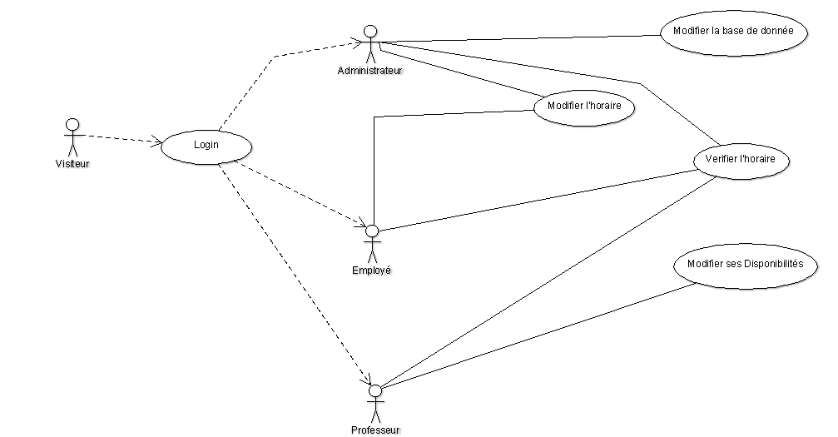

## Finalized Solution

The finalized solution is a windows desktop application that will store / read information on the server.

## Challenges

### Scope and limitations

The scope of the project is to provide an application that will computerize the entire process of managing the premises, groups and teachers of the institute.

Also, it should be more convenient and easy to management the schedule of the institute.

### Timelines/deadlines and Resources

Timelines:

1. Make the analysis.
2. Create SQL database based on old Access database.
3. Program the application and separate the needs.
4. Control of the quality.
5. Debug and test to make sure the application meets their needs.
6. Deploy.

# Conclusion

## Reflection (Learning attained)

This first internship experience allowed me to learn the how to use Microsoft's Team Foundation Server (Azure DevOps) in a development team, and to learn how to solve different and difficult problems while in a team or individually.

### Proposed improvements :

Several improvements are proposed to the director of the institute.

However, most were rejected because the director had a clear picture of the software he wanted us to achieve.

## Suggestions for the school :

For myself, my suggestion of the school is that our school could introduce Github or other Team Foundation Server as a team project in the college. So that it would be easier to getting used to it while working in a real life.

### Frameworks and tools to integrate :

Auzre Devops or GitHub would be good. Also , it could be some real time online server such as Firebase or Auzre.

### Methodologies and strategies :

They are all posted on the “bord” section of Auzre Devops. It is clear that which is done by whom.

# Bibliography

<https://azure.microsoft.com/en-in/services/devops/>

<https://stackoverflow.com/>

<https://msdn.microsoft.com/fr-ca>

# Appendix

## Diagrams and tables :



## Code

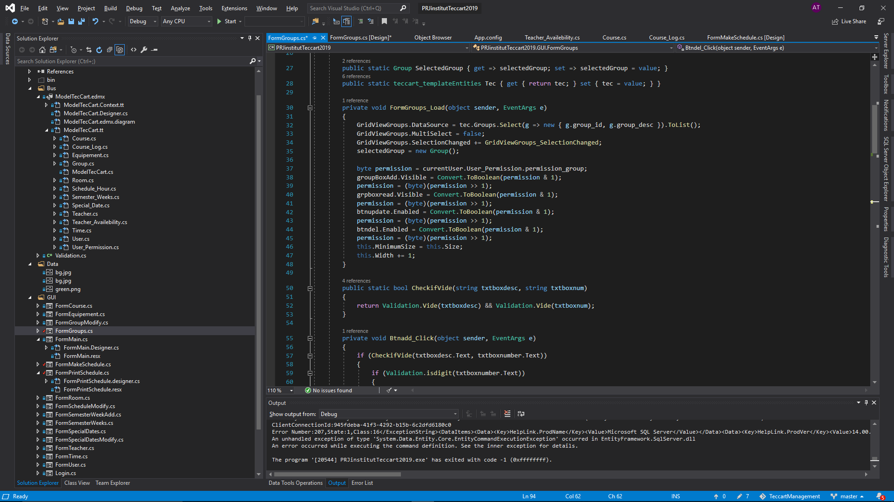

## Screen shots (interfaces)

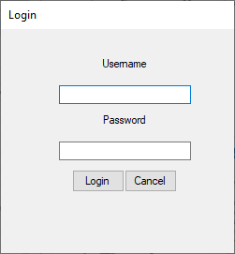



## Weekly reports

*Week 1*:

The team meets with the director to discuss the needs of the institute. The database is designed and then creates the data collected from Mr Dorré. Creation of the team in Azure DevOps.

*Week 2:*

The programming begins. At first, everything goes well. The program is done in C # so it's a familiar language for the team. The tasks to be accomplished are determined. However, by using Entity Framework , we encountered some errors , and we solved them.

*Week 3:*

The programming continues. No problem this week. Several specific questions are asked to Director Patrick Dorré so that we can make sure that the needs of the institutes are matched.

*Week 4:*

Most features are implemented. The team is progressing too well. Some minor bugs. When everyone has a problem, the team tries to help as much as possible so that the person solves the problem.

*Week 5:*

All the basic features are implemented. The director wants to be able to create reports on different aspects of management (schedule, groups or premises). The biggest challenge we face is how to generate a PDF file. My teammate however solved it after searching lots of references and documents.

*Week 6:*

Still the problem of print and generate the PDF file. However, it also are solved by the team with lots of tests and debugs. We do the translations and we make the design more user friendly and also we make our designs in a same pattern.