Method Overriding
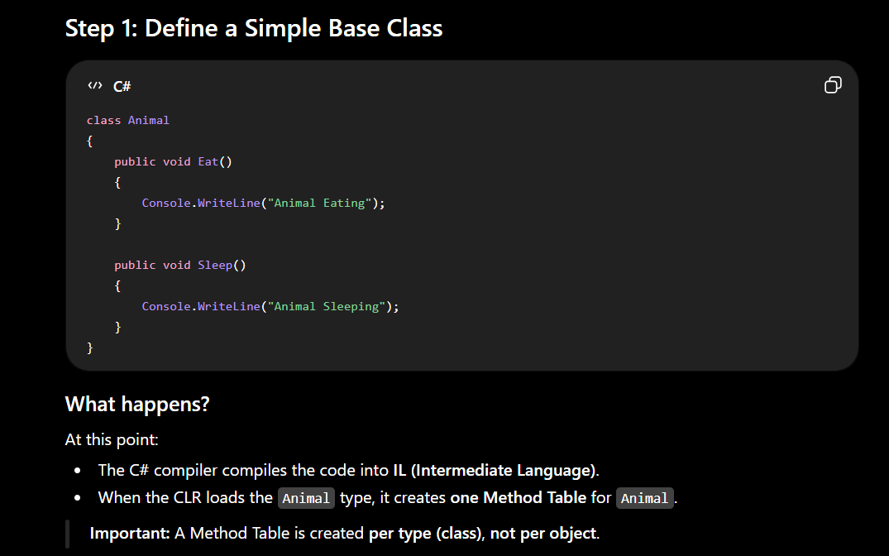

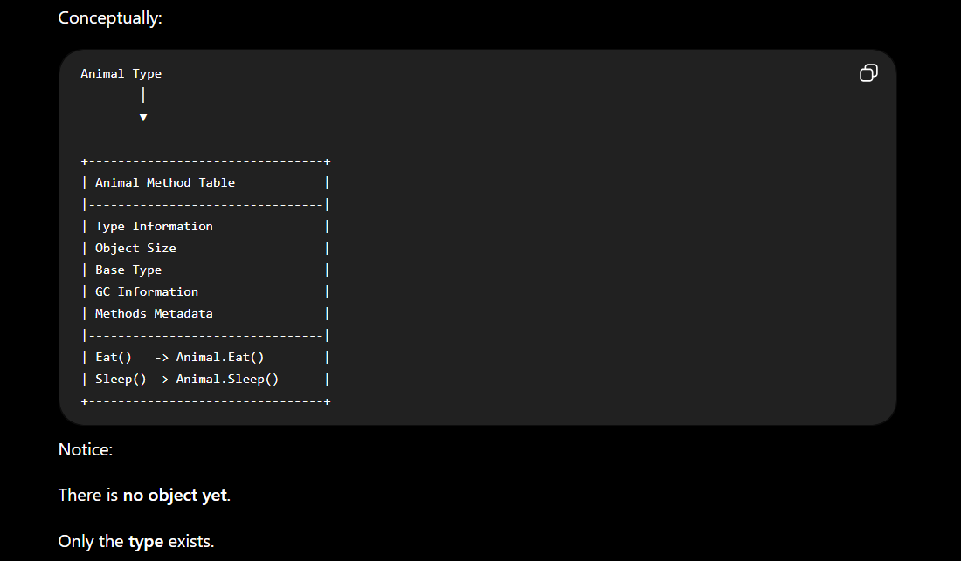

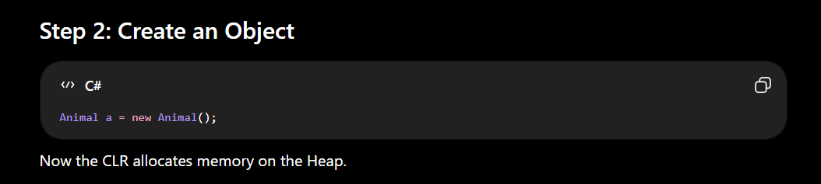

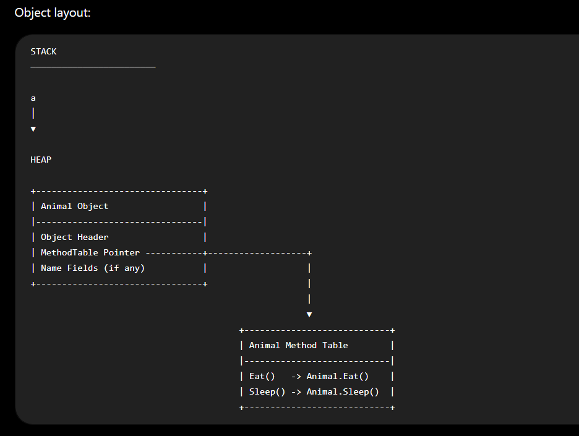

Important Notes
Every object contains:
- Object Header
- MethodTable Pointer
- Instance Fields
It does NOT contain:
- Method code
- Copies of methods
Methods exist only once in memory.
Why?
Imagine creating
Animal a1 = new Animal();
Animal a2 = new Animal();
Animal a3 = new Animal();
Should CLR duplicate
Eat()
Sleep()
three times?
No.
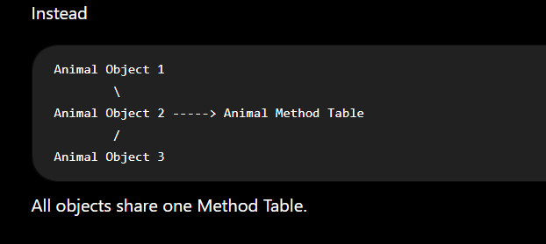
Step 3: Add a Virtual Method
Now change
class Animal
{
public virtual void Speak()
{
Console.WriteLine("Animal");
}
public void Eat()
{
}
public void Sleep()
{
}
}
What changes?
The CLR now knows
Speak()
is virtual.
That means
"This method may be replaced by derived classes."
The Method Table changes.
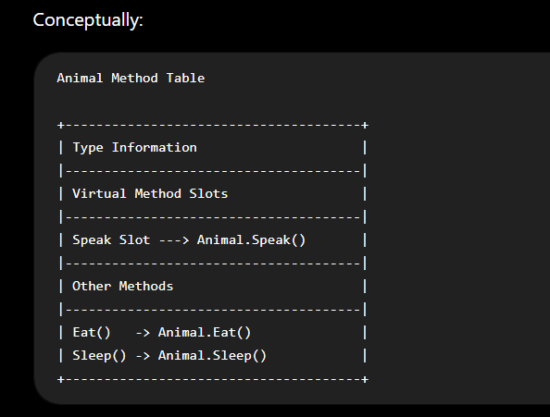
What does virtual actually do?
Many beginners think
virtual
changes the method itself.
It doesn't.
Instead,
it tells the CLR:
"Reserve a virtual dispatch slot for this method."
This slot can later point to another implementation.
Think of it like an empty plug.
Initially
Speak Slot
↓
Animal.Speak()
Later
another class may change it.
Step 4: Create Animal Object
Animal a = new Animal();
Nothing special happens.
Object layout
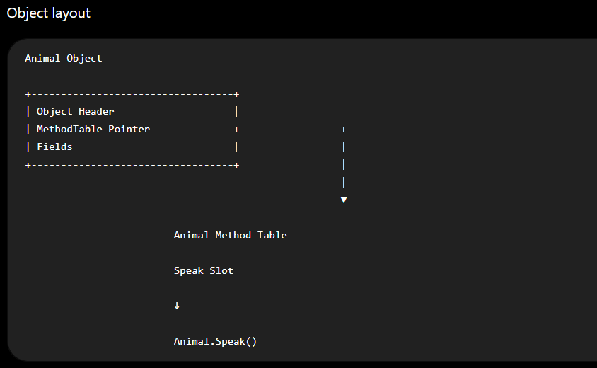

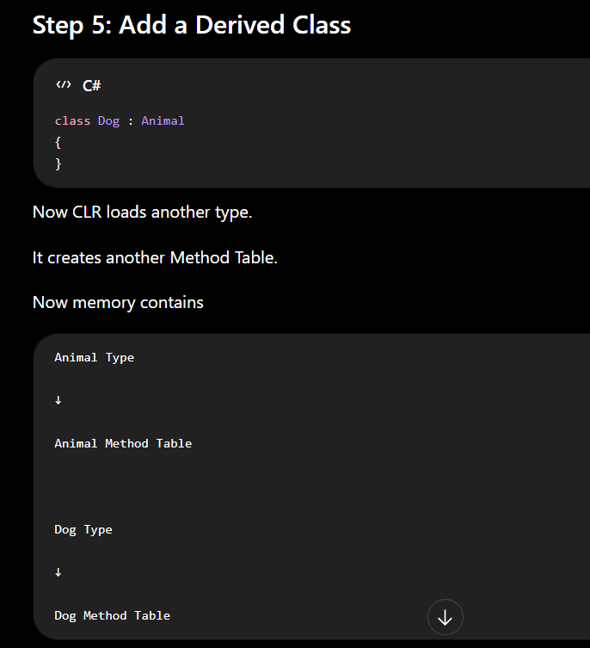
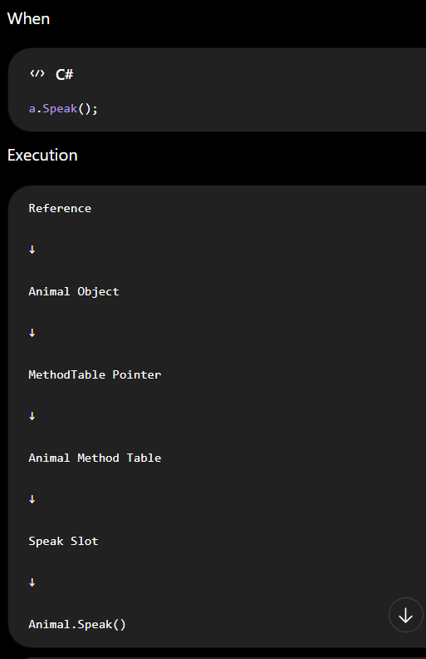
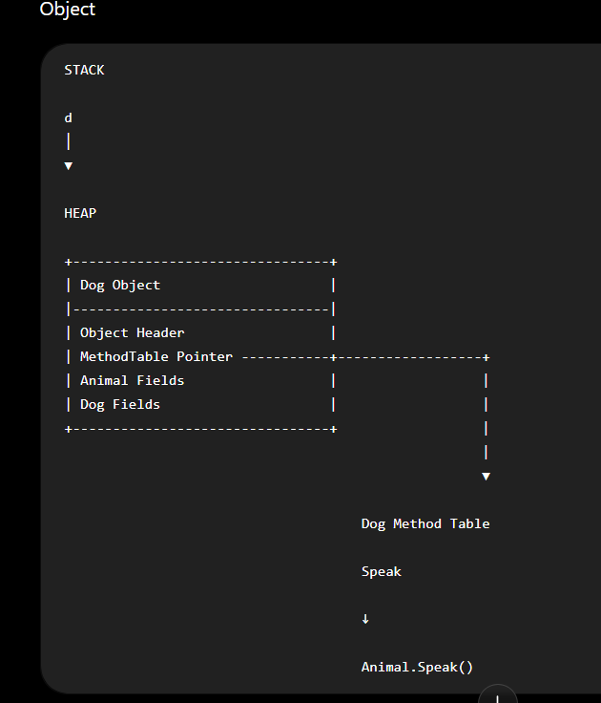
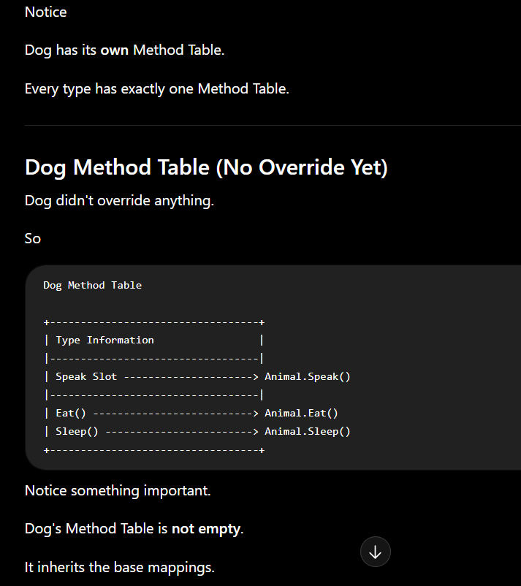

Step 6: Create Dog Object
Dog d = new Dog();

Notice
Dog object points
to
Dog Method Table
NOT
Animal Method Table.
This is one of the most important concepts.
Step 7: Override
Now
class Dog : Animal
{
public override void Speak()
{
Console.WriteLine("Dog");
}
}

What changes?
The CLR does not modify Animal Method Table.
Animal remains
Animal Method Table
Speak
↓
Animal.Speak()

Instead,
Dog Method Table changes.
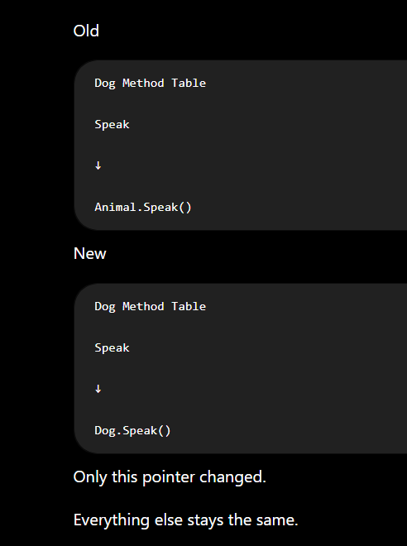
Visual
Animal Method Table
----------------------
Speak
↓
Animal.Speak()
---------------------
Dog Method Table
----------------------
Speak
↓
Dog.Speak()
-------------------
Step 8: Create Dog Object
Dog d = new Dog();
Memory
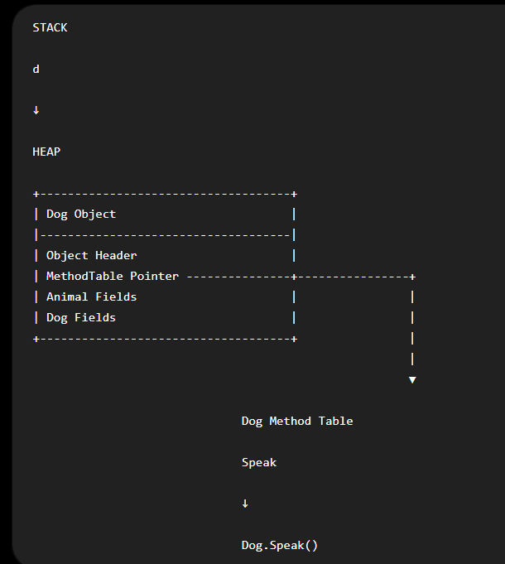

Step 9: Runtime Polymorphism
Now
Animal a = new Dog();
a.Speak();
Memory

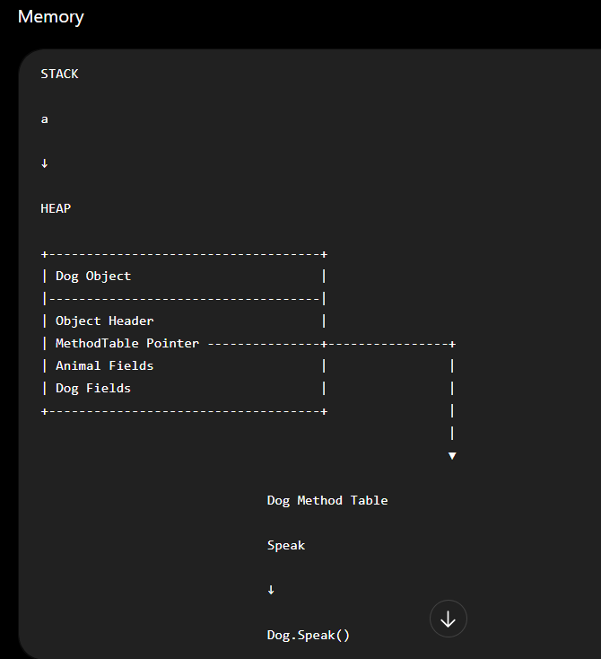
Execution
Reference
↓
Dog Object
↓
MethodTable Pointer
↓
Dog Method Table
↓
Speak Slot
↓
Dog.Speak()
Notice
CLR never asks
Reference Type = Animal
The reference type was only used by the compiler to verify that Speak() is a valid member.
At runtime, the CLR follows the object and its Method Table.
Why Doesn't It Call Animal.Speak()?
Because the object says
I am Dog.
And every Dog object always points to
Dog Method Table
The Method Table already contains the correct overridden implementation.
Final Picture
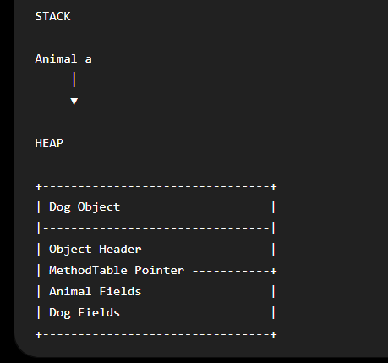
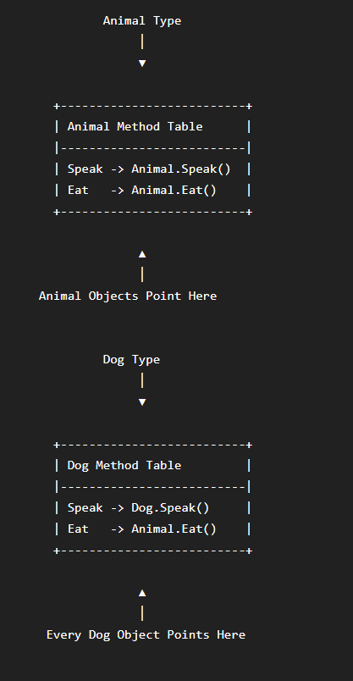

Key Notes to Remember
- One class = One Method Table (created when the CLR loads the type).
- One object = One MethodTable Pointer (stored inside the object).
- Methods are not stored in objects; the executable code exists only once and is shared.
- The virtual keyword tells the CLR to create a virtual dispatch slot for that method in the Method Table.
- A derived class gets its own Method Table; it does not reuse the base class's Method Table.
- If the derived class does not override, its virtual slot still points to the base implementation.
- If the derived class overrides, only the pointer in its Method Table changes—from Animal.Speak() to Dog.Speak().
- During a virtual call, the CLR follows this chain:
Reference
↓
Object
↓
MethodTable Pointer
↓
Method Table
↓
Virtual Slot
↓
Actual Method

Low-Level Difference between Metho Overriding and Method Hinding
Method Hiding | Method Overriding
Uses new keyword | Uses override keyword
Base method is not virtual | Base method must be virtual, abstract, or override
No virtual slot replacement | Virtual slot is replaced in the derived type's Method Table
Compiler decides the target method | CLR decides the target method at runtime
Usually emits a direct call (or another direct call mechanism) because the target is known | Emits callvirt for virtual dispatch
Depends on reference type | Depends on actual object type
No runtime polymorphism | Runtime polymorphism
Method Table's virtual mapping is unchanged | Method Table's virtual slot points to the derived implementation
The Biggest Mental Model
Think of method hiding as creating two independent methods:
Animal
Speak()
(completely unrelated)
Dog
Speak()
They just happen to share the same name.
The compiler chooses which one to call based on the reference type.
Think of method overriding as creating one virtual contract:
Animal
Speak()
│
│ virtual slot
▼
Dog
Speak()
There is still one logical method contract ("Speak"), but the implementation changes depending on the runtime object's type. The derived class doesn't create a separate contract—it replaces the implementation associated with the inherited virtual slot.
One small refinement to our earlier model
Earlier we drew Method Tables with all methods for simplicity. The more accurate CLR view is:
- The Method Table contains information about the type and the entries needed for virtual dispatch.
- Non-virtual methods do not participate in virtual slot replacement. They are resolved directly by the compiler/JIT based on the statically known target.
- When a method is hidden with new, no virtual slot is modified. The hidden method is simply another method defined on the derived type, and ordinary method resolution selects it when the reference type is Dog.
That distinction is the real low-level difference between method hiding and method overriding in .NET.

