🚀 Backend Development – Main Steps (ASP.NET Core Web API)
Think of this as your execution checklist.

1️⃣ Project Setup & Base Configuration
- Create ASP.NET Core Web API project
- Setup basic folder structure (Controllers, Services, etc.)
- Configure environment (appsettings, connection string)
👉 Goal: Skeleton ready

2️⃣ Database Setup & Integration
- Choose DB: PostgreSQL
- Setup connection (EF Core / ORM)
- Configure DbContext
- Ensure DB connectivity works
👉 Goal: App can talk to database

3️⃣ Core Domain Modeling
- Define main entities:
  - User
  - Ticket
  - Role
  - (Optional: Comments)
- Define relationships:
  - Ticket → CreatedBy
  - Ticket → AssignedTo
👉 Goal: Clear data model

4️⃣ Database Migrations
- Create initial schema
- Apply migrations
- Verify tables are created correctly
👉 Goal: Database structure ready

5️⃣ Authentication Setup (JWT)
- Login endpoint
- Token generation
- Token validation setup
- Secure endpoints with [Authorize]
👉 Goal: Secure API access

6️⃣ Authorization (Roles + Ownership)
- Define roles (User, Agent, Admin)
- Role-based access control
- Ownership checks (critical)
👉 Goal: Correct access control

7️⃣ Layered Architecture Implementation
- Controllers (HTTP layer)
- Services (business logic)
- Repository/Data layer
👉 Goal: Clean architecture

8️⃣ DTOs & Mapping
- Create DTOs (Request/Response)
- Map DTO ↔ Entity
👉 Goal: Secure & clean API contracts

9️⃣ Ticket Workflow Logic (CORE)
- Implement:
  - Create ticket
  - Assign ticket
  - Change status (with validation)
- Enforce:
  - Valid transitions
  - Role restrictions
👉 Goal: Not CRUD → real system

🔟 API Design (Endpoints)
Design clean APIs like:
- Create ticket
- Assign ticket
- Change status
- Get tickets (filtered)
👉 Goal: Intent-based APIs

1️⃣1️⃣ Validation
- Input validation
- Business validation
👉 Goal: Prevent bad data

1️⃣2️⃣ Global Exception Handling
- Centralized error handling
- Consistent API responses
👉 Goal: Professional API behavior

1️⃣3️⃣ Pagination, Filtering, Searching
- Ticket list APIs
- Pagination support
- Filters (status, assigned user)
👉 Goal: Performance-ready APIs

1️⃣4️⃣ Logging (Basic)
- Log errors
- Log important actions
👉 Goal: Debuggable system

1️⃣5️⃣ Testing APIs (Manual)
- Use Postman / Swagger
- Verify:
  - Auth
  - Roles
  - Workflow rules
👉 Goal: Backend correctness

1️⃣6️⃣ Deployment Preparation
- Environment configs
- Secure secrets
- Ready for hosting
👉 Goal: Production readiness

🧠 Execution Order (Very Important)
Do NOT jump randomly.
Follow this flow:
Setup → DB → Models → Auth → Roles → Architecture → Business Logic → APIs → Validation → Error Handling → Deployment

❗ Critical Advice (From Experience)
- Don’t start with controllers ❌
- Don’t start with UI ❌
- Don’t start with auth first ❌
👉 Start with:
Data model + DB + basic structure
Everything builds on that.

🏆 What “Backend Done” Means
Your backend is complete when:
- Auth works ✅
- Role-based access works ✅
- Ticket workflow works ✅
- APIs are clean & secure ✅
- Data is consistent ✅
- App is deployable ✅

🎯 Final Thought
You are not “building APIs”.
You are building:
A controlled, secure workflow system.
That mindset changes everything.

🚀 STEP 1: Project Setup & Structure (ASP.NET Core Web API)

🧱 1️⃣ Create the Project
Use:
- ASP.NET Core Web API
- .NET 6 / 7 / 8 (latest stable is fine)
Command (optional):
dotnet new webapi -n TicketingSystem.API

Why Web API Template?
Because:
- Built for REST APIs
- Includes middleware pipeline
- Swagger support out of the box

📁 2️⃣ Folder Structure (VERY IMPORTANT)
Create a clean layered structure from day 1.
TicketingSystem.API
│
├── Controllers
├── Services
├── Repositories
├── Models
│ ├── Entities
│ └── DTOs
├── Data
├── Middleware
├── Helpers
├── Configurations
└── Program.cs

🧠 Why This Structure?
Because it enforces:
- Separation of concerns
- Scalability
- Readability
- Interview clarity

📦 3️⃣ Folder-by-Folder Explanation

📁 Controllers
Purpose: HTTP layer
Contains:
- API endpoints
- Request/response handling
Should NOT contain:
- Business logic ❌
- DB logic ❌

📁 Services
Purpose: Business logic layer
Contains:
- Ticket workflow rules
- Authorization checks (ownership)
- Core logic
This is the brain of your app.

📁 Repositories
Purpose: Data access layer
Contains:
- DB queries
- CRUD operations
Why needed?
- Decouples EF Core from business logic
- Easier testing

📁 Models
Split into:

📁 Entities
- DB models (tables)
- Represent actual database structure
Example:
- User
- Ticket

📁 DTOs
- API request/response models
- What client sees
Why separate?
- Security
- Flexibility
- Clean contracts

📁 Data
Contains:
- DbContext
- DB configuration
This is where EF Core lives.

📁 Middleware
Contains:
- Global exception handling
- Logging middleware (later)
Why?
- Centralized request pipeline control

📁 Helpers
Utility logic:
- Token generation
- Common methods

📁 Configurations
- Dependency injection setup
- Service registration
- App configurations
Keeps Program.cs clean.

⚙️ 4️⃣ Clean Program.cs (Important)
Keep Program.cs minimal.
Bad:
- Everything inside Program.cs ❌
Good:
- Move logic to Configurations folder

🧠 Interview Insight
If asked:
Why did you structure your project this way?
Answer:
To maintain separation of concerns by isolating HTTP handling, business logic, and data access into different layers, making the system more maintainable, testable, and scalable.

❌ Common Beginner Mistakes (Avoid These)

❌ Putting everything in Controllers
- Becomes messy
- Hard to maintain

❌ No DTOs
- Security risk
- Tight coupling

❌ No service layer
- No business abstraction

❌ Mixing DB logic everywhere
- Hard to debug
- Hard to test

🧩 Alternative Structures (For Awareness)

Option 1: Feature-based structure
Tickets/
Users/
Auth/
More advanced, used in large systems.

Option 2: Clean Architecture (too heavy for now)
- Domain layer
- Application layer
- Infrastructure layer
Overkill for your project.

✅ Optimal For You
👉 Layered structure (what we chose)
Best balance between:
- Simplicity
- Professionalism
- Interview clarity

🚀 STEP 2: Database Setup (PostgreSQL + EF Core)

🧱 1️⃣ What You Are Setting Up (Big Picture)
ASP.NET Core → EF Core → PostgreSQL
- ASP.NET Core → your app
- EF Core → ORM (bridge)
- PostgreSQL → actual database

🧠 Why Use EF Core?
Instead of writing SQL everywhere:
👉 EF Core handles:
- Mapping objects ↔ tables
- Queries
- Migrations

Why NOT raw SQL everywhere?
- Harder to maintain
- Error-prone
- Repetitive
- No abstraction

📦 2️⃣ Install Required Packages
You need:
- EF Core
- PostgreSQL provider
dotnet add package Microsoft.EntityFrameworkCore
dotnet add package Microsoft.EntityFrameworkCore.Design
dotnet add package Npgsql.EntityFrameworkCore.PostgreSQL

🧠 Why These?
- EF Core → ORM engine
- Design → migrations
- Npgsql → PostgreSQL connector

⚙️ 3️⃣ Setup Connection String
In appsettings.json:
{
"ConnectionStrings": {
"DefaultConnection": "Host=localhost;Port=5432;Database=TicketDB;Username=postgres;Password=yourpassword"
}
}

🧠 Why This Matters?
- Keeps config outside code
- Environment-specific
- Secure & flexible

📁 4️⃣ Create DbContext (VERY IMPORTANT)
Location:
/Data/AppDbContext.cs

What Is DbContext?
It represents your database session.
It:
- Tracks entities
- Executes queries
- Manages transactions

Example Structure
public class AppDbContext : DbContext
{
public AppDbContext(DbContextOptions<AppDbContext> options)
: base(options) { }
public DbSet<User> Users { get; set; }
public DbSet<Ticket> Tickets { get; set; }
}

🧠 Why DbSet?
Each DbSet = Table
DbSet<User> → Users table
DbSet<Ticket> → Tickets table

🧩 5️⃣ Register DbContext (Dependency Injection)
In Program.cs:
builder.Services.AddDbContext<AppDbContext>(options =>
options.UseNpgsql(builder.Configuration.GetConnectionString("DefaultConnection")));

🧠 Why DI Here?
SOLID (DIP):
- Don’t create DbContext manually ❌
- Let framework manage it ✅

Why Scoped?
One DbContext per request
Prevents:
- Concurrency issues
- Data inconsistency

🧱 6️⃣ Create Initial Entities (Minimal)
Location:
/Models/Entities/
Start simple:

User
public class User
{
public int Id { get; set; }
public string Email { get; set; }
public string PasswordHash { get; set; }
}

Ticket
public class Ticket
{
public int Id { get; set; }
public string Title { get; set; }
public string Status { get; set; }
}

⚠️ Important
Keep entities:
- Clean
- No business logic yet

🧪 7️⃣ Run Migration (Create DB Schema)
Command:
dotnet ef migrations add InitialCreate
dotnet ef database update

What Happens?
- Migration file created
- Tables created in PostgreSQL

🧠 Why Migrations?
- Version control for DB
- Easy updates
- Team-friendly

🔍 8️⃣ Verify Database
Check:
- Tables created?
- Columns correct?
Use:
- pgAdmin / DBeaver / CLI

🧠 Important Design Awareness

Why Not Connect DB Directly in Controller?
Violates:
- SRP
- DIP
Correct flow:
Controller → Service → Repository → DbContext

Why Not Put Logic in DbContext?
DbContext is:
- Data access tool
- Not business layer

Why Not Skip ORM?
You can use raw SQL, but:
- Lose abstraction
- Harder to maintain
- Not interview-friendly

⚖️ Alternatives (Interview Knowledge)
Approach | When Used
EF Core | Most common (your case)
Dapper | High performance
Raw SQL | Special cases

If asked:
Why EF Core over Dapper?
Answer:
EF Core provides higher abstraction, easier development, and built-in change tracking, which is suitable for most business applications, whereas Dapper is preferred for performance-critical scenarios.

🧠 SOLID Applied Here
Principle | Where
SRP | DbContext only handles DB
DIP | Inject DbContext
OCP | Can extend entities
ISP | Keep DbContext focused

🎯 Step 2 Completion Criteria
You are DONE when:
✔ PostgreSQL connected
✔ DbContext created
✔ Entities defined
✔ Migration applied
✔ Tables exist in DB

❗ Common Mistakes (Avoid)
❌ Hardcoding connection string
❌ Creating DbContext manually
❌ Mixing logic in entities
❌ Skipping migrations

🏆 Interview-Ready Summary
I used Entity Framework Core with PostgreSQL, configured through dependency injection with a scoped DbContext. Migrations were used to manage database schema changes, ensuring version control and consistency across environments.

Database Concept

🧠 1️⃣ What is SQL?
👉 SQL

Definition:
SQL is a language used to create, read, update, and delete data in relational databases.

Example:
SELECT * FROM Tickets;
👉 You write SQL → DBMS executes it → data is returned

🧱 2️⃣ What is DBMS?
👉 Database Management System

Definition:
A DBMS is software that manages databases, executes queries, and handles data storage, security, and access.

📊 Examples of DBMS

Relational (SQL-based)
- PostgreSQL
- SQL Server
- MySQL

Embedded
- SQLite

NoSQL
- MongoDB
- Redis

🖥️ 3️⃣ What is a UI Tool?

Definition:
A UI tool is a graphical application used to interact with a DBMS visually instead of writing only SQL.

🧩 DBMS + UI Tool Mapping
DBMS | UI Tool
PostgreSQL | pgAdmin, DBeaver
SQL Server | SSMS
MySQL | MySQL Workbench
SQLite | DB Browser for SQLite
MongoDB | MongoDB Compass

🧠 Important
👉 UI tool is optional
👉 You can always use SQL via terminal

🧠 4️⃣ Full Relationship (Very Important)
SQL (Language)
↓
DBMS (PostgreSQL, SQL Server)
↓
Database (Tables, Data)
↑
UI Tool (pgAdmin, SSMS)

🧱 5️⃣ Architecture of Server-Based DBMS
Now the most important part.

🖥️ Scenario 1: Local System
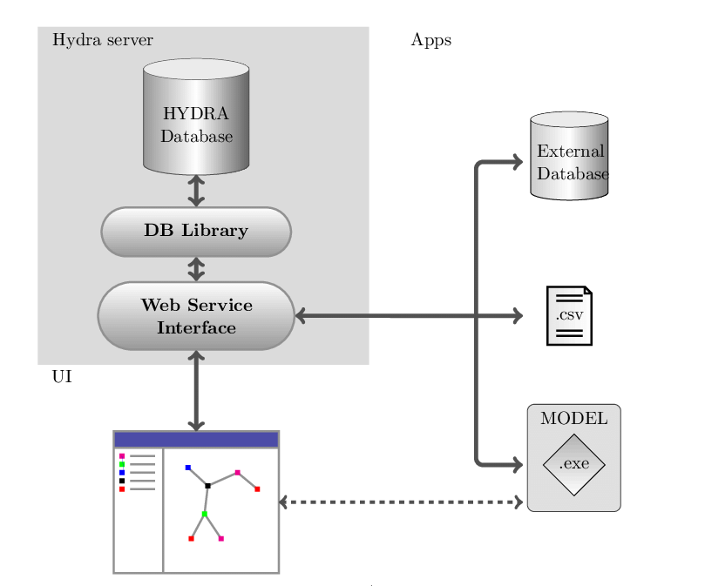
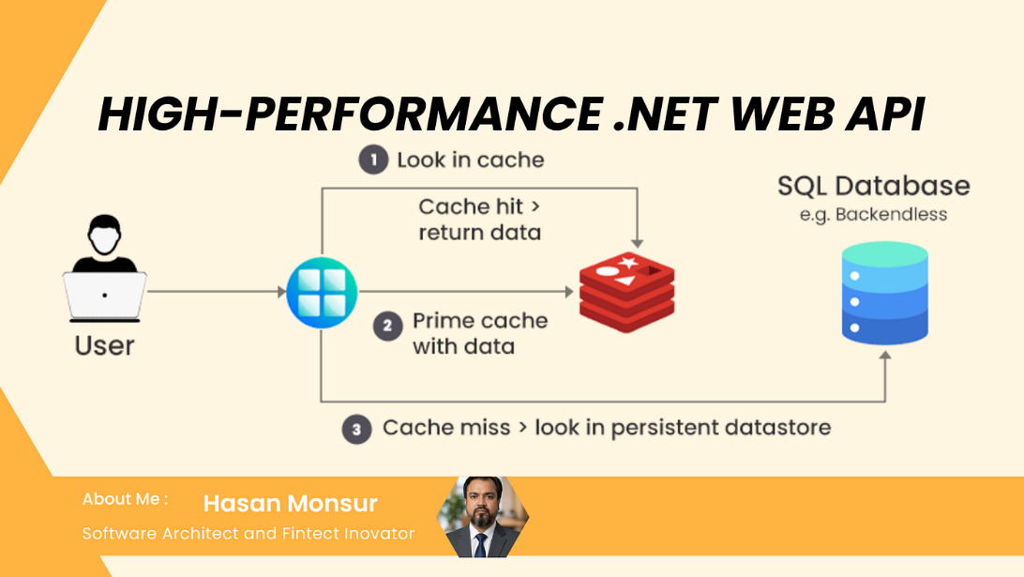

Flow:
Your API → localhost:5432 → PostgreSQL Server
↑
pgAdmin (UI tool)

Explanation:
- PostgreSQL runs as a local server (service)
- It listens on port 5432
- Your ASP.NET app connects using connection string
- UI tool (pgAdmin) also connects to same DB

🧠 Key Point
👉 API and UI tool both talk to DB server
👉 They don’t talk to each other

☁️ Scenario 2: Production (Cloud)
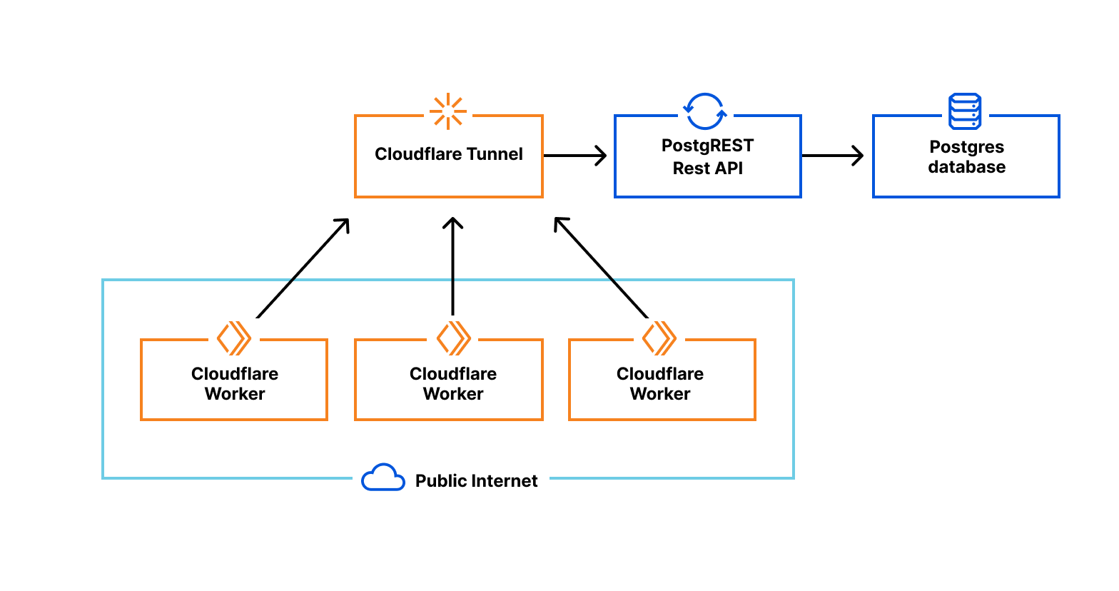

Flow:
User → React App → Backend API → Cloud PostgreSQL
↑
pgAdmin / DBeaver (remote)

Explanation:
- DB runs on cloud (Neon, AWS, etc.)
- Backend connects via internet
- UI tool can also connect remotely
- Multiple users access system

🔐 Important Differences
Aspect | Local | Production
Host | localhost | cloud URL
Access | Local only | Internet
Scale | Small | Large
Security | Basic | Strict

🧠 Core Concept
👉 DBMS = central server
👉 Multiple clients connect:
- Your API
- UI tools
- Other services

🧠 2️⃣ Do ALL DBMS Need a Server?
👉 NO ❌ — Not all DBMS need a server
This is the key concept.

🧱 Two Types of DBMS Based on Architecture

🟢 1. Server-Based DBMS (Most Common)
These run as a separate service

Examples:
- PostgreSQL
- SQL Server
- MySQL
- MongoDB

How they work:
Your App → Network → DB Server (port)
✔ Uses host + port
✔ Supports multiple users
✔ Scalable

🔵 2. Embedded DBMS (No Server)
These run inside your application

Examples:
- SQLite
- H2 (Java world)

How they work:
Your App → directly → database file
✔ No port
✔ No server
✔ Lightweight

🎯 Interview-Ready Answer
If asked:
Explain how a server-based DBMS works.
You say:
A server-based DBMS runs as a separate service that listens on a network port and processes requests from clients such as backend applications or UI tools. Both the application and tools like pgAdmin connect to the DBMS using a connection string. In local environments, it runs on localhost, while in production it is hosted on cloud infrastructure and accessed over the network.

🏆 Final Mental Model
Frontend → Backend API → DBMS (Server)
↑
UI Tool

1️⃣ What is MariaDB (Short)
👉 MariaDB
MariaDB is an open-source relational database (SQL-based) created as a fork of MySQL.
✔ Uses SQL
✔ Server-based
✔ Tables + relationships

⚖️ 2️⃣ MariaDB vs PostgreSQL (Simple Difference)
Feature | MariaDB | PostgreSQL
Origin | Fork of MySQL | Independent
Type | Relational (SQL) | Relational (SQL)
Flexibility | Moderate | Very high
Advanced features | Less | More (JSON, indexing, etc.)
Use case | Web apps (PHP, hosting) | Modern apps, SaaS

🧠 Simple Understanding
- MariaDB → simpler, MySQL-like
- PostgreSQL → more powerful, modern
👉 For your project → PostgreSQL is better

🏢 3️⃣ Oracle Database (High-Level)
👉 Oracle Database

Definition:
Oracle DB is a high-end enterprise relational database system.

Key Points:
- Very powerful
- Used in banks, telecom, large enterprises
- Expensive (licensed)
- Advanced features (scaling, security)

🧠 When Used?
- Banking systems
- Government systems
- Large enterprise apps
👉 Not needed for your project

🖥️ 4️⃣ Microsoft Office DBMS
You’re thinking of:
👉 Microsoft Access

What is Microsoft Access?
A desktop database tool for small applications.

Features:
- GUI-based
- Easy to use
- Stores data locally
- Built for non-developers

Example Use:
- Small office apps
- Student projects
- Local tools

❌ Why Not Used in Modern Backend?
- Not scalable
- Not for web apps
- Not multi-user friendly
- Not cloud-ready

🧠 Final Comparison (All Together)
DBMS | Type | Use Case
PostgreSQL | Relational | Modern apps ✅
SQL Server | Relational | Enterprise (.NET)
MariaDB | Relational | MySQL ecosystem
Oracle | Relational | Large enterprises
SQLite | Embedded | Local apps
MongoDB | NoSQL | Flexible data
MS Access | Desktop DB | Small tools

🎯 One-Line Summary
MariaDB is a MySQL-based relational database, PostgreSQL is a more advanced and modern relational database, Oracle is an enterprise-grade database system, and Microsoft Access is a lightweight desktop database tool not used for scalable backend systems.

STEP 3: Domain Modeling (User, Ticket, Role)

🎯 First — What Are We Designing?
Your system:
A Ticket Management System with workflow + roles + ownership
So we need:
- Users 👤
- Roles 🛡️
- Tickets 🎫

🧱 1️⃣ Core Entities

👤 User
Represents:
- End user / agent / admin

🛡️ Role
Defines:
- What user can do

🎫 Ticket
Represents:
- Issue/request
- Workflow entity

🧠 2️⃣ Relationship Overview (VERY IMPORTANT)
User (1) ──────< (many) Tickets (CreatedBy)
User (1) ──────< (many) Tickets (AssignedTo)
User (many) ─── (1) Role

📊 3️⃣ Table Structure (Final Design)

👤 Users Table
Users
| Id | Name | Email | PasswordHash | RoleId |

🛡️ Roles Table
Roles
| Id | Name |
Example:
1 → User
2 → Agent
3 → Admin

🎫 Tickets Table
Tickets
| Id | Title | Description | Status | CreatedBy | AssignedTo | CreatedAt |

🔗 4️⃣ Relationships Explained

CreatedBy
👉 Who created ticket
Tickets.CreatedBy → Users.Id

AssignedTo
👉 Who is working on ticket
Tickets.AssignedTo → Users.Id

RoleId
Users.RoleId → Roles.Id

🧠 5️⃣ Why This Design? (Interview Level)

Why separate Role table?
❌ Bad:
Role = "Admin"
Problems:
- No control
- Hardcoded
- Error-prone

✅ Good:
- Role table
- Foreign key
- Scalable

Why CreatedBy & AssignedTo?
Because:
- Ownership matters
- Access control depends on it

Why NOT store everything in one table?
Because:
- Violates normalization
- Hard to maintain
- Bad design

🧠 6️⃣ Ticket Status (IMPORTANT)
For now:
Status:
- Open
- InProgress
- Resolved
- Closed

❗ Important Design Decision
Use:
- Enum in code
- String or int in DB
We’ll refine later.

🧠 7️⃣ Minimal vs Overengineering

❌ Don’t add now:
- Comments table
- Attachments
- Notifications

✅ Keep it:
- Simple
- Expand later

🧠 8️⃣ SOLID Applied Here

SRP
- User → user data only
- Ticket → ticket data only

DIP
- You’ll use interfaces later

OCP
- Easy to extend (add priority, comments)

🧠 9️⃣ Future-Ready Design (Important)
This structure supports:
✔ Role-based access
✔ Ownership checks
✔ Workflow transitions
✔ SaaS (add TenantId later)

🎯 Final Schema (Visual)
Users
├── Id
├── Name
├── Email
├── PasswordHash
└── RoleId → Roles.Id
Roles
├── Id
└── Name
Tickets
├── Id
├── Title
├── Description
├── Status
├── CreatedBy → Users.Id
├── AssignedTo → Users.Id
└── CreatedAt

❗ Before Writing Code
You must be clear:
✔ Who creates ticket
✔ Who assigns ticket
✔ Who updates status
✔ Who sees what

🧠 Interview Question You Must Answer
How did you design your entities?
Answer:
I designed a normalized relational schema with Users, Roles, and Tickets. Each ticket maintains relationships for both creator and assigned user, enabling ownership-based access control. Roles are stored in a separate table to support scalable authorization.
Schema vs Database (Technical Difference)

What is a Schema (Technical Definition)
A schema is a logical namespace inside a database that groups and organizes database objects such as tables, views, functions, and indexes.

🧱 Break Down the Definition

🔹 Logical Namespace
- It provides a named container
- Helps avoid naming conflicts
Example:
public.Users
admin.Users
👉 Same table name, different schema

🔹 Inside a Database
A schema is NOT separate from database.
Database → contains → Schemas → contain → Tables

🔹 Contains Objects
A schema can contain:
- Tables
- Views
- Stored procedures
- Functions
- Indexes

🧠 Example (PostgreSQL)
Default schema:
public
Your tables:
public.Users
public.Tickets

🧠 Fully Qualified Name (Important)
Every table has:
SchemaName.TableName
Example:
public.Users

🧠 Why Schema Exists (Technical Reasons)

1️⃣ Namespace Separation
Avoid conflicts:
sales.Users
hr.Users

2️⃣ Security Control
You can:
- Grant access per schema
Example:
- User can access sales but not admin

3️⃣ Organization
Group related tables:
auth.Users
ticket.Tickets

4️⃣ Multi-Tenancy (Advanced)
Each tenant:
tenant1.Users
tenant2.Users

🧠 Internal Representation (Conceptual)
Database
├── Schema: public
│ ├── Table: Users
│ ├── Table: Tickets
│
├── Schema: admin
│ ├── Table: Logs

Schema vs Database (Technical Difference)
Feature | Database | Schema
Level | Top-level container | Inside database
Isolation | Physical/logical | Logical only
Connection | Connect to DB | Use schema inside DB
Purpose | Store all data | Organize objects

🎯 Interview-Ready Answer
A schema is a logical namespace within a database used to organize and group database objects like tables and views, allowing better structure, security control, and avoidance of naming conflicts.

🏆 Final Understanding
✔ Schema = namespace
✔ Exists inside database
✔ Organizes tables
✔ Enables security & separation
Diff Entities and relations

Step 3 Implementation: C# Entities + EF Core Relationships

🧱 1️⃣ Folder Structure (First)
Inside:
/Models/Entities/
Create:
User.cs
Role.cs
Ticket.cs

👤 2️⃣ User Entity
public class User
{
public int Id { get; set; }
public string Name { get; set; }
public string Email { get; set; }
public string PasswordHash { get; set; }
// Foreign Key
public int RoleId { get; set; }
// Navigation Property
public Role Role { get; set; }
// Navigation for Tickets
public ICollection<Ticket> CreatedTickets { get; set; }
public ICollection<Ticket> AssignedTickets { get; set; }
}

🛡️ 3️⃣ Role Entity
public class Role
{
public int Id { get; set; }
public string Name { get; set; }
// Navigation
public ICollection<User> Users { get; set; }
}

🎫 4️⃣ Ticket Entity
public class Ticket
{
public int Id { get; set; }
public string Title { get; set; }
public string Description { get; set; }
public string Status { get; set; }
public DateTime CreatedAt { get; set; }
// Foreign Keys
public int CreatedBy { get; set; }
public int? AssignedTo { get; set; }
// Navigation Properties
public User CreatedByUser { get; set; }
public User AssignedToUser { get; set; }
}

🧠 Important Concepts (Understand This)

🔗 Foreign Keys
public int CreatedBy;
👉 Links to:
Users.Id

🔄 Navigation Properties
public User CreatedByUser;
👉 Lets you access:
ticket.CreatedByUser.Name

⚙️ 5️⃣ Configure Relationships (DbContext)
Now go to:
/Data/AppDbContext.cs
Add:
protected override void OnModelCreating(ModelBuilder modelBuilder)
{
base.OnModelCreating(modelBuilder);
// User → Role (Many-to-One)
modelBuilder.Entity<User>()
.HasOne(u => u.Role)
.WithMany(r => r.Users)
.HasForeignKey(u => u.RoleId);
// Ticket → CreatedBy (Many-to-One)
modelBuilder.Entity<Ticket>()
.HasOne(t => t.CreatedByUser)
.WithMany(u => u.CreatedTickets)
.HasForeignKey(t => t.CreatedBy)
.OnDelete(DeleteBehavior.Restrict);
// Ticket → AssignedTo (Many-to-One)
modelBuilder.Entity<Ticket>()
.HasOne(t => t.AssignedToUser)
.WithMany(u => u.AssignedTickets)
.HasForeignKey(t => t.AssignedTo)
.OnDelete(DeleteBehavior.Restrict);
}

🧠 Why This Configuration?

❓ Why Restrict delete?
Because:
👉 If user is deleted:
- We don’t want tickets to be deleted automatically

❓ Why separate CreatedBy & AssignedTo?
Because:
- Same User table
- Different meaning (creator vs handler)

🧱 6️⃣ Update DbContext
Add DbSets:
public DbSet<User> Users { get; set; }
public DbSet<Role> Roles { get; set; }
public DbSet<Ticket> Tickets { get; set; }

🔄 7️⃣ Run Migration Again
dotnet ef migrations add AddRelationships
dotnet ef database update

1️⃣ What is an Entity?
An Entity is a C# class that represents a table in the database.

Example
public class User
{
public int Id { get; set; }
public string Name { get; set; }
}
👉 This becomes:
Users table
| Id | Name |

🧠 2️⃣ What is a Key?

🔑 Primary Key (PK)
public int Id { get; set; }
👉 Uniquely identifies each row
Example:
User Id = 1, 2, 3

🔗 Foreign Key (FK)
public int RoleId { get; set; }
👉 Points to another table
Example:
Users.RoleId → Roles.Id

🧠 3️⃣ What is a Relationship?
A relationship connects tables logically

Example
User → Ticket
👉 One user can create many tickets

Types (in your project)

1️⃣ One-to-Many
Role (1) → Users (many)
User (1) → Tickets (many)

🧠 4️⃣ Why Do We Need Relationships?
Without relationships:
❌ Data duplication
❌ No structure
❌ No integrity

Example (Bad)
Ticket table:
| Title | UserName |
👉 If username changes → all rows break

Example (Good)
Ticket → UserId
👉 Clean + consistent

🧠 5️⃣ Navigation Properties (VERY IMPORTANT)

What Are They?
Navigation properties are C# references that let you navigate between related entities

Example
public Role Role { get; set; }
👉 Means:
user.Role.Name

Another Example
public ICollection<Ticket> CreatedTickets { get; set; }
👉 Means:
user.CreatedTickets

🧠 Why Needed?
Without navigation:
user.RoleId
👉 Only ID
With navigation:
user.Role.Name
👉 Full object access

🧠 6️⃣ Your Entities Explained Deeply

👤 User
public int RoleId; // FK
public Role Role; // Navigation
public ICollection<Ticket> CreatedTickets;
public ICollection<Ticket> AssignedTickets;

Meaning:
- User belongs to ONE Role
- User can:
  - Create many tickets
  - Be assigned many tickets

🛡️ Role
public ICollection<User> Users;
👉 One role → many users

🎫 Ticket
public int CreatedBy;
public User CreatedByUser;
public int? AssignedTo;
public User AssignedToUser;

Meaning:
- Ticket has ONE creator
- Ticket has ONE assigned user
- Both point to User table

🧠 7️⃣ Why Two Relationships to Same Table?
Ticket → User (CreatedBy)
Ticket → User (AssignedTo)
👉 Same table, different meaning

🧠 8️⃣ What is OnModelCreating?

Definition
A method where you configure how EF Core maps your C# models to database schema.

Why Needed?
EF Core uses:
- Convention (automatic)
- Fluent API (manual → here)

Problem Without It
EF Core may get confused:
Ticket → User (2 times)
👉 It won’t know:
- Which FK maps to which navigation

So we explicitly define:
.HasForeignKey(t => t.CreatedBy)

🧠 9️⃣ How OnModelCreating Works (Flow)

Step-by-step
App starts
↓
DbContext created
↓
OnModelCreating runs
↓
EF builds model (schema mapping)
↓
Used for:
- migrations
- queries

🧠 🔟 Why DeleteBehavior.Restrict?
Default:
👉 Cascade delete
Problem:
- Delete user → deletes tickets ❌
So we use:
Restrict
👉 Prevent accidental data loss

🧠 1️⃣1️⃣ How Many OnModelCreating Methods?
👉 ONLY ONE per DbContext

If More Tables?
👉 Add inside same method:
modelBuilder.Entity<NewEntity>()

🧠 1️⃣2️⃣ What Happens When You Add More Tables?
- Add entity class
- Add DbSet
- Add config in OnModelCreating (if needed)
- Run migration

🧠 1️⃣3️⃣ When Do You NOT Need OnModelCreating?
If simple:
public int RoleId;
public Role Role;
EF can auto-detect.

But YOU need it because:
👉 Multiple relations to same table (User)

🎯 Interview-Level Answer
Navigation properties allow traversal between related entities, while foreign keys define the actual relationship in the database. Relationships are configured explicitly using Fluent API in OnModelCreating to avoid ambiguity and enforce correct mappings.

🏆 Final Mental Model
Entity → Table
Property → Column
FK → Relationship
Navigation → Object link
OnModelCreating → Mapping rules

What is a Relationship?
A relationship defines how data in one table is connected to data in another table.

📊 Example
Users Table Tickets Table
| Id | Name | | Id | Title | CreatedBy |
|----|------| |----|-------|-----------|
| 1 | Rup | | 1 | AC | 1 |
👉 CreatedBy = 1 → refers to Users.Id
👉 That is a relationship

🔗 2️⃣ How Relationship is Implemented?
Using:
👉 Foreign Key (FK)
Tickets.CreatedBy → Users.Id

🧠 Meaning
- FK column stores reference ID
- Ensures data is linked correctly

🧠 3️⃣ Why Relationships Are Important?

❌ Without Relationships
Ticket:
| Title | UserName |
Problems:
- Duplicate data
- Inconsistency
- Hard to update

✅ With Relationships
Ticket:
| Title | UserId |
Benefits:
- Clean data
- No duplication
- Easy updates
- Data integrity

🧠 4️⃣ Referential Integrity (VERY IMPORTANT)
Database ensures FK always points to valid row

Example
❌ Invalid:
CreatedBy = 999 (no user exists)
👉 DB will reject

🧠 5️⃣ Types of Relationships

1️⃣ One-to-One (1:1)
User → Profile
- One user → one profile

2️⃣ One-to-Many (1:N) ✅ (MOST COMMON)
User → Tickets
- One user → many tickets

3️⃣ Many-to-Many (M:N)
User ↔ Projects
- Many users → many projects
👉 Needs junction table

🧠 6️⃣ How DB Stores Relationship Internally
👉 DB DOES NOT store objects
👉 Only IDs
Tickets table:
| Id | CreatedBy |
|----|-----------|
| 1 | 1 |
👉 That’s it

🧠 7️⃣ What About JOIN?
To fetch related data:
SELECT t.Title, u.Name
FROM Tickets t
JOIN Users u ON t.CreatedBy = u.Id;
👉 This is how DB combines data

Relationships in YOUR Project
Now real understanding starts 🔥

🧱 Your Entities
- User
- Role
- Ticket

🔗 1️⃣ User ↔ Role
Role (1) → Users (many)

Meaning:
- One role → many users
- One user → one role

DB Structure
Users
| Id | RoleId |
Roles
| Id | Name |

🔗 2️⃣ User ↔ Ticket (CreatedBy)
User (1) → Tickets (many)

Meaning:
- One user can create many tickets

DB
Tickets.CreatedBy → Users.Id

🔗 3️⃣ User ↔ Ticket (AssignedTo)
User (1) → Tickets (many)

Meaning:
- One agent handles many tickets

⚠️ Special Case (IMPORTANT)
👉 SAME TABLE (User) used twice
Ticket → User (CreatedBy)
Ticket → User (AssignedTo)

🧠 Why This Is Important?
Because:
- Creator ≠ Assignee
- Different business meaning

🧠 4️⃣ How EF Core Represents This

Foreign Keys
public int CreatedBy;
public int? AssignedTo;

Navigation Properties
public User CreatedByUser;
public User AssignedToUser;

Meaning
ticket.CreatedByUser.Name
👉 Access full object

🧠 5️⃣ Flow (Very Important)

DB Level
Ticket stores:
CreatedBy = 1

EF Core Level
ticket.CreatedByUser → full User object

🧠 6️⃣ Why We Need Relationships in YOUR Project?

1️⃣ Access Control
User can see ONLY their tickets
👉 Need CreatedBy relationship

2️⃣ Assignment Logic
Agent works on assigned tickets
👉 Need AssignedTo

3️⃣ Role-Based Authorization
Admin vs Agent vs User
👉 Need Role relationship

🧠 7️⃣ Without Relationships Your App Would Fail
You wouldn’t be able to:
- Track ownership
- Assign tickets
- Filter data
- Enforce security

🧠 8️⃣ Real Example (End-to-End)
User:
Id = 1 (Rup)
Agent:
Id = 2 (Amit)
Ticket:
CreatedBy = 1
AssignedTo = 2

Flow
Rup creates ticket
→ Ticket.CreatedBy = 1
Admin assigns Amit
→ Ticket.AssignedTo = 2
Amit works on it

🎯 Interview-Level Answer
Relationships define how tables are connected using foreign keys. In my system, I used one-to-many relationships where a user can create and be assigned multiple tickets, and roles define user permissions. These relationships ensure data integrity and support business logic like ownership and access control.

🏆 Final Mental Model
DB stores IDs (FK)
↓
Relationships connect tables
↓
EF Core uses navigation properties
↓
Your app uses full objects

🔐 STEP 4: Authentication (JWT)

🧠 1️⃣ What We Are Building
You will implement:
- User Registration
- User Login
- JWT Token Generation
- Securing APIs

🧠 2️⃣ What is JWT?
👉 JSON Web Token
A signed token that proves user identity.

Structure
Header.Payload.Signature

Example Payload
{
"userId": 1,
"email": "user@mail.com",
"role": "Admin"
}

🧠 Key Idea
👉 Server does NOT store session
👉 Token contains identity

⚙️ 3️⃣ Install Required Package
Run:
dotnet add package Microsoft.AspNetCore.Authentication.JwtBearer

🧱 4️⃣ Add JWT Config (appsettings.json)
"Jwt": {
"Key": "THIS_IS_SECRET_KEY_12345",
"Issuer": "TicketSystem",
"Audience": "TicketSystemUsers",
"DurationInMinutes": 60
}

🧠 Why?
- Key → used to sign token
- Issuer → who created token
- Audience → who uses it

⚙️ 5️⃣ Configure JWT in Program.cs
Add:
builder.Services.AddAuthentication(options =>
{
options.DefaultAuthenticateScheme = "JwtBearer";
options.DefaultChallengeScheme = "JwtBearer";
})
.AddJwtBearer("JwtBearer", options =>
{
var key = Encoding.UTF8.GetBytes(builder.Configuration["Jwt:Key"]);
options.TokenValidationParameters = new TokenValidationParameters
{
ValidateIssuer = true,
ValidateAudience = true,
ValidateLifetime = true,
ValidateIssuerSigningKey = true,
ValidIssuer = builder.Configuration["Jwt:Issuer"],
ValidAudience = builder.Configuration["Jwt:Audience"],
IssuerSigningKey = new SymmetricSecurityKey(key)
};
});
builder.Services.AddAuthorization();

🔥 Also add:
app.UseAuthentication();
app.UseAuthorization();
👉 Order matters!

🧠 6️⃣ Create Token Service
📁 /Helpers/JwtService.cs
public class JwtService
{
private readonly IConfiguration _config;
public JwtService(IConfiguration config)
{
_config = config;
}
public string GenerateToken(User user)
{
var claims = new[]
{
new Claim("userId", user.Id.ToString()),
new Claim("email", user.Email),
new Claim("role", user.Role.Name)
};
var key = new SymmetricSecurityKey(
Encoding.UTF8.GetBytes(_config["Jwt:Key"])
);
var creds = new SigningCredentials(key, SecurityAlgorithms.HmacSha256);
var token = new JwtSecurityToken(
issuer: _config["Jwt:Issuer"],
audience: _config["Jwt:Audience"],
claims: claims,
expires: DateTime.Now.AddMinutes(60),
signingCredentials: creds
);
return new JwtSecurityTokenHandler().WriteToken(token);
}
}

⚙️ Register Service
builder.Services.AddScoped<JwtService>();

🧠 7️⃣ Create Auth Controller
📁 /Controllers/AuthController.cs

🔹 Register API
[HttpPost("register")]
public async Task<IActionResult> Register(User user)
{
user.PasswordHash = BCrypt.Net.BCrypt.HashPassword(user.PasswordHash);
_context.Users.Add(user);
await _context.SaveChangesAsync();
return Ok("User created");
}

🔹 Login API
[HttpPost("login")]
public async Task<IActionResult> Login(string email, string password)
{
var user = await _context.Users
.Include(u => u.Role)
.FirstOrDefaultAsync(u => u.Email == email);
if (user == null || !BCrypt.Net.BCrypt.Verify(password, user.PasswordHash))
return Unauthorized();
var token = _jwtService.GenerateToken(user);
return Ok(new { token });
}

🧠 8️⃣ Protect APIs
Use:
[Authorize]
Example:
[Authorize]
[HttpGet]
public IActionResult GetTickets()
{
return Ok();
}

🧠 9️⃣ Role-Based Authorization
[Authorize(Roles = "Admin")]

🧠 🔟 Flow (VERY IMPORTANT)
User logs in
↓
Server validates credentials
↓
Server generates JWT
↓
Client stores token
↓
Client sends token in header
↓
Backend validates token
↓
Access granted

Header Example
Authorization: Bearer <token>

🔐 Security Notes
- NEVER store password plain text ❌
- ALWAYS hash password ✅
- Use HTTPS in real apps ✅

🎯 Interview-Ready Answer
I implemented JWT-based authentication where the backend generates a signed token containing user claims after successful login. The token is then used to authorize subsequent requests using middleware validation.

🏆 What You Achieved
✔ Authentication
✔ Token-based system
✔ Secure APIs
✔ Role-based access

🚀 Next Step
👉 Step 5: Ticket APIs (Create, Assign, Change Status)

Before moving ahead
Try:
- Register user
- Login → get token
- Call API with token

If anything breaks → send error, I’ll fix 👍
before going to step 5 correct my AuthController class : using Microsoft.AspNetCore.Mvc; using Microsoft.EntityFrameworkCore; using TaskManagementSystemWebAPI.Helpers; using TaskManagementSystemWebAPI.Models.Entities; namespace TaskManagementSystemWebAPI.Controllers { public class AuthController { [HttpPost("register")] public async Task<IActionResult> Register(User user) { user.PasswordHash = BCrypt.Net.BCrypt.HashPassword(user.PasswordHash); _context.Users.Add(user); await _context.SaveChangesAsync(); return Ok("User created"); } [HttpPost("login")] public async Task<IActionResult> Login(string email, string password) { var user = await _context.Users .Include(u => u.Role) .FirstOrDefaultAsync(u => u.Email == email); if (user == null || !BCrypt.Net.BCrypt.Verify(password, user.PasswordHash)) return Unauthorized(); var token = _jwtService.GenerateToken(user); return Ok(new { token }); } } }
Good — this is exactly the kind of correction that builds strong backend skills 👍
Your current controller has a few critical issues. I’ll fix it and explain why each change is needed.

❌ Problems in Your Current Code
- No [ApiController]
- No [Route]
- Not inheriting from ControllerBase
- Missing _context and _jwtService (Dependency Injection)
- Login parameters not coming from body
- Using User entity directly (not ideal)

✅ Corrected AuthController (Clean Version)
using Microsoft.AspNetCore.Mvc;
using Microsoft.EntityFrameworkCore;
using TaskManagementSystemWebAPI.Helpers;
using TaskManagementSystemWebAPI.Models.Entities;
using TaskManagementSystemWebAPI.Data;
namespace TaskManagementSystemWebAPI.Controllers
{
[ApiController]
[Route("api/[controller]")]
public class AuthController : ControllerBase
{
private readonly AppDbContext _context;
private readonly JwtService _jwtService;
public AuthController(AppDbContext context, JwtService jwtService)
{
_context = context;
_jwtService = jwtService;
}
[HttpPost("register")]
public async Task<IActionResult> Register([FromBody] User user)
{
// Hash password
user.PasswordHash = BCrypt.Net.BCrypt.HashPassword(user.PasswordHash);
_context.Users.Add(user);
await _context.SaveChangesAsync();
return Ok("User created");
}
[HttpPost("login")]
public async Task<IActionResult> Login([FromBody] LoginRequest request)
{
var user = await _context.Users
.Include(u => u.Role)
.FirstOrDefaultAsync(u => u.Email == request.Email);
if (user == null || !BCrypt.Net.BCrypt.Verify(request.Password, user.PasswordHash))
return Unauthorized("Invalid credentials");
var token = _jwtService.GenerateToken(user);
return Ok(new { token });
}
}
}

🧱 Create LoginRequest DTO (IMPORTANT)
📁 /Models/DTOs/LoginRequest.cs
public class LoginRequest
{
public string Email { get; set; }
public string Password { get; set; }
}

🧠 Explanation (Why Each Change?)

🔹 [ApiController]
👉 Enables:
- Automatic model binding
- Validation
- Cleaner APIs

🔹 [Route("api/[controller]")]
👉 Your endpoints become:
POST /api/auth/register
POST /api/auth/login

🔹 ControllerBase
👉 Required for:
- Ok(), Unauthorized()
- API behavior

🔹 Dependency Injection
private readonly AppDbContext _context;
private readonly JwtService _jwtService;
👉 You must inject, not create manually ❌

🔹 [FromBody]
Login([FromBody] LoginRequest request)
👉 Data comes from JSON body

🔹 DTO Usage (VERY IMPORTANT)
❌ Bad:
Login(string email, string password)
Problems:
- Hard to scale
- Not clean

✅ Good:
LoginRequest

⚠️ Important Improvement (Register API)
Right now:
Register(User user)
👉 Not ideal ❌
Better (later):
- Use Register DTO
- Avoid exposing entity

🧠 Flow Now

Register
Client → POST /register
→ Password hashed
→ Stored in DB

Login
Client → POST /login
→ Verify password
→ Generate JWT
→ Return token

🧪 Example Request

Register
{
"name": "Rup",
"email": "rup@mail.com",
"passwordHash": "123456",
"roleId": 1
}

Login
{
"email": "rup@mail.com",
"password": "123456"
}

🎯 Interview-Level Points
If asked:
Why use DTO instead of entity?
Answer:
DTOs prevent exposing database structure, improve security, and allow flexibility in API contracts.

🏆 What You Fixed
✔ Proper API controller
✔ Dependency injection
✔ Clean request handling
✔ JWT integration ready

🚀 Next (Optional Improvement)
We can upgrade:
- Register DTO
- Validation
- Duplicate email check

👉 Before Step 5
Test:
- Register user
- Login → get token
- Check token returned

If working → say:
Step 5 🎯
okay before stpe 5 can you explain waht is DTO and why we use and where we use if i say in these 3 layer controller service and repository
Perfect — this is a must-know concept for clean architecture + interviews.
Let’s break it down properly 👇

🧠 1️⃣ What is a DTO?
👉 DTO = Data Transfer Object
A DTO is a simple object used to transfer data between layers (or between client and server).

🔍 Example
public class LoginRequest
{
public string Email { get; set; }
public string Password { get; set; }
}
👉 This is a DTO

🧠 2️⃣ Why Do We Use DTO?

❌ Without DTO (Bad Practice)
public async Task<IActionResult> Register(User user)
Problems:
- Exposes DB structure
- Client can send unwanted fields
- Security risk
- Tight coupling

✅ With DTO (Good Practice)
public async Task<IActionResult> Register(RegisterRequest dto)
👉 You control:
- What client sends
- What client receives

🧠 3️⃣ Key Reasons (VERY IMPORTANT)

🔐 1. Security
Hide sensitive fields:
PasswordHash ❌

🎯 2. Control API Contract
You decide:
- What API accepts
- What API returns

🔄 3. Decoupling
👉 DB structure can change
👉 API remains same

🧼 4. Clean Architecture
Each layer has its own responsibility

🧠 4️⃣ Types of DTOs

🔹 Request DTO
Used for input
LoginRequest
RegisterRequest
CreateTicketRequest

🔹 Response DTO
Used for output
UserResponse
TicketResponse

🧠 5️⃣ Where DTO is Used? (IMPORTANT)
You asked about:
👉 Controller
👉 Service
👉 Repository

🧱 Flow (Very Important)
Client → Controller → Service → Repository → DB

🎯 Where DTO is Used?

🟢 Controller Layer
👉 YES (MOST IMPORTANT)
Login(LoginRequest dto)
👉 Why?
- Handles API input/output
- Talks to client

🟡 Service Layer
👉 YES (Recommended)
Login(LoginRequest dto)
👉 Why?
- Business logic uses clean data
- Keeps separation

🔴 Repository Layer
👉 ❌ NO (Important)
Repository should use:
User (Entity)
👉 Why?
- Works directly with DB
- DTO is API concept, not DB concept

🧠 Summary Table
Layer | Use DTO? | Why
Controller | ✅ Yes | API contract
Service | ✅ Yes | Clean logic
Repository | ❌ No | DB operations

🧠 6️⃣ Mapping (Important Concept)
DTO ↔ Entity conversion

Example
User user = new User
{
Email = dto.Email,
PasswordHash = Hash(dto.Password)
};
👉 This is mapping

Tools (later)
- AutoMapper (optional)

🧠 7️⃣ Real Example (Your Project)

Register Flow
Client → RegisterRequest DTO
↓
Controller
↓
Service
↓
Convert DTO → User Entity
↓
Repository → DB

Response
User Entity → UserResponse DTO → Client

🎯 Interview Questions (VERY IMPORTANT)

❓ What is DTO?
A DTO is used to transfer data between layers and helps in controlling API contracts and improving security.

❓ Why not use entity directly?
Using entities exposes database structure and can lead to security and maintainability issues.

❓ Where do you use DTO?
DTOs are used in controller and service layers, while repositories work with entities.

🏆 Final Mental Model
DTO → API communication
Entity → Database structure

🔥 Most Important Takeaway
👉 Never expose Entity directly to client
👉 Always use DTO

🚀 Now You’re Ready
You understand:
- DTO concept
- Layer separation
- Clean architecture

👉 Next Step
Say:
Step 5
Now we build:
- Ticket APIs (Create, Assign, Update Status) 🎯

