**EASTERN COLLEGE OF ENGINEERING**

**(AFFILIATED TO PU)**

**BIRATNAGAR, MORANG**



**[Subject code:- BEG474CO]**

**A project report on**

**“Blood Bank Management System (BBMS)”**

**Submitted By:**

**Jagmohan Prasad Majhi (373271)**

**Kunal Bhattarai (373272)**

**Rahila Eram (373275)**

**Rupesh Choudhary (373276)**

**Saugat Kunwar (373277)**

**Sweaksha Jha (373280)**

**Bachelor of Computer Engineering**

**Submitted To:**

**Department of Computer Engineering**

**Eastern College of Engineering**

**Biratnagar, Morang**

**2080**

**Certificate**

This is to certify that Mr. Jagmohan Prasad Majhi Exam Roll No. 373271; Mr. Kunal Bhattarai Exam Roll No. 373272; Ms. Rahila Eram Exam Roll No. 373275; Mr. Rupesh Choudhary Exam Roll No. 373276; Mr. Saugat Kunwar Exam Roll No. 373277; and Ms. Sweaksha Jha Exam Roll No. 373280; the students of Bachelor In Computer Engineering Seventh Semester has satisfactorily completed their assigned project in partial fulfilment of Bachelor In Computer Engineering Seventh Semester examination under the guidance of Er. Gopal Kumar Shah.

This project has been started from the beginning of the requirement analysis and gap continuity up to design the program and coding. The effort and endeavour on this program are entirely developed by them using various references and guidance. We hope that this will help them to develop some more ideas and build career in web development in future.

………………….. …………………….

Er. Gopal Kumar Shah Er. Janardan Pd. Mehta

Project Supervisor Head of Department

………………….

External

Name:

Date:

**ABSTRACT**

Blood transfusion is a vital medical procedure that can save lives and treat various diseases. However, there are many challenges and risks involved in the process of blood donation and transfusion, such as blood shortage, blood wastage, blood contamination, and transfusion reactions. To overcome these challenges and ensure the safety and efficiency of blood transfusion, a blood bank management system is needed. A blood bank management system is a web application that manages the data and operations of a blood bank. It allows the blood bank staff to register donors, collect blood, store blood, distribute blood, and maintain records.

A blood bank management system is a technological innovation designed to revolutionize the way blood banks operate. It serves as a sophisticated software solution that meticulously orchestrates the complex web of processes inherent to blood banking. By seamlessly integrating technologies like PHP, HTML, CSS, JavaScript, MySQL, and code editor like Microsoft VS Code, this system transcends the limitations of traditional blood bank management methodologies.

**ACKNOWLEDGEMENT**

It is very grateful pleasure for us to express our sincere gratitude towards the entire EASCOLL`S BE team especially to erudite Er. Gopal Kumar Shah. We are indebted towards his guidelines and supervision and most importantly his broad thoughts and his friendly nature towards us.

We are also very thankful to subject teachers who were always ready to help even in small problem if we were unable to perform it without showing superior behaviour on us. They were always in front to give their valuable time when need and also always being there to help in critical situation. They were always here to inspire and motivate us.

We are also equally grateful to our classmate for helping us in case of collecting and buying material as required for our project, giving option for designing and other issues.

We humbly respect to all the concerned teacher and student for their valuable comment, continuous support and constructive suggestion for quality improvement and the sustainability of this software. Yours valuable comments and constructive suggestion are most welcomed and will be sincerely acknowledged.

**TABLE OF CONTENTS**

**Contents Page No.**

1. CHAPTER: Project Overview 1
   1. Introduction 1
   2. Background and significance 2
   3. Objectives of the Project 4
      1. Primary Objective ………………………………………..…..4
      2. Secondary Objective……………………………….................4
2. CHAPTER: Work Division and Time Schedule 5
   1. Work Division 5
   2. Time Scheduling 5
   3. Gantt Chart 6
3. CHAPTER: Design and Specification 7
   1. Use Case Diagram 7
   2. Flow Chart 8
   3. Data Flow Diagram 9
   4. ER Diagram 10
4. CHAPTER: Problems Faced 11
5. CHAPTER: Cost Estimation 12
6. CHAPTER: Software and Technology Used 13
7. CHAPTER: Software and Hardware Requirements 14
8. CHAPTER: Expected Results 15
9. CHAPTER: Limitation 16
10. CHAPTER: Project Screenshots 17
11. CHAPTER: Conclusion 19
12. CHAPTER: Lesson Learnt 20
13. CHAPTER: Future Enhancements 21
14. CHAPTER: Reference 22

**CHAPTER 1**

**PROJECT OVERVIEW**

* 1. **INTRODUCTION**

This system stands as a multifaceted tool, empowering blood bank staff with the capabilities to manage every facet of blood donation, storage, testing, and distribution. Through its intuitive interface, blood bank personnel can effortlessly register donors, oversee the collection of blood units, ensure their secure storage, for transfusion, and seamlessly administer the process of blood distribution. Moreover, the system diligently maintains a comprehensive repository of records, encapsulating the entire lifecycle of each blood unit and donor interaction.

Beyond its operational benefits for blood bank staff, this system extends its utility to the donors and recipients who rely on its functionalities. For donors, it offers the convenience of streamlined registration and appointment scheduling, fostering a more engaging and efficient donation experience. Donors can also track their donation history and receive alerts about optimal timesfor subsequent contributions. Onrecipients' side, the system facilitates the search for compatible blood groups, enabling them to promptly request the blood they need. This expedited process can be crucial in time-sensitive medical situations.

In essence, the Blood Bank Management System is not merely a collection of software modules; it embodies a transformative approach to blood banking. By addressing the core challenges of blood shortage, wastage, contamination, and adverse reactions, this system aligns with the imperatives of modern medical practices. It signifies the convergence of cutting-edge technologies with the noble pursuit of enhancing healthcare outcomes through the efficient management of a precious resources.

* 1. **BACKGROUND AND SIGNIFICANCE**

**Background:**

Blood transfusion stands as a cornerstone of modern healthcare, playing a crucial role in treating various medical conditions and saving countless lives. The process of blood donation, collection, testing, storage, and distribution is complicated and multifaceted, involving numerous stakeholders, complex logistics, and uncompromising safety measures. However, the conventional methods of managing these operations often fall short in addressing the dynamic challenges of blood banking.

Historically, manual record-keeping, disjointed data management systems, and lack of real-time communication have led to inefficiencies, blood shortages, wastage, and compromised safety. Such inefficiencies not only hamper the timely availability of blood but also jeopardize the health and well-being of patients in need of transfusions.

The rise of technology offers a unique chance to completely transform the field of blood banking like never before. A modern, integrated, and automated Blood Bank Management System can mitigate the existing challenges, enhance donor engagement, optimize blood inventory, ensure the safety of transfusions, and contribute to a more effective healthcare ecosystem.

**Significance:**

The significance of developing a comprehensive Blood Bank Management System cannot be overstated. This project holds the potential to revolutionize the blood banking landscape and address critical issues that have plagued the industry for years.

1. **Efficiency and Timeliness**: By automating and streamlining processes, the system will significantly reduce the time taken to register donors, collect blood, and distribute blood to hospitals. This efficiency is paramount in emergency situations where timely access to blood can be a matter of life and death.
2. **Optimized Inventory Management:** The system's real-time tracking and management of blood inventory will help mitigate shortages and wastage. Hospitals can access accurate information about available blood units, reducing the need for excess storage and minimizing the risk of expired blood.
3. **Enhanced Safety**: The system's integration of comprehensive donor and blood unit information, along with validation processes, will minimize the risk of contaminated or incompatible blood transfusions. This directly contributes to patient safety and reduces the occurrence of adverse reactions.
4. **Donor Engagement:** The system will provide donors with a user-friendly platform to register and schedule donations. This convenience and engagement will foster a consistent and reliable blood supply, as well as establish a sense of fulfillment among donors.
5. **Data-Driven Insights:** The system's centralized database will accumulate a wealth of data over time. Analysis of this data can yield insights into donation trends, distribution patterns, and potential areas for improvement, enabling evidence-based decision-making.
6. **Scalability**: As the system is digital in nature, it can be scaled to accommodate the needs of blood banks of varying sizes, from local clinics to regional facilities, contributing to a standardized approach to blood management.
7. **Public Health Impact:** A well-executed Blood Bank Management System can indirectly impact public health by ensuring the timely availability of safe blood, reducing the burden on healthcare facilities, and improving patient outcomes.
   1. **OBJECTIVES OF THE PROJECT**

**1.3.1. Primary Objective**

The primary objectives of the project are mentioned below:

* To fulfil the requirement for achieving the Bachelor’s degree of Computer Engineering
* To know the fundamentals of the “PHP” language and Microsoft Visual Studio Code (VS Code)

**1.3.2. Secondary Objective**

The secondary objectives of this project are mentioned below:

1. Donor Engagement: Develop a user-friendly interface for donors to register, schedule appointments, and update their information.
2. Inventory Tracking: Implement a database to manage blood inventory, track blood types and quantities
3. Donation Scheduling: Allow users to book donation appointments online, reducing waiting times and improving overall donor experience.
4. Camp Coordination: To streamline the organization and management of blood donation camps, ensuring they are well-planned and successful.
5. Certification: To provide certification to blood donors as a recognition of their contribution and to encourage continued participation.

**CHAPTER 2**

**WORK DIVISION AND TIME SCHEDULE**

In order to reduce work load and avoid conflict so that project can be completed before deadline, works were equally divided within the group members and development of the Blood Bank Management System were span over an estimated timeline of 6 months, divided into distinct phases, each focusing on specific aspects of the project. The tentative schedule was outlined as follows:

1. Project Initiation and Planning (15 days):
   * Define project scope, objectives, and requirements.
   * Formulate a detailed project plan.
   * Identify technologies and tools to be used.
   * Set up development environment.
2. Research and Requirement Analysis (1 month):

* Conduct an in-depth analysis of blood banking processes and challenges.
* Gather feedback from potential users (blood bank staff, donors, recipients) for system requirements.
* Identify key features and functionalities to be included.

1. Design and Prototyping (1 month):

* Design the database schema for blood donors, recipients, blood units, and transactions.
* Develop a prototype for initial testing and feedback.

1. Development (1.5 months):

* Implement the front-end using HTML, CSS and JavaScript.
* Develop the back-end functionalities using PHP, integrating MySQL for relational data and XAMPP for local server and data storage.
* Build user registration, appointment scheduling and blood inventory management.

1. Testing and Quality Assurance (1 months):

* Conduct comprehensive testing of the system's functionalities.
* Perform usability testing to ensure a user-friendly interface.
* Debug and address issues identified during testing.

1. Documentation and Finalization (15 days):

* Prepare comprehensive documentation including user manuals, technical specifications, and system architecture.
* Address any last-minute refinements based on user feedback.
* Review the entire project to ensure alignment with objectives.

|  |  |  |  |  |  |  |  |  |  |  |  |
| --- | --- | --- | --- | --- | --- | --- | --- | --- | --- | --- | --- |
| **Weeks** | 1 | 2 | 3 | 4 | 5 | 6 | 7 | 8 | 9 | 10 | 11 |
| **Planning Projects** |  |  |  |  |  |  |  |  |  |  |  |
|  |  |  |  |  |  |  |  |  |  |  |  |
| Analysis & Planning |  |  |  |  |  |  |  |  |  |  |  |
|  |  |  |  |  |  |  |  |  |  |  |  |
| Design & Prototyping |  |  |  |  |  |  |  |  |  |  |  |
|  |  |  |  |  |  |  |  |  |  |  |  |
| Development |  |  |  |  |  |  |  |  |  |  |  |
|  |  |  |  |  |  |  |  |  |  |  |  |
| Testing & QA |  |  |  |  |  |  |  |  |  |  |  |
|  |  |  |  |  |  |  |  |  |  |  |  |
| Report/Documentation |  |  |  |  |  |  |  |  |  |  |  |

*Notes: 1=1*2 weeks, Total weeks=24

Fig: Gantt Chart for Work Schedule

**CHAPTER 3**

**DESIGN AND SPECIFICATION**

**3.1 USE CASE DIAGRAM**

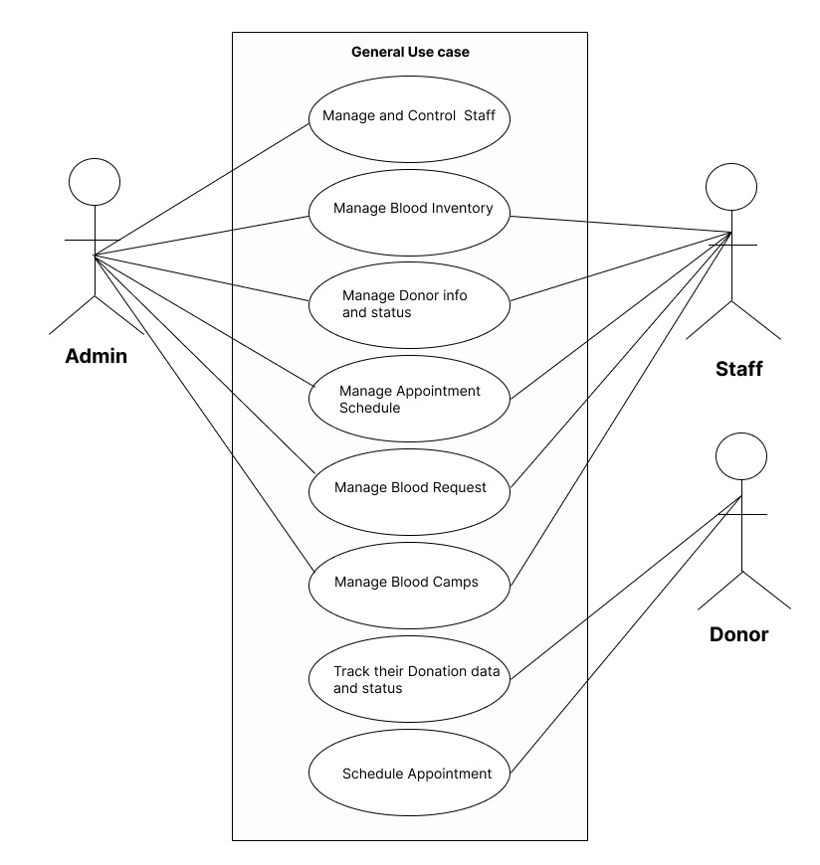

**Fig: Use Case Diagram Of BBMS**

**3.2. FLOWCHART**

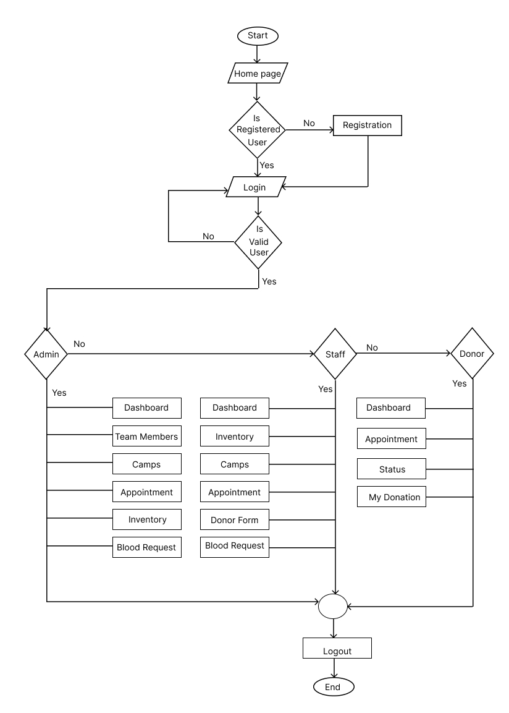

**Fig: Flowchat Of BBMS**

**3.3. DATA FLOW DIAGRAM**

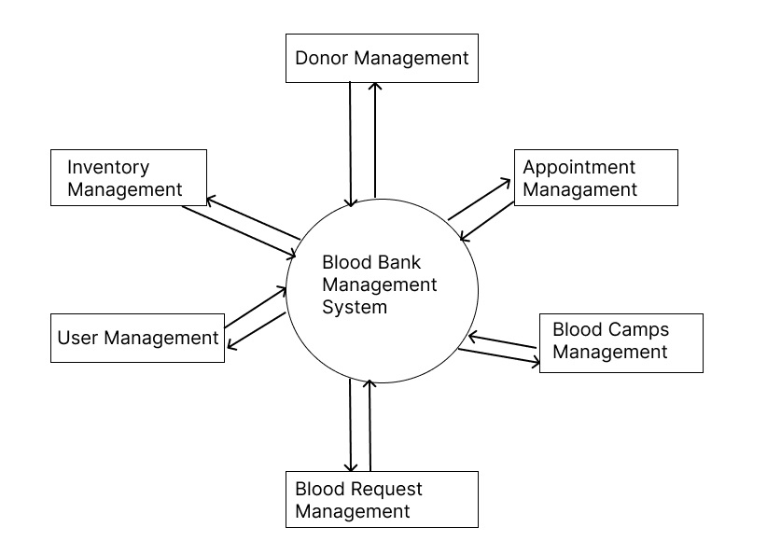

**Fig: 0 Level Data Flow Diagram Of BBMS**

**3.4. ER DIAGRAM**

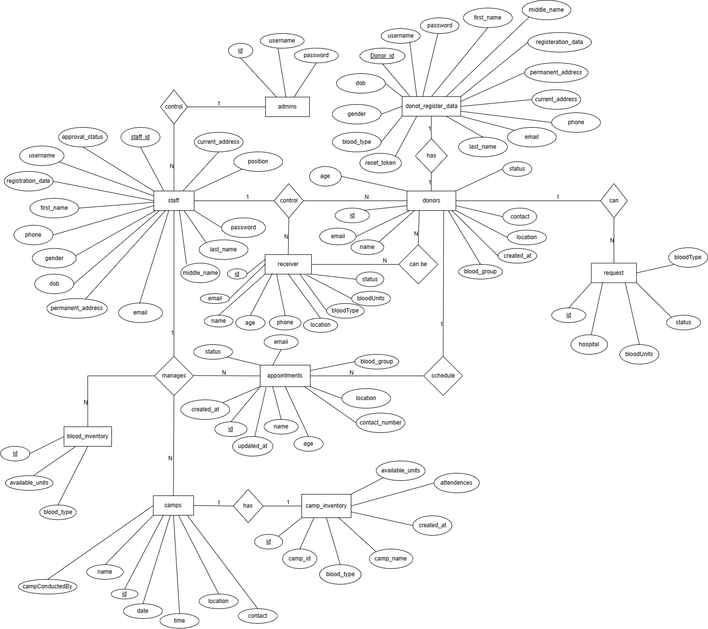

**Fig: ER Diagram Of BBMS**

**CHAPTER 4**

**PROBLEM FACED**

The process of blood donation, collection, storage, testing, and distribution is a complex and critical facet of modern healthcare. However, the existing methods of managing these operations in blood banks are riddled with inefficiencies, shortcomings, and challenges that hinder the seamless and safe delivery of blood products to patients in need. This necessitates the development of a comprehensive Blood Bank Management System to address the following key issues:

1. Inefficient Donor Management
2. Lack of Real-time communication
3. Safety and Compatibility Issues
4. Limited Donor Engagement
5. Absence of Data-Driven Insights
6. Resource Inefficiencies
7. Sub optimal Inventory Tracking

In light of these challenges, the development of a robust Blood Bank Management System emerges as a crucial solution. This system should integrate modern technologies to streamline processes, enhance communication, ensure donor engagement, optimize inventory management, and ultimately, elevate the safety and efficiency of blood transfusions. By tackling these core issues, the system aims to revolutionize the blood banking landscape and contribute to the betterment of healthcare systems worldwide**.**

**CHAPTER 5**

**COST ESTIMATION**

* To know the idea of coding and designing many references were taken
* Compiling and filtering was costlier
* For group decision, meeting was done
* In case of searching codes and plugins from internet

This project mainly uses free and open-sources tools, and there won’t be a need for any additional funds from outside sources.

**CHAPTER 6**

**SOFTWARE AND TECHNOLOGY USED**

* Code Editor: Microsoft Visual Studio Code (VS Code)
* Database: MySQL
* Software: XAMPP
* Language: PHP
* Stylesheet: CSS

VS Code (short for Visual Studio Code) is a free and open-source code editor developed by Microsoft for Windows, Linux, and macOS. It provides a lightweight yet powerful environment for developers to write, debug, and deploy code in various programming languages such as JavaScript, Python, C#, and more. It offers a wide range of features and extensions, including code highlighting and formatting, debugging, version control, IntelliSense for autocompletion and code navigation, and integrated terminal.

MySQL is an open-source relational database management system (RDBMS) that is commonly used for web development, content management systems, e-commerce applications, and other data-intensive applications. MySQL uses Structured Query Language (SQL) to manage and manipulate data in tables, and supports various features such as transaction management, indexing, and replication. It can be installed on multiple platforms and used with different programming languages, making it a flexible and versatile database solution.

PHP (Hypertext Preprocessor) is a popular server-side scripting language used for web development. It is open-source and free to use, and is often used in combination with HTML, CSS, and JavaScript to create dynamic websites and web applications. PHP is used to process data on the server-side, such as generating dynamic content, interacting with databases, and handling user authentication.

CSS (Cascading Style Sheets) is a style sheet language used for describing the presentation of web pages, including their layout, colors, and fonts. It is used in conjunction with HTML and JavaScript to create visually appealing and user-friendly websites. CSS allows developers to separate the content and layout of a web page, making it easier to manage and update.

**CHAPTER 7**

**SOFTWARE AND HARDWARE REQUIREMENTS**

**Software**

* Web Server (Apache)
* PHP 8.x or later − MySQL 5.x or later
* HTML5, CSS3
* Code Editor (Visual Studio Code)
* Web Browser (Chrome, Firefox, Brave, etc.)

**Hardware**

* Computer with sufficient processing power and memory for development
* Networking devices with good internet speed

**CHAPTER 8**

**EXPECTED RESULTS**

The successful completion of the Blood Bank Management System project is anticipated to yield the following outcomes:

1. Efficient Blood Management: The system will streamline blood donation processes, enabling quick and easy donor registration, appointment scheduling, and monitoring of donor histories. This efficiency will contribute to an increased donor engagement and a steady supply of blood units.
2. Optimized Inventory Tracking: The system's real-time tracking and management of blood inventory will minimize wastage due to expired units and ensure the availability of specific blood types as needed.
3. Improved Communication: The system's real-time communication features will facilitate efficient communication between blood banks and hospitals, ensuring timely distribution and improving healthcare response in emergencies.
4. User Engagement: The user-friendly interface will encourage regular donor engagement and recipient participation, fostering a sense of commitment and enhancing the blood supply.
5. Data-Driven Decision-Making: The centralized database will provide valuable insights through data analysis, enabling evidence-based decisions to optimize blood banking processes.
6. Scalability: The system's architecture will be designed with scalability in mind, allowing it to accommodate various sizes of blood banks and adapt to changing requirements.
7. Public Health Impact: Ultimately, the system's successful implementation is expected to contribute to a safer and more efficient blood transfusion ecosystem, positively impacting patient outcomes and healthcare efficiency.

**CHAPTER 9**

**LIMITATIONS**

* No Diagrammatic View
* No mobile Compatibility (Responsive Design)
* Well knowledge about VS Code and PHP is required for editing the program

**CHAPTER 10**

**PROJECT SCREENSHOTS**

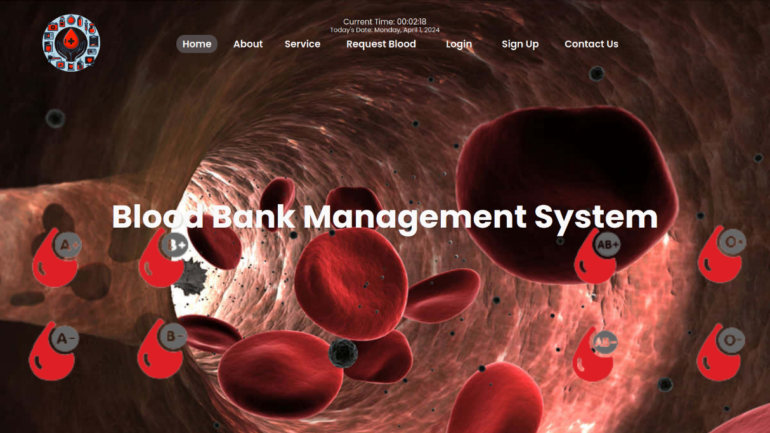

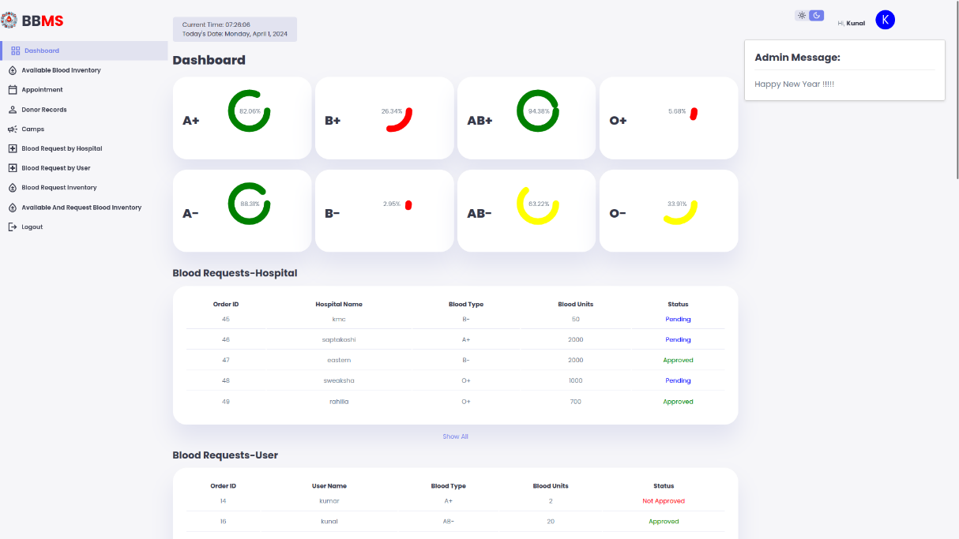

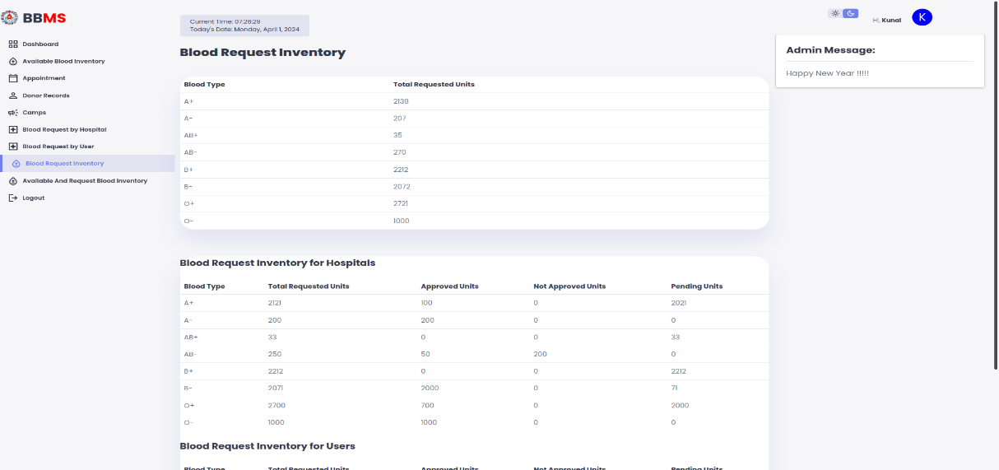

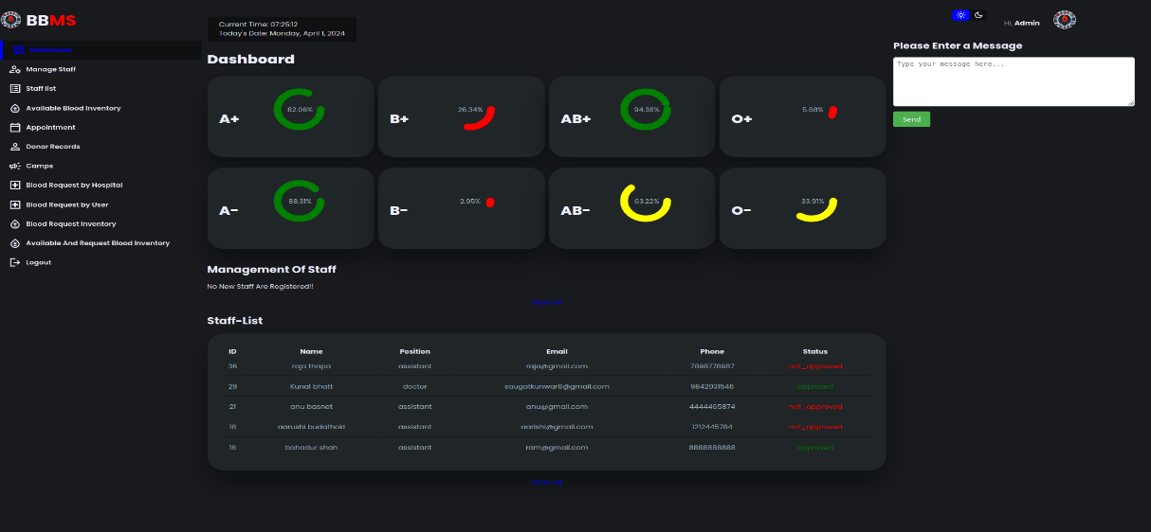



**CHAPTER 11**

**CONCLUSION**

The Blood Bank Management System aims to address the challenges faced by blood banks in maintaining an organized and effective blood donation process. By leveraging modern web development technologies, the proposed system will contribute to a more streamlined and user-friendly experience for donors, improve blood inventory management, and enhance the timely distribution of blood to hospitals in need.

**CHAPTER 12**

**LESSON LEARNT**

Doing something for long time periods always gives good lesson. Some of the things that our team learnt are listed as below:

* Learnt about the BBMS process
* Learnt about PHP, XAMPP and ways to implement them
* Learnt to manage the database under MYSQL
* Finally, tools of VS Code

**CHAPTER 13**

**FUTURE ENHANCEMENTS**

Since this project was started with very little knowledge about the Blood Bank Management System, we came to know about the enhancement capability during the process of building it. Some of the scope we can increase for the betterment and effectiveness are listed below:

* More interactive user interface
* Manage stock in larger amount
* Cross platform compatibility
* SMS and Notifications alert features

**CHAPTER 14**

**REFERENCES**

1. Smith, J., & Johnson, A. (2019). Modern Web Development with PHP and MySQL. O'Reilly Media.
2. Welling, L., & Thomson, L. (2016). PHP and MySQL Web Development. Addison-Wesley Professional.
3. PHP Documentation: [*https://www.php.net/docs.php*](https://www.php.net/docs.php)
4. MySQL Documentation: [*https://dev.mysql.com/doc/*](https://dev.mysql.com/doc/)