CT-01 Course Exam Report & Study Guide
Question 1: Block Diagram of an Embedded System & Associated Syllabus Topics
Official Grading Rubric & Marks Distribution (10 Marks Total)
• Part A: Draw the Block Diagram (4 Marks) — Labeled modules, interconnection buses, and direction flow.
• Part B: Explain Component Blocks (4 Marks) — Sensory input, CPU internals, memory maps, and output devices.
• Part C: List Core Characteristics (2 Marks) — Real-time deadlines, single-function design, and constraints.
Course Exam Code | CT-01 (Continuous Test 01)
Marks Allocation | 10 Marks (Rubric Applied)
Suggested Time Limit | 20 Minutes
Subject Matter | Embedded Systems Block Diagram & Fundamental Design Metrics
Resource Status | Complete Exam-Style Written Answer with Matplotlib Drawing
1. Definition & Core Concept
An Embedded System is a special-purpose computer system designed to perform one or a limited number of dedicated, predefined functions. Unlike general-purpose computers (e.g., personal computers or laptops) which are designed to run a wide array of application programs, an embedded system is highly optimized and customized for the specific application it serves. It tightly integrates both hardware components and firmware/software algorithms to monitor, control, or automate physical environments, often operating under stringent real-time constraints.
Real-World Examples of Embedded Systems
- Washing Machine: Controls wash cycles, monitors water levels, and adjusts drum speeds based on sensor inputs.
- Automated Teller Machine (ATM): Handles secure cryptographic operations, card readings, user verification, and mechanical money dispensing.
- Smart Television: Executes media decoding, network protocol stacks, and drives display panels.
- Office Printer: Manages print queues, controls stepper motors for paper alignment, and checks toner levels.
- Microwave Oven: Regulates heating times, monitors safety interlocks, and drives the magnetron based on user settings.
- Smart Door Lock: Handles wireless authentication (BLE/Wi-Fi), biometric scanning, and controls the locking solenoid.
- Medical Devices (Pacemakers, Insulin Pumps): Continuously monitors physiological signals and administers therapy under strict real-time, low-power constraints.
2. Key Characteristics of Embedded Systems
Based on standard design criteria and classroom syllabus notes, embedded systems are characterized by a unique set of design parameters:
- Single-Functionality: The system executes a dedicated program repeatedly to perform a specific task (e.g., a thermostat only controls temperature; it cannot run spreadsheets or browse the web).
- Tightly Constrained: Embedded systems must operate within strict resource boundaries. Designers must optimize for minimal size, low production cost, limited power budgets, and constrained memory size.
- Reactive & Real-Time: Many systems must continuously react to external stimuli in the environment via sensors. They must compute results and drive actuators within precise time limits (deadlines). Failure to respond within these limits can result in complete system failure.
- High Reliability & Safety: Because many embedded systems are deployed in safety-critical environments (e.g., automotive braking, flight controllers, or medical life support), they must execute with near-zero failure rates.
- Low Power Consumption: Often powered by small batteries or energy harvesting, they must maximize battery life through aggressive power management (e.g., deep sleep modes).
- Non-Recurring Engineering (NRE) Cost Sensitivity: The unit production cost must be kept low, especially for high-volume consumer goods, demanding specialized hardware-software partitioning.
3. Block Diagram of an Embedded System
Below is the functional block diagram of a complete embedded system. It depicts the flow of data starting from physical stimulus detection, progressing through signal conditioning, processing, decision-making, memory retrieval, and ultimately driving external actuators or communications interfaces, all while supported by a dedicated power management system.
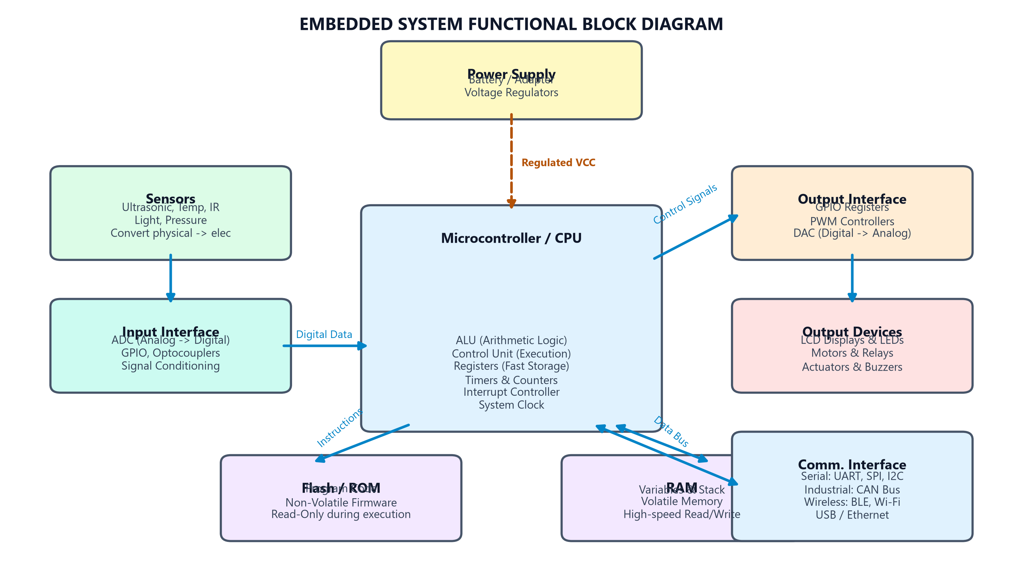
Figure 1.1: Functional block diagram of an Embedded System.
4. Component Breakdown & Working Principle
The operation of an embedded system follows a structured sequential data flow: Data Acquisition → Conversion → Computation → Output Drive. The detailed functions of each key block are explained below:
Sensors & Data Acquisition
Sensors act as the primary input interface to the physical world. They detect environmental changes (such as heat, light, sound, magnetic fields, or pressure) and convert these physical quantities into measurable electrical signals (voltage, current, or frequency).
Input Interface (Signal Conditioning & Conversion)
Since most real-world physical signals are analog and noisy, they cannot be directly processed by digital microcontrollers. The input interface performs crucial preparation steps:
- Signal Conditioning: Uses operational amplifiers (op-amps) and filters to amplify weak sensor outputs and filter out high-frequency noise.
- Analog-to-Digital Converter (ADC): Quantizes the conditioned analog voltage signals into discrete binary values (e.g., 8-bit, 10-bit, or 12-bit digital numbers) that the processor can read.
- General Purpose Input/Output (GPIO): Reads binary status signals (ON/OFF) from switches or digital sensors directly.
The Microcontroller (Processor Core)
The Microcontroller (or CPU) serves as the core intelligence or 'brain' of the embedded system. It is responsible for reading input data, executing the system instructions loaded in memory, performing logic operations, and writing output states. It contains several key internal modules:
- Arithmetic Logic Unit (ALU): Performs mathematical calculations (addition, subtraction) and logical comparisons.
- Control Unit (CU): Directs the instruction fetch, decode, and execute cycles, routing data between registers and external components.
- Registers: Internal, high-speed temporary storage cells used to hold instruction operands and intermediate results.
- Timers and Counters: Crucial for generating precise time delays, measuring signal widths, and executing periodic scheduler ticks.
- Interrupt Controller: Suspends regular code execution instantly to handle critical external events (e.g., emergency stops, packet arrival) in real-time.
Output Interface & Actuators
The Output Interface transfers the decision commands computed by the microcontroller to the output devices. This interface translates low-power digital signals into signals capable of driving physical components:
- Pulse-Width Modulation (PWM): Varies the duty cycle of digital square waves to control analog outputs like motor speeds, LED brightness, or heater power.
- Digital-to-Analog Converter (DAC): Converts binary digital signals back into smooth analog voltages for audio generation or precision control.
- Transistors, Relays & Motor Drivers: Since processor GPIOs can only output small currents (typically 10-20mA), external switching hardware is used to control heavy loads like solenoids, AC appliances, and DC motors.
5. Memory Architecture & Data Flow
Embedded systems utilize specialized memory architectures to store program instructions (firmware) and execute computational tasks. This is typically implemented as a Harvard Architecture (separate instruction and data buses) or Von Neumann Architecture.
Memory Type | Purpose | Volatile | Description
Flash Memory | Stores executable program code | No (Non-Volatile) | Re-programmable ROM where the main firmware binary is stored permanently.
ROM / Mask ROM | Permanent bootloader & firmware | No (Non-Volatile) | Programmed during chip fabrication; stores startup routines and cannot be modified.
EEPROM | Saves user settings & configurations | No (Non-Volatile) | Byte-writable memory used to save non-volatile variables like calibration data or passwords.
RAM (SRAM) | Variables, stacks, and runtime buffers | Yes (Volatile) | Temporary, high-speed workspace that loses all contents when power is disconnected.
Memory Data Flow Execution Sequence
Execution Sequence
1. Power-On Reset: The CPU reads the boot vector from ROM/Flash.
2. Instruction Fetch: The CPU fetches instructions sequentially from Flash memory via the program bus.
3. Variable Allocation: Runtime variables and calculations are dynamically read from and written to RAM.
4. Non-Volatile Write: Critical system changes or user logs are committed to EEPROM before power-down.
6. Sensor Technology & Selection Criteria
Choosing the correct sensor is a critical engineering decision in embedded system design. The selection process requires balancing performance metrics against system cost and physical constraints.
Selection Criteria | Importance / Focus | Engineering Impact
Accuracy & Precision | Measures the closeness to true value | Determines quality of data; critical for feedback loops.
Measurement Range | Defines the min and max input limits | Ensures the sensor can capture all expected environmental states.
Response Time / Bandwidth | Speed at which output registers change | Determines real-time responsiveness; vital for safety control.
Power Consumption | Current draw in active and standby modes | Directly impacts battery sizing and thermal dissipation profiles.
Cost & Form Factor | Unit cost and physical dimensions | Restricts placement and defines commercial feasibility of final product.
Environmental Tolerance | IP ratings, temperature, and moisture limits | Guarantees long-term survival in harsh industrial or outdoor spots.
Reliability & Calibration | Mean Time Between Failures (MTBF) | Dictates how often the system requires field servicing.
Interface Compatibility | Analog voltage vs. digital SPI/I2C/UART | Affects microcontroller pin allocation and PCB design complexity.
Deep Dive: Ultrasonic Distance Sensor
An Ultrasonic Sensor (such as the popular HC-SR04) measures the distance to a target object by emitting high-frequency acoustic waves (typically 40 kHz, beyond human hearing) and timing the interval it takes for the echo to bounce back.
Physical Working Formula
The distance to the target is calculated using the speed of sound in air (approximately 343 m/s at 20°C) and the measured time of flight (t):
Distance = (Speed of Sound × Time of Flight) / 2
The division by 2 accounts for the sound wave traveling out to the target and then returning.
Operating Sequence for Ultrasonic Measurement:
- 1. Trigger Pulse: The host microcontroller outputs a short 10-microsecond high pulse to the sensor's Trigger pin.
- 2. Wave Emission: The sensor internal circuitry generates a burst of eight 40 kHz ultrasonic pulses out of its transmitter transducer.
- 3. Echo Timing: The sensor sets its Echo output pin to high. The wave travels through the air, strikes an obstacle, and reflects back.
- 4. Echo Detection: The receiver transducer detects the returning echo. The sensor drives the Echo pin low immediately.
- 5. Calculation: The microcontroller measures the pulse width of the Echo pin (in microseconds) and computes the distance.
Features and Limitations of Ultrasonic Sensors
Features / Advantages  • Non-contact distance measurement.  • High accuracy (within millimeters under optimal conditions).  • Low unit cost; simple 4-pin hardware interface.  • Works perfectly in total darkness or bright light.  • Highly reliable for solid obstacle detection. | Limitations / Challenges  • Soft materials (sponge, cloth) absorb sound waves.  • Impeded by ambient weather (heavy rain, fog, dust).  • Restricted sensing range (typically 2cm up to 4 meters).  • Temperature and humidity affect speed of sound.  • Poor echoes off irregular, slanted surfaces.
7. Processor Technology & Design Metrics
Modern embedded systems use three primary processor technology classes, selecting one based on speed, power, and unit volume requirements:
Processor Type | Description | Typical Application / Trade-offs
General Purpose Processor (GPP) | Highly flexible processors designed for general computation. Uses standard instruction sets. | Microprocessors like ARM Cortex-A series. High flexibility but higher power and cost.
Single Purpose Processor (ASIC) | Hardwired hardware designed to execute one specific program or logic chain. Zero instruction-fetch overhead. | Application-Specific Integrated Circuits. Extremely fast, lowest unit cost at scale, but zero flexibility and very high NRE.
Application Specific Processor (ASIP/DSP) | Customized instruction set optimized for a specific domain (e.g., audio processing, math arrays). | Digital Signal Processors (DSPs), microcontrollers like ARM Cortex-M. Excellent balance of speed, power, and cost.
Key Design Metrics
Design metrics represent the set of measurable criteria used to gauge the success, cost-effectiveness, and operational stability of an embedded system:
- Performance: The speed or rate at which the system executes operations (e.g., instructions per second, response latency).
- Power Consumption: The energy consumed by the system. Determines battery life limits and thermal heatsink designs.
- Unit Cost: The manufacturing cost per unit (excluding NRE), which governs margins when selling high-volume consumer goods.
- Physical Size / Weight: Space constraints on PCB layouts and device enclosures (e.g., wristwatches, wearable health sensors).
- Time-to-Market (TTM): The duration required to design, manufacture, and release the product. Late entry can lead to massive revenue loss.
- Reliability & Safety: The system's mean time to failure. Must approach infinity for life-critical configurations.
Understanding Non-Recurring Engineering (NRE) Cost
Non-Recurring Engineering (NRE) Cost represents the one-time, upfront capital expenditures required to design, program, simulate, prototype, test, and manufacture tooling for a new embedded product before mass production begins.
Amortization Equation
Total Product Cost = NRE Cost + (Unit Cost × Production Volume)
Key Engineering Insight:
• High NRE is highly acceptable if production volumes are massive (e.g., microchips in smartphones), as the upfront cost is amortized across millions of units.
• Low NRE is mandatory for low-volume, bespoke configurations (e.g., custom factory automation machines), even if the individual unit cost is very high.
8. Design Methodologies: Concurrent Design & Co-Design
Engineering workflows have evolved from rigid sequential systems to dynamic collaborative structures to shorten development times and reduce design flaws.
Traditional vs. Concurrent Design Workflow
Feature | Traditional Sequential Design | Concurrent Design (Parallel)
Workflow Structure | Sequential (Hardware designed -> fabricated -> software written). | Parallel (Hardware and software elements designed simultaneously).
Development Time | Long. Software team must wait for physical boards to begin integration. | Short. Emulation, virtual prototyping, and modeling tools are used.
Total Project Cost | High. Discovering mistakes late forces expensive PCB hardware redesigns. | Low. Errors are detected early in simulation, avoiding physical re-spins.
Design Flexibility | Low. Software is forced to adapt to hardware limits that are fixed late. | High. Hardware-software boundaries are fluid and adjust to feedback.
Integration Timing | Very Late. Happens only after physical prototype assembly. | Continuous. Virtual prototyping platforms enable early integration.
Error Detection | Late. Discovered during bench testing or pilot runs. | Early. Discovered during co-simulations and model checking.
Hardware–Software Co-design
Hardware-Software Co-design is the systematic methodology of designing hardware and software components of a system simultaneously. The goal is to optimize performance, minimize power, reduce cost, and meet real-time requirements by dividing system operations logically:
Hardware Responsibilities  • Processor Selection (microcontroller cores, DSPs).  • Memory Allocation (SRAM, Flash sizing).  • Sensor & Actuator interfaces (pin routing).  • PCB Layout & Schematic design.  • Power supplies, filters, voltage rails.  • Clock trees & oscillator circuits. | Software Responsibilities  • Firmware development (compiled C/C++ or Assembly).  • Hardware abstraction layer (HAL) & register writes.  • Device drivers for peripherals (I2C, SPI, UART).  • Signal processing & control algorithms (PID control).  • Real-Time Operating System (RTOS) task scheduling.  • User interface menus & communication packets.
9. System Data Flow & Case Study
To solidify the concepts, the system data flow can be traced through a real-world case study: An Automatic Sliding Door System.
General System Data Flow Diagram:
Sequential Data Flow Trace
Environment Stimulus (Person approaching)
↓
Sensors (Ultrasonic sensor captures acoustic return)
↓
Input Interface (Timer measures Echo pin width; converts time to digital distance value)
↓
Microcontroller (CPU executes comparison logic: 'Is distance < 1.5 meters?')
↓
Memory (Reads door-speed settings from Flash/EEPROM, stores active loop states in RAM)
↓
Output Interface (GPIO drives gate high; PWM output adjusts motor start ramp)
↓
Output Actuator (Relay engages power supply; DC motor spins to slide door open)
↓
Communication Interface (Wi-Fi module uploads usage count telemetry to server)
Automatic Sliding Door Components mapping:
- Sensor: An ultrasonic distance sensor detects a human within range.
- Input Interface: Performs pulse-width timing to feed distance digits to the controller.
- Microcontroller: Processes variables, computes door status, and triggers interrupts if safety beam is broken.
- Memory: Keeps the compiled control logic, door timer profiles, and calibration offsets.
- Output Interface: Outputs GPIO and PWM pulses to feed commands to high-power motor drivers.
- Actuator: Opens/closes physical sliding doors using a geared DC motor.
- Power Supply: Provides isolated 5V/3.3V rails for digital chips, and 24V for heavy DC motors.

