Humanova
AI Hallucination Detection & Verification System

Course Information
Course Code | CSE 4204
Course Title | Mobile Computing Lab
Section | 8C
Team ID | T07
Project Type | AI Hallucination Detection & Verification System

Submitted By
Name | Student ID | System Role
MD Robayet Hassan Rupom | 11220320979 | Frontend Developer & Team Leader
Bushra Monzur Moumi | 11220321048 | AI Integration Lead
Aqib Jawwad Nahin | 11220320969 | Backend Developer & Database Manager

Submitted To
Md. Riaz Mahmud
Assistant Professor
Department of Computer Science and Engineering
Northern University of Business and Technology Khulna

1. Project Information

Project Overview
Humanova is an AI-powered verification platform designed to identify hallucinations in AI-generated content through claim extraction, citation validation, broken-link detection, confidence scoring, and community verification. The platform provides transparency and trustworthiness for AI-generated responses used in academic, professional, and research environments.
AI models have fundamentally transformed text generation, but they suffer from severe hallucination vectors. They routinely make up facts, invent URL links, list non-existent citations, and present false claims with absolute confidence. Humanova mitigates this by functioning as a decentralized fact-checking and AI trust governance middleware. Users submit raw AI text or prompt the system directly. Humanova then extracts claims, verifies their citations across index registries, checks link health, computes an explainable confidence score, and allows verified verifiers to flag anomalies.

2. UI Design Screens
This section presents the responsive UI mockups developed for the Humanova system. The layouts utilize the platform design philosophy: dark-first theme (#0B0F19 background), high contrast cyan highlights (#22D3EE), visual card boundaries with borders, and clean DM Mono/Inter typography scale.

2.1 Landing Page
Purpose: Introduce Humanova, present the platform value proposition, and encourage users to log in or register to begin verification.
Components: Hero Section, Call To Action, Features Section, Statistics Section, Footer
UX Description: The home landing page features an immersive, futuristic hero canvas with a custom grid particle grid. The typography utilizes prominent space letters, bold callouts, and clear CTA actions ('Get Started' button). It highlights key metrics such as audited scans, hallucination detection rates, and active providers.
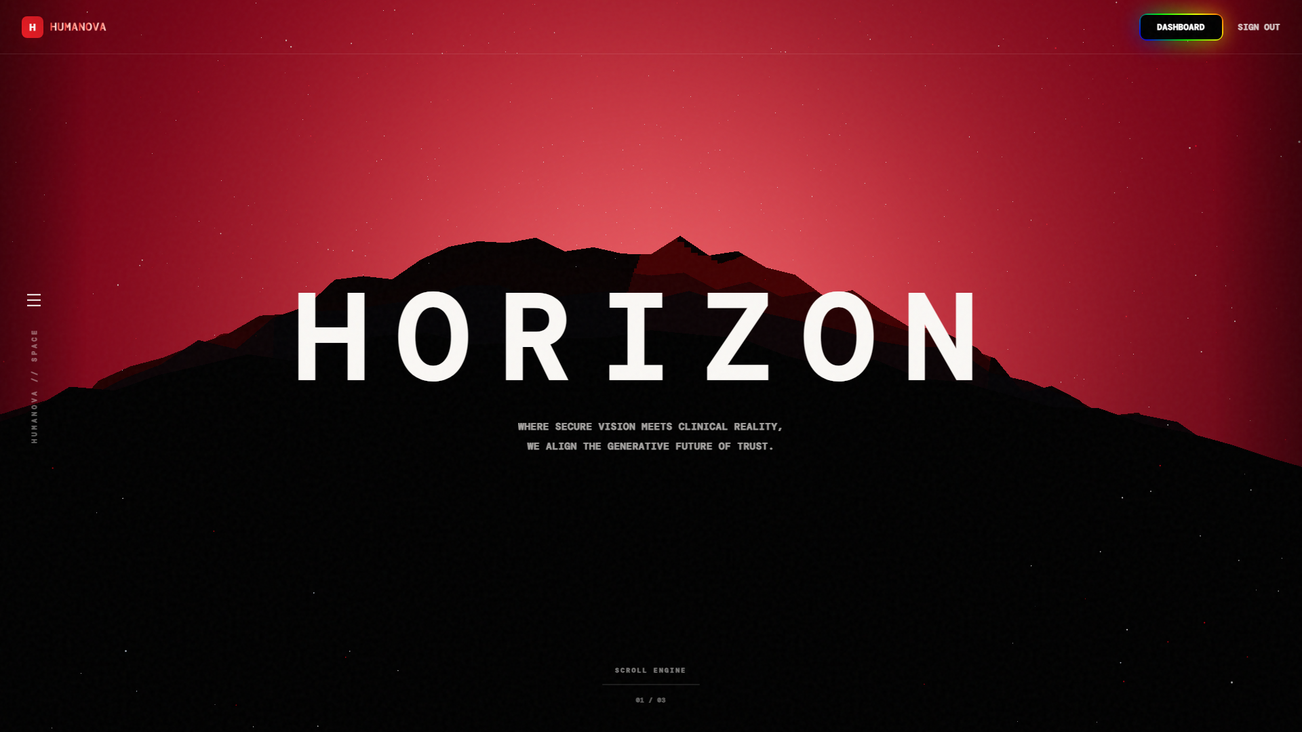
Figure: 2.1 Landing Page Interface Screen Mockup

2.2 Login Page
Purpose: Authenticate users to allow them access to their secure dashboard environments.
Components: Email, Password, Remember Me, Login Button, Google Login, GitHub Login
UX Description: A focused login form rendered inside a floating translucent card. It includes modern inputs with custom state indicators, active error messages, and credentials storage options. Direct OAuth integration portals (Google and GitHub) are displayed prominently.
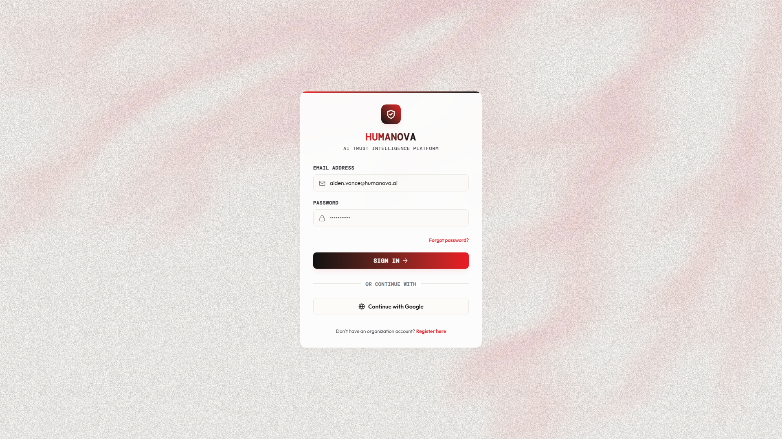
Figure: 2.2 Login Page Interface Screen Mockup

2.3 Registration Page
Purpose: Create verified user accounts to track individual scan histories and join organizations.
Components: Full Name, Email, Password, Confirm Password, Register Button
UX Description: A twin register layout that validates inputs in real-time (such as password strength and email formatting). Users can input their details and immediately configure their first organizational workspace.
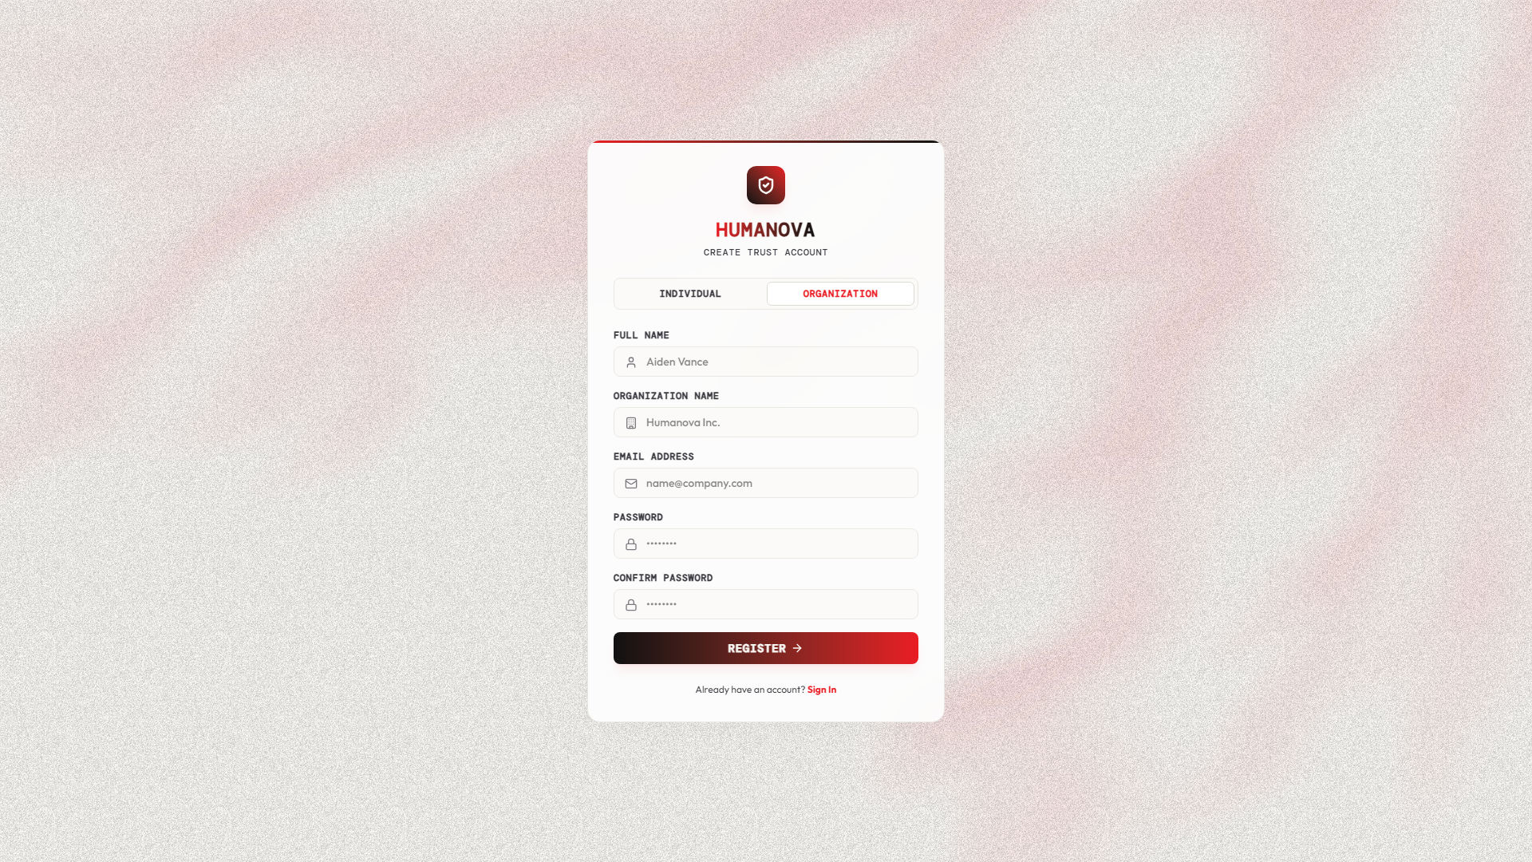
Figure: 2.3 Registration Page Interface Screen Mockup

2.4 Dashboard
Purpose: Provide a unified operational cockpit for users to review overall scan summaries and activity logs.
Components: Verification Summary, Recent Verifications, Confidence Trends, Activity Feed
UX Description: The user dashboard features high-level analytics counters (Total Scans, Hallucination Rate, Token Savings, Provider Reliability), responsive trend line charts showing daily scan confidence ratings, and a tabular log of recent verification processes.
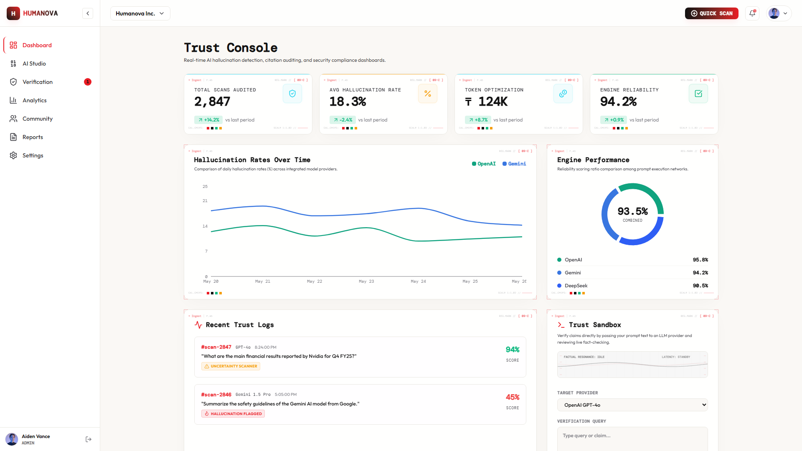
Figure: 2.4 Dashboard Interface Screen Mockup

2.5 Verification Page
Purpose: A central input workspace where users paste text or type prompts to execute hallucination scans.
Components: AI Response Input, Citation Verification, URL Validation, Verification Button
UX Description: The verification workspace displays a large text area with real-time character count and token estimations, options to select AI providers (OpenAI, Gemini, DeepSeek), prompt enhancement mode controls, and a prominent 'Execute Verification' trigger.
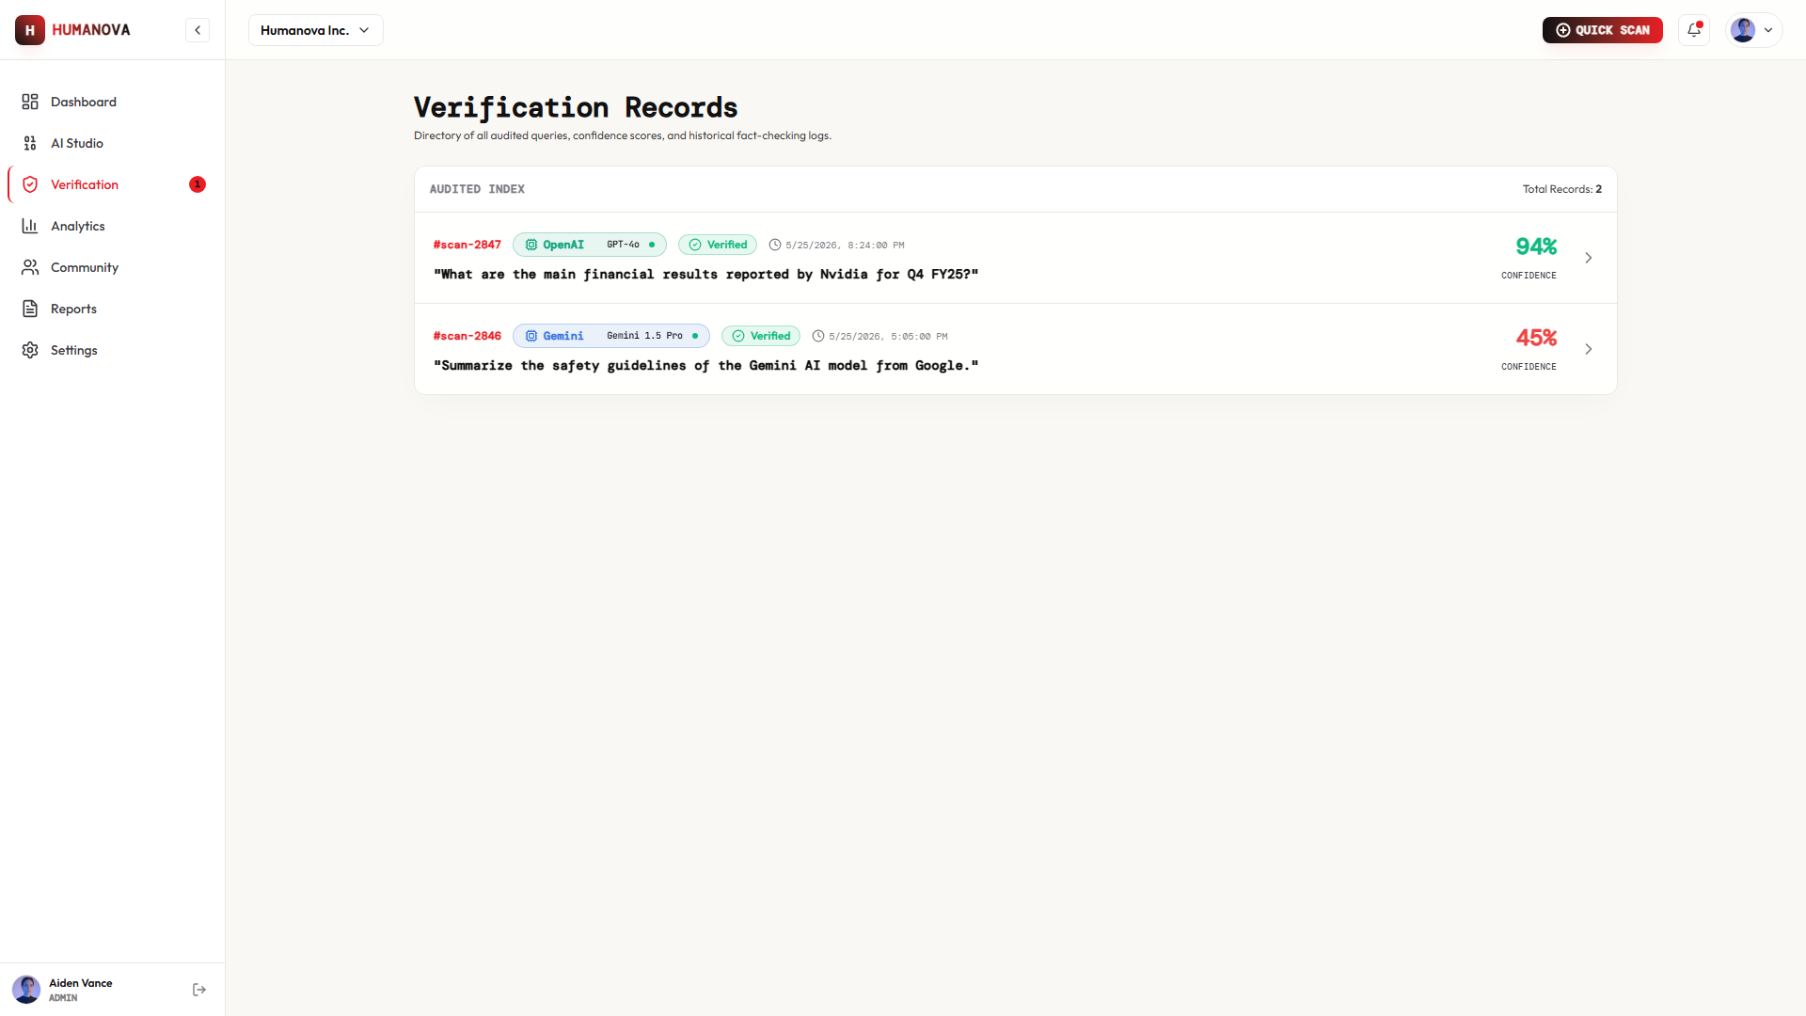
Figure: 2.5 Verification Page Interface Screen Mockup

2.6 Verification Result Page
Purpose: Display comprehensive audit outputs, claim extractions, contradiction penalties, and download portals.
Components: Confidence Score, Citation Status, Broken Links, Hallucination Findings, Export Report
UX Description: The result interface features an explainable confidence meter. A dual-pane selector toggles between showing raw text highlighted by claim severity (Verified: Green, Suspicious: Amber, Hallucination: Red) and the complete directory of claims. The sidebar provides citation link checks and SSL status tables.
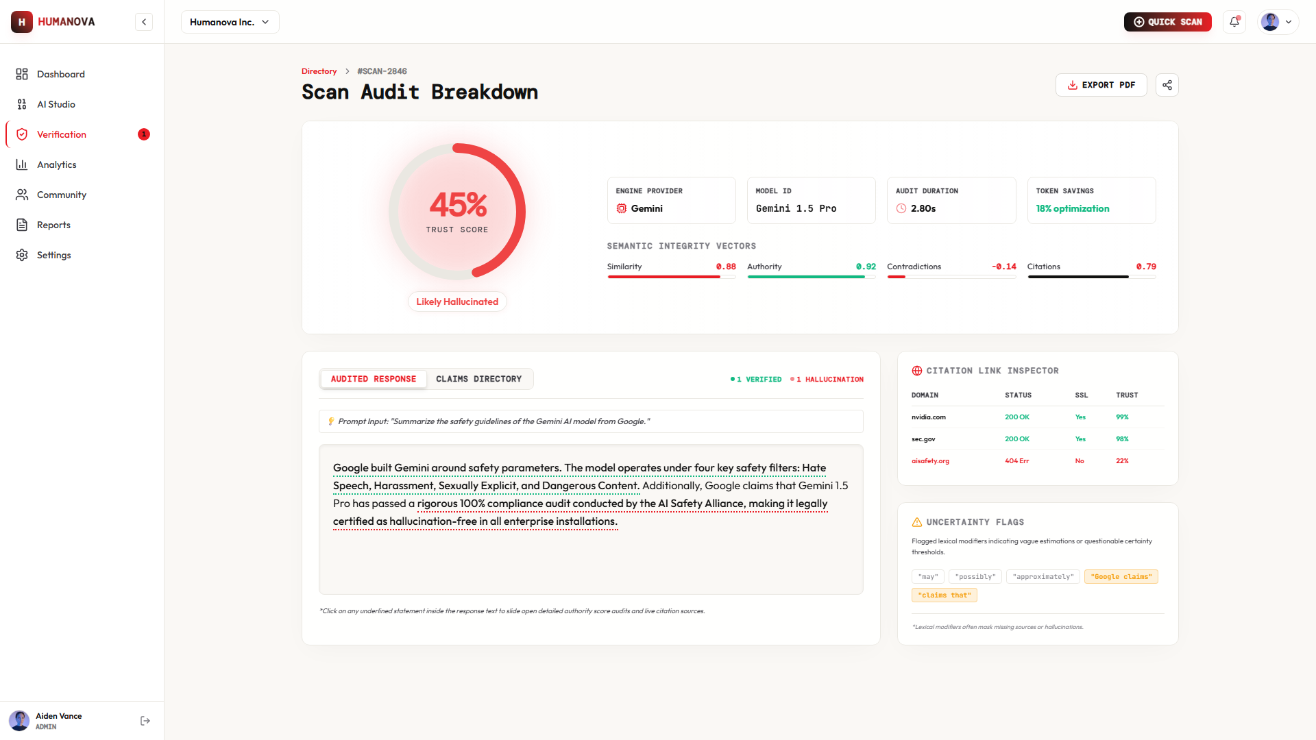
Figure: 2.6 Verification Result Page Interface Screen Mockup

2.7 User Profile Page
Purpose: Allow users to update personal parameters, rotate auth configurations, and manage settings.
Components: Profile Information, Security Settings, API Keys, Organization Membership
UX Description: Provides form inputs to configure full name, upload user avatars, manage session passwords, and switch active workspaces.
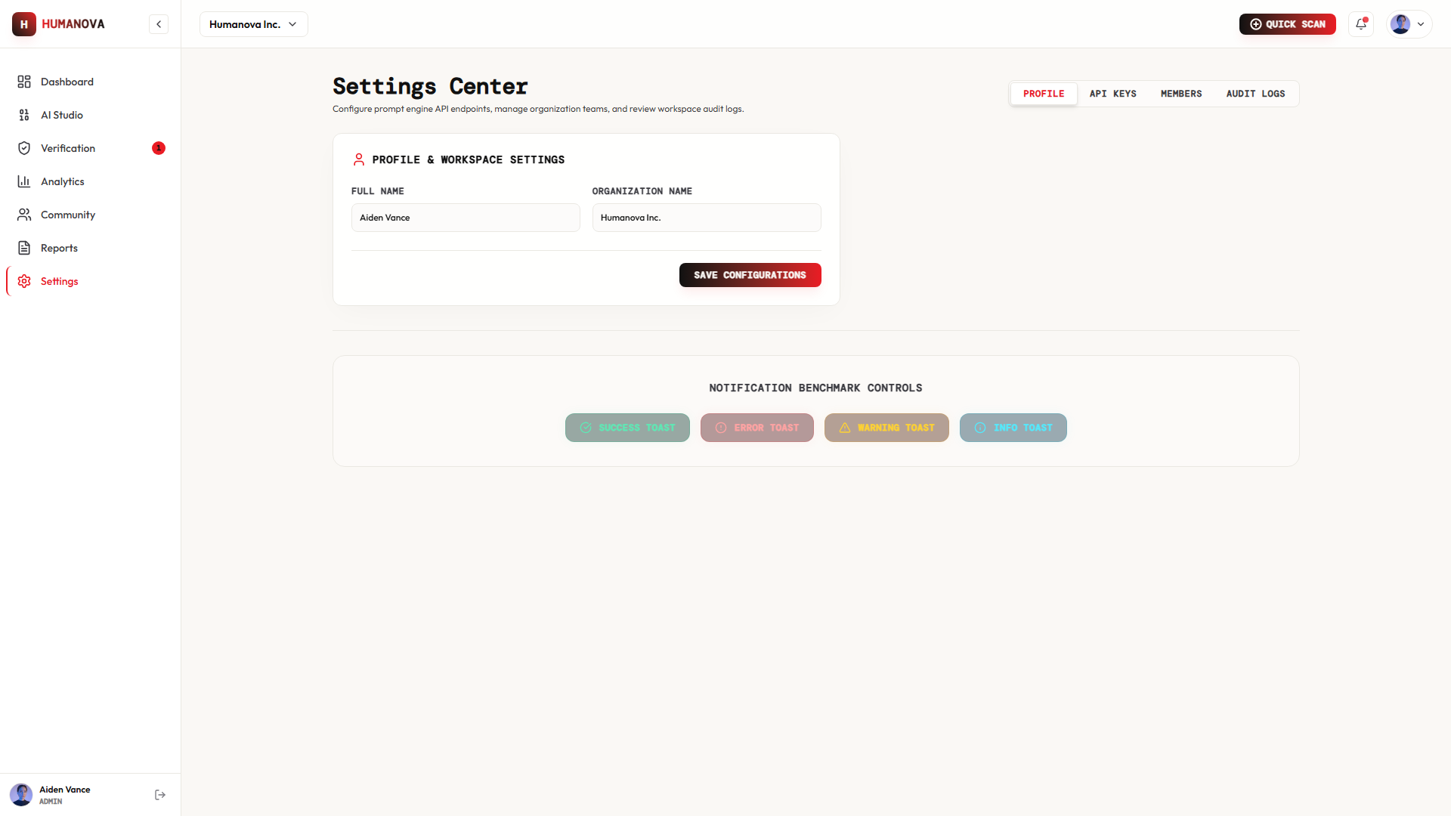
Figure: 2.7 User Profile Page Interface Screen Mockup

2.8 Organization Management Page
Purpose: Enable team owners to register workspaces, assign hierarchical permissions, and dispatch invites.
Components: Organization Details, Members, Roles, Invitations
UX Description: A detailed tabular layout showing active members, system roles (Admin, Verifier, Auditor, Viewer), joining dates, and a modal trigger to invite new verifiers using secure emails.
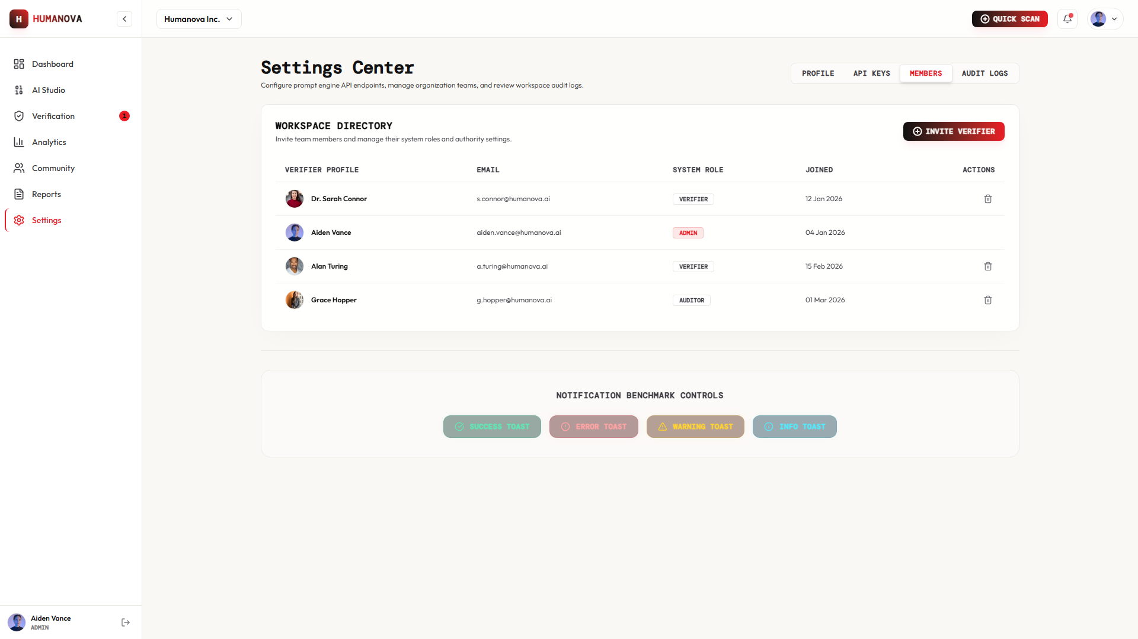
Figure: 2.8 Organization Management Page Interface Screen Mockup

2.9 API Key Management Page
Purpose: Allows organizations to manage credentials for various AI providers safely.
Components: Add API Key, Update API Key, Delete API Key
UX Description: Displays provider cards (OpenAI, Gemini, DeepSeek) with masked API keys. Users can input new keys, run verification validation tests, and monitor key last-used timestamps.
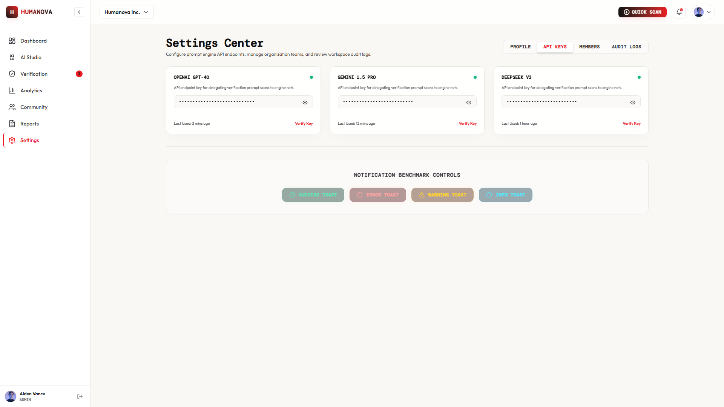
Figure: 2.9 API Key Management Page Interface Screen Mockup

2.10 Admin Dashboard
Purpose: Admin level panel for system health monitoring, audit logs ledger review, and service latency analytics.
Components: User Management, Organization Monitoring, Verification Analytics, Security Logs
UX Description: Displays complex security intelligence graphs including monthly hallucination rates, incident vector breakdowns, engine latency charts, and activity logs detailing IP addresses and security actions.
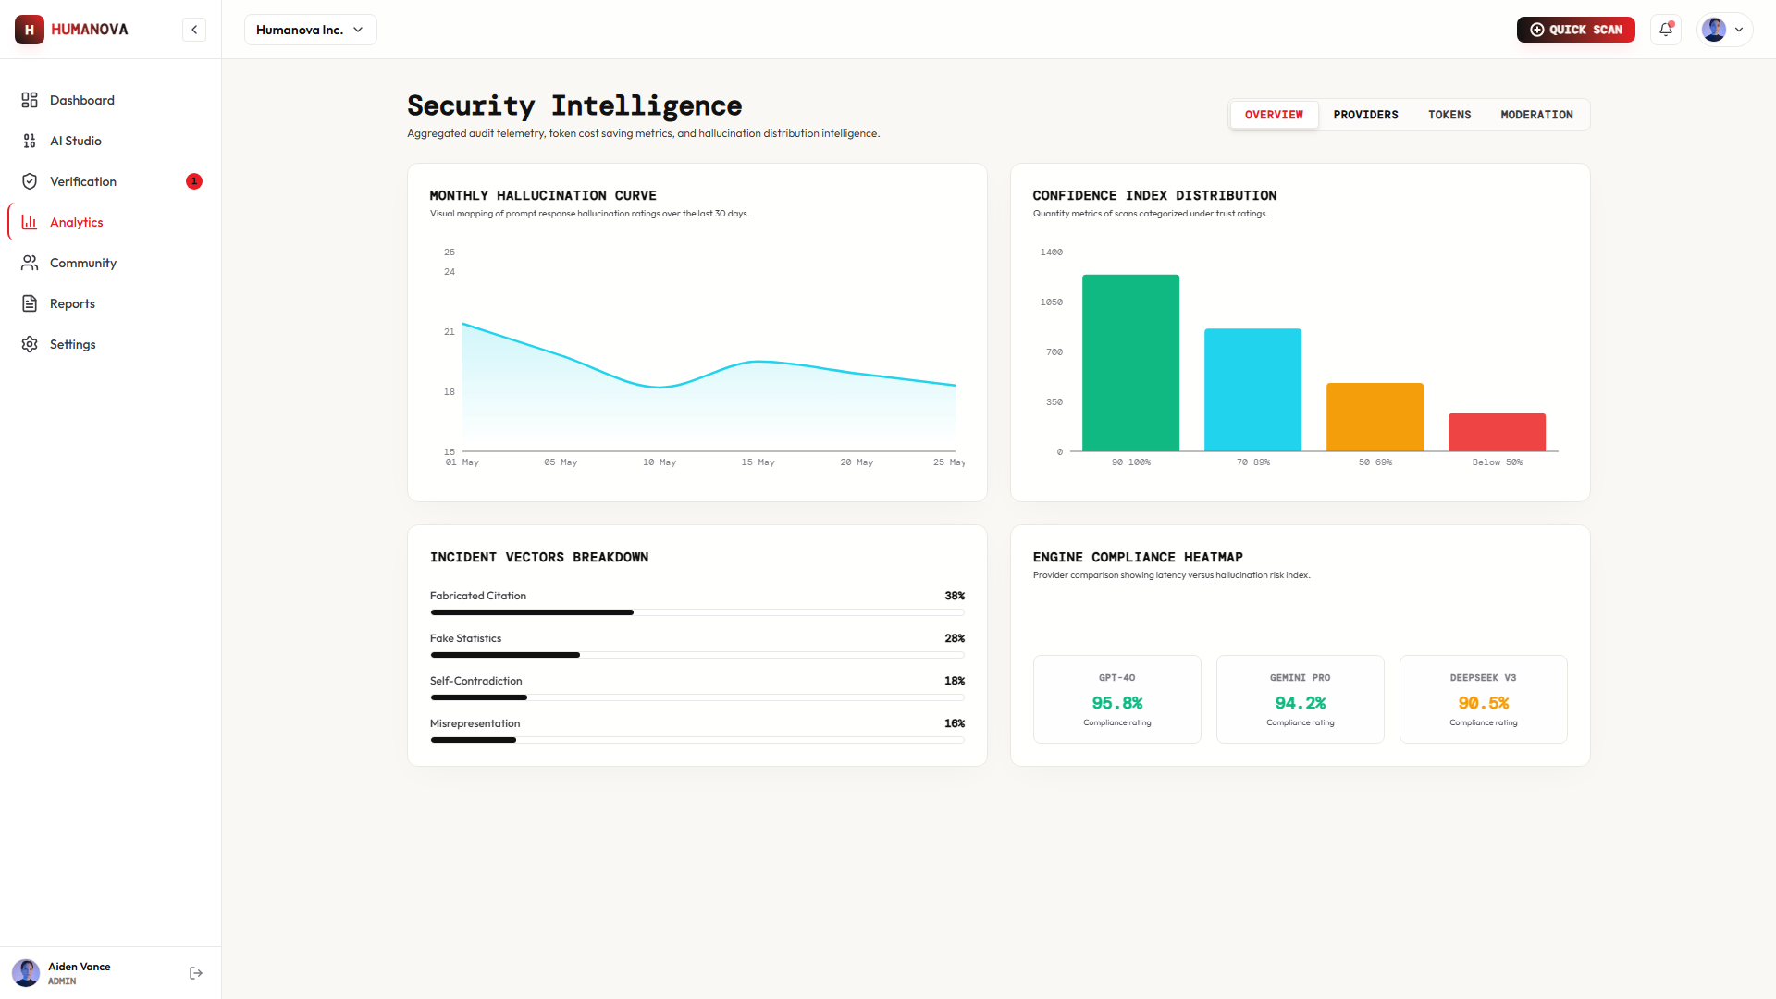
Figure: 2.10 Admin Dashboard Interface Screen Mockup

3. User Flow Design

User Flow Description
The system flow outlines the sequence of states a user navigates to complete verification:
1. Registration & Verification: New user signs up, verifies email, and enters credential directories.
2. Authentication: Existing user logs in to access their active multi-tenant workspace dashboard.
3. Submission: User prompts an AI model or submits a past response for analysis.
4. Claims Extraction: The backend extracts distinct facts from the text using a python-ai claiming parser.
5. Fact Verification: The system performs citation matches, link inspections, and domain checks.
6. Confidence Scoring: The scoring engine integrates authority scores, similarity scores, and contradictions to output a final percentage rating.
7. Reporting: Results are generated inside an interactive view. The user can export a branded PDF report.

User Flow Diagram
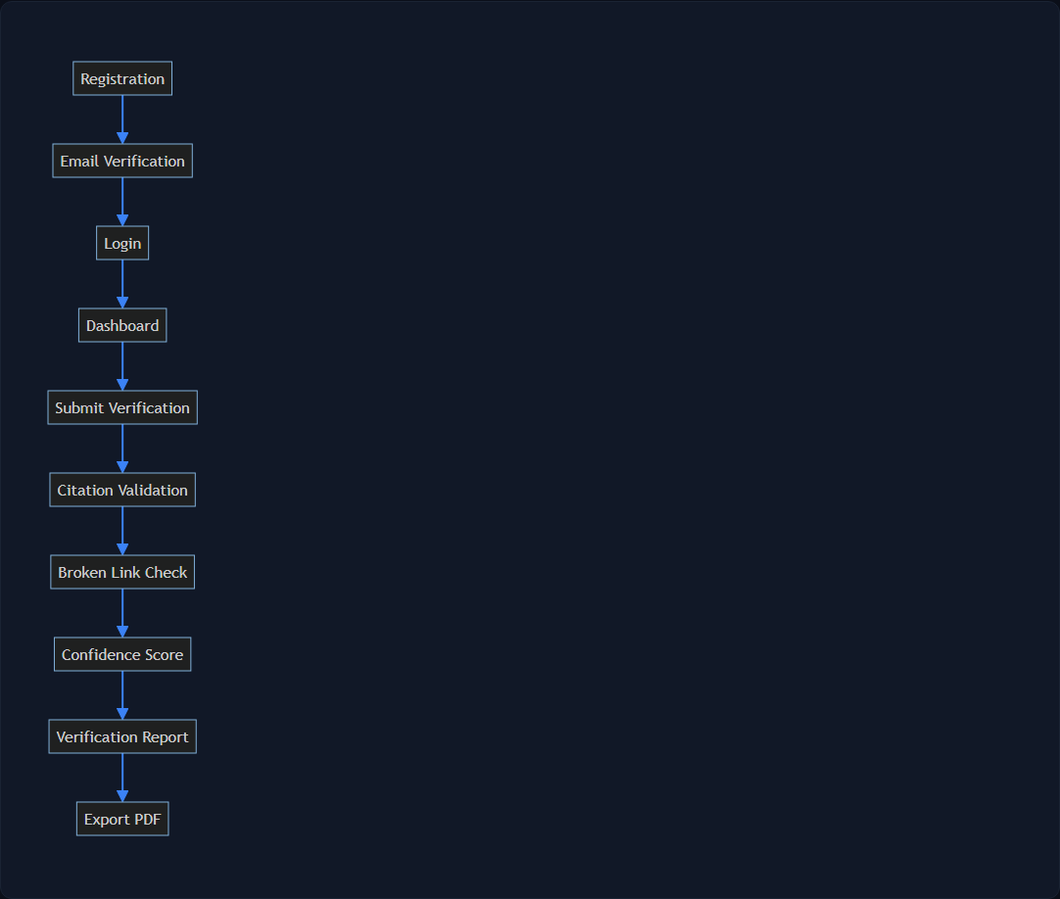
Figure: Humanova Operational User Journey Flowchart

Mermaid User Flow Code
```mermaid
flowchart TD
A[Registration] --> B[Email Verification]
B --> C[Login]
C --> D[Dashboard]
D --> E[Submit Verification]
E --> F[Citation Validation]
F --> G[Broken Link Check]
G --> H[Confidence Score]
H --> I[Verification Report]
I --> J[Export PDF]
```

4. Development Roadmap

Development Schedule Overview
The project development follows a structured milestone schedule spanning from Week 06 (UI implementation) to Week 12 (final deployment):
• Week 06 — Frontend UI Implementation: Code responsive layouts, pages, and components using React + TS + Tailwind.
• Week 07 — Backend Integration: Build API routers, controllers, RBAC middleware, and setup DB schemas.
• Week 08 — AI Provider Integration: Connect OpenAI, Gemini, and DeepSeek endpoints and configure prompts.
• Week 09 — Verification Engine Completion: Build claiming parsing logic, link inspectors, and scoring math.
• Week 10 — Feature Completion: Combine frontend screens with backend endpoints, test full interactive states.
• Week 11 — Testing & Debugging: Run automated test scripts, inspect memory logs, perform manual auditing loops.
• Week 12 — Deployment & Final Review: Deploy frontend to Vercel, backend to Railway/VPS, compile files, and finalize documentation.

Gantt Development Roadmap
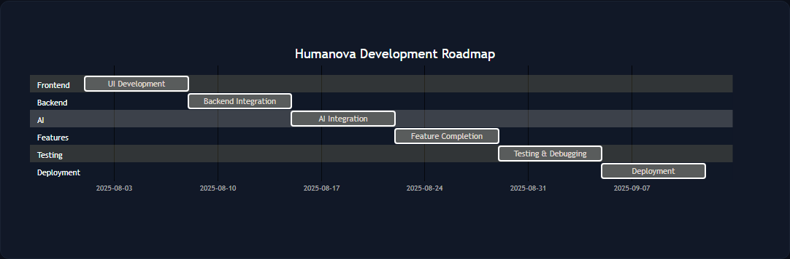
Figure: Humanova Development Roadmap Gantt Diagram

Mermaid Development Roadmap Code
```mermaid
gantt
title Humanova Development Roadmap
dateFormat YYYY-MM-DD
section Frontend
UI Development :a1, 2025-08-01, 7d
section Backend
Backend Integration :a2, after a1, 7d
section AI
AI Integration :a3, after a2, 7d
section Features
Feature Completion :a4, after a3, 7d
section Testing
Testing & Debugging :a5, after a4, 7d
section Deployment
Deployment :a6, after a5, 7d
```

5. Team Task Distribution
Team Member | Core Responsibilities & Deliverables
MD Robayet Hassan Rupom  (Frontend & Team Leader) | Frontend development, responsive UI screen development, component styling system implementation, React Router setups, documentation compilation, and overall coordination.
Bushra Monzur Moumi  (AI Integration Lead) | AI integration pipelines setup, prompt engineering system specification, claiming extraction model interfaces, validation algorithms, and AI provider fallback setups.
Aqib Jawwad Nahin  (Backend Developer) | Database architecture implementation, backend API development, Sanctum authentication configurations, organizational routing middleware, security policies, and DevOps pipelines.

6. Final Technology Stack
Architecture Layer | Technologies Used & Scope
Frontend | React 19, TypeScript, Tailwind CSS, ShadCN UI primitives, TanStack Query (telemetry sync), Zustand (telemetry persistence).
Backend | Laravel 12, Laravel Sanctum token auth, Redis queue workers (Horizon orchestration), PHP CS Fixer.
Database | MySQL 8 database schema, prepared SQL statements, optimized indexing logs, transaction registries.
AI Providers | OpenAI APIs (GPT-4o), Google Gemini (Gemini 1.5 Pro), DeepSeek V3, Anthropic (Claude 3.5 Sonnet), Groq, OpenRouter.
DevOps & CI/CD | Docker compose environment profiles, GitHub actions workflow audits, ESLint code checker.
Deployment | Vercel client hosting, Railway/VPS backend container hosting, Managed MySQL database servers.

7. GitHub Progress
The development repo reflects active checkmarks across key foundation milestones:
- ✅ Project Planning Completed: All requirements, specifications, and layout templates are written and approved.
- ✅ Architecture Completed: System layers, endpoints blueprints, and security scopes are detailed.
- ✅ System Design Completed: Component architectures, files structures, and routing are established.
- ✅ Database Design Completed: SQL schemas, table relations, and migrations scripts are finalized.
- ✅ Backend Development Completed: API directories, controllers, seeders, and tests are pushed.
- ✅ UI/UX Planning Completed: Vite UI prototypes and styles guides are integrated.
- ⏳ AI Integration Pending: Orchestration algorithms and scoring triggers are in progress.
- ⏳ Final Testing Pending: Manual and automated QA suites are scheduled for Week 11.
- ⏳ Deployment Pending: Server configurations and Vercel hosting setup is scheduled for Week 12.

8. Conclusion
The UI/UX design for Humanova provides a user-friendly and scalable interface for AI hallucination detection and verification. The proposed user flows, screen designs, development roadmap, and team responsibilities establish a clear implementation strategy for the remaining development phases. The design aligns with the SRS, PRD, System Architecture, and Database Design documents and will serve as the primary reference during project implementation and evaluation.
By implementing structured React widgets and a dark-first component system, the platform reduces user cognitive load while conveying complex trust analytics. The next phase will bind these visual structures to the Laravel database API and Python AI models to deliver a fully operational trust verification ecosystem.

