**ABOUT US**

Life is exaltation and its fount is wellbeing. Mankind today needs to re-establish itself to a level of fulfillment where every person is enabled to embrace life with celebratory gusto. The effects of the rapid changes in all walks of life brought about by the vast technological advances made by humankind over the last few decades have impacted lifestyle at the individual as well as collective levels. These changes make it all the more necessary to restructure our belief system and placing mental and emotional wellbeing alongside physical health and not merely as a far-removed corollary of “good physical health”. There has been a global shift in wellbeing in the past few years and India has attempted to put mental health on the WHO agenda in 2011 when only non-communicable diseases were given importance. But on May 2, 2018, the then UN Secretary-General António Guterres, launched mental health as its flagship programme. The rising trend of global thought and action on wellness though nascent, has given the world a new vocabulary to use when looking at sustainability of self and the community at large.

***Photo 1***

**Vision:**

Positive mental health and well-being for all.

**Mission:**

To enable people to choose change.

MIND India is formed by dedicated professionals to usher in the benefits of positive mental health for all sections of society. Adopting a three-pronged strategy of Prevent, Prepare and Pursue, we have placed our focus primarily on addressing issues individually and collectively through counselling and other psycho-social interventions to usher in positive mental and social change.

**Our Strategy:**

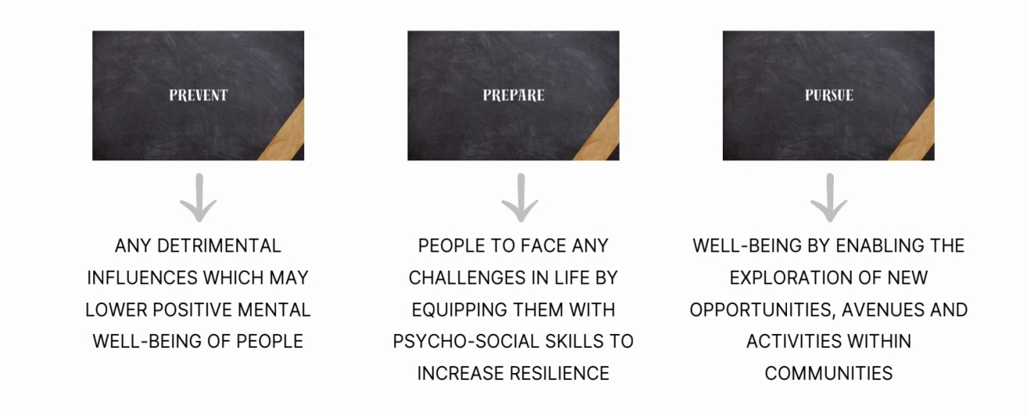

**Area of Work:**

* Evidence based Research
* Quality Human Resource Training
* Disseminating Information
* Removing Stigma
* Changing Mindsets
* Facilitating Social Change

**How we can help (put it in a segment)**

Through our services, we try to create a safe space for you to address every facet of positive living, encompassing the entire range of physical, social, mental, and spiritual aspects of human experience for all age groups.

**Counselling & Therapeutic Intervention**

* Career Assessment and Counselling
* School Mental Health Programme
* Child & Adolescent Counselling
* Youth Counselling
* Individual and Group Counselling & Therapy
* Family Systems & Marriage Counselling
* Relationship Counselling
* Gender Sensitive Counselling
* Geriatric Counselling & Caregiver Support
* Cognitive Rehabilitation

**Mental Health Assessment & Intervention**

* Psychiatric Evaluation & Treatment
* Psychological Assessment & Therapy
* Alcohol and Drug De-addiction Programme
* Rehabilitation for the Elderly (Dementia Screening)

**Child and Adolescent Mental Health Services (CAMHS)**

* IQ Testing
* Remedial Programmes for Children & Adolescents with special needs (disorders of Intellectual Development, Learning Disability, ADHD, Autism etc.)
* Special Education
* Speech & Language Therapy
* Occupational Therapy
* Behaviour Therapy
* Art–Expressive Therapy
* Play Therapy
* Music Therapy

**Alternative Healing**

* Physiotherapy
* Ayurveda
* Homeopathy
* Naturopathy
* Mindfulness Practices
* Acupressure
* Yoga

**OUR TEAM: (flip card format)**