● CISCO AdoptIQ

Executive Intelligence Report
All Managers | All Contact Center | 90 Day Analysis

Generated: April 29, 2026 UTC
Data as of: April 29, 2026 at 20:47 UTC

At-a-Glance Dashboard
Total Customers | Support Cases | Critical (P1) | High (P2) | BEMS Escalations | Software Defects | Security Vulnerabilities
190 | 293 | 0 | 2 | 97 | 99 | 2
Metric source backing:
- Total Customers: 190 [Source: Normalized customer set from team subscriptions + CSConsole + CSOne; Field(s): Customer Name, Account ID; Verification: Cross-check customer IDs/names in source exports]
- Support Cases: 293 [Source: CSOne (TAC case data); Field(s): Case #, Severity, Status; Verification: Query by Case Number / SR Number in CSOne]
- Critical (P1): 0 [Source: CSOne (TAC case data); Field(s): Severity; Verification: Query by Case Number / SR Number in CSOne]
- High (P2): 2 [Source: CSOne (TAC case data); Field(s): Severity; Verification: Query by Case Number / SR Number in CSOne]
- BEMS Escalations: 97 [Source: CSOne (Transaction ID, bemscsc_refs); Field(s): Transaction ID, bemscsc_refs; Verification: Engineering-level escalations; BEMS IDs verifiable in CSOne]
- Software Defects: 99 [Source: help.webex.com, CSC/BST refs in CSOne and Adoption Barriers; Field(s): CSC ID, BST ID; Verification: Defect IDs verifiable in help.webex.com and Bug Search Tool]
- Security Vulnerabilities: 2 [Source: PSIRT advisories and vulnerability feeds; Field(s): CVE ID, Advisory ID; Verification: Verify advisory/CVE identifiers in PSIRT and public advisories]

Risk Summary: Overall Risk Score: 0.7 | High Risk Customers: 0 | Medium Risk (band): 6

Executive Summary
Portfolio Health: [F] [Source: Normalized AdoptIQ composite metrics (CSConsole, CSOne, Snowflake); Field(s): customer_name, Case #, ID; Verification: Verify component records by referenced IDs in source systems]
Grade Assessment: IN CRISIS. With 97 BEMS escalations (33.1% of all cases) and 152 active adoption barriers, the portfolio is experiencing systemic instability. The high volume of engineering-level escalations indicates that standard support is insufficient to resolve core product defects. [Source: Normalized AdoptIQ composite metrics (CSConsole, CSOne, Snowflake); Field(s): customer_name, Case #, ID; Verification: Verify component records by referenced IDs in source systems]
🔴 Critical Trouble Spots [Source: Normalized AdoptIQ composite metrics (CSConsole, CSOne, Snowflake); Field(s): customer_name, Case #, ID; Verification: Verify component records by referenced IDs in source systems]

BEMS Escalations (Complex Engineering Issues)
- NATIONAL GRID PLC US: 26 BEMS - IDs: BEMS01943186, BEMS01947705, BEMS01948562, BEMS01949465, BEMS01950993, BEMS01955585, BEMS01956821, BEMS01960501, BEMS01960728, BEMS01960895, BEMS01961456, BEMS01961580, BEMS01962369, BEMS01962479, BEMS01963073, BEMS01964086, BEMS01965272, BEMS01965635, BEMS01966102, BEMS01966571, BEMS01966998, BEMS01967528, BEMS01967784, BEMS01968650, BEMS01970010, BEMS01970896 - Persistent Finesse/CVP/AIMS instability. [Source: Normalized AdoptIQ composite metrics (CSConsole, CSOne, Snowflake); Field(s): customer_name, Case #, ID; Verification: Verify component records by referenced IDs in source systems]
- FARMERS INSURANCE GROUP US: 20 BEMS - IDs: BEMS01943768, BEMS01952962, BEMS01953906, BEMS01954474, BEMS01954475, BEMS01954766, BEMS01955033, BEMS01956448, BEMS01956533, BEMS01957450, BEMS01957681, BEMS01959543, BEMS01960696, BEMS01961419, BEMS01963511, BEMS01964744, BEMS01968240, BEMS01972245, BEMS01975020, BEMS01976306 - IVR routing, chat failures, and server access issues. [Source: Normalized AdoptIQ composite metrics (CSConsole, CSOne, Snowflake); Field(s): customer_name, Case #, ID; Verification: Verify component records by referenced IDs in source systems]
- AMERICAN EXPRESS GLOBAL BUSINESS TRAVEL GB: 13 BEMS - IDs: BEMS01945924, BEMS01950739, BEMS01955275, BEMS01955731, BEMS01964292, BEMS01966004, BEMS01966653, BEMS01970084, BEMS01970237, BEMS01971885, BEMS01972588, BEMS01973785, BEMS01976626 - Connectivity and WFM integration failures. [Source: Normalized AdoptIQ composite metrics (CSConsole, CSOne, Snowflake); Field(s): customer_name, Case #, ID; Verification: Verify component records by referenced IDs in source systems]
- CERBERUS CAPITAL MANAGEMENT US: 13 BEMS - IDs: BEMS01952571, BEMS01958850, BEMS01958910, BEMS01959912, BEMS01961572, BEMS01961926, BEMS01962891, BEMS01963866, BEMS01964812, BEMS01966670, BEMS01968956, BEMS01971309, BEMS01976283 - Finesse login/logout instability. [Source: Normalized AdoptIQ composite metrics (CSConsole, CSOne, Snowflake); Field(s): customer_name, Case #, ID; Verification: Verify component records by referenced IDs in source systems]

High-Severity Cases (P1/P2)
- NATIONAL GRID PLC US: P2 - Case: 700239287 - Finesse calling/transfer issue - Closed. [Source: Normalized AdoptIQ composite metrics (CSConsole, CSOne, Snowflake); Field(s): customer_name, Case #, ID; Verification: Verify component records by referenced IDs in source systems]
- NATIONAL GRID PLC US: P2 - Case: 700688139 - Finesse agent logout issues - Status: (not in briefing). [Source: Normalized AdoptIQ composite metrics (CSConsole, CSOne, Snowflake); Field(s): customer_name, Case #, ID; Verification: Verify component records by referenced IDs in source systems]
Customers in Trouble [Source: Normalized AdoptIQ composite metrics (CSConsole, CSOne, Snowflake); Field(s): customer_name, Case #, ID; Verification: Verify component records by referenced IDs in source systems]
- NATIONAL GRID PLC US - Risk: CRITICAL [Source: Normalized AdoptIQ composite metrics (CSConsole, CSOne, Snowflake); Field(s): customer_name, Case #, ID; Verification: Verify component records by referenced IDs in source systems]
- Problem: High frequency of Finesse instability, CVP system errors, and agent logout issues. [Source: Normalized AdoptIQ composite metrics (CSConsole, CSOne, Snowflake); Field(s): customer_name, Case #, ID; Verification: Verify component records by referenced IDs in source systems]
- Barriers: 2 barriers - Key Issue: High severity blocking issues [AB-ID: aGte6000000pvlpCAA], [AB-ID: aGte6000000qayfCAA]. [Source: Normalized AdoptIQ composite metrics (CSConsole, CSOne, Snowflake); Field(s): customer_name, Case #, ID; Verification: Verify component records by referenced IDs in source systems]
- Total Support Cases (90d): 35 - Open + critical (P1+P2): 1 (P2) [Source: Normalized AdoptIQ composite metrics (CSConsole, CSOne, Snowflake); Field(s): customer_name, Case #, ID; Verification: Verify component records by referenced IDs in source systems]
- BEMS: 26 [BEMS01943186, BEMS01947705, BEMS01948562, BEMS01949465, BEMS01950993, BEMS01955585, BEMS01956821, BEMS01960501, BEMS01960728, BEMS01960895, BEMS01961456, BEMS01961580, BEMS01962369, BEMS01962479, BEMS01963073, BEMS01964086, BEMS01965272, BEMS01965635, BEMS01966102, BEMS01966571, BEMS01966998, BEMS01967528, BEMS01967784, BEMS01968650, BEMS01970010, BEMS01970896] [Source: Normalized AdoptIQ composite metrics (CSConsole, CSOne, Snowflake); Field(s): customer_name, Case #, ID; Verification: Verify component records by referenced IDs in source systems]
- Impact: Operational disruption for agents and supervisors. [Source: Normalized AdoptIQ composite metrics (CSConsole, CSOne, Snowflake); Field(s): customer_name, Case #, ID; Verification: Verify component records by referenced IDs in source systems]
- Action: Immediate engineering review of Finesse/CVP stability. [Source: Normalized AdoptIQ composite metrics (CSConsole, CSOne, Snowflake); Field(s): customer_name, Case #, ID; Verification: Verify component records by referenced IDs in source systems]
- FARMERS INSURANCE GROUP US - Risk: CRITICAL [Source: Normalized AdoptIQ composite metrics (CSConsole, CSOne, Snowflake); Field(s): customer_name, Case #, ID; Verification: Verify component records by referenced IDs in source systems]
- Problem: Persistent IVR routing to DR, chat failures, and server access/permission issues. [Source: Normalized AdoptIQ composite metrics (CSConsole, CSOne, Snowflake); Field(s): customer_name, Case #, ID; Verification: Verify component records by referenced IDs in source systems]
- Barriers: 4 barriers - Key Issue: High severity blocking issues [AB-ID: aGte6000000popBCAQ], [AB-ID: aGte6000000q8XlCAI]. [Source: Normalized AdoptIQ composite metrics (CSConsole, CSOne, Snowflake); Field(s): customer_name, Case #, ID; Verification: Verify component records by referenced IDs in source systems]
- Total Support Cases (90d): 44 - Open + critical (P1+P2): 0 [Source: Normalized AdoptIQ composite metrics (CSConsole, CSOne, Snowflake); Field(s): customer_name, Case #, ID; Verification: Verify component records by referenced IDs in source systems]
- BEMS: 20 [BEMS01943768, BEMS01952962, BEMS01953906, BEMS01954474, BEMS01954475, BEMS01954766, BEMS01955033, BEMS01956448, BEMS01956533, BEMS01957450, BEMS01957681, BEMS01959543, BEMS01960696, BEMS01961419, BEMS01963511, BEMS01964744, BEMS01968240, BEMS01972245, BEMS01975020, BEMS01976306] [Source: Normalized AdoptIQ composite metrics (CSConsole, CSOne, Snowflake); Field(s): customer_name, Case #, ID; Verification: Verify component records by referenced IDs in source systems]
- Impact: High volume of service disruptions in IVR and Chat. [Source: Normalized AdoptIQ composite metrics (CSConsole, CSOne, Snowflake); Field(s): customer_name, Case #, ID; Verification: Verify component records by referenced IDs in source systems]
- Action: Root cause analysis for IVR/DR routing failures. [Source: Normalized AdoptIQ composite metrics (CSConsole, CSOne, Snowflake); Field(s): customer_name, Case #, ID; Verification: Verify component records by referenced IDs in source systems]
Common Problems Across Portfolio [Source: Normalized AdoptIQ composite metrics (CSConsole, CSOne, Snowflake); Field(s): customer_name, Case #, ID; Verification: Verify component records by referenced IDs in source systems]
Problem #1: Finesse/Agent Desktop Instability [Source: Normalized AdoptIQ composite metrics (CSConsole, CSOne, Snowflake); Field(s): customer_name, Case #, ID; Verification: Verify component records by referenced IDs in source systems]
- What's Happening: Widespread reports of agents being logged out, unable to answer calls, or experiencing "dead air" and RONA issues. [Source: Normalized AdoptIQ composite metrics (CSConsole, CSOne, Snowflake); Field(s): customer_name, Case #, ID; Verification: Verify component records by referenced IDs in source systems]
- Customers Affected: National Grid, Cerberus Capital, T-Mobile, Wintrust. [Source: Normalized AdoptIQ composite metrics (CSConsole, CSOne, Snowflake); Field(s): customer_name, Case #, ID; Verification: Verify component records by referenced IDs in source systems]
- Business Impact: Direct impact on agent productivity and customer wait times. [Source: Normalized AdoptIQ composite metrics (CSConsole, CSOne, Snowflake); Field(s): customer_name, Case #, ID; Verification: Verify component records by referenced IDs in source systems]
- Fix: Engineering investigation into Finesse session management and load balancer configurations. [Source: Normalized AdoptIQ composite metrics (CSConsole, CSOne, Snowflake); Field(s): customer_name, Case #, ID; Verification: Verify component records by referenced IDs in source systems]
Problem #2: Calabrio/WFM Integration Failures [Source: Normalized AdoptIQ composite metrics (CSConsole, CSOne, Snowflake); Field(s): customer_name, Case #, ID; Verification: Verify component records by referenced IDs in source systems]
- What's Happening: Missing recordings, sync failures, and metadata server connectivity issues. [Source: Normalized AdoptIQ composite metrics (CSConsole, CSOne, Snowflake); Field(s): customer_name, Case #, ID; Verification: Verify component records by referenced IDs in source systems]
- Customers Affected: American Express GBT, Wintrust, Markel, Mitsubishi UFJ. [Source: Normalized AdoptIQ composite metrics (CSConsole, CSOne, Snowflake); Field(s): customer_name, Case #, ID; Verification: Verify component records by referenced IDs in source systems]
- Business Impact: Compliance and quality management gaps. [Source: Normalized AdoptIQ composite metrics (CSConsole, CSOne, Snowflake); Field(s): customer_name, Case #, ID; Verification: Verify component records by referenced IDs in source systems]
- Fix: Review of Calabrio metadata server and API integration health. [Source: Normalized AdoptIQ composite metrics (CSConsole, CSOne, Snowflake); Field(s): customer_name, Case #, ID; Verification: Verify component records by referenced IDs in source systems]
Adoption Barriers Breakdown [Source: Normalized AdoptIQ composite metrics (CSConsole, CSOne, Snowflake); Field(s): customer_name, Case #, ID; Verification: Verify component records by referenced IDs in source systems]

Critical Barriers
- HCA UNITED STATES: 36 barriers - Severity: High/Medium - Status: Mostly Open. [Source: Normalized AdoptIQ composite metrics (CSConsole, CSOne, Snowflake); Field(s): customer_name, Case #, ID; Verification: Verify component records by referenced IDs in source systems]
- CVS/CAREMARK US: 12 barriers - Severity: High - Status: Open. [Source: Normalized AdoptIQ composite metrics (CSConsole, CSOne, Snowflake); Field(s): customer_name, Case #, ID; Verification: Verify component records by referenced IDs in source systems]
What We Need To Do [Source: Normalized AdoptIQ composite metrics (CSConsole, CSOne, Snowflake); Field(s): customer_name, Case #, ID; Verification: Verify component records by referenced IDs in source systems]
🔥 IMMEDIATE (This Week): [Source: Normalized AdoptIQ composite metrics (CSConsole, CSOne, Snowflake); Field(s): customer_name, Case #, ID; Verification: Verify component records by referenced IDs in source systems]
- Engineering Audit: Review the 26 BEMS escalations for National Grid to identify common failure points in the AIMS/Finesse environment. [Source: Normalized AdoptIQ composite metrics (CSConsole, CSOne, Snowflake); Field(s): customer_name, Case #, ID; Verification: Verify component records by referenced IDs in source systems]
- Security Patching: Address the two identified CVEs ([CVE-2023-48795], [CVE-2026-20045]) for Farmers Insurance. [Source: Normalized AdoptIQ composite metrics (CSConsole, CSOne, Snowflake); Field(s): customer_name, Case #, ID; Verification: Verify component records by referenced IDs in source systems]
📋 SHORT-TERM (30-60 Days): [Source: Normalized AdoptIQ composite metrics (CSConsole, CSOne, Snowflake); Field(s): customer_name, Case #, ID; Verification: Verify component records by referenced IDs in source systems]
- Stability Initiative: Launch a dedicated task force to address the 152 open adoption barriers, prioritizing the 47 High-severity items. [Source: Normalized AdoptIQ composite metrics (CSConsole, CSOne, Snowflake); Field(s): customer_name, Case #, ID; Verification: Verify component records by referenced IDs in source systems]
- Integration Review: Standardize the Calabrio/Salesforce connector deployment process to reduce the high volume of integration-related support cases. [Source: Normalized AdoptIQ composite metrics (CSConsole, CSOne, Snowflake); Field(s): customer_name, Case #, ID; Verification: Verify component records by referenced IDs in source systems]
Severity provenance: TAC severity comes from CSOne case priority/severity fields; Customer Pulse uses CSConsole pulse ratings (Red/Amber/Green) and recency, not TAC severity. [Source: Normalized AdoptIQ composite metrics (CSConsole, CSOne, Snowflake); Field(s): Severity, Pulse Rating, Created Date; Verification: Verify component records by referenced IDs in source systems]

Risk Analysis
No high-risk customers identified in this analysis period.

🚨 BEMS Escalation Analysis
BEMS (Back-End Engineering Management System) escalations indicate complex technical issues requiring specialized backend engineering attention. These are critical indicators of customer risk.
Summary Metrics:
• Total BEMS Escalations: 97 [Source: CSOne (Transaction ID, bemscsc_refs); Field(s): Transaction ID, bemscsc_refs; Verification: Engineering-level escalations; BEMS IDs verifiable in CSOne]
• Customers Affected: 13
• BEMS Case Type Split: break-fix/technical=26, provisioning requests=6 [Source: CSOne (Transaction ID, bemscsc_refs); Field(s): Case #, Title, Status; Verification: Engineering-level escalations; BEMS IDs verifiable in CSOne]
• BEMS IDs: BEMS01950739, BEMS01943186, BEMS01952872, BEMS01956821, BEMS01955731, BEMS01958935, BEMS01963073, BEMS01959543, BEMS01973785, BEMS01952962, BEMS01976283, BEMS01950594, BEMS01932531, BEMS01964086, BEMS01946121, BEMS01950993, BEMS01949465, BEMS01962891, BEMS01943768, BEMS01960696, BEMS01972245, BEMS01955585, BEMS01968392, BEMS01957450, BEMS01957681, BEMS01971309, BEMS01976626, BEMS01970896, BEMS01960501, BEMS01960728, BEMS01928179, BEMS01942774, BEMS01943963, BEMS01956448, BEMS01966102, BEMS01948562, BEMS01971885, BEMS01968240, BEMS01958837, BEMS01962369, BEMS01962479, BEMS01929895, BEMS01963866, BEMS01975020, BEMS01964292, BEMS01970010, BEMS01960895, BEMS01961456, BEMS01974614, BEMS01947705, BEMS01958910, BEMS01966670, BEMS01961580, BEMS01941051, BEMS01970495, BEMS01961572, BEMS01961926, BEMS01964802, BEMS01959912, BEMS01954474, BEMS01954475, BEMS01966004, BEMS01970084, BEMS01970237, BEMS01972588, BEMS01966998, BEMS01964449, BEMS01971375, BEMS01966571, BEMS01964812, BEMS01959574, BEMS01953906, BEMS01963511, BEMS01956533, BEMS01961419, BEMS01952571, BEMS01951938, BEMS01976306, BEMS01958850, BEMS01968799, BEMS01968650, BEMS01967528, BEMS01966653, BEMS01955033, BEMS01958038, BEMS01954766, BEMS01926352, BEMS01965635, BEMS01967784, BEMS01965272, BEMS01945924, BEMS01955275, BEMS01941378, BEMS01964744, BEMS01961037, BEMS01968956

BEMS Case Type Breakdown
Case Type | Count
Break-fix / Technical | 26
Provisioning Request | 6

TAC Lifecycle Snapshot (Opened / Closed / Days Open)
Case # | Customer | Status | Opened | Closed | Days Open | Type
700755572 | MITSUBISHI UFJ FINANCIAL GROUP INC US | Unknown | 2026-04-28 18:05:00 | 2026-04-28 20:28:00 | 0 | unknown
700741595 | FARMERS INSURANCE GROUP US | Unknown | 2026-04-25 10:49:00 | 2026-04-27 22:40:00 | 2 | break_fix_technical
700741198 | FARMERS INSURANCE GROUP US | Unknown | 2026-04-25 02:40:00 | 2026-04-26 10:20:00 | 1 | provisioning_request
700739602 | NATIONAL GRID PLC US | Unknown | 2026-04-24 10:20:00 | 2026-04-28 15:56:00 | 4 | unknown
700722490 | T-MOBILE US | Unknown | 2026-04-21 13:19:00 | 2026-04-27 14:28:00 | 6 | unknown
700715469 | FARMERS INSURANCE GROUP US | Unknown | 2026-04-20 11:49:00 | 2026-04-24 10:44:00 | 3 | unknown
700713487 | SITEONE LANDSCAPE SUPPLY | Unknown | 2026-04-20 06:33:00 | 2026-04-21 06:50:00 | 1 | unknown
700710786 | AMERICAN EXPRESS GLOBAL BUSINESS TRAVEL GB | Closed | 2026-04-19 23:13:00 | 2026-04-21 06:39:00 | 1 | unknown
700709249 | FARMERS INSURANCE GROUP US | Closed | 2026-04-19 05:33:00 | 2026-04-21 05:27:00 | 1 | unknown
700708345 | FARMERS INSURANCE GROUP US | Unknown | 2026-04-18 08:25:00 | 2026-04-18 10:09:00 | 0 | break_fix_technical
700708112 | FARMERS INSURANCE GROUP US | Unknown | 2026-04-18 04:14:00 | 2026-04-20 01:50:00 | 1 | unknown
700707012 | KRAFT GROUP LLC US | Unknown | 2026-04-17 13:12:00 | 2026-04-20 14:27:00 | 3 | unknown
700699544 | WORLD BANK GROUP US | Unknown | 2026-04-16 07:12:00 | 2026-04-21 07:03:00 | 4 | unknown
700696557 | T-MOBILE US | Unknown | 2026-04-15 21:56:00 | 2026-04-25 00:48:00 | 9 | unknown
700696541 | T-MOBILE US | Unknown | 2026-04-15 21:51:00 | 2026-04-25 00:48:00 | 9 | unknown
700696534 | T-MOBILE US | Unknown | 2026-04-15 21:48:00 | 2026-04-25 00:48:00 | 9 | unknown
700695112 | T-MOBILE US | Unknown | 2026-04-15 12:47:00 | 2026-04-15 13:49:00 | 0 | unknown
700693380 | UAB HEALTH SYSTEM | Unknown | 2026-04-15 07:40:00 | 2026-04-17 08:19:00 | 2 | unknown
700693168 | GOLDEN VALLEY ELECTRIC | Unknown | 2026-04-15 07:12:00 | 2026-04-15 08:07:00 | 0 | unknown
700690913 | T-MOBILE US | Unknown | 2026-04-15 00:30:00 | 2026-04-16 23:34:00 | 1 | unknown
Showing 20 of 293 cases (table truncated; full set available in raw exports).

BEMS Escalations by Customer:
• NATIONAL GRID PLC US: 26 escalation(s)
• FARMERS INSURANCE GROUP US: 20 escalation(s)
• AMERICAN EXPRESS GLOBAL BUSINESS TRAVEL GB: 13 escalation(s)
• CERBERUS CAPITAL MANAGEMENT US: 13 escalation(s)
• WINTRUST FINANCIAL CORPORATION US: 10 escalation(s)
• T-MOBILE US: 4 escalation(s)
• WORLD BANK GROUP US: 3 escalation(s)
• CORT BUSINESS SERVICES CORPORATION: 2 escalation(s)
• MARKEL CORPORATION US: 2 escalation(s)
• ERIE INSURANCE GROUP: 1 escalation(s)
• INOVALON: 1 escalation(s)
• KRAFT GROUP LLC US: 1 escalation(s)
• MITSUBISHI UFJ FINANCIAL GROUP INC US: 1 escalation(s)

Software Defects (BST/CSC IDs)
Total Software Defects Identified: 99 unique BST/CSC defects found in 101 support cases.

Customer Name | Defect Count | Defect IDs
AMERICAN EXPRESS GLOBAL BUSINESS TRAVEL GB | 13 | [BEMS01945924], [BEMS01950739], [BEMS01955275], [BEMS01955731], [BEMS01964292], [BEMS01966004], [BEMS01966653], [BEMS01970084], [BEMS01970237], [BEMS01971885], [BEMS01972588], [BEMS01973785], [BEMS01976626]
CERBERUS CAPITAL MANAGEMENT US | 13 | [BEMS01952571], [BEMS01958850], [BEMS01958910], [BEMS01959912], [BEMS01961572], [BEMS01961926], [BEMS01962891], [BEMS01963866], [BEMS01964812], [BEMS01966670], [BEMS01968956], [BEMS01971309], [BEMS01976283]
CHUBB ACE LTD US | 1 | [BEMS01958723]
CORT BUSINESS SERVICES CORPORATION | 2 | [BEMS01964449], [BEMS01971375]
ERIE INSURANCE GROUP | 1 | [BEMS01974614]
FARMERS INSURANCE GROUP US | 20 | [BEMS01943768], [BEMS01952962], [BEMS01953906], [BEMS01954474], [BEMS01954475], [BEMS01954766], [BEMS01955033], [BEMS01956448], [BEMS01956533], [BEMS01957450], [BEMS01957681], [BEMS01959543], [BEMS01960696], [BEMS01961419], [BEMS01963511], [BEMS01964744], [BEMS01968240], [BEMS01972245], [BEMS01975020], [BEMS01976306]
INOVALON | 1 | [BEMS01958935]
KRAFT GROUP LLC US | 1 | [BEMS01968799]
MARKEL CORPORATION US | 3 | [BEMS01951938], [BEMS01970495], [CSCWR43565]
MITSUBISHI UFJ FINANCIAL GROUP INC US | 1 | [BEMS01968392]
NATIONAL GRID PLC US | 26 | [BEMS01943186], [BEMS01947705], [BEMS01948562], [BEMS01949465], [BEMS01950993], [BEMS01955585], [BEMS01956821], [BEMS01960501], [BEMS01960728], [BEMS01960895], [BEMS01961456], [BEMS01961580], [BEMS01962369], [BEMS01962479], [BEMS01963073], [BEMS01964086], [BEMS01965272], [BEMS01965635], [BEMS01966102], [BEMS01966571], [BEMS01966998], [BEMS01967528], [BEMS01967784], [BEMS01968650], [BEMS01970010], [BEMS01970896]
T-MOBILE US | 4 | [BEMS01928179], [BEMS01942774], [BEMS01943963], [BEMS01950594]
UAB HEALTH SYSTEM | 1 | [CSCWS06843]
WINTRUST FINANCIAL CORPORATION US | 10 | [BEMS01926352], [BEMS01929895], [BEMS01932531], [BEMS01941051], [BEMS01941378], [BEMS01946121], [BEMS01958038], [BEMS01958837], [BEMS01959574], [BEMS01961037]
WORLD BANK GROUP US | 2 | [BEMS01952872], [BEMS01964802]

Security Vulnerabilities (CVEs & PSIRT)
Total Vulnerability References: 2 reference(s) across cases / extracts; 2 distinct CVEs and 0 distinct PSIRT advisories.

CVE IDs: [CVE-2023-48795], [CVE-2026-20045]

• FARMERS INSURANCE GROUP US: [CVE-2023-48795], [CVE-2026-20045]

Known Software Defects (help.webex.com)
Known software defects from help.webex.com that may be impacting portfolio customers:
Total Known Defects: 377

• [CSCWT78756]: Known Issue: CSCWT78756
Source: https://help.webex.com/en-us/article/mqkve8/Webex-App-%7C-Release-notes
• [CSCWT65565]: Known Issue: CSCWT65565
Source: https://help.webex.com/en-us/article/mqkve8/Webex-App-%7C-Release-notes
• [CSCWT61947]: Known Issue: CSCWT61947
Source: https://help.webex.com/en-us/article/mqkve8/Webex-App-%7C-Release-notes
• [CSCWT45951]: Known Issue: CSCWT45951
Source: https://help.webex.com/en-us/article/mqkve8/Webex-App-%7C-Release-notes
• [CSCWT28934]: Known Issue: CSCWT28934
Source: https://help.webex.com/en-us/article/mqkve8/Webex-App-%7C-Release-notes
• [CSCWT19261]: Known Issue: CSCWT19261
Source: https://help.webex.com/en-us/article/mqkve8/Webex-App-%7C-Release-notes
• [CSCWT46392]: Known Issue: CSCWT46392
Source: https://help.webex.com/en-us/article/mqkve8/Webex-App-%7C-Release-notes
• [CSCWJ12804]: Known Issue: CSCWJ12804
Source: https://help.webex.com/en-us/article/mqkve8/Webex-App-%7C-Release-notes
• [CSCWT19473]: Known Issue: CSCWT19473
Source: https://help.webex.com/en-us/article/mqkve8/Webex-App-%7C-Release-notes
• [CSCWS72713]: Known Issue: CSCWS72713
Source: https://help.webex.com/en-us/article/mqkve8/Webex-App-%7C-Release-notes
• [CSCWS78816]: Known Issue: CSCWS78816
Source: https://help.webex.com/en-us/article/mqkve8/Webex-App-%7C-Release-notes
• [CSCWT05325]: Known Issue: CSCWT05325
Source: https://help.webex.com/en-us/article/mqkve8/Webex-App-%7C-Release-notes
• [CSCWS06832]: Known Issue: CSCWS06832
Source: https://help.webex.com/en-us/article/mqkve8/Webex-App-%7C-Release-notes
• [CSCWS48514]: Known Issue: CSCWS48514
Source: https://help.webex.com/en-us/article/mqkve8/Webex-App-%7C-Release-notes
• [CSCWS59825]: Known Issue: CSCWS59825
Source: https://help.webex.com/en-us/article/mqkve8/Webex-App-%7C-Release-notes
• [CSCWT36723]: Known Issue: CSCWT36723
Source: https://help.webex.com/en-us/article/mqkve8/Webex-App-%7C-Release-notes
• [CSCWT58153]: Known Issue: CSCWT58153
Source: https://help.webex.com/en-us/article/mqkve8/Webex-App-%7C-Release-notes
• [CSCWT35515]: Known Issue: CSCWT35515
Source: https://help.webex.com/en-us/article/mqkve8/Webex-App-%7C-Release-notes
• [CSCWT64568]: Known Issue: CSCWT64568
Source: https://help.webex.com/en-us/article/mqkve8/Webex-App-%7C-Release-notes
• [CSCWS82154]: Known Issue: CSCWS82154
Source: https://help.webex.com/en-us/article/mqkve8/Webex-App-%7C-Release-notes
• [CSCWS62120]: Known Issue: CSCWS62120
Source: https://help.webex.com/en-us/article/mqkve8/Webex-App-%7C-Release-notes
• [CSCWS49665]: Known Issue: CSCWS49665
Source: https://help.webex.com/en-us/article/mqkve8/Webex-App-%7C-Release-notes
• [CSCWS36645]: Known Issue: CSCWS36645
Source: https://help.webex.com/en-us/article/mqkve8/Webex-App-%7C-Release-notes
• [CSCWS59871]: Known Issue: CSCWS59871
Source: https://help.webex.com/en-us/article/mqkve8/Webex-App-%7C-Release-notes
• [CSCWS09365]: Known Issue: CSCWS09365
Source: https://help.webex.com/en-us/article/mqkve8/Webex-App-%7C-Release-notes
• [CSCWS03706]: Known Issue: CSCWS03706
Source: https://help.webex.com/en-us/article/mqkve8/Webex-App-%7C-Release-notes
• [CSCWS01987]: Known Issue: CSCWS01987
Source: https://help.webex.com/en-us/article/mqkve8/Webex-App-%7C-Release-notes
• [CSCWR87962]: Known Issue: CSCWR87962
Source: https://help.webex.com/en-us/article/mqkve8/Webex-App-%7C-Release-notes
• [CSCWR77539]: Known Issue: CSCWR77539
Source: https://help.webex.com/en-us/article/mqkve8/Webex-App-%7C-Release-notes
• [CSCWR84017]: Known Issue: CSCWR84017
Source: https://help.webex.com/en-us/article/mqkve8/Webex-App-%7C-Release-notes
• [CSCWR74331]: Known Issue: CSCWR74331
Source: https://help.webex.com/en-us/article/mqkve8/Webex-App-%7C-Release-notes
• [CSCWR85286]: Known Issue: CSCWR85286
Source: https://help.webex.com/en-us/article/mqkve8/Webex-App-%7C-Release-notes
• [CSCWR48890]: Known Issue: CSCWR48890
Source: https://help.webex.com/en-us/article/mqkve8/Webex-App-%7C-Release-notes
• [CSCWR97209]: Known Issue: CSCWR97209
Source: https://help.webex.com/en-us/article/mqkve8/Webex-App-%7C-Release-notes
• [CSCWR75860]: Known Issue: CSCWR75860
Source: https://help.webex.com/en-us/article/mqkve8/Webex-App-%7C-Release-notes
• [CSCWR70587]: Known Issue: CSCWR70587
Source: https://help.webex.com/en-us/article/mqkve8/Webex-App-%7C-Release-notes
• [CSCWR48831]: Known Issue: CSCWR48831
Source: https://help.webex.com/en-us/article/mqkve8/Webex-App-%7C-Release-notes
• [CSCWR46099]: Known Issue: CSCWR46099
Source: https://help.webex.com/en-us/article/mqkve8/Webex-App-%7C-Release-notes
• [CSCWR33487]: Known Issue: CSCWR33487
Source: https://help.webex.com/en-us/article/mqkve8/Webex-App-%7C-Release-notes
• [CSCWR29411]: Known Issue: CSCWR29411
Source: https://help.webex.com/en-us/article/mqkve8/Webex-App-%7C-Release-notes
• [CSCWR26395]: Known Issue: CSCWR26395
Source: https://help.webex.com/en-us/article/mqkve8/Webex-App-%7C-Release-notes
• [CSCWR10276]: Known Issue: CSCWR10276
Source: https://help.webex.com/en-us/article/mqkve8/Webex-App-%7C-Release-notes
• [CSCWO09701]: Known Issue: CSCWO09701
Source: https://help.webex.com/en-us/article/mqkve8/Webex-App-%7C-Release-notes
• [CSCWR74210]: Known Issue: CSCWR74210
Source: https://help.webex.com/en-us/article/mqkve8/Webex-App-%7C-Release-notes
• [CSCWS01335]: Known Issue: CSCWS01335
Source: https://help.webex.com/en-us/article/mqkve8/Webex-App-%7C-Release-notes
• [CSCWR46845]: Known Issue: CSCWR46845
Source: https://help.webex.com/en-us/article/mqkve8/Webex-App-%7C-Release-notes
• [CSCWR15854]: Known Issue: CSCWR15854
Source: https://help.webex.com/en-us/article/mqkve8/Webex-App-%7C-Release-notes
• [CSCWQ94524]: Known Issue: CSCWQ94524
Source: https://help.webex.com/en-us/article/mqkve8/Webex-App-%7C-Release-notes
• [CSCWQ89724]: Known Issue: CSCWQ89724
Source: https://help.webex.com/en-us/article/mqkve8/Webex-App-%7C-Release-notes
• [CSCWR10386]: Known Issue: CSCWR10386
Source: https://help.webex.com/en-us/article/mqkve8/Webex-App-%7C-Release-notes
• [CSCWQ65993]: Known Issue: CSCWQ65993
Source: https://help.webex.com/en-us/article/mqkve8/Webex-App-%7C-Release-notes
• [CSCWR20478]: Known Issue: CSCWR20478
Source: https://help.webex.com/en-us/article/mqkve8/Webex-App-%7C-Release-notes
• [CSCWQ99845]: Known Issue: CSCWQ99845
Source: https://help.webex.com/en-us/article/mqkve8/Webex-App-%7C-Release-notes
• [CSCWQ71110]: Known Issue: CSCWQ71110
Source: https://help.webex.com/en-us/article/mqkve8/Webex-App-%7C-Release-notes
• [CSCWQ55969]: Known Issue: CSCWQ55969
Source: https://help.webex.com/en-us/article/mqkve8/Webex-App-%7C-Release-notes
• [CSCWQ34964]: Known Issue: CSCWQ34964
Source: https://help.webex.com/en-us/article/mqkve8/Webex-App-%7C-Release-notes
• [CSCWQ48060]: Known Issue: CSCWQ48060
Source: https://help.webex.com/en-us/article/mqkve8/Webex-App-%7C-Release-notes
• [CSCWQ22539]: Known Issue: CSCWQ22539
Source: https://help.webex.com/en-us/article/mqkve8/Webex-App-%7C-Release-notes
• [CSCWQ21130]: Known Issue: CSCWQ21130
Source: https://help.webex.com/en-us/article/mqkve8/Webex-App-%7C-Release-notes
• [CSCWQ23651]: Known Issue: CSCWQ23651
Source: https://help.webex.com/en-us/article/mqkve8/Webex-App-%7C-Release-notes
• [CSCWP59653]: Known Issue: CSCWP59653
Source: https://help.webex.com/en-us/article/mqkve8/Webex-App-%7C-Release-notes
• [CSCWQ43544]: Known Issue: CSCWQ43544
Source: https://help.webex.com/en-us/article/mqkve8/Webex-App-%7C-Release-notes
• [CSCWQ50070]: Known Issue: CSCWQ50070
Source: https://help.webex.com/en-us/article/mqkve8/Webex-App-%7C-Release-notes
• [CSCWQ29544]: Known Issue: CSCWQ29544
Source: https://help.webex.com/en-us/article/mqkve8/Webex-App-%7C-Release-notes
• [CSCWQ15261]: Known Issue: CSCWQ15261
Source: https://help.webex.com/en-us/article/mqkve8/Webex-App-%7C-Release-notes
• [CSCWP96014]: Known Issue: CSCWP96014
Source: https://help.webex.com/en-us/article/mqkve8/Webex-App-%7C-Release-notes
• [CSCWP64209]: Known Issue: CSCWP64209
Source: https://help.webex.com/en-us/article/mqkve8/Webex-App-%7C-Release-notes
• [CSCWP31465]: Known Issue: CSCWP31465
Source: https://help.webex.com/en-us/article/mqkve8/Webex-App-%7C-Release-notes
• [CSCWK60931]: Known Issue: CSCWK60931
Source: https://help.webex.com/en-us/article/mqkve8/Webex-App-%7C-Release-notes
• [CSCWQ18149]: Known Issue: CSCWQ18149
Source: https://help.webex.com/en-us/article/mqkve8/Webex-App-%7C-Release-notes
• [CSCWP83645]: Known Issue: CSCWP83645
Source: https://help.webex.com/en-us/article/mqkve8/Webex-App-%7C-Release-notes
• [CSCWP17556]: Known Issue: CSCWP17556
Source: https://help.webex.com/en-us/article/mqkve8/Webex-App-%7C-Release-notes
• [CSCWP19264]: Known Issue: CSCWP19264
Source: https://help.webex.com/en-us/article/mqkve8/Webex-App-%7C-Release-notes
• [CSCWP05927]: Known Issue: CSCWP05927
Source: https://help.webex.com/en-us/article/mqkve8/Webex-App-%7C-Release-notes
• [CSCWP09816]: Known Issue: CSCWP09816
Source: https://help.webex.com/en-us/article/mqkve8/Webex-App-%7C-Release-notes
• [CSCWP12070]: Known Issue: CSCWP12070
Source: https://help.webex.com/en-us/article/mqkve8/Webex-App-%7C-Release-notes
• [CSCWP38768]: Known Issue: CSCWP38768
Source: https://help.webex.com/en-us/article/mqkve8/Webex-App-%7C-Release-notes
• [CSCWP63932]: Known Issue: CSCWP63932
Source: https://help.webex.com/en-us/article/mqkve8/Webex-App-%7C-Release-notes
• [CSCWP27758]: Known Issue: CSCWP27758
Source: https://help.webex.com/en-us/article/mqkve8/Webex-App-%7C-Release-notes
• [CSCWP25296]: Known Issue: CSCWP25296
Source: https://help.webex.com/en-us/article/mqkve8/Webex-App-%7C-Release-notes
• [CSCWP22696]: Known Issue: CSCWP22696
Source: https://help.webex.com/en-us/article/mqkve8/Webex-App-%7C-Release-notes
• [CSCWO88405]: Known Issue: CSCWO88405
Source: https://help.webex.com/en-us/article/mqkve8/Webex-App-%7C-Release-notes
• [CSCWN19735]: Known Issue: CSCWN19735
Source: https://help.webex.com/en-us/article/mqkve8/Webex-App-%7C-Release-notes
• [CSCWP14704]: Known Issue: CSCWP14704
Source: https://help.webex.com/en-us/article/mqkve8/Webex-App-%7C-Release-notes
• [CSCWP11119]: Known Issue: CSCWP11119
Source: https://help.webex.com/en-us/article/mqkve8/Webex-App-%7C-Release-notes
• [CSCWP06654]: Known Issue: CSCWP06654
Source: https://help.webex.com/en-us/article/mqkve8/Webex-App-%7C-Release-notes
• [CSCWO84294]: Known Issue: CSCWO84294
Source: https://help.webex.com/en-us/article/mqkve8/Webex-App-%7C-Release-notes
• [CSCWO84414]: Known Issue: CSCWO84414
Source: https://help.webex.com/en-us/article/mqkve8/Webex-App-%7C-Release-notes
• [CSCWO54937]: Known Issue: CSCWO54937
Source: https://help.webex.com/en-us/article/mqkve8/Webex-App-%7C-Release-notes
• [CSCWN99759]: Known Issue: CSCWN99759
Source: https://help.webex.com/en-us/article/mqkve8/Webex-App-%7C-Release-notes
• [CSCWM46096]: Known Issue: CSCWM46096
Source: https://help.webex.com/en-us/article/mqkve8/Webex-App-%7C-Release-notes
• [CSCWI83382]: Known Issue: CSCWI83382
Source: https://help.webex.com/en-us/article/mqkve8/Webex-App-%7C-Release-notes
• [CSCWO56131]: Known Issue: CSCWO56131
Source: https://help.webex.com/en-us/article/mqkve8/Webex-App-%7C-Release-notes
• [CSCWO97820]: Known Issue: CSCWO97820
Source: https://help.webex.com/en-us/article/mqkve8/Webex-App-%7C-Release-notes
• [CSCWO97919]: Known Issue: CSCWO97919
Source: https://help.webex.com/en-us/article/mqkve8/Webex-App-%7C-Release-notes
• [CSCWO43596]: Known Issue: CSCWO43596
Source: https://help.webex.com/en-us/article/mqkve8/Webex-App-%7C-Release-notes
• [CSCWO16312]: Known Issue: CSCWO16312
Source: https://help.webex.com/en-us/article/mqkve8/Webex-App-%7C-Release-notes
• [CSCWO57505]: Known Issue: CSCWO57505
Source: https://help.webex.com/en-us/article/mqkve8/Webex-App-%7C-Release-notes
• [CSCWN42900]: Known Issue: CSCWN42900
Source: https://help.webex.com/en-us/article/mqkve8/Webex-App-%7C-Release-notes
• [CSCWM91544]: Known Issue: CSCWM91544
Source: https://help.webex.com/en-us/article/mqkve8/Webex-App-%7C-Release-notes
• [CSCWM79927]: Known Issue: CSCWM79927
Source: https://help.webex.com/en-us/article/mqkve8/Webex-App-%7C-Release-notes
• [CSCWM12993]: Known Issue: CSCWM12993
Source: https://help.webex.com/en-us/article/mqkve8/Webex-App-%7C-Release-notes
• [CSCWO72852]: Known Issue: CSCWO72852
Source: https://help.webex.com/en-us/article/mqkve8/Webex-App-%7C-Release-notes
• [CSCWO81883]: Known Issue: CSCWO81883
Source: https://help.webex.com/en-us/article/mqkve8/Webex-App-%7C-Release-notes
• [CSCWO54443]: Known Issue: CSCWO54443
Source: https://help.webex.com/en-us/article/mqkve8/Webex-App-%7C-Release-notes
• [CSCWO74923]: Known Issue: CSCWO74923
Source: https://help.webex.com/en-us/article/mqkve8/Webex-App-%7C-Release-notes
• [CSCWO49740]: Known Issue: CSCWO49740
Source: https://help.webex.com/en-us/article/mqkve8/Webex-App-%7C-Release-notes
• [CSCWO46334]: Known Issue: CSCWO46334
Source: https://help.webex.com/en-us/article/mqkve8/Webex-App-%7C-Release-notes
• [CSCWO52374]: Known Issue: CSCWO52374
Source: https://help.webex.com/en-us/article/mqkve8/Webex-App-%7C-Release-notes
• [CSCWO52335]: Known Issue: CSCWO52335
Source: https://help.webex.com/en-us/article/mqkve8/Webex-App-%7C-Release-notes
• [CSCWO43868]: Known Issue: CSCWO43868
Source: https://help.webex.com/en-us/article/mqkve8/Webex-App-%7C-Release-notes
• [CSCWO41317]: Known Issue: CSCWO41317
Source: https://help.webex.com/en-us/article/mqkve8/Webex-App-%7C-Release-notes
• [CSCWO48048]: Known Issue: CSCWO48048
Source: https://help.webex.com/en-us/article/mqkve8/Webex-App-%7C-Release-notes
• [CSCWO05206]: Known Issue: CSCWO05206
Source: https://help.webex.com/en-us/article/mqkve8/Webex-App-%7C-Release-notes
• [CSCWO08335]: Known Issue: CSCWO08335
Source: https://help.webex.com/en-us/article/mqkve8/Webex-App-%7C-Release-notes
• [CSCWN60775]: Known Issue: CSCWN60775
Source: https://help.webex.com/en-us/article/mqkve8/Webex-App-%7C-Release-notes
• [CSCWN59522]: Known Issue: CSCWN59522
Source: https://help.webex.com/en-us/article/mqkve8/Webex-App-%7C-Release-notes
• [CSCWN51932]: Known Issue: CSCWN51932
Source: https://help.webex.com/en-us/article/mqkve8/Webex-App-%7C-Release-notes
• [CSCWM58840]: Known Issue: CSCWM58840
Source: https://help.webex.com/en-us/article/mqkve8/Webex-App-%7C-Release-notes
• [CSCWO00680]: Known Issue: CSCWO00680
Source: https://help.webex.com/en-us/article/mqkve8/Webex-App-%7C-Release-notes
• [CSCWN66315]: Known Issue: CSCWN66315
Source: https://help.webex.com/en-us/article/mqkve8/Webex-App-%7C-Release-notes
• [CSCWM66467]: Known Issue: CSCWM66467
Source: https://help.webex.com/en-us/article/mqkve8/Webex-App-%7C-Release-notes
• [CSCWN80375]: Known Issue: CSCWN80375
Source: https://help.webex.com/en-us/article/mqkve8/Webex-App-%7C-Release-notes
• [CSCWN80532]: Known Issue: CSCWN80532
Source: https://help.webex.com/en-us/article/mqkve8/Webex-App-%7C-Release-notes
• [CSCWM65477]: Known Issue: CSCWM65477
Source: https://help.webex.com/en-us/article/mqkve8/Webex-App-%7C-Release-notes
• [CSCWN62622]: Known Issue: CSCWN62622
Source: https://help.webex.com/en-us/article/mqkve8/Webex-App-%7C-Release-notes
• [CSCWN53880]: Known Issue: CSCWN53880
Source: https://help.webex.com/en-us/article/mqkve8/Webex-App-%7C-Release-notes
• [CSCWN49947]: Known Issue: CSCWN49947
Source: https://help.webex.com/en-us/article/mqkve8/Webex-App-%7C-Release-notes
• [CSCWN34757]: Known Issue: CSCWN34757
Source: https://help.webex.com/en-us/article/mqkve8/Webex-App-%7C-Release-notes
• [CSCWN31241]: Known Issue: CSCWN31241
Source: https://help.webex.com/en-us/article/mqkve8/Webex-App-%7C-Release-notes
• [CSCWN53858]: Known Issue: CSCWN53858
Source: https://help.webex.com/en-us/article/mqkve8/Webex-App-%7C-Release-notes
• [CSCWN42409]: Known Issue: CSCWN42409
Source: https://help.webex.com/en-us/article/mqkve8/Webex-App-%7C-Release-notes
• [CSCWN39734]: Known Issue: CSCWN39734
Source: https://help.webex.com/en-us/article/mqkve8/Webex-App-%7C-Release-notes
• [CSCWN15699]: Known Issue: CSCWN15699
Source: https://help.webex.com/en-us/article/mqkve8/Webex-App-%7C-Release-notes
• [CSCWM78598]: Known Issue: CSCWM78598
Source: https://help.webex.com/en-us/article/mqkve8/Webex-App-%7C-Release-notes
• [CSCWN04038]: Known Issue: CSCWN04038
Source: https://help.webex.com/en-us/article/mqkve8/Webex-App-%7C-Release-notes
• [CSCWM69704]: Known Issue: CSCWM69704
Source: https://help.webex.com/en-us/article/mqkve8/Webex-App-%7C-Release-notes
• [CSCWN39391]: Known Issue: CSCWN39391
Source: https://help.webex.com/en-us/article/mqkve8/Webex-App-%7C-Release-notes
• [CSCWN15338]: Known Issue: CSCWN15338
Source: https://help.webex.com/en-us/article/mqkve8/Webex-App-%7C-Release-notes
• [CSCWM55901]: Known Issue: CSCWM55901
Source: https://help.webex.com/en-us/article/mqkve8/Webex-App-%7C-Release-notes
• [CSCWM65246]: Known Issue: CSCWM65246
Source: https://help.webex.com/en-us/article/mqkve8/Webex-App-%7C-Release-notes
• [CSCWN00507]: Known Issue: CSCWN00507
Source: https://help.webex.com/en-us/article/mqkve8/Webex-App-%7C-Release-notes
• [CSCWN04478]: Known Issue: CSCWN04478
Source: https://help.webex.com/en-us/article/mqkve8/Webex-App-%7C-Release-notes
• [CSCWM78892]: Known Issue: CSCWM78892
Source: https://help.webex.com/en-us/article/mqkve8/Webex-App-%7C-Release-notes
• [CSCWM38603]: Known Issue: CSCWM38603
Source: https://help.webex.com/en-us/article/mqkve8/Webex-App-%7C-Release-notes
• [CSCWM56065]: Known Issue: CSCWM56065
Source: https://help.webex.com/en-us/article/mqkve8/Webex-App-%7C-Release-notes
• [CSCWM84638]: Known Issue: CSCWM84638
Source: https://help.webex.com/en-us/article/mqkve8/Webex-App-%7C-Release-notes
• [CSCWM75413]: Known Issue: CSCWM75413
Source: https://help.webex.com/en-us/article/mqkve8/Webex-App-%7C-Release-notes
• [CSCWM63091]: Known Issue: CSCWM63091
Source: https://help.webex.com/en-us/article/mqkve8/Webex-App-%7C-Release-notes
• [CSCWM76026]: Known Issue: CSCWM76026
Source: https://help.webex.com/en-us/article/mqkve8/Webex-App-%7C-Release-notes
• [CSCWM38593]: Known Issue: CSCWM38593
Source: https://help.webex.com/en-us/article/mqkve8/Webex-App-%7C-Release-notes
• [CSCWM38522]: Known Issue: CSCWM38522
Source: https://help.webex.com/en-us/article/mqkve8/Webex-App-%7C-Release-notes
• [CSCWM34614]: Known Issue: CSCWM34614
Source: https://help.webex.com/en-us/article/mqkve8/Webex-App-%7C-Release-notes
• [CSCWM73059]: Known Issue: CSCWM73059
Source: https://help.webex.com/en-us/article/mqkve8/Webex-App-%7C-Release-notes
• [CSCWK38689]: Known Issue: CSCWK38689
Source: https://help.webex.com/en-us/article/mqkve8/Webex-App-%7C-Release-notes
• [CSCWK68607]: Known Issue: CSCWK68607
Source: https://help.webex.com/en-us/article/mqkve8/Webex-App-%7C-Release-notes
• [CSCWH74497]: Known Issue: CSCWH74497
Source: https://help.webex.com/en-us/article/mqkve8/Webex-App-%7C-Release-notes
• [CSCWM63494]: Known Issue: CSCWM63494
Source: https://help.webex.com/en-us/article/mqkve8/Webex-App-%7C-Release-notes
• [CSCWM61631]: Known Issue: CSCWM61631
Source: https://help.webex.com/en-us/article/mqkve8/Webex-App-%7C-Release-notes
• [CSCWM58362]: Known Issue: CSCWM58362
Source: https://help.webex.com/en-us/article/mqkve8/Webex-App-%7C-Release-notes
• [CSCWM50597]: Known Issue: CSCWM50597
Source: https://help.webex.com/en-us/article/mqkve8/Webex-App-%7C-Release-notes
• [CSCWM51370]: Known Issue: CSCWM51370
Source: https://help.webex.com/en-us/article/mqkve8/Webex-App-%7C-Release-notes
• [CSCWM34661]: Known Issue: CSCWM34661
Source: https://help.webex.com/en-us/article/mqkve8/Webex-App-%7C-Release-notes
• [CSCWM30447]: Known Issue: CSCWM30447
Source: https://help.webex.com/en-us/article/mqkve8/Webex-App-%7C-Release-notes
• [CSCWM28094]: Known Issue: CSCWM28094
Source: https://help.webex.com/en-us/article/mqkve8/Webex-App-%7C-Release-notes
• [CSCWM11215]: Known Issue: CSCWM11215
Source: https://help.webex.com/en-us/article/mqkve8/Webex-App-%7C-Release-notes
• [CSCWK89178]: Known Issue: CSCWK89178
Source: https://help.webex.com/en-us/article/mqkve8/Webex-App-%7C-Release-notes
• [CSCWM13113]: Known Issue: CSCWM13113
Source: https://help.webex.com/en-us/article/mqkve8/Webex-App-%7C-Release-notes
• [CSCWM14730]: Known Issue: CSCWM14730
Source: https://help.webex.com/en-us/article/mqkve8/Webex-App-%7C-Release-notes
• [CSCWM11039]: Known Issue: CSCWM11039
Source: https://help.webex.com/en-us/article/mqkve8/Webex-App-%7C-Release-notes
• [CSCWM28299]: Known Issue: CSCWM28299
Source: https://help.webex.com/en-us/article/mqkve8/Webex-App-%7C-Release-notes
• [CSCWM11890]: Known Issue: CSCWM11890
Source: https://help.webex.com/en-us/article/mqkve8/Webex-App-%7C-Release-notes
• [CSCWK62355]: Known Issue: CSCWK62355
Source: https://help.webex.com/en-us/article/mqkve8/Webex-App-%7C-Release-notes
• [CSCWK90504]: Known Issue: CSCWK90504
Source: https://help.webex.com/en-us/article/mqkve8/Webex-App-%7C-Release-notes
• [CSCWK87355]: Known Issue: CSCWK87355
Source: https://help.webex.com/en-us/article/mqkve8/Webex-App-%7C-Release-notes
• [CSCWK80403]: Known Issue: CSCWK80403
Source: https://help.webex.com/en-us/article/mqkve8/Webex-App-%7C-Release-notes
• [CSCWK63943]: Known Issue: CSCWK63943
Source: https://help.webex.com/en-us/article/mqkve8/Webex-App-%7C-Release-notes
• [CSCWK66417]: Known Issue: CSCWK66417
Source: https://help.webex.com/en-us/article/mqkve8/Webex-App-%7C-Release-notes
• [CSCWK40882]: Known Issue: CSCWK40882
Source: https://help.webex.com/en-us/article/mqkve8/Webex-App-%7C-Release-notes
• [CSCWK68089]: Known Issue: CSCWK68089
Source: https://help.webex.com/en-us/article/mqkve8/Webex-App-%7C-Release-notes
• [CSCWK80099]: Known Issue: CSCWK80099
Source: https://help.webex.com/en-us/article/mqkve8/Webex-App-%7C-Release-notes
• [CSCWK61355]: Known Issue: CSCWK61355
Source: https://help.webex.com/en-us/article/mqkve8/Webex-App-%7C-Release-notes
• [CSCWJ40643]: Known Issue: CSCWJ40643
Source: https://help.webex.com/en-us/article/mqkve8/Webex-App-%7C-Release-notes
• [CSCWJ28396]: Known Issue: CSCWJ28396
Source: https://help.webex.com/en-us/article/mqkve8/Webex-App-%7C-Release-notes
• [CSCWI70333]: Known Issue: CSCWI70333
Source: https://help.webex.com/en-us/article/mqkve8/Webex-App-%7C-Release-notes
• [CSCWK81465]: Known Issue: CSCWK81465
Source: https://help.webex.com/en-us/article/mqkve8/Webex-App-%7C-Release-notes
• [CSCWK63315]: Known Issue: CSCWK63315
Source: https://help.webex.com/en-us/article/mqkve8/Webex-App-%7C-Release-notes
• [CSCWK55204]: Known Issue: CSCWK55204
Source: https://help.webex.com/en-us/article/mqkve8/Webex-App-%7C-Release-notes
• [CSCWK57913]: Known Issue: CSCWK57913
Source: https://help.webex.com/en-us/article/mqkve8/Webex-App-%7C-Release-notes
• [CSCWK36109]: Known Issue: CSCWK36109
Source: https://help.webex.com/en-us/article/mqkve8/Webex-App-%7C-Release-notes
• [CSCWI51220]: Known Issue: CSCWI51220
Source: https://help.webex.com/en-us/article/mqkve8/Webex-App-%7C-Release-notes
• [CSCWK53508]: Known Issue: CSCWK53508
Source: https://help.webex.com/en-us/article/mqkve8/Webex-App-%7C-Release-notes
• [CSCWK31006]: Known Issue: CSCWK31006
Source: https://help.webex.com/en-us/article/mqkve8/Webex-App-%7C-Release-notes
• [CSCWJ87836]: Known Issue: CSCWJ87836
Source: https://help.webex.com/en-us/article/mqkve8/Webex-App-%7C-Release-notes
• [CSCWJ79406]: Known Issue: CSCWJ79406
Source: https://help.webex.com/en-us/article/mqkve8/Webex-App-%7C-Release-notes
• [CSCWK30409]: Known Issue: CSCWK30409
Source: https://help.webex.com/en-us/article/mqkve8/Webex-App-%7C-Release-notes
• [CSCWK30580]: Known Issue: CSCWK30580
Source: https://help.webex.com/en-us/article/mqkve8/Webex-App-%7C-Release-notes
• [CSCWK29103]: Known Issue: CSCWK29103
Source: https://help.webex.com/en-us/article/mqkve8/Webex-App-%7C-Release-notes
• [CSCWK22094]: Known Issue: CSCWK22094
Source: https://help.webex.com/en-us/article/mqkve8/Webex-App-%7C-Release-notes
• [CSCWK29855]: Known Issue: CSCWK29855
Source: https://help.webex.com/en-us/article/mqkve8/Webex-App-%7C-Release-notes
• [CSCWJ95461]: Known Issue: CSCWJ95461
Source: https://help.webex.com/en-us/article/mqkve8/Webex-App-%7C-Release-notes
• [CSCWJ48738]: Known Issue: CSCWJ48738
Source: https://help.webex.com/en-us/article/mqkve8/Webex-App-%7C-Release-notes
• [CSCWJ79158]: Known Issue: CSCWJ79158
Source: https://help.webex.com/en-us/article/mqkve8/Webex-App-%7C-Release-notes
• [CSCWJ36734]: Known Issue: CSCWJ36734
Source: https://help.webex.com/en-us/article/mqkve8/Webex-App-%7C-Release-notes
• [CSCWJ58370]: Known Issue: CSCWJ58370
Source: https://help.webex.com/en-us/article/mqkve8/Webex-App-%7C-Release-notes
• [CSCWK07489]: Known Issue: CSCWK07489
Source: https://help.webex.com/en-us/article/mqkve8/Webex-App-%7C-Release-notes
• [CSCWK08697]: Known Issue: CSCWK08697
Source: https://help.webex.com/en-us/article/mqkve8/Webex-App-%7C-Release-notes
• [CSCWJ85242]: Known Issue: CSCWJ85242
Source: https://help.webex.com/en-us/article/mqkve8/Webex-App-%7C-Release-notes
• [CSCWJ79350]: Known Issue: CSCWJ79350
Source: https://help.webex.com/en-us/article/mqkve8/Webex-App-%7C-Release-notes
• [CSCWJ99870]: Known Issue: CSCWJ99870
Source: https://help.webex.com/en-us/article/mqkve8/Webex-App-%7C-Release-notes
• [CSCWJ99178]: Known Issue: CSCWJ99178
Source: https://help.webex.com/en-us/article/mqkve8/Webex-App-%7C-Release-notes
• [CSCWJ99100]: Known Issue: CSCWJ99100
Source: https://help.webex.com/en-us/article/mqkve8/Webex-App-%7C-Release-notes
• [CSCWJ92721]: Known Issue: CSCWJ92721
Source: https://help.webex.com/en-us/article/mqkve8/Webex-App-%7C-Release-notes
• [CSCWJ88084]: Known Issue: CSCWJ88084
Source: https://help.webex.com/en-us/article/mqkve8/Webex-App-%7C-Release-notes
• [CSCWJ70762]: Known Issue: CSCWJ70762
Source: https://help.webex.com/en-us/article/mqkve8/Webex-App-%7C-Release-notes
• [CSCWJ69613]: Known Issue: CSCWJ69613
Source: https://help.webex.com/en-us/article/mqkve8/Webex-App-%7C-Release-notes
• [CSCWJ91066]: Known Issue: CSCWJ91066
Source: https://help.webex.com/en-us/article/mqkve8/Webex-App-%7C-Release-notes
• [CSCWJ08091]: Known Issue: CSCWJ08091
Source: https://help.webex.com/en-us/article/mqkve8/Webex-App-%7C-Release-notes
• [CSCWJ15644]: Known Issue: CSCWJ15644
Source: https://help.webex.com/en-us/article/mqkve8/Webex-App-%7C-Release-notes
• [CSCWJ14717]: Known Issue: CSCWJ14717
Source: https://help.webex.com/en-us/article/mqkve8/Webex-App-%7C-Release-notes
• [CSCWJ99719]: Known Issue: CSCWJ99719
Source: https://help.webex.com/en-us/article/mqkve8/Webex-App-%7C-Release-notes
• [CSCWJ77387]: Known Issue: CSCWJ77387
Source: https://help.webex.com/en-us/article/mqkve8/Webex-App-%7C-Release-notes
• [CSCWJ63056]: Known Issue: CSCWJ63056
Source: https://help.webex.com/en-us/article/mqkve8/Webex-App-%7C-Release-notes
• [CSCWJ33612]: Known Issue: CSCWJ33612
Source: https://help.webex.com/en-us/article/mqkve8/Webex-App-%7C-Release-notes
• [CSCWJ34146]: Known Issue: CSCWJ34146
Source: https://help.webex.com/en-us/article/mqkve8/Webex-App-%7C-Release-notes
• [CSCWJ31751]: Known Issue: CSCWJ31751
Source: https://help.webex.com/en-us/article/mqkve8/Webex-App-%7C-Release-notes
• [CSCWJ90987]: Known Issue: CSCWJ90987
Source: https://help.webex.com/en-us/article/mqkve8/Webex-App-%7C-Release-notes
• [CSCWJ67731]: Known Issue: CSCWJ67731
Source: https://help.webex.com/en-us/article/mqkve8/Webex-App-%7C-Release-notes
• [CSCWJ66310]: Known Issue: CSCWJ66310
Source: https://help.webex.com/en-us/article/mqkve8/Webex-App-%7C-Release-notes
• [CSCWJ64191]: Known Issue: CSCWJ64191
Source: https://help.webex.com/en-us/article/mqkve8/Webex-App-%7C-Release-notes
• [CSCWJ51725]: Known Issue: CSCWJ51725
Source: https://help.webex.com/en-us/article/mqkve8/Webex-App-%7C-Release-notes
• [CSCWJ19440]: Known Issue: CSCWJ19440
Source: https://help.webex.com/en-us/article/mqkve8/Webex-App-%7C-Release-notes
• [CSCWJ12802]: Known Issue: CSCWJ12802
Source: https://help.webex.com/en-us/article/mqkve8/Webex-App-%7C-Release-notes
• [CSCWI97788]: Known Issue: CSCWI97788
Source: https://help.webex.com/en-us/article/mqkve8/Webex-App-%7C-Release-notes
• [CSCWJ68428]: Known Issue: CSCWJ68428
Source: https://help.webex.com/en-us/article/mqkve8/Webex-App-%7C-Release-notes
• [CSCWJ51973]: Known Issue: CSCWJ51973
Source: https://help.webex.com/en-us/article/mqkve8/Webex-App-%7C-Release-notes
• [CSCWJ26744]: Known Issue: CSCWJ26744
Source: https://help.webex.com/en-us/article/mqkve8/Webex-App-%7C-Release-notes
• [CSCWJ24465]: Known Issue: CSCWJ24465
Source: https://help.webex.com/en-us/article/mqkve8/Webex-App-%7C-Release-notes
• [CSCWJ25487]: Known Issue: CSCWJ25487
Source: https://help.webex.com/en-us/article/mqkve8/Webex-App-%7C-Release-notes
• [CSCWJ61192]: Known Issue: CSCWJ61192
Source: https://help.webex.com/en-us/article/mqkve8/Webex-App-%7C-Release-notes
• [CSCWJ44935]: Known Issue: CSCWJ44935
Source: https://help.webex.com/en-us/article/mqkve8/Webex-App-%7C-Release-notes
• [CSCWJ33714]: Known Issue: CSCWJ33714
Source: https://help.webex.com/en-us/article/mqkve8/Webex-App-%7C-Release-notes
• [CSCWJ30200]: Known Issue: CSCWJ30200
Source: https://help.webex.com/en-us/article/mqkve8/Webex-App-%7C-Release-notes
• [CSCWJ19430]: Known Issue: CSCWJ19430
Source: https://help.webex.com/en-us/article/mqkve8/Webex-App-%7C-Release-notes
• [CSCWJ17523]: Known Issue: CSCWJ17523
Source: https://help.webex.com/en-us/article/mqkve8/Webex-App-%7C-Release-notes
• [CSCWJ15795]: Known Issue: CSCWJ15795
Source: https://help.webex.com/en-us/article/mqkve8/Webex-App-%7C-Release-notes
• [CSCWJ12794]: Known Issue: CSCWJ12794
Source: https://help.webex.com/en-us/article/mqkve8/Webex-App-%7C-Release-notes
• [CSCWJ09809]: Known Issue: CSCWJ09809
Source: https://help.webex.com/en-us/article/mqkve8/Webex-App-%7C-Release-notes
• [CSCWI58803]: Known Issue: CSCWI58803
Source: https://help.webex.com/en-us/article/mqkve8/Webex-App-%7C-Release-notes
• [CSCWI98344]: Known Issue: CSCWI98344
Source: https://help.webex.com/en-us/article/mqkve8/Webex-App-%7C-Release-notes
• [CSCWJ23986]: Known Issue: CSCWJ23986
Source: https://help.webex.com/en-us/article/mqkve8/Webex-App-%7C-Release-notes
• [CSCWJ02981]: Known Issue: CSCWJ02981
Source: https://help.webex.com/en-us/article/mqkve8/Webex-App-%7C-Release-notes
• [CSCWI59276]: Known Issue: CSCWI59276
Source: https://help.webex.com/en-us/article/mqkve8/Webex-App-%7C-Release-notes
• [CSCWI58703]: Known Issue: CSCWI58703
Source: https://help.webex.com/en-us/article/mqkve8/Webex-App-%7C-Release-notes
• [CSCWI64650]: Known Issue: CSCWI64650
Source: https://help.webex.com/en-us/article/mqkve8/Webex-App-%7C-Release-notes
• [CSCWJ15902]: Known Issue: CSCWJ15902
Source: https://help.webex.com/en-us/article/mqkve8/Webex-App-%7C-Release-notes
• [CSCWJ02231]: Known Issue: CSCWJ02231
Source: https://help.webex.com/en-us/article/mqkve8/Webex-App-%7C-Release-notes
• [CSCWI78111]: Known Issue: CSCWI78111
Source: https://help.webex.com/en-us/article/mqkve8/Webex-App-%7C-Release-notes
• [CSCWI76268]: Known Issue: CSCWI76268
Source: https://help.webex.com/en-us/article/mqkve8/Webex-App-%7C-Release-notes
• [CSCWI12646]: Known Issue: CSCWI12646
Source: https://help.webex.com/en-us/article/mqkve8/Webex-App-%7C-Release-notes
• [CSCWJ33740]: Known Issue: CSCWJ33740
Source: https://help.webex.com/en-us/article/mqkve8/Webex-App-%7C-Release-notes
• [CSCWJ02494]: Known Issue: CSCWJ02494
Source: https://help.webex.com/en-us/article/mqkve8/Webex-App-%7C-Release-notes
• [CSCWI92688]: Known Issue: CSCWI92688
Source: https://help.webex.com/en-us/article/mqkve8/Webex-App-%7C-Release-notes
• [CSCWI64454]: Known Issue: CSCWI64454
Source: https://help.webex.com/en-us/article/mqkve8/Webex-App-%7C-Release-notes
• [CSCWI80059]: Known Issue: CSCWI80059
Source: https://help.webex.com/en-us/article/mqkve8/Webex-App-%7C-Release-notes
• [CSCWJ12354]: Known Issue: CSCWJ12354
Source: https://help.webex.com/en-us/article/mqkve8/Webex-App-%7C-Release-notes
• [CSCWI92682]: Known Issue: CSCWI92682
Source: https://help.webex.com/en-us/article/mqkve8/Webex-App-%7C-Release-notes
• [CSCWI81229]: Known Issue: CSCWI81229
Source: https://help.webex.com/en-us/article/mqkve8/Webex-App-%7C-Release-notes
• [CSCWI63440]: Known Issue: CSCWI63440
Source: https://help.webex.com/en-us/article/mqkve8/Webex-App-%7C-Release-notes
• [CSCWI64453]: Known Issue: CSCWI64453
Source: https://help.webex.com/en-us/article/mqkve8/Webex-App-%7C-Release-notes
• [CSCWI18059]: Known Issue: CSCWI18059
Source: https://help.webex.com/en-us/article/mqkve8/Webex-App-%7C-Release-notes
• [CSCWI33478]: Known Issue: CSCWI33478
Source: https://help.webex.com/en-us/article/mqkve8/Webex-App-%7C-Release-notes
• [CSCWI60329]: Known Issue: CSCWI60329
Source: https://help.webex.com/en-us/article/mqkve8/Webex-App-%7C-Release-notes
• [CSCWI48963]: Known Issue: CSCWI48963
Source: https://help.webex.com/en-us/article/mqkve8/Webex-App-%7C-Release-notes
• [CSCWI37687]: Known Issue: CSCWI37687
Source: https://help.webex.com/en-us/article/mqkve8/Webex-App-%7C-Release-notes
• [CSCWI30467]: Known Issue: CSCWI30467
Source: https://help.webex.com/en-us/article/mqkve8/Webex-App-%7C-Release-notes
• [CSCWI12217]: Known Issue: CSCWI12217
Source: https://help.webex.com/en-us/article/mqkve8/Webex-App-%7C-Release-notes
• [CSCWI15272]: Known Issue: CSCWI15272
Source: https://help.webex.com/en-us/article/mqkve8/Webex-App-%7C-Release-notes
• [CSCWH55257]: Known Issue: CSCWH55257
Source: https://help.webex.com/en-us/article/mqkve8/Webex-App-%7C-Release-notes
• [CSCWI31312]: Known Issue: CSCWI31312
Source: https://help.webex.com/en-us/article/mqkve8/Webex-App-%7C-Release-notes
• [CSCWI42731]: Known Issue: CSCWI42731
Source: https://help.webex.com/en-us/article/mqkve8/Webex-App-%7C-Release-notes
• [CSCWI59693]: Known Issue: CSCWI59693
Source: https://help.webex.com/en-us/article/mqkve8/Webex-App-%7C-Release-notes
• [CSCWI34823]: Known Issue: CSCWI34823
Source: https://help.webex.com/en-us/article/mqkve8/Webex-App-%7C-Release-notes
• [CSCWI42126]: Known Issue: CSCWI42126
Source: https://help.webex.com/en-us/article/mqkve8/Webex-App-%7C-Release-notes
• [CSCWH95081]: Known Issue: CSCWH95081
Source: https://help.webex.com/en-us/article/mqkve8/Webex-App-%7C-Release-notes
• [CSCWI22539]: Known Issue: CSCWI22539
Source: https://help.webex.com/en-us/article/mqkve8/Webex-App-%7C-Release-notes
• [CSCWH90247]: Known Issue: CSCWH90247
Source: https://help.webex.com/en-us/article/mqkve8/Webex-App-%7C-Release-notes
• [CSCWH80833]: Known Issue: CSCWH80833
Source: https://help.webex.com/en-us/article/mqkve8/Webex-App-%7C-Release-notes
• [CSCWH92228]: Known Issue: CSCWH92228
Source: https://help.webex.com/en-us/article/mqkve8/Webex-App-%7C-Release-notes
• [CSCWH71035]: Known Issue: CSCWH71035
Source: https://help.webex.com/en-us/article/mqkve8/Webex-App-%7C-Release-notes
• [CSCWE79519]: Known Issue: CSCWE79519
Source: https://help.webex.com/en-us/article/mqkve8/Webex-App-%7C-Release-notes
• [CSCWH75059]: Known Issue: CSCWH75059
Source: https://help.webex.com/en-us/article/mqkve8/Webex-App-%7C-Release-notes
• [CSCWH64801]: Known Issue: CSCWH64801
Source: https://help.webex.com/en-us/article/mqkve8/Webex-App-%7C-Release-notes
• [CSCWH51445]: Known Issue: CSCWH51445
Source: https://help.webex.com/en-us/article/mqkve8/Webex-App-%7C-Release-notes
• [CSCWH36546]: Known Issue: CSCWH36546
Source: https://help.webex.com/en-us/article/mqkve8/Webex-App-%7C-Release-notes
• [CSCWH63868]: Known Issue: CSCWH63868
Source: https://help.webex.com/en-us/article/mqkve8/Webex-App-%7C-Release-notes
• [CSCWI00837]: Known Issue: CSCWI00837
Source: https://help.webex.com/en-us/article/mqkve8/Webex-App-%7C-Release-notes
• [CSCWH33120]: Known Issue: CSCWH33120
Source: https://help.webex.com/en-us/article/mqkve8/Webex-App-%7C-Release-notes
• [CSCWH40389]: Known Issue: CSCWH40389
Source: https://help.webex.com/en-us/article/mqkve8/Webex-App-%7C-Release-notes
• [CSCWH42276]: Known Issue: CSCWH42276
Source: https://help.webex.com/en-us/article/mqkve8/Webex-App-%7C-Release-notes
• [CSCWH37258]: Known Issue: CSCWH37258
Source: https://help.webex.com/en-us/article/mqkve8/Webex-App-%7C-Release-notes
• [CSCWH47379]: Known Issue: CSCWH47379
Source: https://help.webex.com/en-us/article/mqkve8/Webex-App-%7C-Release-notes
• [CSCWH33040]: Known Issue: CSCWH33040
Source: https://help.webex.com/en-us/article/mqkve8/Webex-App-%7C-Release-notes
• [CSCWH13437]: Known Issue: CSCWH13437
Source: https://help.webex.com/en-us/article/mqkve8/Webex-App-%7C-Release-notes
• [CSCWH08826]: Known Issue: CSCWH08826
Source: https://help.webex.com/en-us/article/mqkve8/Webex-App-%7C-Release-notes
• [CSCWF94258]: Known Issue: CSCWF94258
Source: https://help.webex.com/en-us/article/mqkve8/Webex-App-%7C-Release-notes
• [CSCWH41256]: Known Issue: CSCWH41256
Source: https://help.webex.com/en-us/article/mqkve8/Webex-App-%7C-Release-notes
• [CSCWF82588]: Known Issue: CSCWF82588
Source: https://help.webex.com/en-us/article/mqkve8/Webex-App-%7C-Release-notes
• [CSCWF95913]: Known Issue: CSCWF95913
Source: https://help.webex.com/en-us/article/mqkve8/Webex-App-%7C-Release-notes
• [CSCWF94213]: Known Issue: CSCWF94213
Source: https://help.webex.com/en-us/article/mqkve8/Webex-App-%7C-Release-notes
• [CSCWF81985]: Known Issue: CSCWF81985
Source: https://help.webex.com/en-us/article/mqkve8/Webex-App-%7C-Release-notes
• [CSCWF80498]: Known Issue: CSCWF80498
Source: https://help.webex.com/en-us/article/mqkve8/Webex-App-%7C-Release-notes
• [CSCWF23560]: Known Issue: CSCWF23560
Source: https://help.webex.com/en-us/article/mqkve8/Webex-App-%7C-Release-notes
• [CSCWF38313]: Known Issue: CSCWF38313
Source: https://help.webex.com/en-us/article/mqkve8/Webex-App-%7C-Release-notes
• [CSCWF80549]: Known Issue: CSCWF80549
Source: https://help.webex.com/en-us/article/mqkve8/Webex-App-%7C-Release-notes
• [CSCWF49128]: Known Issue: CSCWF49128
Source: https://help.webex.com/en-us/article/mqkve8/Webex-App-%7C-Release-notes
• [CSCWF52640]: Known Issue: CSCWF52640
Source: https://help.webex.com/en-us/article/mqkve8/Webex-App-%7C-Release-notes
• [CSCWF52282]: Known Issue: CSCWF52282
Source: https://help.webex.com/en-us/article/mqkve8/Webex-App-%7C-Release-notes
• [CSCWF42036]: Known Issue: CSCWF42036
Source: https://help.webex.com/en-us/article/mqkve8/Webex-App-%7C-Release-notes
• [CSCWF30986]: Known Issue: CSCWF30986
Source: https://help.webex.com/en-us/article/mqkve8/Webex-App-%7C-Release-notes
• [CSCWF39949]: Known Issue: CSCWF39949
Source: https://help.webex.com/en-us/article/mqkve8/Webex-App-%7C-Release-notes
• [CSCWE95203]: Known Issue: CSCWE95203
Source: https://help.webex.com/en-us/article/mqkve8/Webex-App-%7C-Release-notes
• [CSCWF63432]: Known Issue: CSCWF63432
Source: https://help.webex.com/en-us/article/mqkve8/Webex-App-%7C-Release-notes
• [CSCWF01125]: Known Issue: CSCWF01125
Source: https://help.webex.com/en-us/article/mqkve8/Webex-App-%7C-Release-notes
• [CSCWF71662]: Known Issue: CSCWF71662
Source: https://help.webex.com/en-us/article/mqkve8/Webex-App-%7C-Release-notes
• [CSCWF60149]: Known Issue: CSCWF60149
Source: https://help.webex.com/en-us/article/mqkve8/Webex-App-%7C-Release-notes
• [CSCWF03630]: Known Issue: CSCWF03630
Source: https://help.webex.com/en-us/article/mqkve8/Webex-App-%7C-Release-notes
• [CSCWF36725]: Known Issue: CSCWF36725
Source: https://help.webex.com/en-us/article/mqkve8/Webex-App-%7C-Release-notes
• [CSCWF23810]: Known Issue: CSCWF23810
Source: https://help.webex.com/en-us/article/mqkve8/Webex-App-%7C-Release-notes
• [CSCWF13002]: Known Issue: CSCWF13002
Source: https://help.webex.com/en-us/article/mqkve8/Webex-App-%7C-Release-notes
• [CSCWF15658]: Known Issue: CSCWF15658
Source: https://help.webex.com/en-us/article/mqkve8/Webex-App-%7C-Release-notes
• [CSCWF01040]: Known Issue: CSCWF01040
Source: https://help.webex.com/en-us/article/mqkve8/Webex-App-%7C-Release-notes
• [CSCWF00782]: Known Issue: CSCWF00782
Source: https://help.webex.com/en-us/article/mqkve8/Webex-App-%7C-Release-notes
• [CSCWE88794]: Known Issue: CSCWE88794
Source: https://help.webex.com/en-us/article/mqkve8/Webex-App-%7C-Release-notes
• [CSCWE88291]: Known Issue: CSCWE88291
Source: https://help.webex.com/en-us/article/mqkve8/Webex-App-%7C-Release-notes
• [CSCWE39478]: Known Issue: CSCWE39478
Source: https://help.webex.com/en-us/article/mqkve8/Webex-App-%7C-Release-notes
• [CSCWF29496]: Known Issue: CSCWF29496
Source: https://help.webex.com/en-us/article/mqkve8/Webex-App-%7C-Release-notes
• [CSCWE72559]: Known Issue: CSCWE72559
Source: https://help.webex.com/en-us/article/mqkve8/Webex-App-%7C-Release-notes
• [CSCWE44564]: Known Issue: CSCWE44564
Source: https://help.webex.com/en-us/article/mqkve8/Webex-App-%7C-Release-notes
• [CSCWE04682]: Known Issue: CSCWE04682
Source: https://help.webex.com/en-us/article/mqkve8/Webex-App-%7C-Release-notes
• [CSCWD96138]: Known Issue: CSCWD96138
Source: https://help.webex.com/en-us/article/mqkve8/Webex-App-%7C-Release-notes
• [CSCWF29487]: Known Issue: CSCWF29487
Source: https://help.webex.com/en-us/article/mqkve8/Webex-App-%7C-Release-notes
• [CSCWE56669]: Known Issue: CSCWE56669
Source: https://help.webex.com/en-us/article/mqkve8/Webex-App-%7C-Release-notes
• [CSCWE45801]: Known Issue: CSCWE45801
Source: https://help.webex.com/en-us/article/mqkve8/Webex-App-%7C-Release-notes
• [CSCWF30905]: Known Issue: CSCWF30905
Source: https://help.webex.com/en-us/article/mqkve8/Webex-App-%7C-Release-notes
• [CSCWF30908]: Known Issue: CSCWF30908
Source: https://help.webex.com/en-us/article/mqkve8/Webex-App-%7C-Release-notes
• [CSCWE48416]: Known Issue: CSCWE48416
Source: https://help.webex.com/en-us/article/mqkve8/Webex-App-%7C-Release-notes
• [CSCWF30912]: Known Issue: CSCWF30912
Source: https://help.webex.com/en-us/article/mqkve8/Webex-App-%7C-Release-notes
• [CSCWE54539]: Known Issue: CSCWE54539
Source: https://help.webex.com/en-us/article/mqkve8/Webex-App-%7C-Release-notes
• [CSCWE58633]: Known Issue: CSCWE58633
Source: https://help.webex.com/en-us/article/mqkve8/Webex-App-%7C-Release-notes
• [CSCWE21233]: Known Issue: CSCWE21233
Source: https://help.webex.com/en-us/article/mqkve8/Webex-App-%7C-Release-notes
• [CSCWE52351]: Known Issue: CSCWE52351
Source: https://help.webex.com/en-us/article/mqkve8/Webex-App-%7C-Release-notes
• [CSCWE33560]: Known Issue: CSCWE33560
Source: https://help.webex.com/en-us/article/mqkve8/Webex-App-%7C-Release-notes
• [CSCWB59263]: Known Issue: CSCWB59263
Source: https://help.webex.com/en-us/article/mqkve8/Webex-App-%7C-Release-notes
• [CSCWE44372]: Known Issue: CSCWE44372
Source: https://help.webex.com/en-us/article/mqkve8/Webex-App-%7C-Release-notes
• [CSCWE49021]: Known Issue: CSCWE49021
Source: https://help.webex.com/en-us/article/mqkve8/Webex-App-%7C-Release-notes
• [CSCWE58374]: Known Issue: CSCWE58374
Source: https://help.webex.com/en-us/article/mqkve8/Webex-App-%7C-Release-notes
• [CSCWE31394]: Known Issue: CSCWE31394
Source: https://help.webex.com/en-us/article/mqkve8/Webex-App-%7C-Release-notes
• [CSCWE29829]: Known Issue: CSCWE29829
Source: https://help.webex.com/en-us/article/mqkve8/Webex-App-%7C-Release-notes
• [CSCWD94964]: Known Issue: CSCWD94964
Source: https://help.webex.com/en-us/article/mqkve8/Webex-App-%7C-Release-notes
• [CSCWD70648]: Known Issue: CSCWD70648
Source: https://help.webex.com/en-us/article/mqkve8/Webex-App-%7C-Release-notes
• [CSCWE15236]: Known Issue: CSCWE15236
Source: https://help.webex.com/en-us/article/mqkve8/Webex-App-%7C-Release-notes
• [CSCWE00187]: Known Issue: CSCWE00187
Source: https://help.webex.com/en-us/article/mqkve8/Webex-App-%7C-Release-notes
• [CSCWE41625]: Known Issue: CSCWE41625
Source: https://help.webex.com/en-us/article/mqkve8/Webex-App-%7C-Release-notes
• [CSCWE41627]: Known Issue: CSCWE41627
Source: https://help.webex.com/en-us/article/mqkve8/Webex-App-%7C-Release-notes
• [CSCWE09486]: Known Issue: CSCWE09486
Source: https://help.webex.com/en-us/article/mqkve8/Webex-App-%7C-Release-notes
• [CSCWD87860]: Known Issue: CSCWD87860
Source: https://help.webex.com/en-us/article/mqkve8/Webex-App-%7C-Release-notes
• [CSCWD89257]: Known Issue: CSCWD89257
Source: https://help.webex.com/en-us/article/mqkve8/Webex-App-%7C-Release-notes
• [CSCWE41624]: Known Issue: CSCWE41624
Source: https://help.webex.com/en-us/article/mqkve8/Webex-App-%7C-Release-notes
• [CSCWD86695]: Known Issue: CSCWD86695
Source: https://help.webex.com/en-us/article/mqkve8/Webex-App-%7C-Release-notes
• [CSCWE41628]: Known Issue: CSCWE41628
Source: https://help.webex.com/en-us/article/mqkve8/Webex-App-%7C-Release-notes
• [CSCWE41629]: Known Issue: CSCWE41629
Source: https://help.webex.com/en-us/article/mqkve8/Webex-App-%7C-Release-notes
• [CSCWD72893]: Known Issue: CSCWD72893
Source: https://help.webex.com/en-us/article/mqkve8/Webex-App-%7C-Release-notes
• [CSCWE41630]: Known Issue: CSCWE41630
Source: https://help.webex.com/en-us/article/mqkve8/Webex-App-%7C-Release-notes
• [CSCWE41631]: Known Issue: CSCWE41631
Source: https://help.webex.com/en-us/article/mqkve8/Webex-App-%7C-Release-notes
• [CSCWE41632]: Known Issue: CSCWE41632
Source: https://help.webex.com/en-us/article/mqkve8/Webex-App-%7C-Release-notes
• [CSCWD88595]: Known Issue: CSCWD88595
Source: https://help.webex.com/en-us/article/mqkve8/Webex-App-%7C-Release-notes

Recent Service Incidents
Recent service incidents from status.webex.com that may have impacted portfolio customers:
Total Incidents: 12

• 138ee91042b611f1b6340721d4e3cbc6: Webex Services: Users may notice degraded experience with Meetings, Webex Contact Center and Webex Calling (2026-04-28T05:11:03Z)
• 3dd0c4903f3311f1b55bd9310326c2b9: Webex App: Newly created users may be unable to login to the Webex App (2026-04-24T02:10:10Z)
• 97cbb13039a211f1b6340721d4e3cbc6: Webex Contact Center: Service degradation for AI agent interactions in the US and Canada (2026-04-16T14:43:11.939Z)
• 361aa190398311f18c26b98cf3af4460: Webex App: Users using the Webex Web App are experiencing failures with 1:1 messaging (2026-04-16T10:58:33.641Z)
• 31247360392d11f1b55bd9310326c2b9: Webex Contact Center: Agent Desktop login failures for Singapore users (2026-04-16T00:42:48.598Z)
• 70e73250381311f1b55bd9310326c2b9: Webex Calling: Users unable to login to queues or change queue status in the US region (2026-04-14T15:05:57.493Z)
• 31ce24d034e311f18c26b98cf3af4460: Webex Calling: Some users in the US and Canada regions may experience E911 emergency call failures (2026-04-10T13:43:02.301Z)
• fc65336034e211f1b6340721d4e3cbc6: Webex Calling: Some users in the US region may experience E911 emergency call failures (2026-04-10T13:41:32.694Z)
• d952973034cb11f1b55bd9310326c2b9: Webex Meetings: Some users in the Middle East region may experience degraded media quality and split meeting conditions (2026-04-10T10:55:55.428Z)
• 5d071f2032a011f18c26b98cf3af4460: Webex Contact Center: Agents in the US region are experiencing disruptions affecting call consultations and transfers for both inbound and outbound traffic (2026-04-07T16:39:36.210Z)
• 9b149b002db711f1b6340721d4e3cbc6: Webex Developer API: Administrators are unable create or manage their service apps within the Webex Developer portal (2026-04-01T10:43:22.928Z)
• 46f6e1702bac11f1b55bd9310326c2b9: Webex Service: Global services disruption (2026-03-29T20:17:15.015Z)

Strategic Recommendations
Static playbook (no AI-generated recommendations available for this run):
- Prioritize resolution of high-severity adoption barriers
- Implement proactive outreach for high-risk customers
- Schedule executive business reviews for customers with BEMS escalations
- Develop targeted success plans for moderate-risk accounts
- Monitor renewal dates and initiate early engagement strategy

Visual Analysis
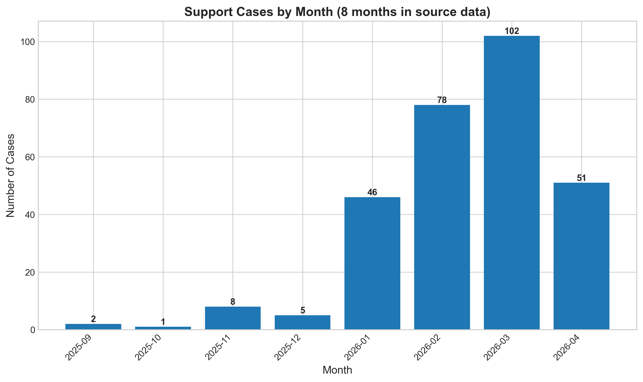
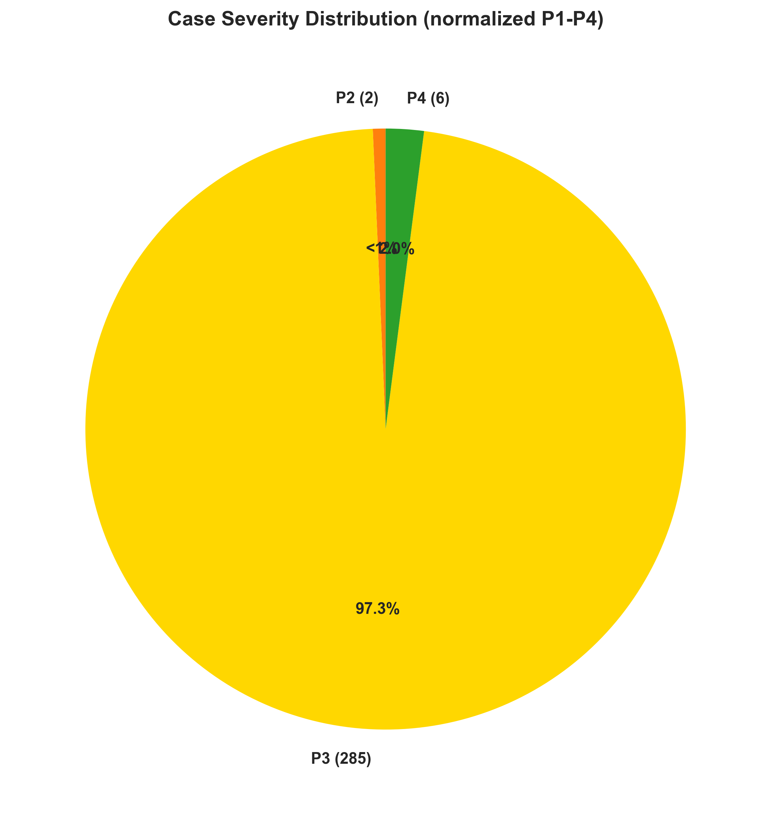
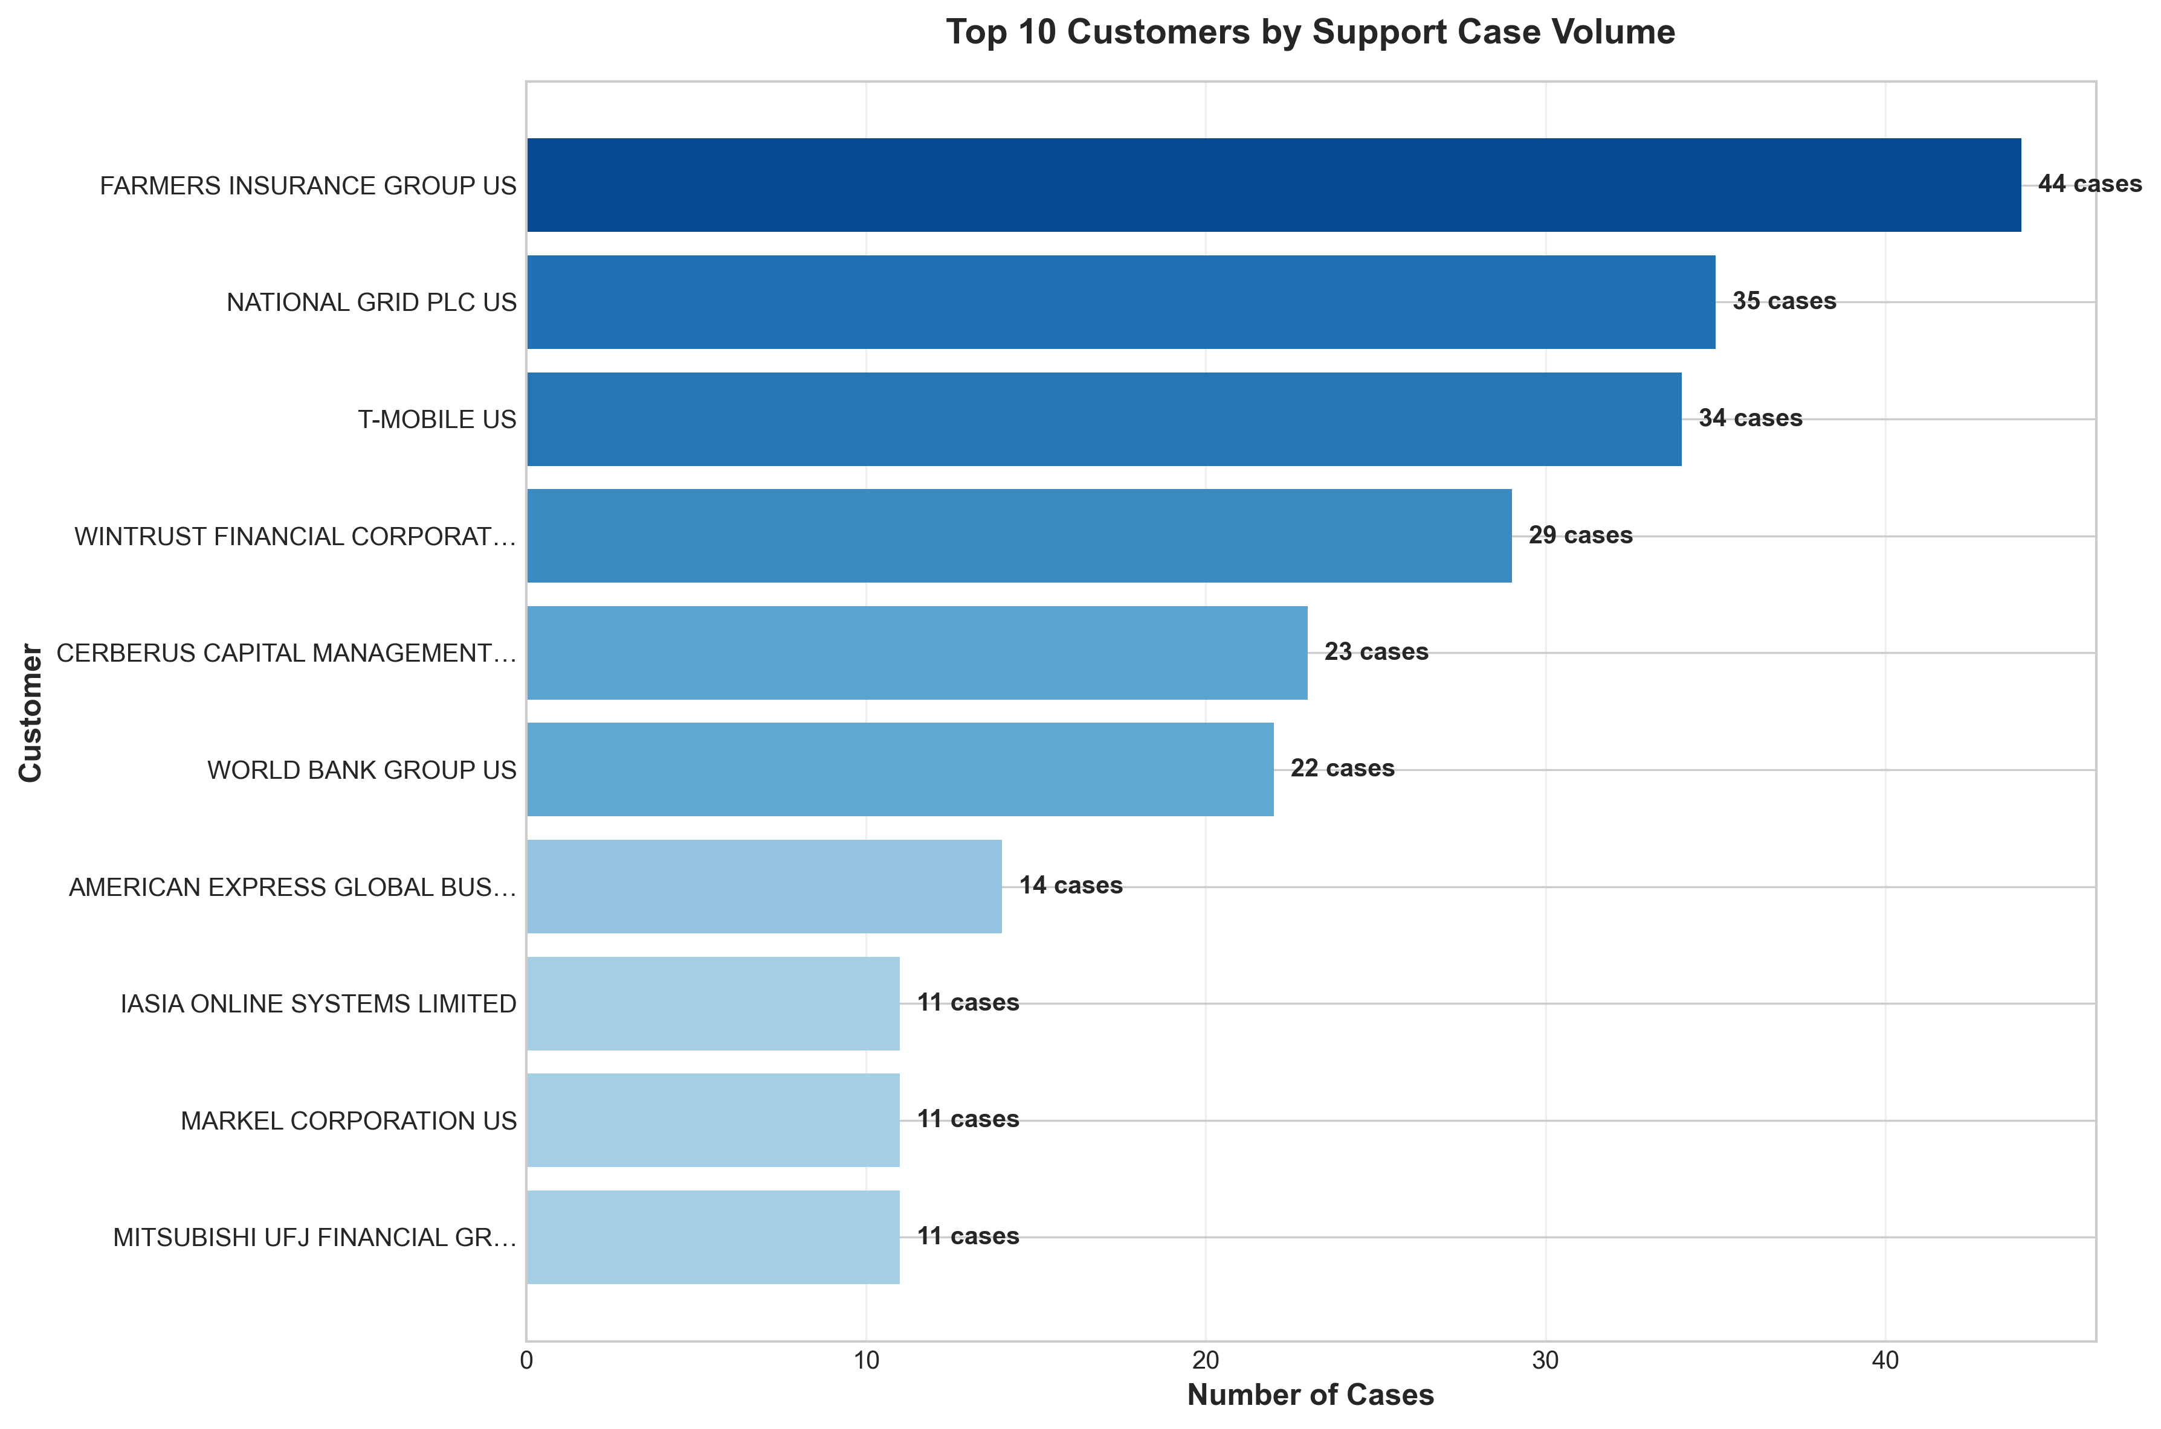
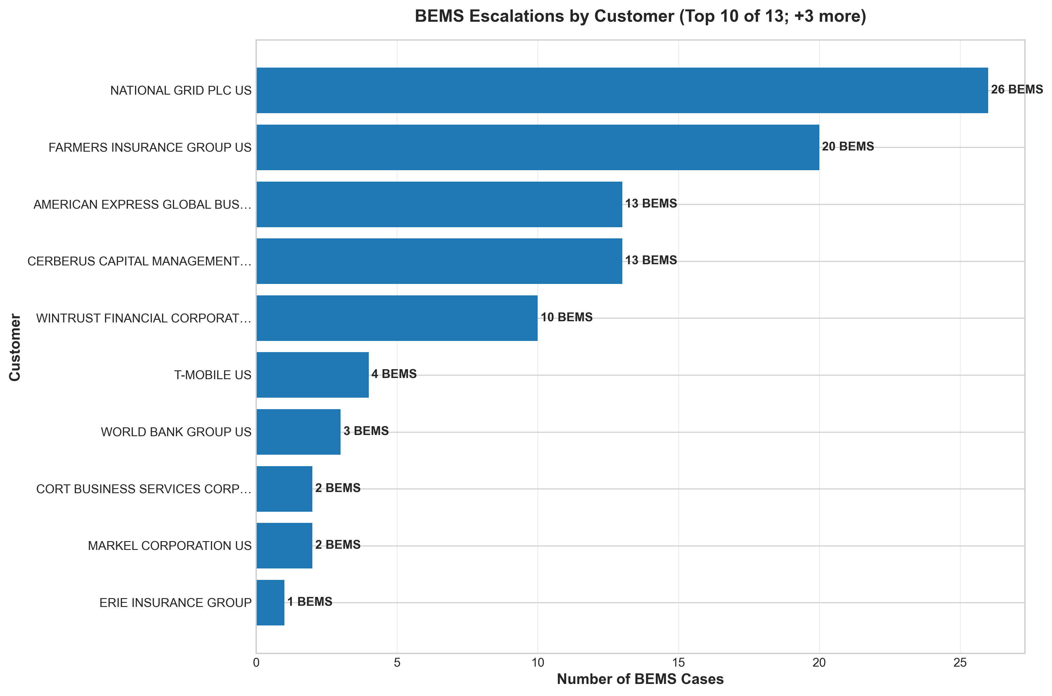
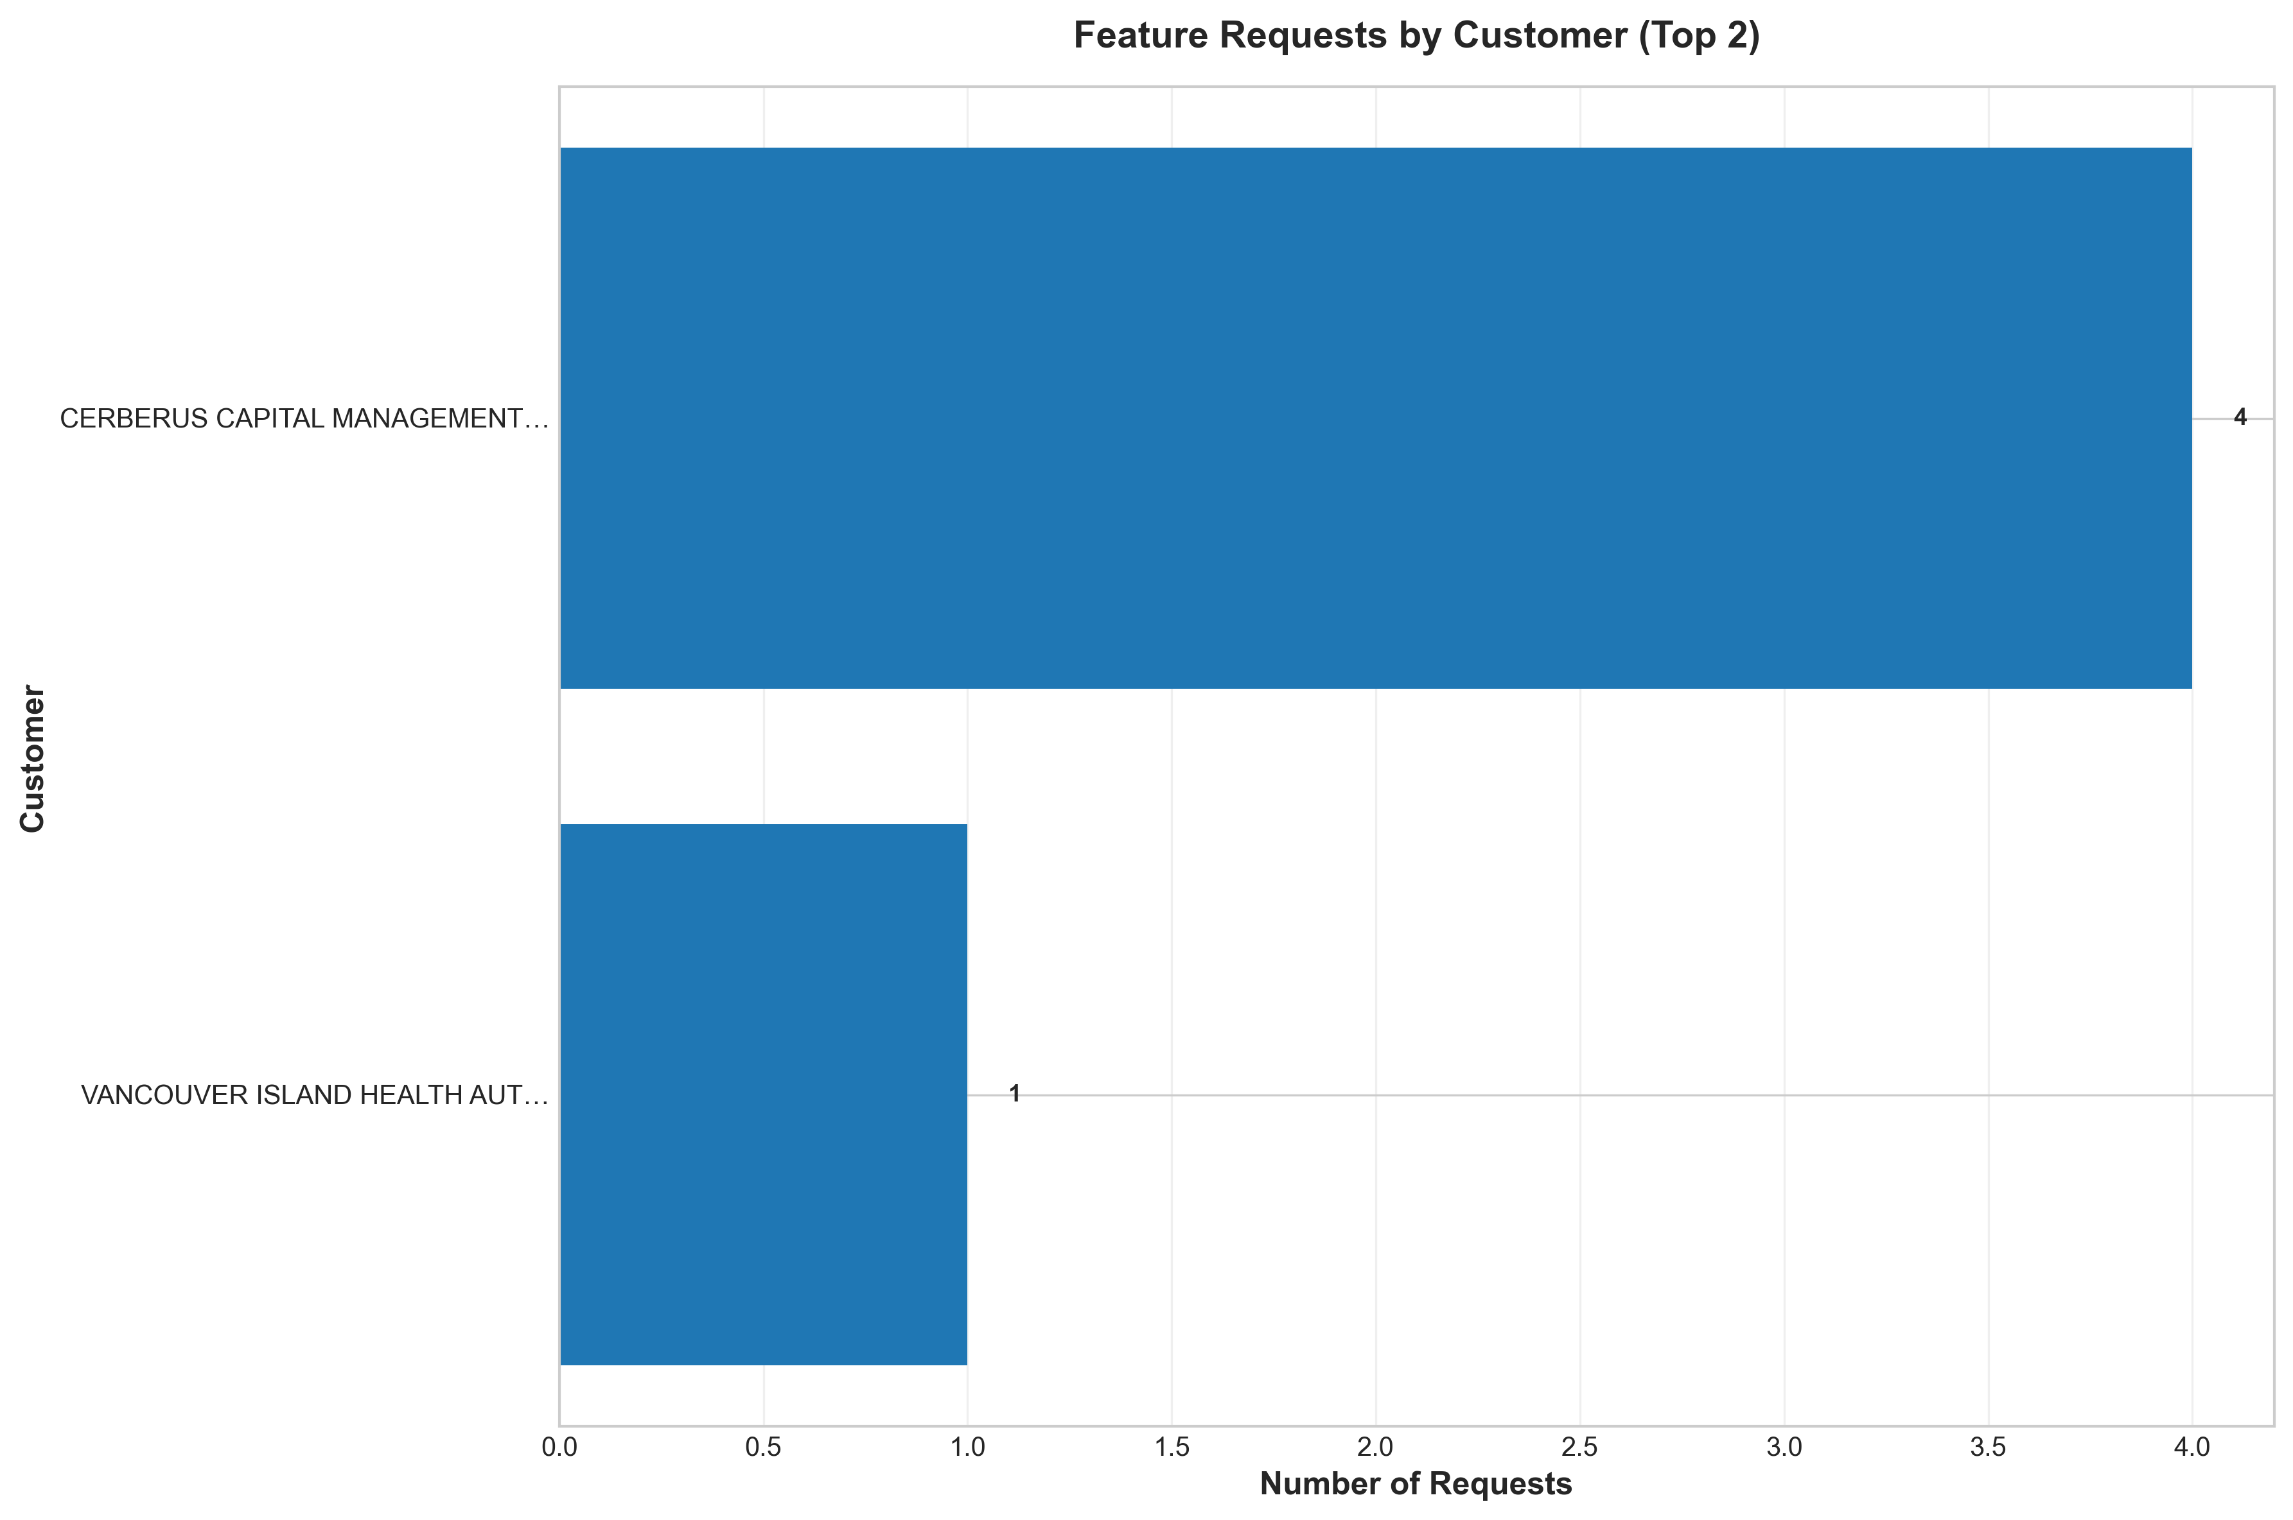

Report Data Sources
All data in this report is traceable. Same canonical sources used across all AdoptIQ reports.
All metrics and references in this report cite their origin. Adoption Barriers: CSConsole / Snowflake C360_CS_TASK_C_VW. Support Cases: CSOne (TAC case data). BEMS Escalations: CSOne (Transaction ID, bemscsc_refs — engineering-level escalations). Service Incidents: status.webex.com. Software Defects: help.webex.com, plus CSC/BST references in CSOne and Adoption Barriers. Customer Pulse, Action Plans, Success Priorities: CSConsole.

Record counts in this run:
• CSOne TAC Cases: 293 row(s) (each row = one TAC case in scope window)
• Adoption Barriers: 168 row(s) (each row = one adoption-barrier task in scope window)
• BEMS Escalations: extracted from CSOne Transaction ID / bemscsc_refs (counted per BEMS ID, not per case)
• Service Incidents: status.webex.com RSS feed (counted per published incident entry)
• AI Insights: CircuIT AI narrative grounded in the above sources (no independent counts)

🔗 Verifiable IDs: All [BEMSxxxxxxxx], [CSCxxxxxxx], and TAC case numbers can be validated in their source systems.

