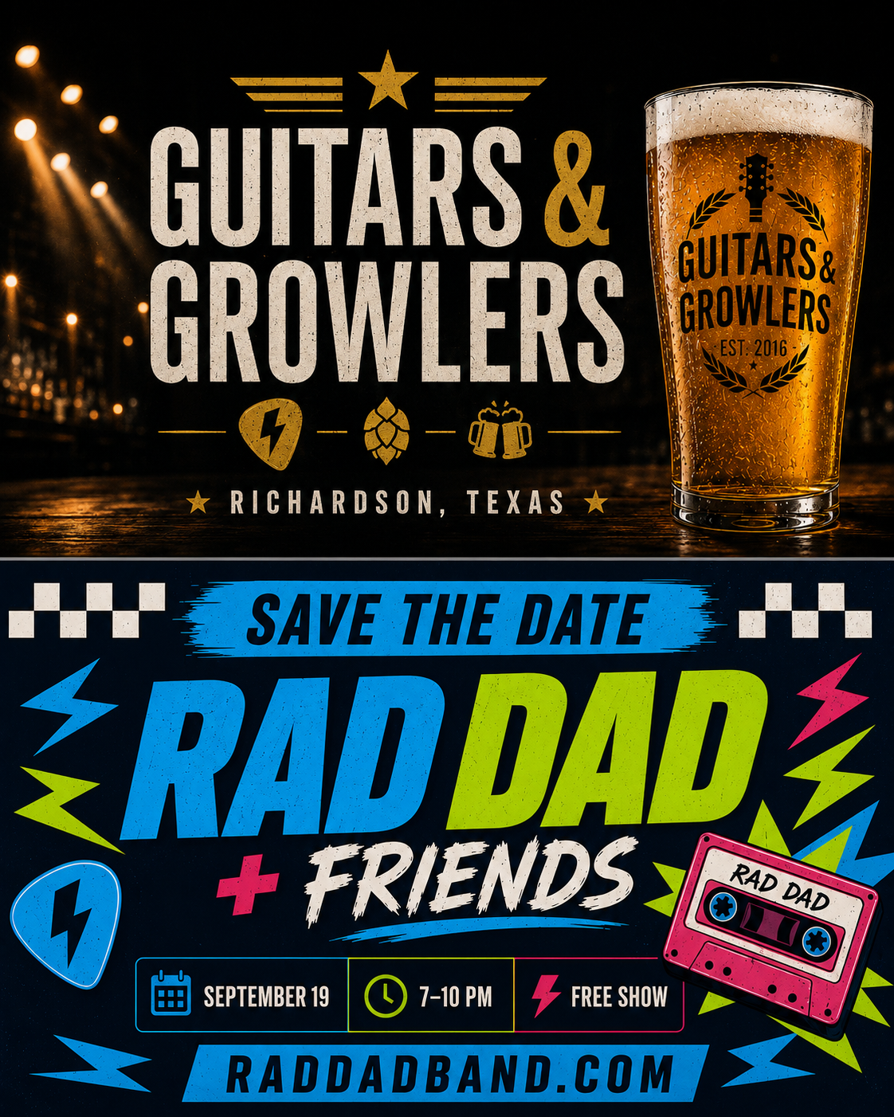
/// PERFORMER PACKET SATURDAY / SEPTEMBER 19 / 2026
SHOW NIGHT
RUN OF SHOW / CHANGEOVERS / PERFORMANCE ORDER
DATE  SAT 09.19.26 | VENUE  GUITARS & GROWLERS | SHOW  7:00 - 10:00 PM | PLANNED WRAP  10:00 PM

/// MASTER TIMELINE KEEP THE NIGHT MOVING
TIME | ON STAGE / TASK | WINDOW
7:00 - 7:35 | Jeff Story & Friends | 35 MIN
7:35 - 7:45 | SETUP / Mason + The Fault Lines | 10 MIN
7:45 - 8:25 | Mason + The Fault Lines | 40 MIN
8:25 - 8:35 | CHANGEOVER / Stalemate | 10 MIN
8:35 - 8:55 | Stalemate | 20 MIN
8:55 - 9:00 | QUICK CHANGE / Rad Dad | 5 MIN
9:00 - 10:00 | Rad Dad | 60 MIN

/// SHOW PRIORITIES HELP EACH OTHER / KEEP HANDOFFS QUICK
SHARED BACKLINE  Use shared gear where possible. | PROTECTED SETUP  Mason + The Fault Lines: 7:35 - 7:45. | BEFORE SHOW  Confirm guest-song keys and endings.

CURRENT WORKING ORDER / UPDATED AUGUST 9, 2026 / 1 OF 2

/// RAD DAD + FRIENDS PERFORMER SET MAP / 09.19.26
SETS + CUES
GUEST FEATURES / TRANSITIONS / CLOSING HOUR
/// GUEST SETS SONG ORDER / FEATURED PLAYERS
JEFF STORY & FRIENDS / 7:00 - 7:35 PM  # SONG FEATURED  1 Badfish  2 Nutshell  3 The Drinking Song  4 Heart-Shaped Box Travis Story - guitar  5 Creep Carly - vocals / Travis Worsham - guitar  6 Just a Girl Zella - vocals / Kelly - guitar  7 Misery Business Zella - vocals | STALEMATE / 8:35 - 8:55 PM  # SONG  1 Turn Over the Flag  2 TBFH  3 Manic  4 Be With You  5 Better Than Now  6 Take the Step

/// RAD DAD / 9:00 - 10:00 PM ARROWS = CONTINUOUS TRANSITION
# SONGS 1 - 10  1 Basket Case  2 The Rock Show  3 Ruby Soho  4 When I Come Around  5 Stand By Me  6 Miles Away  7 First Date →  8 Chick Magnet  9 Blind  10 The Way I Love You → | # SONGS 11 - 19  11 The Story Of Us  12 The Middle  13 On The Road Again  14 Breed  15 Country Roads  16 Tomorrow's Another Day  17 Linoleum  18 All The Small Things  19 She

/// FLEX SONGS USE ONLY IF RUNNING AHEAD
My Own Worst Enemy | Mable | Say It Ain't So | Dammit

CURRENT WORKING ORDER / UPDATED AUGUST 9, 2026 / 2 OF 2

