**Exercise 1 : Singleton Pattern**

**Week – 1 (Hands-on) ))Exercises)**

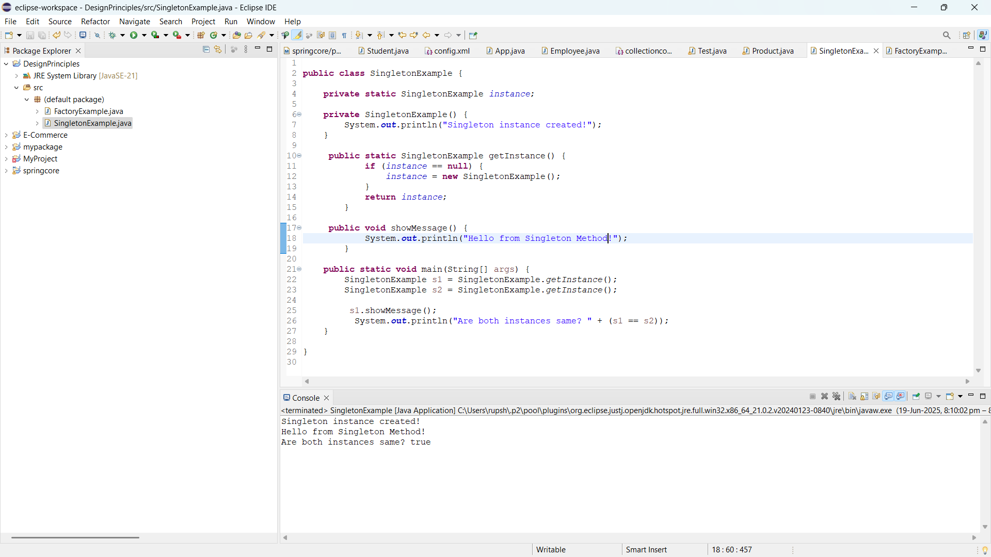

**Exercise 2 : Factory Pattern**

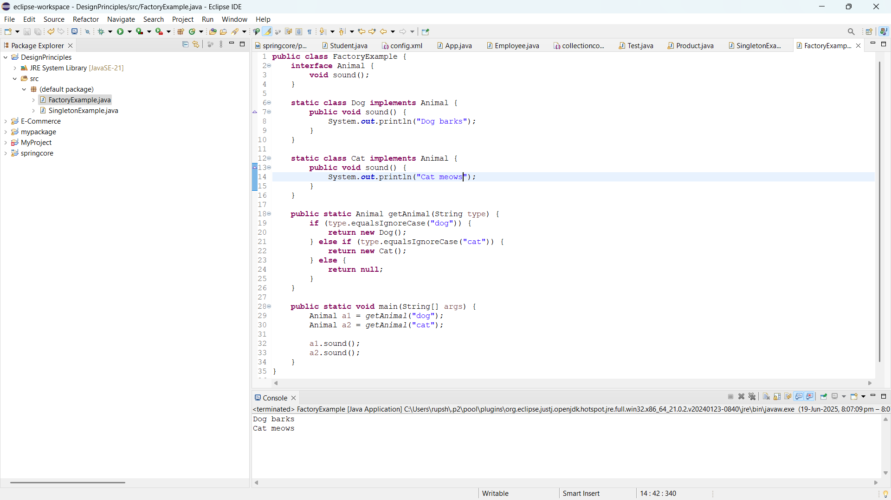

**Exercise 3 : Ecommerce Platform Search Function**

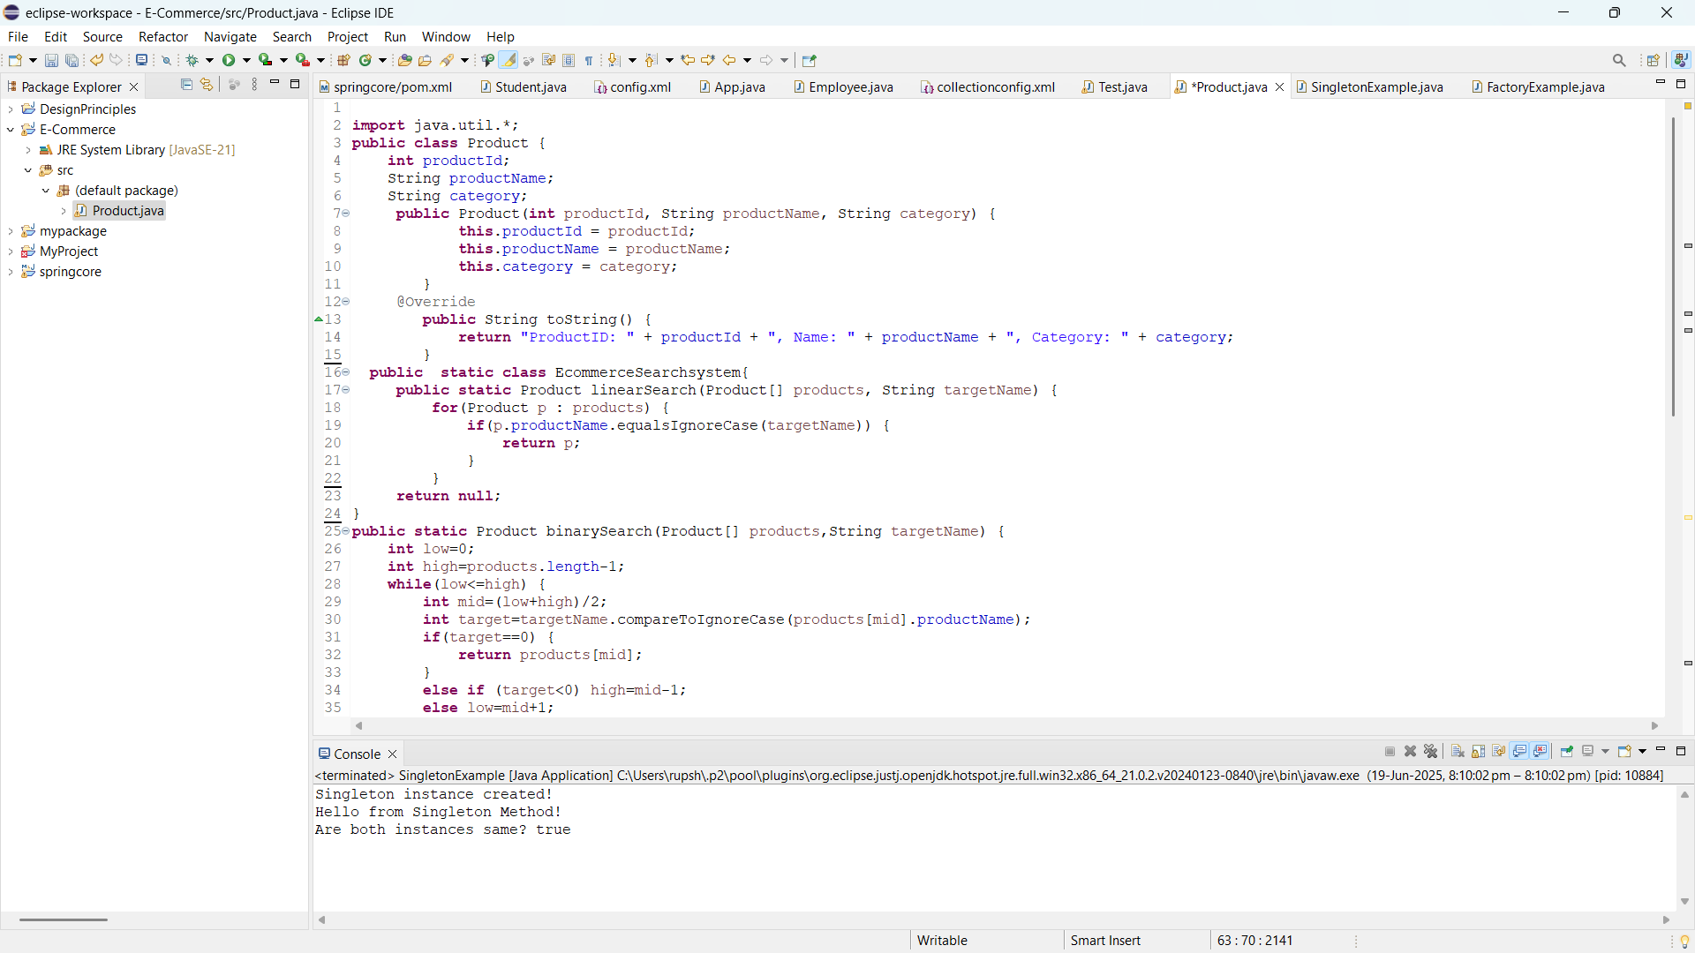 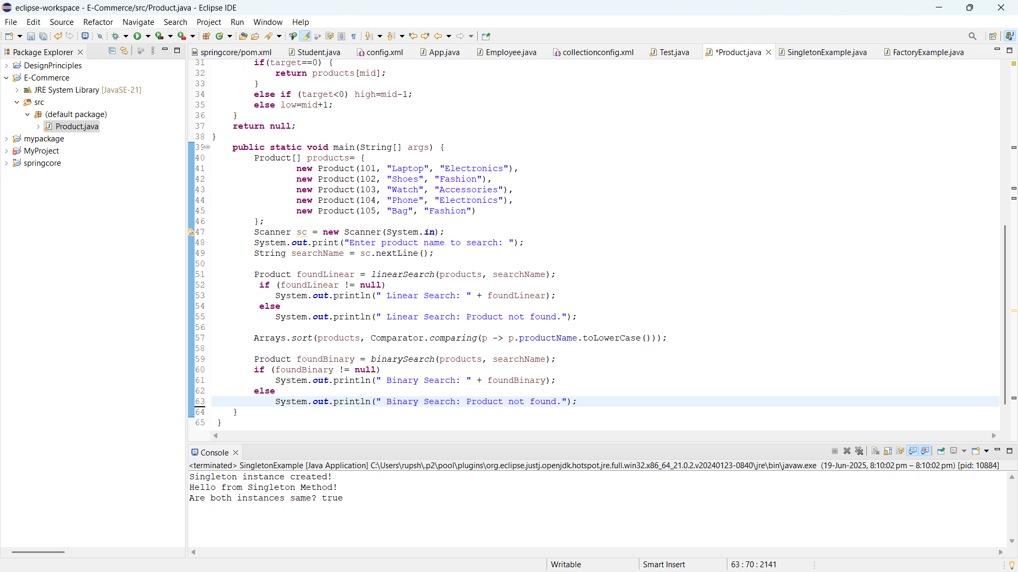

**Exercise 4 : Financial Forecasting**

