

**Scenario:** Your company is developing a web application for managing a library. You need to use the Spring Framework to handle the backend operations.

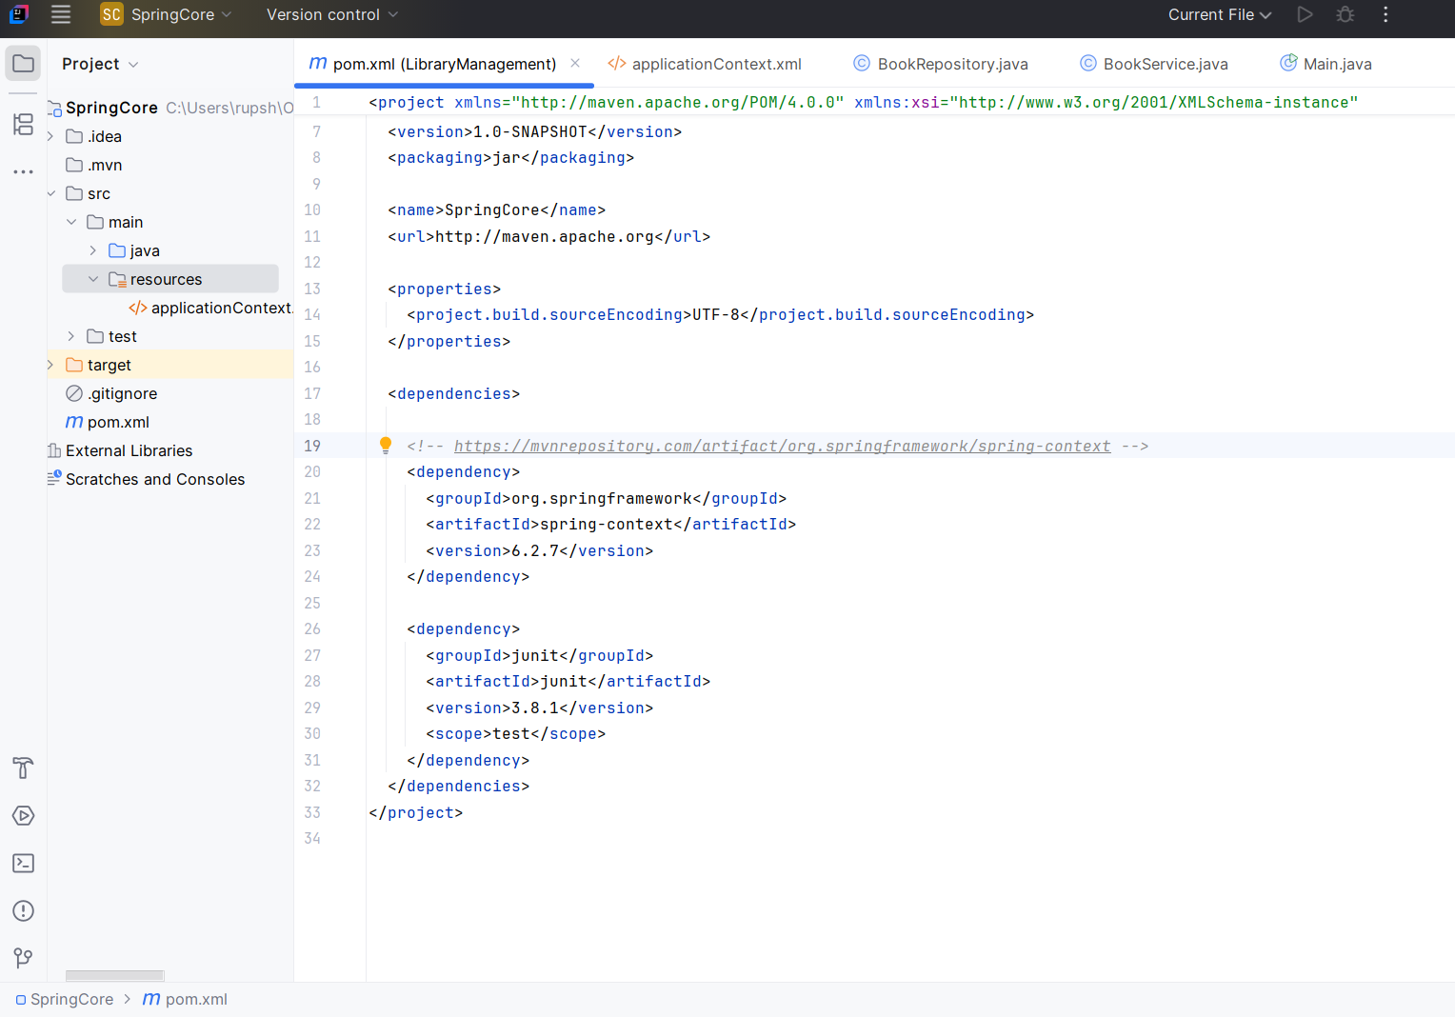

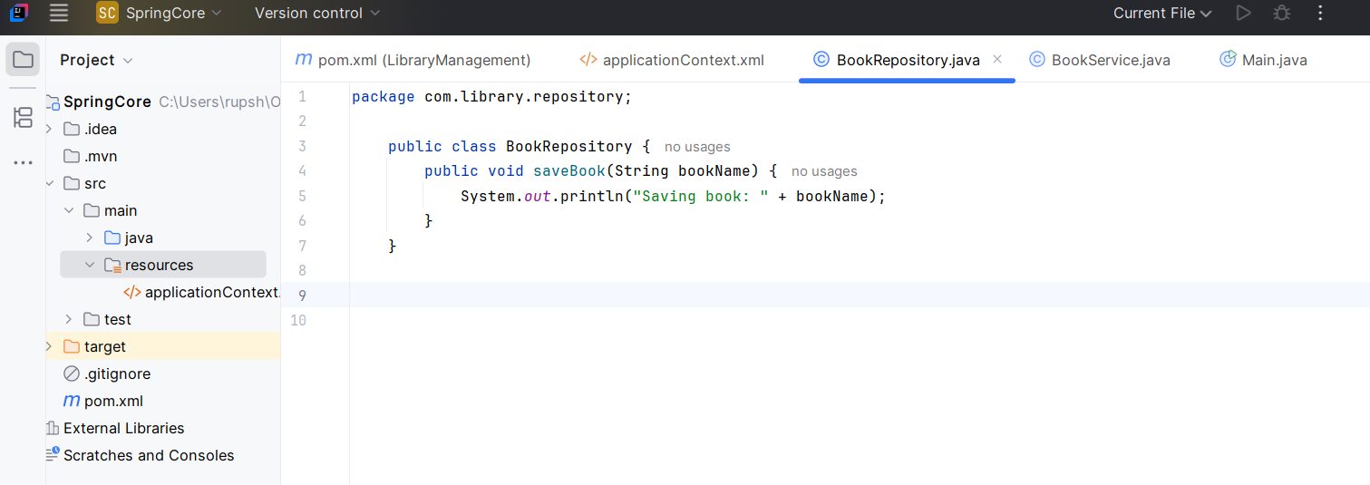

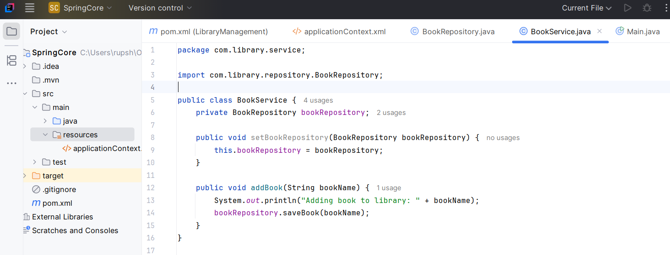

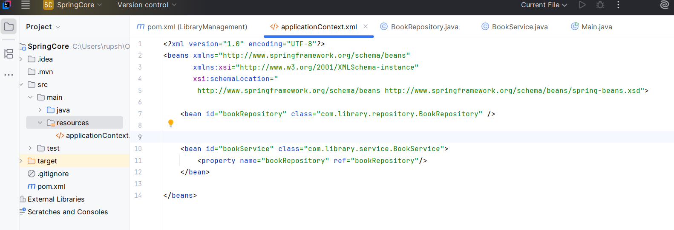

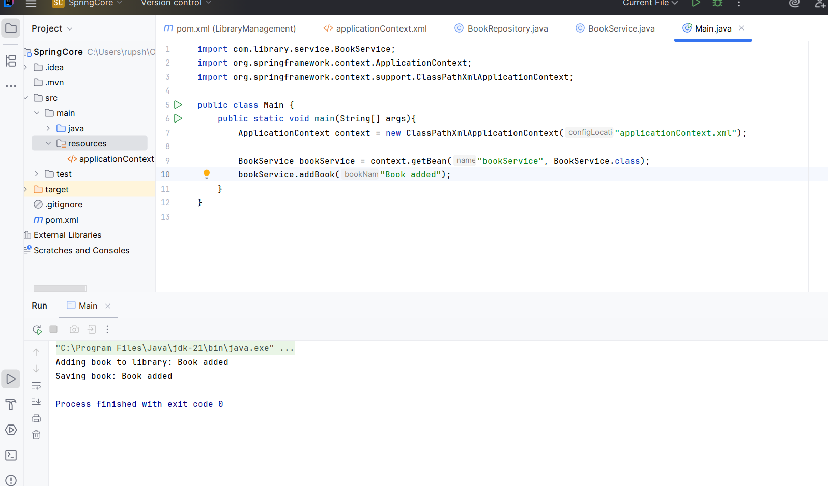

**Exercise 2: Implementing Dependency Injection**

**Scenario:** In the library management application, you need to manage the dependencies between the BookService and BookRepository classes using Spring's IoC and DI.







**Exercise 4: Creating and Configuring a Maven Project**

**Scenario:** You need to set up a new Maven project for the library management application and add Spring dependencies.

