LEADING SHARES analysis project
http://www.webstersystems.co.uk/project.htm

Introduction

This project involved a study of commonly available literature on private investment appraisal, stock selection and portfolio administration in the form of investment handbooks, textbooks, novels and articles. Much of this literature concentrates on appraising the performance of organisations, so arriving at an indication of future performance. It often teaches analysis of the past performance and assessment of future prospects of a company so a decision can be made about inclusion in a portfolio. Despite this central message, due to personal experience in equities markets, it becomes clear that an investor in such markets cannot afford to focus concentration on appraisals or valuations of individual organisations in order to reduce risk and to achieve superior returns on investment.
For example an analysis of the performance of Vodafone up to 2000 showed a company with excellent year on year growth figures for all areas of the business - years of steadily increasing earnings per share, increasing customers, increasing share price, increasing brand acceptance, increasing international operations, increasing profits and altogether a healthy appearance for a potential investor in the stock. However, triggered by effects essentially larger than the organisation itself the stock price has steadily declined since this time. Nowadays this price decline is reflected in the financial reports, but at the time the turn came, the financial reports showed healthy operations and an optimistic forecast for the future. Macro-economic factors that affect the majority of organisations through time were a primary contributory agent to this price decline in Vodafone shares over the past three years.
Investment appraisal handbooks such as Slater (1996) show innovative ways of valuing companies and their potential stock performances, but do not really advise on the macro-economic effects. One teaching of his books is “elephants don’t gallop”, which shows the view that smaller company prices often outperform larger companies. This is a well-known empirical fact. Slater explains this by saying it is easier to understand a company with a market capitalisation of $1 million doubling or tripling in value quite quickly, compared to a company with a market cap of $1 billion. Yet if macro-economic market conditions are adverse, it is unlikely that any company will even trot!
In Buffet (1998), Mary Buffet expounds some of the business and investment philosophies of her father, the famous Sage of Omaha, Warren Buffet, who is arguably unsurpassed in achieving investment return. Buffet points to building portfolios of "companies you can understand", "would hold forever", and accounting ratio calculations that "determine if a company is an excellent business". Again the view of an investment portfolio appears diminished to performance appraisal at only a corporate level. Buffet is a very successful investor and must be aware of general market conditions, but these are not focussed on in his daughter’s book.
Fisher (1958) points out that a potential investor must assess the whole market, then the industry and then the individual company in order to improve the chance of investment success. This triangular view for critiquing businesses and business prospects is echoed in strategic management analysis where it is understood that the condition of a company’s industry is often a critical success factor in the corporate performance of that company. However, undergraduate strategic management appears not to devote much study to key factors affecting conditions across all industries and so the whole business environment. These are macro-economic factors summed up in phenomenon such as inflation, levels of interest rates and the quality of corporate profits throughout the world, which subsequently affect the investment appraisal and performance of all companies in all markets.
Le Fèvre (1923) in his classic novel, entertainingly and enticingly points out the importance of acknowledging general market conditions that can drive all business for better or worse. A focus on the business environment is more often than not critical to success in the battle for investment survival. So determining the market conditions that can affect the risks, returns and market values for the great majority of organisations and investing according to this ‘big swing’ is the basis for a winning strategy. Remember the example of Vodafone in 2000. A further point from this novel has influenced the development of the software produced in this project. Smitten (2001), who wrote a biography of Jesse Livermore, the remarkable character described in Le Fèvre (1923), re-iterates the point.
"Tracking the leaders provided strong timing clues for the direction of the market. Trading several stocks in each of the major leading groups also helped confirm when a specific industry group was falling out of favour and reversing, or vice versa, coming into favour. The leaders, in Livermore's mind, were also surrogates for the Dow Jones Averages. When these leading groups faltered, it was a warning signal, and his attention to the overall direction of the market was heightened. The signal occurred when the leaders stopped making new highs and stalled, often reversing direction before the overall market turned."
So although this does not explain why leading groups and market averages fall into and out of favour, it may be a useful aid to determining and following the big swing of price changes. So this project focuses on a study of leading shares and their relationship, if any, to the market average. It does not investigate how leading shares reverse direction from new highs, but just starts with observations of daily money flow into high volume, high quality corporate stocks, and daily money flow into the Dow average. Livermore points out (Smitten 2001) that if you are going to speculate in the markets, work with the leading issues of the day. If you cannot make money using the leading shares, you are unlikely to make money in any of the huge number of other available securities.
As the project may produce a technical aid in market analysis, it is useful to quickly critique technical analysis. A review of literature on technical analysis shows many wonderful visual charts, graphs and statistical equations that model past and present performance, sometimes to produce indications of future performance. There is a distinction between assessment of the health of an organisation in terms of its industry, management, market share and financial accounts, and an assessment by technical analysis. Among thousands of technical indicators, techniques such as moving averages of prices, price and volume momentum indicators, stochastic processes and relative strength indicators are produced to assess the performance of an organisation (Omega Research 2003). Less attention is given to underlying macroeconomic reasons pitching the state of markets for or against business conditions in general. There is some incredibly comprehensive software available to study the scores of individual securities and their market movements. For examples see Omega TradeStation, RadarScreen and OptionStation, or ShareScope or TC2000. These software packages calculate values for the impressive array of mathematical indicators derived from market movements. Quickly flipping through hundreds of price charts (and their indicators) a “benign” price chart can be discovered. After fundamental analysis of the security typically involving accounting ratios, financial reports and an assessment of the quality of management, a decision for or against inclusion in a portfolio can be made.
It appears to be in the large and active financial institutions that general market conditions are actively monitored and portfolios adjusted accordingly. Lowenstein (2002) describes how the fund managers at Long-Term Capital Management analysed the state of international interest rates. Before the Euro was introduced Italian interest rates stood at 8% and German interest rates nearer 3%, so when both countries planned to merge their currencies into the Euro it was a sound bet that these interest rates would converge. Indeed they did.
Goldman Sachs (http://www.goldmansachs.com/econderivs) has recently announced Economic Derivatives. These are tradable options on economic data releases such as employment, retail sales, industrial production, inflation, consumer sentiment and economic growth. This means that investors can take positions based on macro-economic views, hedging portfolios against “market action” such as when an investor predicts the number accurately, but misjudges the market impact of the report.
So this project attempts to take a step away from the analysis of individual companies and their industry sectors in order to try and illustrate a measurement of macro market action. With any number of dynamic knowns and unknowns influencing the conditions of market averages, any attempt to discern future conditions is through a fog of uncertainty. To reduce this uncertainty to a minimum it appears that ideally only when fundamental, technical, global socio-political and economic conditions match, correlate with individual experience and current market psychology and when measures are taken for risk control that any directional position ought to be taken. Since each factor influences market averages, wait until all indicate a positive environment, then take a positive position, or vice versa. This is along the lines of the strong form of market efficiency, where we reflect all possible information in our investment decision. Then again, due to efficient markets pricing in available information, perhaps when each factor indicates positive conditions, take a negative position? One wonders...
The project does not focus on typical market influences such as economic conditions, social and political news reports, corporate financial reports or any other news. This is partly because brokers and dealers on the floors of major exchanges often are not aware of the news that may affect securities prices when prices change. They simply mark prices according to the present state of supply and demand for their securities from the market. The underlying reasons for price changes often only become clear to those who implement price changes some time after market moving events occur (Bartiromo 2001). This is also why the software concentrates on prices and volumes.
Due to the empirical findings of Le Fèvre (1923), is it reasonable to believe today that market averages as a whole change in price less efficiently than actively traded shares? In other words, do market averages follow the leaders?
Efficient markets show that price changes are random. This is not disputed, because this hypothesis considers relationships between securities undergoing random price changes. Is there any relationship, and if so, is it also random? Brealey and Myers (2000) shows as soon as a cycle in prices becomes apparent to investors, they immediately eliminate it by their trading. Does this trading start with leading shares, then spin off to lagging shares, so creating a time differential and a relationship between leading shares and the market averages? Le Fèvre (1923) claims a time differential is in action between securities prices, which would imply markets are not perfectly efficient. As competition between investors tends to produce a market where all prices are efficient, can any measurable relationship exist where some prices actually lead market averages? The project uses information systems knowledge and statistical techniques to investigate this.

Research/Development Method

With the advent of the networking revolution, financial data is now easily available over the Internet. To keep the project at a manageable level, and to fit with a position trading investment approach, only end of day data on only the Dow Jones Industrial Average components was gathered for the research. This allows quantitative analysis of any relationship between the five most actively traded securities in the DJIA against the market average, over a time series. To enable consistently updated analytics, a software program was constructed which is scheduled to gather the relevant data at the end of each working day, update a local database and then show the results of regression analysis.
The research does not use the five most actively traded securities across all global equity markets, for example, because again as Livermore pointed out through Smitten (2001), if you are going to invest money in the markets, invest in the leading issues of the day. If you cannot make money using the leading shares, you are unlikely to make money in any of the huge number of other available securities. While data on active securities are continually illustrated in the majority of financial newspapers and websites, and smaller companies undergoing frenetic trading activity are interesting in their day, is this useful for an investor who wishes to assess a more lasting relationship in the big swing of financial movements across the globe? I believe Livermore is looking at high volume, high quality stocks and the research concentrates on these.
Things get more technical from here on. As the project deals with learning about a relationship between variables, it culminates in a least squares regression analysis between aggregate money flow into or out of leading active issues and money flow into or out of the market average. It also includes multivariate regression analysis to look at the relationship between the top five issues and the market average on an individual basis. The leading issues are identified using their traded volumes. The price change for the day is then multiplied by the number of outstanding shares in the issue to find an approximation of the actual dollar amount of money flowing into or out of the issue for that day.

Money flow = price change * outstanding shares

This is an approximation because the numbers of outstanding shares are not checked for new issues of stock each day. With the huge amount of outstanding shares in each of the DOW 30 components, it is assumed new issues are unlikely to make a great difference in the calculation of money flow as they happen rarely to the top five stocks and are in denominations of millions when DOW components have billions of shares on world markets. (See appendix)
For the simple regression, the money flows are added together to make an overall money flow for the top five shares.
Aggregate active money flow =
(+/-) money flow for most active issue 1
+ (+/-) money flow for second active issue 2
+ (+/-) money flow for third active issue 3
+ (+/-) money flow for fourth active issue 4
+ (+/-) money flow for fifth active issue 5

This ‘active five’ money flow is then modelled against the money flow for the market average, calculated in the same way, by multiplying the price changes for each issue by the outstanding shares for that issue, and adding all the positive or negative money flows together.
Money flows for different combinations of active leading issues are modelled against the money flow for the market average. Three main regression models are implemented to investigate if any discernable relationship exists between the following:
- Yesterday’s aggregate money flow of the five most active issues against today’s market average money flow.
- The change from yesterday to today in the top-five money flow against the change from today to tomorrow in the Dow average money flow.
- The individual changes from yesterday to today in the top-five money flow against the change from today to tomorrow in the Dow average money flow.
To perform the regression I have used Vista, the Visual Statistics System by Forrest W. Young (http://www.visualstats.org). It was originally intended that I design a simple regression program myself, but since this software was available free and far more advanced than any I could design, my project plan changed. With Vista the project produces far more comprehensive and detailed results of analysis, rather than much less adequate statistics but elaborate software design.
To design the software to fetch the data and populate the database, which starts the information systems part of the project, I elected to use Microsoft Visual Studio Net. This is a state-of-the-art software development environment allowing use of the latest Object Oriented and Internet technologies, with a huge library of pre-coded software objects. I have learned the all-purpose C# language for the application code. As well as a general software language, C# also interfaces with Active Server Pages (ASP.Net) so results can easily be released to the Internet through a set of C#, ASP and HTML pages. I have created a webpage for this at http://www.webstersystems.co.uk/project.htm.
Data is stored in an SQL Server 2000 database in relational tables, and ADO objects are used to manage the inputs and outputs to and from the database and the program calculations. This is because SQL Server 2000 is an all-purpose relational database in general use. (Please see appendix)
Visual Studio .Net also provides a comprehensive programming and debugging environment, which reflects the state of the art in computing in 2003. (Please see appendix for screenshots of VS.Net in action)
The historical data source was the Yahoo Finance website, (http://table.finance.yahoo.com/d?a=6&b=1&c=2002&d=3&e=26&f=2003&g=d&s=MSFT) where data by volume, open and close prices for the last 200 days for each DOW component was gathered using Excel spreadsheets. This was transformed into SQL database tables, and the .NET project LI_hist created in C# to handle the calculation of money flows and the updates of the regression tables for each historical day.
The ongoing data source is the New York Stock Exchange website (http://marketrac.nyse.com/Light). They provide clear data on leading shares in the Dow Jones average, and DOW market average data. The main data gathering and analytics module, LI_app, is scheduled to run every day from the website at 11am to get the previous day’s data which is made available publicly by the NYSE.

Data/Findings/Designs

The outcomes of the project are segmented into two main parts, and a webpage. Firstly there is a program to gather data and perform simple calculations on the data before populating a database with information useful for regression analysis. Secondly there is an analytical part which uses statistical techniques to test the hypothesis and learn if any relationship exists between the variables. The webpage shows details of the project and shows the results for the daily program (LI_App). This section will start with the outcome of the software projects and then address the outcome of the statistical tests.
Three Visual Studio .Net C# projects were written. Firstly the LI_app project which handles collecting the data on a day-to-day basis, appending rows to the database tables and handling continuing analytics. The main function, which kicks off the application, is in the control_class.cs class. Program control is handled from this class, which sequentially steps through object methods until the program requirements are met. The development of the software followed no particular methodology because the requirements were so clear. If any, it followed ‘the software lifecycle’. Requirements were collected, technology feasibilities were investigated, some simple process and data design options considered before and during coding and implementation. The coding followed a trial and error approach making extensive use of the .Net debugging environment. Class control_class.cs was constructed and the first requirement of data gathering was considered. It was here decided to modularise the software, which came in very useful in the program use. A data gathering class, data_capture.cs, was constructed and the first of its methods implemented using a top down design approach to the requirements. It was as if the requirement was broken down into methods necessary to achieve it, and modularised by using a separate class. So the data_capture class, when instantiated as an object, uses a .Net C# Internet object from the object library to access the NYSE website and return with all the data from one specific page. This raw data is then broken down using several format methods written into the data_capture class. Data is transformed into the data structures of the shares and Dow database table. An ADO object then updates the data into the database table, the class finishes and program control is returned to the control_class.
Database inputs and outputs were also modularised into two classes, the db_in.cs and db_out.cs classes. To populate and read the database, db_in and db_out object methods are used through the classes in the program. When necessary, database-handling objects are instantiated and their methods called by the classes fulfilling the program requirements. The actual code in the database classes is a mixture of C#, .Net C# objects and SQL which was designed as requirements were broken down by coding and it became clear that a particular database call was needed. Each time a specific call was necessary, a new method was added to either of these classes to handle it.
After the database is populated with the formatted data from the NYSE and program control passes from the data_capture object to the control_class object, and the analytical techniques begin. Now the requirement is to calculate tallies of money flows for the top-five and for the DOW Average, then update the SQL database with the results. Multi-dimensional arrays of objects are declared to hold raw data on the top-five shares and to hold results of their money flows calculations. A double variable is declared to hold the results of calculations on the DOW Average money flow for the day. A value_calc.cs class is created to handle these requirements, which is instantiated in the control_class.
Broken down further, analysing the data requires calls to and from the database. So, the control_class gets the active five data from the database, through a method of the db_out object. It then uses a value_calc object method to calculate the aggregate value of the money flow into the top-five shares for the day and puts the results into the multi-dimensional array of objects. It then does the same for the Dow tally, putting the results into the double variable. Now it updates the simple_regression table using the db_in object. As you can see from the control_class.cs in the appendix, these broken down linear requirements match exactly the software code, and this is the way they were written.
Lastly, to handle the calculation of changes in value from one day to the next, a single dimension array of objects is declared, then populated with a call to a db_out object method which returns yesterday’s top five money flows from the database. An array of doubles is declared, and the changes in money flow from yesterday to today are simply calculated by the control_class. Perhaps for the sake of modularisation, the three lines of code that do this could be made into a method and placed in the value_calc class.
Finally the database is updated with the results using a last call to the db_in object methods. Unfortunately for you to see the calculations are correct, you must watch the program in action in the .Net debugging environment. There are screenshots in the appendix.
This is the C# program at calculates the money flow of the top five shares and the Dow average each day, calculates the change in money flow from yesterday, and updates a database with the results. The results are used in the regression tests by the regression software.
After advice from tutors it was decided at least 120 days data must be used for regression testing. I could not wait for 120 days of running the program each day, so the LI_hist software project was written to handle updating the database with historical data. This was 2 columns of 30 rows for 200 days, as 200 days was easy to handle from the data source, Yahoo Finance. Yahoo Finance provides up to 400 days of historical data on each Dow component, for each working day, from their website. The data includes date, price and volume so it was perfect for this research.
Using the control_class for LI_App as a template, and using exactly the same methodology of breaking down requirements step by step, and modularising code into classes, LI_Hist was written. Additional functionality was written into the database classes to populate the regression analysis tables with the historical money flows. Although the calculations of money flow and change in money flow are very similar to LI_App, there was considerable effort made to ensure dates were correct. Change in money flow for each day is calculated from yesterday’s money flows to today. This meant calls to the database for rows of yesterday’s data and rows of today’s data, which was retrieved into multi-dimensional arrays of objects, just like in the previous program.
After running this in a ‘for loop’ for each day in all 200 days, the source data for the main regression analysis modules was retrieved, formatted and populated.
In the same way, the third software project, LI_multiple_regression, was created to handle the money flows for the individual top-five components, and to update the multiple_regression_tally table with the historical money flows. This was the source data for the multivariate regression testing.
Lastly, LI_app was upgraded to meet the same standards as used when populating the historical data. In all this was an excellent software exercise in data retrieval, formatting, calculation and recording. The Visual Studio environment was excellent for helping solve the errors that occurred, the most notable being casting errors, where I eventually had to make the database ‘numeric’ types ‘float’ to allow C# to cast from object to double so the tallies could be calculated. Also arrays out of bounds only came as runtime errors, and handling the ‘DateTime’ variables between C# and SQL Server was extremely difficult and time consuming. There was extensive use of .Net help-pages, and of the Internet to try to address programming problems. I wanted to draw Data Flow Diagrams and Logical Data Structures for the project but I ran out of time, and anyway, I did not use these techniques directly in the project. Knowledge of these techniques did help, however in visualisation of data and processes interacting. Please see the appendices for details of all the programs, and the SQL Server database.

Regression

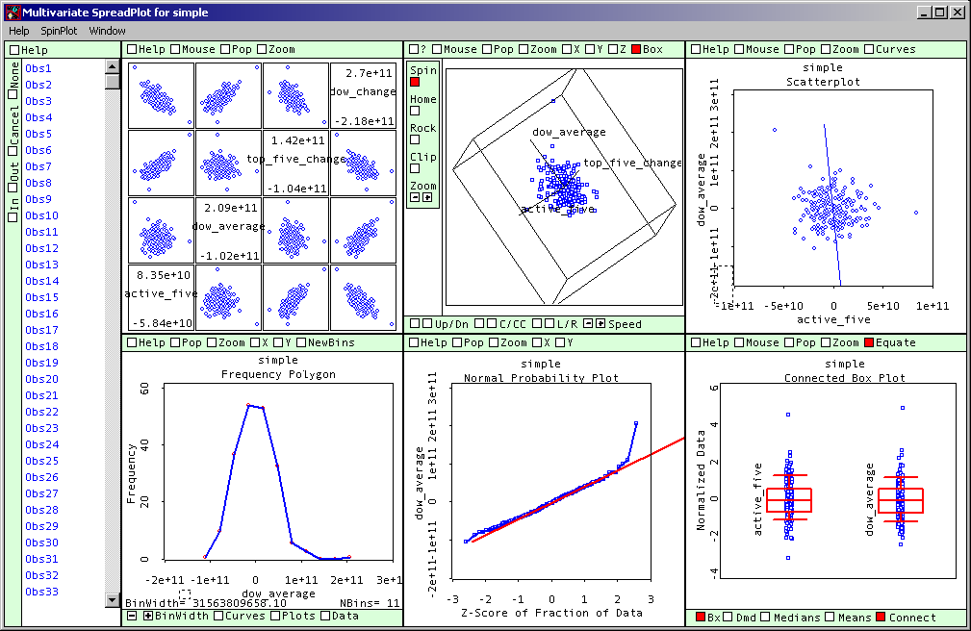
For the statistical tests I created an LSP file of data using Excel to set the target data to the target dates, which was imported into the Vista statistical software. The source tables remained unchanged in the SQL Server database. Vista creates simple and multiple regression reports and a graphical representation of the reports. An example screenshot of the Vista graphical analytics for data from the regression_tally table is shown below:

First regression

The report for the first regression test (Yesterday’s aggregate money flow into the five most active issues against today’s market average money flow) produced a negatively correlated result. The scatterplot (top right pane above) shows this relationship between the two variables. Although the results show a significant negative correlation between the variables, the coefficient of determination (r²) is 0.06, which shows that X predicts Y 6% of the time. The ρ-value of 0.0003 is low, but as these results were poor compared to the other regression results, I did not continue analysis of this regression test.
The actual report shows:
PARAMETER ESTIMATES (LEAST SQUARES) WITH TWO-TAILED T-TESTS.
Term......... Estimate Std. Error t-Ratio P-Value
Constant...... 245429872.37 2911108489.83 0.08 0.9329
active_five... -0.58 0.16 -3.65 0.0003

SUMMARY OF FIT:
R Squared (Total Effect Strength): 0.06
Adjusted R Squared: 0.06
Sigma hat (RMS error): 40949151317.30
Number of cases: 198
Degrees of freedom: 196

Second regression

The second regression test (The change from yesterday to today in the top five money flow against the change from today to tomorrow in the Dow average money flow) produced an interesting result. The Scatterplot and the regression line show an inversely proportional relationship between the two variables. See below:

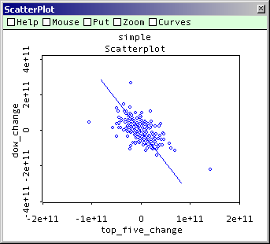
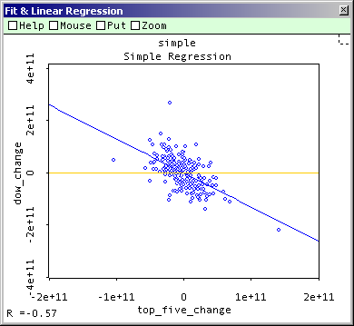

These results show a clear negative correlation. When there is an above average positive change in the money flow into the top five leading shares, then the following day there is a negative change in the money flow into the Dow averages, and vice versa. When the money flow is near average, the relationship is not so clear. Please see the connected box plots below for graphical representations of this relationship.
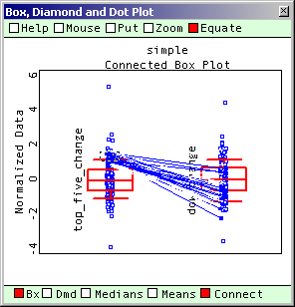
Box plot I: An above average positive change from yesterday to today in the top five money flow produces a negative change from today in tomorrow’s Dow average

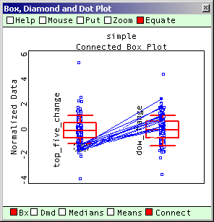
Box plot II: An above average negative change from yesterday to today in the top five money flow produces a positive change from today in tomorrow’s Dow average

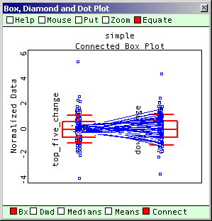
Box plot III: An average change from yesterday to today in the top five money flow produces a random change from today in tomorrow’s Dow average

The written report of the data for the second regression is in appendix. In the report, the following parameter estimates were observed:

PARAMETER ESTIMATES (LEAST SQUARES) WITH TWO-TAILED T-TESTS.
Term.............. Estimate Std. Error t-Ratio P-Value
Constant.......... 418633884.14 3243839831.95 0.13 0.8974
top_five_change...-1.53 0.12 -12.56 <.0001

This produces a regression equation of:

Y = 418633884.14 – 1.53x
This means that the least squares estimate of the slope (β1) is –1.53, implying the change in money flow into the Dow average tomorrow decreases by 1.53 for each unit of increase in money flow into today’s leading shares. The estimated y-intercept of 418633884.14 approximates that no change in the leading issues makes a change of 418633884.14 in the Dow average.
The estimated standard deviation of E is 45644872368.60, which implies that most of the changes in the Dow average will fall to within approximately $91,289,744,737.2 of their predicted values.

Are the results really useful for predicting the DOW average?

H (0): β1 = 0
H (a): β1 > 0
This tests the null hypothesis that there is no relationship (a random relationship) between the changes in money flow into the top five shares today and the changes in money flow for the Dow average tomorrow against the alternative hypothesis that the change in the Dow money flow tomorrow decreases as today’s change in money flow into the leading shares increases.
The observed ρ-value from the results is <0.0001, which leaves little doubt that there is at least a linear relationship between our variables.
The 95% confidence interval for the variables, with a T (0.25) value from the critical T-values chart of 1.960 is:
–1.53 ± (1.960)(0.12) = (-1.7652, -1.2948)
implying that the interval from -1.7652 to -1.2948 encloses the mean decrease in tomorrow’s Dow average from today for each increase in today’s change of the leading shares from yesterday.

Correlations

OBSERVATIONS active_five dow_aver five_change dow_change
active_five 1.00 -0.07 0.72 -0.71
dow_average -0.07 1.00 -0.12 0.73
five_change 0.72 -0.12 1.00 -0.57
dow_change -0.71 0.73 -0.57 1.00

The coefficient of correlation between the two variables was found to be –0.57, which implies a negative linear correlation trend, as seen in the regression plot. Notice the –0.71 correlation between today’s money flow into the active five (as opposed to the change in money flow from yesterday) and the change in the Dow average tomorrow. This has prompted regression four.
The coefficient of determination (r²) was found to be 0.45 which means that in using today’s change in the top five stocks to predict the change in tomorrow’s Dow average, only 45% of any change can be explained. This is not as high a reading as I had hoped for after finding the –0.57 coefficient of correlation result.

Using the regression model

Suppose we would like to predict the change in the Dow average tomorrow if a change of $25,000,000,000 ($25 billion) occurred today in the top five shares.

Using y = 418633884.14 – 1.53x we find:
Y = 418633884.14 – 1.53(25000000000)
Y = 418633884.14 – 38250000000
Y = -37831366115.86

So the change in the money flow into the Dow average tomorrow is predicted to be - $37,831,366,116

Third Regression

The third regression (The individual changes from yesterday to today in the top five money flow against the change from today to tomorrow in the Dow average money flow) also showed varying degrees of negatively correlated relationships. Every predictor variable in this multivariate regression was negatively correlated with the response variable, but no result was as strong as regression two, where these individual variables had been aggregated. See the charts below for regression plots of each predictor variable against the response:
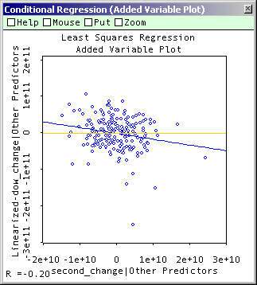
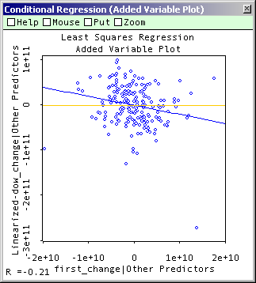

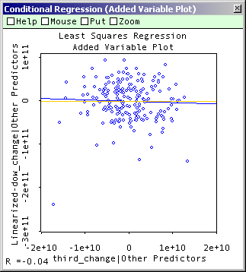
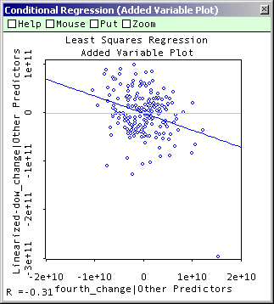
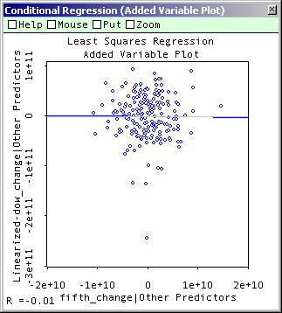
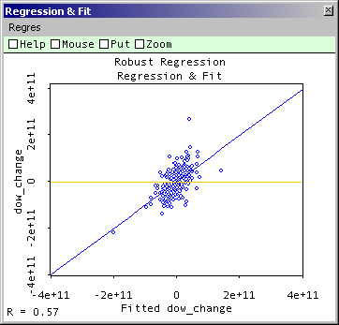

The written report of the data for the third regression is in the appendix. In the report, the following parameter estimates were observed:
PARAMETER ESTIMATES (LEAST SQUARES) WITH TWO-TAILED T-TESTS.
Term............ Estimate Std. Error t-Ratio P-Value
Constant........ 437476762.34 3187316482.45 0.14 0.891
first_change.... -1.99 0.66 -3.02 0.0028
second_change... -1.59 0.57 -2.80 0.0056
third_change.... -0.31 0.57 -0.54 0.5883
fourth_change... -3.49 0.79 -4.45 <.0001
fifth_change.... -0.10 0.84 -0.12 0.906

SUMMARY OF FIT:
R Squared (Total Effect Strength): 0.48
Adjusted R Squared: 0.46
Sigma hat (RMS error): 44845168535.32
Number of cases: 198
Degrees of freedom: 192

ANALYSIS OF VARIANCE: MODEL TEST
Source Sum-of-Squares df Mean-Square
Model 351131633870595430000000.00 5 70226326774119087000000.00
Error 386129115064578800000000.00 1 922011089140961347900000.00
Total 737260748935174230000000.00 197

Signficance Strength
F-Ratio P-Value R-Square
34.92 <.0001 0.48

VIF, Square root of VIF, and Multiple R-squared of Predictor Variables
PREDICTORS VIF SqrtVIF RSquare
first_change 2.221 1.490 0.550
second_change 2.113 1.454 0.527
third_change 1.800 1.341 0.444
fourth_change 1.913 1.383 0.477
fifth_change 1.523 1.234 0.343

Autocorrelation = -4.0113E-2

which produces a regression equation of:
y = 437476762.34 - 1.99(X1) - 1.59(X2) - 0.31(X3) - 3.49(X4) - 0.10(X5)
Each variant was negatively correlated, but variables three and five are not significant because they are below the T-ratio threshold of 1.96, and this also is seen in their p-values.
Are the results really useful for predicting the DOW average?
The observed ρ-values from the results first, second and fifth are significant which leaves doubt that another regression using only these variables may produce a significant negative correlation.
Correlations

OBSERVATIONS 1st 2nd 3rd 4th 5th DOW ch_1st ch_2nd ch_3rd ch_4th ch_5th ch_DOW
1st 1.00 0.70 0.60 0.57 0.47 -0.09 0.77 0.56 0.44 0.46 0.35 -0.61
2nd 0.70 1.00 0.58 0.53 0.47 -0.12 0.47 0.75 0.40 0.39 0.32 -0.62
3rd 0.60 0.58 1.00 0.55 0.48 0.02 0.38 0.41 0.68 0.35 0.29 -0.55
4th 0.57 0.53 0.55 1.00 0.48 -0.07 0.40 0.41 0.41 0.71 0.38 -0.56
5th 0.47 0.47 0.48 0.48 1.00 -0.04 0.31 0.33 0.38 0.37 0.71 -0.49
DOW -0.09 -0.12 0.02 -0.07 -0.04 1.00 -0.12 -0.13 -0.06 -0.12 0.00 0.73
ch_1st 0.77 0.47 0.38 0.40 0.31 -0.12 1.00 0.68 0.57 0.59 0.45 -0.48
ch_2nd 0.56 0.75 0.41 0.41 0.33 -0.13 0.68 1.00 0.57 0.55 0.44 -0.50
ch_3rd 0.44 0.40 0.68 0.41 0.38 -0.06 0.57 0.57 1.00 0.54 0.48 -0.44
ch_4th 0.46 0.39 0.35 0.71 0.37 -0.12 0.59 0.55 0.54 1.00 0.53 -0.48
ch_5th 0.35 0.32 0.29 0.38 0.71 0.00 0.45 0.44 0.48 0.53 1.00 -0.34
ch_DOW -0.61 -0.62 -0.55 -0.56 -0.49 0.73 -0.48 -0.50 -0.44 -0.48 -0.34 1.00

The coefficient of correlation between the variables is not as accurate as regression three. The coefficient of determination (r²) was found to be 0.48, which means that in using today’s change in the top five stocks to predict the change in tomorrow’s Dow average, 48% of any change could be explained.

The project is not going to attempt a prediction using this equation because the data is not as well correlated as regression two.

Regression Four

Since in regression two, a correlation coefficient of –0.71 was found in combining imported data sets, a new regression was calculated which measured the dollar value money flow into the top five aggregate shares today and the corresponding change in the Dow average tomorrow. The report shows:

PARAMETER ESTIMATES
Term.......... Estimate Std. Error t-Ratio P-Value
Constant...... -793383343.85 2798863469.78 -0.28 0.7771
active_five... -2.55 0.15 -16.72 <.0001

R Squared (Total Effect Strength): 0.59
Adjusted R Squared: 0.59
Sigma hat (RMS error): 39370255056.14
Number of cases: 198
Degrees of freedom: 196

ANALYSIS OF VARIANCE: MODEL TEST
Source Sum-of-Squares df Mean-Square
Model 433457420230886440000000.00 1 433457420230886440000000.00
Error 303803328704288060000000.00 1 961550016983185143100000.00
Total 737260748935174500000000.00 197

Signficance Strength
F-Ratio P-Value R-Square
279.65 <.0001 0.59

With a coefficient of determination (r²) at 0.59, showing Y can be explained by X 59% of the time these results look to be the most useful of the project. A graph of the regression line is below:
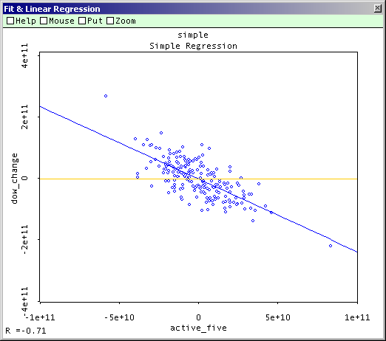

Regression Five

A multivariate regression test of regression four was run. Again each variable showed negative correlation. The results of this test are listed in the appendices.

Conclusion

These results, particularly regression four, suggest that there is a negative correlation between the value of money flows into today’s leading shares and the value of money flows into the DOW average on the next day. They echo papers by Fama (1965) showing a negative correlation effect between changes in securities prices. Efficient markets theory suggests that all information is priced into stocks, so why do DOW averages fall in value the day after leading shares increase? It may be profit taking when the leading five shares are driven up, driving down the overall average the next day. Similarly bargain hunting when the leading five shares fall in price, driving up the average the next day, or similar effects of this nature throughout international markets which cause the effect.
The original hypothesis was: "Tracking the leaders provided strong timing clues for the direction of the market. Trading several stocks in each of the major leading groups also helped confirm when a specific industry group was falling out of favour and reversing, or vice versa, coming into favour. The leaders, in Livermore's mind, were also surrogates for the Dow Jones Averages. When these leading groups faltered, it was a warning signal, and his attention to the overall direction of the market was heightened. The signal occurred when the leaders stopped making new highs and stalled, often reversing direction before the overall market turned."

This empirical work of Livermore, expressed through Le Fèvre (1923) led to an investigation of leading shares and the market average. The overall direction of the market average has not been investigated, nor has the phenomenon of leading shares making new highs been studied. The simpler relationship studied shows that when leading shares fall strongly on one day, the money flows into the market averages tend to rise the next day, and vice versa.
The results show that the work is not dated, even though the original ideas are founded on work done in the 1920’s, because there is a relationship between leading shares and the average. I am left with the question of what is the continuity of the relationship? A further area for research is how the leading shares make turning points. This project has created a direction for research of what happens to the leading shares after they make a strong move in one direction or the other, and how does this relate to the market average.
The results can be used as a short-term indicator, or possibly a basis for a position trading strategy. When a strong move by the leading five is perceived, it may be time to short the averages, or at least be ready for a turning point. One possible trading strategy may be to enter the market after a strong move in the leading five by taking an opposite position on the market average, and remain in the market until the software registers another strong move by the leading five in the opposite direction. Of course in using this strategy market uncertainty must be minimised by remaining aware of fundamental, technical, global socio-political and economic conditions, individual experience, market psychology and measures for risk control, as discussed in the introduction.
The results of the indicator may give entry and exit points over a matter of days or even weeks. Further study must be made on the continuity of the readings. This could be done by prototyping the results over time and assessing whether the regression equation still accurately predicts the market average. For example, when a strong negative money flow occurs for the active five, paper trade the DOW average. Use the software to assess money flows for each subsequent day and see if the market continues upward until a strong positive active five money flow occurs, at which time heighten attention to the direction of the market average. It may be time to take measures to protect your investment.
If the aim of the project was to develop a software program that monitors the state of the most active five Dow components, with a view to heightening attention to turning points in the overall averages, several goals have been accomplished. Firstly, the software developed can now be targeted towards the relationship found by regression four. Much of the software is now redundant. For instance there is no need to plot changes in the active five as the project has shown where the software development efforts must be focussed. This is the largest individual software project I have undergone, and that statistical techniques like regression can help target software development is interesting. Of course, at the beginning all the software had to be written because all the data was needed to test if relationships could be shown to exist.
This was also the first ever regression testing I have done. It was interesting to watch correlations between the response variable and sets of predictor variables until the best-correlated relationship was discovered. With each study of regression techniques it became easier and easier to conjecture on possible relationships, then source the data and run the software to see if any relationship was accurate. With the data and the Vista software it is now easy for me to run multivariate regression tests and instantly see coefficients and significances so a large amount of variable testing could be done. It would be interesting to use economic reports as variables, such as those discussed in the introduction.

Regarding the software development, to see the data turned into information on money flows into and out of the leading issues each day was staggering. It was easier than expected to find the necessary data and convert it to SQL tables. Having had experience in Microsoft Visual Studio I found the newer .Net functionality had achieved Microsoft’s objectives of providing a better development platform. Indeed with knowledge of C, C++ and Java, C# was comparatively easy to master for this project’s functionality, but only because of the extensive and well designed help texts and the easy way C# programs implement the .Net base classes. The user interface is clear and simple to understand. The most enjoyable feature was the excellent debugging technologies that Microsoft Visual Studio offers. It was invaluable when formulating dynamic SQL SELECT and UPDATE statements from arrays of C# objects containing the calculation data. However, there was a dearth of examples for some of the more complex computations involving localisation, database type casting and declaring multi-dimensional arrays, which must be implemented in the next edition.

Reflections

After finding the results of regression four quite surprising, I had to go and check the C# program to double check that I had not confused today’s data with yesterday’s data and so produced a negative result when I ought to have produced a positive result. The program for historical data, which was used by the regression software, does the following:
Gets all the data for the day.
Adds it to the hist_shares database.
Calculates the top-five money flow for the day.
Calculates the Dow money flow for the day.
Adds these flows, both for the same day, to the regression_table.
So there is no change of dates when the data is collected.
I then exported the data to Excel and deleted the first days data (1 day) from the Dow column and moved up the remaining data 1 row so I would result with a row for today’s top five figures and tomorrow’s Dow figures... this was used for the regression.

For example:
Active_five dow_average change_top_five change_dow date
-17736558000 –37311090000 3536000 16104769000 02/07/2002
20217531000 44203481000 37954089000 81514571000 03/07/2002
33088800000 69408724000 12871269000 25205243000 05/07/2002
-16204700000 -26348057000 -49293500000 –95756781000 08/07/2002
-18516341000 –55566861000 –2311641000 –29218804000 09/07/2002

moves to:
Active_five dow_average change_top_five change_dow
-17736558000 44203481000 3536000 81514571000
20217531000 69408724000 37954089000 25205243000
33088800000 -26348057000 12871269000 -95756781000
-16204700000 -55566861000 -49293500000 -29218804000

for today’s top five and tomorrows Dow change in the same row. So I concluded my data was correct.
In the early stages of the project it became clear that more background information was needed on why I chose to write the program I did so I enlarged the introduction considerably. It provoked interesting questions about the nature of organisations and the nature of finance and economics, but although it was clear to me why I chose this direction, it was not to others. If I had more time, I would read more literature and talk to professionals. I would also compare development methodologies and their claims more intensively by further developing programs using several different methodologies and investigating the differences in performance of all stages in the methodology. I had hoped to produce Visio data flow diagrams, logical data structures and other visual programming aids. There was not time to complete this.
On collecting the data it was difficult to arrange to collect the data from leading provider Bloomberg, who were uncooperative and difficult to communicate with on this topic. In the end, Yahoo Finance provided ample data after only a few mouse clicks. The NYSE website also provided clear and easily accessible analytical data on the subject.
I had to learn a number of new technologies to achieve execution of the programs C#, the .Net object library, ADO.Net datasets and connections were some of these. I found it easy to handle the data, but it brought up an interesting problem. How do you organise the data in professional trading systems when it will soon be 1000000+ rows? For this project, we get 30 rows per day, so only about 7800 rows per working year.
Many design decisions were made on the fly on how to populate database tables. It was especially difficult to find a consistent Date type between the Visual Studio .Net program, the NYSE website, the historical data and SQL Server tables. In the end, I opted to use dates as String types because I could easily manipulate the constituent parts using C# String functions. The DateTime functionality in C# offered the useful tool of adding 1 day to a date or taking away 1 day from a date, so that the “yesterday” and “today” data could be manipulated. I converted DateTime types into strings and vice versa. Eventually using a 10 length nvarchar type in SQL Server allowed easy access by date to and from the database.
Numbers were set up in the database as type float to allow C# casting from object[] to double types in order to calculate the money flows for each security. After the consistent approach was found by mainly trial and error, no further problems occurred in interfacing numbers between the database and the calculation program.
The two dimensional object arrays out of bounds errors only came as runtime errors, which was easy to solve during the testing period of writing the program.
I decided to try and keep class sizes down to five/six methods but also to use a modular approach where related methods appeared in the same class. Hence the use of classes like db_in and db_out for the database in and out functionality.
It would be useful to create a "working day" enumeration containing all the working days of the year, however, problems with holidays and weekends are solved using the web based scheduler, which only fires the program on a working day. I still find this messy, especially since if the computer is not running for a day, that day’s data is lost. However, for the investor, when prompted to investigate position trading opportunities, he could turn the program on only when involved in a position.
Missing rows from the historical data caused problems which were resolved by using more extensive validation for the data arrays. In the end the program executed correctly only with checks to see if the first and last elements of arrays were populated.
The exception handling is very basic for the database input and output. If access to the database is compromised, then the program will not run for the day. Any exceptions are rolled back, so partial data in the tables is avoided.
The NameSpaces functionality in visual studio .Net was very useful for the multiple projects.
I was very pleased with the results, and that they echoed the results of others. I think a great thing about this system is it focuses on only a few, market-leading stocks, not thousands and thousands of issues so it is easy to avoid information overload.

References

Fisher A.F (1958), Common Stocks and Uncommon Profits, Harper & Brothers.
Slater J (1994), The Zulu Principle, Orion Business, London.
Slater J (1996), Beyond the Zulu Principle, Orion Business, London.
Le Fèvre (1924), Reminiscences of a Stock Operator, Wiley, NY.
Smitten (2001), Jesse Livermore World’s Greatest Stock Trader, Wiley, NY.
Brealey & Myers (2000), Principles of Corporate Finance, Irwin McGraw-Hill.
Lowenstein R (2002), When Genius Failed: The Rise and Fall of Long-Term Capital Management, Harper Collins
Bartiromo, M (2002), Use The News, Harper Collins

Fama, E. (1965), The behaviour of stock market prices, Journal of Business

Bibliography

Financial Times Handbook of Management, Stuart Crainer (Editor);
SSADM a practical approach
Programming pearls
Avisson and Fitzgerald information systems
Using economic indicators to improve investment analysis (E. M. Tainer)
Liars Poker
CDM lecture notes by Steve Counsell.
http://www.dowjones.com
http://investor.stockpoint.com
http://mam.econoday.com
http://www.trading-glossary.com/links/technicalanalysis.asp
http://www.stock-charts-analysis.com/
http://www2.barchart.com/vleaders.asp
Code Complete: A Practical Handbook of Software Construction
by Steve C. McConnell;
Getting Started in Technical Analysis (Getting Started)
by Jack D. Schwager, Mark Etzkorn;
How Charts Can Help You in the Stock Market
The Affluent Society J. K Galbraith (Penguin Business)
The Worldly Philosophers R. L. Heilbroner (Penguin Business)
One Up on Wall Street: How to Use What You Already Know to Make Money in the Market by Peter Lynch, John Rothchild;
Market Wizards: Interviews with Top Traders by Jack D. Schwager;
The New Market Wizards by Jack D. Schwager;
How to Make Money in Stocks: A Winning System in Good Times or Bad by William J. O'Neil;
It Was a Very Good Year: Extraordinary Moments in Stock Market History by Martin S. Fridson;
Valuing Wall Street: Protecting Wealth in Turbulent Markets by Andrew Smithers, Stephen Wright;
Devil Take The Hindmost: A History of Financial Speculation by Edward Chancellor;
The Battle for Investment Survival (Wiley Investment Classic) by Gerald M. Loeb;

Appendices

Please see http://www.webstersystems.co.uk/project.htm for appendices. They are put here because they can be properly organised and linked together in an online system. They comprise C# programs, SQL Server database tables, Visual Studio screenshots, Charts, plots, results and source data for all the regression tests. Listing them all here would be very cumbersome and I hope this solution will be acceptable.

