**INTRODUCTION**

**Overview:-**

**1**. Existing System:-

Currently, the retail bookshop owners have to separately visit or call the respective book publisher for placing order. The whole book purchasing record and book details are stored manually for future use. Retailer does not get all required information about the book while purchasing the book. If any new book is available at the publisher the retailer has to ask publisher for updates. The record is maintained having information regarding the book and book publishers which helps to identify book publisher while placing order next time. This all manual, paperwork complicates the work of a retailer. Hence an automated system is needed which can simplify the task of retailers and publishers.

**2**. Need of the System:-

In order to bring all publishers and retailers under one hood from where they can do their business efficiently and gain more profit. Providing all required details regarding book to the retailers while placing order. Place order to multiple publisher through one portal. Get a categorized view of the books, books sorted as per book publishers. Reduce the task of maintaining records of transactions, book-publisher relations and book details.

**3.** Overview of the Project:

The goal of this project is to design an online bookstore named BookShop.com that sells books from different publishers. The book inventories are stored in SQL database. Customers can access the bookstore web site through the World Wide Web. Customers will be able to search the database to find the books they want, and place the order to buy the book.

It is the graphical user interface. It has a form for user to input query information to search the database. The users interface then pass the input to the control function, which is implemented in PHP. The control function is designed to process the input from the users interface, generate the searching query and then gets data from the database and returns to the users interface. This project reduces the paperwork for retailers and publishers and provides a simple user interface for running business.

The basic functionalities provided by the website are:

* Register publisher.
* Register retailers.
* Search the book by title, category and publisher name
* Get the information regarding book.
* Place order for the required books.
* Maintain order details.

**Requirements:-**

1. Hardware requirements : A system with following Configuration:

Ram 2GB and above.

Secondary memory 10GB and above.

1. Software requirements : Windows Operating system xp/7 and above.

Wamp Server.

**System development lifecycle**

**Feasibility study:**

Feasibility study is made to see whether the project on completion will serve the purpose of the organization for the amount of work, effort and the time that spend on it or not. The document provides the feasibility of the project that is being designed and lists various areas that were considered very carefully during the feasibility study of this project such as Technical, Operational, Time, Economical feasibilities.

1. Technical Feasibility:

Technical feasibility is made to study that whether the proposed system is technically feasible or not. This rose following technical issues during investigation:

* Does the existing technology sufficient for the proposed system?
* Can the system expand if it developed?

After technical feasibility study, we found that the system is technically feasible and project can be done .The project can be developed using HTML, JavaScript, Php, SQL Database in combination.

1. Operational Feasibility:

It is a measure of how well a proposed system solves the problems, and takes advantages of the opportunities identified during scope definition and how it satisfies the requirements identified in requirement analysis phase of the system development.

Our proposed system can provide lots of benefits to satisfy the requirements of the user. Proposed system is able to satisfy most of the requirements specified by user. Hence, we found that our system is feasible according to operational aspect.

1. Economic Feasibility:

The developing system must be justified by cost and benefit. Criteria to ensure that is concentrated on project, which will give best return at the earliest. One of the factors which affect the development of the new system is cost. The following are the some important financial questions asked during preliminary investigation.

* Cost of required hardware and software
* Cost of installment
* Cost of maintenance
* Benefits against cost spent

Since the system will be developed as part of project work, there is no manual cost required to be spend on it. All resources are also available already. Also this software doesn’t require any expensive hardware. In order to deploy the service a domain name is to be purchased. Hence after the economic feasibility of the proposed system, we found that the system is economically feasible.

1. Time Feasibility:

It is a measure of how much will be required in order to complete the project. It’s a very imported aspect that is to be considered while initializing project.

* The cost of project is depended on it.
* The total time required will help to set priorities
* Working according to timely goals will improve development and deployment.

**Data Dictionary:**

Admin Table:

|  |  |  |  |
| --- | --- | --- | --- |
| **Field Name** | **Description** | **Data Type** | **Constraint** |
| A_Name | Admin Name | Varchar(50) | Primary key |
| Password | Admin Password | Varchar(50) | Not Null |

Publisher Table:

|  |  |  |  |
| --- | --- | --- | --- |
| **Field Name** | **Description** | **Data Type** | **Constraint** |
| P_Id | Publisher Id | Integer | Primary key |
| Firm_Name | Publisher Firm Name | Varchar(50) | Not Null |
| P_Name | Publisher Name | Varchar(50) | Not Null |
| P_User | Publisher Username | Varchar(50) | Not Null |
| P_Pass | Publisher Password | Varchar(50) | Not Null |
| P_Email | Publisher Email | Varchar(50) | Not Null |
| P_Contact | Publisher Mobile_no | Number(10) | Not Null |
| P_Address | Publisher Address | Varchar(50) | Not Null |

Retailer Table:

|  |  |  |  |
| --- | --- | --- | --- |
| **Field Name** | **Description** | **Data Type** | **Constraint** |
| R_Id | Retailer Id | Integer | Primary key |
| Firm_Name | Retailer Firm Name | Varchar(50) | Not Null |
| R_Name | Retailer Name | Varchar(50) | Not Null |
| R_User | Retailer Username | Varchar(50) | Not Null |
| R_Pass | Retailer Password | Varchar(50) | Not Null |
| R_Email | Retailer Email | Varchar(50) | Not Null |
| R_Contact | Retailer Mobile_no | Number(10) | Not Null |
| R_Address | Retailer Address | Varchar(50) | Not Null |

Book Table:

|  |  |  |  |
| --- | --- | --- | --- |
| **Field Name** | **Description** | **Data Type** | **Constraint** |
| B_Id | Book Id | Integer | Primary key |
| B_Name | Book Name | Varchar(50) | Not Null |
| B_Category | Book Category | Varchar(50) | Not Null |
| B_Description | Book Description | Varchar(50) | Not Null |
| B_Author | Book Author | Varchar(50) | Not Null |
| B_Publisher | Book Publisher | Varchar(50) | Not Null |
| B_Page | Book Page | Integer | Not Null |
| B_Price | Book Price | Integer | Not Null |
| B_Img | Book Image | Varchar(50) | Not Null |
| B_Pdf | Book Pdf | Varchar(50) | Not Null |

Category Table:

|  |  |  |  |
| --- | --- | --- | --- |
| **Field Name** | **Description** | **Data Type** | **Constraint** |
| C_Id | Category Id | Integer | Primary key |
| C_Name | Category Name | Varchar(50) | Not Null |
| Subcat | SubCategory | Varchar(50) | Not Null |

Order Table:

|  |  |  |  |
| --- | --- | --- | --- |
| **Field Name** | **Description** | **Data Type** | **Constraint** |
| O_no | Order Number | Integer | Primary key |
| O_date | Order date | Date | Not Null |
| I_Name | Item Name | Varchar(50) | Not Null |
| P_Name | Publisher Name | Varchar(50) | Not Null |
| R_Name | Retailer Name | Varchar(50) | Not Null |
| Quantity | Quantity of item | Number(10) | Not Null |
| Total | Total | Integer | Not Null |

Shipping Table:

|  |  |  |  |
| --- | --- | --- | --- |
| **Field Name** | **Description** | **Data Type** | **Constraint** |
| S_id | Shipping Id | Integer | Primary key |
| S_Name | Receiver Name | Varchar(50) | Not Null |
| Address | Address of receiver | Number(10) | Not Null |
| S_Contact | Receiver Mobile_no | Number(10) | Not Null |

**Diagrams**

**Entity Relationship Diagram:-**

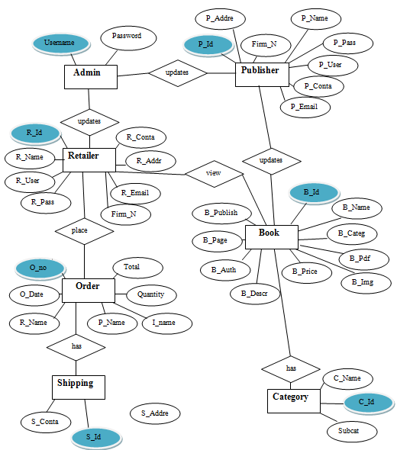

**UML Diagrams:**

Class Diagram:



Use case Diagram:



Sequence Diagram:



Collaboration Diagram:

**:Inventory / Database**

2.3: [order_complete]

Update_inventory

* 1. :Search()

1.3: add_to_cart()

2.1: get_books()

**:Shopping cart**

2.2: make_order()

**:Order**

2: checkout()

1.2: (interested)   
View_book()

1: find_bookshop()

**:Book**

**:Online Bookshop**

Deployment Diagram:

Home Page

Search

Form

Payment   
Form

Ordering

Form

Login  
Form

Updation

Form

Registration

Form

**Output Screens:**

**HOME PAGE**

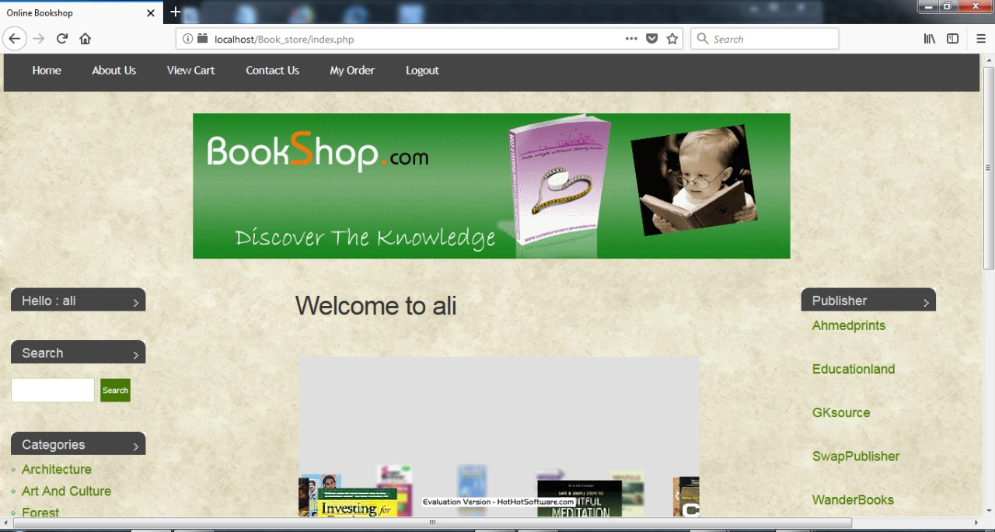

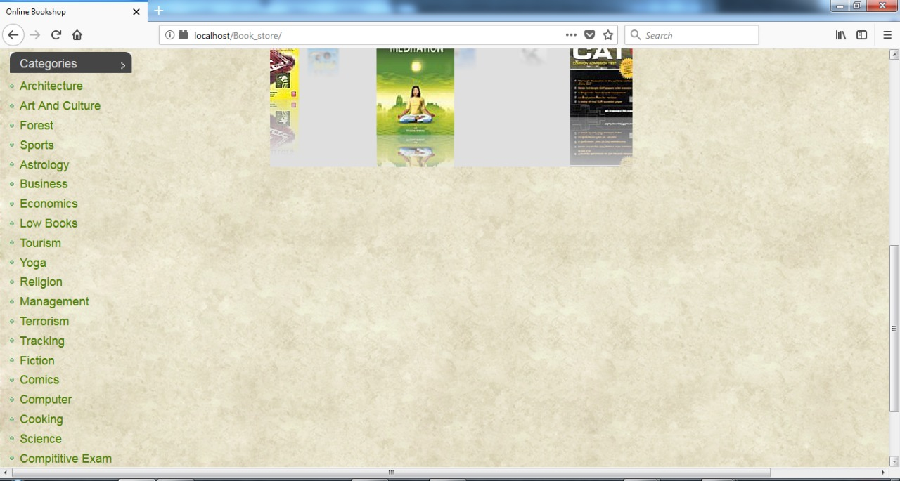

**Retailer Book Search View**

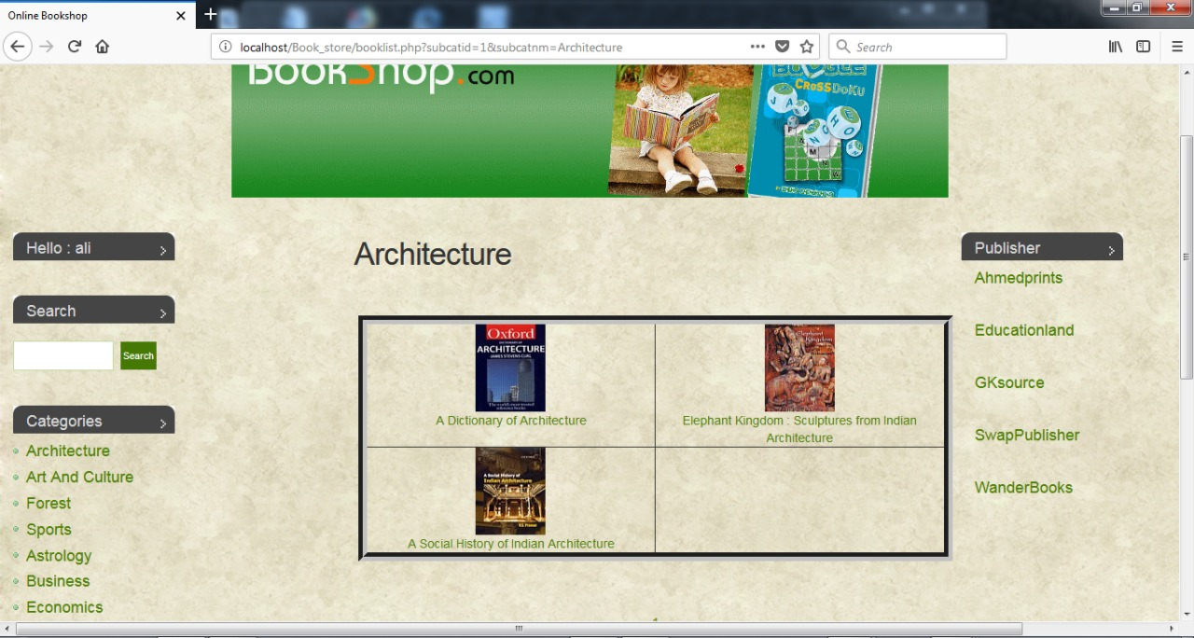

**Book Detail:**

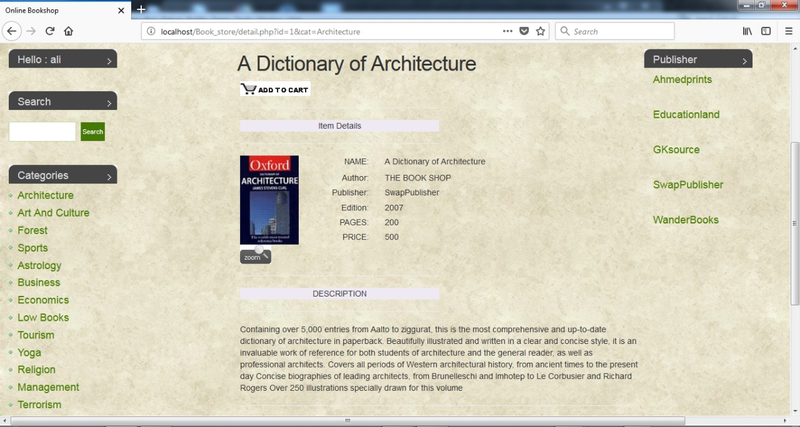

**Shipping Detail:**

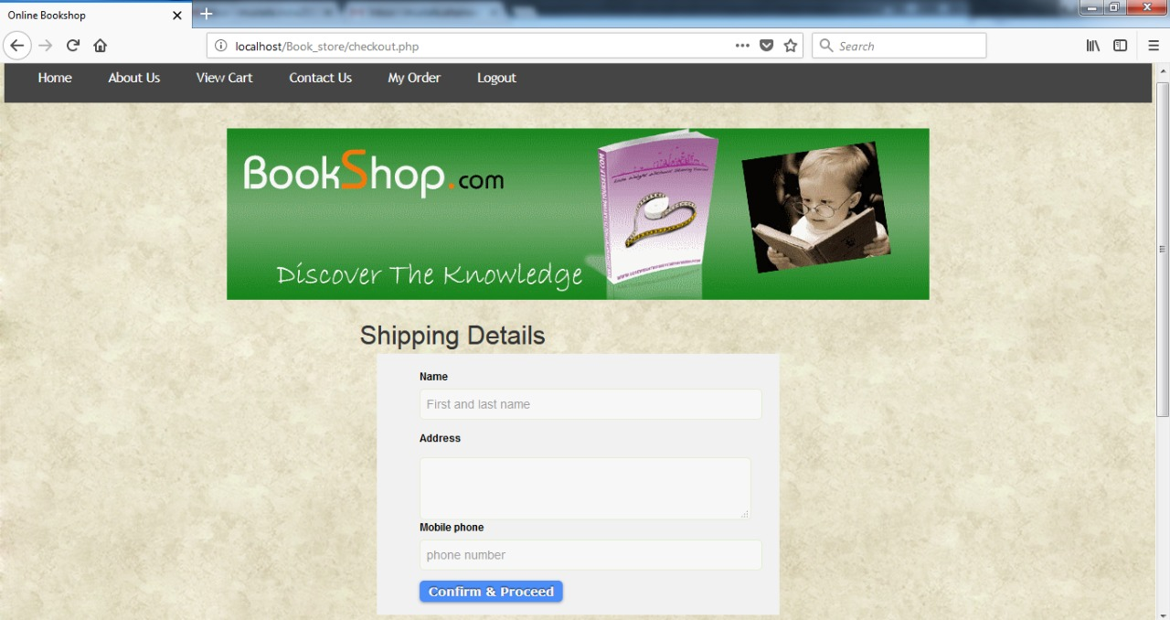

**Admin Side:**

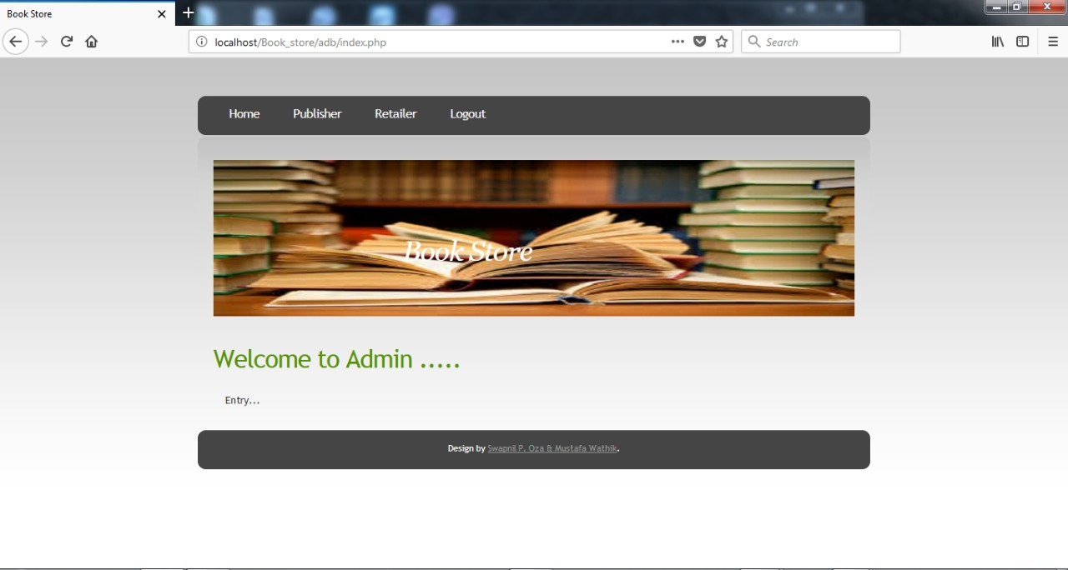

**Retailer Registration:**

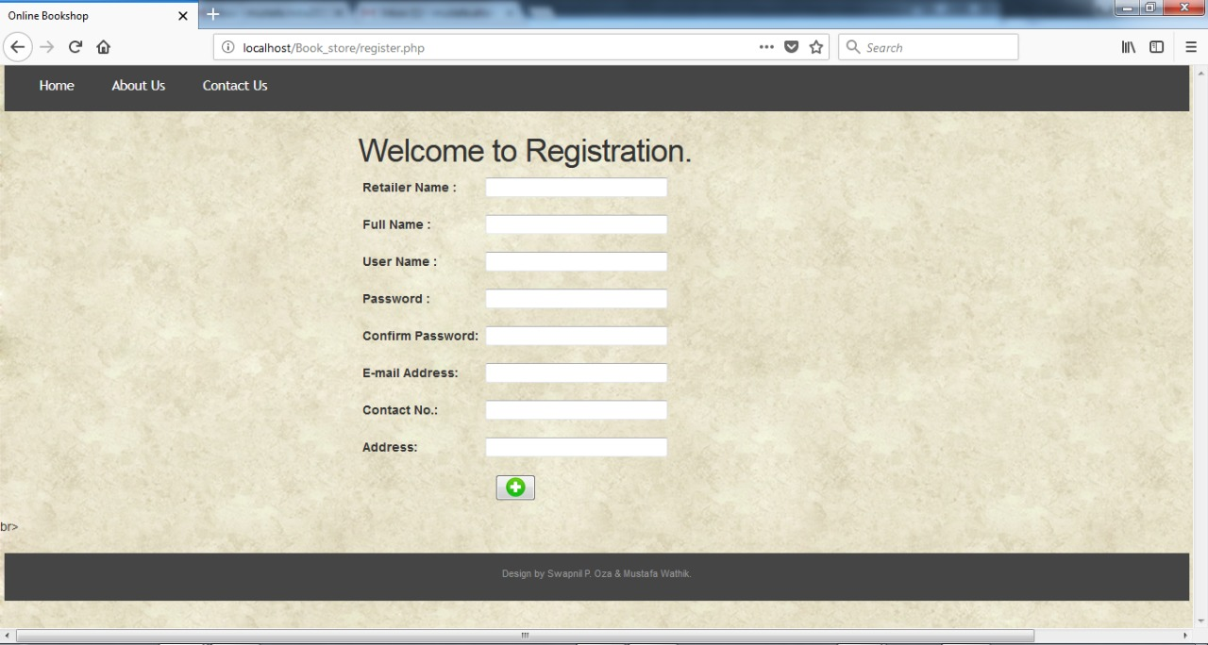

**Publisher Registration:**

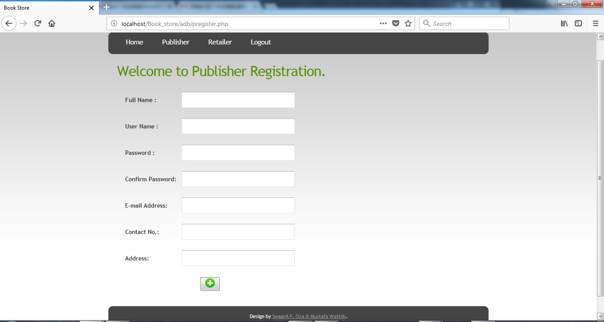

**Update Retailer:** 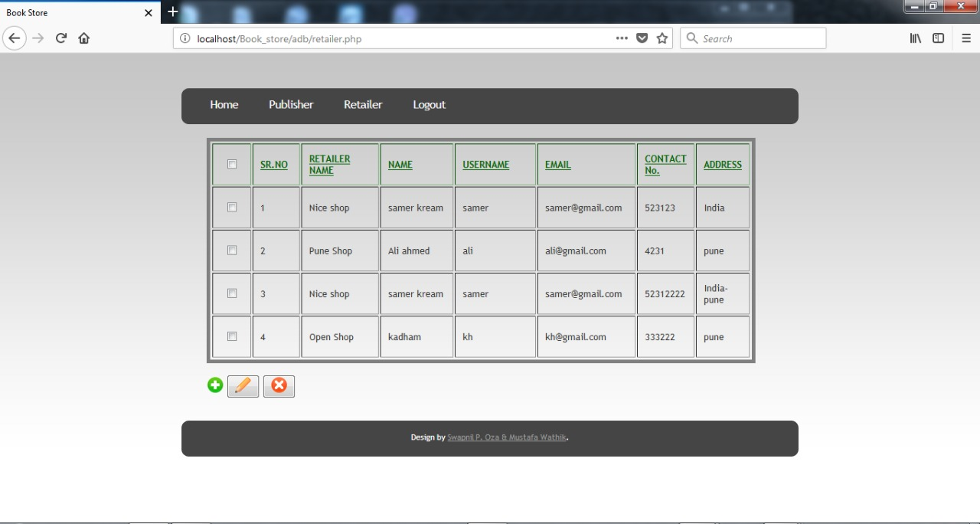

**Update Publisher:**

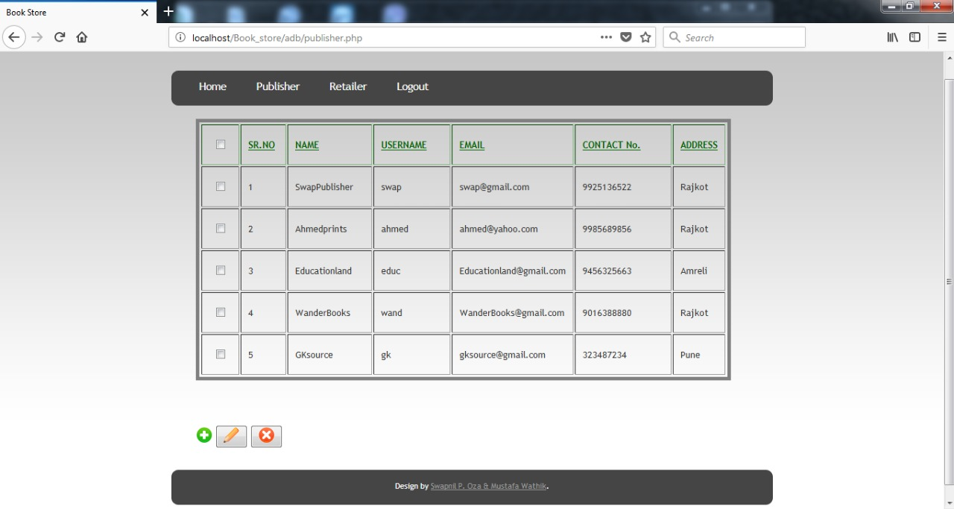

**Publisher Side:**



**Add Category:**

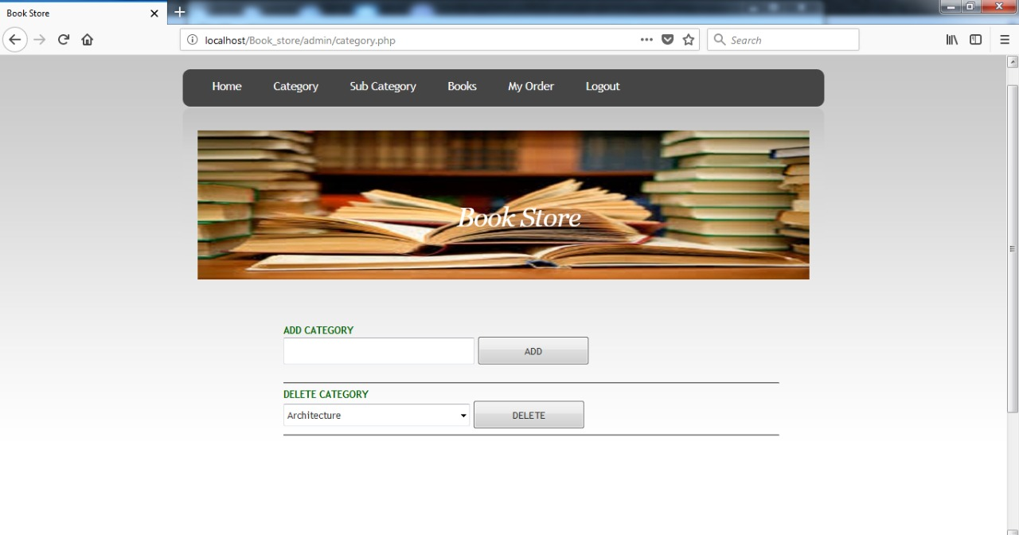

**Add/Delete Book:**

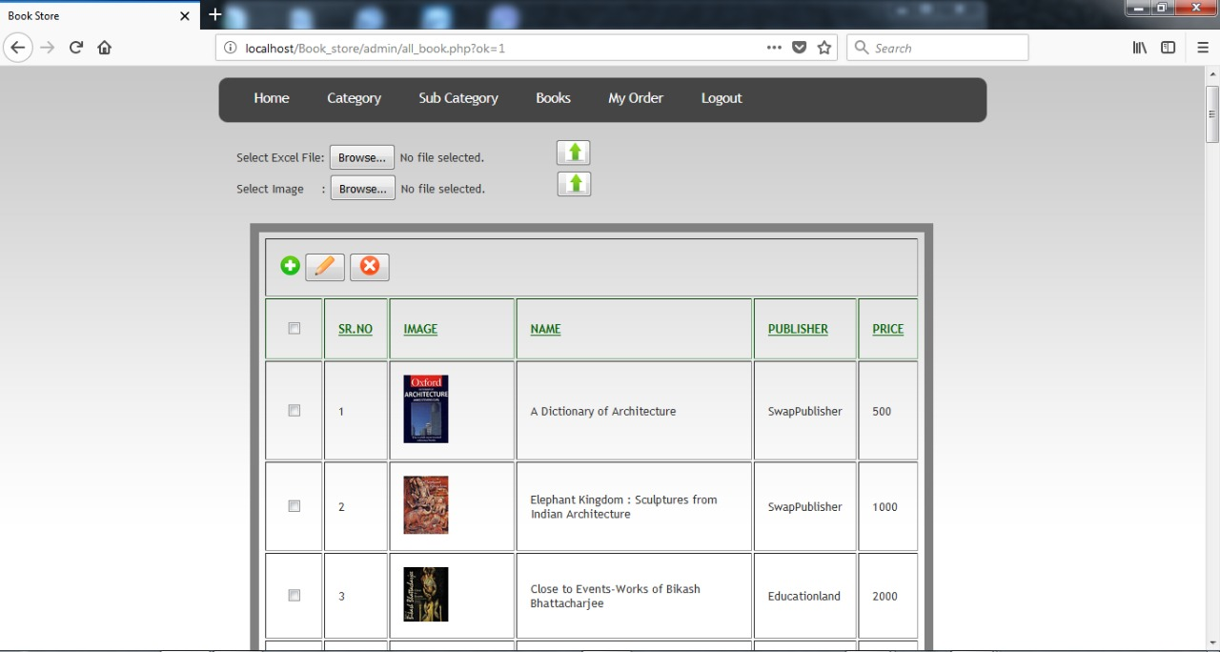

**Update Book:**

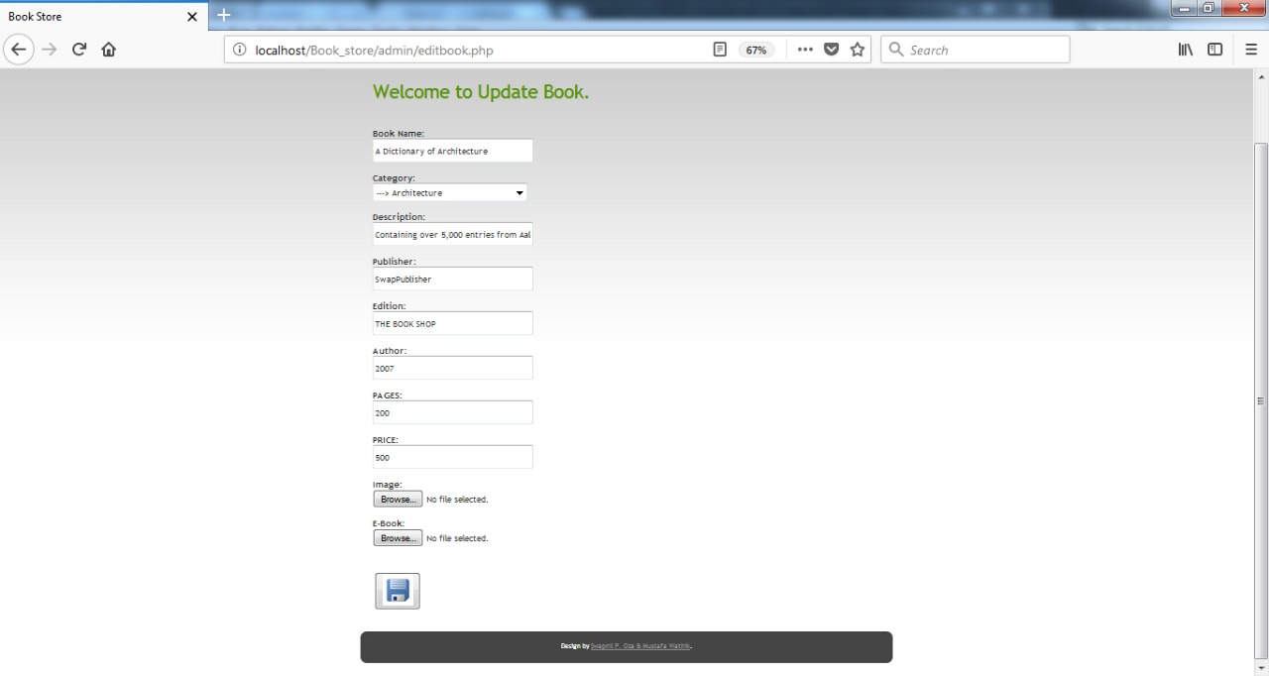

**View order:**

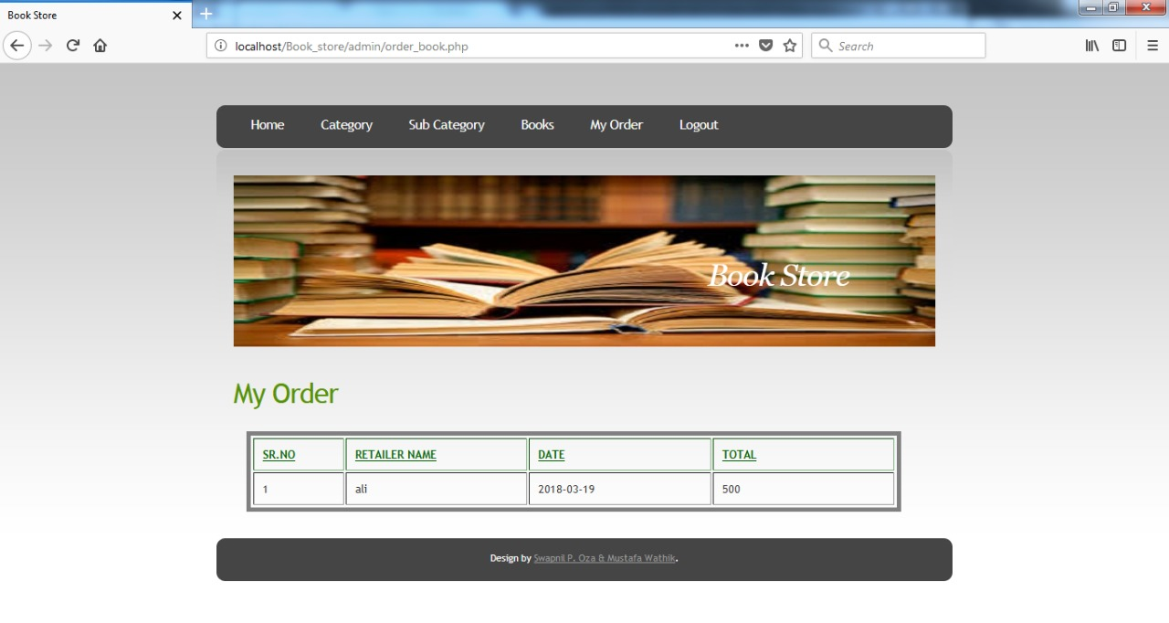

**Add Subcategory:**

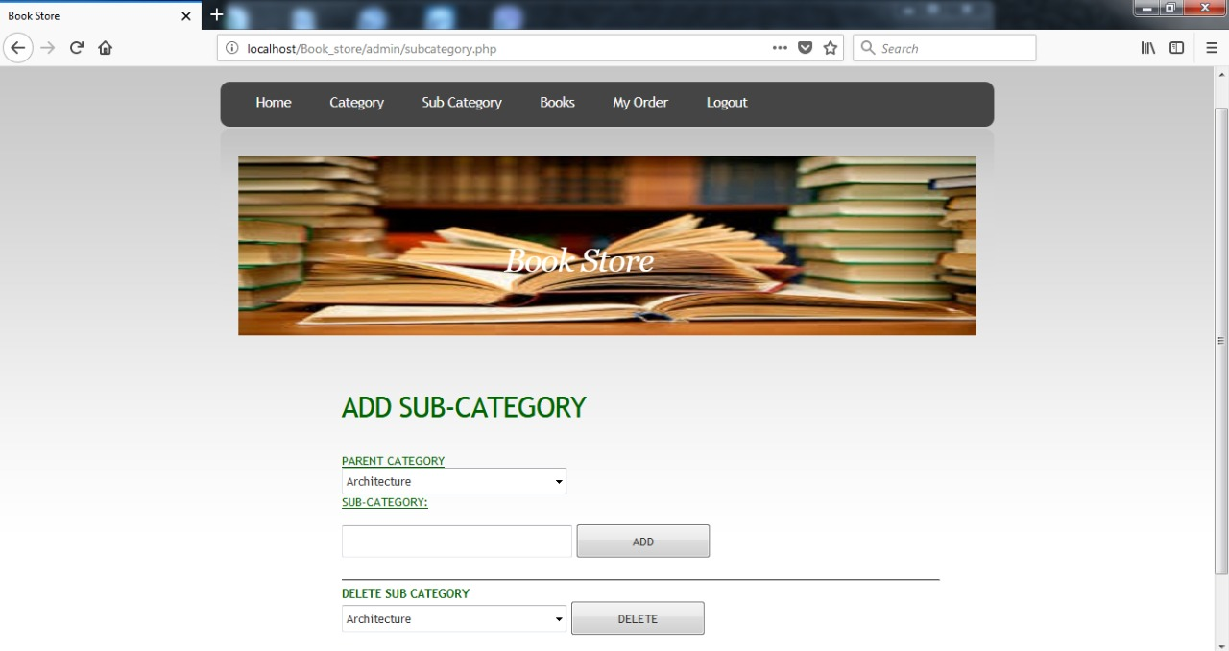

**About us:**

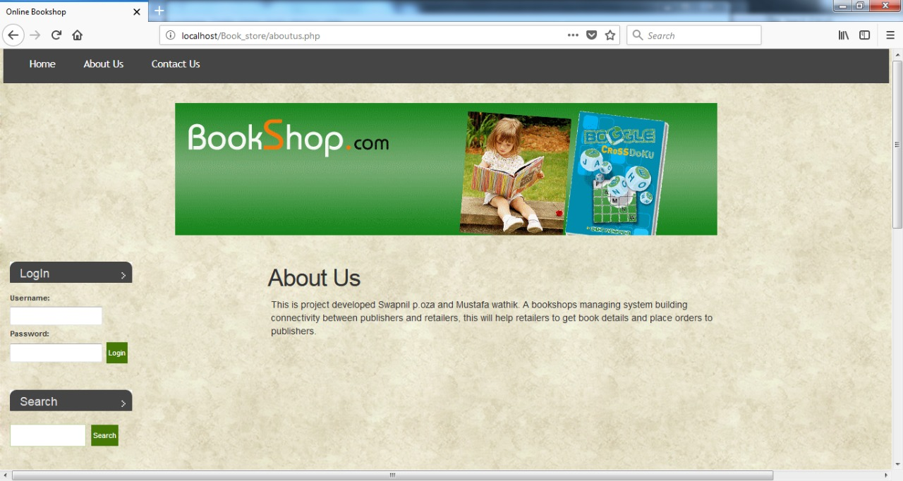

**Contact:**

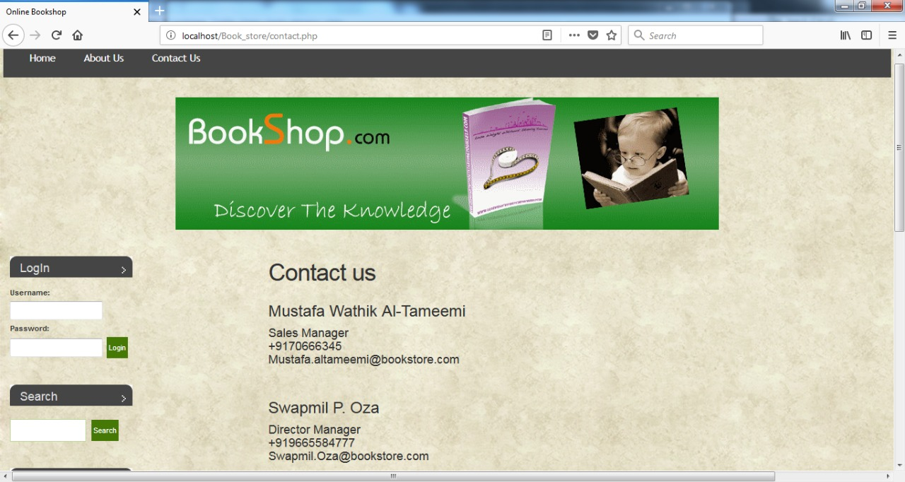

**Testing:**

* The system runs smoothly and handles varying inputs.
* Authentication of user is working accurately.

Hence, System has successfully cleared tests queries.

Importance of testing:

* Software testing is really required to point out the [defects](http://istqbexamcertification.com/what-is-defect-or-bugs-or-faults-in-software-testing/)and errors that were made during the [developmentphases](http://istqbexamcertification.com/what-are-the-software-development-life-cycle-sdlc-phases/).
* It’s essential since it makes sure of the Customer’s reliability and their satisfaction in the application.
* It is very important to ensure the Quality of the product.  Quality product delivered to the customers helps in gaining their confidence.
* Testing is necessary in order to provide the facilities to the customers like the delivery of high quality product or software application which requires lower maintenance cost and hence results into more accurate, consistent and reliable results.
* Testing is required for an effective performance of software application or product.
* It’s important to ensure that the application should not result into any [failures](http://istqbexamcertification.com/what-is-a-failure-in-software-testing/)because it can be very expensive in the future or in the later stages of the development.

**Future Enhancement and Conclusion:**

* Payment gateway to be added to the system.
* Deploy database to cloud.

**Bibliography**:

* “Javascript for php developers”

Writer:-Luke Welling

* “Web Development Dummies”

Writer:-Steve Suehring

[www.W3schools.com](http://www.W3schools.com)

[www.quora.com](http://www.quora.com)

[www.stackoverflow.com](http://www.stackoverflow.com)

[www.ppoint.com](http://www.ppoint.com)