Advanced Algorithm 41052 – Assignment 1
Phouvanai Inthavongsa
Student ID: 14679361
Phouvanai.Inthavongsa@student.uts.edu.au

The GitHub repository of this project is as the link below (take a read on “What I have built” first):
https://github.com/rurifu/Karatsuba-algorithm-Assignment-1-41052

Karatsuba’s Algorithm – Track A: Implementation and Empirical Study
What I have built
For this assignment, I have implemented two algorithms to compare one to another:
- Karatsuba algorithm, a recursive algorithm that reduces the multiplication of two n-digit numbers to three sub-multiplications of n/2 numbers (The star of this report).
- Schoolbook algorithm, an algorithm that mimics the step-by-step multiplication, then addition, which is mostly taught and well understood by everyone in primary school.
The heart of the code is built on the language C++; visualisation of graph is done by using matplotlib and NumPy in Python.
Key Design
- Within one of the C++ files (bignum.hpp), I have created a struct “BigInt”, a vector of uint32_t that stores huge number as a list of small chunks (“limbs”), each chunk holding up to 9 decimal digits, because no single variable can hold a number with thousands of digits. This design is deliberate as it allows for easy reading on each number units, and it allows for simple string concatenation if BigInt needs to be printed (Though this is mainly used for debugging purposes, not used by the automated code itself). One big constraint with BigInt is that it only supports non-negative integers and only the operations Karatsuba needs. It’s not a general-purpose bignum.

- The cutoff parameter is a parameter that is passed onto Karatsuba Algorithm to control when the recursion should stop splitting the number further and calls the schoolbook algorithm to directly finish the multiplication. One important thing to note is that the integer in the cutoff parameter does not indicate the number of decimal digits in a particular number, but the number of limbs. For example: If the cutoff number is 16, it doesn’t mean “stop recursing once we’re down 16 digits” but “stop recursing once we’re down 16 limbs”, which is roughly about 144 decimal digits.

- The base case design for the recursive Karatsuba Algorithm uses OR operation, not AND (a.size() <= cutoff || b.size() <= cutoff), which helps in the case of small integer multiplied with big integer, as it allows for the algorithm to fall back directly to schoolbook algorithm once the small operand is below the cutoff point.

Code Navigation
Within the repository lies six main codes, which are amalgamated and run together to achieve the CSV file presented in the results folder. Those five codes are:
- Bignum.hpp – As mentioned above, this file is used for the big number representation, connected by contiguous unit of numbers as one big number.
- MultiplyingAlgorithm.cpp/.hpp – This file is where schoolbook algorithm and Karatsuba algorithm lies. The header file is used to instantiate and include the .cpp file, which is used to connect them to CorrectnessTest.cpp and BenchmarkHarness.cpp.
- CorrectnessTest.cpp – This file is used to check whether school algorithm and Karatsuba algorithm produces the same result, to debug and see if there’s anything wrong with the algorithm.
- BenchmarkHarness.cpp – The ultimate file that utilises the previous C++ files (excluding CorrectnessTest.cpp) to record the time-complexity of schoolbook and Karatsuba algorithm, measured in nanosecond, which is then recorded in benchmark.csv file (However, you would see two versions of it in the result file, which will be explained later on in “Result Analysis” section). This file is starkly different from CorrectnessTest.cpp as it is the that generates the data for the whole project and implements it into a CSV, whereas CorrectnessTest.cpp is only used to check if the algorithm itself works or not.
- PlottingResult.py – The only python file in the list is used to create the visualisation that will be shown below in the “The Empirical Study on Karatsuba Algorithm” section. It mainly uses matplotlib and NumPy to gather data from the CSV and generate the graphic.

The Empirical Study on Karatsuba Algorithm
The big question in this study is “Where’s the actual crossover point between the two algorithms?” or “Where does Karatsuba, with a given cutoff point, starts beating schoolbook Algorithm?” and as such, I have compared the two multiplication algorithms for large random integers: schoolbook multiplication, which is known to be O(n²) time complexity, and Karatsuba multiplication, with O(n^{log}₂³), approximately O(n^{1.585}) time complexity. Since both use BigInt representation, the performance should reflect the actual algorithm itself rather than the differences in data handling.

The digit size that I gave for the test ranges from 8 digits all the way up to 65, 536 digits, which the operand size accounts for 14 digit counts (8, 16, 32, 64, 128, 256, 512, 1024, 2048, 4096, 8192, 16384, 32768, 65536). This range of numbers is used to capture behaviour across several orders of magnitude of number in a log-log scale.

Since the recursive Karatsuba’s algorithm base case falls back to schoolbook below a certain configurable limb-count, I did not treat Karatsuba algorithm as a standalone algorithm, but to also work with the schoolwork algorithm with the usage of cutoff parameter. I tested between six different cutoff values (1, 4, 8, 16, 32, and 64 limbs) because the crossover points at which Karatsuba overtakes schoolbook algorithm is not fixed; it depends entirely on where the recursion stops (the cutoff point). And thus, a poorly chosen cutoff (e.g. recursing all the way down to single-limb base case) pushes the recursion and allocation overhead, which could completely overwrite the time saved from fewer multiplications at that depth and eliminates the advantage that Karatsuba has over schoolbook algorithm. Sweeping cutoff alongside digit size not just helps to show that Karatsuba wins, but to also show where it wins due to how it’s tuned.

My hypothesis, forming from looking at the theoretical time complexity of both algorithms, led me to expect that the best-performing Karatsuba algorithm will outperform schoolbook once operand size exceeded around 512 digits upward as it seems like a good turning point for the algorithm. Another thing I am expecting is that the cutoff value of 1 would perform the worst due to recursion overhead compounding as the breaks down to trivial multiplication. And lastly, I am expecting is that each algorithm should approach their own said time complexity; 1.585 for Karatsuba, and 2.0 for schoolbook.
Methodology
For each (digit size, trial) pair, I generated two random operands using randomBigInt (located in bignum.hpp), supported by std::mt19937_64 generator seed, which means that the exact same input pairs will be reused across every algorithm/cutoff combination at a given size. I ran 5 trials per digit size at first, then 20 trials to average out measurement noises.

For the timing, I used std::chronos::steady_clock, recording elapsed time (from when the library was created!) in nanoseconds around each individual multiplication call. All final measurements were taken from the Release build. The debug build exists but it also includes unoptimized code and extra runtime that is used to check the program, making the resulting numbers bloated and meaningless for studying the algorithms’ actual scaling behaviour.

After executing BenchmarkHarness.cpp, each measurement is then written as one row to a CSV file with 5 features (algorithm, cutoff, digits, trial, time_ns). This CSV is essentially the bridge between the C++ measurement code and the Python code analysis. PlottingResult.py reads the CSV file independently to produce the runtime comparison plot and the log-log exponent graph fits, with no direct connection to the C++ files themselves.

Result Analysis
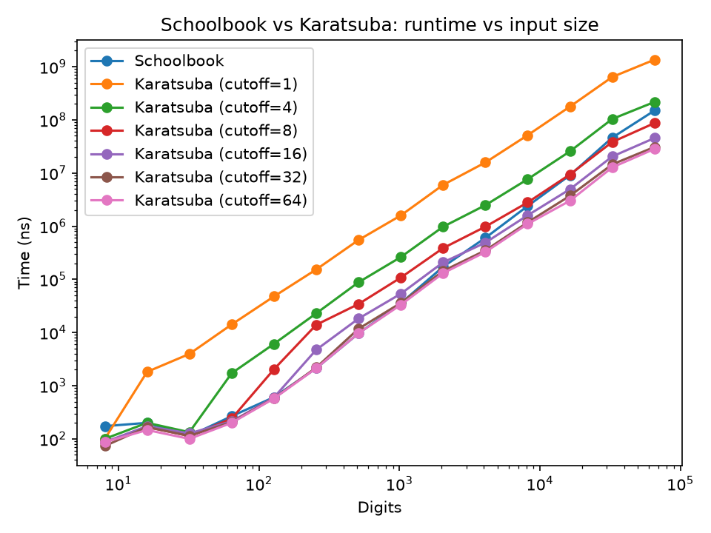
Figure 1: Log-Log Graph of Digits against Time (ns). Taken from runtime_comparsion.png from the results file

The graph above represents the log-log graph that maps the ever-increasing number of digits to the amount of time it takes in nanoseconds. My first hypothesis was off by quite a wide margin, where the threshold of when the best-performing Karatsuba algorithm starts beating schoolbook is in between 10³ to 10⁴ digits at the lower bound of that region. But as hypothesised, cutoff = 1 produces the worst time result of all due how poorly tuned it is and the accumulated recursion overhead at each iteration, resulting in a predictable worse result.
Making a conclusion from the graph, we can observe that cutoff = 16, 32 and 64 performed better than the schoolbook, with cutoff = 64 (around 576 digits) performing the best. Although, even if it performs the best among all, cutoff = 32 followed it very closely, suggesting that there’s a diminishing return the more you increase the parameter’s number.

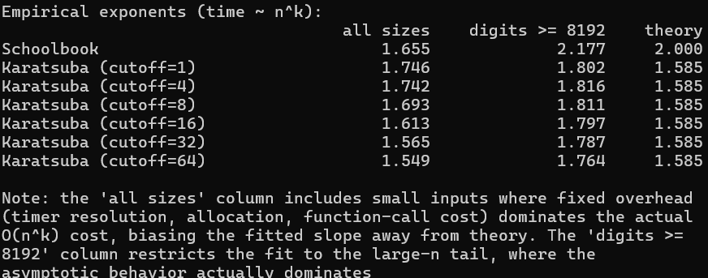
Figure 2: Time complexity comparison between schoolbook and each version of Karatsuba, trialBySize=5. Taken from running the python script ‘PlottingResult.py’ in Powershell
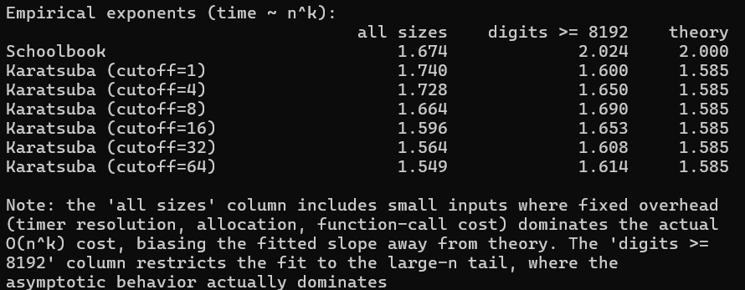
Figure 3: Time complexity comparison between schoolbook and each version of Karatsuba, trialBySize=20. Taken from running the python script ‘PlottingResult.py’ in Powershell

The figures originally exist as “all sizes” compared against theory. However, due to far schoolbook’s exponent deviate from 2.0 from the theory, it led me to believe there might be something wrong with the dataset. And as such, I have added a new digit threshold where it only takes the data value higher than 8192. This is done due to how fast the smaller digit finishes its own time, resulting in a very noisy data as they act as an outlier. Although, doing this introduces another problem, which is that there’s not much data for the python to write from, as seen in Figure 2, which generates a significantly deviated exponent value from their theory value. After retrial of 20 per iteration, the exponent seemed to be smoothened out afterwards.
After the threshold, it can be observed that schoolbook sits right about where the theory would suggest. However, for Karatsuba, the result varies quite heavily with different cutoff values, especially at cutoff = 8 where the exponent is 1.690, an increase from its own all size comparison. This suggests that the recursive overhead calls from Karatsuba algorithm still have a meaningful large constant factor relative to the actual multiplication work, which is something that the theory doesn’t cover. The overhead accumulation acts like a friction to the algorithm, making it run slower than the expected 1.585 exponent value.

I also suspect that memory cache might be in play. The theory for O(n²) and O(n^{1.585}) bounds assume that every limb-level operation costs the same amount. However, the theory never accounted for higher time needed for bigger numbers. As the number grow large enough to not be able to fit in cache anymore, each memory access gets more expensive due the missing cache, and that extra cost scales with input sizes. Though this suspicion remains inconclusive as I struggle to find a method to check out this possibility.

What I Learned
When I was learning about Karatsuba’s algorithm initially, the question of how I can find the most optimal split in the number comes into view. But as I dug in deeper, I realised that I was mixing up the Karatsuba’s split (the halving/slicing of number that happens at every recursion) with the cutoff point (where the number turn to base case, schoolbook, for the solution). It was a very small, yet very important distinction I caught on earlier so that I didn’t jeopardise my own case study and implementation. After that, I shifted my focus to the question I initially portrayed, and the result is as above.
I spent quite a lot of time looking through C++ materials as I have heavily relied on Claude for the huge body of the code. There was a significant gap in knowledge on C++ library, such as the std::chronos::steady_clock, std::mt19937_64, and std::uniform_int_distribution. The implementation of bignum.hpp was a big challenge, having to understand different standard libraries was an eye-opener experience, and it taught me much more about the C++ language. During the time of making this project, I had to learn CMake along the way, which was surprisingly simple to understand and get it right, resulting in a perfectly executable file after running a few commands through PowerShell.
I learned a fair a bit about fine-tuning and testing out different volume of data to achieve a better or expected result. During my first attempt to try to make sense of different exponent of Karatsuba and schoolbook, the data showed a huge divergence from the theory value. By restricting the digit to be at least 8192, the Karatsuba’s exponent pushes further from 1.585 instead of getting closer. My initial guess, like the one I mentioned above, would be a weird cache behaviour interacting with large operand sizes. But after increasing trialBySize to 20 and rerunning, the same digit restriction applied landed the data much closer to the theory (e.g. cutoff=64 moved from 1.764 to 1.614). This tells me immediately that the original divergence was mostly due to the small sample size, which would allow a single noisy/outlier trial to swing the slope of the fitted plot substantially. Going through this, it’s a useful reminder for myself that an unexpected result is itself something to test, not a conclusion to report right away.

AI Usage
For this project, I have used Claude heavily for much of the implementation, especially when it comes to writing BigInt struct, the correctness test, the benchmark test, and the plotting of the result. As I also begin to read Claude’s explanation of Karatsuba algorithm, I can’t help but to cross-reference it to an actual video explaining the algorithm, uncertainty in the validity of its information. I tried to work on the main algorithm AI-free, but I have used Claude for debugging purposes, checking if I have missed a syntax or my logics are flawed. The whole entire implementation took around four hours, as most of the time spent was to consult and understand the underlying principle the code generated have. As the time comes around to build the program, I also let Claude explain CMake, and guide me through the CMake command to run on the PowerShell, as I encounter a program of the command not working on normal PowerShell, only to realise that I have to use Developer PowerShell of VS for utilising the code written in Visual Studio. Other than that, I spend most of my time looking at the data generated by the automated script, theorising why the exponent itself didn’t match the theory, what could’ve caused more time increase aside from the algorithm, and what changes could I make to better build the implementation (e.g. The change of the trial size to a larger one so that noisy data can’t interfere with a saturated amount of data).

A moment where the AI tried to lead me down different research was from the very beginning, as it asks whether I want to create a comparison of Karatsuba Algorithm to Python’s built-in version. Although I’ll admit that it’s also an interesting route to explore, but I thought to myself that being able to compare it to the normal grade school multiplication technique would hit closer to home (and it could be due to poor prompting that led the AI to dive into that path). One more thing that Claude crucially got wrong was the usage of CMake. At first, Claude let me know that it is a complier then backtracks on it later, which prompts me to have a google search on it instead. Upon discovering that it’s a build system generator, it makes it much clearer on why the AI backtracked on it in the first place.

When it comes to what I trust Claude on in the code, I find the BigInt struct very convoluted when I first approached it, which is why I put my faith heavily on Claude to make it work. Aside from that, I had an idea that I want to verify that the two algorithms would generate the same answer, so I let Claude generate CorrectnessTest.cpp. Surprisingly, the AI sets up was up to what I believe is good enough. 500 different trials, each generating random unique numbers to best test it. The two edge cases below the for loop, which allows the algorithm to be tested sufficiently, is also a nice touch that I find very important to a general multiplication algorithm like Karatsuba. Lastly, as someone who uses matplotlib before, Claude seems to build a satisfactory graphic for the task at hand, so I left most of the code unmodified except for the CSV directory and the threshold constant.

