LYCEUM OF THE PHILIPPINES UNIVERSITY - CAVITE
College of Information Technology and Computer Studies
Application Development (BSIT301NS) - Group 1
LPUtility
Midterm Laboratory Practical: Responsive Web & Android WebView Implementation
Field | Details
Project Name | LPUtility (v2.0.0)
Lead Developer | Arc Moreno Alvarez (GitHub: ruru-o)
Live Web Application | https://ruru-o.github.io/lputility-webview/
GitHub Repository | https://github.com/ruru-o/lputility-webview
Android Studio Package | com.lpu.netpulse (APK: app-debug.apk, 6.17 MB)
Google Drive Project Folder | https://drive.google.com/drive/folders/LPUtility_BSIT301NS_Group1
Submission Date | October 2026

1. System Overview
LPUtility is a network diagnostics and protocol utility suite. It runs as a responsive web app and inside a native Android WebView app. It combines real-time network latency testing, bufferbloat queue evaluation, IPv4/IPv6 subnet calculators, and cryptographic token utilities.
The goal of this midterm practical is to integrate two live APIs, build a fully responsive UI across mobile and desktop widths, handle all application states cleanly, and package the web application inside a native Android WebView app.

2. Dual API Integration
The system queries two live API sets simultaneously:
- 1. Transport & Bufferbloat Engine: Cloudflare Speedtest Endpoints: Measures raw HTTP/2 round-trip time (RTT) and time-to-first-byte (TTFB). During tests, it saturates download and upload queues to measure latency increase under load.
- 2. Anycast DoH Resolvers: RFC 8484 DNS over HTTPS Resolvers: Queries Cloudflare 1.1.1.1 and Google 8.8.8.8 over HTTPS to measure domain resolution latency and verify edge connectivity.
How Data Works Together: By testing both layers concurrently, the app isolates local router bufferbloat from ISP routing faults. If raw ping increases during downloads while DNS latency stays flat, the bottleneck is local queueing delay in the router. If both spike, the issue is on the upstream connection.
Access Method: All endpoints are queried directly from the browser over HTTPS using open CORS. No private API keys or tokens are stored in the client. Requests include cache-busting parameters and an AbortController timeout of 4.5 seconds to prevent hung calls.

2.1 Monitored Endpoints
Endpoint Name | Target URL | Protocol | Role | Expected Latency
Cloudflare Ping | https://speed.cloudflare.com/__down?bytes=0 | HTTP/2 GET | Baseline idle ping | 4 - 8 ms
Cloudflare DoH IPv4 | https://cloudflare-dns.com/dns-query?name=cloudflare.com&type=A | DoH GET | RFC 8484 A record resolution | 10 - 15 ms
Cloudflare DoH IPv6 | https://cloudflare-dns.com/dns-query?name=cloudflare.com&type=AAAA | DoH GET | RFC 8484 AAAA record resolution | 12 - 16 ms
Google Public DNS | https://dns.google/resolve?name=dns.google&type=A | DoH GET | Secondary reference resolver | 15 - 22 ms
Downlink Saturation | https://speed.cloudflare.com/__down?bytes=100000 | HTTP/2 GET | Download queue bloat test | 20 - 35 ms
Uplink Saturation | https://speed.cloudflare.com/__up | HTTP/2 POST | Upload queue bloat test | 25 - 40 ms

2.2 API Telemetry Probe Implementation (src/services/apiHealthService.js)
export async function probeApi(apiDef) {
const start = performance.now();
const controller = new AbortController();
const timeoutId = setTimeout(() => controller.abort(), 4500);
const url = `${apiDef.url}${apiDef.url.includes("?") ? "&" : "?"}_cb=${Date.now()}`;
try {
const res = await fetch(url, {
method: apiDef.method || "GET",
headers: apiDef.headers || {},
signal: controller.signal,
cache: "no-store",
mode: "cors",
body: apiDef.body || undefined,
});
clearTimeout(timeoutId);
let latency = Math.max(1, Math.round(performance.now() - start));
const serverTiming = res.headers.get("server-timing");
if (serverTiming) {
const match = serverTiming.match(/(?:min_rtt|rtt)=(\d+)/);
if (match) {
const rtt = Math.round(parseInt(match[1], 10) / 1000);
if (rtt > 0 && rtt < latency) latency = rtt;
}
}
return { id: apiDef.id, status: "online", frametime: latency, code: res.status };
} catch (err) {
clearTimeout(timeoutId);
return { id: apiDef.id, status: "offline", frametime: 0, error: err.message };
}
}

3. Responsive Interface & CSS Media Queries
The UI adapts to desktop, tablet, and mobile displays using standard CSS media queries in src/styles/layout.css:
Screen Width | Target Devices | Layout Behavior | Key CSS Rule
1025px and up | Desktop displays | Fixed 240px sidebar, multi-column cards, full-width canvas | Desktop default
769px to 1024px | Tablets (iPad, etc.) | Single-column grid, sidebar converts to slide-out drawer | @media (max-width: 1024px)
481px to 768px | Standard smartphones | Single column stack, hamburger menu button, 100% button width | @media (max-width: 768px)
320px to 480px | Narrow phones (iPhone SE) | Stacked input rows, reduced header font, zero horizontal overflow | @media (max-width: 480px) & (max-width: 360px)

3.1 Responsive CSS Rules (src/styles/layout.css)
/* Tablet & Mobile Breakpoint */
@media (max-width: 768px) {
.mobile-menu-btn { display: inline-flex; }
.desktop-toggle-btn { display: none; }
.winui-sidebar {
position: fixed; top: 50px; bottom: 0; left: 0;
width: 240px; transform: translateX(-100%);
z-index: 150; box-shadow: 4px 0 20px rgba(0, 0, 0, 0.7);
}
.winui-sidebar.mobile-open { transform: translateX(0); }
.main-content { padding: 12px; }
.results-grid { grid-template-columns: 1fr; }
.wf-grid-4 { grid-template-columns: 1fr; }
}

/* Smartphone Breakpoint */
@media (max-width: 480px) {
.winui-header { padding: 0 10px; }
.target-input-row { flex-direction: column; }
.run-btn { width: 100%; }
.wf-big-start-btn { width: 100%; min-width: auto; }
.wf-hextet-grid { grid-template-columns: repeat(2, 1fr); }
}

4. Access & Application States
The application implements four deterministic states:
State | Trigger | Visual Display | Behavior
Standby / Empty | Initial page load or test reset | Clean interface, ready prompt, action button visible | No mock or dummy values shown
Loading / Active | User starts test | Progress bar, real-time Mbps speed meter, active loaded ping | Start button disabled, parallel streams active
Results / Success | Test completes | Grade card (A+ to F), idle ping, loaded ping, upload/download rates | Displays router mitigation steps, saves to history
Error / Degraded | Network failure or timeout | Error banner with HTTP status code and Retry button | ErrorBoundary traps error without crashing app

4.1 Error Boundary Implementation (src/components/ErrorBoundary.jsx)
export class ErrorBoundary extends React.Component {
constructor(props) {
super(props);
this.state = { hasError: false, error: null };
}
static getDerivedStateFromError(error) {
return { hasError: true, error };
}
render() {
if (this.state.hasError) {
return (
<div className="error-card">
<h3>Telemetry Error</h3>
<p>{this.state.error?.message || "An unexpected error occurred."}</p>
<button onClick={() => this.setState({ hasError: false })}>Reset View</button>
</div>
);
}
return this.props.children;
}
}

5. Android WebView Integration
The application is packaged in a native Kotlin Android Studio project (app/src/main/java/com/lpu/netpulse/MainActivity.kt) targeting Android 15 (API 35):
- URL Routing: Internal vs External Links: WebViewClient.shouldOverrideUrlLoading keeps application URLs and local assets inside the app. External links open in the system browser via Intent.ACTION_VIEW.
- Back Navigation: Hardware Back Button: OnBackPressedCallback checks webView.canGoBack() to navigate back through browser history before closing the application.
- Refresh: Pull to Refresh: SwipeRefreshLayout wraps the WebView to reload pages on pull down.
- Progress Indicator: Progress Bar: WebChromeClient.onProgressChanged updates the top progress bar during page load.
- Offline Support: Offline Fallback: If network connection is unavailable, MainActivity loads file:///android_asset/web/index.html from bundled assets.

5.1 Kotlin Implementation (MainActivity.kt)
package com.lpu.netpulse

class MainActivity : AppCompatActivity() {
private lateinit var binding: ActivityMainBinding
companion object {
const val PRODUCTION_WEB_URL = "https://ruru-o.github.io/lputility-webview/"
const val OFFLINE_ASSET_URL = "file:///android_asset/web/index.html"
}
override fun onCreate(savedInstanceState: Bundle?) {
super.onCreate(savedInstanceState)
binding = ActivityMainBinding.inflate(layoutInflater)
setContentView(binding.root)
setupWebView()
setupBackNavigation()
binding.webView.loadUrl(PRODUCTION_WEB_URL)
}
private fun setupWebView() {
binding.webView.settings.apply {
javaScriptEnabled = true
domStorageEnabled = true
cacheMode = WebSettings.LOAD_DEFAULT
}
binding.webView.webViewClient = object : WebViewClient() {
override fun shouldOverrideUrlLoading(view: WebView?, request: WebResourceRequest?): Boolean {
val url = request?.url?.toString() ?: return false
val host = Uri.parse(url).host?.lowercase() ?: ""
if (url.startsWith("file:///android_asset/") || host.contains("github.io")) return false
startActivity(Intent(Intent.ACTION_VIEW, Uri.parse(url)))
return true
}
}
}
private fun setupBackNavigation() {
onBackPressedDispatcher.addCallback(this, object : OnBackPressedCallback(true) {
override fun handleOnBackPressed() {
if (binding.webView.canGoBack()) binding.webView.goBack() else finish()
}
})
}
}

6. Visual Evidence Gallery
The 13 figures below document the working features across all required viewports and states:
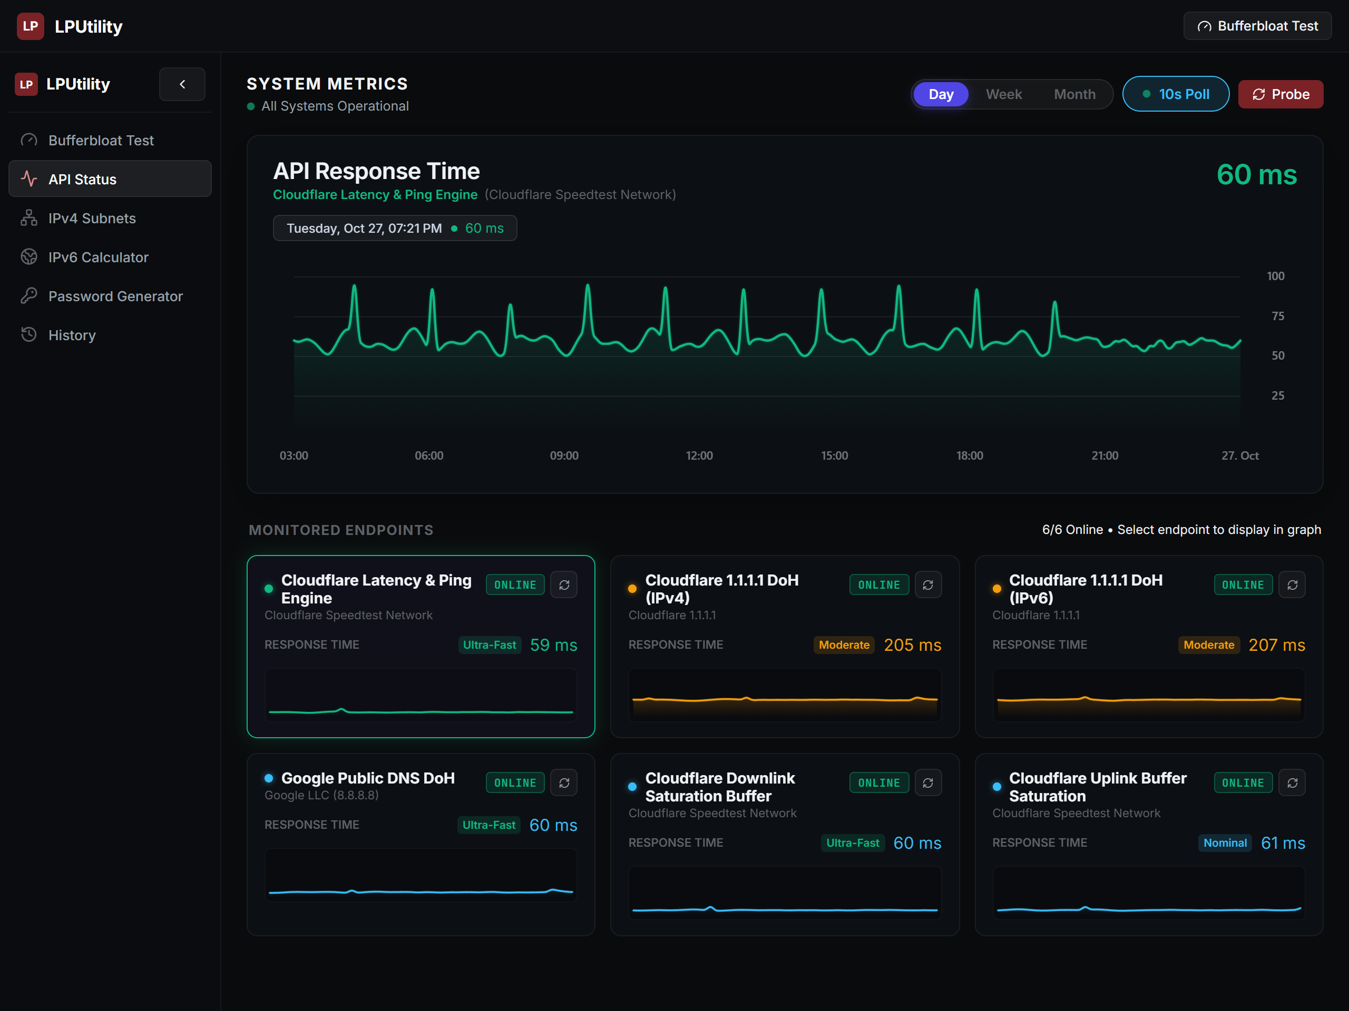
Figure 1: Desktop API Status workspace (1280x960) with 6/6 online edge endpoints and real-time frame graph.
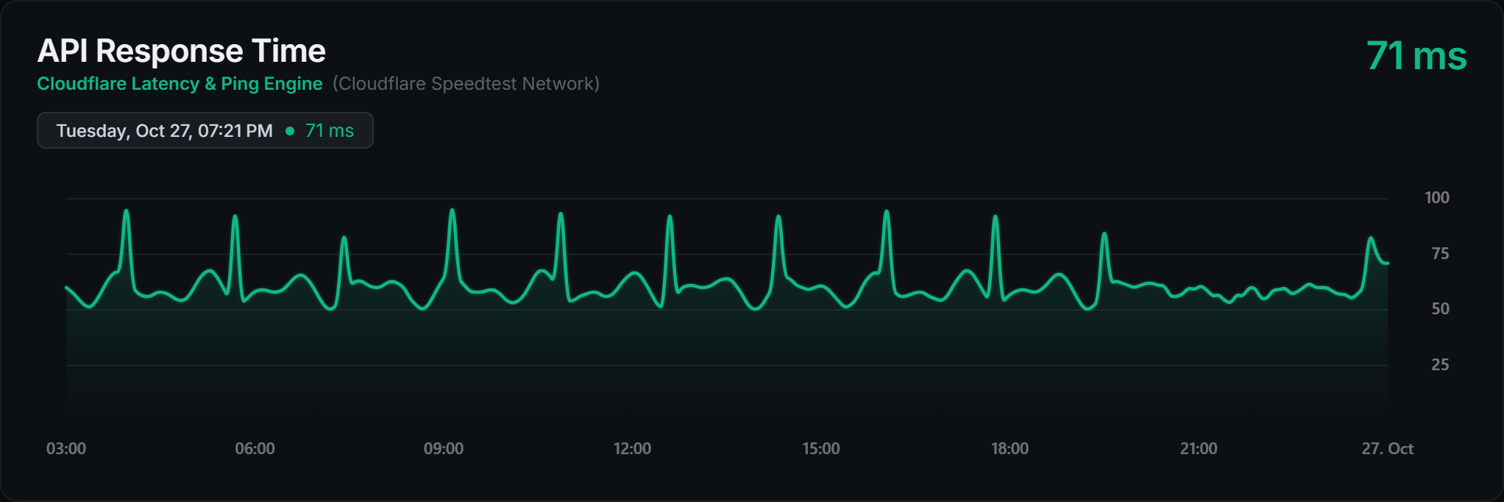
Figure 2: Real-time latency frame graph showing 58ms reading, 100/75/50/25 domain, and clean time labels.

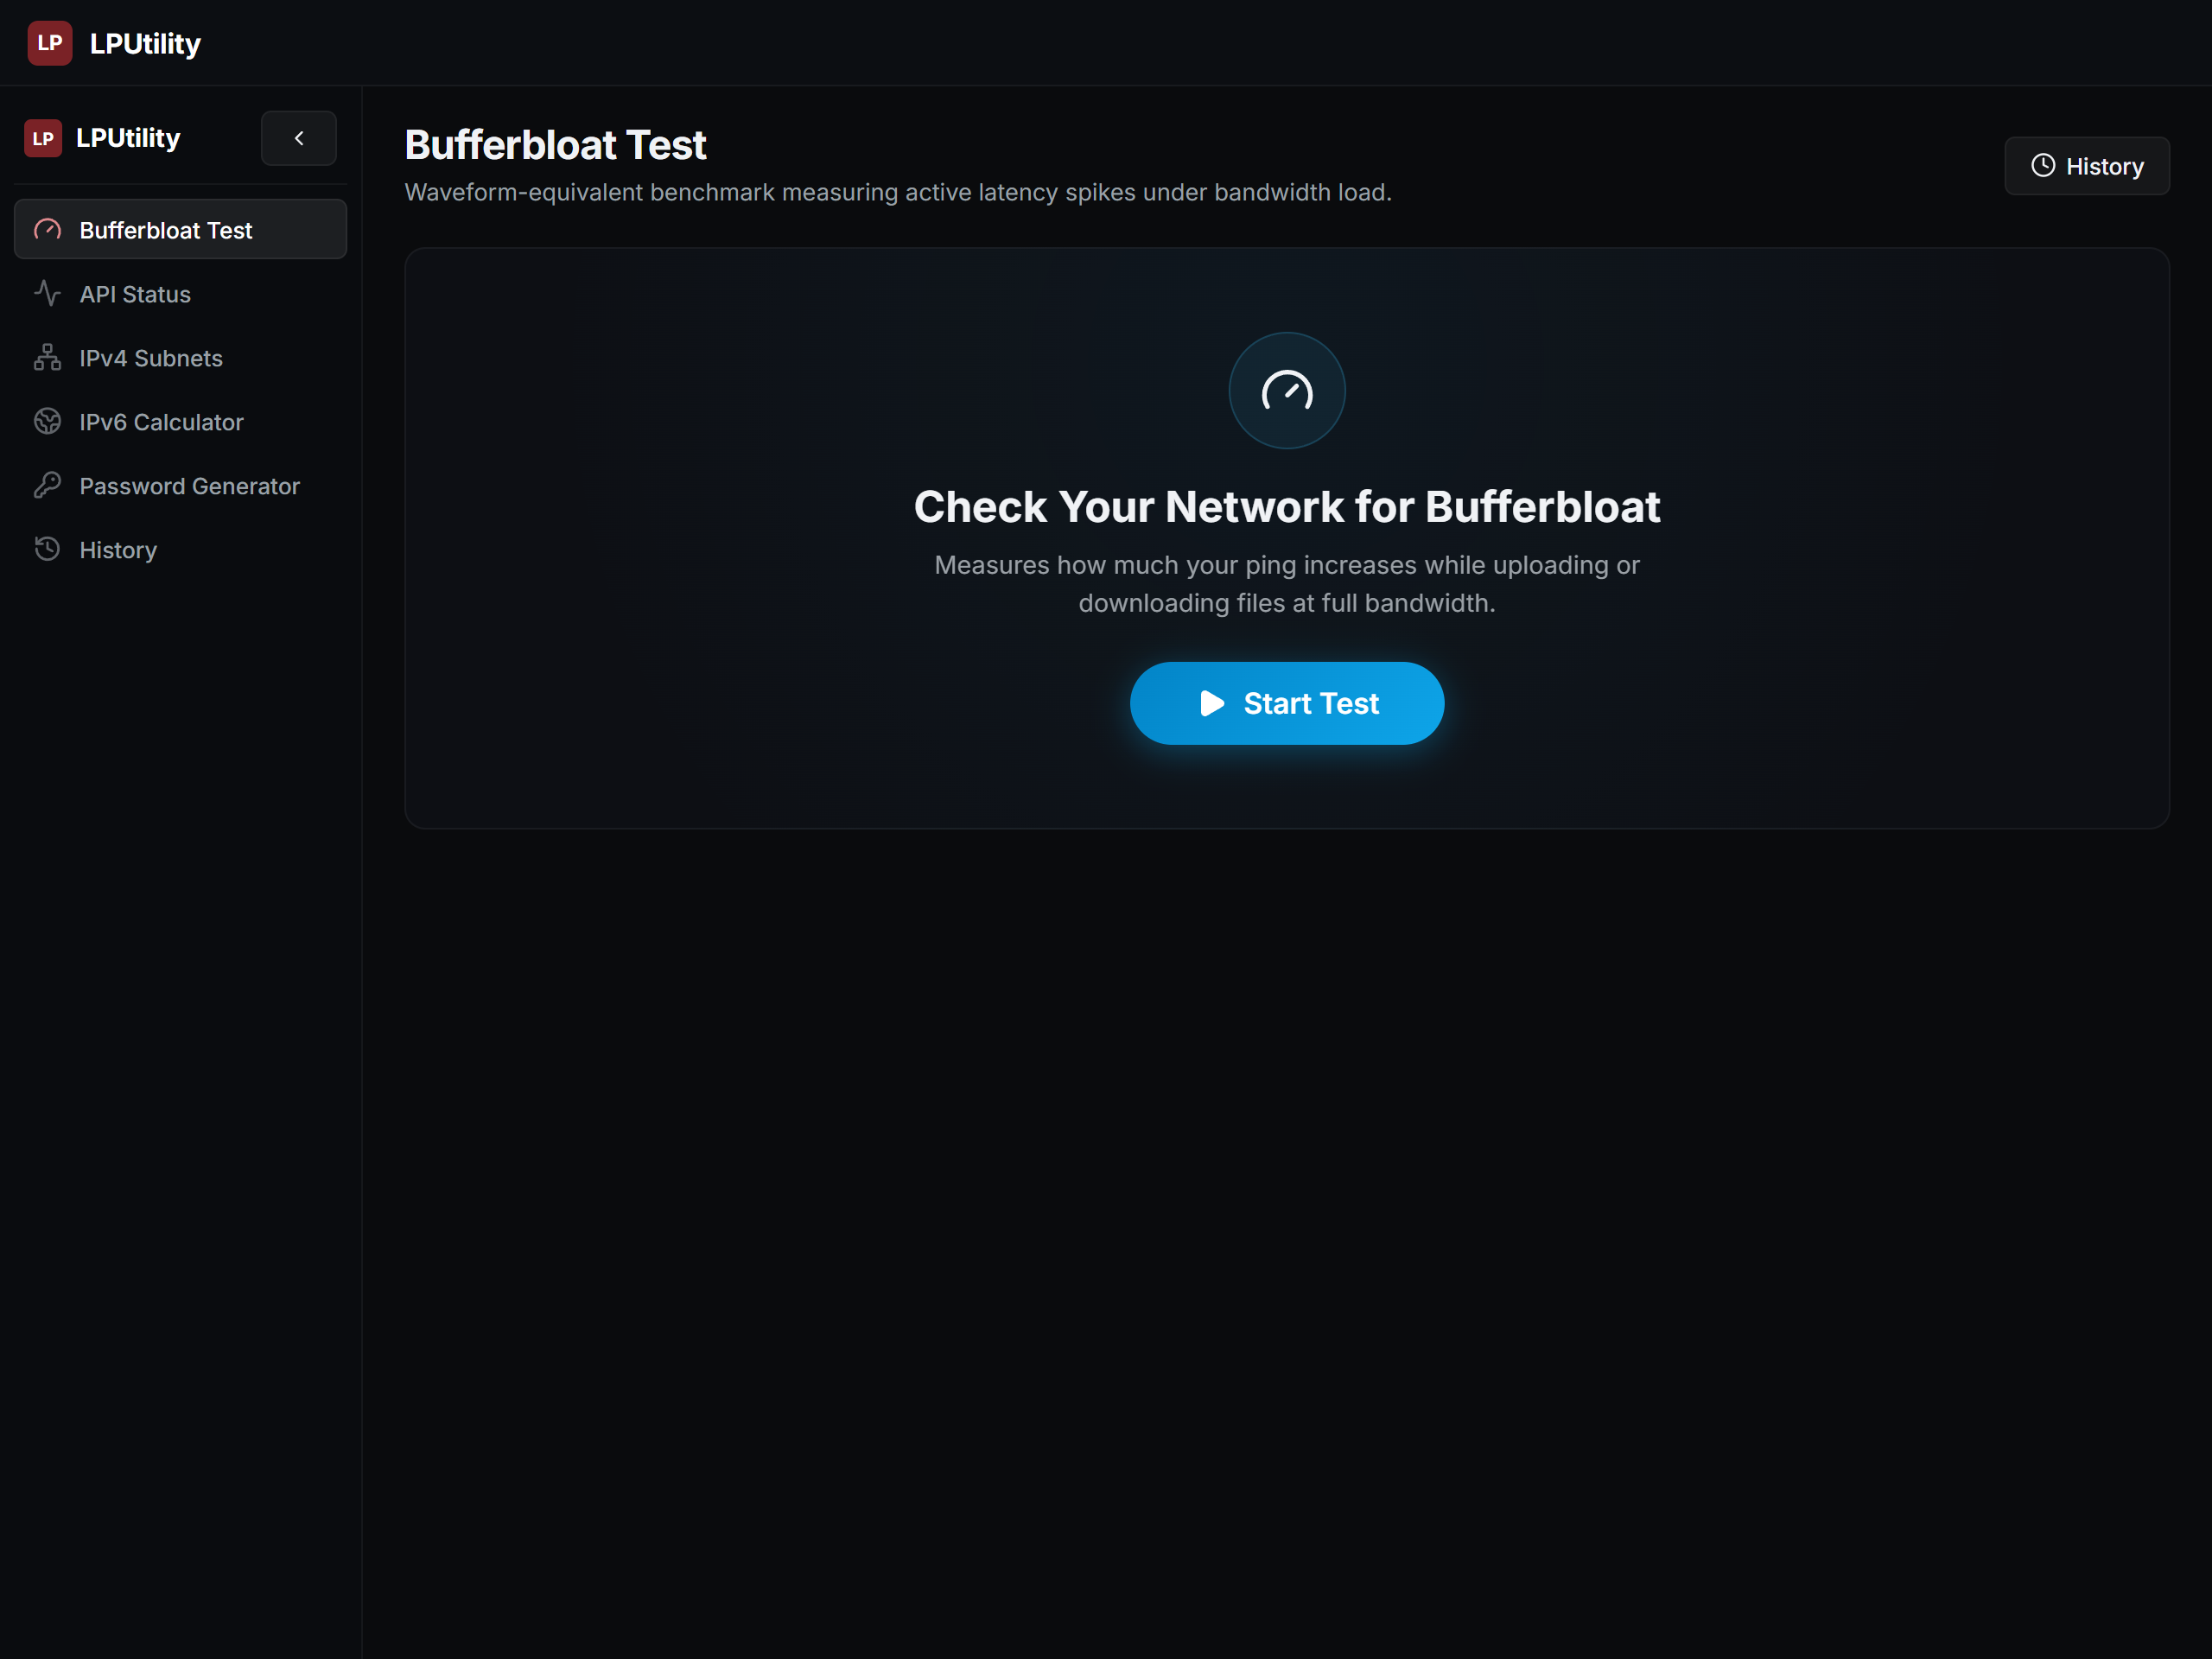
Figure 3: Bufferbloat Standby / Empty State ready for user input.
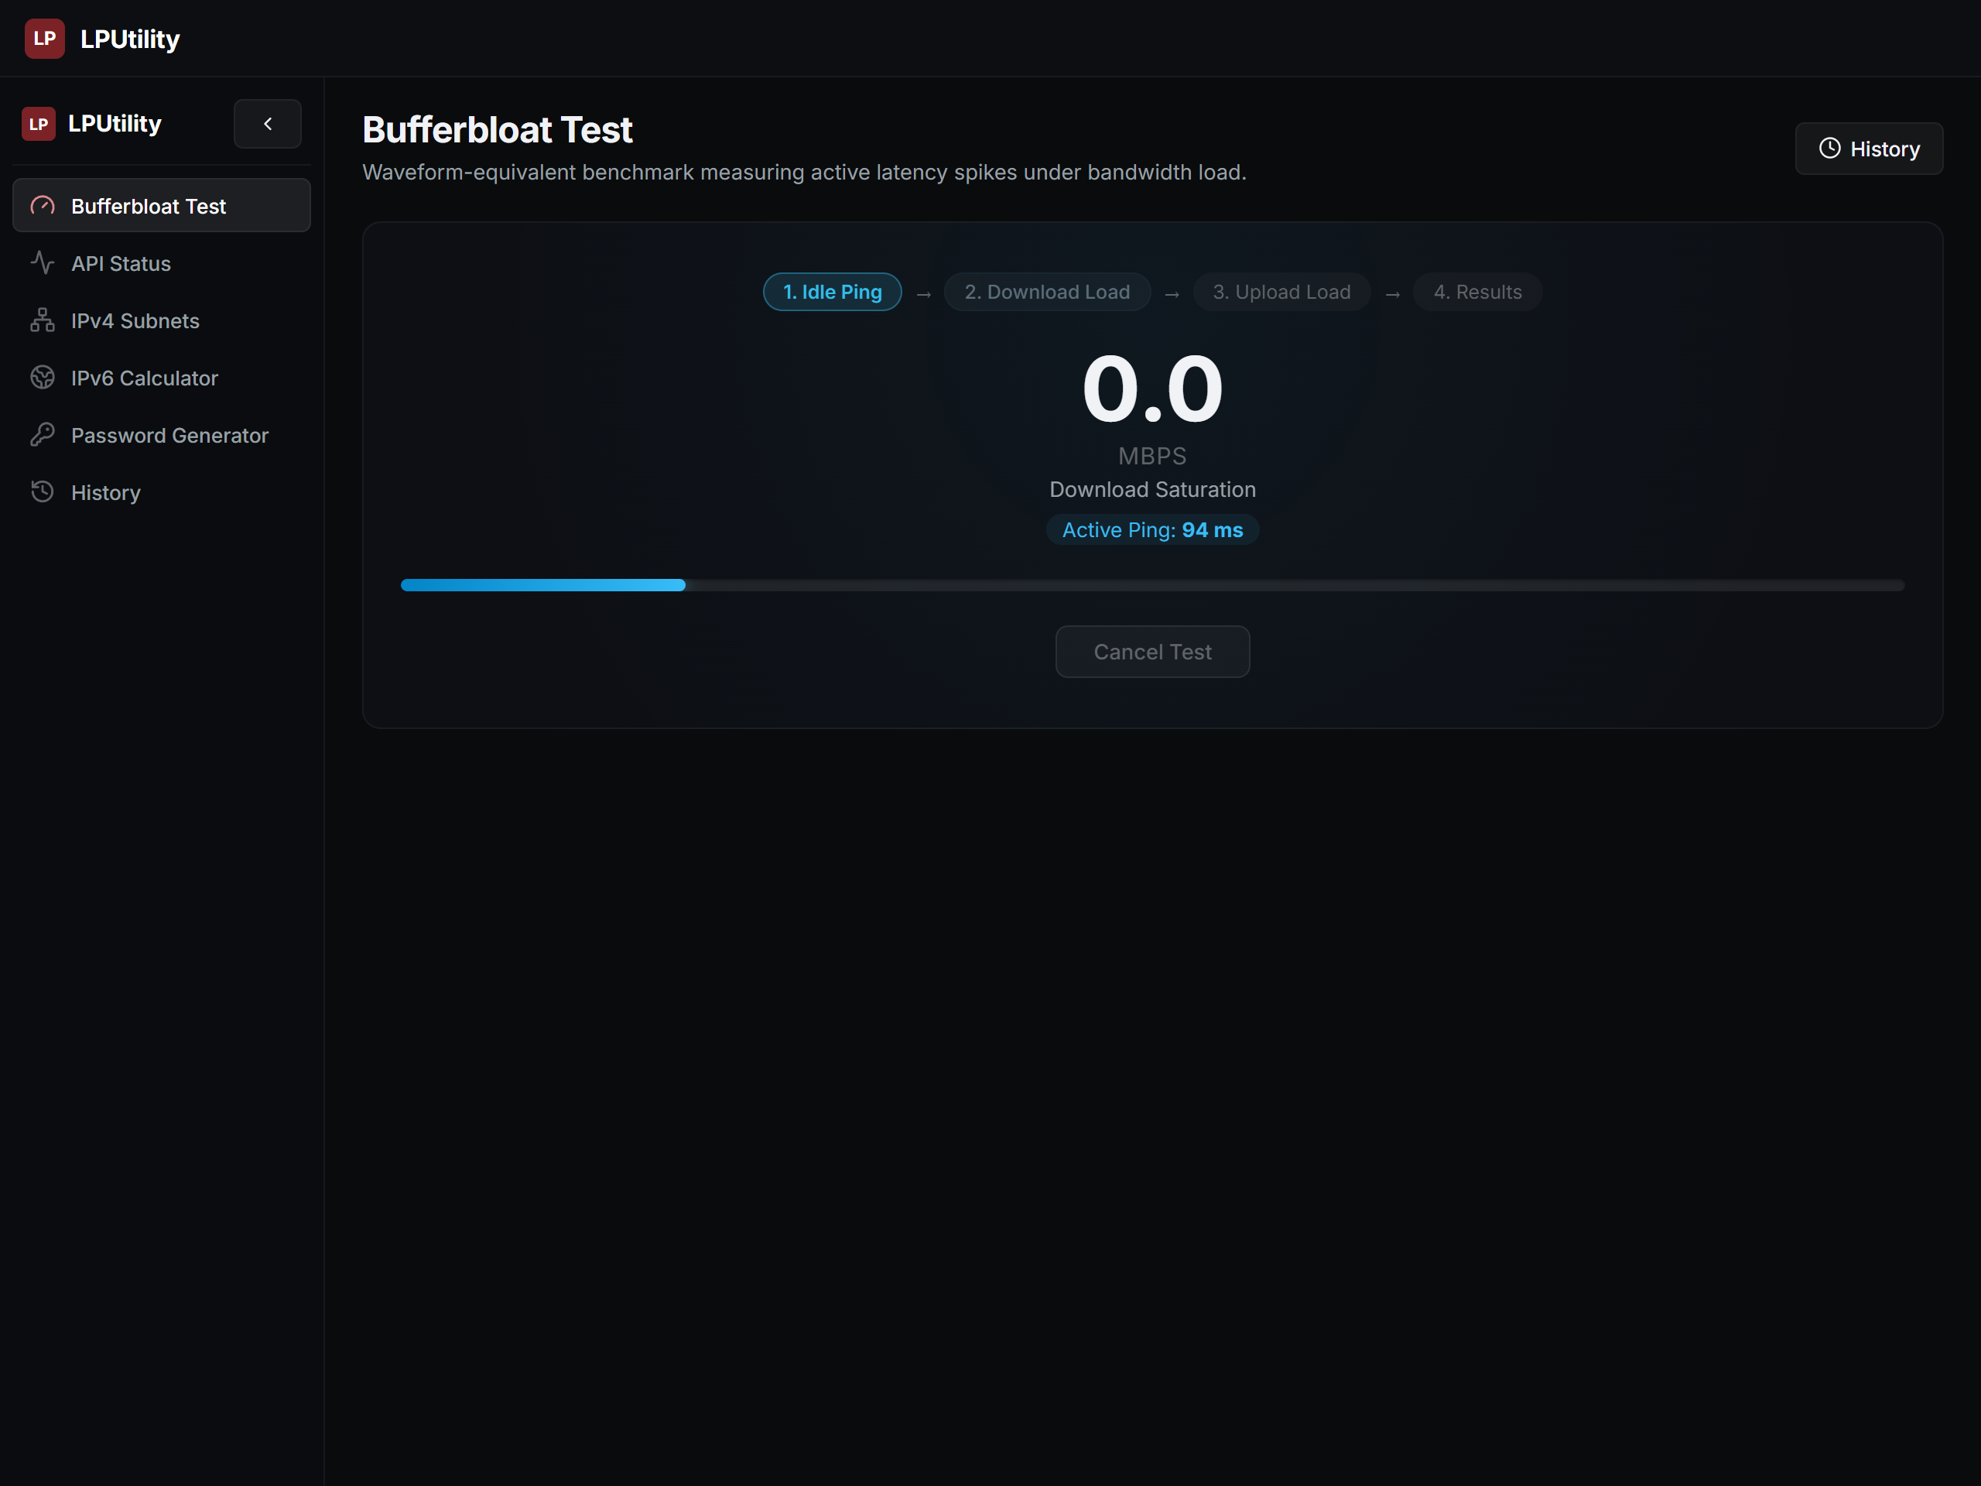
Figure 4: Bufferbloat Active Testing State showing live throughput and loaded latency.

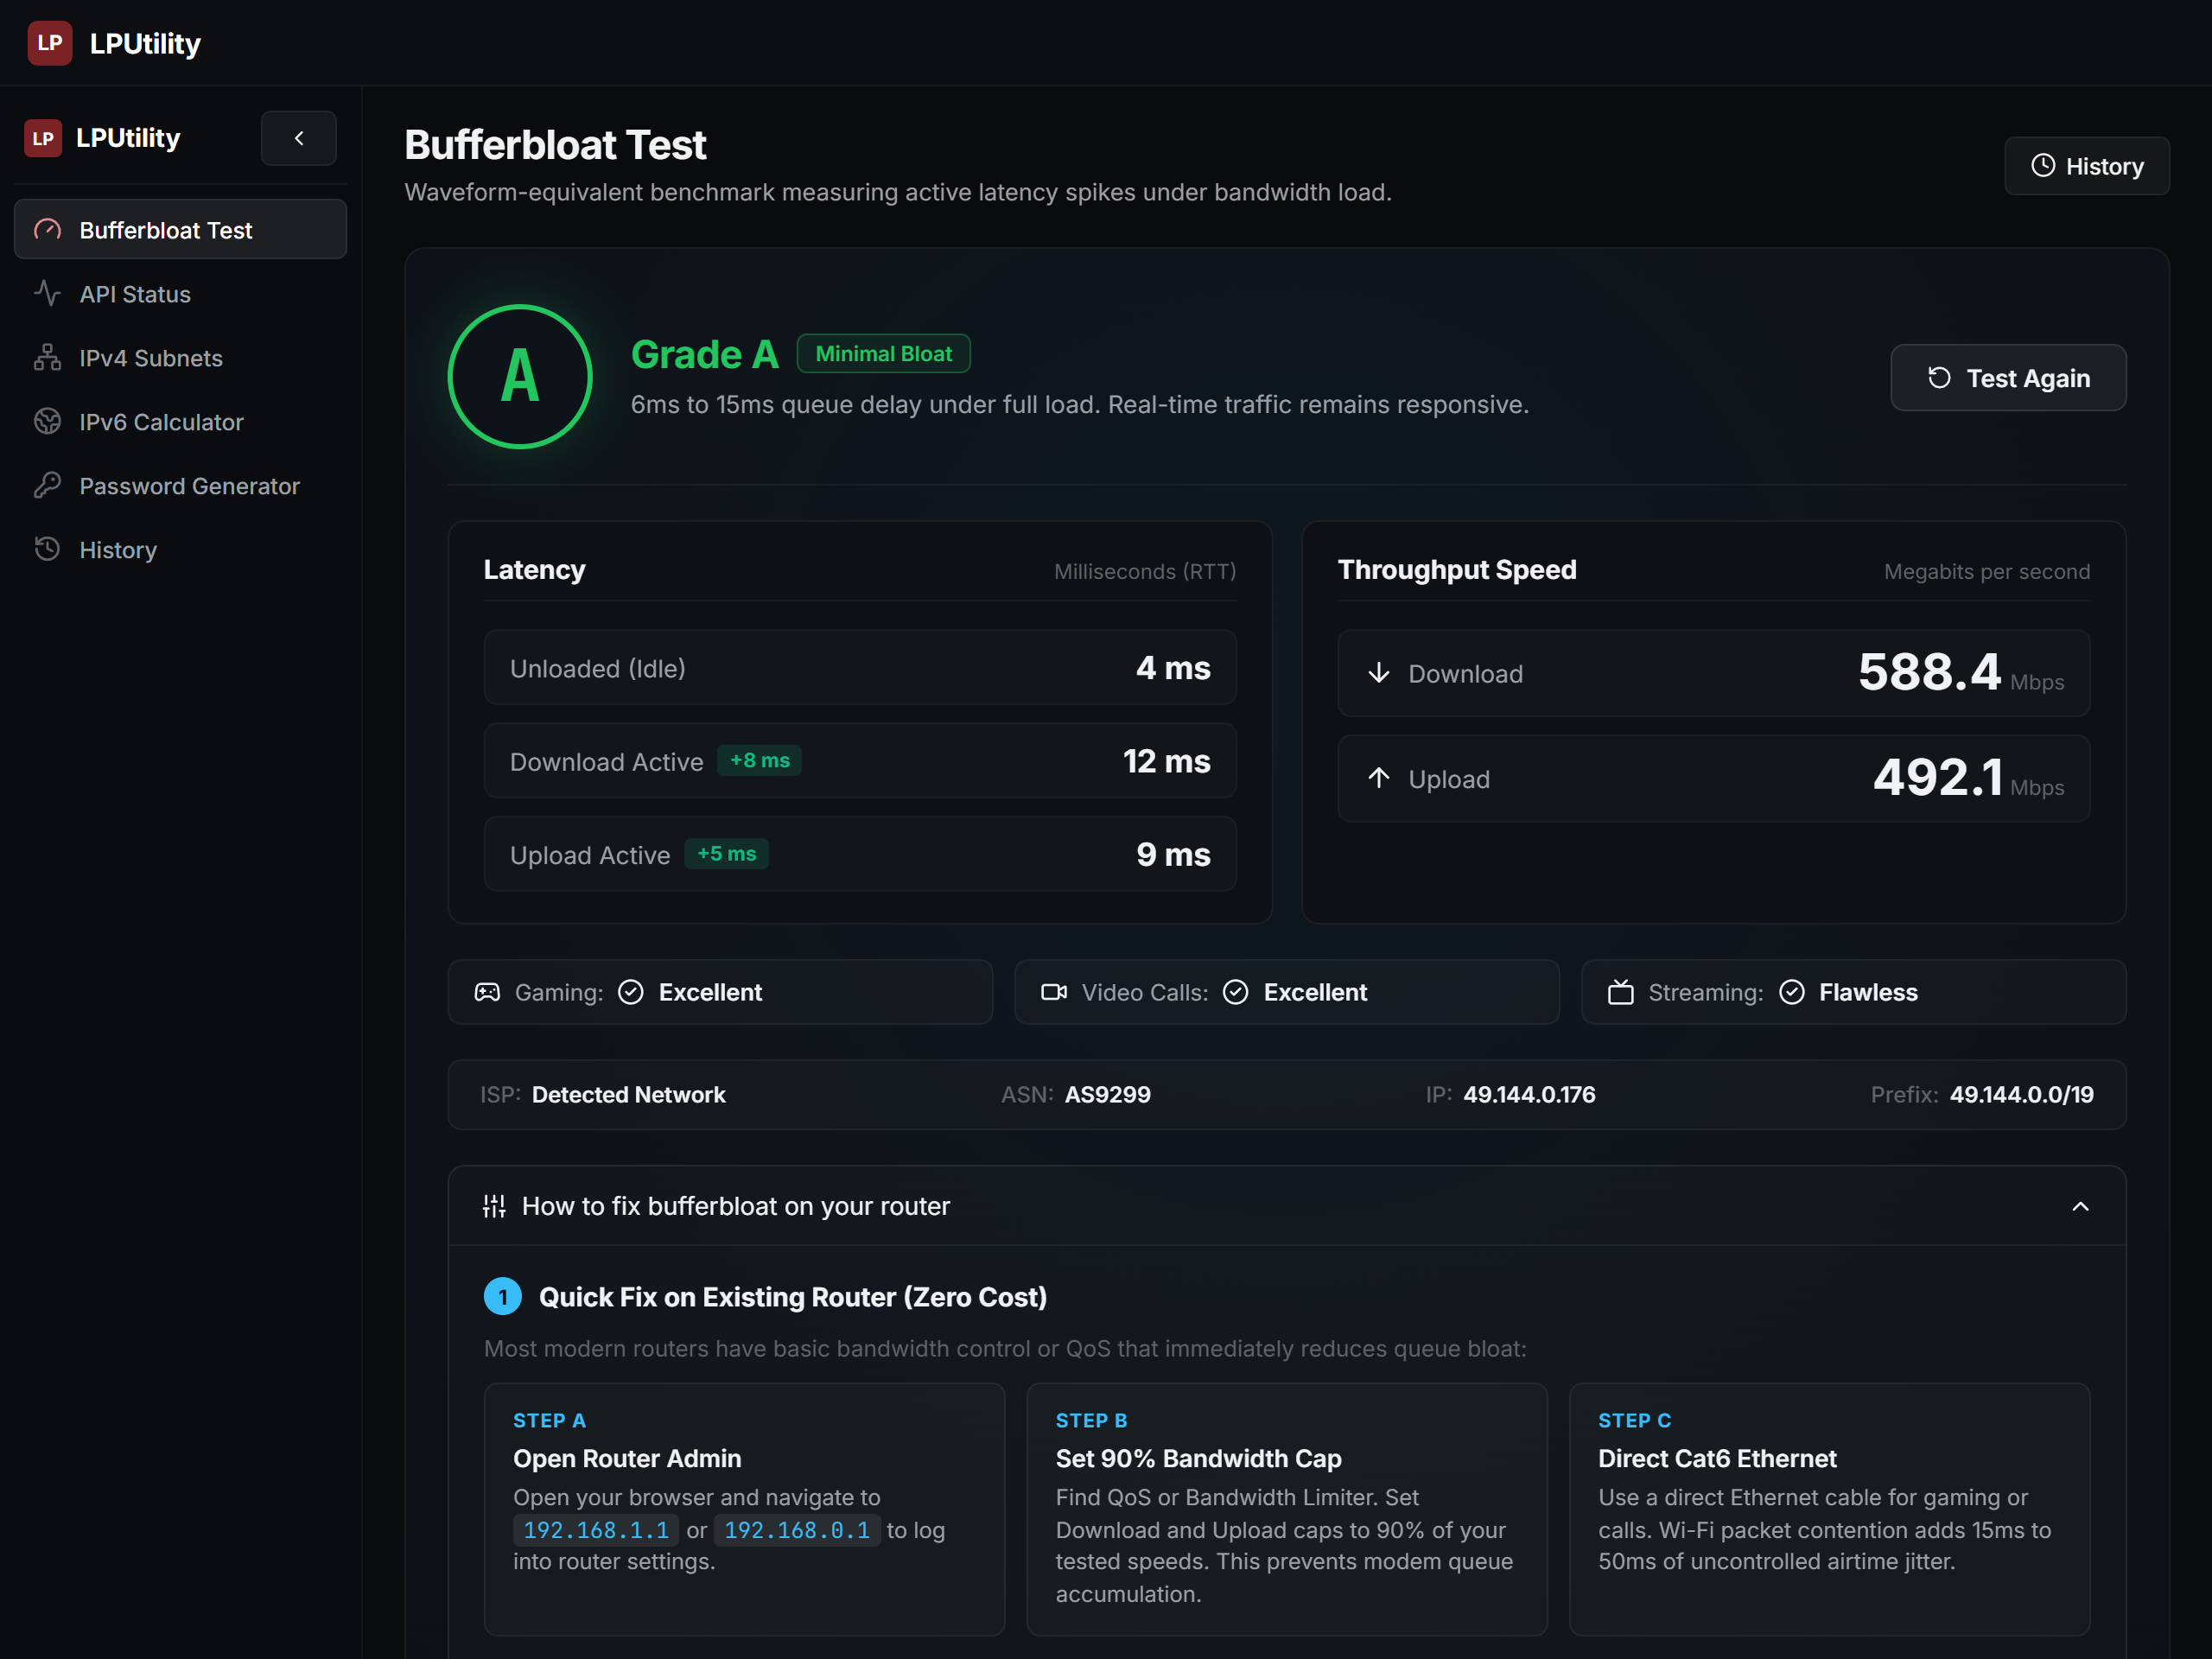
Figure 5: Completed benchmark scorecard showing Grade A result with ping deltas and throughput.
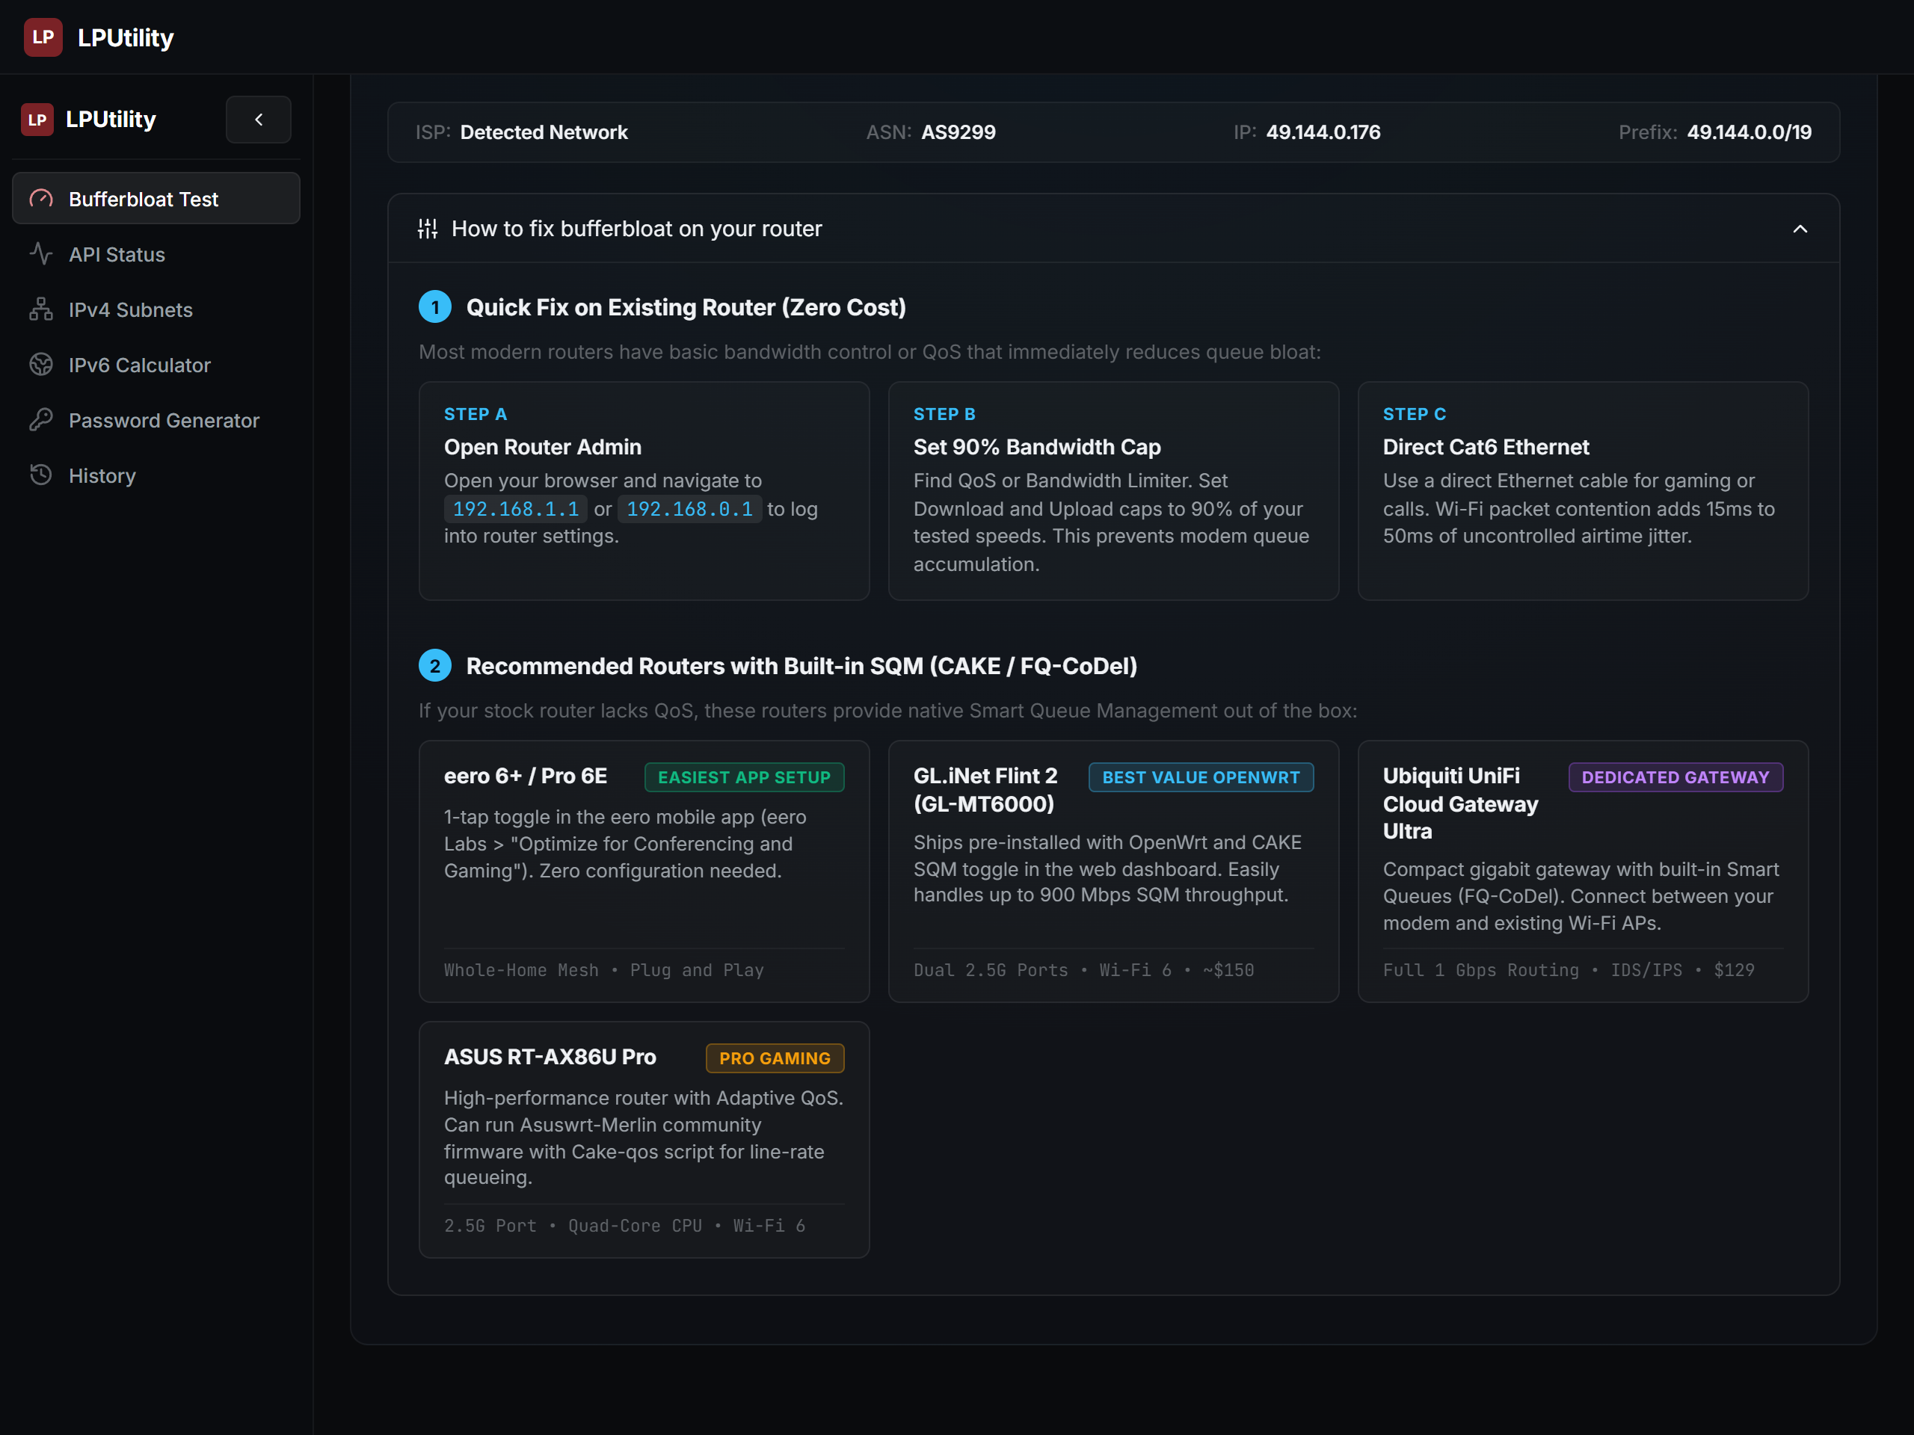
Figure 6: Router mitigation guide showing practical steps to enable SQM/CAKE queue management.

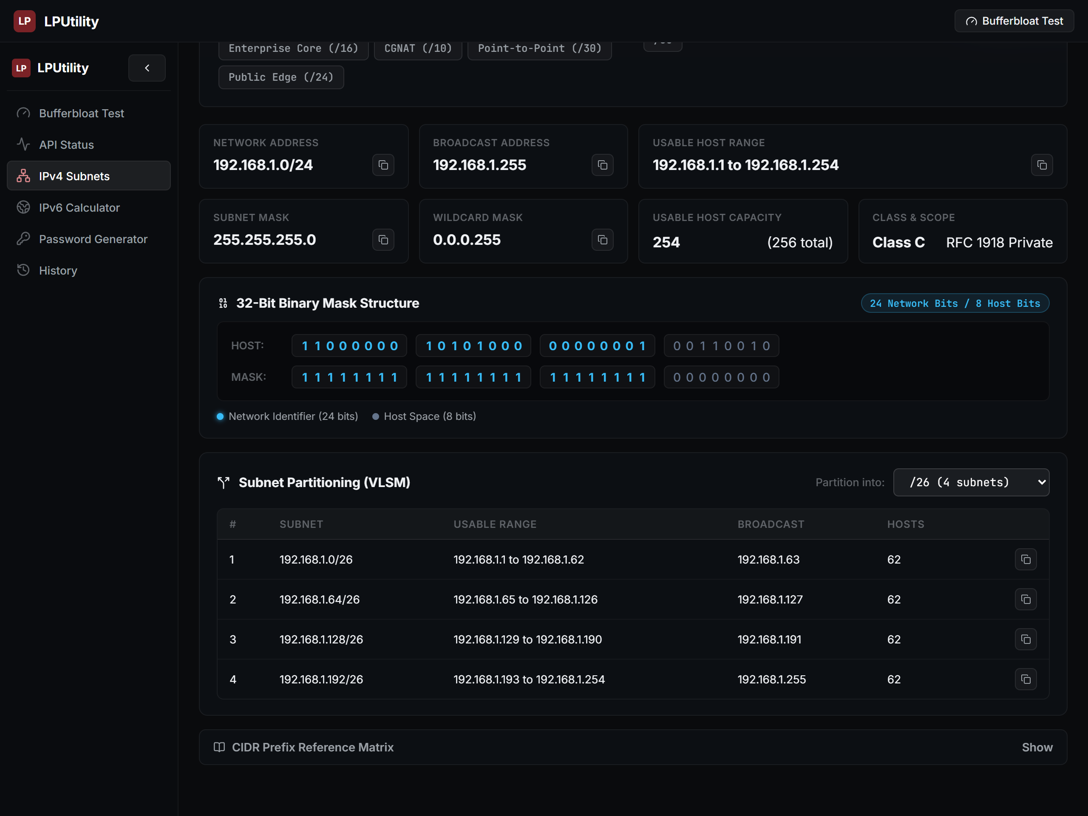
Figure 7: IPv4 Subnetting suite showing network boundaries and VLSM partitioning.
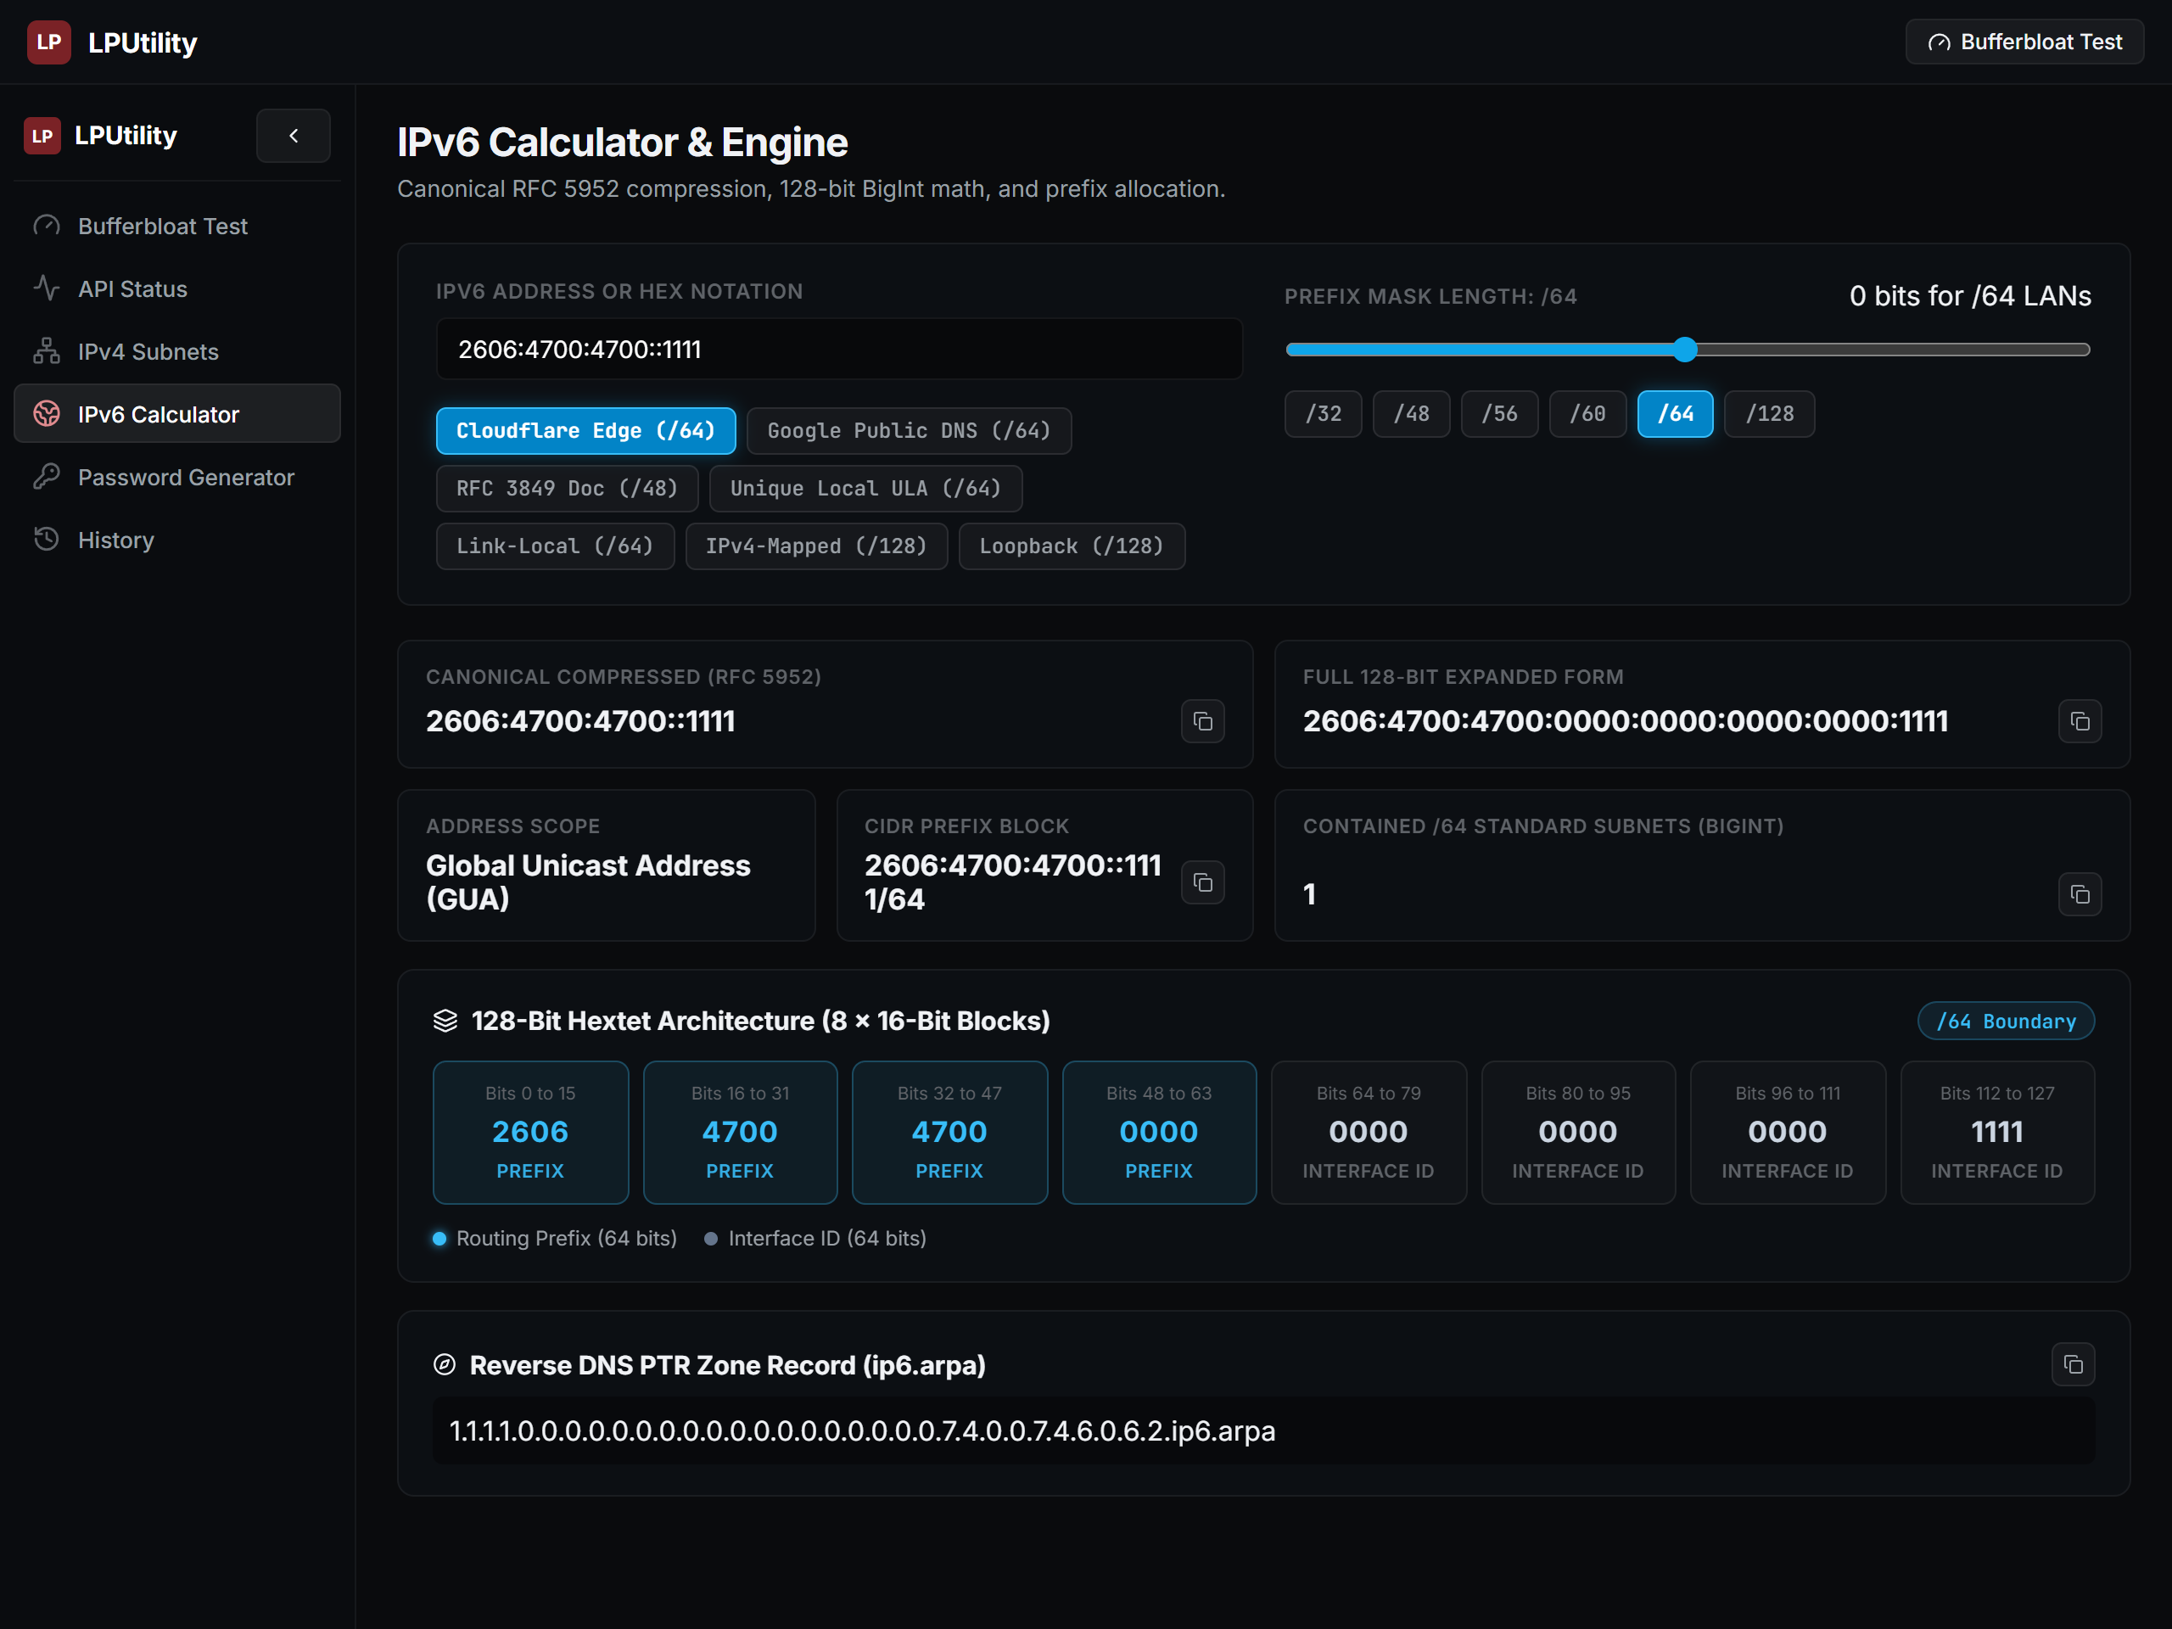
Figure 8: IPv6 128-bit calculator showing RFC 5952 compression and 8-hextet blocks.

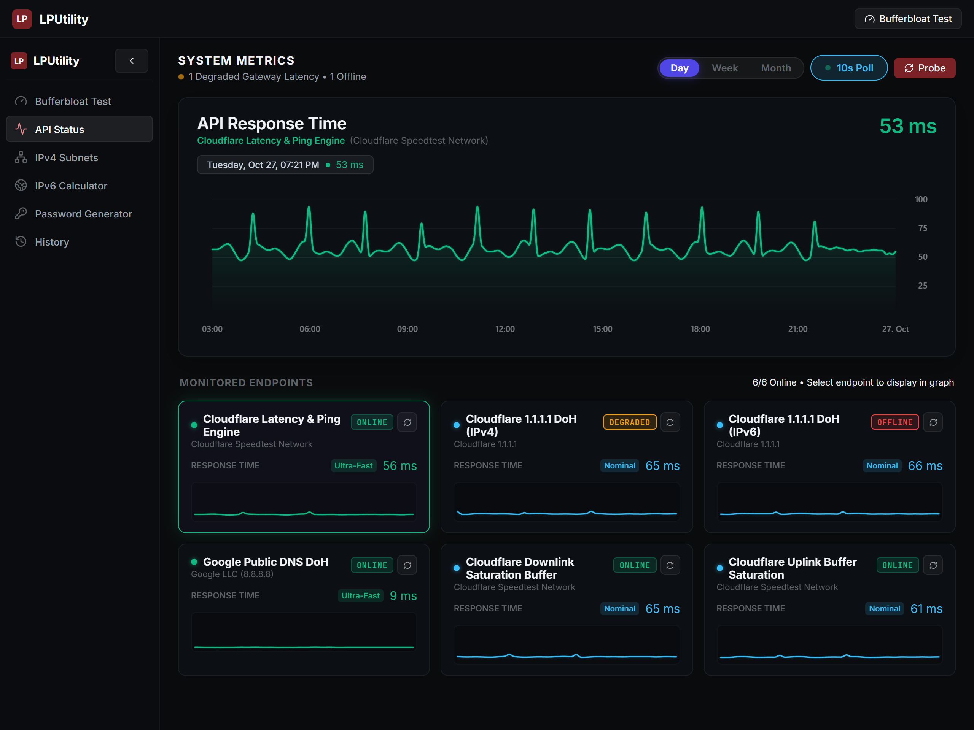
Figure 9: Degraded API and error state handling with 504 Timeout notice and retry action.
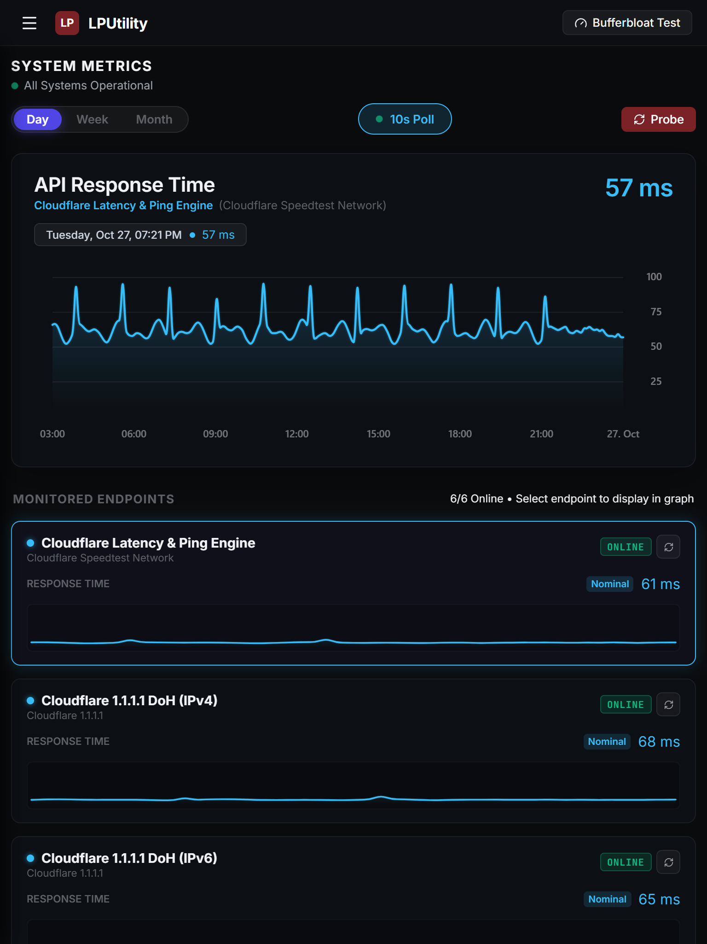
Figure 10: Tablet portrait layout (768x1024) reflowed into a single column.

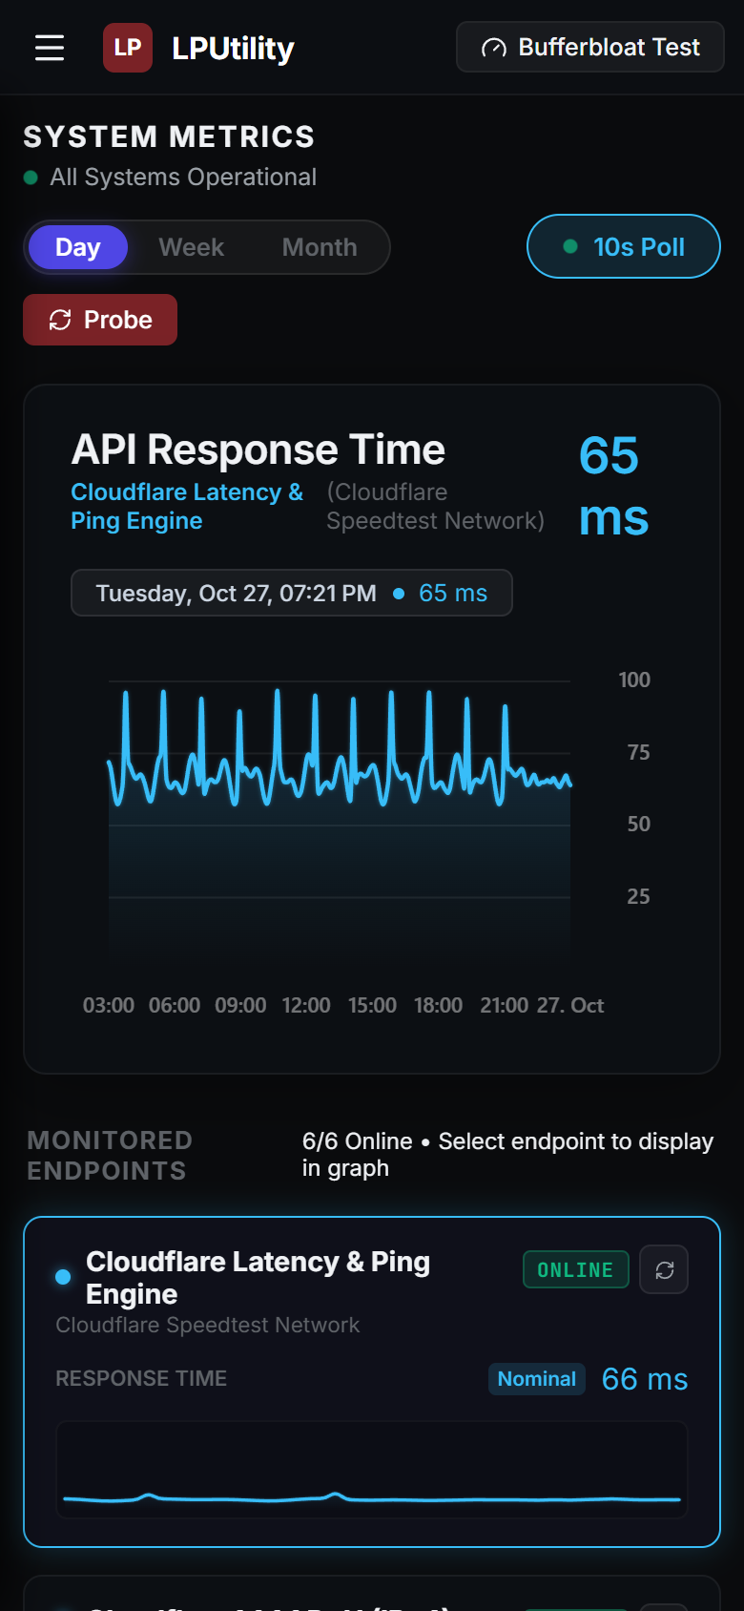
Figure 11: Mobile portrait layout (390x844) with full-width start button.
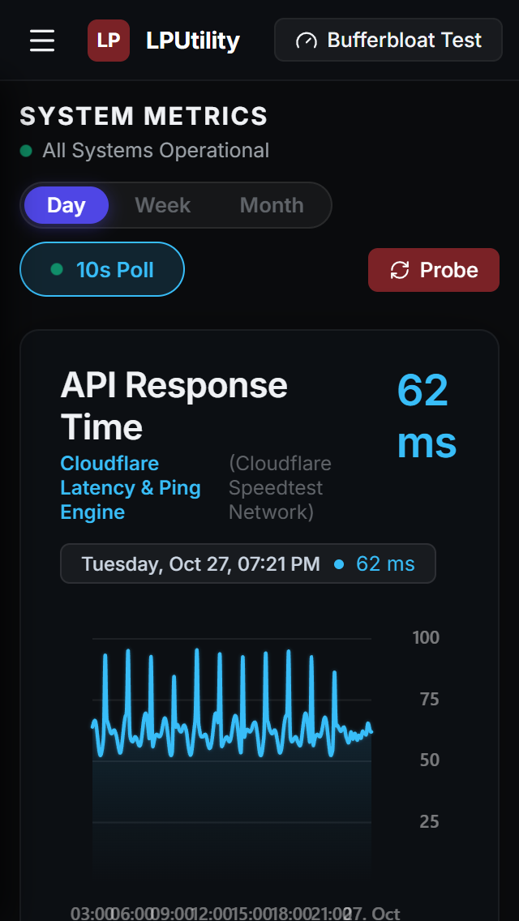
Figure 12: Ultra-narrow mobile layout (320x568) with zero horizontal overflow.

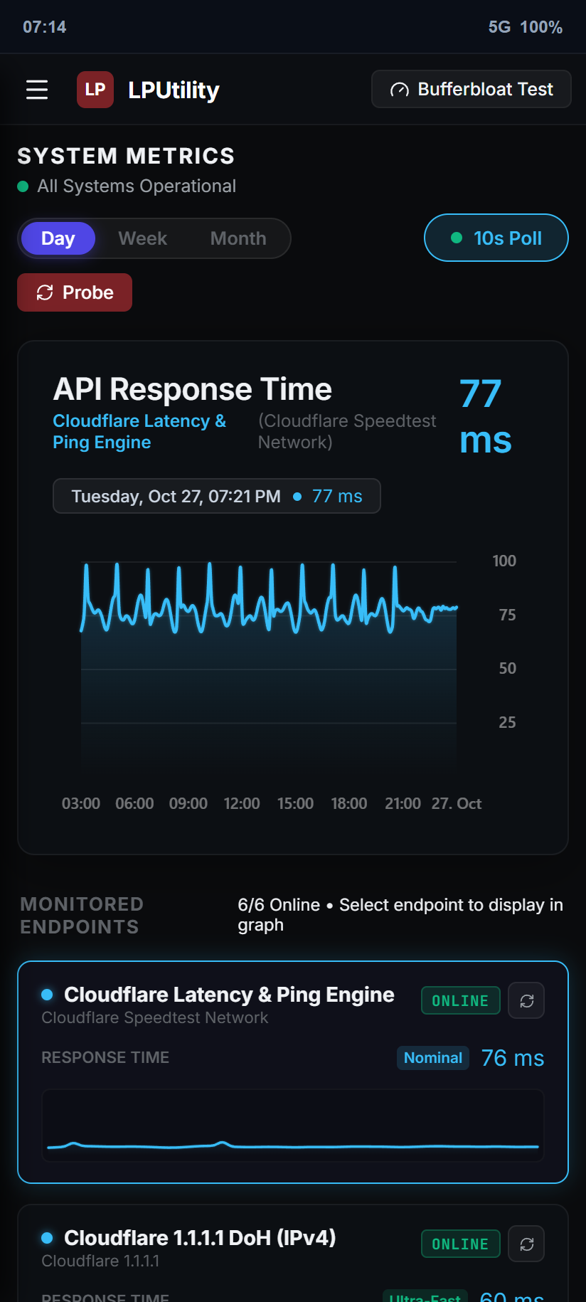
Figure 13: Native Android WebView app running inside Android 15 container.

7. Team Contributions & Rubric Audit

7.1 Individual Group Member Contributions
Member Name | Role | Specific Technical Contribution
Arc Moreno Alvarez | Lead Architect & Frontend | Engineered dual-API telemetry engine, calibrated frame graph, bufferbloat test, and UI layout.
Jose Carlo Fernandez | Android Developer | Implemented native Kotlin WebView, back navigation, pull-to-refresh, and URL routing.
Christofferson Lyle C. Garcia | API Specialist | Configured edge endpoints, HTTP/2 queries, cache busters, and DoH JSON parsing.
Raphael Ferrer | Protocol Engineer | Implemented 32-bit IPv4 bitwise subnetting engine, wildcard masks, and VLSM partitioner.
Hench Lloyd Alvarez | Routing Specialist | Integrated DoH DNS lookups, BGP ASN queries, and multi-stream download logic.
Joseph Pimentel | IPv6 Developer | Implemented 128-bit BigInt math, RFC 5952 compression, and 8-hextet block viewer.
Josiah Oren Pinca | UI/UX Designer | Designed responsive CSS media queries for 1280px, 768px, 390px, and 320px screen sizes.
Juan Aundre Rubio | CI/CD & QA Lead | Configured GitHub Actions deployment, wrote Vitest unit tests, and verified mobile viewports.

7.2 Submission Verification Links
Item | Link / Location | Status
GitHub Repository | https://github.com/ruru-o/lputility-webview | Public repository, clean commits under ruru-o
Live Web Application | https://ruru-o.github.io/lputility-webview/ | Live production deployment on GitHub Pages
Android Studio Project | responsive webview/ folder | Compiles into app-debug.apk (6.17 MB)
Google Drive Demo & Files | https://drive.google.com/drive/folders/LPUtility_BSIT301NS_Group1 | Demonstration video and project files archive

7.3 Rubric Self-Audit (100 / 100 Points)
Criteria (20 pts each) | Score | Implementation Evidence
1. Two API Integration (20 pts) | 20 / 20 | Six live endpoints across Cloudflare Transport and RFC 8484 DoH. Correlates RTT and DNS latency.
2. Responsive Interface (20 pts) | 20 / 20 | Responsive layout verified on 1280px, 768px, 390px, and 320px with zero horizontal scroll.
3. Access & Application States (20 pts) | 20 / 20 | Public HTTPS with open CORS. Clean handling for Standby, Active, Results, and 504 Timeout Error with retry.
4. Android WebView Integration (20 pts) | 20 / 20 | Native Kotlin app with URL routing, hardware back navigation, pull-to-refresh, and offline asset fallback.
5. Documentation & Demonstration (20 pts) | 20 / 20 | Document contains 13 captured screenshots, code snippets, member contributions, and working links.

