ORM介绍
ORM（ Object Relational Mapping ）：对象关系映射，用于实现面向对象编程语言里不同系统之间数据的转换。
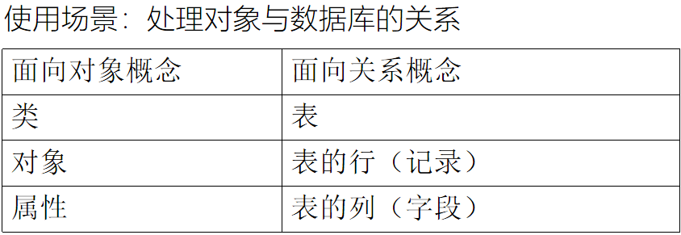
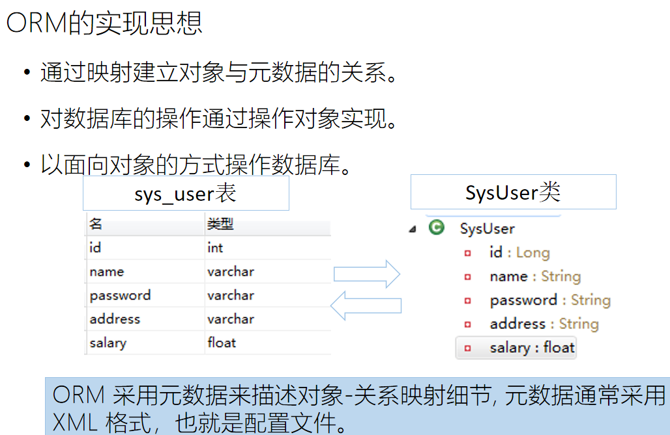
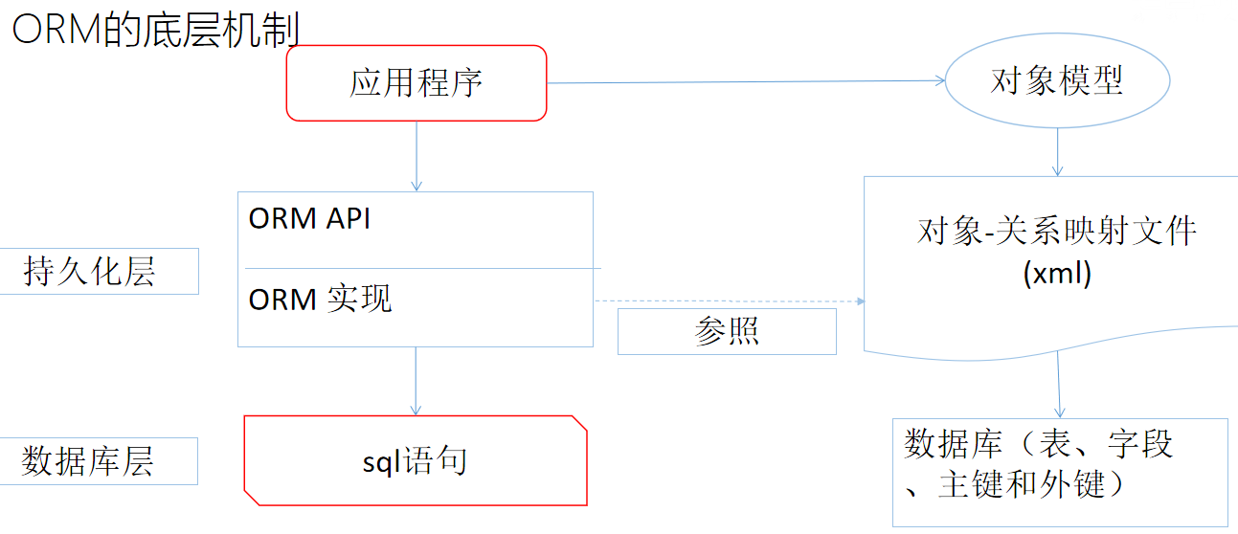

hibernate是什么
Hibernate： 面向java环境的对象/关系数据库映射工具，ORM的具体实现。
开源的持久层框架。
基于ORM(Object/Relational Mapping)思想的具体实现。
连接java应用和数据库的中间件。
对JDBC进行封装，负责java对象的持久化。
封装对数据库的访问细节，以面相对象的方式操作数据库。

使用Hibernate的优点
Hibernate对JDBC访问数据库的代码做了封装，大大简化了数据访问层繁琐的重复性代码
Hibernate使用java的反射机制，而不是字节码增强程序类实现透明性
Hibernate最终生成sql语句并执行，性能较好。
灵活性高，支持各种关联关系。
支持多种数据库类型，使用hibernate开发的程序可以在不同数据库中移植。

Hibernate资源下载
https://sourceforge.net/projects/hibernate/files/hibernate-orm/

使用hibernate操作数据库的步骤

创建一个数据表，记住数据库名和表名
user表： 编号id、用户名username、密码password、生日birthday、手机号phone

pom.xml
<dependency>
<groupId>mysql</groupId>
<artifactId>mysql-connector-java</artifactId>
<version>8.0.30</version>
</dependency>
<dependency>
<groupId>org.hibernate</groupId>
<artifactId>hibernate-core</artifactId>
<version>4.1.1.Final</version>
</dependency>

hibernate.cfg.xml src/main/resources
<?xml version="1.0" encoding="UTF-8"?>
<!DOCTYPE hibernate-configuration PUBLIC
"-//Hibernate/Hibernate Configuration DTD 3.0//EN"
"http://hibernate.sourceforge.net/hibernate-configuration-3.0.dtd">
<hibernate-configuration>

<session-factory>
<property name="connection.username">root</property>
<property name="connection.url">
jdbc:mysql://localhost:3306/cc
</property>
<property name="hibernate.dialect">
org.hibernate.dialect.MySQLDialect
</property>
<property name="connection.password">123456</property>
<property name="connection.driver_class">
com.mysql.jdbc.Driver
</property>
<property name="show_sql">true</property>
<property name="format_sql">true</property>
<property name="hbm2ddl.auto">update</property>
<mapping resource="com/tjetc/domain/User.hbm.xml"/>

</session-factory>

</hibernate-configuration>

在src/main/java中创建实体类User
public class User {
private Integer id;
private String username;
private String password;
private Date birthday;
private String phone;

@Override
public String toString() {
return "User{" +
"id=" + id +
", username='" + username + '\'' +
", password='" + password + '\'' +
", birthday=" + birthday +
", phone='" + phone + '\'' +
'}';
}

public User(Integer id, String username, String password, Date birthday, String phone) {
this.id = id;
this.username = username;
this.password = password;
this.birthday = birthday;
this.phone = phone;
}

public User() {
}

public Integer getId() {
return id;
}

public void setId(Integer id) {
this.id = id;
}

public String getUsername() {
return username;
}

public void setUsername(String username) {
this.username = username;
}

public String getPassword() {
return password;
}

public void setPassword(String password) {
this.password = password;
}

public Date getBirthday() {
return birthday;
}

public void setBirthday(Date birthday) {
this.birthday = birthday;
}

public String getPhone() {
return phone;
}

public void setPhone(String phone) {
this.phone = phone;
}
}

在src/main/resources中创建对应的xml文件 User.hbm.xml 注意和实体类的包名和类名保持一致
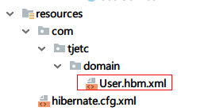

<?xml version="1.0" encoding="utf-8"?>
<!DOCTYPE hibernate-mapping PUBLIC "-//Hibernate/Hibernate Mapping DTD 3.0//EN"
"http://hibernate.sourceforge.net/hibernate-mapping-3.0.dtd">
<hibernate-mapping package="com.tjetc.domain">
<class name="User">
<id name="id">
<generator class="native" />
</id>
<property name="username" />
<property name="password" />
<property name="birthday" type="date" />
<property name="phone" />
</class>
</hibernate-mapping>

修改hibernage.cfg.xml 中对文件的映射文件
<?xml version="1.0" encoding="UTF-8"?>
<!DOCTYPE hibernate-configuration PUBLIC
"-//Hibernate/Hibernate Configuration DTD 3.0//EN"
"http://hibernate.sourceforge.net/hibernate-configuration-3.0.dtd">
<hibernate-configuration>

<session-factory>
<property name="connection.username">root</property>
<property name="connection.url">
jdbc:mysql://localhost:3306/b?serverTimezone=GMT%2B8
</property>
<property name="hibernate.dialect">
org.hibernate.dialect.MySQLDialect
</property>
<property name="connection.password">123456</property>
<property name="conne.Driverction.driver_class">
com.mysql.cj.jdbc.Driver
</property>
<property name="show_sql">true</property>
<property name="format_sql">true</property>
<property name="hbm2ddl.auto">update</property>
<mapping resource="com/tjetc/domain/User.hbm.xml"/>

</session-factory>

</hibernate-configuration>

增删改查测试:
<dependency>
<groupId>junit</groupId>
<artifactId>junit</artifactId>
<version>4.13.2</version>
</dependency>

public final class HibernateUtil {

private static SessionFactory sessionFactory;

private HibernateUtil() {

}

static {
try {
sessionFactory= new Configuration().configure().buildSessionFactory();
} catch (Throwable e) {
throw new ExceptionInInitializerError(e);
}
}

public static SessionFactory getSessionFactory() {
return sessionFactory;
}
}
public class Test1 {
private SessionFactory factory= HibernateUtil.getSessionFactory();
@Test
public void testAdd() {
Session session = factory.openSession();
Transaction transaction = session.beginTransaction();
User user = new User();
user.setId(3);
user.setUsername("lizi3");
user.setPassword("1233");
user.setBirthday(new Date());
user.setPhone("133123456789");
session.save(user);
transaction.commit();
session.close();
}
@Test
public void testUpdate() {
Session session = factory.openSession();
Transaction transaction = session.beginTransaction();
User user = new User();
user.setId(1);
user.setUsername("lizi3");
user.setPassword("1233");
user.setBirthday(new Date(System.currentTimeMillis()-10000000));
user.setPhone("18912345678");
session.update(user);
transaction.commit();
session.close();
}
@Test
public void testDel() {
Session session = factory.openSession();
Transaction transaction = session.beginTransaction();
User user = new User();
user.setId(1);
session.delete(user);
transaction.commit();
session.close();
}
@Test
public void testSelect() {
Session session = factory.openSession();
List list = session.createQuery("from User where username like ?").setString(0, "%z%").setFirstResult(0).setMaxResults(2).list();
System.out.println("list = " + list);
session.close();
}
@Test
public void testCount() {
Session session = factory.openSession();
int count=((Long)session.createQuery("select count(*) from User where username like ?").setString(0,"%%").uniqueResult()).intValue();
System.out.println("count = " + count);
session.close();
}
@Test
public void testFindById() {
Session session = factory.openSession();
User user = (User) session.createQuery("from User where id=?").setInteger(0, 1).uniqueResult();
System.out.println("user = " + user);
session.close();
}
}

hibernate运行流程
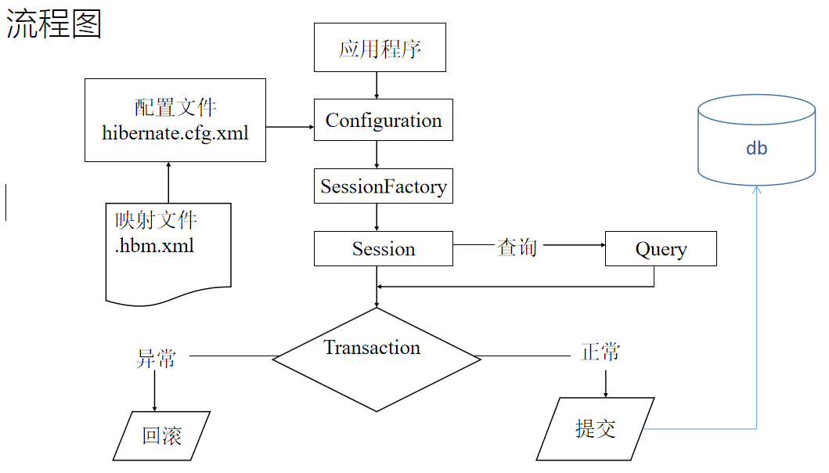
应用程序先调用Configuration类,该类读取Hibernate配置文件及映射文件中的信息;
读取后创建SessionFactory对象，该对象封装了配置配置信息;
通过工厂类SessionFactory创建Session对象（数据库操作对象）；
通过Session对象生成Transaction对象（事务控制对象）；
调用Session对象的方法进行CURD等操作；
提交事物。
关闭资源

注解
hibernate.cfg.xml
<mapping class="com.tjetc.domain.User"/>
User.java
@Entity
public class User {
@Id
@GeneratedValue(strategy = GenerationType.IDENTITY)
private Integer id;
private String username;
private String password;
@Type(type = "date")
private Date birthday;
private String phone;

@Override
public String toString() {
return "User{" +
"id=" + id +
", username='" + username + '\'' +
", password='" + password + '\'' +
", birthday=" + birthday +
", phone='" + phone + '\'' +
'}';
}

public User(Integer id, String username, String password, Date birthday, String phone) {
this.id = id;
this.username = username;
this.password = password;
this.birthday = birthday;
this.phone = phone;
}

public User() {
}

public Integer getId() {
return id;
}

public void setId(Integer id) {
this.id = id;
}

public String getUsername() {
return username;
}

public void setUsername(String username) {
this.username = username;
}

public String getPassword() {
return password;
}

public void setPassword(String password) {
this.password = password;
}

public Date getBirthday() {
return birthday;
}

public void setBirthday(Date birthday) {
this.birthday = birthday;
}

public String getPhone() {
return phone;
}

public void setPhone(String phone) {
this.phone = phone;
}
}

Struts2 Hibernate实现用户登录功能
任务名称 基于struts2整合hibernate实现数据库用户信息表CURD操作设计
开发环境 Intellij IDEA Chrome
完成功能 Struts2整合Hibernate实现用户登录，登录后进入主页面，提供用户的列表，同时提供新增链接，实现CRUD操作。

pom.xml
<?xml version="1.0" encoding="UTF-8"?>
<project xmlns="http://maven.apache.org/POM/4.0.0"
xmlns:xsi="http://www.w3.org/2001/XMLSchema-instance"
xsi:schemaLocation="http://maven.apache.org/POM/4.0.0 http://maven.apache.org/xsd/maven-4.0.0.xsd">
<modelVersion>4.0.0</modelVersion>

<groupId>com.tjetc</groupId>
<artifactId>day0620struts3</artifactId>
<version>1.0-SNAPSHOT</version>
<packaging>war</packaging>
<dependencies>
<dependency>
<groupId>org.apache.struts</groupId>
<artifactId>struts2-core</artifactId>
<version>2.5.2</version>
</dependency>
<dependency>
<groupId>javax.servlet</groupId>
<artifactId>javax.servlet-api</artifactId>
<version>4.0.1</version>
<scope>provided</scope>
</dependency>
<dependency>
<groupId>org.hibernate</groupId>
<artifactId>hibernate-core</artifactId>
<version>4.1.1.Final</version>
</dependency>
<dependency>
<groupId>mysql</groupId>
<artifactId>mysql-connector-java</artifactId>
<version>8.0.30</version>
</dependency>
<dependency>
<groupId>jstl</groupId>
<artifactId>jstl</artifactId>
<version>1.2</version>
</dependency>

</dependencies>
<build>
<plugins>
<plugin>
<groupId>org.apache.tomcat.maven</groupId>
<artifactId>tomcat7-maven-plugin</artifactId>
<version>2.2</version>
<configuration>
<port>8080</port>
<path>/</path>
</configuration>
</plugin>
</plugins>
</build>
</project>

web.xml
<?xml version="1.0" encoding="UTF-8"?>
<web-app xmlns="http://xmlns.jcp.org/xml/ns/javaee"
xmlns:xsi="http://www.w3.org/2001/XMLSchema-instance"
xsi:schemaLocation="http://xmlns.jcp.org/xml/ns/javaee http://xmlns.jcp.org/xml/ns/javaee/web-app_4_0.xsd"
version="4.0">
<filter>
<filter-name>struts2</filter-name>
<filter-class>org.apache.struts2.dispatcher.filter.StrutsPrepareAndExecuteFilter</filter-class>
</filter>
<filter-mapping>
<filter-name>struts2</filter-name>
<url-pattern>/*</url-pattern>
</filter-mapping>
</web-app>

struts.xml
<?xml version="1.0" encoding="UTF-8"?>

<!DOCTYPE struts PUBLIC
"-//Apache Software Foundation//DTD Struts Configuration 2.5//EN"
"http://struts.apache.org/dtds/struts-2.5.dtd">

<struts>
<package name="hello" namespace="/" extends="struts-default">
<action name="hello" class="com.tjetc.action.HelloAction">
<result name="hello">/hello.jsp</result>
</action>
</package>
<package name="login" namespace="/" extends="struts-default">
<global-allowed-methods>regex:.*</global-allowed-methods>
<action name="user_*" class="com.tjetc.action.UserAction" method="{1}">
<result name="msg">msg.jsp</result>
<result name="toList" type="redirect">/user_list</result>
<result name="list">/list.jsp</result>
<result name="update">/update.jsp</result>
</action>
</package>
</struts>

hibernate.cfg.xml
<?xml version="1.0" encoding="UTF-8"?>
<!DOCTYPE hibernate-configuration PUBLIC
"-//Hibernate/Hibernate Configuration DTD 3.0//EN"
"http://hibernate.sourceforge.net/hibernate-configuration-3.0.dtd">
<hibernate-configuration>

<session-factory>
<property name="connection.username">root</property>
<property name="connection.url">
jdbc:mysql://localhost:3306/b?serverTimezone=GMT%2B8
</property>
<property name="hibernate.dialect">
org.hibernate.dialect.MySQLDialect
</property>
<property name="connection.password">123456</property>
<property name="connection.driver_class">
com.mysql.jdbc.Driver
</property>
<property name="show_sql">true</property>
<property name="format_sql">true</property>
<property name="hbm2ddl.auto">update</property>
<mapping resource="com/tjetc/domain/User.hbm.xml"/>

</session-factory>

</hibernate-configuration>

User.hbm.xml
<?xml version="1.0" encoding="utf-8"?>
<!DOCTYPE hibernate-mapping PUBLIC "-//Hibernate/Hibernate Mapping DTD 3.0//EN"
"http://hibernate.sourceforge.net/hibernate-mapping-3.0.dtd">
<hibernate-mapping package="com.tjetc.domain">
<class name="com.tjetc.domain.User" table="user">
<id name="id">
<generator class="native" />
</id>
<property name="username" />
<property name="password" />
<property name="birthday" type="date" />
<property name="phone" />
</class>
</hibernate-mapping>

Login.jsp
<%@ page contentType="text/html;charset=UTF-8" language="java" %>
<html>
<head>
<title>Title</title>
<base href="${pageContext.request.contextPath}/"/>
</head>
<body>
<form action="user_login" method="post">
用户名: <input type="text" name="username"> <br>
密码: <input type="password" name="password"> <br>
<input type="submit" value="提交">
</form>
</body>
</html>

UserAction.java
package com.tjetc.action;

import com.opensymphony.xwork2.ModelDriven;
import com.sun.org.apache.regexp.internal.RE;
import com.tjetc.domain.User;
import com.tjetc.service.UserService;
import org.apache.struts2.ServletActionContext;

import java.util.List;

public class UserAction implements ModelDriven<User> {
private UserService userService=new UserServiceImpl();
private User user=new User();
private String msg;

public String getMsg() {
return msg;
}

public void setMsg(String msg) {
this.msg = msg;
}

public User getUser() {
return user;
}

public void setUser(User user) {
this.user = user;
}

@Override
public User getModel() {
return user;
}
public String login(){
User user1=userService.findByUsername(user.getUsername());
if (user1==null){
msg="用户名不存在";
return "msg";
}
else if (!user1.getPassword().equals(user.getPassword())){
msg="密码不正确";
return "msg";
}
else {
ServletActionContext.getRequest().getSession().setAttribute("user", user1);
return "toList";
}
}
public String list(){
String username = user.getUsername();
username=username==null?"":username;
List<User> list=userService.list(username);
ServletActionContext.getRequest().setAttribute("list", list);
return "list";
}
public String findById(){
user=userService.findById(user.getId());
return "update";
}
public String update(){
System.out.println("UserAction.update([])方法:"+user);
boolean b=userService.update(user);
return "toList";
}
public String add(){
System.out.println("UserAction.add([])方法:"+user);
boolean b=userService.add(user);
return "toList";
}
public String del(){
System.out.println("UserAction.del([])方法:"+user);
boolean b=userService.del(user);
return "toList";
}
}

UserDao
public interface UserDao {
User findByUsername(String username);

List<User> list(String username);

User findById(Integer id);

boolean add(User user);

boolean update(User user);

boolean del(User user);
}

HibernateUtil
public final class HibernateUtil {

private static SessionFactory sessionFactory;

private HibernateUtil() {

}

static {
try {
sessionFactory= new Configuration().configure().buildSessionFactory();
} catch (Throwable e) {
throw new ExceptionInInitializerError(e);
}
}

public static SessionFactory getSessionFactory() {
return sessionFactory;
}
}

UserDaoImpl
public class UserDaoImpl implements com.tjetc.dao.UserDao {
private static SessionFactory sessionFactory = HibernateUtil.getSessionFactory();
@Override
public User findByUsername(String username) {
Session session = sessionFactory.openSession();
User user = (User) session.createQuery("from User where username=?").setString(0, username).uniqueResult();
session.close();
return user;
}

@Override
public List<User> list(String username) {
Session session = sessionFactory.openSession();
List list = session.createQuery("from User u where u.username like ?").setString(0,"%"+username+"%").list();
session.close();
return list;
}

@Override
public User findById(Integer id) {
Session session = sessionFactory.openSession();
User user = (User) session.createQuery("from User where id=?").setInteger(0, id).uniqueResult();
session.close();
return user;
}

@Override
public boolean add(User user) {
Session session = sessionFactory.openSession();
Transaction transaction = session.beginTransaction();
Serializable save = session.save(user);
transaction.commit();
session.close();
return save!=null;
}

@Override
public boolean update(User user) {
try {
Session session = sessionFactory.openSession();
Transaction transaction = session.beginTransaction();
session.update(user);
transaction.commit();
session.close();
return true;
} catch (HibernateException e) {
e.printStackTrace();
}
return false;
}

@Override
public boolean del(User user) {
try {
Session session = sessionFactory.openSession();
Transaction transaction = session.beginTransaction();
session.delete(user);
transaction.commit();
session.close();
return true;
} catch (HibernateException e) {
e.printStackTrace();
}
return false;
}
}

UserService
public interface UserService {
User findByUsername(String username);

List<User> list(String username);

User findById(Integer id);

boolean update(User user);

boolean del(User user);

boolean add(User user);
}

10．UserServiceImpl
public class UserServiceImpl implements UserService {
private UserDao userDao = new UserDaoImpl();

@Override
public User findByUsername(String username) {
return userDao.findByUsername(username);
}

@Override
public List<User> list(String username) {
return userDao.list(username);
}

@Override
public User findById(Integer id) {
return userDao.findById(id);
}

@Override
public boolean update(User user) {
return userDao.update(user);
}

@Override
public boolean del(User user) {
return userDao.del(user);
}

@Override
public boolean add(User user) {
return userDao.add(user);
}
}

User
public class User {
private Integer id;
private String username;
private String password;
private Date birthday;
private String phone;

public Integer getId() {
return id;
}

public void setId(Integer id) {
this.id = id;
}

public String getUsername() {
return username;
}

public void setUsername(String username) {
this.username = username;
}

public String getPassword() {
return password;
}

public void setPassword(String password) {
this.password = password;
}

public Date getBirthday() {
return birthday;
}

public void setBirthday(Date birthday) {
this.birthday = birthday;
}

public String getPhone() {
return phone;
}

public void setPhone(String phone) {
this.phone = phone;
}
}

list.jsp
<%@ taglib prefix="c" uri="http://java.sun.com/jsp/jstl/core" %>
<%@ page contentType="text/html;charset=UTF-8" language="java" %>
<html>
<head>
<title>Title</title>
<base href="${pageContext.request.contextPath}/"/>
<script>
function query() {
location.href='user_list?username='+document.getElementById("username").value
}
function add() {
location.href='add.jsp'
}
</script>
</head>
<body>
<div>
<input type="text" id="username" value="${username}">
<button onclick="query()">查询</button>
<button onclick="add()">提交</button>
</div>
<table border="1" cellspacing="0" width="70%">
<tr align="center">
<th>序号</th>
<th>用户名</th>
<th>密码</th>
<th>生日</th>
<th>手机</th>
<th>操作</th>
</tr>
<c:forEach items="${list}" var="user">
<tr align="center">
<td>${user.id}</td>
<td>${user.username}</td>
<td>${user.password}</td>
<td>${user.birthday}</td>
<td>${user.phone}</td>
<td>
<a href="user_findById?id=${user.id}">修改</a>
<a href="user_del?id=${user.id}">删除</a>
</td>
</tr>
</c:forEach>
</table>
</body>
</html>

add.jsp
<%@ page contentType="text/html;charset=UTF-8" language="java" %>
<html>
<head>
<title>Title</title>
<base href="${pageContext.request.contextPath}/"/>
</head>
<body>
<form action="user_add" method="post">
用户名:<input type="text" name="username" /><br/>
密码:<input type="password" name="password" /><br/>
生日:<input type="date" name="birthday" /><br/>
手机:<input type="text" name="phone" /><br/>
<input type="submit" value="提交"/><br/>
</form>
</body>
</html>

update.jsp

<%@ page contentType="text/html;charset=UTF-8" language="java" %>
<html>
<head>
<title>Title</title>
<base href="${pageContext.request.contextPath}/"/>
</head>
<body>
<form action="user_update" method="post">
<input type="hidden" name="id" value="${user.id}">
用户名:<input type="text" name="username" value="${user.username}"/><br/>
密码:<input type="password" name="password" value="${user.password}"/><br/>
生日:<input type="date" name="birthday" value="${user.birthday}" /><br/>
手机:<input type="text" name="phone" value="${user.phone}" /><br/>
<input type="submit" value="提交"/><br/>
</form>
</body>
</html>

msg.jsp
<%@ page language="java" contentType="text/html; charset=UTF-8"
pageEncoding="UTF-8"%>
<!DOCTYPE html PUBLIC "-//W3C//DTD HTML 4.01 Transitional//EN" "http://www.w3.org/TR/html4/loose.dtd">
<html>
<head>
<meta http-equiv="Content-Type" content="text/html; charset=UTF-8">
<title>Insert title here</title>
</head>
<body>
${msg} <br>
<a href="login.jsp">去登录</a>
</body>
</html>

