javaweb模块级开发示例

目录
1、html+css+js示例 3
2、 表单接收示例 5
Servlet 5
Jsp 5
3、JavaBeans示例 7
4、会话管理 9
使用HttpSession对象管理会话。 10
使用Cookie跟踪会话 11
5、 数据库访问 15

1、html+css+js示例
<!DOCTYPE html>
<html>
<head>
<meta charset="utf-8">
<title>网页示例</title>
<style>
body {
background-color:#d0e4fe;
}
h1 {
color:orange;
text-align:center;
}
p {
font-family:"Times New Roman";
font-size:20px;
}
</style>
<script>
function formSubmit(){
var x = document.forms["frm1"]["username"].value;
if (x == null || x == "") {
alert("需要输入名字。");
return false;}
else{
document.getElementById("frm1").submit();
}
}
</script>
</head>
<body>
<h1>CSS 实例：这是一个标题!</h1>
<p>这是一个段落。</p>
<form id="frm1" action="form_action.jsp">
用户名称: <input type="text" name="username"><br>
登录密码: <input type="text" name="passwd" required="required"><br><br>
<input type="button" onclick="formSubmit()" value="提交表单">
</form>
</body>
</html>

表单接收示例

Servlet
import java.io.IOException;
import java.io.PrintWriter;
import javax.servlet.ServletException;
import javax.servlet.annotation.WebServlet;
import javax.servlet.http.HttpServlet;
import javax.servlet.http.HttpServletRequest;
import javax.servlet.http.HttpServletResponse;
/**
* Servlet implementation class formshow1
*/
@WebServlet("/formshow1")
public class formshow1 extends HttpServlet {
/**
*
*/
private static final long serialVersionUID = 1L;
public void service(HttpServletRequest request,HttpServletResponse response)
throws ServletException, IOException{
String userName = request.getParameter("uName");
PrintWriter pw = response.getWriter();
pw.println("<html>");
pw.println("<head>");
pw.println("</head>");
pw.println("<body>");
pw.println("<h3>Hello, " + userName + "</h3>");
pw.println("<h3>Hello, " + new java.util.Date() + "</h3>");
pw.println("</body>");
pw.println("</html>");
}
}

Jsp
<html>
<head>
<title>Using GET and POST Method to Read Form Data</title>
</head>
<body>
<center>
<h1>Read Form Data</h1>
<ul>
<li><p><b>user Name:</b>
<%= request.getParameter("uname")%>
</p></li>
<li><p><b>password:</b>
<%= request.getParameter("passwd")%>
</p></li>
</ul>
</body>
</html>

3、JavaBeans示例
创建一个JavaBean包，并在其下创建StudentBean的class。下面是一个属性很少的StudentBean.java 文件：
public class StudentBean implements java.io.Serializable {
private String firstName = null;
private String lastName = null;
private int age = 0;

public void StudentsBean() {
}
public String getFirstName(){
return firstName;
}
public String getLastName(){
return lastName;
}
public int getAge(){
return age;
}
public void setFirstName(String firstName){
this.firstName = firstName;
}
public void setLastName(String lastName){
this.lastName = lastName;
}
public void setAge(int age){
this.age = age;
}
}

访问JavaBean
<jsp:useBean> 标签可以在 JSP 中声明一个 JavaBean，然后使用。声明后，JavaBean 对象就成了脚本变量，可以通过脚本元素或其他自定义标签来访问。
jsp:useBean 标签的语法格式如下：
<jsp:useBean id = "bean's name" scope = "bean's scope" typeSpec></jsp:useBean>
其中，根据具体情况，scope 的值可以是 page，request，session 或 application。id值可任意只要不和同一 JSP 文件中其它<jsp:useBean>中 id 值一样就行了。

访问 JavaBean 对象的属性
在 <jsp:useBean> 标签主体中使用 <jsp:getProperty></jsp:getProperty> 标签来调用 getter 方法，使用 <jsp:setProperty></jsp:setProperty> 标签来调用 setter 方法，语法格式如下：
<jsp:useBean id = "id" class = "bean's class" scope = "bean's scope">
<jsp:setProperty name = "bean's id" property = "property name"
value = "value"></jsp:setProperty>
<jsp:getProperty name = "bean's id" property = "property name"></jsp:getProperty>
...........
</jsp:useBean>
name属性指的是Bean的id属性。property属性指的是想要调用的getter或setter方法。
接下来给出使用以上语法进行属性访问的一个简单例子：
<html>
<head>
<title>get and set properties Example</title>
</head>

<body>
<jsp:useBean id = "students" class = "JavaBean.StudentsBean">
<jsp:setProperty name = "students" property = "firstName" value = "Zara"></jsp:setProperty>
<jsp:setProperty name = "students" property = "lastName" value = "Ali"></jsp:setProperty>
<jsp:setProperty name = "students" property = "age" value = "10"></jsp:setProperty>
</jsp:useBean>
<p>Student First Name:
<jsp:getProperty name = "students" property = "firstName"></jsp:getProperty>
</p>
<p>Student Last Name:
<jsp:getProperty name = "students" property = "lastName"></jsp:getProperty>
</p>
<p>Student Age:
<jsp:getProperty name = "students" property = "age"></jsp:getProperty>
</p>
</body>
</html>
将以上代码放入BeanExample.jsp中。运行结果如下：
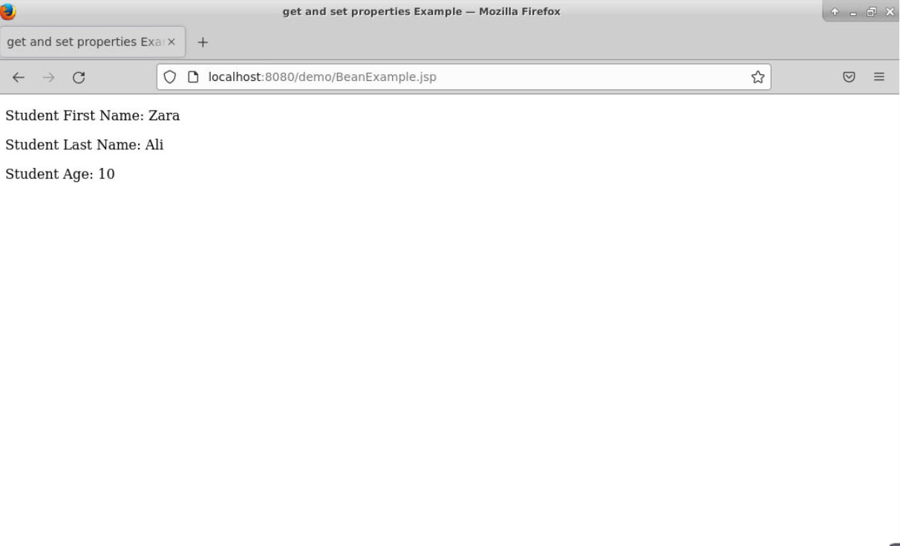

4、会话管理
Web服务器跟踪客户的状态方法通常有：
（1）使用HttpSession对象管理会话；（2）使用持久的Cookie对象；

使用HttpSession对象管理会话。
新建一个名为ShowSession的Servlet类，代码如下
package com.demo;
import java.io.*;
import javax.servlet.*;
import javax.servlet.http.*;
import java.util.Date;

public class ShowSession extends HttpServlet{
public void doGet(HttpServletRequest request,
HttpServletResponse response)
throws ServletException, IOException {

response.setContentType("text/html");
HttpSession session = request.getSession();
String heading =null;
Integer accessCount = (Integer)session.getAttribute("accessCount");

if(accessCount==null){
accessCount = new Integer(0);
heading = "Welcome, Newcomer";
}else{
heading = "Welcome Back.";
accessCount = new Integer(accessCount.intValue()+1);
}
session.setAttribute("accessCount",accessCount);

PrintWriter out = response.getWriter();
out.println("<html><head>");
out.println("<title>Session Tracking Example</title></head>");
out.println("<body><center>");
out.println("<h1>"+heading+"</h1>");
out.println("<h2>Information about your session.</h2>");
out.println("<table border='1'>");
out.println("<tr bgcolor=\"ffad00\"><th>Info Type<th>Value\n");
out.println("<tr><td>ID<td>"+session.getId()+"\n");
out.println("<tr><td>Creation Time:<td>");
out.println(""+new Date(session.getCreationTime())+"\n");
out.println("<tr><td>Time of last access:<td>");
out.println(""+new Date(session.getLastAccessedTime())+"\n");
out.println("<tr><td>Access number:<td>"+accessCount+"\n");
out.println("</table></center></body></html>");
}
}
在web.xml中加入内容
<servlet>
<servlet-name>ShowSession</servlet-name>
<servlet-class>com.demo.ShowSession</servlet-class>
</servlet>
<servlet-mapping>
<servlet-name>ShowSession</servlet-name>
<url-pattern>/showSession</url-pattern>
</servlet-mapping>
运行ShowSession查看结果
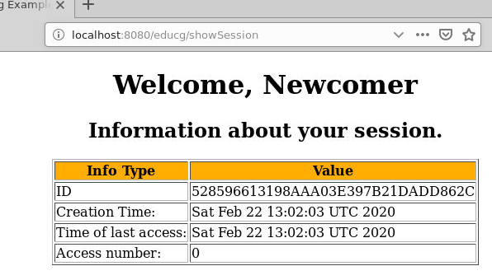

使用Cookie跟踪会话
新建一个名为SendCookie的Sevlet类，向客户端写入Cookie对象
package com.demo;

import java.io.*;
import javax.servlet.*;
import javax.servlet.http.*;

public class SendCookie extends HttpServlet{
public void doGet(HttpServletRequest request,
HttpServletResponse response)
throws IOException,ServletException{

Cookie userCookie = new Cookie("user", "uid1234");
userCookie. setMaxAge(60*60*24*7);
response.addCookie(userCookie);

response.setContentType("text/html");
PrintWriter out=response.getWriter();

out.println("<html><title>add cookies</title>");
out.println("<body><h2>"+
"A cookie has been sent to brower</h2></body>");
out.println("</html>");
}
}
新建一个名为GetCookie的Servlet类，读取客户端的Cookie对象
package com.demo;

import java.io.*;
import javax.servlet.*;
import javax.servlet.http.*;

public class GetCookie extends HttpServlet{
public void doGet(HttpServletRequest
request,HttpServletResponse response)
throws IOException,ServletException{

String cookieName = "user";
String cookieValue = null;
Cookie[] cookies = request.getCookies();
if (cookies!=null){
for(int i = 0;i<cookies.length;i++){
Cookie cookie = cookies[i];
if(cookie.getName().equals(cookieName))
cookieValue = cookie.getValue();
}
}

response.setContentType("text/html");
PrintWriter out=response.getWriter();
out.println("<html><title>get cookies</title>");
out.println("<body><h2>A cookie has been got from brower</h2>");
out.println("CookieName:"+cookieName+"<br>");
out.println("CookieValue:"+cookieValue+"<br>");
out.println("</body></html>");
}
}
在web.xml中添加内容
<servlet>
<servlet-name>SendCookie</servlet-name>
<servlet-class>com.demo.SendCookie</servlet-class>
</servlet>
<servlet-mapping>
<servlet-name>SendCookie</servlet-name>
<url-pattern>/sendCookie</url-pattern>
</servlet-mapping>
<servlet>
<servlet-name>GetCookie</servlet-name>
<servlet-class>com.demo.GetCookie</servlet-class>
</servlet>
<servlet-mapping>
<servlet-name>GetCookie</servlet-name>
<url-pattern>/getCookie</url-pattern>
</servlet-mapping>
运行SendCookie和GetCookie查看结果
运行SendCookie向客户端写入一个Cookie
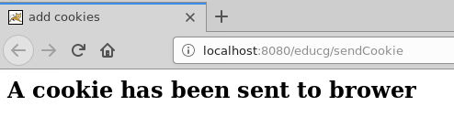
运行GetCookie后可查看对应目录看是否写了一个文件
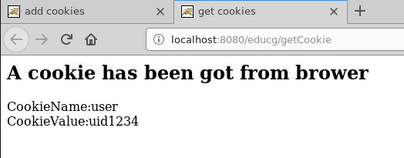

数据库访问
数据库：TEST
数据表：Employees ，字段：id（int）, first（string）, last（string）, age（int）
用户：root 密码：1234
import java.io.*;
import java.util.*;
import javax.servlet.*;
import javax.servlet.http.*;
import java.sql.*;

public class DatabaseAccess extends HttpServlet{

public void doGet(HttpServletRequest request, HttpServletResponse response)
throws ServletException, IOException {

// JDBC driver name and database URL
final String JDBC_DRIVER = "com.mysql.cj.jdbc.Driver";
final String DB_URL="jdbc:mysql://localhost:3306/Employees?useUnicode=true&characterEncoding=utf8&serverTimezone=GMT";

// Database credentials
final String USER = "root";
final String PASS = "1234";

// Set response content type
response.setContentType("text/html");
PrintWriter out = response.getWriter();
String title = "Database Result";

String docType =
"<!doctype html public \"-//w3c//dtd html 4.0 " + "transitional//en\">\n";

out.println(docType +
"<html>\n" +
"<head><title>" + title + "</title></head>\n" +
"<body bgcolor = \"#f0f0f0\">\n" +
"<h1 align = \"center\">" + title + "</h1>\n");

Connection conn = null;
Statement stmt = null;
try {
// Register JDBC driver
Class.forName("com.mysql.cj.jdbc.Driver");

// Open a connection
conn = DriverManager.getConnection(DB_URL, USER, PASS);

// Execute SQL query
stmt = conn.createStatement();
String sql;
sql = "SELECT id, first, last, age FROM Employees";
ResultSet rs = stmt.executeQuery(sql);

// Extract data from result set
while(rs.next()){
//Retrieve by column name
int id = rs.getInt("id");
int age = rs.getInt("age");
String first = rs.getString("first");
String last = rs.getString("last");

//Display values
out.print("ID: " + id);
out.print(", Age: " + age);
out.print(", First: " + first);
out.print(", Last: " + last);
out.println("<br>");
}
out.println("</body></html>");

// Clean-up environment
rs.close();
stmt.close();
conn.close();
}
catch(SQLException se) {
//Handle errors for JDBC
se.printStackTrace();
}
catch(Exception e) {
//Handle errors for Class.forName
e.printStackTrace();
}
finally {
//finally block used to close resources
try {
if(stmt!=null)
stmt.close();
}
catch(SQLException se2) {
} // nothing we can do
try {
if(conn!=null)
conn.close();
}
catch(SQLException se) {
se.printStackTrace();
} //end finally try
} //end try
}

