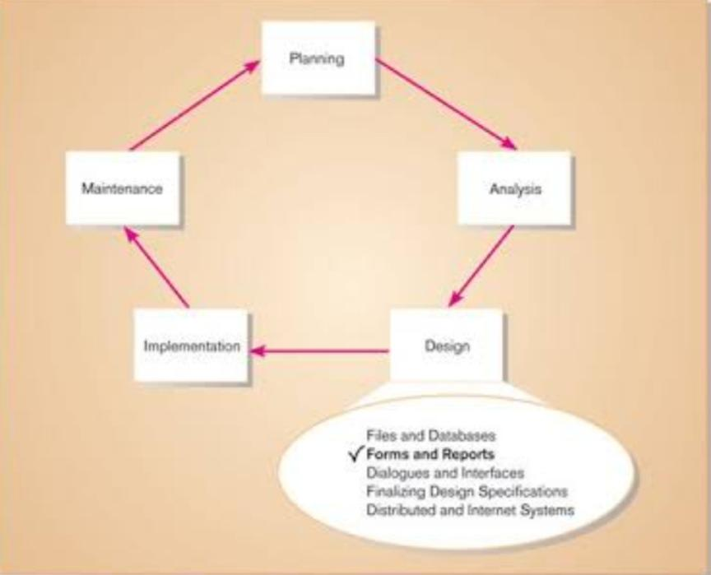**Week 7: Designing the User Interface**

**Designing Forms and Reports**

In studying the topic of Designing Forms and Reports, I gained a deeper understanding of the critical role these elements play in creating effective user interfaces. The design of forms and reports significantly impacts how users interact with a system and how efficiently they can input and retrieve information.

**Designing Forms**

1. **Purpose and Clarity**

I learned that every form must have a well-defined purpose. It should clearly communicate to users what information is needed and why, reducing confusion and improving completion rates.

1. **Logical Layout**

Organizing form fields in a logical flow helps users complete tasks more efficiently. Grouping related fields and using headings or sections enhances readability and usability.

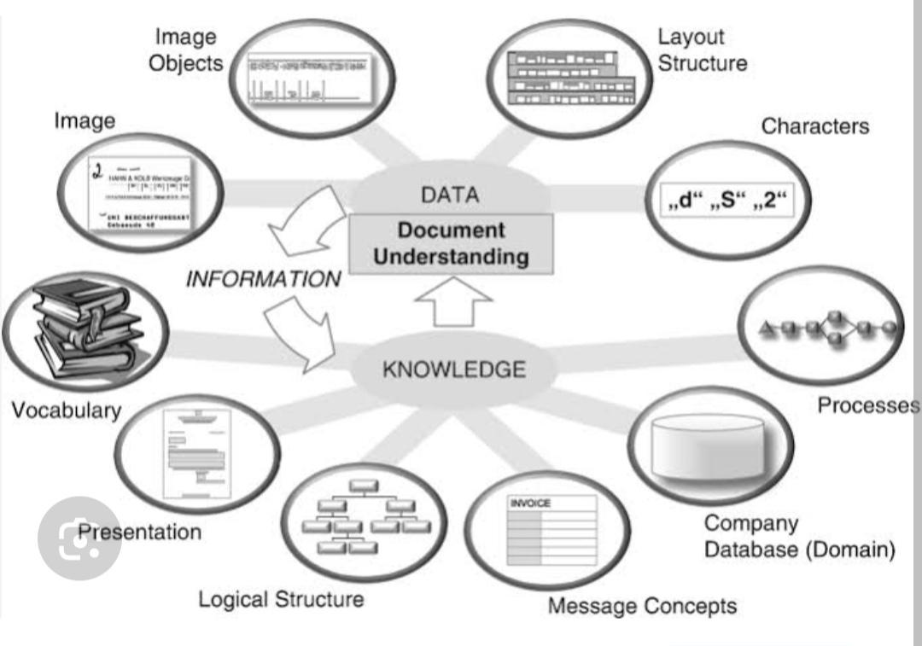

1. **Field Design**

Choosing the right input controls, such as text boxes, dropdowns, or checkboxes, is essential for guiding users to provide accurate data. Labels and placeholders further clarify what is required.

1. **Validation and Feedback**

Real-time validation provides immediate feedback, reducing errors and frustration. I realized how important it is to highlight errors clearly and offer guidance on corrections.

1. **Accessibility**

Ensuring forms are accessible to all users, including those with disabilities, is a critical aspect of inclusive design. Features like proper labeling, keyboard navigation, and alternative text are essential.

1. **Minimizing User Input**

Reducing the amount of data users need to enter, by using defaults or pre-filled fields, simplifies the process and encourages form completion.

**Designing Reports**

1. **Purpose and Audience**

Reports should be tailored to meet the specific needs of the audience. Understanding the purpose of a report helps in structuring content and choosing the right level of detail.

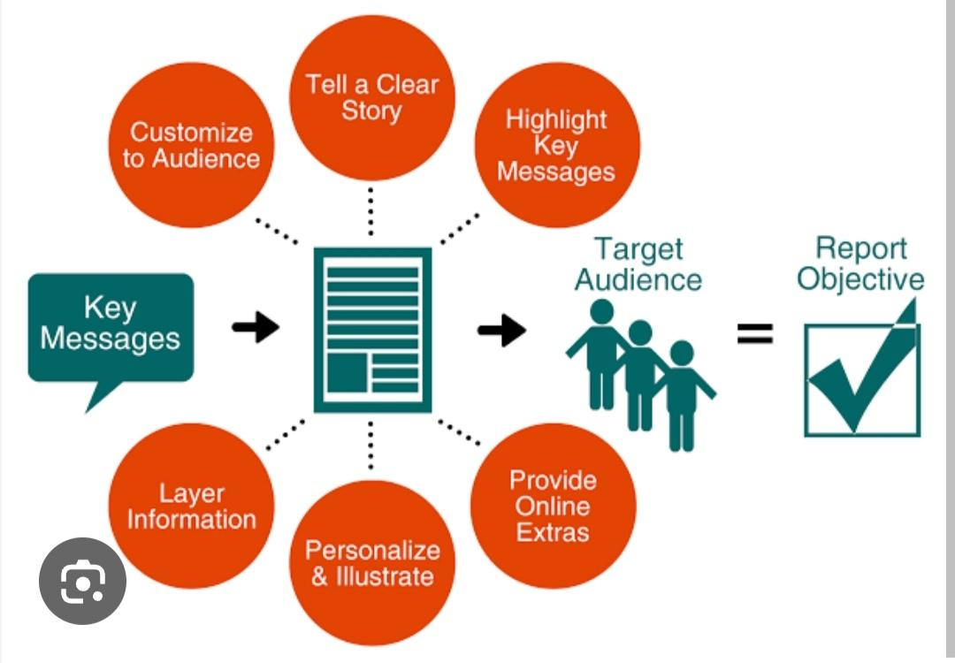

1. **Structure and Organization**

A well-organized report with headings, subheadings, and bullet points makes it easier for users to locate and understand key information.

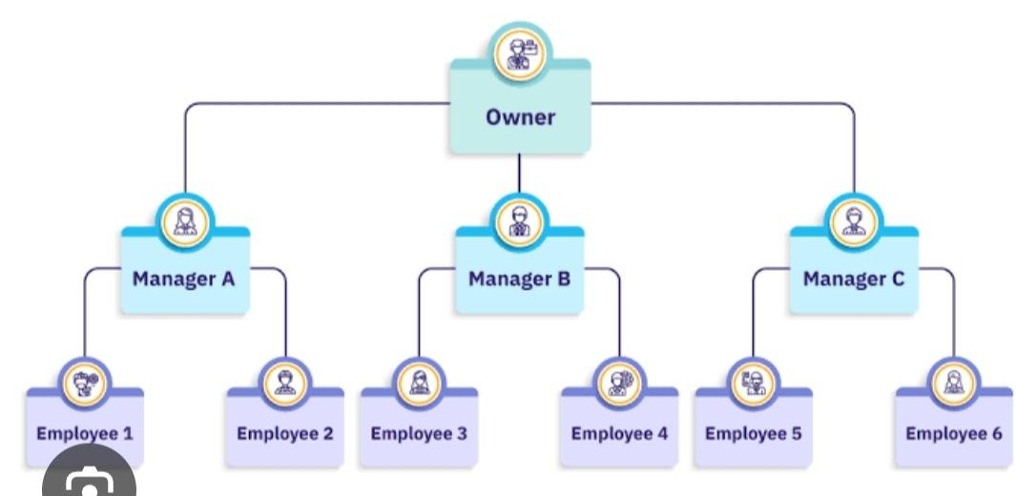

1. **Visual Elements**

Visual aids such as charts, graphs, and tables make complex data more digestible. They help highlight trends and insights at a glance.

1. **Clarity and Conciseness**

Using clear and concise language ensures that reports are accessible to all readers, even those unfamiliar with technical jargon.

1. **Consistency**

Maintaining uniform formatting, fonts, and colors throughout a report enhances professionalism and readability.

1. **Interactivity**

Incorporating interactive elements, like filters or drill-down capabilities, can make reports more engaging and useful for data exploration.

