**Week 1 - Introduction to Information System**

**System**

refers to an organized collection of elements that collaborate to accomplish a particular purpose or series of goals.

**Types of Information System**

* **Transaction Processing Systems (TPS)** are designed to efficiently manage and process huge amounts of transaction data.

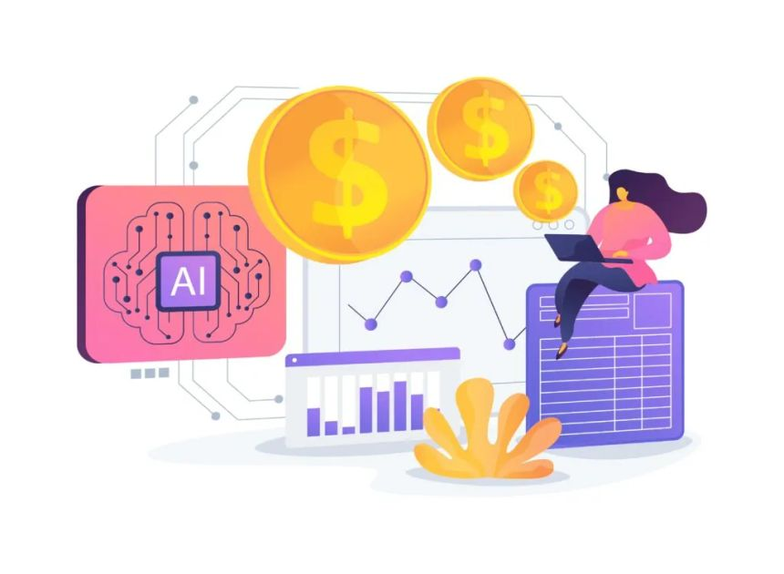

* **Management Information System (MIS)** is an information system that an organization uses to make decisions and to coordinate, control, analyze, and visualize its information.

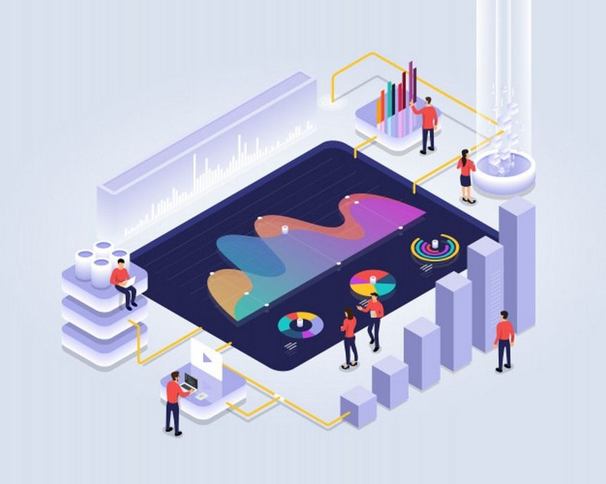

* **Customer Relationship Management (CRM)** is a system that helps you keep track of all the contacts your business has with both existing and new clients.

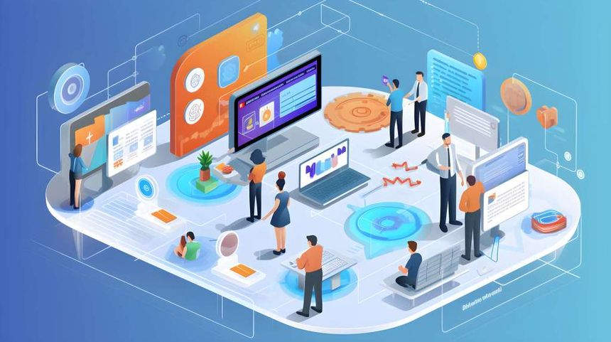

* **Enterprise Resource Planning (ERP**) systems is complex software programs that connect and manage fundamental business activities to ensure maximum performance.

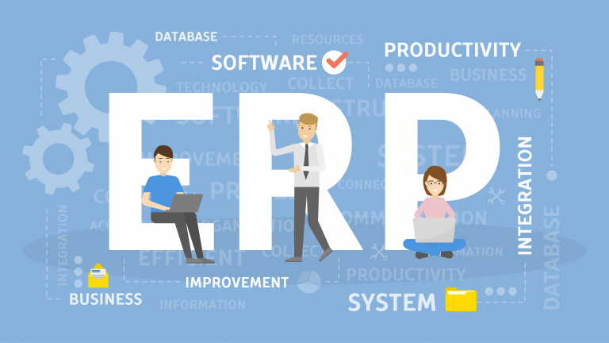

* Decision Support Systems (DSS) are designed to help decision makers by giving them tools to improve the quality of their decisions, data analysis, and pertinent information.

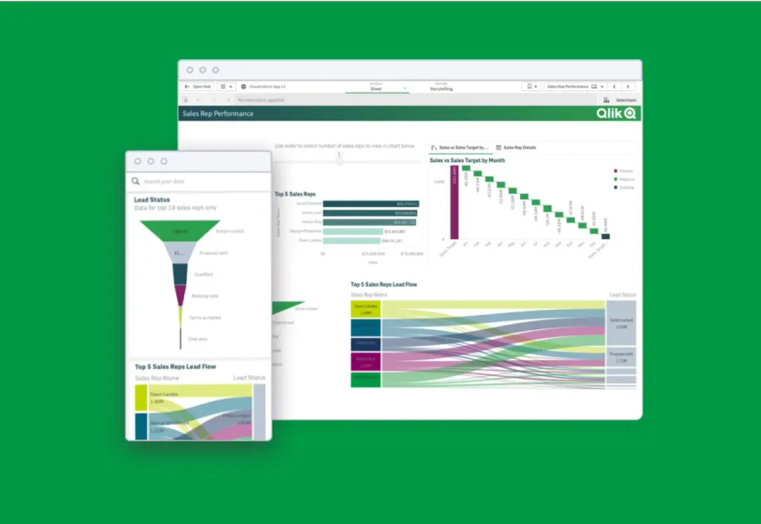

**Week 2 - Approaches to System Development**

The **Software Development Life Cycle (SDLC)** is a systematic method for designing, developing, and maintaining high-quality software.

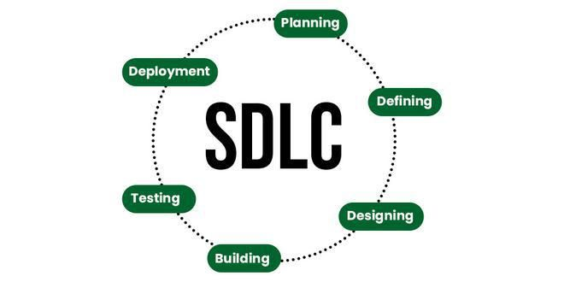

**Software Development Life Cycle (Models):**

* **Waterfall Model** is a sequential software development process in which each step is completed before moving on to the next.

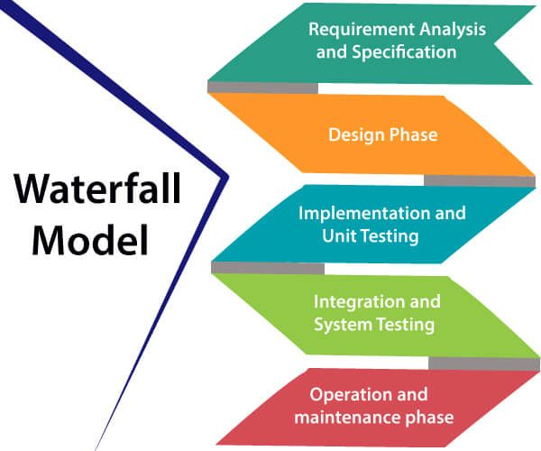

* **Spiral Model** is a Software Development Life Cycle (SDLC) model that emphasizes a systematic and iterative approach to software development.

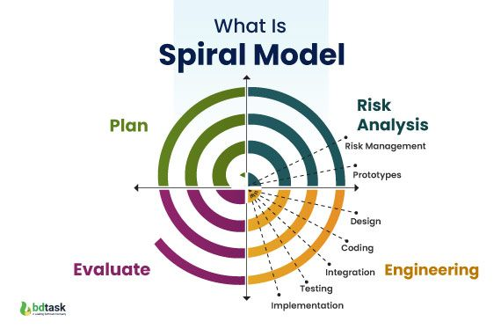

* **Extreme Programming (XP)** is an agile methodology for software development that seeks to enhance development teams' quality of life while producing high-quality software.

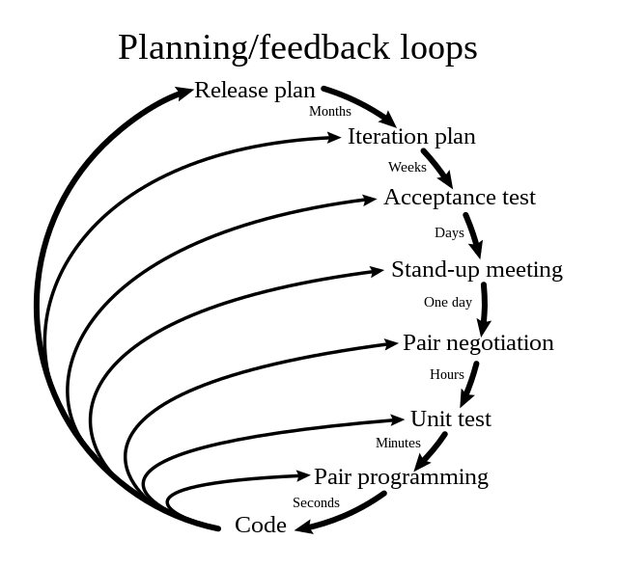

* **Unified Process (UP)** is a software development methodology for modeling applications at the start of their life cycle.



* **Rapid Application Development (RAD)** is a software development process that prioritizes iterative development and rapid prototyping in order to produce functional software in shorter amounts of time.

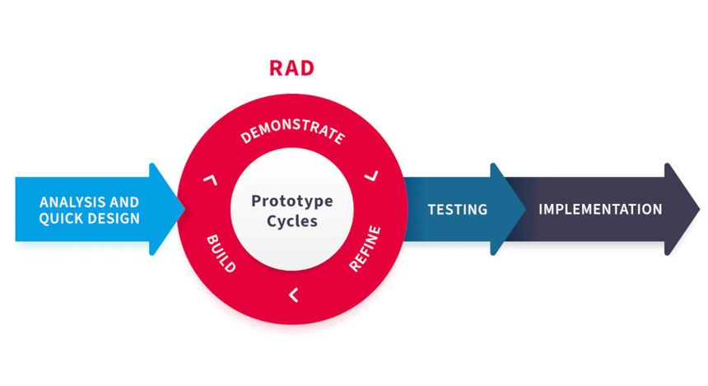

* **Joint Application Development (JAD)** is a method to software development that places a strong emphasis on end users and clients working together to design and develop a system.

