1. Alain Catari, Doris Rush-Lopez, and Toni Aldous Norman
2. Theme: El Jardin de Luz
   1. Here are some of the ideas that we had: Flower garden, Floral Mosaic, Flower puzzle, Garden Mosaic, El Jardin Mosaico, and El Jardin de Luz.
   2. Our last decision was El Jardin de Luz.
   3. 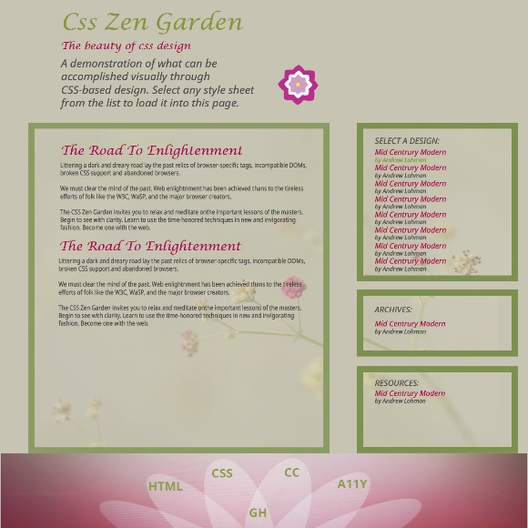We wanted some kind of a flower garden idea. Our first idea was the mosaic idea with animation in the footer.

Figure First Idea

* 1. After some thought we changed our thinking to more graphic designs rather than using a picture image.
  2. We then decided on some kind of garden path. Our second design for the small screen was a garden path with flowers. We were thinking we could use flip boxes for the animation for the large screen with flowers on the front and the information on the back of the flip box. The box would flip when a person hovered over the area.
  3. 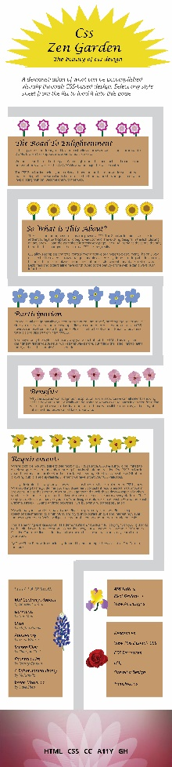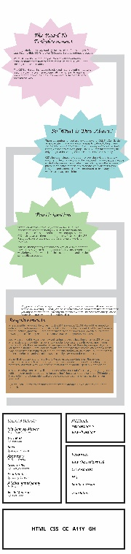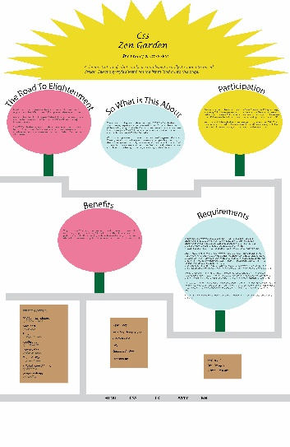Then we decided on flower pop-ups still with a walking path. We haven’t chosen colors, but this was the large and small screen that we finally decided we liked the best. The final idea will have flower images in place of the circles and star shapes.

Figure Second Idea

Figure Large Screen

Figure Small Screen