Сontent

Part 1 Matlab Simulink processing 2

Part 2 Python processing 6

Part 3 Python code 10

# Part 1 Matlab Simulink processing

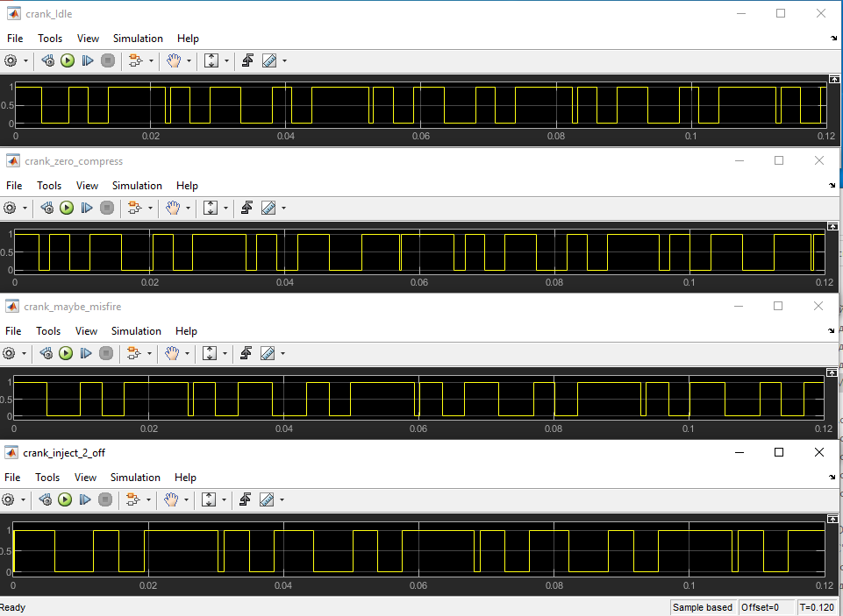

Raw_signal_of_crank (matlab simulink), duration 0.12 s

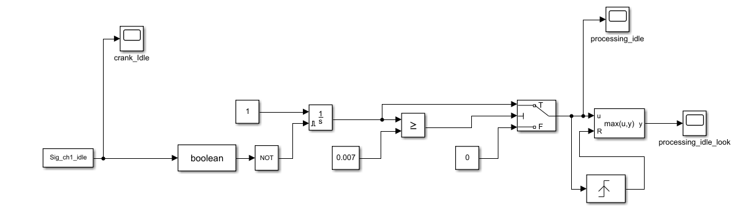

Simulink model

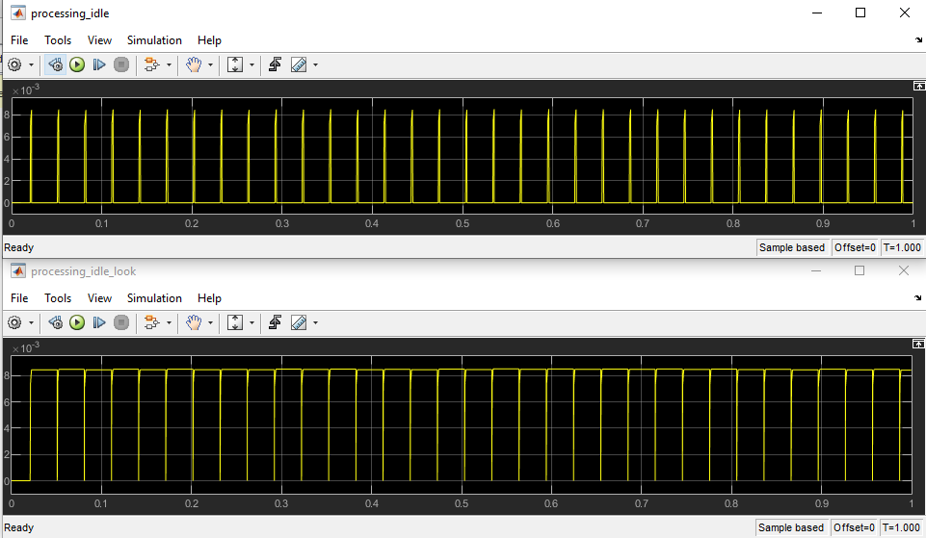

Result idle signal processing, duration 1 s

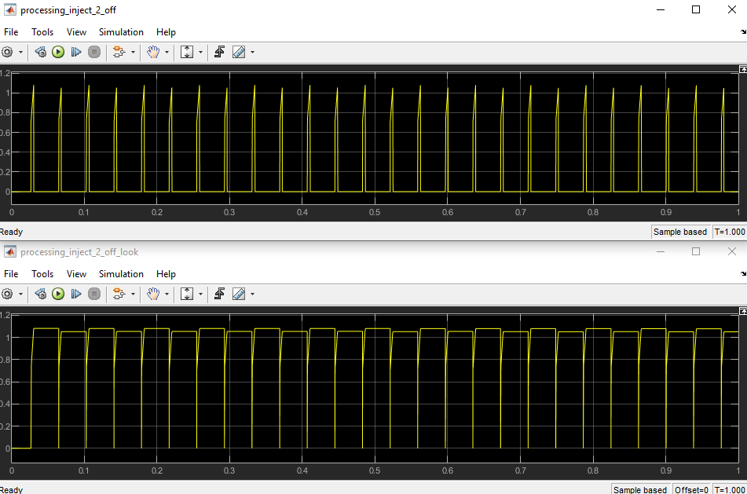

Result inject_2 off signal processing, duration 1 s

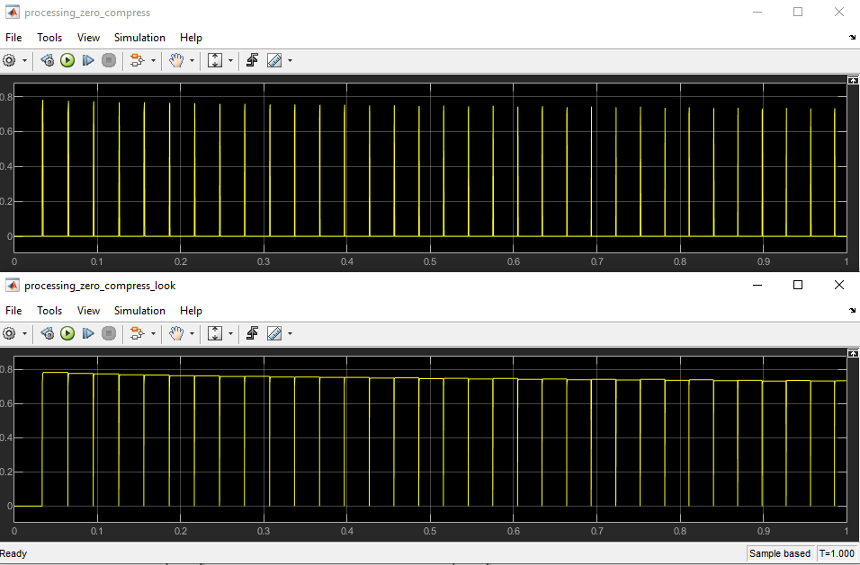

Result zero compressing signal processing, duration 1 s

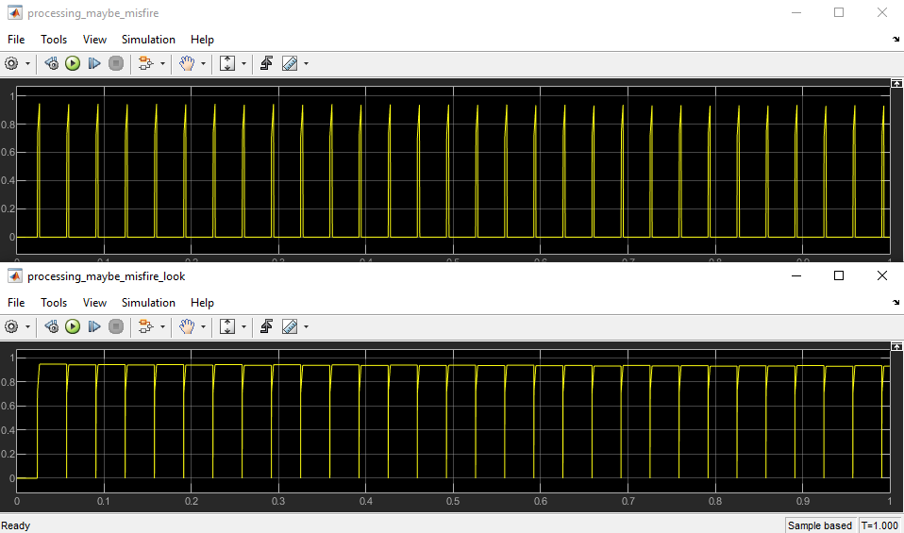

Result maybe misfire signal processing, duration 1 s

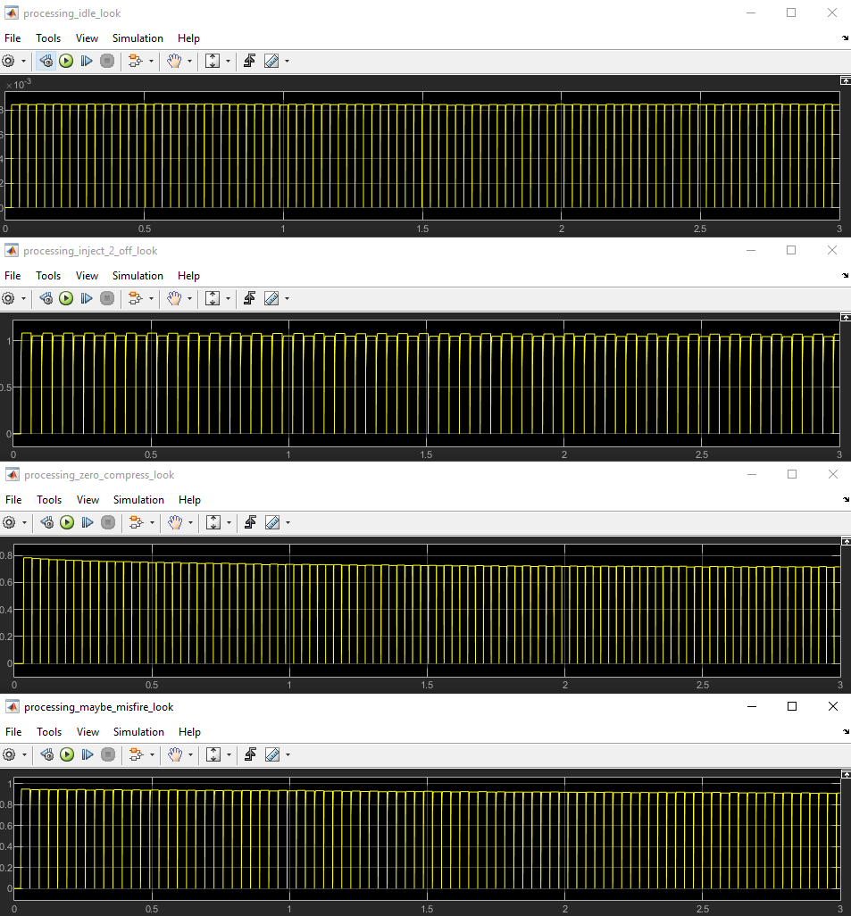

Signals processing, duration 3 s

# Part 2 Python processing

Period calc by crank signal and time series data:

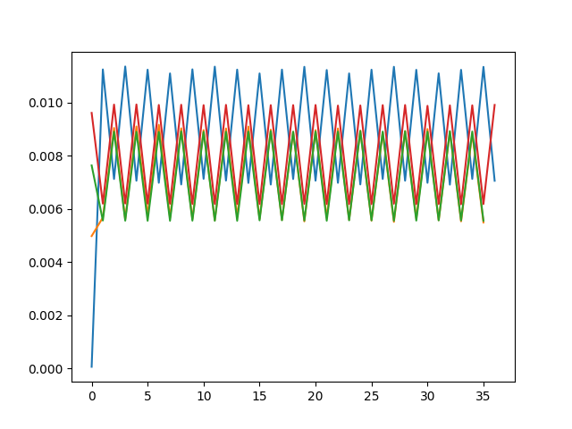

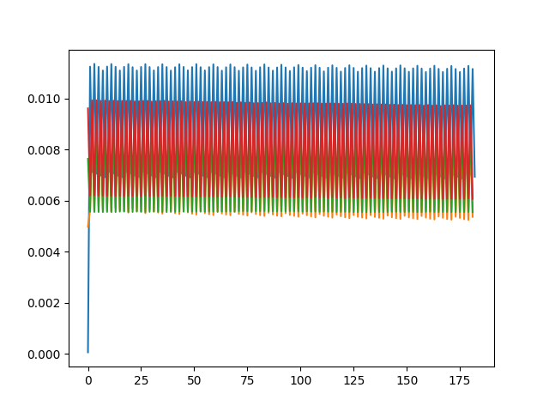

green – idle, blue – inject 2 off, yolo (bed look on picture..) – zero compression, red – suspected bad sparkplug

About Y axis – calc period, About X axis – number of data

Filtered by level (0.007 s) period data:

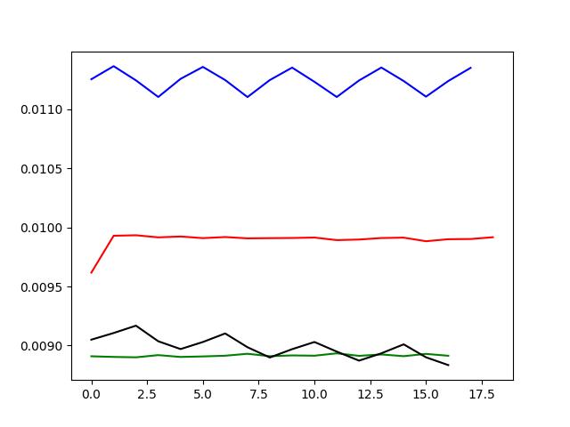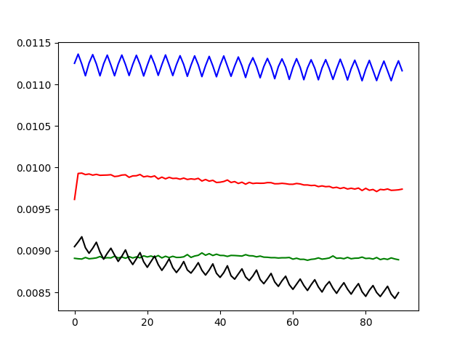

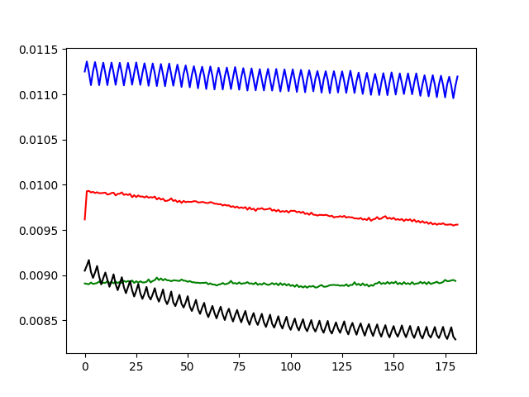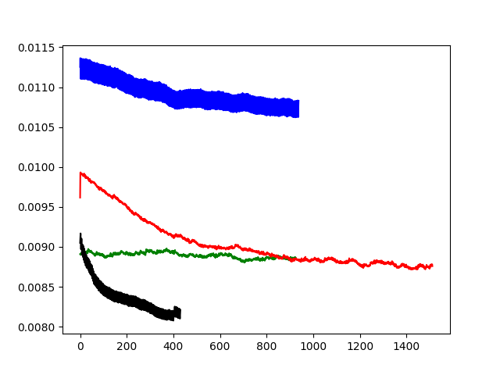

green – idle, blue – inject 2 off, black – zero compression, red – suspected bad sparkplug

About Y axis – calc period, About X axis – number of data

Filtered and diff period data:

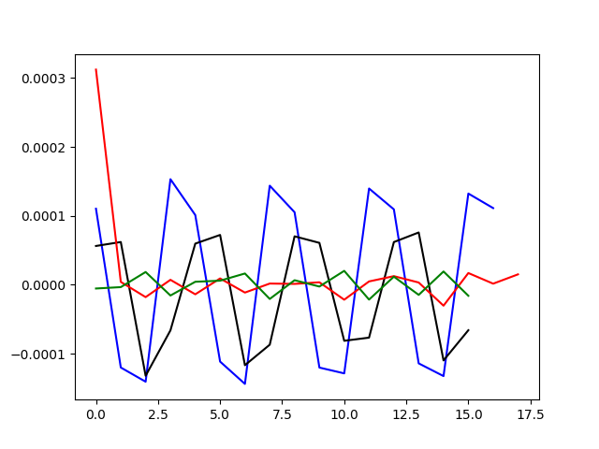

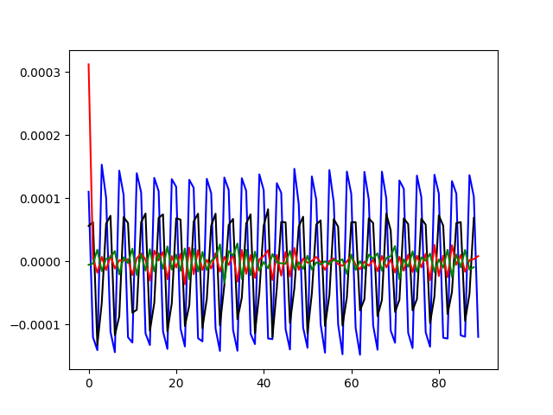

green – idle, blue – inject 2 off, black – zero compression,

red – suspected bad sparkplug

***(see next page)***

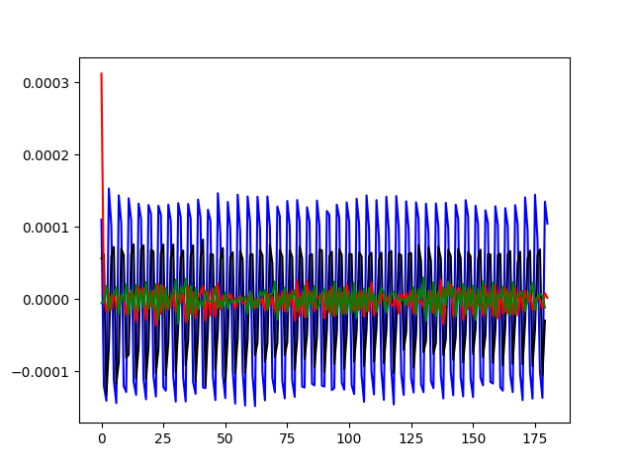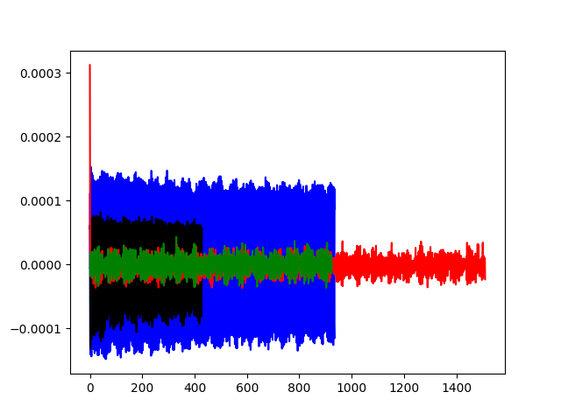

green – idle, blue – inject 2 off, black – zero compression,

red – suspected bad sparkplug

About Y axis – calc period, About X axis – number of data

# Part 3 Python code

import csv

import numpy as np

from matplotlib import pyplot as plt

path_file_idle = r'C:\Users\home\Documents\nb2-happy-warmup-idle.csv'

path_file_miss = r'C:\Users\home\Documents\nb2-idle-without-injector-2.csv'

path_file_zero = r'C:\Users\home\Documents\nb2-sparkplug-1-completely-removed-zero-compression-in-1.csv'

path_file_maby = r'C:\Users\home\Documents\nb2-suspected-bad-sparkplug-1.csv'

def parse_data(path_file_idle):

data = np.array([[]])

time_s = []

cam = []

crank = []

with open(path_file_idle) as csvfile:

reader = csv.DictReader(csvfile)

for row in reader:

cam.append(row['cam'])

time_s.append(row['Time [s]'])

crank.append(row['crank'])

cam = np.array(cam)

time_s = np.array(time_s)

crank = np.array(crank)

cam = cam.astype(int)

time_s = time_s.astype(float)

crank = crank.astype(int)

#plt.plot(crank[:100])

data = np.vstack((crank, time_s)).T

print(data.shape)

return data

data_idle = parse_data(path_file_idle)

data_miss = parse_data(path_file_miss)

data_zero = parse_data(path_file_zero)

data_maby = parse_data(path_file_maby)

def invert_value(in_val):

out_val = []

for i in range(in_val.shape[0]):

if in_val[i] == 0:

out_val.append(1)

else:

out_val.append(0)

return out_val

def calc_period(data):

sig_period = []

t_0 = data[0, 1]

t_1 = float()

print('perid in data len --> ', data.shape[0])

for i in range(data.shape[0]):# 100

if i == 0:

crank_current = data[0, 0]

print('ferst_data')

pass

crank_mem = crank_current

crank_current = data[i, 0]

if crank_current == crank_mem:

pass

if crank_current > crank_mem:

t_0 = data[i, 1]

if crank_current < crank_mem:

t_1 = data[i, 1]

period = t_1 - t_0

sig_period.append(period)

'''

if i == 2000:

break

'''

sig_period = np.array(sig_period)

sig_period = sig_period.astype(float)

print(sig_period.shape)

return sig_period

sig_period_idle = calc_period(data_idle)

sig_period_miss = calc_period(data_miss)

sig_period_zero = calc_period(data_zero)

sig_period_maby = calc_period(data_maby)

#print(sig_1)

plt.figure('period')

plt.plot(sig_period_miss)

plt.plot(sig_period_zero)

plt.plot(sig_period_idle)

plt.plot(sig_period_maby)

level = 0.008

def filt_level(level, data_in):

data_out = []

for i in range(data_in.shape[0]):

if data_in[i] >= level:

data_out.append(data_in[i])

else:

pass

return data_out

filt_level_data_idle = filt_level(level, sig_period_idle)

filt_level_data_miss = filt_level(level, sig_period_miss)

filt_level_data_zero = filt_level(level, sig_period_zero)

filt_level_data_maby = filt_level(level, sig_period_maby)

plt.figure('filt')

plt.plot(filt_level_data_idle, color='green')

plt.plot(filt_level_data_miss, color='blue')

plt.plot(filt_level_data_zero, color='black')

plt.plot(filt_level_data_maby, color='red')

filt_and_diff_level_data_idle = np.diff(filt_level_data_idle)

filt_and_diff_level_data_miss = np.diff(filt_level_data_miss)

filt_and_diff_level_data_zero = np.diff(filt_level_data_zero)

filt_and_diff_level_data_maby = np.diff(filt_level_data_maby)

plt.figure('filt_and_diff')

plt.plot(filt_and_diff_level_data_miss, color='blue')

plt.plot(filt_and_diff_level_data_zero, color='black')

plt.plot(filt_and_diff_level_data_maby, color='red')

plt.plot(filt_and_diff_level_data_idle, color='green')

sensor_level = 0.00007

def sensor(sensor_level, data_in):

miss = []

miss_value = []

print('count_cycle -->', data_in.shape[0])

for i in range(data_in.shape[0]):

if i == 0:

val_current = data_in[0]

pass

val_mem = val_current

val_current = data_in[i]

if abs(val_current - val_mem) >= sensor_level:

miss.append(i)

miss_value.append(abs(val_current - val_mem))

print('count miss --> ', len(miss))

if len(miss) <= 30:

print('numba_of_cycle_miss -->', miss)

print('numba_of_cycle_miss_value -->', miss_value)

return miss

miss_idle = sensor(sensor_level, filt_and_diff_level_data_idle)

miss_miss = sensor(sensor_level, filt_and_diff_level_data_miss)

miss_miss = sensor(sensor_level, filt_and_diff_level_data_zero)

miss_maby = sensor(sensor_level, filt_and_diff_level_data_maby)

def SKO():

pass

plt.show()

#print(cam_idle)

#print(time_idle)

#print(data_idle)