Software Design Description

for

“Human Resource Information System (HRIS)
for Arcenas Development Corporation”

List of Figures
List of Tables
Figure No. Description Page
Document Version: 1.0
Date: September 3, 2026
Prepared By: Jay Mark A. Reños, Liza Mae C. Sugala, Rusel R. Portes, Efren S. Cabudbud Jr., CarlVey Sente, Rayla G. Lanaza
Technical Adviser: Eric Bulala
Subject Adviser: Engr. Clark Kevin V. Villamor — Head, College of Computer Studies

Figure 1.0 Employee & Workforce Management Class Diagram
Figure 2.0 Crew Assignment & Site Deployment Class Diagram
Figure 3.0 Offline Attendance Checklist Class Diagram
Figure 4.0 Cryptographic Attendance Integrity Class Diagram
Figure 5.0 Background Sync Engine Class Diagram
Figure 6.0 Payroll Processing Class Diagram
Figure 7.0 Leave & Overtime Class Diagram
Figure 8.0 Audit & Analytics Class Diagram
Figure 9.0 Entity-Relationship Diagram
Figure 10.0 Login & RBAC Authentication Sequence Diagram
Figure 11.0 Offline Attendance Logging Sequence Diagram
Figure 12.0 Cryptographic Signing Sequence Diagram
Figure 13.0 Background Sync Sequence Diagram
Figure 14.0 Payroll Computation Sequence Diagram
Figure 15.0 Leave & Overtime Approval Sequence Diagram
Figure 16.0 Web Portal – Login Interface
Figure 17.0 Web Portal – Dashboard Interface
Figure 18.0 Web Portal – Employee Management Interface
Figure 19.0 Web Portal – Crew Assignment Interface
Figure 20.0 Web Portal – Attendance Monitoring Interface
Figure 21.0 Web Portal – Payroll Interface
Figure 22.0 Web Portal – Leave & Overtime Interface
Figure 23.0 Web Portal – Executive Analytics Dashboard
Figure 24.0 Mobile App – Login Interface
Figure 25.0 Mobile App – Attendance Checklist Interface
Figure 26.0 Mobile App – Sync Status Interface

Table No. Description Page

Table 1.0 Definitions, Acronyms, Abbreviations……………………………………………………… 54
Table 2.0 Employee……………………………………………………………………………………………..64
Table 3.0 Role……………………………………………………………………………………………………..64
Table 4.0 Site………………………………………………………………………………………………………64
Table 5.0 Crew…………………………………………………………………………………………………….65
Table 6.0 Crew Assignment…………………………………………………………………………………65
Table 7.0 Attendance……………………………………………………………………………………………65
Table 8.0 Attendance Sync Queue………………………………………………………………………… 66
Table 9.0 Crypto Signature Ledger…………………………………………………………………………66
Table 10.0 Payroll………………………………………………………………………………………………..66
Table 11.0 Payroll Detail……………………………………………………………………………………… 66
Table 12.0 Leave Request……………………………………………………………………………………. 66
Table 13.0 Overtime Request………………………………………………………………………………..66
Table 14.0 Audit Log…………………………………………………………………………………………….66

Introduction

Purpose

This document presents the design and development progress of the Human Resource Information System (HRIS) for Arcenas Development Corporation. It provides a detailed description of the system's software architecture and outlines the general structural design, covering the mobile attendance application and the web-based HR administration platform.

Scope

This document describes the system design for the Human Resource Information System (HRIS) for Arcenas Development Corporation. It explains how the application will be built, the main components it will use, and how these components work together to help HR personnel manage employee records, attendance, leave, and payroll, and to help site foremen record employee attendance at construction sites — including offline recording, cryptographic validation, and automatic synchronization once internet connectivity becomes available.

Definition, Acronyms, and Abbreviations

Terms | Definition
HRIS | Human Resource Information System — a system designed to manage employee information, attendance, leave, payroll, and other human resource processes in a centralized platform.
Arcenas Development Corporation | The organization for which the Human Resource Information System is developed and implemented.
Class Diagram | A diagram that describes the static structure of a system by showing its classes, their attributes, methods (operations), and the relationships between the classes.
Sequence Diagram | A UML diagram that shows the step-by-step flow of messages, actions, or data between system components over time. In data design, it illustrates how users, applications, and databases interact to complete a specific process.
ERD | Entity-Relationship Diagram — a diagram that visually shows the entities in a system, their attributes, and the relationships between them for database design.
Offline-First | A system approach that allows users to continue performing essential functions without an internet connection and synchronizes stored data once connectivity becomes available.
SQLite | A lightweight database used for storing attendance records and other necessary data locally on the mobile device.
Synchronization | The process of transferring and updating locally stored data with the central system when an internet connection becomes available.

Table 1.0 Definitions, Acronyms, Abbreviations

References

[1] Laravel LLC, Laravel Documentation. [Online]. Available: https://laravel.com/docs
[2] Meta Platforms, Inc., React Documentation. [Online]. Available: https://react.dev
[3] Meta Platforms, Inc., React Native Documentation. [Online]. Available: https://reactnative.dev/docs/getting-started
[4] Oracle Corporation, MySQL 8.0 Reference Manual. [Online]. Available: https://dev.mysql.com/doc/refman/8.0/en/
[5] SQLite Consortium, SQLite Documentation. [Online]. Available: https://www.sqlite.org/docs.html
[6] Zetetic LLC, SQLCipher Documentation. [Online]. Available: https://www.zetetic.net/sqlcipher/documentation/
[7] National Institute of Standards and Technology, FIPS 186-5: Digital Signature Standard (DSS), Feb. 2023. [Online]. Available: https://doi.org/10.6028/NIST.FIPS.186-5
[8] National Institute of Standards and Technology, FIPS 198-1: The Keyed-Hash Message Authentication Code (HMAC), Jul. 2008. [Online]. Available: https://csrc.nist.gov/pubs/fips/198-1/final
[9] National Institute of Standards and Technology, SP 800-186: Recommendations for Discrete Logarithm-Based Cryptography: Elliptic Curve Domain Parameters, Feb. 2023. [Online]. Available: https://csrc.nist.gov/pubs/sp/800/186/final
[10] Google Inc., Android Keystore System, Android Developers. [Online]. Available: https://developer.android.com/privacy-and-security/keystore
[11] Apple Inc., Protecting Keys with the Secure Enclave, Apple Developer Documentation. [Online]. Available: https://developer.apple.com/documentation/security/protecting-keys-with-the-secure-enclave
[12] Object Management Group, Unified Modeling Language (UML) Specification, Version 2.5.1, Dec. 2017. [Online]. Available: https://www.omg.org/spec/UML/
[13] P. P. Chen, "The Entity-Relationship Model — Toward a Unified View of Data," ACM Transactions on Database Systems, vol. 1, no. 1, pp. 9–36, 1976.

System Architecture

The HRIS follows a layered client-server architecture composed of a React Native mobile client, a React.js web client, a Laravel REST API layer, and a MySQL 8.0 relational database. This section presents the class diagrams for each major module of the system.
  - Class Diagram

2.1.1 Employee & Workforce Management
Represents the classes that manage employee profiles, trade skills, certifications, daily pay rates, and employment status. Core classes include Employee and Role, which are used across the web portal by HR Personnel.
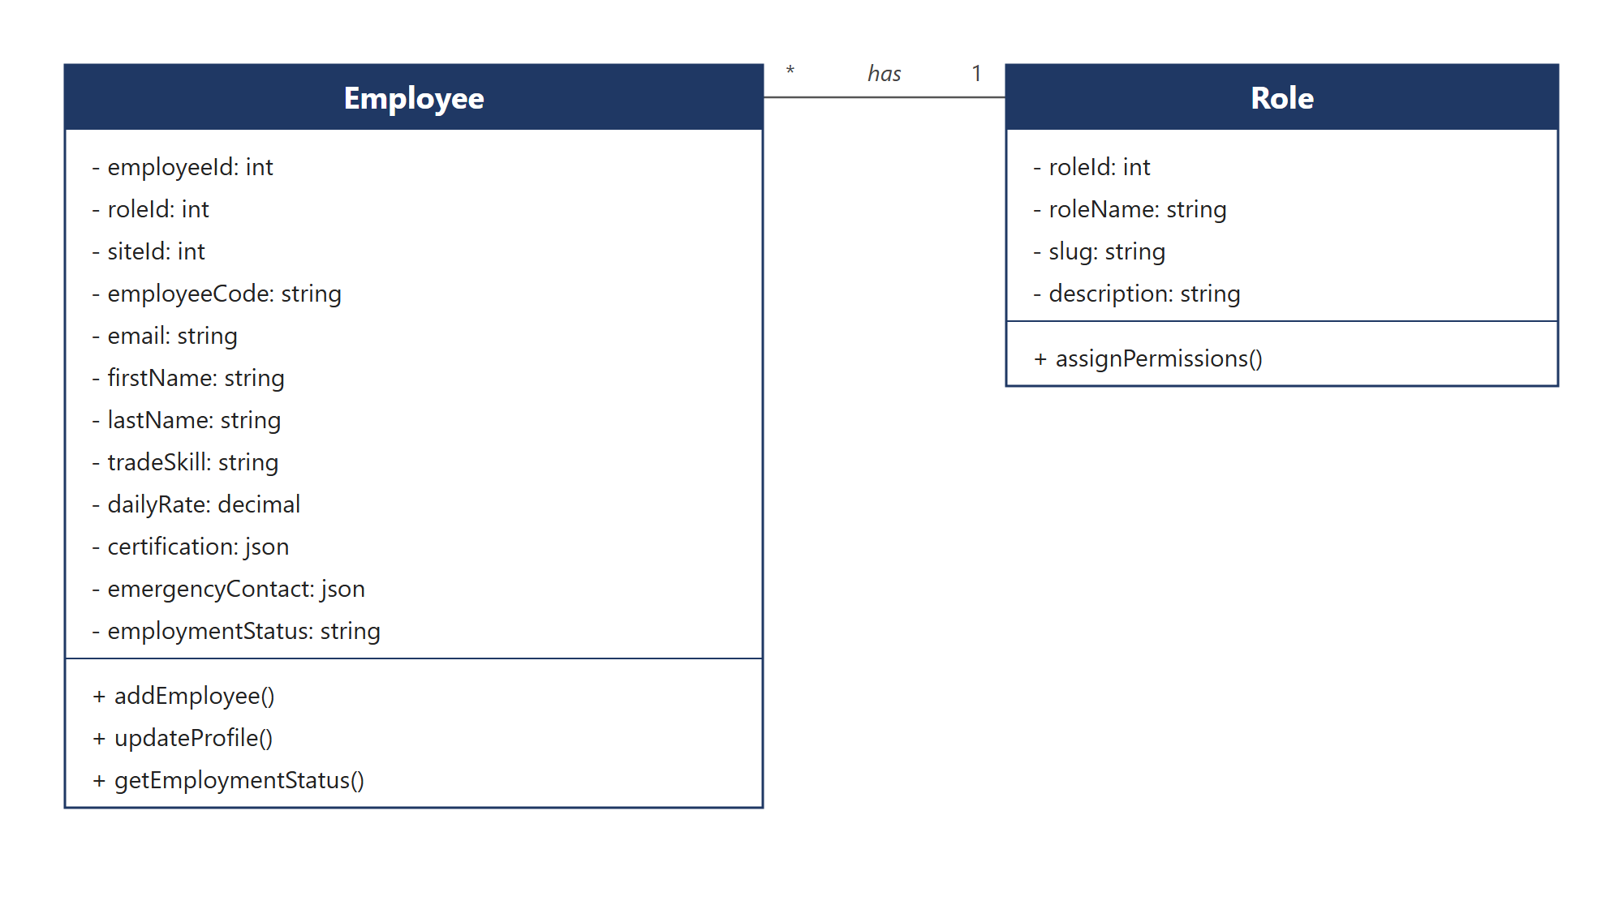
Figure 1.0 Employee & Workforce Management Class Diagram

2.1.2 Crew Assignment & Site Deployment
Represents how Site Engineers organize workers into crews, assign them to project sites, and designate responsible foremen. Core classes include Site, Crew, and CrewAssignment.
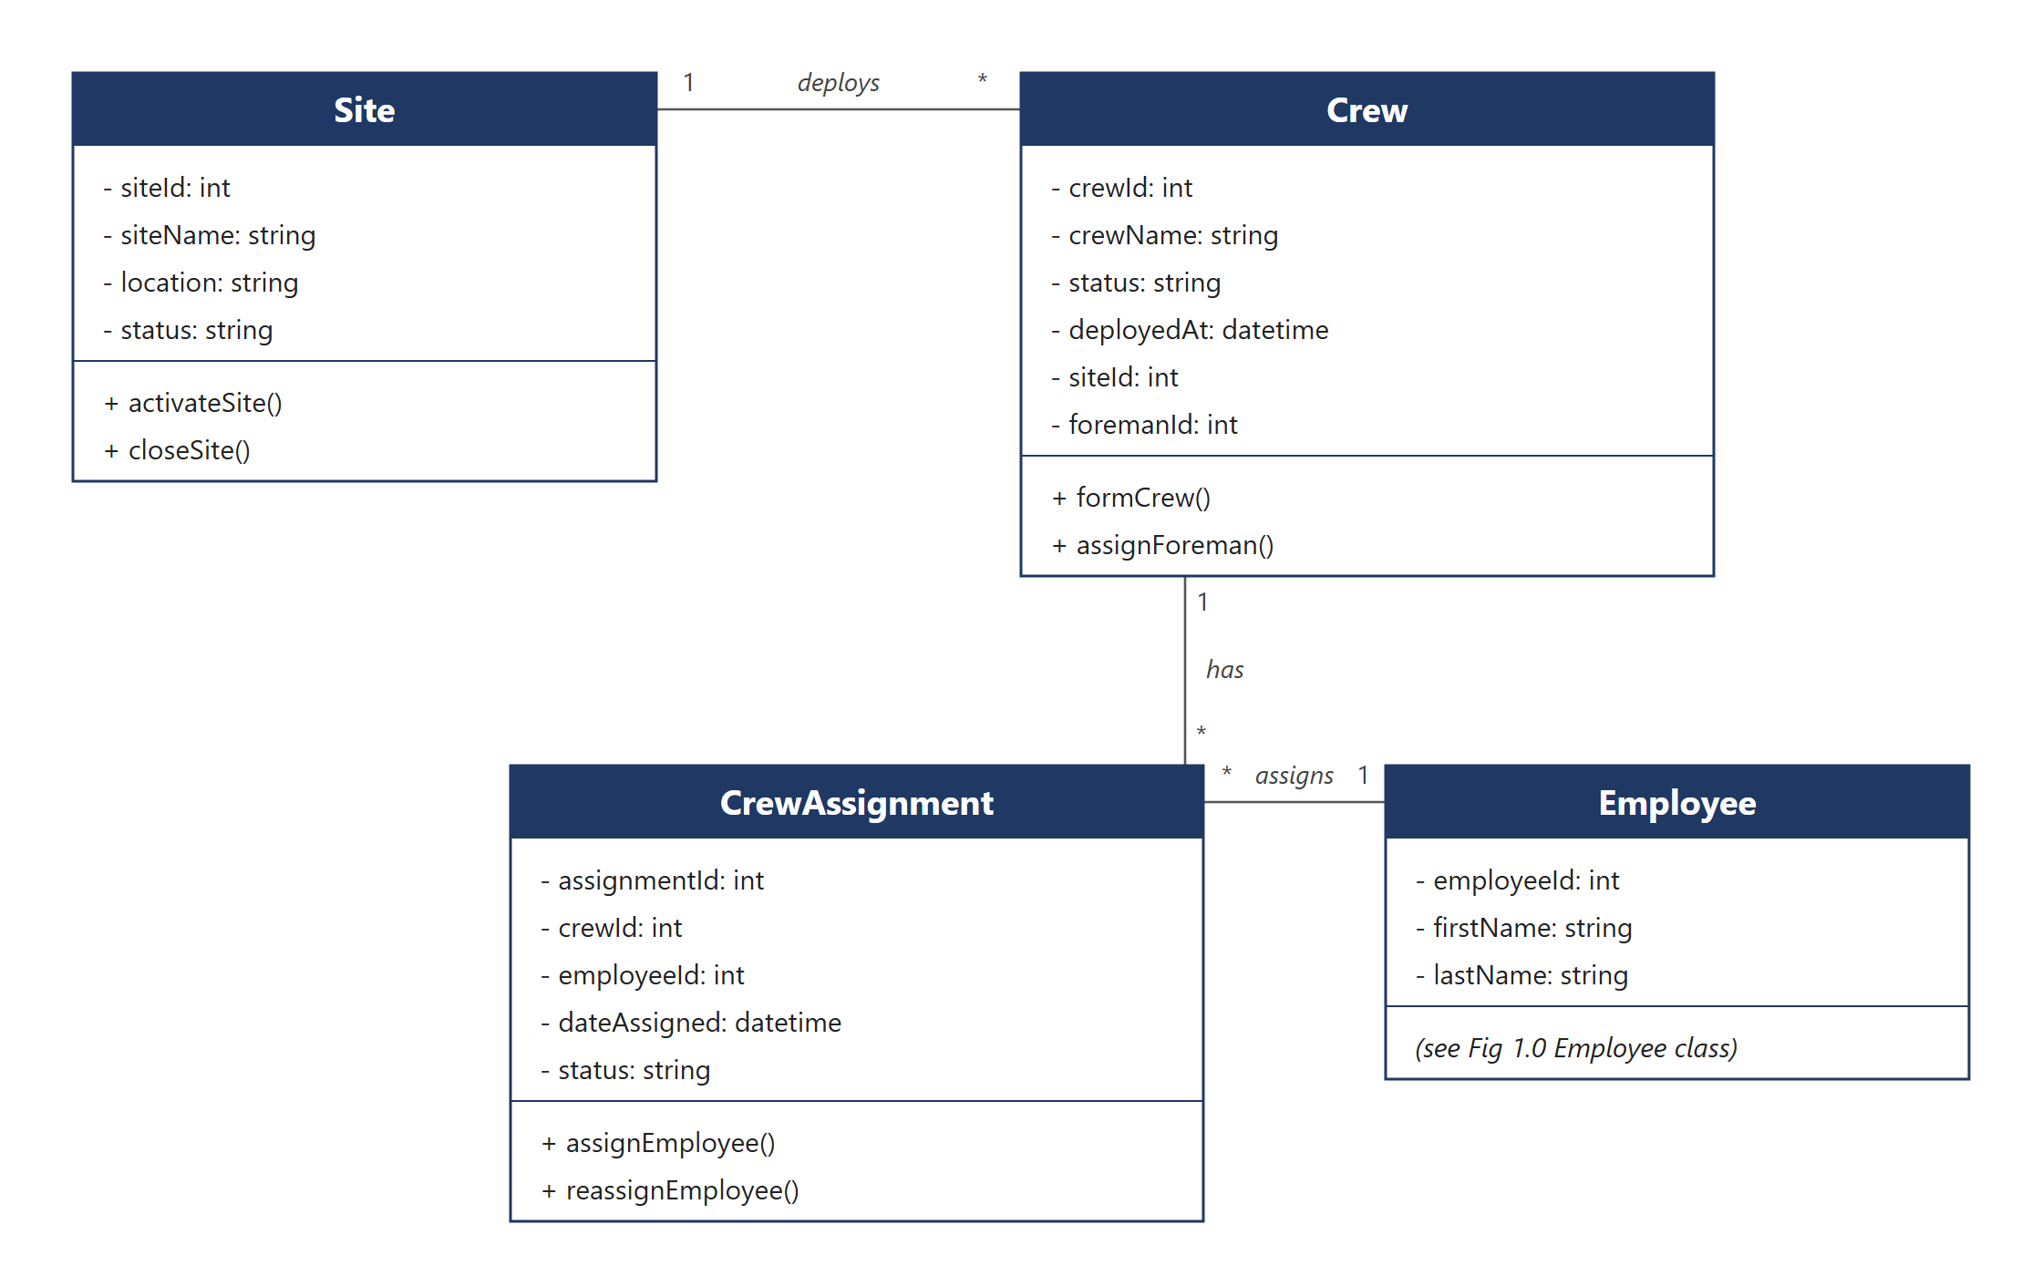Figure 2.0 Crew Assignment & Site Deployment Class Diagram

2.1.3 Offline Attendance Checklist
Represents the mobile-side classes that allow a Site Foreman to record crew attendance through a digital tap-based checklist while offline. Core classes include AttendanceEntry, LocalAttendanceStore, and ChecklistController.
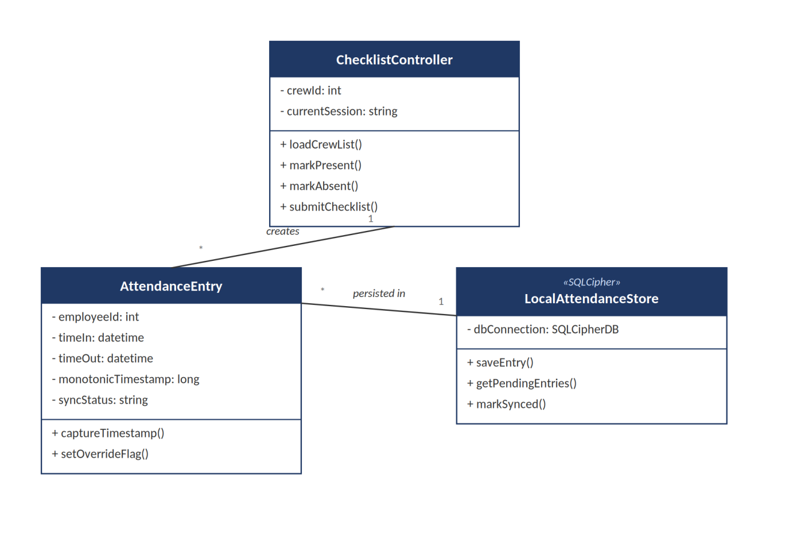
Figure 3.0 Offline Attendance Checklist Class Diagram

2.1.4 Cryptographic Attendance Integrity
Represents the 4-layer security engine that protects attendance timestamps from manipulation: MonotonicClockService, HashChainBuilder (HMAC-SHA256), TEESigner (ECDSA P-256), and SignatureVerifier.
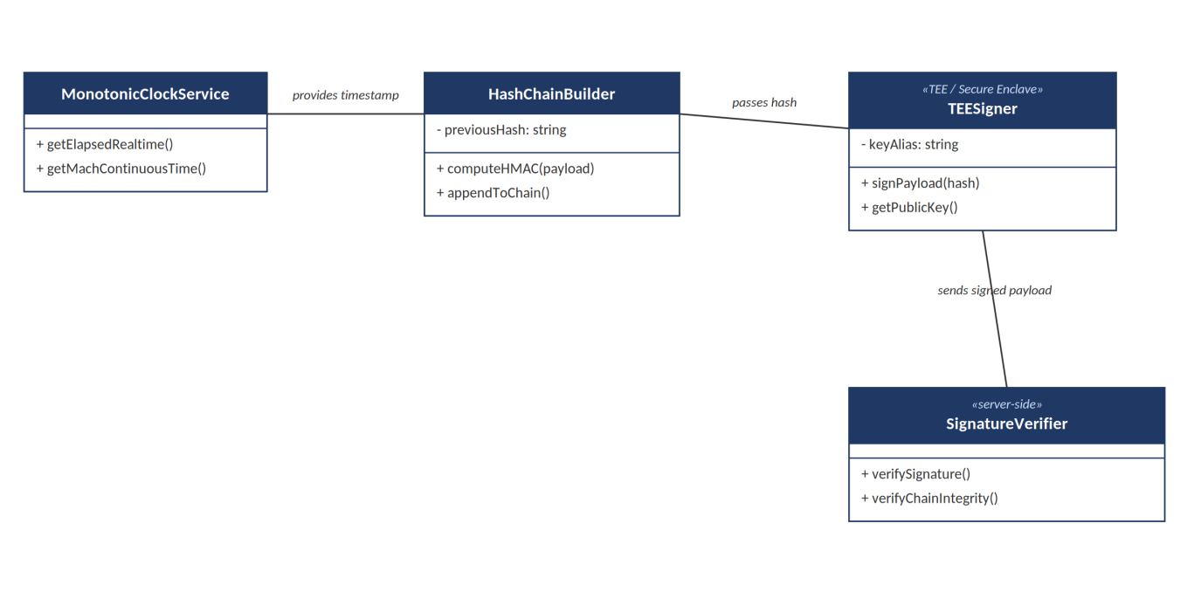
Figure 4.0 Cryptographic Attendance Integrity Class Diagram

2.1.5 Background Sync Engine
Represents the classes responsible for detecting connectivity and transmitting queued offline attendance records to the central server. Core classes include SyncQueueManager, ConnectivityMonitor, and SyncApiClient.
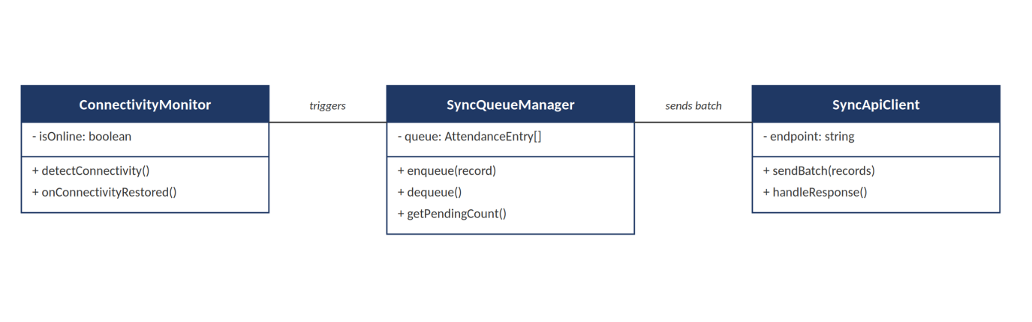Figure 5.0 Background Sync Engine Class Diagram

2.1.6 Payroll Processing
Represents the classes that compute gross and net pay in compliance with the Philippine Labor Code. Core classes include PayrollEngine, PayrollDetail, and RateCalculator (Regular, OT 1.25x, Night Diff 1.10x, Rest Day 1.30x, Holiday 2.0x).
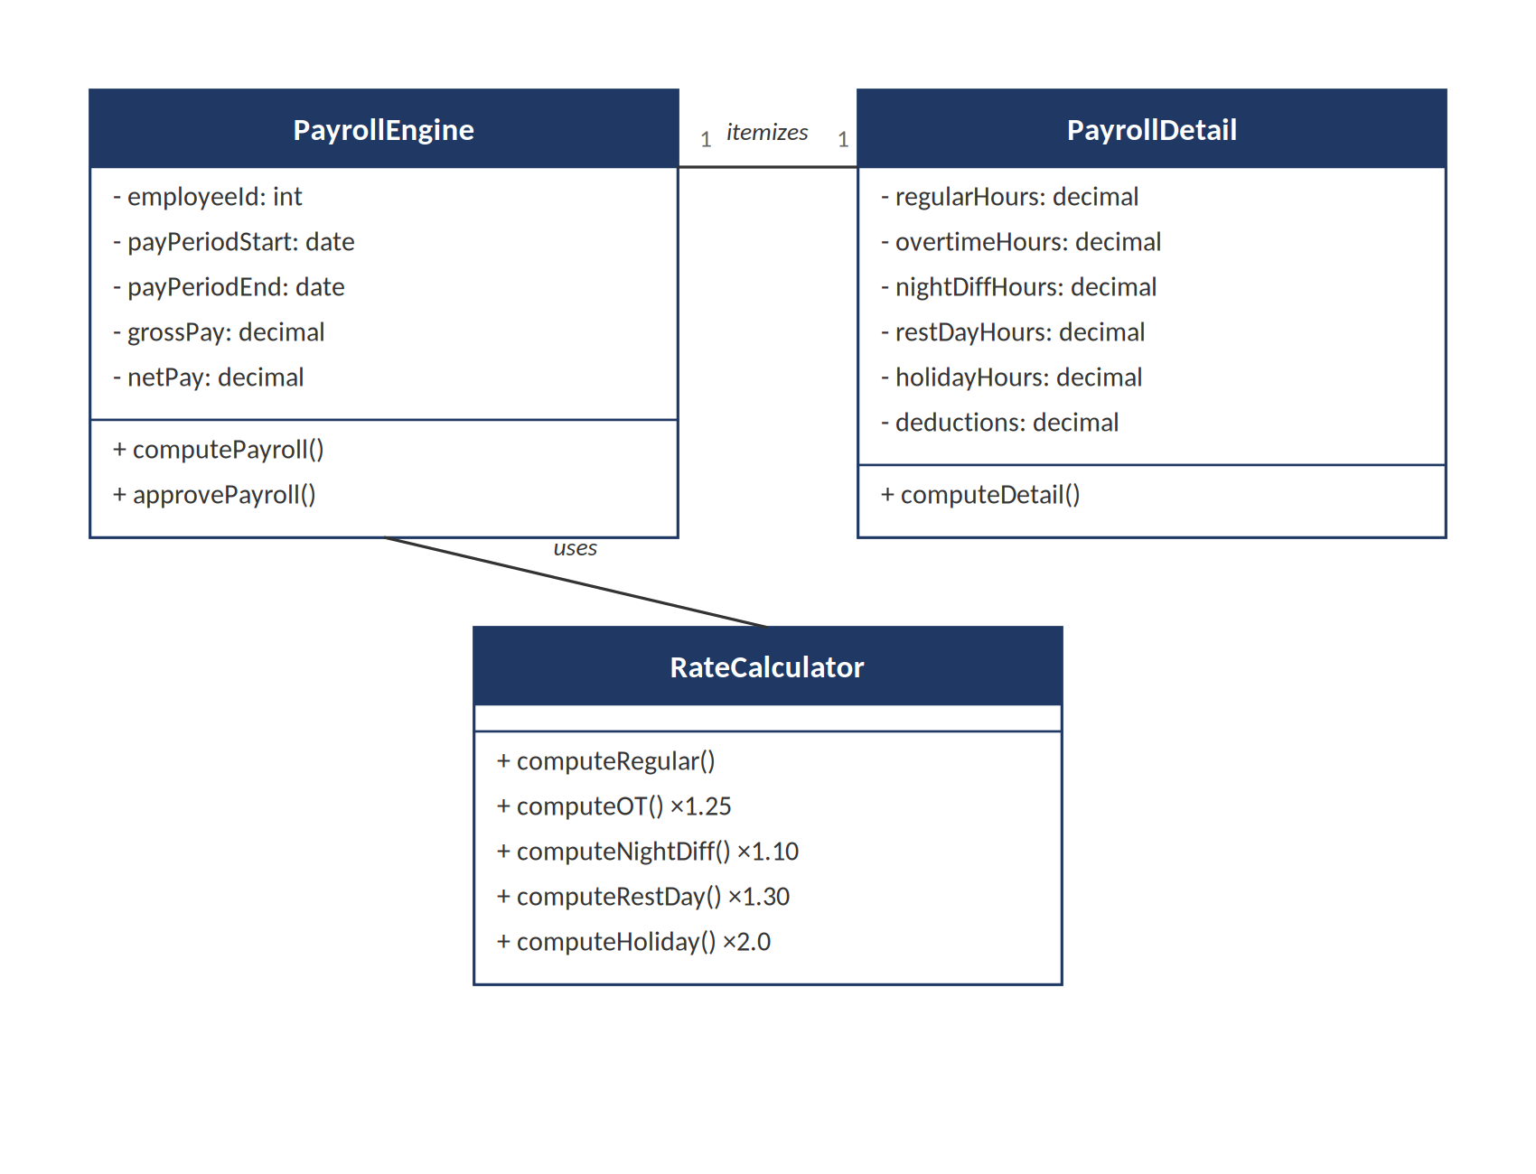Figure 6.0 Payroll Processing Class Diagram

2.1.7 Leave & Overtime
Represents the classes handling leave and overtime filing and the multi-tier approval workflow. Core classes include LeaveRequest, OvertimeRequest, and ApprovalWorkflow.
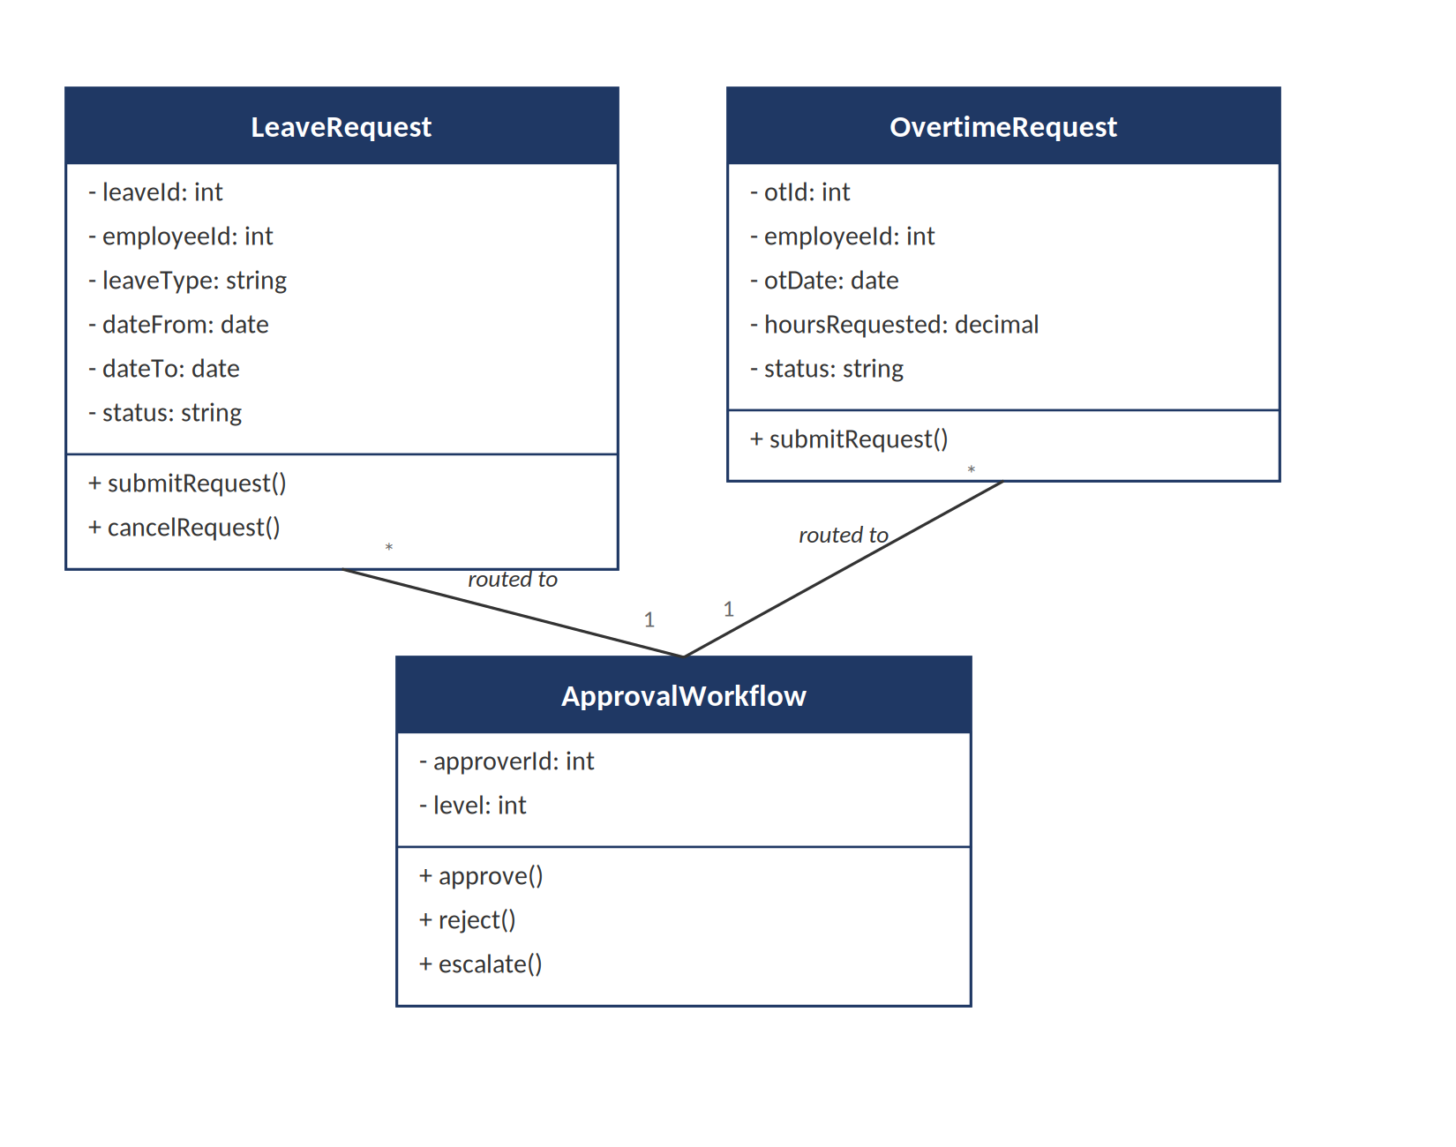Figure 7.0 Leave & Overtime Class Diagram

2.1.8 Audit & Analytics
Represents the classes that log override events and generate executive-level dashboards for labor cost analytics, punctuality tracking, and audit review. Core classes include AuditLog, AnalyticsAggregator, and DashboardService.
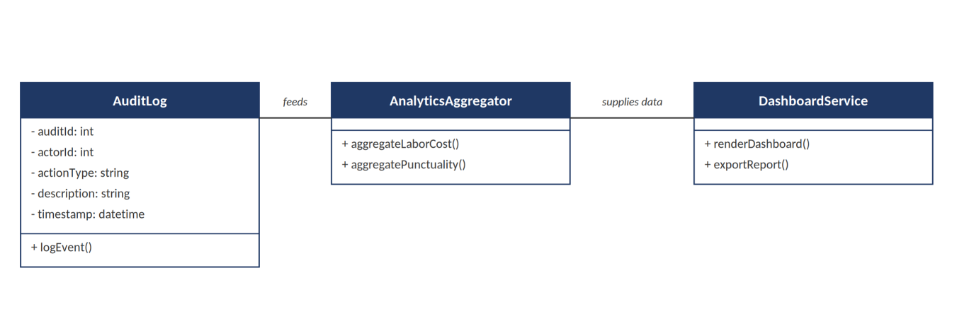
Figure 8.0 Audit & Analytics Class Diagram

Data Design

Data Description
3.1.1 Employee
Table Name: tbl_employee
Table Description: Table where employee profile, trade skill, pay rate, and login credential information is stored.
Primary Key: employee_id
Foreign Key: role_id, site_id

Fieldname | Data Type | Length | Description
employee_id | int | 11 | Unique identifier for the employee
employee_code | varchar | 255 | ADC-NNNN identifier; used alongside email as a login identifier
email | varchar | 255 | Login identifier; nullable, as most field workers have no company email
password | varchar | 255 | Hashed login secret; null means the account cannot sign in
first_name | varchar | 100 | Employee's first name
middle_name | varchar | 255 | Employee's middle name (nullable)
last_name | varchar | 100 | Employee's last name
trade_skill | varchar | 100 | Employee's construction trade skill (e.g., Mason, Electrician)
daily_rate | decimal | 10,2 | Employee's daily pay rate
certification | json | - | Field that stores skill certification details (array of certification records)
emergency_contact | json | - | Emergency contact name and number (structured object)
employment_status | varchar | 50 | Probationary, Active, On Leave, or Terminated
date_of_birth | date | - | Employee's date of birth
mobile | varchar | 255 | Employee's mobile number
civil_status | varchar | 255 | Employee's civil status
dependents | tinyint | 3 | Number of declared dependents
address | varchar | 255 | Employee's home address
blood_type | varchar | 255 | Employee's blood type
tin | varchar | 255 | Tax Identification Number
sss | varchar | 255 | Social Security System number
philhealth | varchar | 255 | PhilHealth number
pag_ibig | varchar | 255 | Pag-IBIG (HDMF) number
date_hired | date | - | Date the employee was hired
cost_centre | varchar | 255 | Cost centre code the employee's pay is charged to
role_id | int | 11 | Field that links to the employee's system role
site_id | int | 11 | Field that links to the employee's primary/current project site (nullable)

Table 2.0 Employee

3.1.2 Role
Table Name: tbl_role
Table Description: Table where RBAC roles are stored (HR Personnel, Site Foreman, Site Engineer / Construction Manager, System Administrator, Executive, Worker, Operator). Only the first five are login-capable; Worker and Operator are record-only classifications.
Primary Key: role_id
Foreign Key: None
Fieldname | Data Type | Length | Description
role_id | int | 11 | Unique identifier for the role
role_name | varchar | 50 | Display name of the role
slug | varchar | 255 | Machine key used by RBAC gate/middleware checks (e.g., hr, foreman, engineer, worker, operator, admin, executive)
description | varchar | 255 | Field that describes the role's access scope

Table 3.0 Role
3.1.3 Site
Table Name: tbl_site
Table Description: Table where construction project site information is stored.
Primary Key: site_id
Foreign Key: None

Fieldname | Data Type | Length | Description
site_id | int | 11 | Unique identifier for the site
site_name | varchar | 150 | Name of the construction site
location | varchar | 255 | Physical address or coordinates of the site
status | varchar | 50 | Active or Completed

Table 4.0 Site

3.1.4 Crew
Table Name: tbl_crew
Table Description: Table where crew groupings and their assigned site and foreman are stored.
Primary Key: crew_id
Foreign Key: site_id, foreman_id

Fieldname | Data Type | Length | Description
crew_id | int | 11 | Unique identifier for the crew
crew_name | varchar | 100 | Name or code of the crew
status | varchar | 20 | Deployment state: draft (default), deployed, or archived
deployed_at | datetime | - | Date and time the crew was deployed; null while in draft
site_id | int | 11 | Field that links to the assigned site
foreman_id | int | 11 | Field that links to the employee designated as foreman

Table 5.0 Crew

3.1.5 Crew Assignment
Table Name: tbl_crew_assignment
Table Description: Table where the deployment of employees to crews is recorded.
Primary Key: assignment_id
Foreign Key: crew_id, employee_id

Fieldname | Data Type | Length | Description
assignment_id | int | 11 | Unique identifier for the crew assignment
crew_id | int | 11 | Field that links to the crew
employee_id | int | 11 | Field that links to the assigned employee
date_assigned | datetime | - | Date and time the employee was assigned
status | varchar | 50 | Active or Reassigned

Table 6.0 Crew Assignment

3.1.6 Attendance
Table Name: tbl_attendance
Table Description: Table where daily attendance records captured on-site or via the mobile app are stored.
Primary Key: attendance_id
Foreign Key: employee_id, crew_id

Fieldname | Data Type | Length | Description
attendance_id | int | 11 | Unique identifier for the attendance record
employee_id | int | 11 | Field that links to the employee
crew_id | int | 11 | Field that links to the crew at the time of logging
time_in | datetime | - | Recorded time-in
time_out | datetime | - | Recorded time-out
monotonic_timestamp | bigint | 20 | Hardware monotonic clock value captured at logging time
sync_status | varchar | 50 | Pending, Synced, or Failed
override_flag | boolean | - | Indicates whether a late foreman override was applied

Table 7.0 Attendance
3.1.7 Attendance Sync Queue
Table Name: tbl_attendance_sync_queue
Table Description: Table where offline attendance records awaiting transmission to the central server are queued.
Primary Key: queue_id
Foreign Key: attendance_id

Fieldname | Data Type | Length | Description
queue_id | int | 11 | Unique identifier for the queue entry
attendance_id | int | 11 | Field that links to the pending attendance record
device_id | varchar | 100 | Identifier of the foreman's mobile device
queued_at | datetime | - | Date and time the record was queued locally
synced_at | datetime | - | Date and time the record was successfully synced
sync_status | varchar | 50 | Queued, In Progress, Synced, or Failed

Table 8.0 Attendance Sync Queue

3.1.8 Crypto Signature Ledger
Table Name: tbl_crypto_signature
Table Description: Table where the cryptographic hash chain and digital signatures for each attendance record are stored.
Primary Key: signature_id
Foreign Key: attendance_id

Fieldname | Data Type | Length | Description
signature_id | int | 11 | Unique identifier for the signature entry
attendance_id | int | 11 | Field that links to the signed attendance record
hmac_hash | varchar | 255 | HMAC-SHA256 hash of the attendance payload
prev_hash | varchar | 255 | Hash of the previous ledger entry, forming the hash chain
ecdsa_signature | varchar | 500 | ECDSA P-256 signature generated inside the device TEE/Secure Enclave
verified | boolean | - | Indicates whether the server successfully verified the signature

Table 9.0 Crypto Signature Ledger

3.1.9 Payroll
Table Name: tbl_payroll
Table Description: Table where computed payroll summaries per employee per pay period are stored.
Primary Key: payroll_id
Foreign Key: employee_id

Fieldname | Data Type | Length | Description
payroll_id | int | 11 | Unique identifier for the payroll record
employee_id | int | 11 | Field that links to the employee
pay_period_start | date | - | Start date of the pay period
pay_period_end | date | - | End date of the pay period
gross_pay | decimal | 10,2 | Total computed gross pay
net_pay | decimal | 10,2 | Total computed net pay after deductions
status | varchar | 50 | Draft, Approved, or Released

Table 10.0 Payroll

3.1.10 Payroll Detail
Table Name: tbl_payroll_detail
Table Description: Table where the itemized computation of each payroll record is stored, in compliance with the Philippine Labor Code.
Primary Key: detail_id
Foreign Key: payroll_id

Fieldname | Data Type | Length | Description
detail_id | int | 11 | Unique identifier for the payroll detail record
payroll_id | int | 11 | Field that links to the payroll record
regular_hours | decimal | 5,2 | Total regular hours worked
overtime_hours | decimal | 5,2 | Total overtime hours (computed at 1.25x)
night_diff_hours | decimal | 5,2 | Total night differential hours (computed at 1.10x)
rest_day_hours | decimal | 5,2 | Total rest day hours (computed at 1.30x)
holiday_hours | decimal | 5,2 | Total holiday hours (computed at 2.0x)
deductions | decimal | 10,2 | Total statutory and other deductions

Table 11.0 Payroll Detail

3.1.11 Leave Request
Table Name: tbl_leave_request
Table Description: Table where employee leave applications are stored.
Primary Key: leave_id
Foreign Key: employee_id, approved_by

Fieldname | Data Type | Length | Description
leave_id | int | 11 | Unique identifier for the leave request
employee_id | int | 11 | Field that links to the requesting employee
leave_type | varchar | 50 | Sick, Vacation, Emergency, etc.
date_from | date | - | Start date of the requested leave
date_to | date | - | End date of the requested leave
status | varchar | 50 | Pending, Approved, or Rejected
approved_by | int | 11 | Field that links to the approving supervisor

Table 12.0 Leave Request

3.1.12 Overtime Request
Table Name: tbl_overtime_request
Table Description: Table where employee overtime applications are stored.
Primary Key: ot_id
Foreign Key: employee_id, approved_by

Fieldname | Data Type | Length | Description
ot_id | int | 11 | Unique identifier for the overtime request
employee_id | int | 11 | Field that links to the requesting employee
ot_date | date | - | Date the overtime is requested for
hours_requested | decimal | 5,2 | Number of overtime hours requested
status | varchar | 50 | Pending, Approved, or Rejected
approved_by | int | 11 | Field that links to the approving supervisor

Table 13.0 Overtime Request

3.1.13 Audit Log
Table Name: tbl_audit_log
Table Description: Table where override events and administrative actions are logged for compliance review.
Primary Key: audit_id
Foreign Key: actor_id

Fieldname | Data Type | Length | Description
audit_id | int | 11 | Unique identifier for the audit entry
actor_id | int | 11 | Field that links to the employee who performed the action
action_type | varchar | 100 | Late Foreman Override, Crew Re-assignment, Retroactive Recovery, etc.
description | varchar | 255 | Details of the logged action
timestamp | datetime | - | Date and time the action occurred

Table 14.0 Audit Log

Entity-Relationship Diagram

The Entity-Relationship Diagram below illustrates the relationships among Employee, Role, Site, Crew, Crew Assignment, Attendance, Attendance Sync Queue, Crypto Signature Ledger, Payroll, Payroll Detail, Leave Request, Overtime Request, and Audit Log.
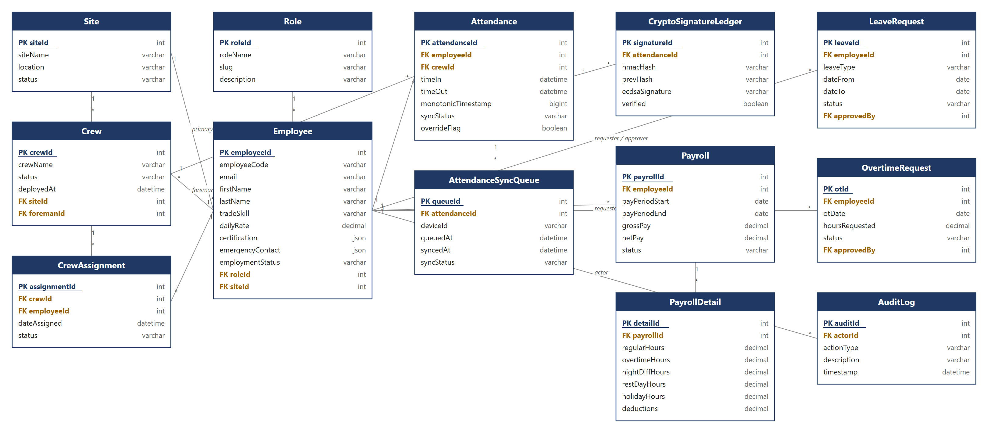
Figure 9.0 Entity-Relationship Diagram

Detailed Design

4.1 Login & RBAC Authentication Sequence Diagram
Illustrates how a user (HR Personnel, Site Engineer, Executive, or Site Foreman) logs in and how the Laravel API validates credentials and enforces role-based access control before granting access to the corresponding module.
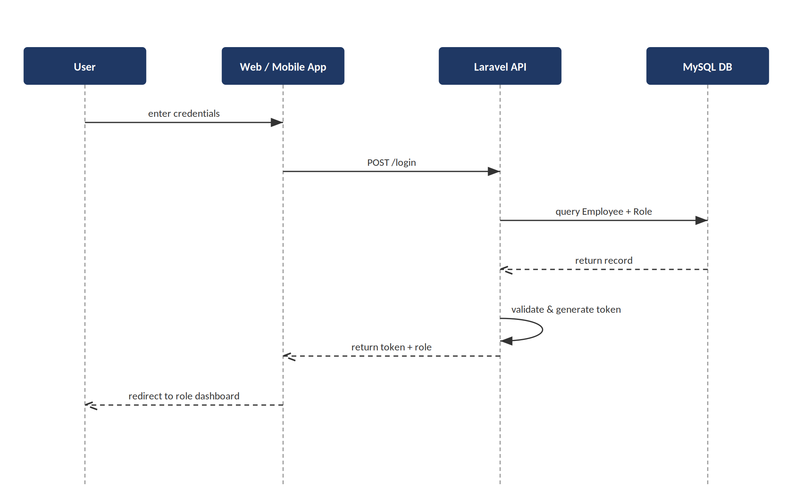
Figure 10.0 Login & RBAC Authentication Sequence Diagram

4.2 Offline Attendance Logging Sequence Diagram
Illustrates how a Site Foreman records crew attendance through the mobile checklist while offline, and how each entry is captured with a monotonic timestamp and stored locally in the SQLCipher-encrypted database.
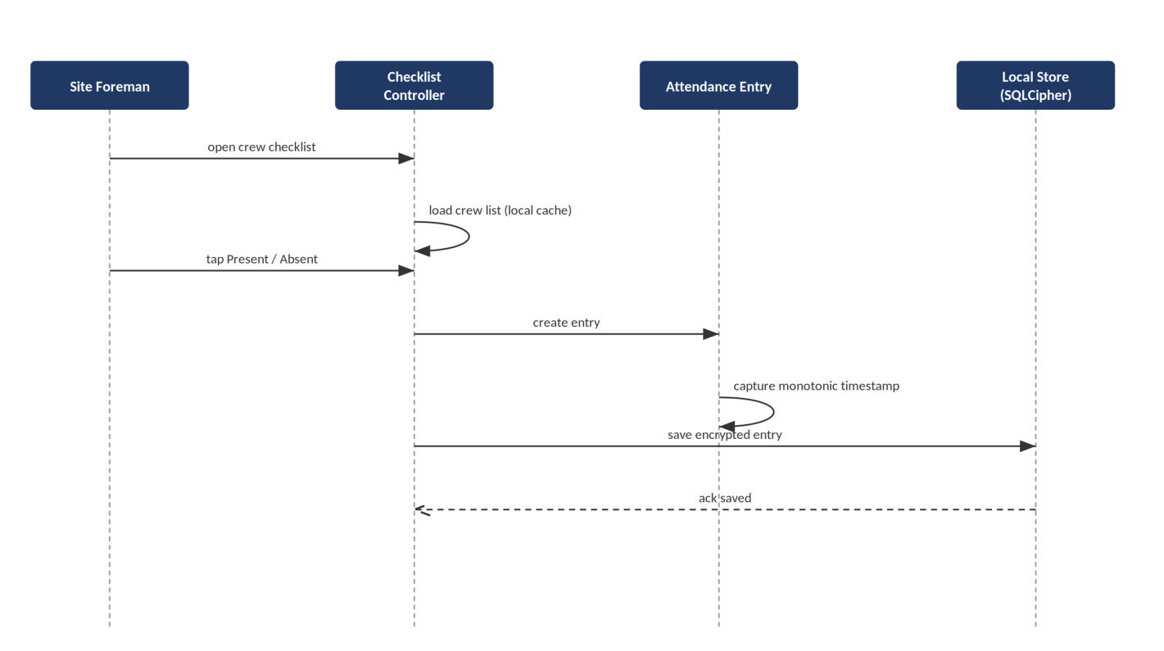
Figure 11.0 Offline Attendance Logging Sequence Diagram
4.3 Cryptographic Signing Sequence Diagram
Illustrates the 4-layer signing process: monotonic clock capture, HMAC-SHA256 hash chaining, and ECDSA P-256 signing inside the device TEE/Secure Enclave, prior to queuing for sync.
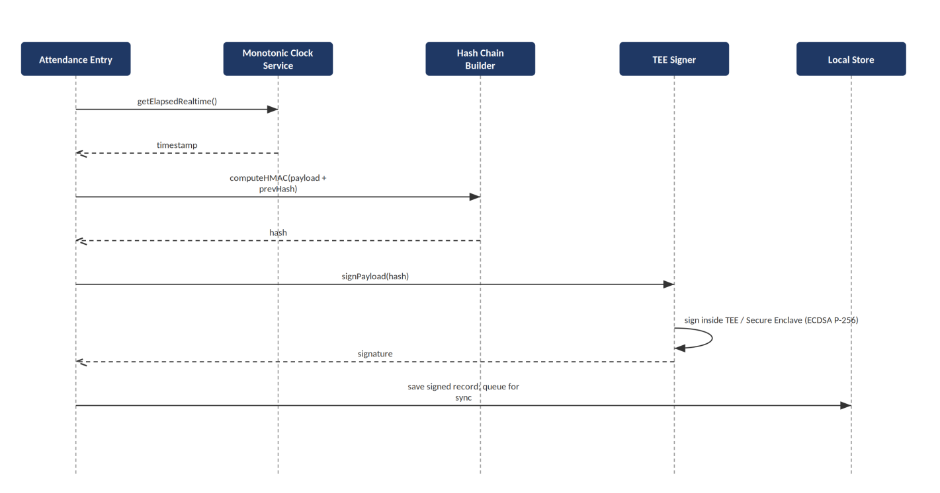
Figure 12.0 Cryptographic Signing Sequence Diagram
4.4 Background Sync Sequence Diagram
Illustrates how the mobile app detects restored connectivity, transmits queued attendance batches to the Laravel API, and how the server verifies the HMAC hash chain and ECDSA signatures before committing records to MySQL.
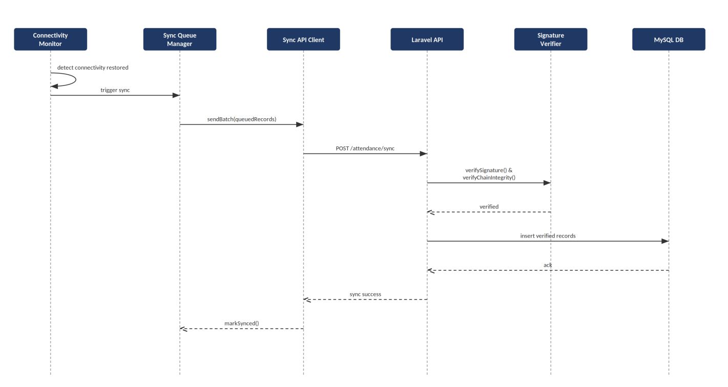
Figure 13.0 Background Sync Sequence Diagram
4.5 Payroll Computation Sequence Diagram
Illustrates how the Payroll Engine retrieves verified and synced attendance records for a pay period and computes gross and net pay using the applicable Philippine Labor Code rates (Regular, OT 1.25x, Night Diff 1.10x, Rest Day 1.30x, Holiday 2.0x).
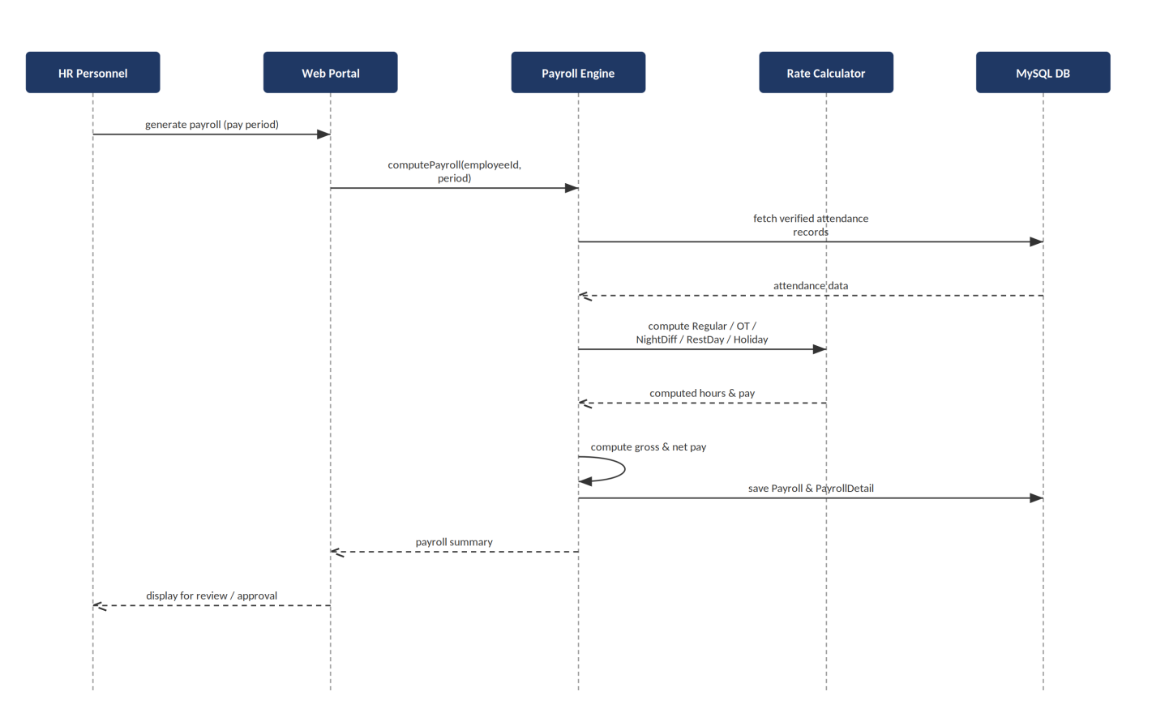
Figure 14.0 Payroll Computation Sequence Diagram
4.6 Leave & Overtime Approval Sequence Diagram
Illustrates the multi-tier workflow for filing and approving leave and overtime requests, from employee submission through supervisor and HR approval.
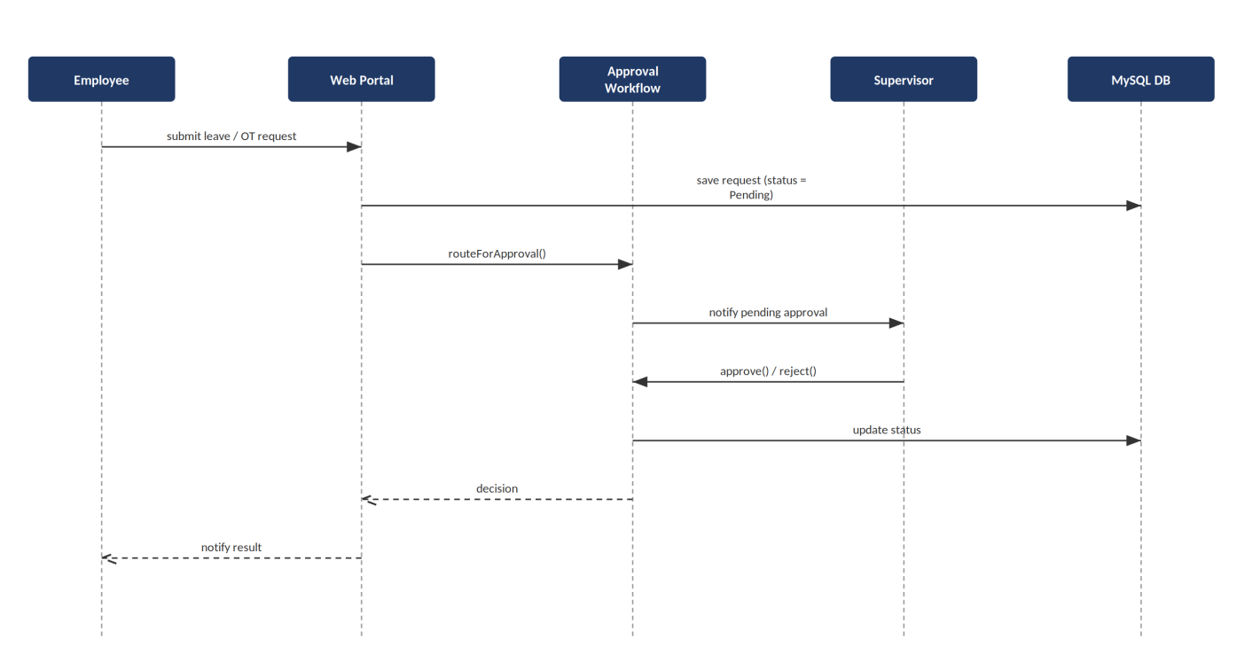
Figure 15.0 Leave & Overtime Approval Sequence Diagram

Human Interface Design

