Software Project Management Plan

for

Human Resource Information System (HRIS)
for Arcenas Development Corporation

List of Figures
List of Tables

Document Version: 1.0
Date: July 27, 2026
Prepared By: Jay Mark A. Reños, Liza Mae C. Sugala, Rusel R. Portes, Efren S. Cabudbud Jr., CarlVey Sente, Rayla G. Lanaza
Technical Adviser: Eric Bulala
Subject Adviser: Engr. Clark Kevin V. Villamor — Head, College of Computer Studies
Figure No. Description Page

Figure 1.0 External Structure………………………………………………………………………11
Figure 2.0 Internal Structure..…………………………………………………………………….12
Figure 3.0 Feature Breakdown Structure………………………………………………………14

Table No. Description Page

Table 1.0 Milestone Task………………………………………………………………………………..6
Table 2.0 Definition, Acronyms, and Abbreviations……………………………………………10
Table 3.0 Roles and Responsibilities………………………………………………………………..14
Table 4.0 Staff and Person Involved in Project………………………………………………….17
Table 5.0 Work Plan……………………………………………………………………………………….20
Table 6.0 Work Activities………………………………………………………………………………..23
Table 7.0 Methods and Techniques………………………………………………………………….29
Table 8.0 Tools……………………………………………………………………………………………..30

Overview
The Human Resource Information System (HRIS) for Arcenas Development Corporation is a web-based and mobile-enabled system developed to improve the organization, management, and monitoring of employee-related information and human resource processes. The project aims to provide a centralized platform for managing employee records, attendance, payroll, leave, user accounts, and HR-related reports.
The system consists of a web-based HRIS for centralized human resource management and an offline-first React Native mobile application designed for site foremen working in construction sites. The mobile application allows site foremen to record crew attendance through a digital checklist even when an internet connection is unavailable. Attendance records are stored securely on the mobile device and automatically synchronized with the central HRIS when connectivity is restored.
The project will be developed using an Agile Software Development approach, allowing the development team to work through multiple iterations of planning, development, testing, evaluation, and refinement. The system will use React.js for the web frontend, React Native for the mobile application, Laravel for backend services, MySQL for the central database, and SQLite for local mobile storage.
The project will involve requirements analysis, system and database design, development of the core HRIS modules, development of the mobile attendance application, integration and synchronization, security implementation, testing, documentation, and final deployment. The project is intended to provide Arcenas Development Corporation with a more organized, reliable, secure, and efficient solution for managing human resource and construction-site attendance processes.

Project Summary
The Human Resource Information System (HRIS) for Arcenas Development Corporation is a software project intended to centralize and improve the management of employee and human resource information within the organization. The system will provide authorized personnel with tools for managing employee records, attendance, payroll, leave requests, user accounts, and reports through a web-based platform.
A major component of the project is the development of an offline-first mobile attendance application for site foremen. The application is designed to address the challenges of recording attendance at construction sites where internet connectivity may be limited or unavailable. Site foremen will be able to record crew attendance using a digital checklist, store attendance information securely on the device, and synchronize the records with the central HRIS once an internet connection becomes available.
The project will follow an Agile development approach and will be implemented through three development iterations followed by final testing and deployment. The first iteration will focus on the system foundation, database, authentication, and employee information management. The second iteration will focus on the core HRIS modules, including attendance, leave, payroll, reporting, and user management. The third iteration will focus on the mobile attendance application, offline storage, synchronization, and cryptographic validation.
The completed project will deliver a web-based HRIS, an offline-first mobile attendance application, integrated HR modules, reporting functionality, security mechanisms, system documentation, testing results, user documentation, and system deployment.

Purpose, Scope and Objectives
The Human Resource Information System (HRIS) for Arcenas Development Corporation is a comprehensive human resource management system designed to improve the organization, accuracy, and efficiency of employee-related processes within the company. The system manages essential human resource functions such as employee records, payroll, leave management, and attendance monitoring.
A key feature of the system is its offline-first React Native mobile application designed specifically for site foremen working in construction sites. Since construction projects are often located in temporary and remote areas where stable internet connectivity and fixed biometric devices may not be available, the mobile application enables site foremen to record crew attendance using a digital checklist even while offline.
The mobile application securely stores attendance data locally using encrypted storage and automatically synchronizes the recorded information with the central HRIS once an internet connection becomes available. The system also incorporates cryptographic validation mechanisms to help prevent unauthorized modification and time-tampering of attendance records. This approach provides a more reliable and secure alternative to traditional manual attendance logbooks.
The goal of the Human Resource Information System (HRIS) for Arcenas Development Corporation is to provide the following features required by the target users:
- Employee Information Management Module Functionalities
- Employee Profile Management: Stores and manages employee information, including personal details, employment information, position, and other relevant records.
- Employee Records Management: Allows authorized personnel to add, view, update, and maintain employee records in a centralized system.
- Employee Information Retrieval: Enables authorized users to quickly search and access employee information when needed.
- Attendance Management Module Functionalities
- Digital Attendance Recording: Allows site foremen to record crew attendance through a digital checklist instead of relying on manual logbooks.
- Offline Attendance Recording: Enables site foremen to record attendance even when the construction site has limited or no internet connectivity.
- Encrypted Local Storage: Securely stores attendance records on the mobile device while the application is offline.
- Automatic Data Synchronization: Automatically uploads and synchronizes locally stored attendance records with the central HRIS once an internet connection becomes available.
- Cryptographic Validation: Uses cryptographic validation to help verify the integrity of attendance records and prevent unauthorized modification or time-tampering.
- Payroll Management Module Functionalities
- Attendance-Based Payroll Information: Provides attendance-related information that can support payroll processing and computation.
- Payroll Record Management: Allows authorized personnel to manage and maintain employee payroll records.
- Payroll Information Monitoring: Enables authorized users to review relevant payroll information for proper documentation and monitoring.
- Leave Management Module Functionalities
- Leave Request Management: Allows employees or authorized personnel to record and manage employee leave requests.
- Leave Monitoring: Enables authorized HR personnel to review and monitor employee leave information.
- Leave Records Management: Maintains organized records of employee leave history for documentation and reference.
- User and Access Management Module Functionalities
- User Authentication: Provides a secure login mechanism to ensure that only authorized users can access the system.
- Role-Based Access Control: Provides different system permissions based on the user's role, such as Site Foreman, Site Engineer, Construction Manager, and authorized HR personnel.
- Account Management: Allows authorized administrators to manage user accounts and their corresponding access privileges.
- Reporting and Monitoring Module Functionalities
- Employee Reports: Generates organized reports containing relevant employee information.
- Attendance Reports: Provides attendance summaries and records that can be used for monitoring and payroll-related purposes.
- Leave Reports: Generates records and summaries of employee leave information.
- Payroll Reports: Provides relevant payroll information and reports for authorized users.
- Offline-First Mobile Application Functionalities
- Digital Crew Checklist: Provides site foremen with a simple digital checklist for quickly recording the attendance of construction crews.
- Offline Operation: Allows the application to continue recording attendance without requiring an active internet connection.
- Secure Local Data Storage: Protects locally stored attendance information through encryption while the device is offline.
- Automatic Synchronization: Synchronizes locally stored records with the central HRIS when network connectivity is restored.
- Attendance Data Integrity: Applies cryptographic validation to help ensure that attendance records remain authentic and have not been improperly altered.

1.1.2. Assumptions and Constraints
The Human Resource Information System (HRIS) for Arcenas Development Corporation is designed as a web-based and mobile-enabled human resource management system. The system will provide centralized HR management through the web application while supporting attendance recording through an offline-first mobile application for site foremen. Therefore, the system will be developed and implemented using the following technologies:
- Frontend: React.js
- Mobile Application: React Native
- Backend: Laravel Framework
- Database Server: MySQL
- Local Mobile Database: SQLite
- Coding Pattern: Model-View-Controller (MVC) with appropriate service-based architecture
- Web Application: Human Resource Information System (HRIS)
- Mobile Application: Offline-first attendance recording application for Site Foremen
- Security: Encrypted local data storage and cryptographic validation for attendance records
- Data Synchronization: Automatic synchronization between the mobile application and the central HRIS when an internet connection becomes available

Project Deliverables
All of the items listed in this subsection are the deliverables to be provided prior to the completion of the project.
- Web-Based Human Resource Information System (HRIS) for Arcenas Development Corporation
- Mobile Application for offline-first crew attendance recording
- Employee Information Management Module
- Attendance Management Module
- Payroll Management Module
- Leave Management Module
- User and Access Management Module
- Reporting and Monitoring Module
- Offline Attendance and Synchronization Functionality
- Software Documentation (Software Engineering Documents)
o Software Requirements Specification (SRS)
o Software Design Document (SDD)
o Software Project Management Plan (SPMP)
o Software Test Document (STD)
- System Testing and Evaluation Results
- Database and System Configuration
- User Interface and System Prototype
- User Manual and Instructional Materials needed for the orientation and proper use of the HRIS and mobile attendance application
- System Deployment and Installation on the designated devices and environment of Arcenas Development Corporation.

Schedule and Budget Summary
The budget will be based on the estimated costs associated with system development, software requirements, testing, deployment, documentation, and other resources necessary for the completion of the project. Since the system primarily uses software-based technologies, the budget will focus on development and operational requirements rather than hardware components.

Milestone Task | Date Started | Completion Date
Project Proposal | July 6, 2026 | August 5, 2026
Development Phase I – System Design and Database Development | August 6, 2026 | September 18, 2026
Software Test I | September 21, 2026 | October 2, 2026
Development Phase II – HRIS Core Modules | October 5, 2026 | November 20, 2026
Software Test II | November 23, 2026 | November 30, 2026
Development Phase III – Mobile Attendance and Synchronization | February 2, 2027 | February 26, 2027
Final Testing and Deployment | March 1, 2027 | March 12, 2027

Table 1.0 Milestone Task

Evolution of Plan
All changes to the Human Resource Information System (HRIS) for Arcenas Development Corporation Project Management Plan must be reviewed and approved by the project manager and development team before implementation. Any modifications related to the system requirements, user roles, database structure, HRIS modules, mobile attendance application, security mechanisms, or system architecture should be properly documented to maintain consistency, accuracy, and updated project records.
The project plan may evolve due to changes in user requirements, technical limitations, construction site conditions, internet connectivity issues, software compatibility, security requirements, or improvements identified during the development and testing phases. Changes may also be necessary to improve the offline-first attendance functionality, data synchronization process, and cryptographic validation of attendance records.
All approved changes must be reflected in the official project documentation and relevant system specifications. The project team shall review the impact of each modification on the project scope, schedule, budget, resources, and system functionality before implementation. This process ensures that the project remains aligned with the objectives and requirements of Arcenas Development Corporation while maintaining proper control over the development process.

Definition, Acronyms, and Abbreviations

Terms | Definition
HRIS | Human Resource Information System. A system designed to manage and organize employee information, attendance, payroll, leave, and other human resource-related processes.
Arcenas Development Corporation (ADC) | The organization for which the Human Resource Information System is developed and implemented.
React.js | A JavaScript library used to develop the user interface of the web-based Human Resource Information System.
React Native | A framework used to develop the mobile application for recording employee and crew attendance on construction sites.
Laravel | A PHP-based web application framework used to develop the backend and server-side functionalities of the HRIS.
MySQL | A relational database management system used to store and manage centralized employee, attendance, payroll, leave, and other HR-related information.
SQLite | A lightweight database used for local storage of attendance information within the mobile application when the device is offline.
Offline-First | An application approach that allows the mobile system to continue performing essential functions and storing data even without an active internet connection.
Synchronization | The process of transferring and updating locally stored mobile data with the central HRIS when an internet connection becomes available.
Encryption | A security process that converts data into a protected format to prevent unauthorized access to stored information.
Cryptographic Validation | A security mechanism used to verify the integrity and authenticity of attendance records and help detect unauthorized modification or time-tampering.
API(Application Programming Interface) | A set of rules and protocols that allows the web application, mobile application, and backend system to communicate and exchange data.
MVC (Model-View-Controller) | A software architectural pattern that separates an application into three main components: Model for data, View for the interface, and Controller for application logic.
CRUD | Create, Read, Update, Delete. The basic operations used to manage records within the HRIS.
UI (User Interface) | The visual interface through which users interact with the HRIS and mobile application.
UX (User Experience) | The overall experience of users when interacting with the HRIS, including ease of use, accessibility, and system responsiveness.
Authentication | The process of verifying the identity of a user before granting access to the system.
Authorization | The process of determining which system functions and information a user is allowed to access based on their assigned role.
Role-Based Access Control (RBAC) | A security approach that assigns system permissions according to the user's role and responsibilities.
Site Foreman | A construction site personnel responsible for supervising workers and recording crew attendance using the mobile application.
Site Engineer | A construction professional responsible for monitoring and managing engineering-related activities at the project site and may access relevant HR and attendance information.
Construction Manager | A personnel responsible for overseeing construction operations and accessing relevant employee and attendance information.
Attendance Management | The process of recording, monitoring, and maintaining employee attendance information.
Digital Attendance Checklist | A mobile-based checklist used by site foremen to quickly record the attendance status of construction workers.
Leave Management | The process of recording, monitoring, and managing employee leave requests and leave records.
Payroll | The process of managing employee compensation and related payroll information based on available employee and attendance records.
Employee Records | Information maintained by the HRIS concerning employees, including personal, employment, position, and other relevant details.
Local Storage | The storage of application data directly on the mobile device, allowing attendance records to remain available even when offline.
Data Integrity | The accuracy, consistency, and reliability of information stored and processed by the system.
Web-Based System | A software application that is accessed through a web browser and connected to a server or network.
Mobile Application | A software application designed to run on mobile devices and used by site foremen for attendance recording.
Database | An organized collection of information that allows the system to store, retrieve, update, and manage data efficiently.

Table 2.0 Definition, Acronyms, and Abbreviations

References
React, “React Documentation.” Web. https://react.dev/ Accessed 2026.
[2] Meta Platforms, Inc., “React Native Documentation.” Web. https://reactnative.dev/docs/getting-started Accessed 2026.
[3] Laravel, “Laravel Documentation.” Web. https://laravel.com/docs Accessed 2026.
[4] Oracle, “MySQL Documentation.” Web. https://dev.mysql.com/doc/ Accessed 2026.
[5] SQLite, “SQLite Documentation.” Web. https://www.sqlite.org/docs.html Accessed 2026.
[6] OWASP Foundation, “OWASP Application Security Verification Standard (ASVS).” Web. https://owasp.org/www-project-application-security-verification-standard/ Accessed 2026.
[7] OWASP Foundation, “OWASP Top 10: The Ten Most Critical Web Application Security Risks.” Web. https://owasp.org/www-project-top-ten/ Accessed 2026.
[8] International Organization for Standardization, “ISO/IEC 25010:2011 – Systems and software engineering — Systems and software Quality Requirements and Evaluation (SQuaRE) — System and software quality models.” 2011.
[9] IEEE, “IEEE Std 830-1998: IEEE Recommended Practice for Software Requirements Specifications.” 1998.
[10] IEEE, “IEEE Std 1058-1998: IEEE Standard for Software Project Management Plans.” 1998.
[11] MDN Web Docs, “Web APIs and Web Development Documentation.” Web. https://developer.mozilla.org/en-US/docs/Web/API Accessed 2026.
[12] Android Developers, “Android Developers Documentation.” Web. https://developer.android.com/docs Accessed 2026.

Project Organization
This section of the Software Project Management Plan (SPMP) describes the organizational structure of the Human Resource Information System (HRIS) for Arcenas Development Corporation. It identifies the organizational entities that interact with or provide requirements for the project, describes the internal structure of the development team, and defines the roles and responsibilities of each project member.
The project organization is established to ensure clear communication, proper delegation of tasks, effective decision-making, and accountability throughout the planning, development, testing, and deployment of the HRIS.

External Structure
The project team will coordinate with Arcenas Development Corporation as the primary external organization and intended client of the system. The organization will provide the necessary business requirements, employee-related processes, feedback, and validation needed during the development of the HRIS.
The primary external stakeholders include:
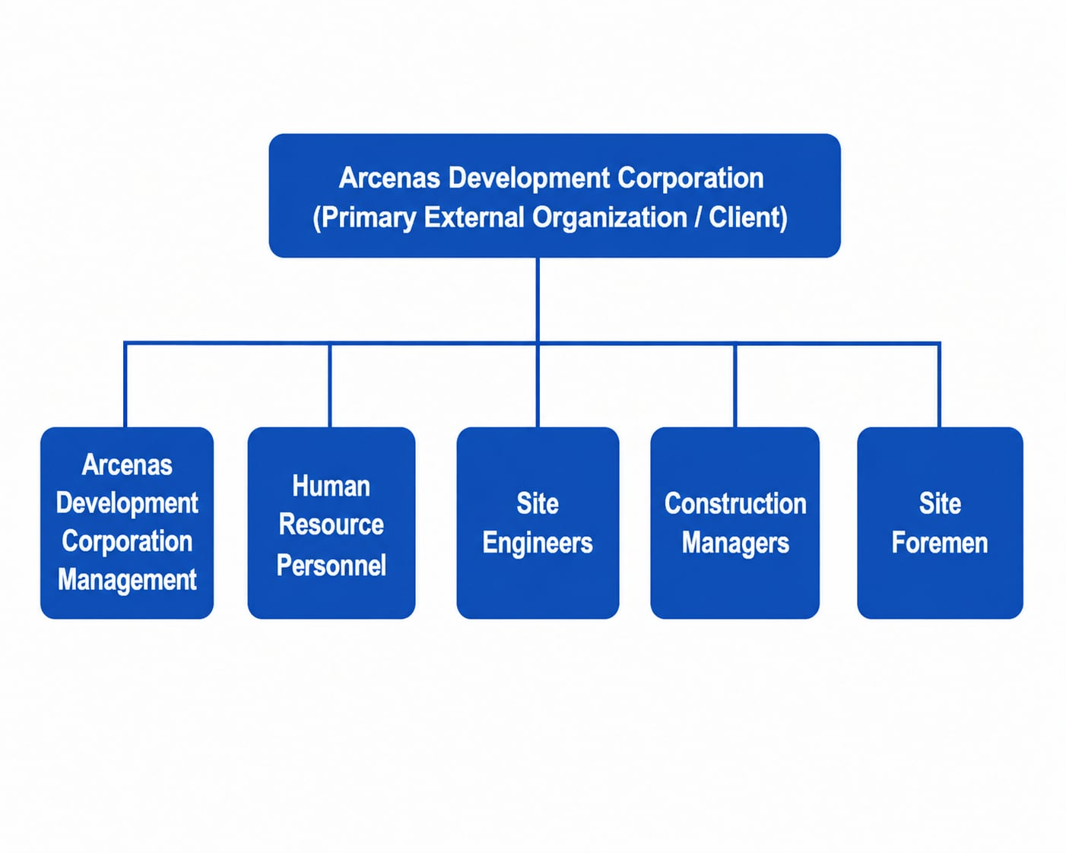
Figure 1.0 External Structure
Communication with external stakeholders will be conducted through meetings, consultations, demonstrations, system testing, and feedback sessions. Requirements and approved changes provided by the organization shall be properly documented and reviewed by the project team.

Internal Structure
The project will be managed by a development team responsible for planning, designing, developing, testing, documenting, and deploying the HRIS. Each member will be assigned specific responsibilities based on their role and area of expertise.
The internal project organization consists of the following roles:
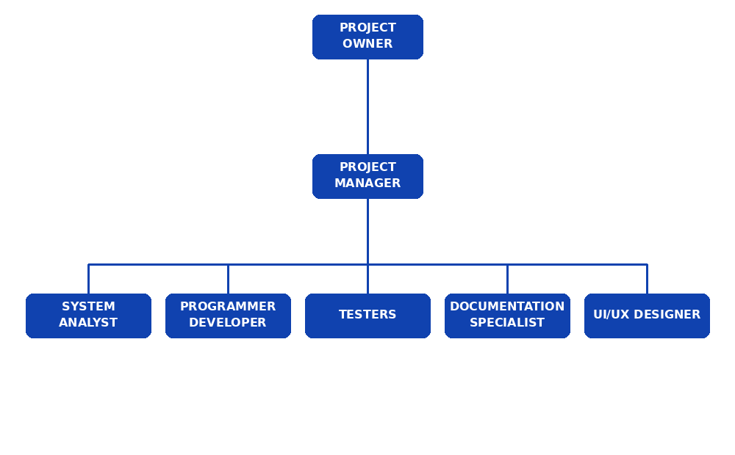
Figure 2.0 Internal Structure

Roles and Responsibilities

Role | Responsibilities
Project Manager | Overall project coordination, timeline management, milestone tracking, stakeholder communication, risk management, resource allocation, meeting facilitation.
Systems Analyst | Requirements gathering, use case specifications (UC-01 to UC-10), SRS drafting, stakeholder interviews, functional requirement validation.
Lead Developer / Programmer | Laravel backend API, React.js web frontend, React Native mobile app, cryptographic engine (Monotonic Clock, HMAC, TEE Signing), background sync engine.
Database & QA Lead | MySQL database schema, ERD, data dictionary, SQLCipher implementation, test case execution, defect tracking, STD preparation.
Documentation Lead | SRS, SDD, SPMP, and STD preparation  Technical documentation  User manual preparation  Documentation maintenance
UI/UX | User interface design  User experience planning  Wireframe and prototype development (PR-01 to PR-10)  Design consistency across web and mobile applications  Usability improvement and user feedback integration

Table 3.0 Roles and Responsibilities

Managerial Process Plans
This section of the Software Project Management Plan (SPMP) specifies the project management processes that will be followed in the development of the Human Resource Information System (HRIS) for Arcenas Development Corporation. The management processes are aligned with the approved project scope and are intended to ensure effective planning, resource allocation, risk management, project monitoring, and successful completion of the system.
The managerial process plans include the Project Start-up Plan, Risk Management Plan, Project Work Plan, Project Control Plan, and Project Closeout Plan. These processes will guide the development team throughout the project lifecycle, from initial planning and requirements gathering to system deployment and project completion.

Start-up Plan
The Start-up Plan defines the activities required to formally begin the development of the HRIS. It covers project estimation, staffing, resource acquisition, and training of project personnel. The plan ensures that the development team has the necessary skills, tools, resources, and understanding of the project requirements before the main development activities begin.
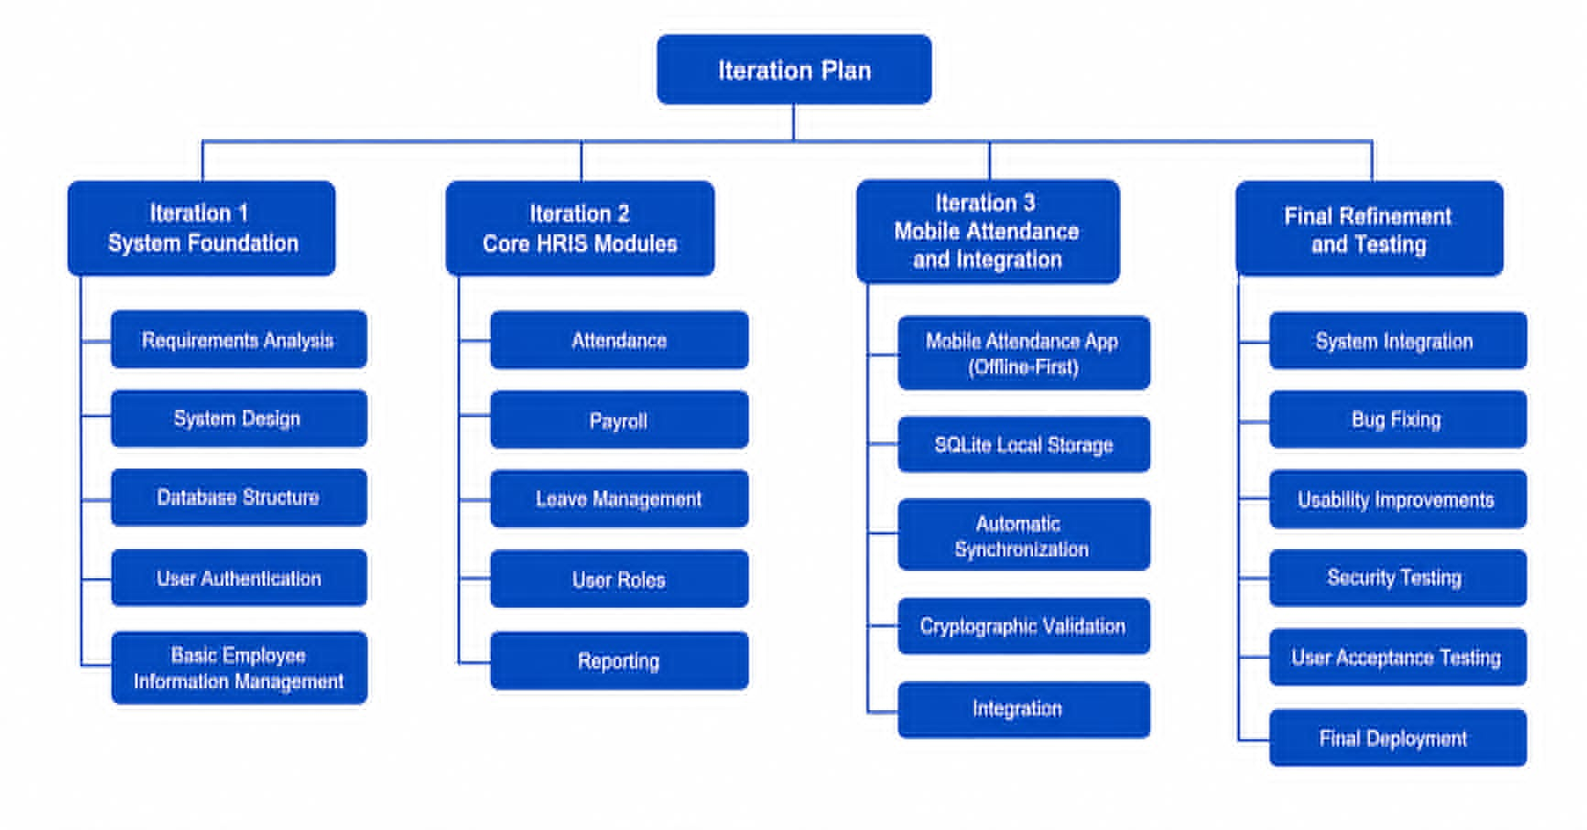
Figure 3.0 Feature Breakdown Structure

Estimation Plan
The proponents will use an Agile Software Development approach for the development of the Human Resource Information System (HRIS) for Arcenas Development Corporation because the system requirements may change based on user feedback, testing results, and the actual needs of the organization.
The Agile approach allows the development team to continuously evaluate and improve the system throughout the development process. Requirements may be refined or modified during development to address changes in HR processes, attendance requirements, user roles, and the operational conditions of construction sites.
The development will be divided into several iterations. Each iteration will include planning, development, testing, evaluation, and refinement of selected system functionalities. The initial iterations will focus on the core HRIS functionalities, while succeeding iterations will focus on additional features, integration, security, and improvements.
The planned development iterations are as follows:
- Iteration 1 – System Foundation: Requirements analysis, system design, database structure, user authentication, and basic employee information management.
- Iteration 2 – Core HRIS Modules: Development of attendance, payroll, leave management, user roles, and reporting functionalities.
- Iteration 3 – Mobile Attendance and Integration: Development of the React Native offline-first attendance application, SQLite local storage, automatic synchronization, and cryptographic validation of attendance records.
- Final Refinement and Testing: System integration, bug fixing, usability improvements, security testing, user acceptance testing, and final deployment.
The number of iterations may be adjusted if additional requirements, technical issues, or necessary improvements are identified during development. Any major changes that may affect the project's scope, schedule, or resources shall be reviewed and approved before implementation.
Estimation will consider the following factors:
- Complexity of each system module
- Number and type of required functionalities
- Development and testing effort
- Database and API requirements
- Mobile offline and synchronization requirements
- Security and data protection requirements
- Availability and skills of project team members
- Time required for documentation and deployment
- Feedback and changes requested by the target users

Staffing Plan
The table below shows the team members involved in the development of the Human Resource Information System (HRIS) for Arcenas Development Corporation.

Name | Position | Status
Jay Mark A. Reños | Project Manager | Full Time
Liza Mae C. Sugala | System Analyst | Full Time
Rusel R. Portes | Lead Developer | Full Time
CarlVey Sente | UI/UX Designer | Full Time
Efren S. Cabudbud Jr. | Lead Tester | Full Time
Rayla G. Lanaza | Documentation Specialist | Full Time

Table 4.0 Staff and Person Involved in Project

Resource Acquisition Plan
All necessary software, development tools, and resources required for the development of the Human Resource Information System (HRIS) for Arcenas Development Corporation will be identified and prepared by the project team before and during the development process. The primary technologies to be used include React.js, React Native, Laravel, MySQL, and SQLite, together with the necessary development environments, testing devices, internet connectivity, and documentation tools.
For the requirements needed for the project, the development team will coordinate with Arcenas Development Corporation and its designated representatives to obtain relevant information regarding current human resource processes, employee records, attendance monitoring, payroll, leave management, and construction site attendance procedures.
The project team will prepare appropriate request letters and conduct consultations, interviews, observations, and discussions with authorized personnel such as HR personnel, Site Engineers, Construction Managers, and Site Foremen. The information gathered will be documented, reviewed, and analyzed to identify the functional and non-functional requirements of the system.
Any company-provided data or information will be handled appropriately and used only for the purposes of system analysis, development, testing, and documentation. Access to sensitive employee information will be limited to authorized project members and stakeholders.

Project Staffing Plan
The project team members have the necessary basic knowledge and skills in software development, system analysis, database management, user interface design, and software testing required for the development of the Human Resource Information System (HRIS) for Arcenas Development Corporation.
However, project-specific orientation and technical familiarization may be conducted when necessary, particularly for the technologies and functionalities used in the system. The team may review the use of React.js, React Native, Laravel, MySQL, SQLite, offline-first application development, data synchronization, encryption, and cryptographic validation to ensure that the members are properly prepared for their assigned tasks.
Training and orientation activities may include:
- Familiarization with the approved system requirements and project scope.
- Review of the development workflow and coding standards.
- Familiarization with the React.js and React Native development environments.
- Review of Laravel backend and API development.
- Database management using MySQL and SQLite.
- Understanding of offline data storage and synchronization.
- Review of security practices, encryption, and cryptographic validation.
- Familiarization with the testing procedures and documentation standards.
The Project Manager and Lead Developer will coordinate any necessary training or knowledge-sharing activities. Team members may also conduct self-learning, technical discussions, and peer-to-peer knowledge sharing throughout the development process to address new technical requirements or challenges encountered during implementation.

Work Plan
This section describes the detailed decomposition of the total scope of work for the Human Resource Information System (HRIS) for Arcenas Development Corporation. The work plan identifies the major project tasks, activities, and estimated schedules that will be performed by the project team to accomplish the project objectives and produce the required system deliverables.
The development process will be divided into several iterations following the Agile Software Development approach. Each iteration will focus on specific system functionalities and will include development, integration, testing, evaluation, and necessary revisions.
Project Task |  | Estimated Schedule
1. | Iteration 1 | July 6 – October 2, 2026
1.1 | Requirements Analysis and System Planning | July 6 – July 24, 2026
1.2 | System Architecture and Database Design | July 27 – August 21, 2026
1.3 | User Account and Authentication | August 24 – September 4, 2026
1.4 | Employee Information Management | September 7 – September 18, 2026
1.5 | Software Testing I | September 21 – October 2, 2026
2. | Iteration 2 | October 5 – November 30, 2026
2.1 | Iteration 1 Revisions | October 5 – October 9, 2026
2.2 | Attendance Management | October 12 – October 23, 2026
2.3 | Leave Management | October 26 – October 30, 2026
2.4 | Payroll Management | November 2 – November 13, 2026
2.5 | Reports and Monitoring | November 16 – November 20, 2026
2.6 | Software Testing II | November 23 – November 30, 2026
3. | Iteration 3 | February 2 – February 26, 2027
3.1 | Iteration 1 and 2 Revisions | February 2 – February 5, 2027
3.2 | React Native Mobile Attendance Application | February 8 – February 12, 2027
3.3 | Offline Attendance and SQLite Local Storage | February 15 – February 17, 2027
3.4 | Automatic Data Synchronization | February 18 – February 19, 2027
3.5 | Cryptographic Validation and Attendance Security | February 22 – February 24, 2027
3.6 | System Integration and Final Testing | February 25 – February 26, 2027
4. | Final Testing and Deployment | March 1 – March 12, 2027
4.1 | User Acceptance Testing | March 1 – March 3, 2027
4.2 | Final Revisions and Bug Fixing | March 4 – March 8, 2027
4.3 | System Deployment | March 9 – March 10, 2027
4.4 | Documentation Finalization | March 11 – March 12, 2027
Table 5.0 Work Plan

Work Activities

The work activity table specifies the major activities to be performed for each project task and iteration. It also identifies the personnel assigned to each activity and the estimated labor hours required to complete the task.
Project Task |  | Role | Labor Hours
1. | Iteration 1
1.1 | Requirements and System Planning |  | 80 hrs
 | Requirements Gathering | System Analyst | 24 hrs
 | System Planning | Project Manager | 16 hrs
 | System Design | Lead Developer | 24 hrs
 | Requirements Review | Lead Tester | 16 hrs
1.2 | Database and UI Design |  | 72 hrs
 | Database Design | Database Developer | 32 hrs
 | UI/UX Design | UI/UX Designer | 24 hrs
 | System Architecture | Lead Developer | 16 hrs
1.3 | User Accounts and Authentication |  | 64 hrs
 | User Interface Development | Lead Developer | 24 hrs
 | Authentication Development | Backend Developer | 24 hrs
 | Software Testing | Lead Tester | 16 hrs
1.4 | Employee Information Management |  | 64 hrs
 | Requirements and Database | System Analyst / Database Developer | 16 hrs
 | Module Development | Lead Developer | 32 hrs
 | Software Testing | Tester | 16 hrs
1.5 | Software Testing I |  | 48 hrs
 | Functional Testing | Lead Tester | 24 hrs
 | Bug Fixing and Verification | Developers | 24 hrs
2. | Iteration 2
2.1 | Iteration 1 Revisions |  | 48 hrs
 | Development Revisions | Lead Developer | 32 hrs
 | Software Testing | Lead Tester | 16 hrs
2.2 | Attendance Management |  | 72 hrs
 | Requirements Gathering | System Analyst | 16 hrs
 | Module Development | Lead Developer | 40 hrs
 | Software Testing | Tester | 16 hrs
2.3 | Leave Management |  | 56 hrs
 | Module Development | Lead Developer | 40 hrs
 | Software Testing | Tester | 16 hrs
2.4 | Payroll Management |  | 72 hrs
 | Module Development | Lead Developer | 48 hrs
 | Software Testing | Tester | 24 hrs
2.5 | Reports and Monitoring |  | 56 hrs
 | Report Development | Web Developer / Backend Developer | 40 hrs
 | Software Testing | Tester | 16 hrs
2.6 | Software Testing II |  | 56 hrs
 | System Testing | Lead Tester / Tester | 40 hrs
 | Approval | Project Manager | 16 hrs
3. | Iteration 3
3.1 | Iteration 1 and 2 Revisions |  | 48 hrs
 | Development Revisions | Lead Developer | 32 hrs
 | Software Testing | Tester | 16 hrs
3.2 | Mobile Attendance Application |  | 72 hrs
 | UI/UX Design | UI/UX Designer | 16 hrs
 | React Native Development | Lead Developer | 40 hrs
 | Software Testing | Tester | 16 hrs
3.3 | Offline Storage and Synchronization |  | 72 hrs
 | SQLite Implementation | Lead Developer | 32 hrs
 | Synchronization Development | Lead Developer | 24 hrs
 | Software Testing | Tester | 16 hrs
3.4 | Cryptographic Validation |  | 56 hrs
 | Security Implementation | Security Developer | 40 hrs
 | Security Testing | Lead Tester | 16 hrs
3.5 | Final Integration and Testing |  | 72 hrs
 | System Integration | Lead Developer | 32 hrs
 | Final Testing | Lead Tester / Tester | 24 hrs
 | Approval |  | 16 hrs
4. | Final Testing and Deployment
4.1 | User Acceptance Testing |  | 56 hrs
 | User Acceptance Test | Lead Tester | 24 hrs
 | Feedback and Evaluation | System Analyst | 16 hrs
 | Approval | Project Manager | 16 hrs
4.2 | Final Revisions and Deployment |  | 80 hrs
 | Bug Fixing | Developers | 40 hrs
 | Deployment | Lead Developer | 24 hrs
 | Deployment Verification | Tester | 16 hrs
4.3 | Documentation Finalization |  | 48 hrs
 | Documentation | Documentation Specialist | 32 hrs
 | Final Review | Project Manager | 16 hrs

Table 6.0 Work Activities

Schedule Allocation
The project duration is divided into three major iterations followed by the final testing and deployment phase. Each iteration is allocated with a specific amount of working time based on the complexity and number of tasks assigned to the development team. The schedule may be adjusted when necessary depending on changes in user requirements, testing results, technical issues, and other approved project modifications.

Resource Allocation
The development team has a fixed amount of time available for the completion of the project. The development period is divided into three iterations and a final testing and deployment phase. Based on the estimated labor hours assigned to the project activities, the development team is allocated approximately 128 labor hours for Iteration 1, 168 labor hours for Iteration 2, 148 labor hours for Iteration 3, and 70 labor hours for the Final Testing and Deployment phase.
The allocated labor hours cover requirements analysis, system design, development, testing, revisions, mobile application development, synchronization, security implementation, deployment, and documentation. The allocation may be adjusted depending on project progress, team availability, and approved changes in system requirements.

Budget Allocation
The project will primarily utilize the available resources and development tools of the proponents. The development budget will cover necessary expenses such as internet connectivity, testing resources, documentation and printing, deployment requirements, and other project-related materials when applicable.
Any additional expenses that may arise during development shall be reviewed by the project team and documented accordingly. Since the project is primarily software-based, no major hardware acquisition is expected to be required for the development of the system.

Control Plan
This section of the Software Project Management Plan (SPMP) specifies the metrics, reporting mechanisms, and control procedures necessary to measure, report, and control the requirements, project schedule, resources, quality, and development activities of the Human Resource Information System (HRIS) for Arcenas Development Corporation.
The control procedures will be used throughout the project to ensure that development activities remain aligned with the approved project scope, schedule, requirements, and quality standards. Any significant changes identified during development will be reviewed and properly documented by the project team.

Requirements Control Plan
System requirements will be managed and documented through the Software Requirements Specification (SRS) and related use case descriptions. Changes in requirements may occur based on stakeholder feedback, testing results, or changes in organizational processes.
All proposed changes shall be reviewed by the Project Manager and System Analyst to determine their effect on the project scope, schedule, resources, and system functionality. Approved changes shall be updated in the appropriate project documentation and communicated to the development team before implementation.

Schedule Control Plan
The development team will conduct regular progress meetings to monitor the status of project activities. Daily or scheduled team meetings will be supervised by the Project Manager to review completed tasks, current activities, encountered problems, and upcoming tasks.
Each team member will report their progress and identify any impediments that may affect the project schedule. The Project Manager will monitor the progress of each iteration and compare actual accomplishments against the planned schedule.
At the end of each iteration, the development team will conduct a retrospective meeting to evaluate the team's performance, identify problems encountered, and determine improvements that can be applied to the next iteration.

Budget Control Plan
The project will primarily utilize the existing resources and development tools available to the proponents. Project-related expenses such as internet connectivity, testing resources, documentation, printing, and deployment requirements will be monitored throughout the development period.
Any additional expenses required during development shall be reviewed and documented by the project team to ensure that resources are used appropriately.

Quality Control Plan
The Quality Assurance and Testing team will prepare and maintain the Software Test Document (STD) containing test cases, testing procedures, test results, and identified defects.
Quality control will be performed through unit testing, functional testing, integration testing, usability testing, security testing, and user acceptance testing. Identified defects will be documented and assigned to the appropriate developer for correction and verification.
Special attention will be given to the reliability of the offline-first attendance application, data synchronization, employee information management, and cryptographic validation of attendance records.
A more detailed quality assurance and testing procedure will be presented in the Software Test Document.

Reporting Plan
The development team will provide progress reports to the Project Manager and relevant stakeholders at the end of each iteration. These reports will summarize completed activities, current progress, identified issues, testing results, and planned activities for the next iteration.
Regular team meetings will also serve as a mechanism for reporting task accomplishments, problems, and project status. Major issues or changes affecting the project scope and schedule shall be reported immediately to the Project Manager.

Metrics Collection Plan
Project metrics will be collected throughout the development process to monitor progress and team performance. The following metrics may be used:
- Percentage of completed project tasks.
- Number of completed requirements.
- Number of identified and resolved defects.
- Number of completed test cases.
- Actual labor hours compared with estimated labor hours.
- Iteration completion rate.
- Number of approved requirement changes.
- System testing and user acceptance results.
The collected metrics will be reviewed during progress meetings and iteration retrospectives to determine whether the project is progressing according to the approved plan.

Risk Management Plan
Project risks will be identified during project planning and continuously monitored throughout each development iteration. The Project Manager and development team will maintain a prioritized list of identified risks based on their likelihood and potential impact on the project.
During regular project meetings, team members will report newly identified risks, technical problems, schedule delays, and other issues that may affect the project. Mitigation and contingency actions will be identified for high-priority risks and assigned to responsible team members.
Potential risks include changes in user requirements, limited internet connectivity at construction sites, mobile device compatibility issues, data synchronization failures, security vulnerabilities, technical difficulties, and delays in development or testing.
All identified risks, mitigation actions, and their status will be properly documented and reviewed throughout the project.

Project Closeout Plan
The development team will ensure the proper closeout of the Human Resource Information System (HRIS) for Arcenas Development Corporation after the completion of final testing, user acceptance testing, deployment, and documentation.
The project closeout activities will include:
- Completion of all approved system requirements.
- Resolution and verification of critical system defects.
- Completion of final system testing and user acceptance testing.
- Deployment of the completed system.
- Finalization of SRS, SDD, SPMP, STD, and user documentation.
- Turnover of the completed system and necessary instructional materials.
- Final review and approval of project deliverables.
- Documentation of lessons learned and project outcomes.
The Project Manager will confirm that all required deliverables have been completed and accepted before formally closing the project.

Technical Process Plans
This section of the Software Project Management Plan (SPMP) specifies the technical processes, development methodology, tools, techniques, project infrastructure, and product acceptance procedures to be used in developing the Human Resource Information System (HRIS) for Arcenas Development Corporation.
The technical process plans are designed to ensure that the system is developed systematically and that all required web-based HRIS and mobile attendance functionalities are properly designed, implemented, tested, and accepted.

Process Model
The development team will use an Agile Software Development methodology for the development of the Human Resource Information System (HRIS). Agile is appropriate for the project because the system requirements may change based on stakeholder feedback, testing results, and the operational needs of Arcenas Development Corporation.
The project will be developed through a series of iterations. Each iteration will focus on a specific set of functionalities and will include planning, development, testing, review, and revision. This approach allows the team to identify issues early and make necessary improvements before proceeding to the next iteration.
The Agile process will include the following activities:
- Iteration Planning – The team will identify and prioritize the tasks and requirements to be completed during the iteration.
- Development – Developers will implement the assigned system functionalities based on the approved requirements.
- Testing – The testing team will evaluate the developed functionalities and document any identified defects.
- Iteration Review – At the end of each iteration, the team will present the completed functionalities and gather feedback from the stakeholders.
- Daily Stand-up Meeting – Team members will provide updates regarding completed tasks, current activities, and encountered issues.
- Iteration Retrospective – The team will evaluate the development process and identify improvements for the next iteration.
The Agile process will allow the project team to continuously improve the HRIS while maintaining alignment with the requirements of Arcenas Development Corporation.

Methods, Tools, and Technique
The methods and techniques listed in the following tables will be evaluated and applied to the appropriate areas of the Human Resource Information System (HRIS) for Arcenas Development Corporation.
Category | Methods and Techniques
Requirements | Interviews, consultations, observations, meetings, and requirements analysis
Formal Specification and Analysis | Use Case Diagrams, Activity Diagrams, Class Diagrams, and other UML models to represent system requirements and design
System Design | Wireframes, prototypes, database design, and user interface design
Development | Agile Software Development, iterative development, modular programming, and MVC architecture
Testing | Unit Testing, Functional Testing, Integration Testing, Usability Testing, Security Testing, and User Acceptance Testing
Data Management | Relational database design, data validation, database normalization, and data integrity techniques
Security | Authentication, authorization, role-based access control, encryption, and cryptographic validation
Documentation | SRS, SDD, SPMP, STD, user manual, and other project documentation

Table 7.0 Methods and Techniques

Tools

Category | Tools
Operating System | Windows
Programming Languages | JavaScript, PHP
Web Framework/Library | React.js
Mobile Framework | React Native
Backend Framework | Laravel
Database | MySQL
Local Mobile Database | SQLite
Development Environment | Visual Studio Code
API Testing | Postman
Diagrams and Modeling | Draw.io / UML Diagramming Tools
Version Control | Git and GitHub
Documentation | Microsoft Word
Web Browser | Google Chrome / Microsoft Edge
Mobile Testing | Android Device / Android Emulator

Table 8.0 Tools

Infrastructure Plan
The project infrastructure will consist of the development computers, mobile testing devices, software development environments, database systems, internet connectivity, and version control tools required for the development and testing of the HRIS.
The development team will use computers with the necessary hardware specifications to run the React.js, React Native, Laravel, MySQL, and SQLite development environments. Mobile devices or Android emulators will be used to test the React Native attendance application.
The project will also utilize a centralized code repository for source code management and version control. Internet connectivity will be required for development activities, package installation, API communication, repository synchronization, and testing of the mobile application's data synchronization functionality.
The infrastructure may be adjusted based on the technical requirements identified during development and deployment.

Product Acceptance Plan
Upon completion of the Human Resource Information System (HRIS) for Arcenas Development Corporation, the completed system will be presented to the designated representatives of Arcenas Development Corporation for evaluation and user acceptance testing.
The client representatives will evaluate the system based on the approved requirements, functionality, usability, security, attendance recording, data synchronization, and other agreed project specifications.
After the system has successfully passed the required testing and evaluation, the designated representative of Arcenas Development Corporation will be provided with a Project Acceptance Form. The authorized representative will sign the form as confirmation that the completed system has been reviewed and accepted.
Any identified issues or required modifications prior to acceptance will be documented and addressed by the development team before final acceptance and deployment.

Supporting Process Plans
This section of the Software Project Management Plan (SPMP) contains the supporting processes that will be applied throughout the development of the Human Resource Information System (HRIS) for Arcenas Development Corporation. These processes support the verification and validation, documentation, quality assurance, and resolution of problems encountered during the project.
The supporting processes will be performed throughout the project lifecycle to ensure that the system meets the approved requirements, maintains quality, and that identified problems are properly documented and resolved.

Verification and Validation Plan
The development team will create and maintain a separate Software Test Document (STD) for the verification and validation of the HRIS. The STD will contain the test cases, testing procedures, test results, identified defects, and validation activities required to determine whether the system meets the specified requirements.
Verification and validation activities will include unit testing, functional testing, integration testing, usability testing, security testing, and user acceptance testing. The results will be reviewed by the testing team and documented accordingly.

Documentation Plan
Several documents will be produced and maintained throughout the development lifecycle of the project. All project documents will be prepared and maintained by the assigned project team members. The following documents will be created and maintained:
- Software Project Management Plan (SPMP)
- Software Requirements Specification (SRS)
- Software Design Document (SDD)
- Software Test Document (STD)
- User Manual
- System and Technical Documentation
- Project Acceptance Documentation
All major project documents will be reviewed and updated when necessary to reflect approved changes in requirements, system design, development activities, testing results, and project decisions.

Quality Assurance Plan
To ensure the quality of the HRIS, the results documented in the Software Test Document (STD) will be evaluated to identify functional errors, usability issues, security concerns, and other problems encountered during development and testing.
Problems identified during testing will be documented and assigned to the appropriate developer for correction. After corrections are implemented, the affected functionality will be retested to verify that the problem has been properly resolved and that the correction does not introduce additional errors.
The Quality Assurance and Testing team will monitor the quality of the system throughout each iteration and during final system testing.

Problem Resolution Plan

Any major problem encountered by the development team during the project shall be reported and discussed during regular team meetings or daily stand-up meetings. Problems may include technical issues, development delays, system defects, synchronization errors, security issues, or changes in user requirements.
The team will identify the cause and possible solutions for each problem. Tasks for resolving the problem will be assigned to the appropriate team member and monitored until completion.
For major issues that may affect the project scope, schedule, resources, or deliverables, the Project Manager will review the issue and make the final decision regarding the appropriate action. All major problems and their corresponding resolutions will be properly documented for project reference.

