Software Requirement Specification
For
“LGU Mabini - MSWD Programs and Services Monitoring System”

List of Figures
Figure No. | Description | Page
Figure 1.0 | Login Use Case | 11

List of Figures
List of Tables

List of Tables
Table No. | Description | Page
Table 1.0 | Definitions, Acronyms, and Abbreviation | 4

Software Requirement Specification
“LGU Mabini - MSWD Programs and Services Monitoring System”
1. Introduction
In the fabric of local governance, Municipal Service Welfare Development (MSWD) stands as a cornerstone dedicated to the holistic betterment of communities. Operating within the framework of municipal administrations, MSWD initiatives encapsulate a spectrum of programs and services strategically designed to uplift the quality of life for residents across diverse socio-economic strata. At the heart of MSWD’s mandate lies a commitment to addressing the intricate web of challenges faced by communities, ranging from socio-economic disparities to vulnerabilities stemming from age, disability, or adverse circumstances. Through a combination of proactive planning, community engagement, and targeted interventions, MSWD endeavors to create an environment where every individual has the opportunity to thrive.
The Municipal Social Welfare and Development (MSWD) is a vital governmental agency dedicated to promoting social welfare and community development in the Mabini region. Committed to enhancing the well-being of residents, MSWD implements a diverse array of programs and services. From addressing economic challenges through financial aid and livelihood support to safeguarding the rights of children and empowering marginalized groups, MSWD plays a crucial role in fostering a more inclusive and resilient community. Through its initiatives, the agency seeks to create positive social change, provide assistance during crises, and contribute to the overall progress and welfare of the Mabini community.
Embarking on this transformative journey signifies a commitment to modernizing the delivery of programs and services within the Municipal Social Welfare Development (MSWD). Our aspiration is to leverage digital platforms and technology to revolutionize the way assistance is provided.
22

Software Requirement Specification
“LGU Mabini - MSWD Programs and Services Monitoring System”
In this section, purpose, goals, and scope of the proposed system shall be explained.
1.1. Purpose
The main purpose of creating the "LGU Mabini - MSWD Programs and Services Monitoring System" would likely be to enhance the efficiency, transparency, and effectiveness of the programs and services provided by the Local Government Unit (LGU) in Mabini, particularly those related to the Municipal Social Welfare and Development (MSWD) department.
1.2. Scope
The goal of the proposed system is to provide the following features required by the target users:
•Dashboard: Graphical interface that aggregates and visualizes data from various sources to monitor the health, performance, or efficiency of systems.
•Constituent Management: System should be able to store the personal informations of every constituent who will avail the programs or services in the said municipality.•Household Manager: For storing the address and family position and counts in every household.
•Sector Management: For storing the range of activities.
•Programs Management: For storing of beneficiaries with the program and services availed.
•Services Management: Lists of Services offered and requested.
•VAWC: Lists of victims and abuser.
•Reports
oHousehold List
oSolo Parent List
oPWD List
oSenior Citizens List
oPrograms and Beneficiaries List
oServices and who availed List
oVAWC Cases
23

Software Requirement Specification
““LGU Mabini - MSWD Programs and Services Monitoring System”
1.3. Definition, Acronyms, and Abbreviations

Terms | Definition
MSWD | Municipal Social Welfare and Development refers to the government department or agency responsible for addressing social welfare and development issues at the municipal or local government level.
DSWD | Department of Social Welfare and Development is the executive department of the Philippine Government responsible for the protection of the social welfare of rights of Filipinos and to promote the social  development.
VAWC | VIOLENCE AGAINST WOMEN AND CHILDREN refers to a range of violent acts committed against women and children, including physical, sexual, psychological, and economic violence.
PWD | Person With Disability is an individual who has a physical, sensory, cognitive, or mental impairment that substantially limits one or more major life activities.
LGU | Local Government Unit is an administrative or political division within a country that is responsible for governing and providing public services at the local or regional level.
HTML | Hypertext Markup Language is a markup language for web application.
CSS | Cascading Style Sheet Is a language use to design an HTML document.
MYSQL | MYSQL is an Oracle – backed open-source relational database management system (RDBMS) based on Structured Query Language (SQL).
PHP | Stands for "PHP: Hypertext Preprocessor," a recursive acronym. PHP is a scripting language web developers use to create dynamic websites.
Prototype | This is an initial creation of the product that shows the basics of what a product looks like, what a product do and how it operates.
Table 1.0 Definitions, Acronyms, and Abbreviations
24

Software Requirement Specification
“LGU Mabini - MSWD Programs and Services Monitoring System”
1.4. References

[1] Paessier AG (2022). Monitoring Systems.
[2] Pandora FMS (2022). The Importance of Having a Good Monitoring System.
[3] Paul RD (2019). CoMSCA Network.
[4] Valencia & Roxas (2014). Advantages and Disadvantages of Manual and Computerized.
[5] Garcia, F.L. et al. (2022) Environmental Fund in Community Managed Savings and Credit Associations: A Guide for Facilitators – First Edition.
[6] Celine d’Cruz (2014). Community savings.

25

Software Requirement Specification
““LGU Mabini - MSWD Programs and Services Monitoring System”
2. Overall Description
LGU Mabini - MSWD Programs and Services Monitoring System is designed to be a comprehensive tool for the Municipal Social Welfare and Development (MSWD) department within the local government unit (LGU) of Mabini. The system aims to enhance the efficiency, transparency, and effectiveness of social welfare and development programs and services provided to the community.
In this section, overall description of LGU Mabini - MSWD Programs and Services Monitoring System shall be outlined from system’s essential features, functionality, constraints, assumptions and dependencies. All data gathered as part of software requirement specification shall be the basis for the concept of LGU Mabini - MSWD Programs and Services Monitoring System.
2.1. Product Perspective
Monitoring, Supervision, and Workforce Development (MSWD) programs and services monitoring systems are essential tools for governments and organizations to ensure the effective implementation of their initiatives. These systems provide a structured approach to assess, evaluate, and improve the quality and impact of various programs and services.
MSWD programs and services monitoring systems play a crucial role in ensuring the success, accountability, and effectiveness of various initiatives. They are a valuable tool for governments, nonprofits, and other organizations to deliver services and programs that genuinely make a positive impact on the communities they serve.
The system will be using different pioneering technologies in the development and fulfillment of the product’s features. For back-end or server-side, the system will be using Laravel, and HTML, CSS, Bootstrap, JavaScript for the front-end or client-side. It will also impose MVC Architecture as its coding pattern while having MYSQL as the database server and Apache as its web server.
26

Software Requirement Specification
“LGU Mabini - MSWD Programs and Services Monitoring System”
The main end-users of the system are identified as the Admin, its staffs.
2.2. Product Functions
This subsection of the SRS provides the summary of the major functions that LGU Mabini - MSWD Programs and Services Monitoring Systemwill perform.
Hence, from the viewpoint of the end-users, LGU Mabini - MSWD Programs and
Services Monitoring System offers various functionalities:
✓Dashboard: Graphical interface that aggregates and visualizes data from various sources to monitor the health, performance, or efficiency of systems.
✓Constituent Management: System should be able to store the personal informations of every constituent who will avail the programs or services in the said municipality.
✓Household Manager: For storing the address and family position and counts in every household.
✓Sector Management: For storing the range of activities.
✓Programs Management: For storing of beneficiaries with the program and services availed.
✓Services Management: Lists of Services offered and requested.
✓VAWC: Lists of victims and abuser.
✓Reports
□Household List
□Solo Parent List
□PWD List
□Senior Citizens List
□Programs and Beneficiaries List
□Services and who availed List
□ VAWC
27

Software Requirement Specification
““LGU Mabini - MSWD Programs and Services Monitoring System”
2.3. User Characteristics
The potential users are identified, classified, and described as follows:
•Administrator Access:
• Dashboard
• Constituent Management
• Household Manager
• Programs Management
• Sector Management
• Services Management
• VAWC
• Reports
•Staff 1 Access:
• Constituent Registration
• Service Management
• Reports
•Staff 2 Access:
•  •  • | Programs Management  VAWC  Reports

2.4. Constraints
A constraint is any limitation or risk that must be accounted for over the duration of the
project life cycle. Solution will be impossible if any of these limitations are violated.
2.4.1. Hard Constraints
Hard constraints are constraints that are absolutely non-negotiable. A hard
constraint
is a constraint that must be satisfied by any feasible solution to the model.
•Constituent Management. Legal requirements for privacy and data protection,
accessibility standards, and mandatory reporting deadlines.
•Programs Management. Budget limits, regulatory compliance requirements, fixed
deadlines for certain deliverables, and resources availability.
28

Software Requirement Specification
“LGU Mabini - MSWD Programs and Services Monitoring System”
2.4.2. Soft Constraints
Soft constraints, on the other hand, are constraints that could be negotiated once in a
while.
•Constituents Management. Preferences for communication channels,
engagement levels desired by constituents, and targeted satisfactory levels.
2.5. Assumptions and Dependencies
Assumption is defined statement that is generally considered to be true without any proof
or evidence while dependency simply means that one task or activity is reliant on another
one. The following are assumptions and dependencies made in order to maximize system
utilization:
•User Hardware and Operating System Compatibility. It assumes that users have computers with hardware specifications and operating systems are compatible with the browser version.
•Security Measures. Users will have some basic security measure in place, such as firewalls and antivirus software, to complement the browser’s built-in security features.
•User Technical Savvy. The design and usability of the browser often assumes a certain level of technical proficiency among users, enabling them to navigate, customize settings, and use advanced features effectively.
•Software Dependencies. The application server and database system may depend on other software components or libraries that need to be present or installed on the desktop system.
•Backup and Recovery Solutions. The integrity and availability of data depend on external backup and recovery solutions that users must implement to protect against data loss or corruption.
29

Software Requirement Specification
““LGU Mabini - MSWD Programs and Services Monitoring System”
3. Specific Requirements
3S
This section of the SRS identifies the system’s hardware and software interfaces; the user
interface’s fundamental prototypes; the functional and performance requirements; design
constraints; and software system attributes.
3.1. External Interfaces Requirements
External Interfaces Requirements specify hardware and software with which a system or
component must interface. This section provides information to ensure that the system will
communicate properly with external components.
3.1.1. Hardware Interfaces
A computer server is necessary to put the software’s server-client architecture into
practice. This contains the user’s accessible websites and database. Below are the minimal
hardware specifications:
Server:
• Processor: 3.00GHz
• RAM: 8GB DDR4
• Main Drive: 500 SSD
3.1.2. Software Interfaces
Server:
• Operating System: Windows 11
• Database Server: MySQL
• Web Server: Apache 2.4.37
• Programming Language: PHP, Laravel
• Front-end Design: Tailwind, JQUERY
• Use Case: Draw.io
30

Software Requirement Specification
“LGU Mabini - MSWD Programs and Services Monitoring System”
3.2. Functional Requirements
3.2.1. Use Case
3.2.1.1 Login Use Case
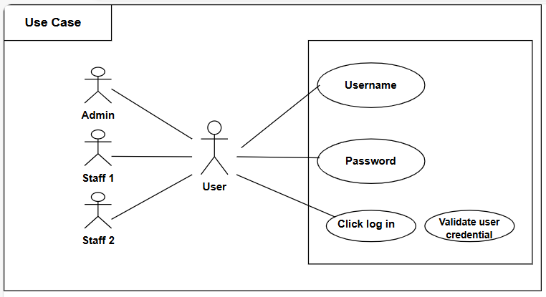
Figure 1.0 Login Use Case
31

Software Requirement Specification
““LGU Mabini - MSWD Programs and Services Monitoring System”
3.2.1.2. Admin Dashboard Use Case
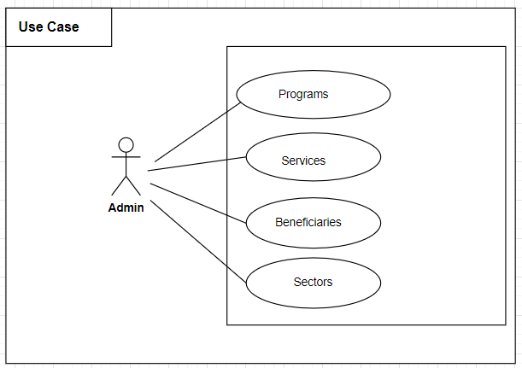
Figure 2.0 Admin Dashboard Use Case
32

Software Requirement Specification
“LGU Mabini - MSWD Programs and Services Monitoring System”
3.2.1.3. Create Household Use Case
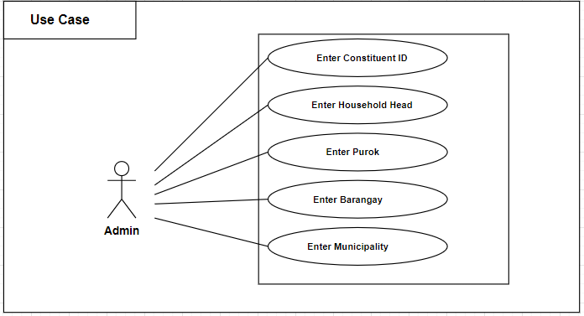
Figure 3.0 Create Household Use Case
3.2.1.4. Create Family Use Case
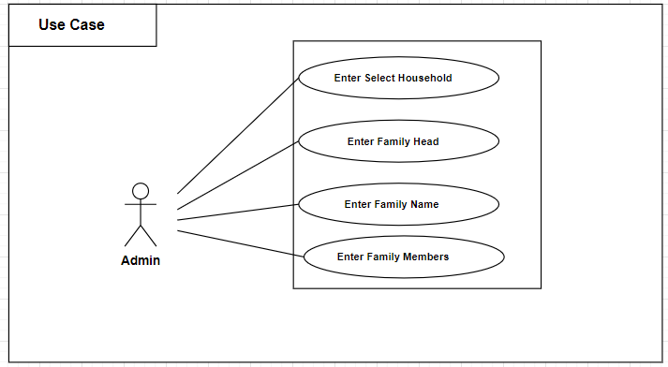
Figure 4.0 Create Family Use Case
33

Software Requirement Specification
““LGU Mabini - MSWD Programs and Services Monitoring System”
3.2.1.5. Constituent Profile Entry Use Case
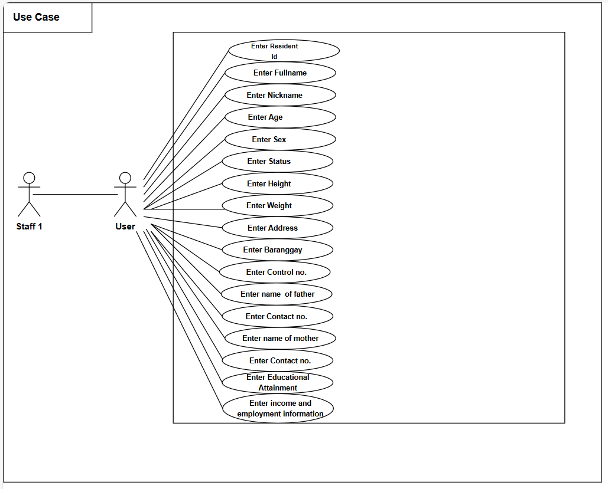
Figure 5.0 Constituent Profile Entry Use Case
34

Software Requirement Specification
“LGU Mabini - MSWD Programs and Services Monitoring System”
3.2.1.6. Service Request Form Use Case
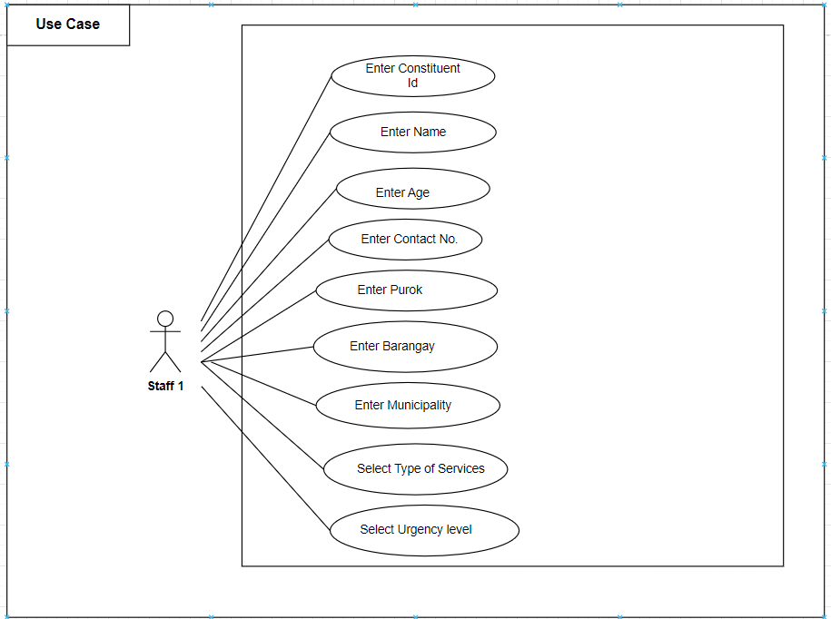
Figure 6.0 Service Request Form Use Case
35

Software Requirement Specification
““LGU Mabini - MSWD Programs and Services Monitoring System”
3.2.1.7. Programs Management Use Case
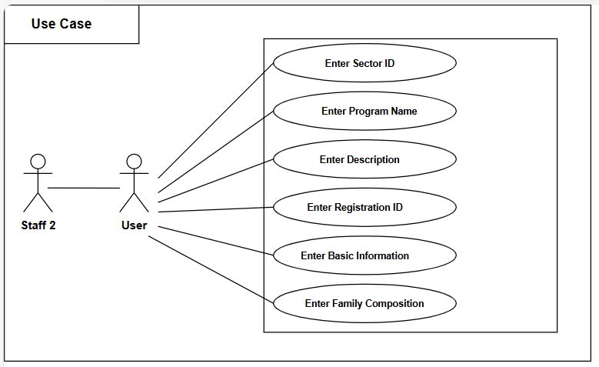
Figure 7.0 Programs Management Use Case
36

Software Requirement Specification
“LGU Mabini - MSWD Programs and Services Monitoring System”
3.2.1.8. Create Program Use Case
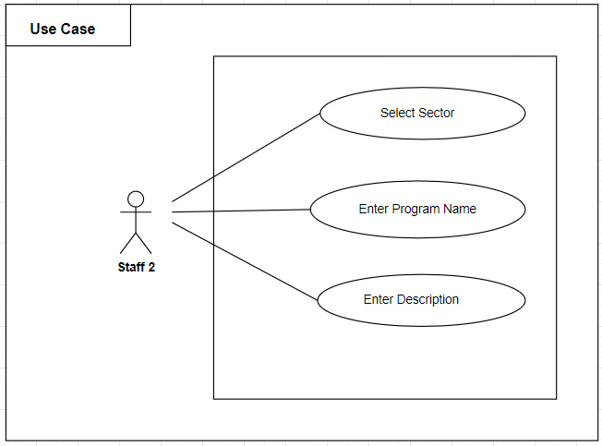
Figure 8.0 Create Program Use Case
37

Software Requirement Specification
““LGU Mabini - MSWD Programs and Services Monitoring System”
3.2.1.9. Add Beneficiaries Use Case
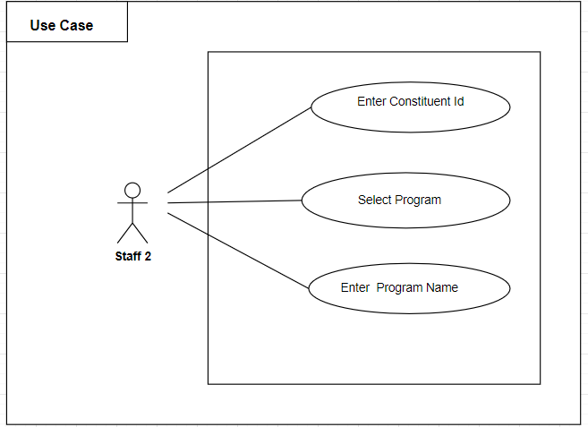
Figure 9.0 Add Beneficiaries Use Case
38

Software Requirement Specification
“LGU Mabini - MSWD Programs and Services Monitoring System”
3.2.1.10. VAWC Use Case
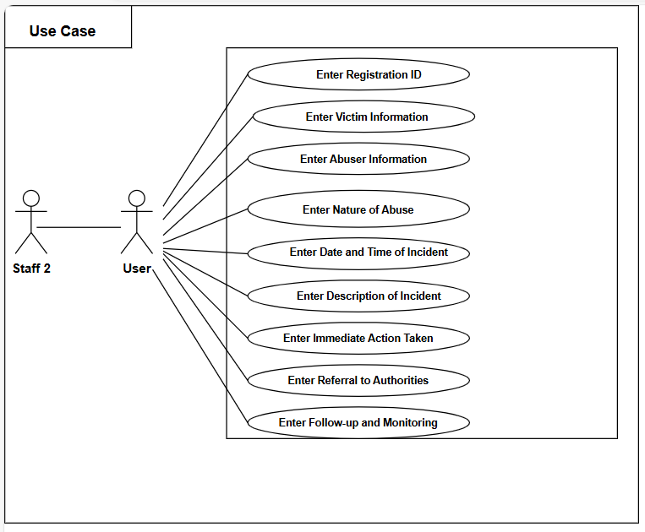
Figure 10.0 VAWC Use Case
39

Software Requirement Specification
““LGU Mabini - MSWD Programs and Services Monitoring System”
3.2.2. Prototype
3.2.2.1 Log-In Prototype
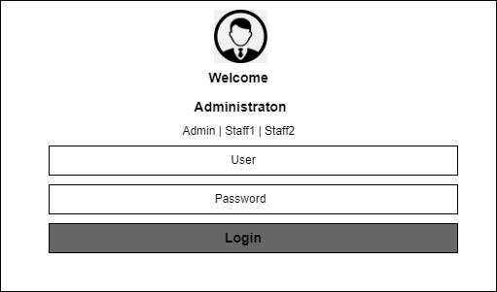
`
Figure 11.0 Log-In Prototype
4.2.2.2 Admin Dashboard Prototype
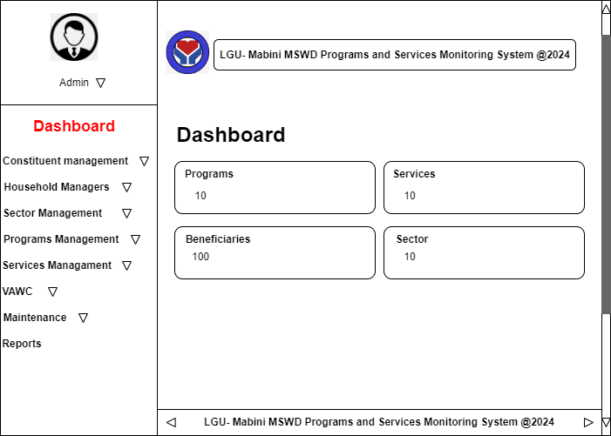
Figure 12.0 Admin Dashboard Prototype
40

Software Requirement Specification
“LGU Mabini - MSWD Programs and Services Monitoring System”
3.2.2.3 Constituent Profile Entry Prototype
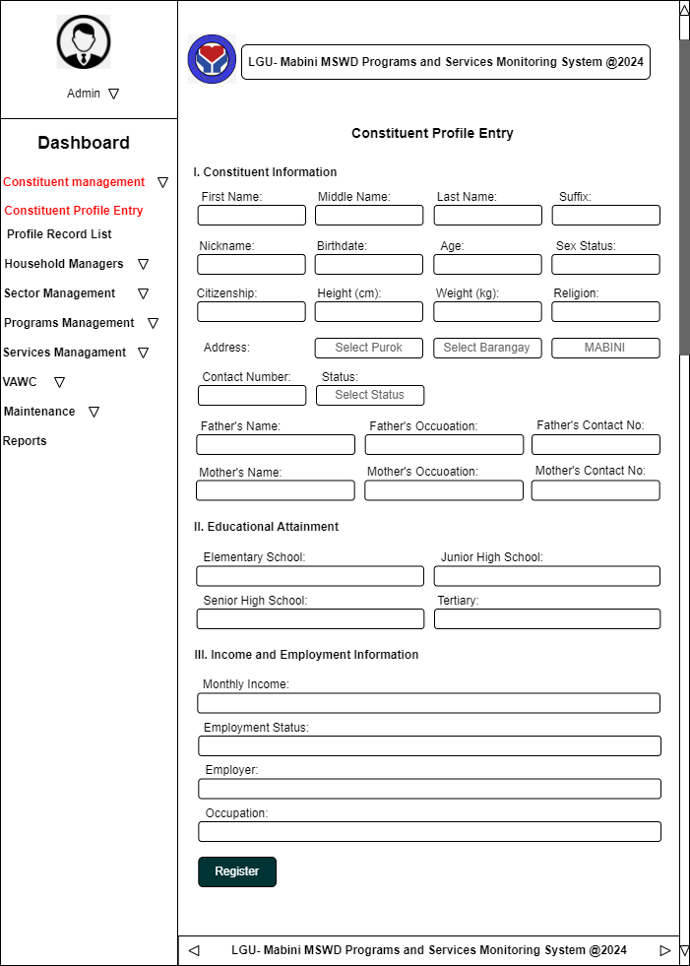
Figure 13.0 Constituent Profile Entry Prototype
41

Software Requirement Specification
““LGU Mabini - MSWD Programs and Services Monitoring System”
3.2.2.4 Profile Record List Prototype
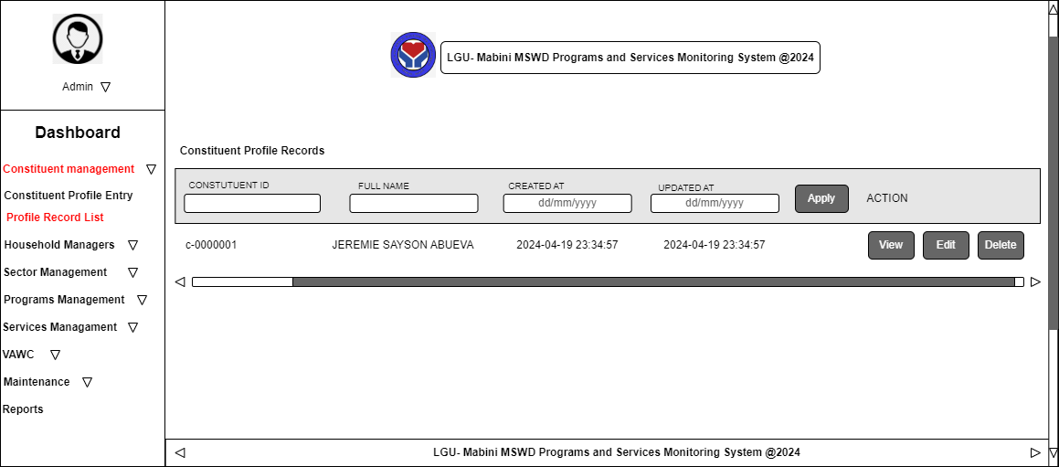
Figure 14.0 Profile Record List Prototype
4.2.2.5 Household Managers Prototype
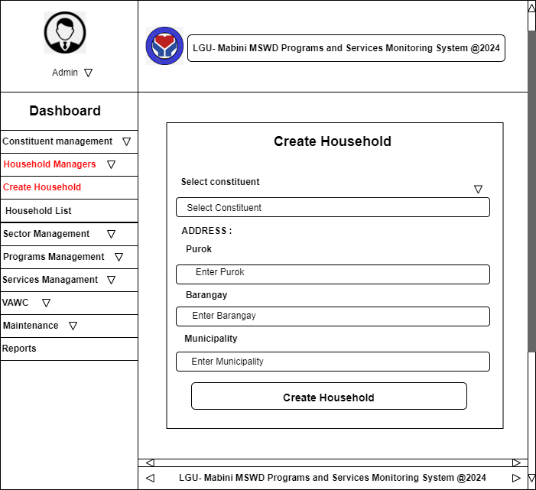
Figure 15.0 Household Managers Prototype
42

Software Requirement Specification
“LGU Mabini - MSWD Programs and Services Monitoring System”
3.2.2.6 Create Family Prototype
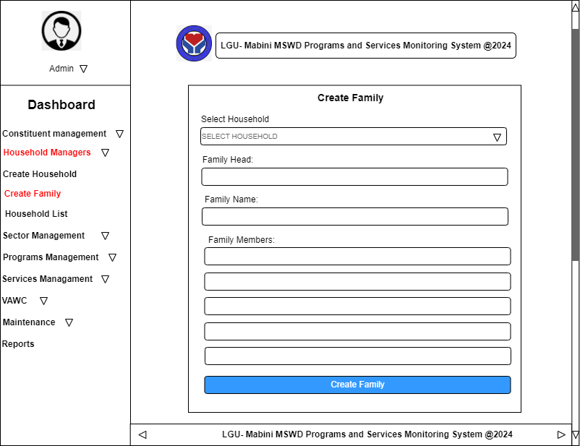
Figure 16.0 Create Family Prototype
3.2.2.7 Sector Management Prototype
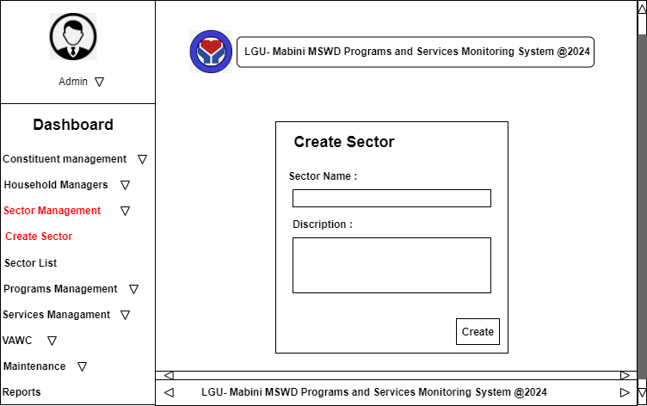
Figure 17.0 Sector Management Prototype
43

Software Requirement Specification
““LGU Mabini - MSWD Programs and Services Monitoring System”
3.2.2.8 Sector List Prototype
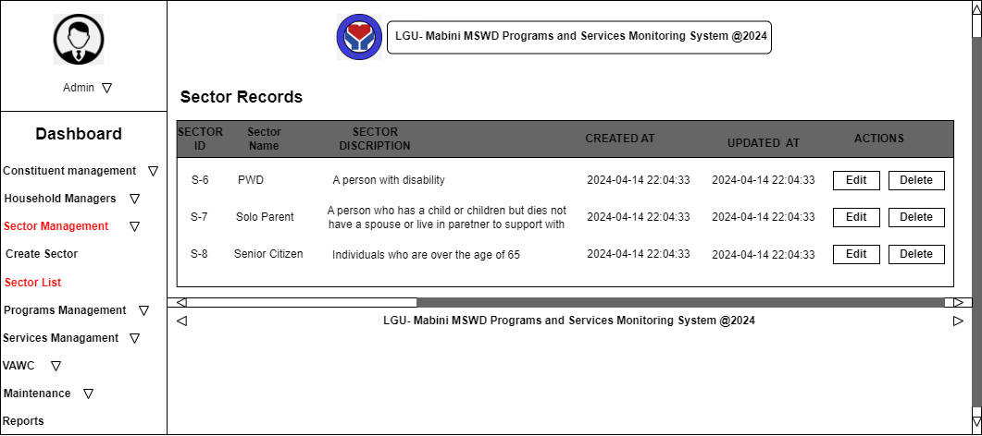
Figure 18.0 Sector List Prototype
3.2.2.9 Programs Management Prototype
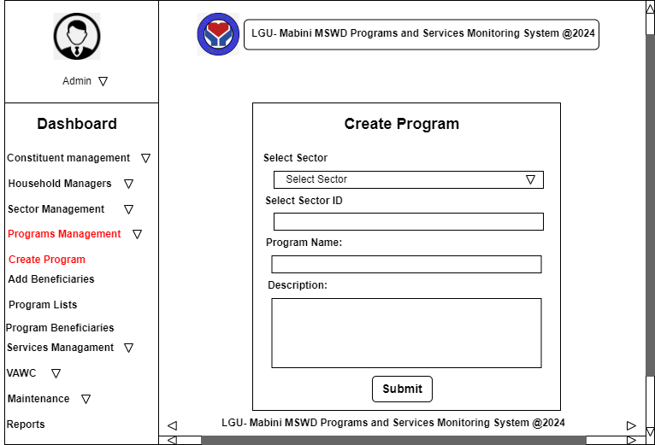
Figure 19.0 Programs Management Prototype
44

Software Requirement Specification
“LGU Mabini - MSWD Programs and Services Monitoring System”
3.2.2.10 Add Beneficiary Prototype
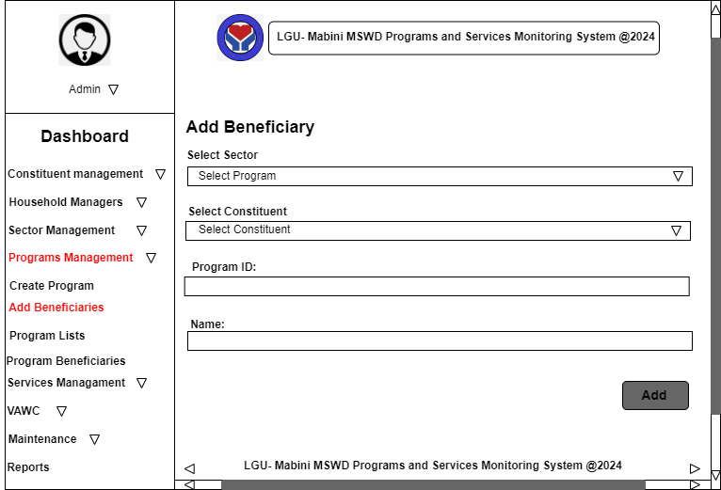
Figure 20.0 Add Beneficiary Prototype
3.2.2.11 Program Lists Prototype
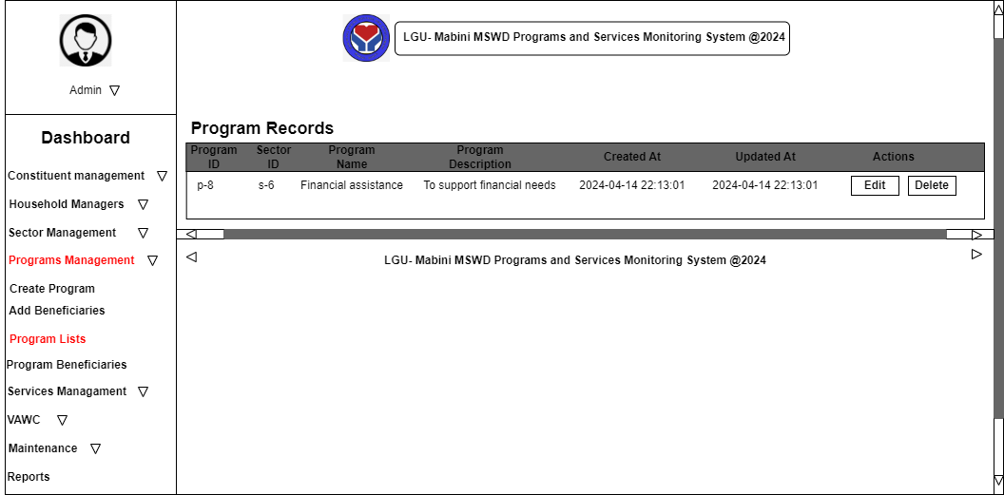
Figure 21.0 Program Lists Prototype
45

Software Requirement Specification
““LGU Mabini - MSWD Programs and Services Monitoring System”
3.2.2.12 Program Beneficiaries Prototype
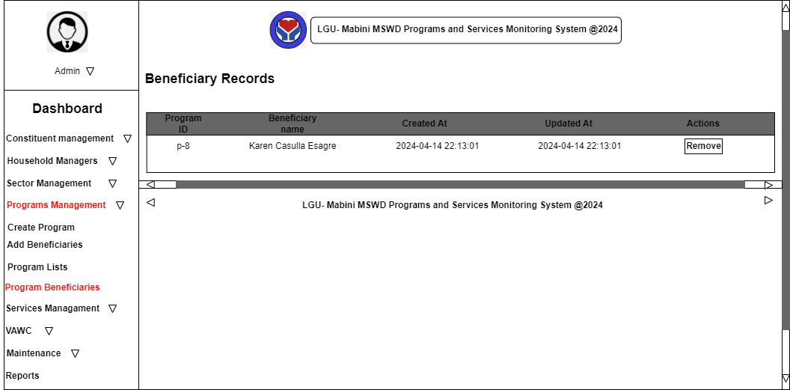
Figure 22.0 Program Beneficiaries Prototype
3.2.2.13 Service Management Prototype
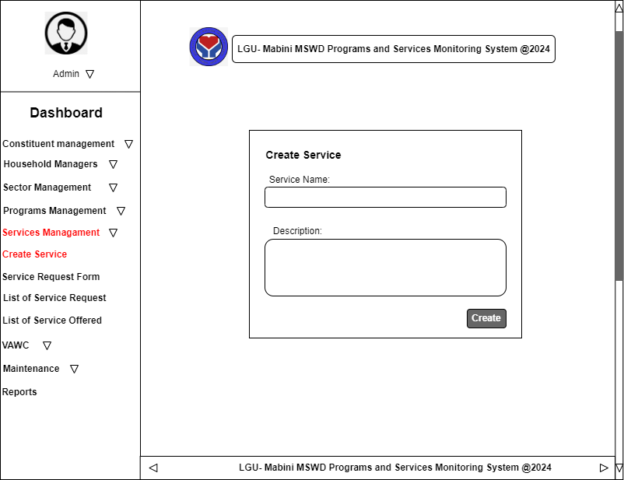
Figure 23.0 Service Management Prototype
46

Software Requirement Specification
“LGU Mabini - MSWD Programs and Services Monitoring System”
3.2.2.14 Service Request Form Prototype
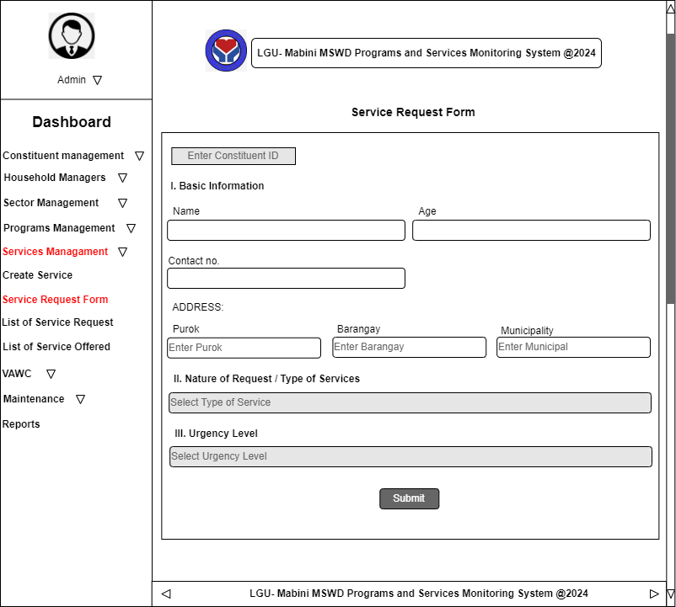
Figure 24.0 Service Request Form Prototype
3.2.2.15 List of Service Request Prototype
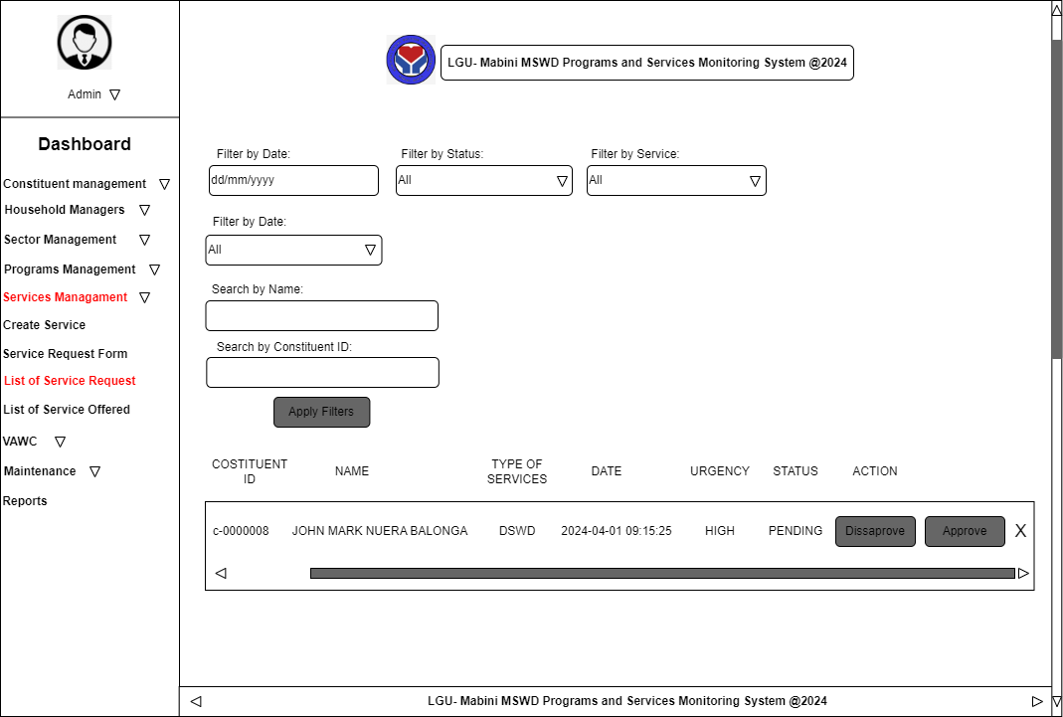
Figure 25.0 List of Service Request Prototype
47

Software Requirement Specification
““LGU Mabini - MSWD Programs and Services Monitoring System”
3.2.2.16 List of Services Offered Prototype
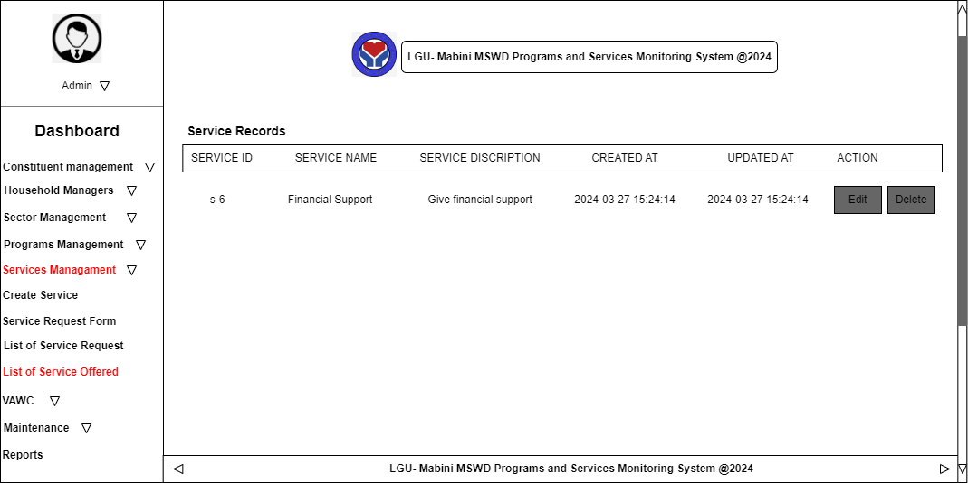
Figure 26.0 List of Services Offered Prototype
48

Software Requirement Specification
“LGU Mabini - MSWD Programs and Services Monitoring System”
3.2.2.17 VAWC Form Prototype
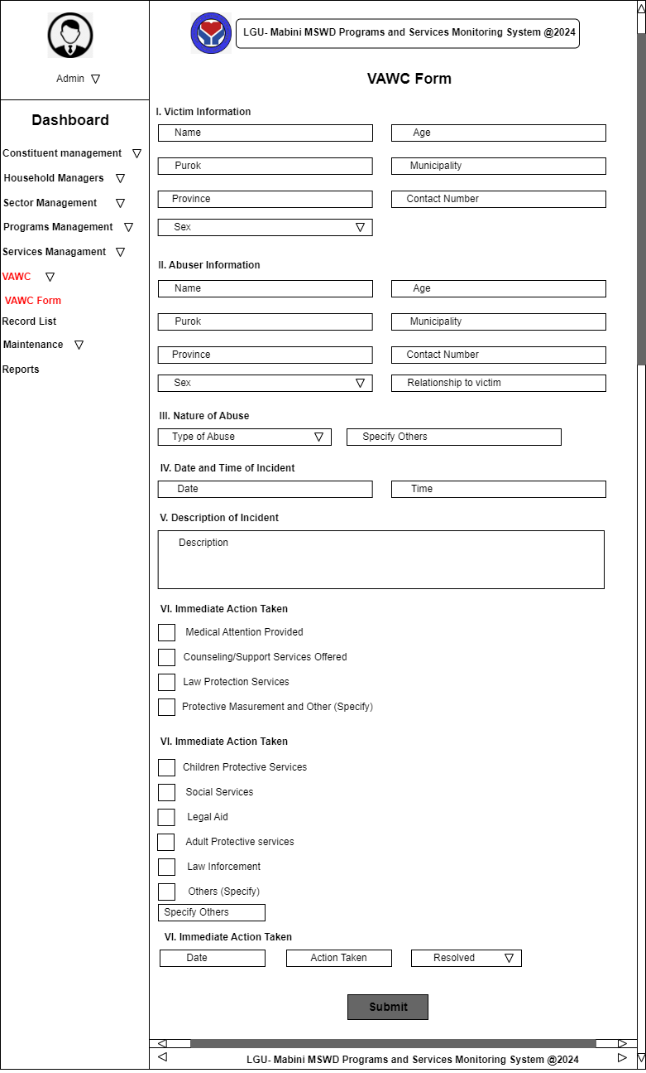
Figure 27.0 VAWC Form Prototype
49

Software Requirement Specification
““LGU Mabini - MSWD Programs and Services Monitoring System”
3.2.2.18 VAWC Lists Prototype
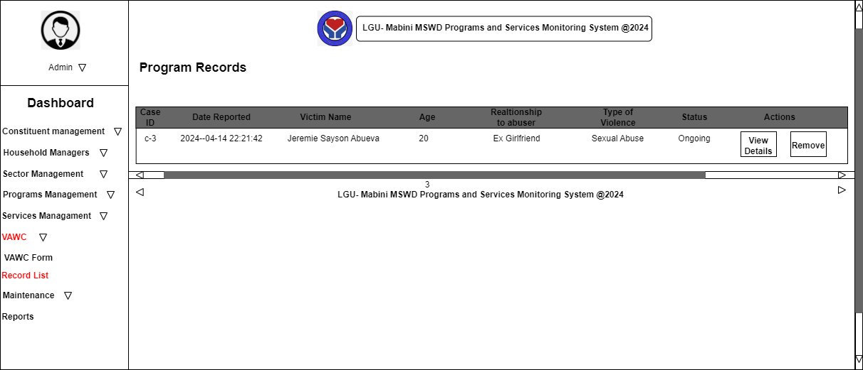
Figure 28.0 VAWC List Prototype
3.2.2.19 User Account Prototype
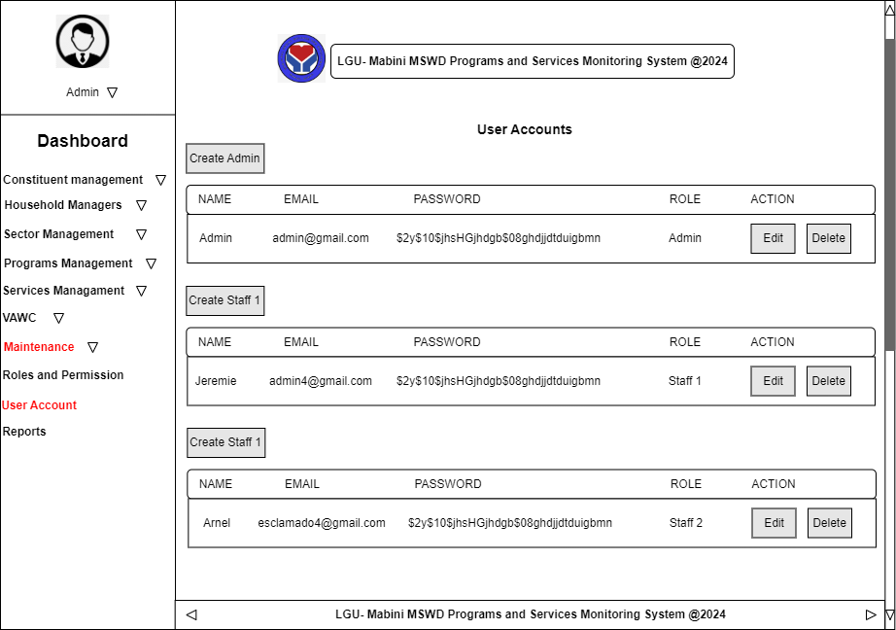
Figure 29.0 User Account Prototype
50

Software Requirement Specification
“LGU Mabini - MSWD Programs and Services Monitoring System”
3.2.2.20 Roles and Permission Prototype
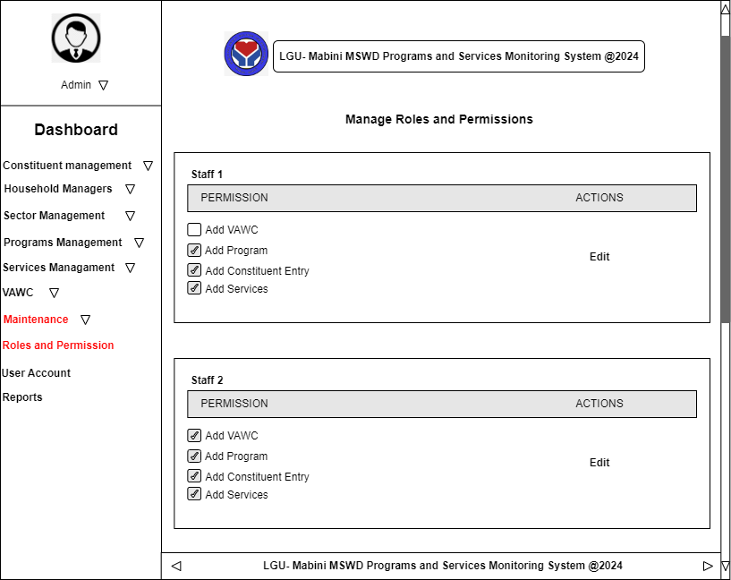
Figure 30.0 Roles and Permission Prototype
51

Software Requirement Specification
““LGU Mabini - MSWD Programs and Services Monitoring System”
3.2.2.21 Reports Prototype
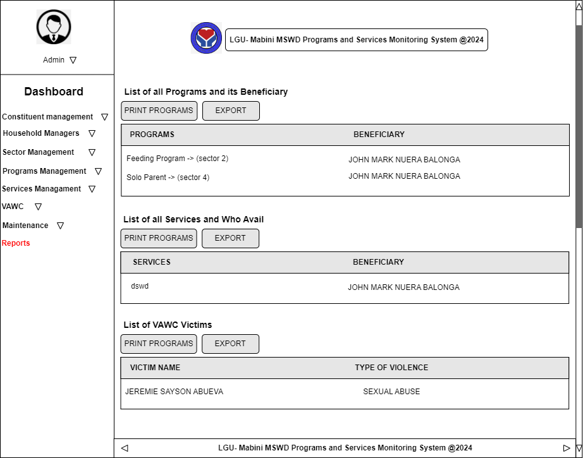
Figure 31.0 Reports Prototype
52

Software Requirement Specification
“LGU Mabini - MSWD Programs and Services Monitoring System”
3.3. Performance Requirements
Performance requirements define how well the system performs certain functions to meet its intended goals. It helps to ensure that the system function efficiently and effectively, meeting user expectations and business needs.
3.3.1. Execution Time
In general, the execution time of a system or a specific process within a system refers to the amount of time it takes for the system or process to complete its operations. This can be influenced by a wide range of factors including, but not limited to, system hardware, software efficiency, current system load, and the specific tasks being executed.
3.3.2. Efficiency
The project enhances the ability of local governments to monitor and improve the delivery of services, respond to the needs of their communities more effectively, and make data-driven decisions that can lead to improved welfare outcomes. However, achieving high efficiency requires careful planning, continuous improvement, and the commitment of sufficient resources.
3.4. Design Constraints
This should specify design constraints that can be imposed by other standards, hardware limitations, etc.
3.4.1. Software Language
53

Software Requirement Specification
““LGU Mabini - MSWD Programs and Services Monitoring System”
The system is developed using a variety of languages. It uses PHP (Hypertext Preprocessor) to manage dynamic content and database development.
3.4.2. Graphical-User Interface
An amalgam of CSS, HTML, JavaScript, and a few frameworks and APIs make up the graphical user interface. The system also employed bootstrap framework UI designing.
3.5. Software System Attributes
LGU Mabini- MSWD Programs and Services Monitoring System, which aims to track and improve the delivery of local government services focused on welfare and development, several software system attributes would be crucial.
3.5.1. Reliability
LGU Mabini- MSWD Programs and Services Monitoring System is reliable. Ensures that the data collected and reported are correct and reflective of actual services provided and minimizes downtime to ensure continuous operation and access to information.
3.5.2. Availability
LGU Mabini- MSWD Programs and Services Monitoring System is available. Ensuring that municipal services can be delivered without interruption, and that welfare and development initiative are effectively monitored and managed.
3.5.3. Security
LGU Mabini- MSWD Programs and Services Monitoring System protects sensitive information, especially individual welfare records, through encryption and secure access controls.
54

Software Requirement Specification
“LGU Mabini - MSWD Programs and Services Monitoring System”
3.5.4. Maintainability
LGU Mabini- MSWD Programs and Services Monitoring System continuously monitor system performance, health, and security to identify and address issues before they impact availability. Apply software updates, patches, and security fixes regularly to maintain system integrity and protect against vulnerabilities.
3.5.5. Portability
LGU Mabini- MSWD Programs and Services Monitoring System is portable. Runs on various hardware and operating systems to accommodate different technology infrastructures in municipal offices.
55

