A Project Report
On

“Air Quality Index Prediction using Random Forest”

by

Rushabh Nakum: 21SE02ML046
Govind Solanki: 21SE02ML051
Ashishkumar Verma: 21SE02ML057

under the mentorship of

Mr. Sumit Pandit

Assistant Professor, School of Engineering



November 2024

P P SAVANI SCHOOL OF ENGINEERING
P P SAVANI UNIVERSITY
NH NO.: 8, VILLAGE: DHAMDOD, TA. MANGROL, NEAR KOSAMBA, SURAT – 394 125. (GUJARAT).

CERTIFICATE

This is to certify that the Project Report submitted by Rushabh Nakum(21SE02ML046) to the P P SAVANI UNIVERSITY for the partial fulfilment of the subject credit requirements is a bonafied work carried out by the student.

This is to further certify that I have been supervising the Major/Minor Project of Rushabh Nakum(21SE02ML046)
The contents of this report, in full or in parts, have not been submitted to any other Institute or University for award of any degree, diploma or titles.

Sign of Faculty Mentor :

Name of Faculty Mentor :

Date:

CERTIFICATE

This is to certify that the Project Report submitted by Govind Solanki(21SE02ML051) to the P P SAVANI UNIVERSITY for the partial fulfilment of the subject credit requirements is a bonafied work carried out by the student.

This is to further certify that I have been supervising the Major/Minor Project of Govind Solanki(21SE02ML051)
The contents of this report, in full or in parts, have not been submitted to any other Institute or University for award of any degree, diploma or titles.

Sign of Faculty Mentor :

Name of Faculty Mentor :

Date:

CERTIFICATE

This is to certify that the Project Report submitted by Ashishkumar Verma(21SE02ML057) to the P P SAVANI UNIVERSITY for the partial fulfilment of the subject credit requirements is a bonafied work carried out by the student.

This is to further certify that I have been supervising the Major/Minor Project of Ashishkumar Verma(21SE02ML057)
The contents of this report, in full or in parts, have not been submitted to any other Institute or University for award of any degree, diploma or titles.

Sign of Faculty Mentor :

Name of Faculty Mentor :

Date:

ACKNOWLEDGEMENT

This report would not have been possible without my teachers who were always there when I needed them the most. I take this chance to acknowledge them and extend my sincere gratitude for helping me make this Report a possible.

I wish to thank my faculty mentor Mr. Sumit Pandit, Assistant Professor, School of Engineering. It has been an honor to learn under their mentorship.

As my mentor, he has constantly motivated me to remain focused on achieving my goal. Their observations and guidance helped me to establish the overall direction of the report and to move forward with learning in depth. Their vital support at each juncture, which culminated in successful completion of my project work. I express my sincere gratitude to them for constant support during the project work.

I am also thankful to faculty members of the department for constant support and guidance.

I am thankful to Dean, School of Engineering for his initiative of imparting Project during tenure of your study making us learn new things and to help us in expanding our horizons.
Name of Student : Rushabh Nakum
Enrollment No : 21SE02ML046
Name of Student : Govind Solanki
Enrollment No : 21SE02ML051
Name of Student : Ashishkumar Verma
Enrollment No : 21SE02ML057

ABSTRACT

Air quality prediction using Random Forest is a machine learning approach designed to forecast pollution levels based on historical environmental data. The Random Forest algorithm, known for its ability to handle complex datasets and nonlinear relationships, is employed to predict air quality by analysing various factors, including meteorological conditions (such as temperature, humidity, and wind speed) and pollutant concentrations (like PM2.5, PM10, and NO2). By building an ensemble of decision trees, the model reduces the risk of overfitting and improves the accuracy of predictions. This method is particularly valuable for estimating the Air Quality Index (AQI), providing crucial insights for public health and allowing authorities to take preventive measures when hazardous pollution levels are anticipated. In addition to training on historical data, the system can incorporate real-time data from IoT sensors to offer dynamic, up-to-date forecasts. The Random Forest approach also includes steps such as data preprocessing to handle missing or noisy information and feature importance analysis to identify key variables influencing air quality. Its performance is typically evaluated using metrics like Root Mean Square Error (RMSE) and Mean Absolute Error (MAE), making it an effective tool for air quality prediction.

TABLE OF CONTENTS

Sr. No | Component | Page. No.
1. | Table of Contents | i
2. | Introduction to Project | 1
4. | System Analysis | 4
5. | System Design | 6
6. | Standardization Of Coding | 7
7. | Testing | 9
8. | Cost Estimation of Project | 10
9. | Future Work | 11
10. | Bibliography | 12

INTRODUCTION

The primary objective of this project is to develop an AQI prediction platform, catering to users ranging from health-conscious individuals to environmental researchers. The growing need for accurate, accessible air quality data underscores the motivation behind this project. Existing solutions often lack real-time insights combined with advanced data models. This platform aims to bridge this gap by providing a user-friendly, interactive interface for AQI analysis, featuring AI-driven predictive models and real-time data. Leveraging modern web technologies and machine learning, the project offers a scalable, informative solution to enhance air quality monitoring.

  - Project Objectives:

- Develop a platform for predicting AQI with a clear, user-friendly interface for analyzing and understanding air quality trends.

- Implement a Random Forest machine learning model using PM10, PM2.5, O3, CO, NO2, and SO3 as input features to predict AQI.

- Integrate Flask for the backend and HTML/CSS for the frontend, ensuring responsive and seamless interactions.

- Prediction Capabilities: A Random Forest model predicts AQI based on real-time pollutant data inputs (PM10, PM2.5, O3, CO, NO2, SO3). This provides users with accurate AQI levels categorized by air quality standards, including indicators like ‘Good,’ ‘Moderate,’ and ‘Poor.’
- Real-Time Data Analysis: The platform presents real-time AQI predictions, continuously updating with IoT data inputs. Users can instantly view the AQI level based on pollutant detection from connected IoT devices, ensuring live updates on local air quality.

- IoT-Driven Alerts and Notifications:
An IoT system continuously monitors pollution levels using a NodeMCU (ESP8266) connected to sensors like the MH-Z19 for CO2 detection.

When elevated pollution levels are detected, the system issues up to five internal alerts to the server, helping monitor sustained trends without triggering false alarms.

After five consecutive warnings, a message is sent to the Air Pollution Control Department to notify them of a potential air quality breach, ensuring efficient and appropriate response without reacting to minor fluctuations002E

  - Frontend Tool:

- HTML, CSS, JavaScript: The frontend focuses on a clean, intuitive interface, allowing users to input pollutant levels and retrieve AQI predictions.

- Real-Time Updates: The interface dynamically updates predictions, displaying user-friendly alerts and AQI trends.

1.3 Backend Tool:

- Flask (Python): Manages server-side requests and interfaces with the Random Forest model to generate real-time predictions.

- Random Forest Model: Trained on data of pollutants (PM10, PM2.5, O3, CO, NO2, SO3) to predict AQI with accuracy.

1.4 Need for the Project:

With rising air pollution concerns, this AQI prediction platform addresses the gap in accessible, real-time data and insights. Many platforms lack user engagement features, making it challenging to understand data and make proactive decisions.

1.5 Evolution of Chess Websites/Bots:

- 2000s: Standalone air quality monitors focused on basic pollutant data without real-time prediction.

- 2010s: Improved models and mobile apps provided broader access, though limited in predictive power and user engagement.

- Present: Advanced AI/ML-based platforms predict AQI with real-time adaptability, crucial for proactive air quality management

1.5 Pitfalls of Existing Systems:

- Lack of Accuracy: Many platforms fail to provide reliable predictions due to simplistic models or lack of real-time data.

- User Engagement: Few systems offer user-friendly, educational interfaces that enhance data interpretation.

- Customizability: Limited options for users to input data or analyze AQI trends based on local factors.

1.6 Application Areas:

- Public Health Monitoring: Allows users and health professionals to assess air quality for informed health decisions, particularly useful for individuals with respiratory conditions or vulnerable populations.

- Research and Environmental Studies: Provides researchers and environmental scientists a real-time testing platform to analyze air quality trends, pollution patterns, and their impact on ecosystems and urban areas.

- Public Awareness Campaigns: Educates users on the health impact of pollutants, promoting community awareness and encouraging pollution reduction efforts through easy-to-understand information on AQI levels and pollutant sources.

- Urban Planning and Policy Making: Assists city planners and policymakers in understanding pollution hotspots, enabling data-driven decisions for zoning, green space planning, and pollution control measures.

- Industrial and Workplace Safety: Monitors air quality in and around industrial sites or workplaces where pollutant exposure is high, ensuring compliance with safety regulations and protecting worker health.

SYSTEM ANALYSIS

1. Overview

The AQI prediction platform is designed to provide real-time air quality insights and educational resources on pollutant impact. Integrating IoT devices for pollutant detection and machine learning models for AQI prediction, the system serves both individuals and public institutions by ensuring accurate, timely data for health, research, and policy decisions. The system’s functionality is built around real-time data handling, predictive analytics, and responsive user alerts.

2. Functional Requirements

Real-Time Data Collection:
- IoT sensors gather real-time data on pollutants (PM10, PM2.5, O3, CO, NO2, SO3).
- Data is transmitted to the backend, where it is continuously monitored.

AQI Prediction:
- A Random Forest model predicts the AQI based on pollutant levels.
- Outputs are categorized into defined air quality levels, such as ‘Good,’ ‘Moderate,’ and ‘Poor.’

Alerts and Notifications:
- The system sends notifications after five consecutive elevated AQI readings to avoid unnecessary alerts.
- Notifications are sent to both users and the Air Pollution Control Department to initiate action in case of consistent pollution spikes.

User Interface and Interaction:
- The frontend displays live AQI predictions, pollutant insights, and air quality levels.
- Users can explore educational content on pollutant impact and mitigation.
- Chat and community functions can be integrated to foster user interaction.

Data Storage and Logging:
- Historical AQI and pollutant data are stored for trend analysis and user access.
- The backend logs pollutant levels, warnings, and notifications for future reference and analysis.

3. Non-Functional Requirements

Scalability:
- The system can handle increasing numbers of IoT inputs and user queries.
- The architecture should support both individual users and institutional clients, with the ability to expand data collection nodes.

Performance and Reliability:
- AQI predictions and IoT data updates must be real-time or near real-time for effective decision-making.
- The system should ensure reliable data transmission from IoT sensors to prevent data gaps.

Usability:
- An intuitive user interface built with HTML, CSS, and JavaScript ensures accessibility for users with varied technical backgrounds.
- Visual representations of AQI data, including graphs and charts, enhance user understanding.

Security:
- Data transmission between IoT devices and the backend is secured to prevent unauthorized access.
- User data privacy, especially in cases involving notifications to public departments, is maintained.

4. System Architecture

Frontend:
- Built with HTML, CSS, and JavaScript, it provides real-time updates, AQI visualization, and educational resources.
- Flask is used for API communication between frontend and backend for data exchanges and AQI updates.

Backend:
- Developed with Python and Flask, using a Random Forest model for AQI prediction.
- Express.js and Socket.IO enable real-time communication, facilitating quick alerts and data updates.

Machine Learning Model:
- A Random Forest model is trained on historical pollutant data to predict AQI.
- Predictive capabilities are regularly updated with new data to improve accuracy.

IoT Integration:
- IoT devices with sensors (e.g., MH-Z19 for CO2) continuously monitor pollutants.
- The IoT system sends data to the backend, which processes this data for AQI prediction and warning notifications.

5. Data Flow

Data Collection:
- Pollutant data is gathered through IoT sensors and transmitted to the backend.

Data Processing and Prediction:
- The backend processes raw data and uses the Random Forest model to generate AQI predictions.

Alerts and Notifications:
- Based on AQI trends, alerts are issued after a threshold of five warnings, notifying both users and relevant departments.

User Interaction and Feedback:
- The frontend displays live AQI data, historical trends, and educational insights.
- Users receive notifications based on AQI predictions, helping them take preventive actions.

6. Constraints and Challenges

Network Dependence: Real-time updates rely on stable internet connectivity, especially for IoT data transmission.

Data Accuracy: Accurate predictions depend on the quality of IoT sensor data, which may vary based on environmental factors.

Privacy and Security: Handling user data, especially notifications sent to public departments, requires strict privacy protocols.

7. Conclusion

This AQI prediction platform with IoT integration addresses a critical need for accurate, real-time air quality monitoring, catering to users' informational and health-related needs.

SYSTEM DESIGN

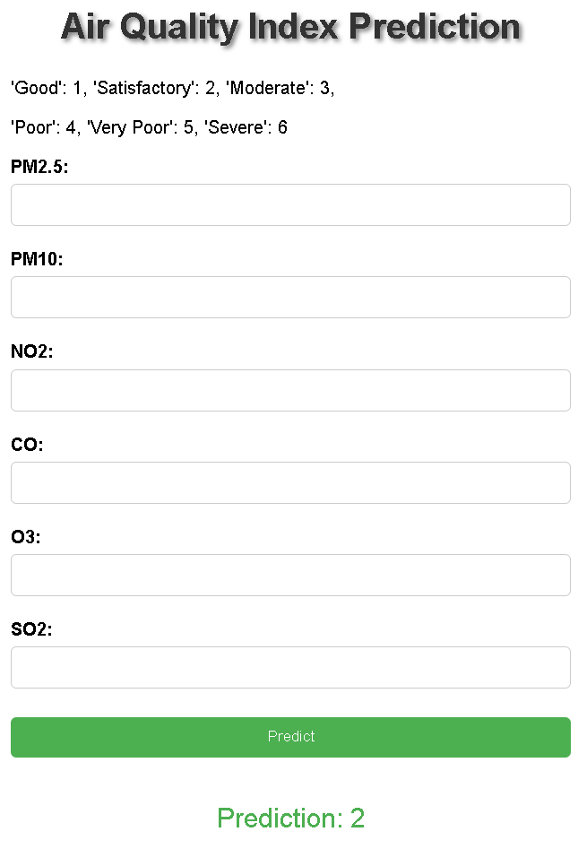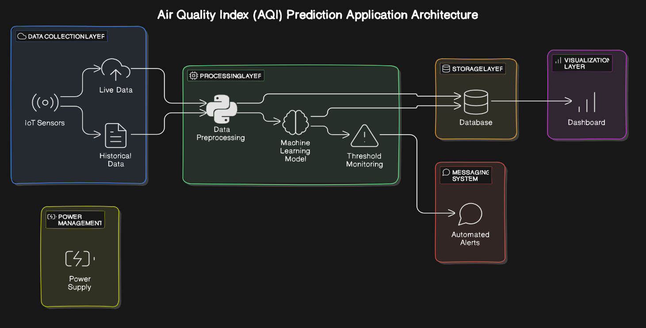

STANDARDIZATION OF CODING

Standardization in coding refers to the practice of adhering to consistent coding styles, conventions, and best practices throughout the development process. This ensures that the code is maintainable, readable, and efficient. Standardization in coding ensures that the codebase is consistent, maintainable, and easy to understand.

1. Code Structure and Organization
Backend (Python & Flask)

- Folder Structure:

project-root/
── app.py # Main entry point for Flask app
── config.py # Configuration settings
── requirements.txt # Dependencies
── models/
│ └── aqi_model.pkl # Pre-trained Random Forest model
── static/
│ ── css/ # CSS files
│ └── js/ # JavaScript files
── templates/
│ └── index.html # HTML templates
── utils/
│ └── preprocessing.py # Data preprocessing helper functions
── iot/
│ └── sensors.py # IoT data processing scripts
└── tests/
└── test_aqi.py # Unit tests

- Module Separation:
Data Processing: utils/preprocessing.py
IoT Sensor Data Handling: iot/sensors.py
Configuration: config.py (stores API keys, paths, and other settings)

- Frontend (HTML, CSS, Django)

- Structure CSS and JavaScript files in /static/css and
- Follow naming conventions like kebab-case for file names (main-style.css).

- Code Styling and Linting

- Python: Apply PEP8 guidelines and use tools like flake8 or pylint.
- JavaScript: Use a linter like ESLint with a pre-defined configuration.
- HTML/CSS: Use Prettier for consistent formatting.

Python Function

def predict_aqi(data: dict) -> str:
"""
Predicts the Air Quality Index (AQI) based on input data.

Args:
data (dict): A dictionary with pollutant levels.

Returns:
str: Predicted AQI category (e.g., 'Good', 'Moderate').
"""
# Process input data
processed_data = preprocess_data(data)
prediction = model.predict(processed_data)
return map_aqi_category(prediction)

JSON

{
"status": "success",
"data": {
"aqi": "Moderate",
"details": {
"PM10": 55,
"PM2.5": 35,
"CO": 1.2,
"NO2": 0.8,
"SO2": 0.6
}
}
}

Python Flask

@app.errorhandler(404)
def not_found_error(error):
return jsonify({'error': 'Not found', 'message': str(error)}), 404

@app.route('/predict', methods=['POST'])
def predict_aqi():
try:
data = request.json
# Prediction logic
result = predict_aqi(data)
return jsonify({'status': 'success', 'aqi': result})
except ValueError as e:
return jsonify({'status': 'error', 'message': str(e)}), 400

TESTING
1. Unit Testing
Unit tests verify individual functions and modules in isolation. These are especially crucial for your data processing, prediction, and IoT alert functions.

Testing Backend Functions (Python/Flask)

Using pytest, you can create unit tests for core functionalities like data preprocessing, model predictions, and alert generation.

project-root/
└── tests/
├── test_app.py # Tests for Flask endpoints
├── test_preprocessing.py # Unit tests for preprocessing functions

Test Cases
- Data Preprocessing (test_preprocessing.py):
Test if the function correctly processes and validates input data.

# tests/test_preprocessing.py
from utils.preprocessing import preprocess_data

def test_preprocess_data_valid_input():
input_data = {'PM10': 50, 'PM2.5': 30, 'CO': 0.8, 'NO2': 0.5, 'SO2': 0.3}
processed_data = preprocess_data(input_data)
assert isinstance(processed_data, list) and len(processed_data) == 5

- Model Prediction (test_app.py):
Test if the prediction function correctly returns expected AQI categories.

from app import predict_aqi

def test_predict_aqi():
input_data = {'PM10': 50, 'PM2.5': 30, 'CO': 0.8, 'NO2': 0.5, 'SO2': 0.3}
result = predict_aqi(input_data)
assert result in ['Good', 'Moderate', 'Poor']

COST ESTIMATION OF PROJECT

Use Open-Source Tools and Libraries:
- Leverage free and open-source libraries for data processing and modelling (e.g., Scikit-learn, NumPy, Pandas). All these libraries can be utilized without any licensing fees.

Local Development Environment:
- Set up your development environment locally on your computer using free IDEs like Visual Studio Code or Jupyter Notebook, eliminating any costs associated with development tools.

Free Hosting Solutions:
- Instead of cloud services like AWS, use free hosting platforms like Heroku or PythonAnywhere to deploy your Flask application. Both provide a free tier for hosting small projects.

Utilize Local Hardware:
- Use personal devices or existing hardware for the IoT setup, such as Raspberry Pi or Arduino, instead of purchasing new components. Leverage existing sensors if available.

Open-Source IoT Frameworks:
- Use free frameworks like Node-RED for managing IoT data instead of purchasing proprietary software. This can help integrate your sensors with the web application without additional costs.

Public Datasets:
- Use publicly available datasets for training your ML model, instead of purchasing datasets. Many environmental data repositories provide free access to historical air quality data.

Community Contributions:
- Collaborate with friends or colleagues who can contribute their expertise in development or data analysis, thereby reducing or eliminating labor costs.

Flask for API Development:
- Use Flask to create a web API that serves your predictions and data visualization, keeping all development in-house and avoiding costs related to third-party services.

FUTURE WORK AND FURTHER ENHANCEMENT OF PROJECT

Conclusion

This project successfully develops an Air Quality Index (AQI) prediction system utilizing a Random Forest model integrated with IoT devices and a messaging system. The system provides real-time monitoring of air quality, leveraging various sensors to collect critical environmental data. The implementation of a robust machine learning algorithm enables accurate predictions of AQI levels, offering valuable insights for users concerned about air quality.
A key feature of the system is its alert messaging mechanism, designed to notify users when air quality deteriorates. After five warnings, indicating a consistent decline in air quality, an automated message will be sent to the relevant authorities. This approach not only enhances user awareness but also facilitates timely intervention by authorities, potentially mitigating health risks associated with poor air quality.

Future Scope

Looking ahead, there are several opportunities for enhancing the AQI prediction system:
- Enhanced Prediction Accuracy: Further fine-tuning the Random Forest model with additional datasets and hyperparameter optimization can improve prediction accuracy.
- Integration of Additional Sensors: Incorporating more types of sensors to monitor other pollutants (e.g., PM2.5, CO, NO2) can provide a comprehensive view of air quality.
- Mobile Application Development: Creating a mobile app to provide users with real-time AQI data and alerts can increase accessibility and user engagement.
- User Feedback System: Implementing a feedback mechanism will allow users to report discrepancies in AQI readings, contributing to data accuracy and system improvement.
- Data Visualization Dashboard: Developing an interactive dashboard for visualizing air quality trends and predictions can enhance user understanding and engagement.
- Community Awareness Programs: Initiating community outreach programs to educate the public about air quality and its health impacts can foster greater awareness and proactive measures.
- Collaboration with Authorities: Establishing partnerships with local authorities for data sharing and collaborative response efforts can enhance the system's impact on public health and safety.

BIBLIOGRAPHY

  - Dataset of Air Quality:
https://www.kaggle.com/datasets/rohanrao/air-quality-data-in-india ,
https://www.kaggle.com/datasets/azminetoushikwasi/aqi-air-quality-index-scheduled-daily-update ,
https://www.kaggle.com/datasets/fedesoriano/air-quality-data-in-india

  - Random Forest Machine Learning: https://pubs.aip.org/aip/acp/article/1820/1/080020/886341/Research-on-machine-learning-framework-based-on

  - The Air Quality Index (AQI) in historical and analytical perspective a tutorial review:
https://www.sciencedirect.com/science/article/abs/pii/S0039914023010111

  - A quick introduction to version control with Git: https://journals.plos.org/ploscompbiol/article?id=10.1371/journal.pcbi.1004668

