1. INTRODUCTION
- The Student Performance Prediction and Tracking System is a comprehensive educational platform designed to bridge the communication and monitoring gap between students, educators, and parents. In today's highly competitive educational environment, identifying a student's academic trajectory early is crucial for providing timely guidance and interventions. Traditional methods of tracking student progress often rely on retrospective report cards that offer little opportunity for proactive course correction. There is a pressing need for an intelligent application that not only records current academic standings, continuous attendance, and daily study habits, but also leverages this data to forecast future outcomes. By employing artificial intelligence and machine learning models trained on historical student records, this system aims to predict forthcoming academic performance, thereby allowing students to recognize potential areas of improvement well before their final examinations.

- This application is built to serve as a centralized, transparent hub for all academic monitoring activities. It empowers administrators to seamlessly manage user accounts and publish ongoing internal evaluations, external results, and attendance reports. Students are provided with personalized dashboards where they can actively maintain daily study logs, monitor their attendance, and utilize the AI prediction engine to estimate their final scores based on their current metrics. Furthermore, the application introduces a vital layer of accessibility for parents, granting them secure registration and direct access to independently review their child's internal and external marks. By integrating predictive analytics with daily academic tracking, the platform transitions educational monitoring from a reactive, end-of-term process into a proactive, continuous strategy.

A. Use Factor of this application
1. AI driven marks prediction.
- Allows students to input their current internal marks, attendance, and study hours to generate highly accurate predictions of their upcoming external scores.
2. Overall Study Tracking
- Provides a dedicated interface for students to log, update, delete, and evaluate their daily self-study habits and educational routines.
3. Parental Academic Monitoring
- Enables parents through a secure portal to directly view their child's internal assessments, external exam results, and progress without needing a mediator.
4. Centralized Result Management
- Allows institutional administrators to efficiently upload, store, and manage standardized records for student results and attendance.
5. Early Intervention Support
- Helps students and parents identify potential academic shortcomings early on, affording them the time to seek extra tutoring or shift focus to weaker subjects.
6. Transparent Information Sharing
- Creates a single, accessible source of truth that keeps students, parents, and administrative staff completely aligned on academic standings.

2. OBJECTIVE OF THE PROJECT
- The primary objective of this project is to develop an intelligent, centralized web application that predicts and tracks student academic performance. Specifically, the project aims:
2.1 To Develop a Predictive AI Model
- To build and integrate a machine learning model that accurately forecasts a student's future external exam scores based on their current academic metrics, such as internal marks, attendance rates, and daily study hours.
2.2 To Centralize Academic Records
- To create a secure, unified platform where administrators can efficiently upload, manage, and disseminate student data, including internal assessments, external results, and attendance logs.
2.3 To Promote Student Self-Monitoring
- To provide students with an interactive "Overall Study Tracker" (study log) that encourages them to consistently record, review, and optimize their daily self-study habits and educational routines.
2.4 To Facilitate Parental Involvement
- To establish a dedicated, secure portal for parents that allows them to independently and transparently monitor their child’s academic progress, internal scores, and final results in real-time.
2.5 To Enable Early Educational Interventions
- To shift the educational monitoring process from reactive to proactive, providing students and parents with early insights into potential academic shortcomings so they can seek extra tutoring or adjust their focus before final exams.
2.6 To Improve Accessibility and Communication
- To bridge the communication gap between the institution, students, and parents by providing personalized dashboards that deliver standardized, up-to-date academic information to all stakeholders.

3. SOFTWARE AND HARDWARE REQUIREMENTS

HARDWARE REQUIREMENTS
DEVICE NAME | Laptop-VNJSA6LM
RAM | Minimum 4 GB
HARDISK | 510 GB
BACKUP | Pen drive or USB for mass storage

SOFTWARE REQUIREMENTS
FRONTEND | React with MUI framework
BACKEND | PHP CodeIgniter and Python
DATABASE | MySQL
OPERATING SYSTEM | Windows 2008,09,10,11
EDITOR | Visual Studio Code
BROWSER | Google Chrome
SERVER | Laragon

4. SYSTEM DESIGN
A. SYSTEM LEVEL DIAGRAM. 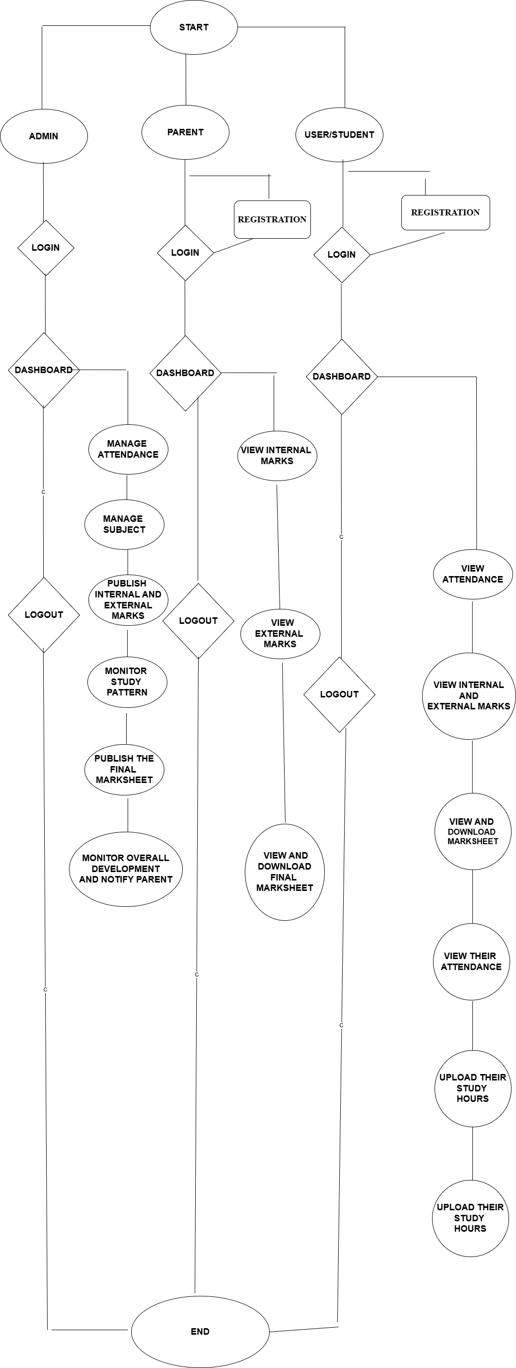
B. DATA FLOW DIAGRAM
B1. O LEVEL / CONTEXT LEVEL DIAGRAM

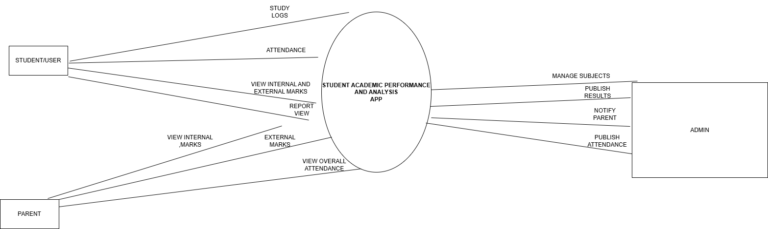

4.1. DATA DICTIONARY
A class is a collection of objects that share similar attributes and behaviours. In Unified Modelling Language (UML), a class is represented by a rectangle divided into three sections:
• Top section: Class name
• Middle section: Attributes (data elements)
• Bottom section: Operations (methods or functions)
Class diagrams provide a visual representation that helps developers and system analysts understand the static structure of the Online Student Academic Performance Analytics System. They organize the system into different entities (classes) such as Student, Subject, Marks, Faculty, and Performance Report, each having specific attributes and functions. These diagrams improve system clarity by defining how data is structured and how different components interact with each other. They also assist in identifying relationships among classes, such as associations between students and their academic records. The Data Dictionary provides clear and detailed definitions of all attributes and operations used in the Online Student Academic Performance Analytics System. It acts as a reference guide for developers, database designers, and system administrators.
It ensures:
• Consistency in database structure and design
• Accuracy during application development and implementation
• Better understanding of data relationships and system functionality
• Reliability and efficiency in system maintenance and future updates

4.2 DATA TABLE

