Technical Documentation
Autonomous AI Data Analysis Agent

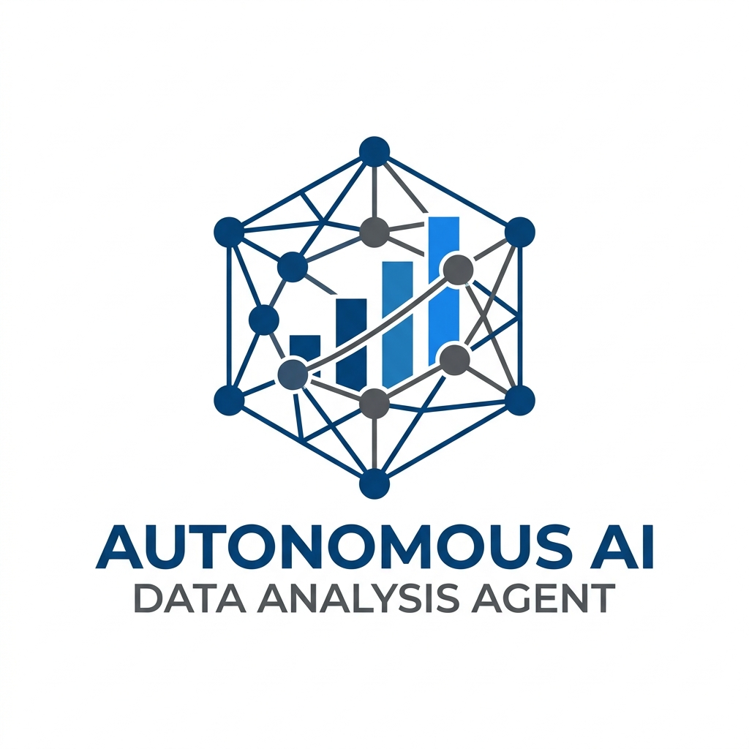

Version 1.0.0
Date: April 8, 2026
Prepared for: DeepMind Engineering Review

Table of Contents
- 1. Executive Summary
- 2. Project Overview & Motivation
- 3. System Architecture
- 4. AI Agent & Orchestration Engine
- 5. Contextual Memory & RAG (Deep Dive)
- 6. AutoML & Predictive Modeling (Deep Dive)
- 7. Visual Analytics & Reporting
- 8. User Interface (Glassmorphic Design)
- 9. Installation & Deployment
- 10. Conclusion & Future Roadmap

1. Executive Summary
The Autonomous AI Data Analysis Agent is a state-of-the-art platform designed to bridge the gap between complex raw data and actionable intelligence. By leveraging the Gemini Pro API, ChromaDB, and an automated machine learning pipeline, the agent allows users to interact with their datasets using natural language. The system handles end-to-end data tasks: from automated cleaning and schema inference to complex predictive modeling and interactive visualizations. This document provides a comprehensive technical breakdown of the system components, design philosophy, and implementation details.

2. Project Overview & Motivation
In the modern era, organizations are inundated with data, but the bottleneck remains the 'last mile' of analysis. Traditional tools require deep proficiency in SQL, Python, or specialized BI software. Our motivation was to create a 'Conversational Data Scientist'—an agent that not only answers questions but understands the underlying context of the data it explores.
- Key design pillars for this project include:
1. Accessibility: No-code interface for complex operations.
2. Autonomy: Self-correcting data cleaning and model selection.
3. Transparency: Reasoning traces showing how the agent arrived at a conclusion.

3. System Architecture
The system is built on a modular micro-services inspired architecture, integrated via a central Streamlit orchestrator. The core flow involves a user query being routed to an Intent Classifier (powered by Gemini), which then selects the appropriate tool for execution.
Component Layers:
- Presentation Layer: Streamlit Glassmorphic Frontend.
- Logic Layer: Gemini Pro Orchestrator and Agent Router.
- Persistence Layer: ChromaDB Vector Store for RAG-based context.
- Execution Layer: Scikit-Learn (ML) and Plotly (Visualization).

5. Contextual Memory & RAG (Deep Dive)
One of the primary challenges in LLM-based data analysis is 'context window overflow'—large datasets contain thousands of rows and dozens of columns, which cannot all fit into a single prompt. Our solution is a Retrieval-Augmented Generation (RAG) system specifically designed for Metadata Discovery.

5.1 Vector Store Implementation
We utilize ChromaDB to store vector embeddings of column names, data types, and sample unique values. When a user asks a question, the agent performs a similarity search against the vector store to retrieve only the relevant column metadata.
Example Workflow:
- User: 'How many premium customers in the North?'
- RAG: Retrieves columns 'Subscription_Type', 'Region', and 'Customer_Count'.
- Prompt: Only provides these specific columns to the LLM, ensuring high precision and lower token cost.

5.2 Dynamic Context Injection
The RAG engine doesn't just store names; it stores 'semantic intent'. We use the Gemini API to generate descriptions for cryptic column names, making them searchable by their real-world meaning.

6. AutoML & Predictive Modeling (Deep Dive)
The AutoML engine (located in src/ml/automl.py) is the 'brain' of the agent's predictive capabilities. It eliminates the need for manual feature engineering and model tuning for standard tasks.

6.1 Automated Problem Classification
Upon receiving a prediction request, the agent analyzes the target variable's distribution and data type:
- Continuous Target -> Regression Pipeline (Random Forest / Gradient Boosting).
- Categorical Target -> Classification Pipeline (Logistic Regression / XGBoost style).

6.2 The Pipeline Architecture
Each ML task follows a robust 4-step sequence:
1. Dynamic Feature Selection: Identifying correlated features defined in the query.
2. Imputation & Scaling: Handling missing values and normalizing variance.
3. Model Selection: Evaluating multiple algorithms and selecting the best performer based on R2 or F1-Score.
4. Evaluation: Generating a report with RMSE, Accuracy, and Feature Importance.
This allows a user to simply say 'Predict Churn' and receive a fully trained, validated model in seconds.

7. Visual Analytics & Reporting
Visualizations are generated using Plotly. The LLM identifies the 'Visual Intent'—for example, a trend requires a line chart, while a distribution requires a histogram. The code is generated on-the-fly, ensuring the UI is always dynamic and tailored to the data.

8. User Interface (Glassmorphic Design)
The UI uses a custom CSS layer over Streamlit to achieve a 'Glassmorphic' aesthetic. Blur effects, semi-transparent panels, and subtle gradients create a premium feel that resonates with modern software standards.

9. Installation & Deployment
To deploy the agent, follow these steps:
1. Install Python 3.9+
2. Run 'pip install -r requirements.txt'
3. Configure .env with GEMINI_API_KEY
4. Start with 'streamlit run ui/app.py'

10. Conclusion & Future Roadmap
The current iteration of the Autonomous AI Data Agent marks a significant step toward democratization of data science. Future releases will include support for local Llama-3 models, direct SQL database connections, and multi-agent collaborative reasoning.

--- End of Documentation ---

