Video 2: Hypervisors

Type 1: bare metal. Physical hardware.

Acts as a host. Runs directly on HW.

**Example: VMware ESXi**

**Runs VMware fusion as hypervisor on top of ESXI**

Uses less overhead than Type 2.

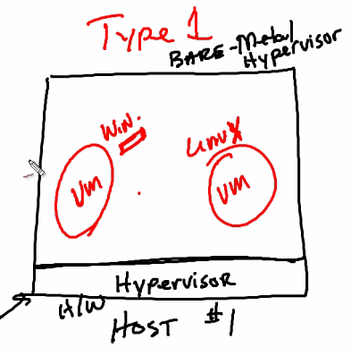

Type 2: OS based.

Physical hw has host OS… On top of OS, runs a hypervisor (Virtulbox)

**Example: VMware Workstation**

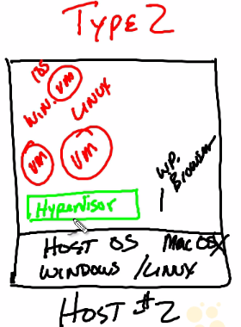

# Video 3: vSphere

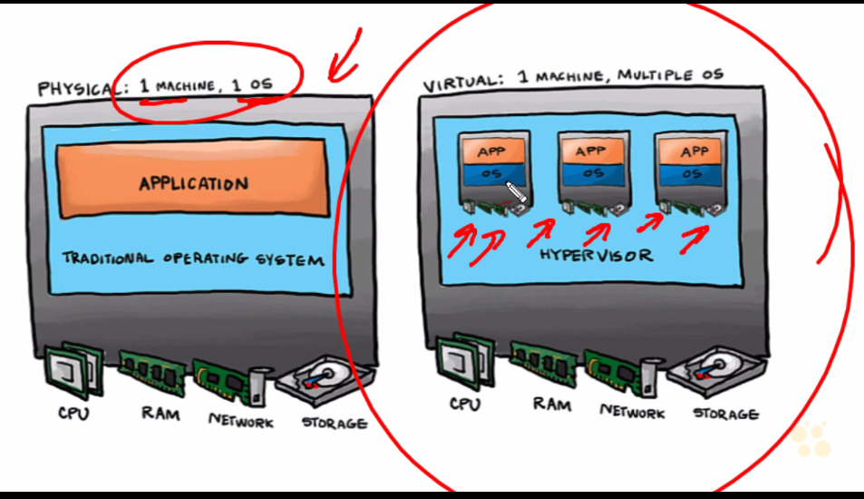

Virtual Server (ESXi)

* User resources of another host if not utilized fully.
* Takes minutes to add virtual machines

Physcial Server

* Cant adjust physical resources as 1 machine belongs to 1 host only.

**TOPOLOGY**

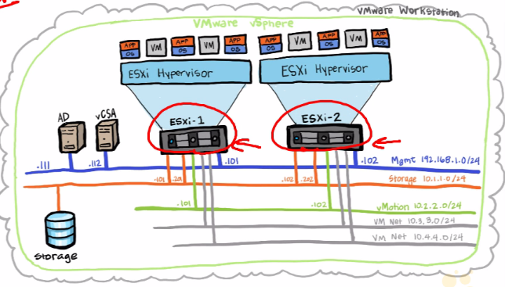

ESXi 1 and ESXi2 are multiple hosts… on whch multiple VMS are installed

* VCenter server is used to manage multiple ESXi hosts (vCSA)
* 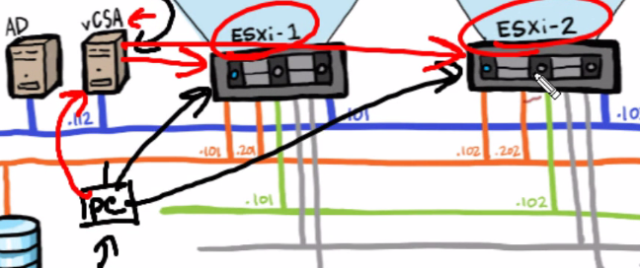

AD:

* Authentication is important. Hence be a part of Active directory for authentication of multiple devices
* Authentication oh VMS, vCSA (To check admin rights and credentials)

Networking:

* Connecting ESXi hosts to connect with network storages, active directory, live migration, vcenter etc

# Video 4: lab design and preparation

Use VMware workstation for lab environment

* VM for vCSA
* VM for AD
* ESXi1 and ESXi2 as VM

PC NIC is connected to 192.168.1.0/24 Management network

* Connects ESXi1 , ESXi2, AD and vCenter

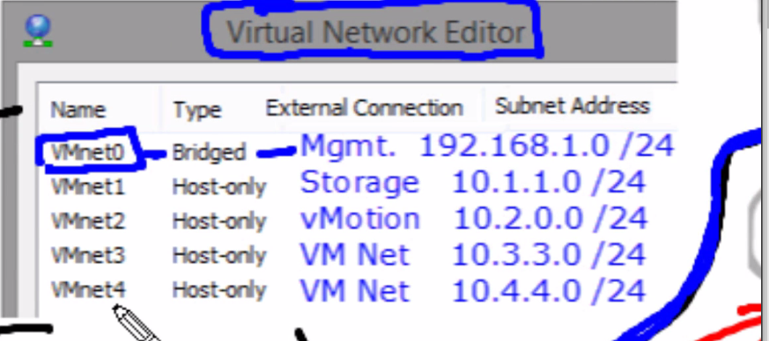

Mind that VMnet0 is Brided

VMnet 3: Virtual machine 1 network (Connecting VMs launched on ESXi to networks)

VMnet 4 Virtual Machine 2 network

# Video 7: AD, DNS and others

AD server(Windows) Windows 2012

* DNS, File services(ISCI target), NFS storage, DHCP services
* All services are enabled and 4 NIC must be given
* Management 192.168.1.111, storage(For file server) 10.1.1.111
* VM nets 10.3.3.111 and VM4 10.4.4.111. By this, Deployed VM on ESXi-Hosts can be associated with AD thorugh 10.3.3.111 and 4.111

Use Server Manager

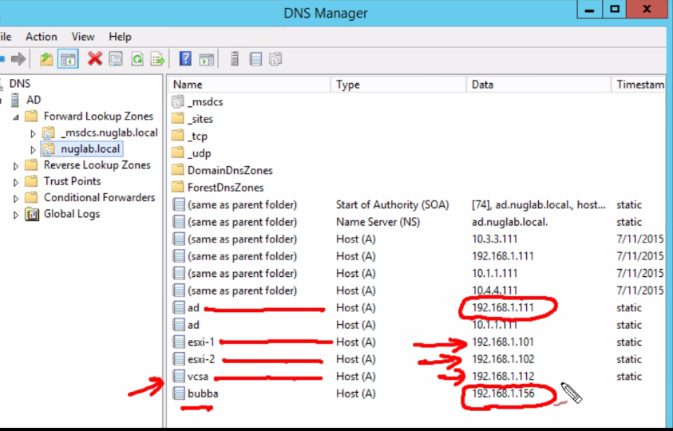

**My PC must use .111 AD as a DNS server and use alternate as 8.8.8.8**

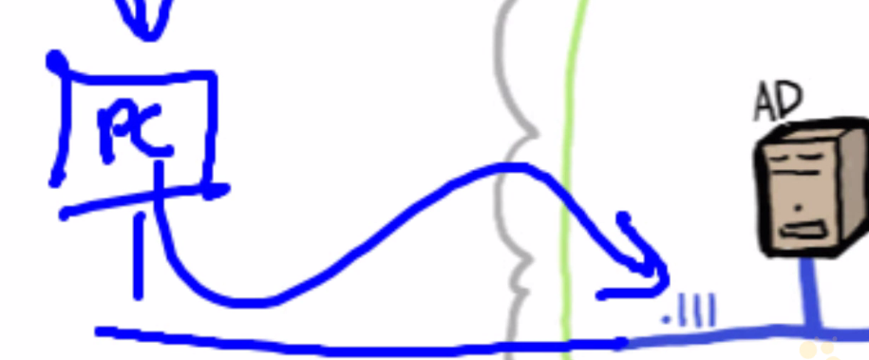

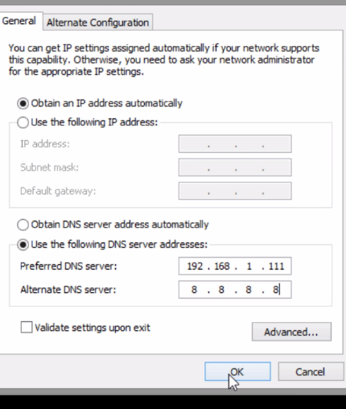

* Now use following on PC
* Cmd >> ns lookup ESXi-1.nuglab.local

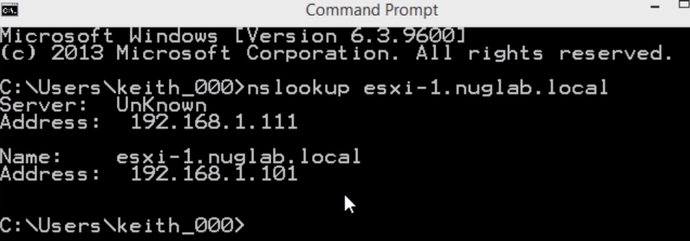

* Check ESXi if its using DNS server from AD

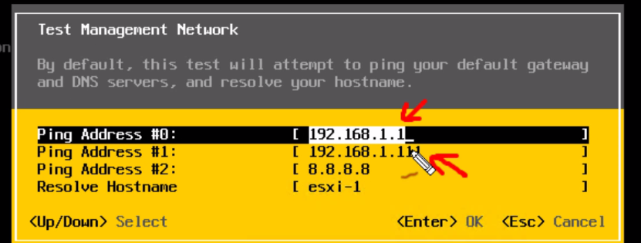

Must be Successful!

# Video 8: vSphere Windows Client

* It’s a GUI
* Vsphere windows client and vSphere Web client
* Doesn’t scale very well… Windows client is 1:1, 1 pc can configure only 1 ESXi Host

**Use vCenter server(Web client)**

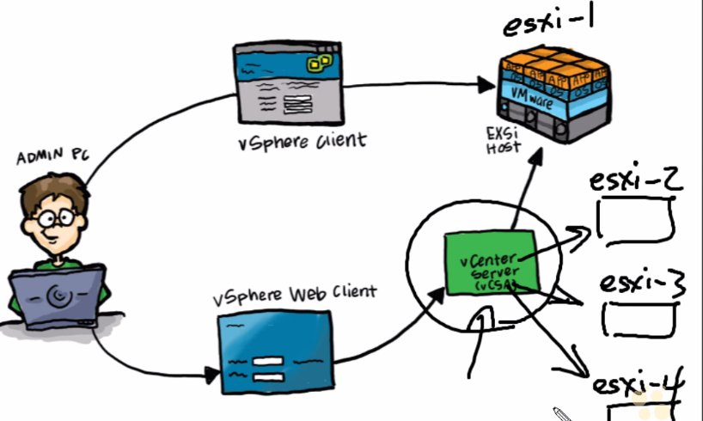

* Admins connect to vsphere center server and then use Web client
* Vcenter server interacts with all hosts

# Video 10: Deploying the Vcsa

* Vcsa.nuglab.local ---must be resolved(With DNS and reverse dns)

# Video 13 Datastore

* .vmx and other supporting files are stored in datastore
* Created using local storage space given to hosts
* 2 datastores cant have exact same name.
* Storage>datastore1>related Objects>Hosts

---- Show’s hosts connected

* You can rename datastores (Rename to esxi-1-Datastore)
* Type VMFS5 VM File system (Can change to NFS)

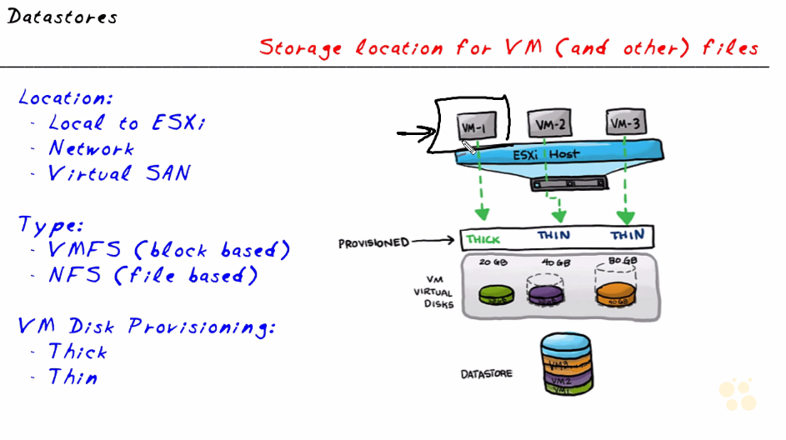

Thick: Full storage space dedicated will be used by Virtual machine (20/20GB)

Thin: Part of storage is allotted to VM and remaining is dedicated but not occupied(20/40 GB)

>> Add a new folder ISO-images in data store

>> Click upload file—Add Ubuntu.iso file

# Vid 14 Deploy VM in vsphere

Will install Ubuntu from IOS in data store we stored in previous video

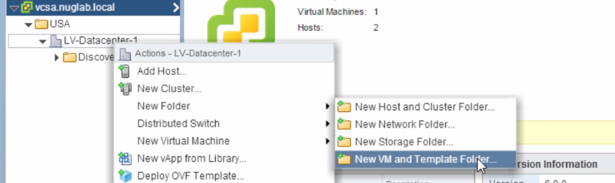

Name: Linux

* Right click > New Virtual Machine

CD/DVD Drive: Change from client device to Datastore ISO and select ISO

By default: New Hard disk is provisioned in Thick manner

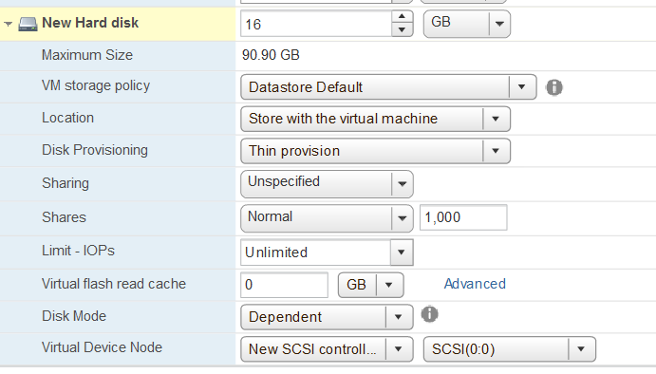

Thick Eager Zero: Zero out all that space(Format) before utilizing any space

Lazy zero: NO zero out until it starts to be used

# Vid 13 VM TOOLS

apt-get open-vm-tools

# Vid 14: Using VM Templates

Clone to template : Creating copies of a perfect virtual machine. Doesnt delete original machine. Template cant be powered on, you can create VM from template

Convert to template: Creates a template but deletes original

Steps:

-- Name: Ubutn-Template, Give storage details

-- Compute resource: ESXi-1 or ESXi-2 ?

-- Datastore name.. Select thin provision

Cant change any specific info in Template

-- No direct option to configre cpu, memory, hdd for template

-- We can deploy a new vm and change the templates value for that machine ONLY

# Vid 17: OVF OPEN Virtualization FOrmat

OVF: Set of files

OVA: ALl in bundle

MY MACHIN: Power off >> GO to Datastore >> Browse all files for my VM which describe everything >> ANd other person gets files and installs my VM

XXX NOT BAD, but not efficient

>>> USE OVF!!!

What is OVF:

Open Virtualization Format(SEt of all files, including manifest.ovf)

OVA: Open Virtualization APpliance

Exporting set of files as a budle into only 1 .ova file

## DEMO

Right click on VM >> Template >> Export OVF Template

1) AS OVF 2) As .ova

"""DOnt want to export attached ISO image in CD/DVD drive? DIsconnect that in VM MACHIN to client device and then export!

THis is becoz ISO is not required in OVF file as it is actually installed on VM""""

Export OVF Temp >> Directory: PC on local Computer(WHERE you want to save .ovf files.. OVF and OVA) >> Done! (Check recent task to check export)

Right click on Linux folder >> Deploy OVF Template: you can create from preconfigured OVF

((( OVA is zipped version of OVF. Use 7z to see contents of OVA)

# Vid 18: Snapshots:

Snapshots help to revert back at particular state of VM

Helpful in test cases: install a patch, revert to original state using snapshot

VM > Right click > Snapshots

Do it with system powered off( On amchines snapshtos memory contains large overheads)

Browse Files after and before snapshots

.vmsd file size is increased

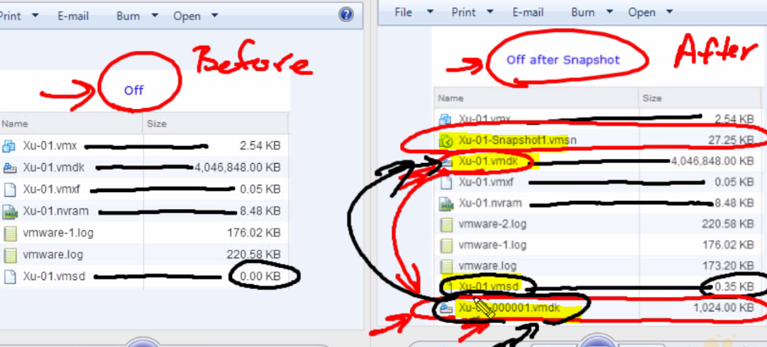

* The .vmsn file is state of VM while taking snapshot
* .vmdk is actual HDD while taking snapshot
* .vmdk (00001) is a Delta HDD file

>> The moment snapshot is started, the OG HDD .vmdk is converted to read only mode, thereby containing the state and integrity. Hence when snapshot is restored, this HDD contents are copied and hence state is maintaed.

>> Hence, all new changes must be saved in another HDD which is now generated at the end of the file list: 00001.vmdk.

>> IF this snapshot is to be deleted, the delta HDD , which contains all the changes, must be **merged** into the original HDD, and covert the OG HDD to Read-Write.

### Use Manage Snapshots:

(NOTES: Don’t create too many snapshots as it sits unnecessary, as all creates delta disks and grow a lot as changes happen)

Try downloading multiple ISO files and let the delta file grow.

Reverting to snapshots:

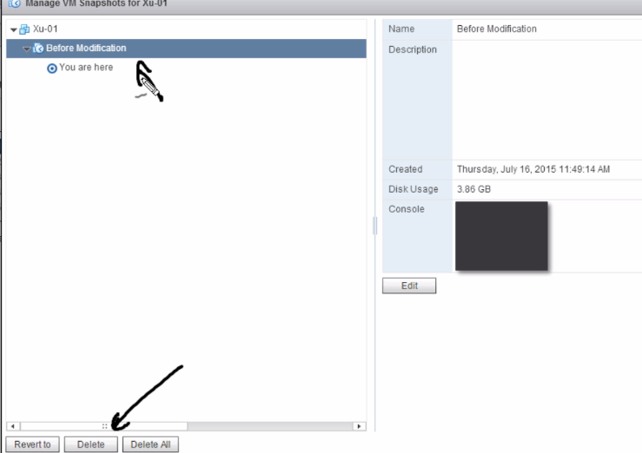

**SNAPSHOT IS NOT A BACKUP!!!!!**