**Date:** 12/11/2016

**Roll No. and Name:** 14BCE151 Baldaniya Rushabhkumar H.

**Course Code and Name:** Open Source Development Lab (CE703)

**Practical No.:** 3 (Wordpress)

**AIM:** To develop a mini project in wordpress of Blog for a Poet

**Methodology followed (Description):**

My project is all about developing a blog for a writer like a poet through which he/she can write their poet via a post of the blog and the subscribed user will get notification soon as they published the post. The try that I made here is to make a good look and feel of the blog through which user will get the best UI design and it will be easy for the user to navigate through the site.

Basically this website (blog) contains the following pages:

1. Home Page
2. About me page
3. Contact me page
4. All post page
5. Blog post page

Here the following images shows the complete demo and understanding of the blog:

And if some user wants to share the post of author in social networking sites like Facebook, youtube or google+ then user can also share the post as the icon given on the right side panel of the page.

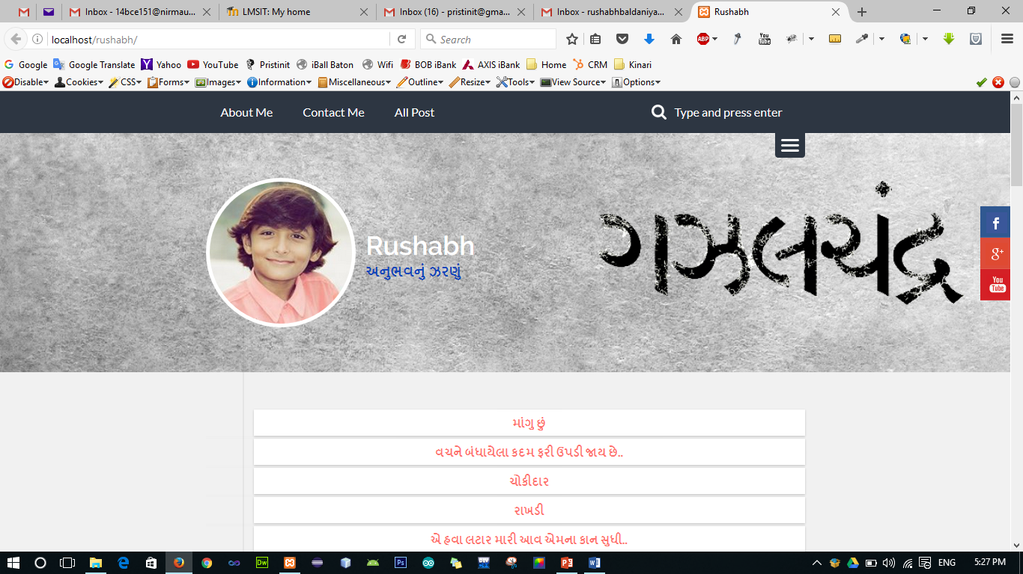

Image1: Home Page

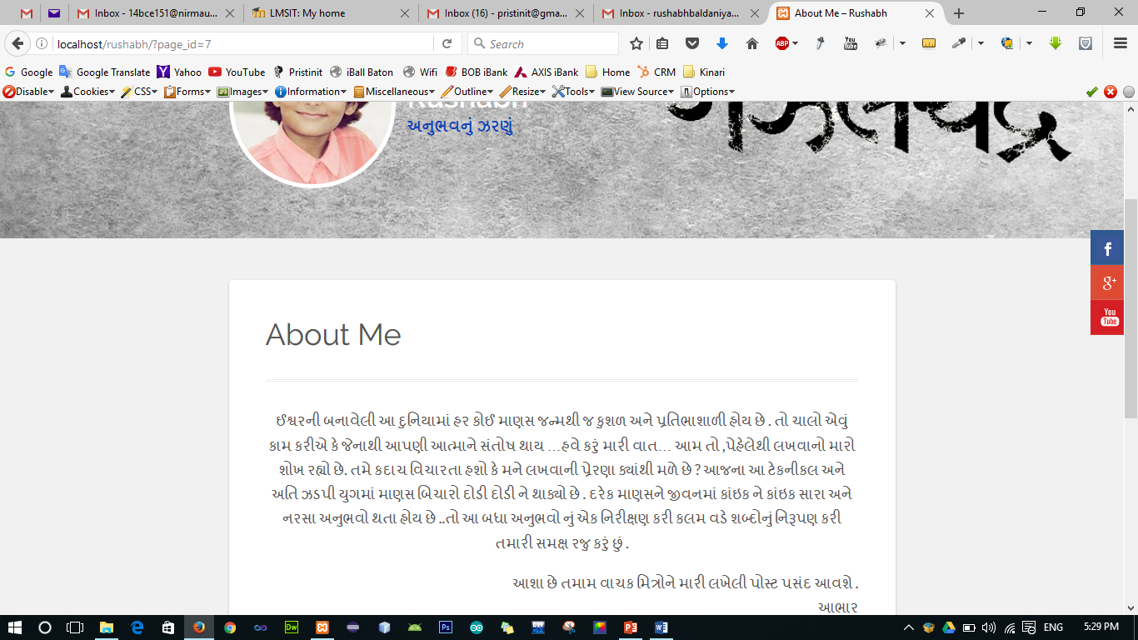

Image2: About me Page

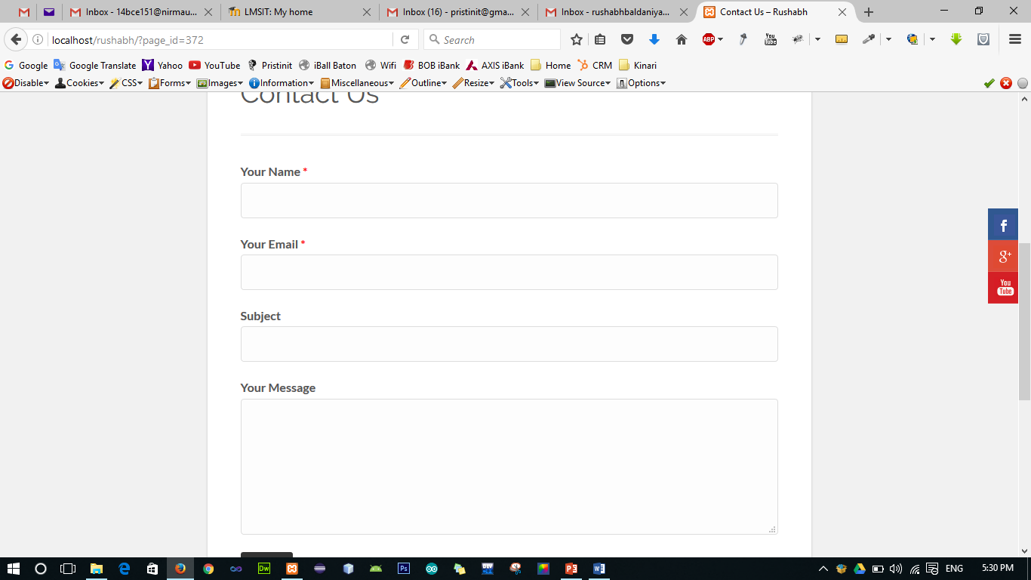

Image3: Contact Page

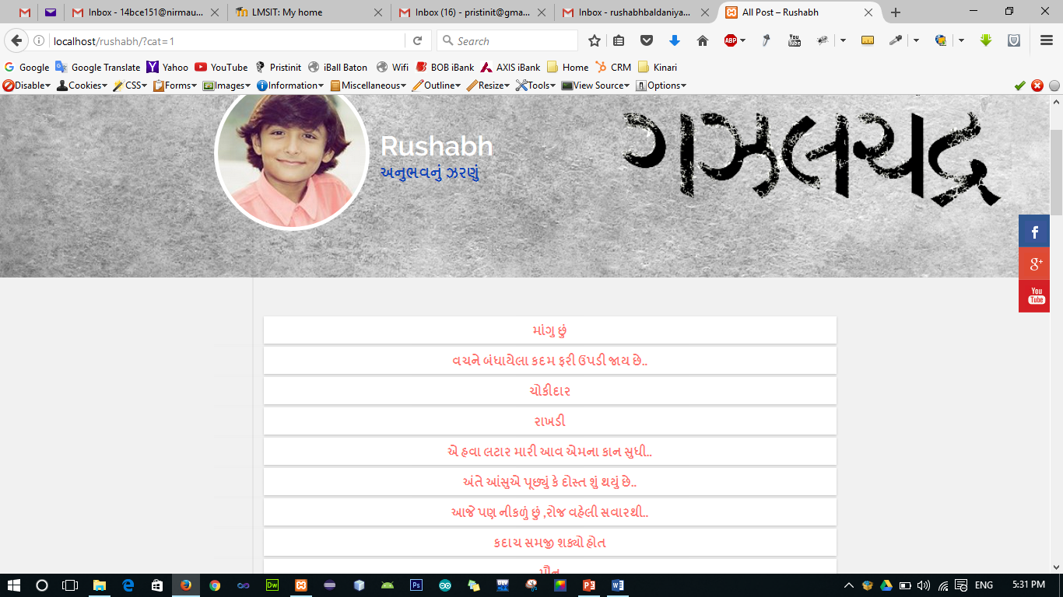

Image4: All post Page

Furthermore if user is interested to read particular post then user can click on any post link and this link will navigate them to the post’s page through which user can completely read the post and even like or dislike the post and also user can write comment about that post.

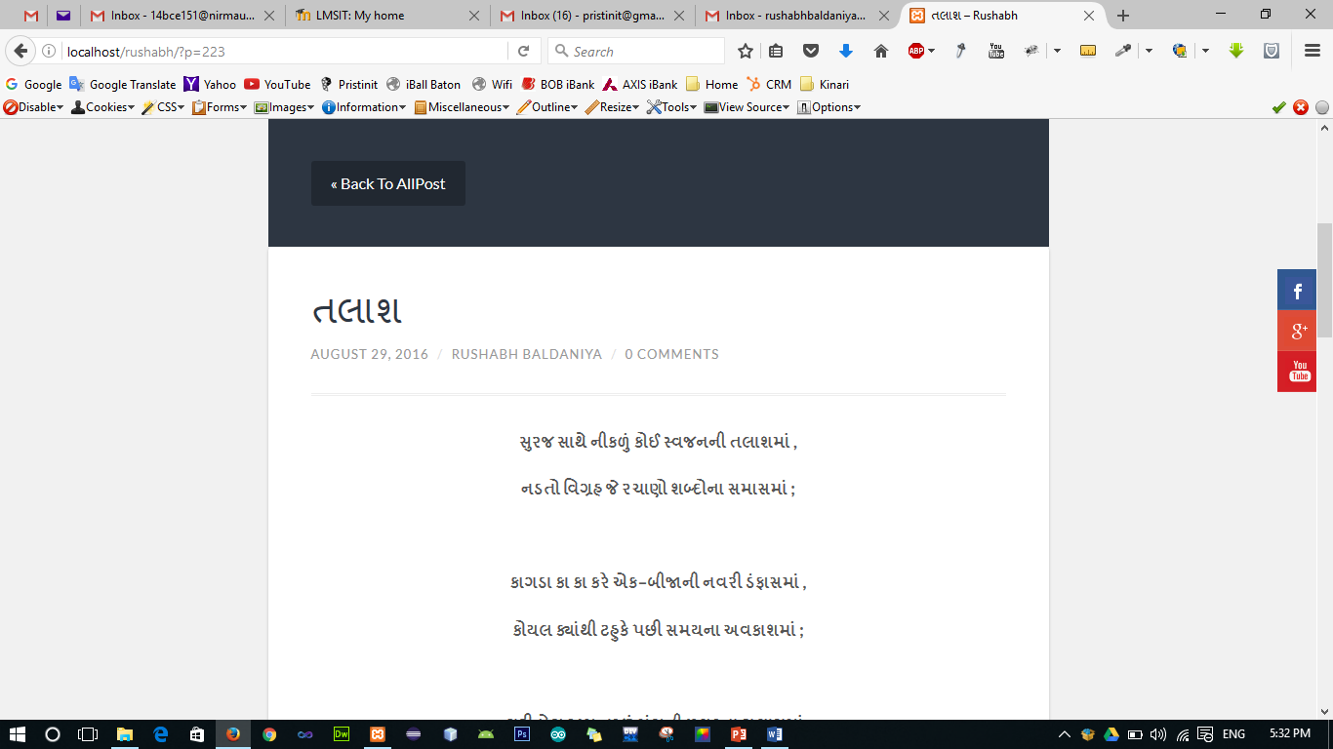

Image5: Post’s Page

And this whole blog is totally dynamic in nature, so an admin panel provides the complete interface to modify or add all the site contents and control many more things.

**Conclusions:**

In this project I explored the development of Wordpress CMS framework and how to implement such a web applications in Wordpress. The designing and developing phase helped us a lot through which I can develop and think of many more applications from this knowledge. So in nutshell, I learnt so many things in Wordpress through this mini project offered in this course.

**Signature of Teacher:**