Project 3 Task 0:

1. The details for the lastest block in the block chain:

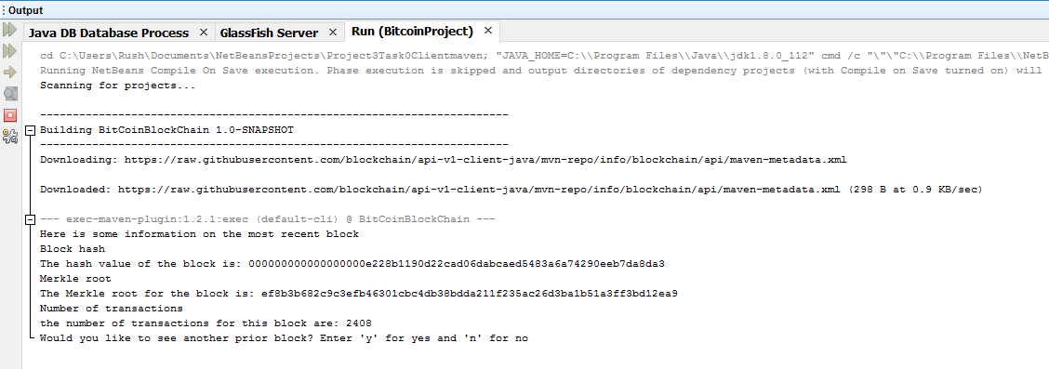

1. User prompted to see the prior block. User says yes:

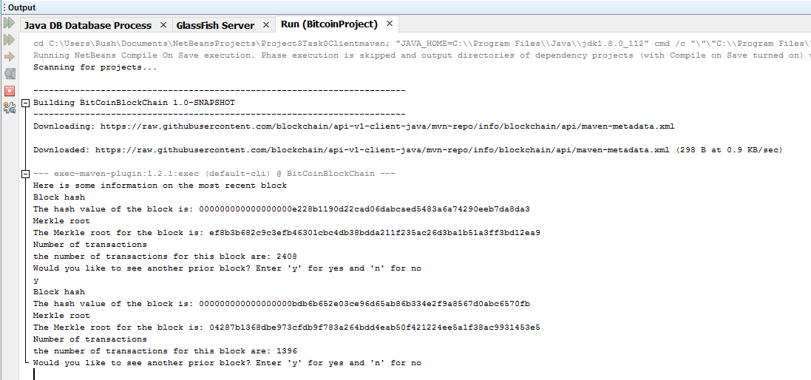

1. Again, user prompted to see the prior block, user says no

