**Project 3 Task 1:**

1.

When PublishSensorData class is ran, it calls the web service ‘roomChangeinStatus’ to update the status of the room along with sensorID and timestamp.

A sensor is reading noise levels in a room every 5 seconds and the server returns message ‘Ok successfully room status changed’ if the message signed by the client was authenticated by the server and the room status was successfully was updated.

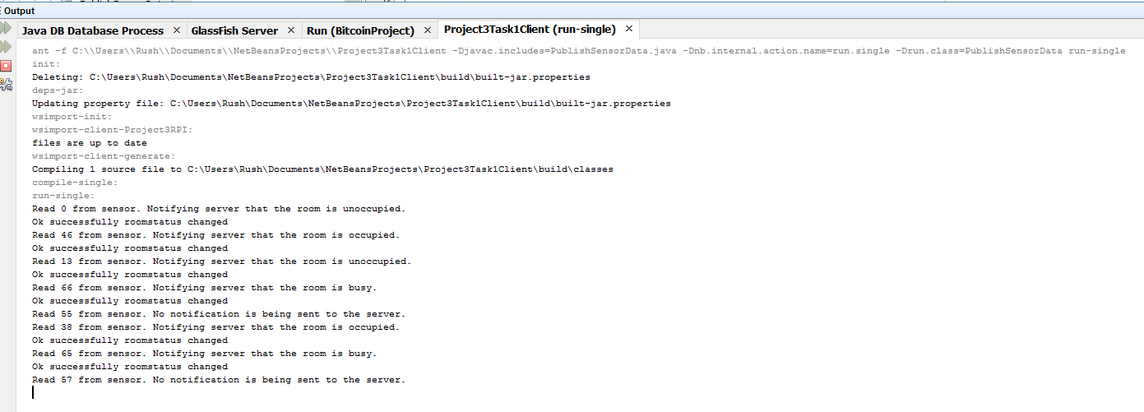

2.

When ReadSensorData class is ran, it calls the web service ‘getRoomStatusMsg’ to read the room’s current status.

