**Project3 Task2:**

1.

When PublishSensorData class is ran, it calls the web service ‘singleMessageOperations’. If the action tag is roomChangeInStatus, the web service performs the operation to update the status of the room along with sensorID and timestamp.

A sensor is reading noise levels in a room every 5 seconds and the server returns message ‘Ok successfully room status changed’ if the message signed by the client was authenticated by the server and the room status was successfully updated.

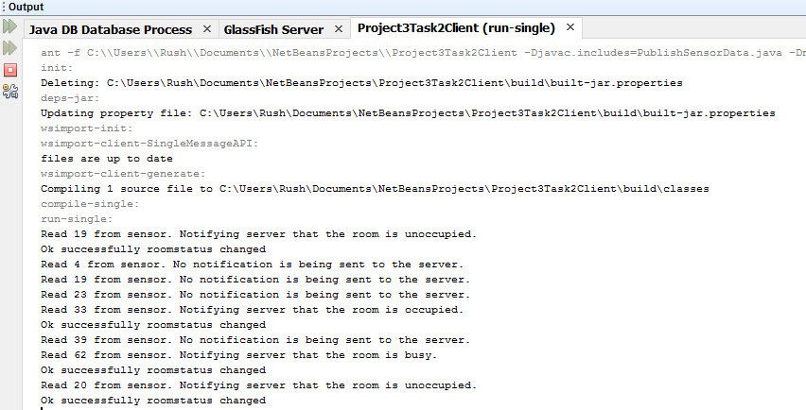

2.

When ReadSensorData class is ran, it calls the web service ‘singleMessageOperations’ and if the action tag is ‘getRoomStatusMsg’, the web service performs the operation to read the room’s current status.

