**Project3 Task3:**

1.

When PublishSensorData class is ran, it calls the doPost method of the servlet ‘APIDesignRestStyle’ to update the status of the room along with sensorID and timestamp.

A sensor is reading noise levels in a room every 5 seconds and the server returns message ‘Ok successfully room status changed’ if the message signed by the client was authenticated by the server and the room status was successfully updated.

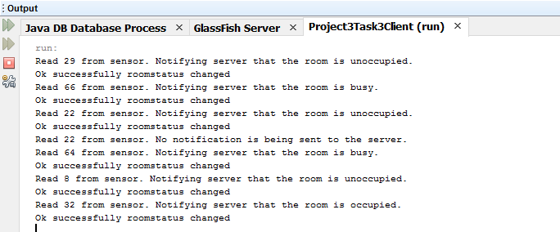

2.

When ReadSensorData class is ran, it calls the doGet method of the servlet ‘APIDesignRestStyle’ to read the room’s current status.

