**Low Level Design (LLD)**

Analyze International Debt Statistics

**Revision Number - 1.0**

**Last Date of Revision –03/11/2022**

**Rushabh Halmare**

**Document Control**

|  |  |  |  |
| --- | --- | --- | --- |
| **Date** | **Version** | **Description** | **Author** |
| 05/10/2022 | 1.0 | Introduction, Problem Statement | Rushabh Halmare |
| 29/10/2022 | 1.0 | Dataset Information, Architecture Description | Rushabh Halmare |
| 03/11/2022 | 1.0 | Final Revision | Rushabh Halmare |

**Why this Low-Level Design Document?**

The purpose of this document is to present a detailed description of the International debt analysis technique. It will explain the necessary steps which have to be followed before any analysis can begin. The document would also describe the algorithms and techniques used to predict the presence and absence of the international debt and present a comparative result for the same. LLD describes the class diagrams with the methods and relations between classes and programs specs. It describes the modules so that the programmer can directly code the program from the document.

The LLD will be focusing on the below objectives:

* Problem Understanding.
* Data Acquisition.
* Data Pre-Processing and Exploratory Analysis
* Development of models
* Auditing accuracy and retrain if require
* Finalizing the model
* Dashboard report for important activities

**Scope**

The LLD documentation presents the detailed structure of the international debt statistics for each of its individual components. The goal of LLD is to give the internal logical design of the actual program code. Low-level design is created based on the high-level design. The LLD documentation contains the complete description of the model used along with the comparisons of the proposed model/library compared with a baseline (existing) model against a set of metrics.

1. **Project Introduction**

It's not that we humans only take debts to manage our necessities. A country may also take debt to manage its economy. For example, infrastructure spending is one costly ingredient required for a country's citizens to lead comfortable lives. The World Bank is the organization that provides debt to countries.

**Constraints**

Our analysis is done based on International Debt Statistics Dataset. There are many features because, every year dept. is separated by one column 1970-2028 each column for each year.

1. **Technical Specification**

The Dataset is taken from iNeuron’s provided Project Description Document.

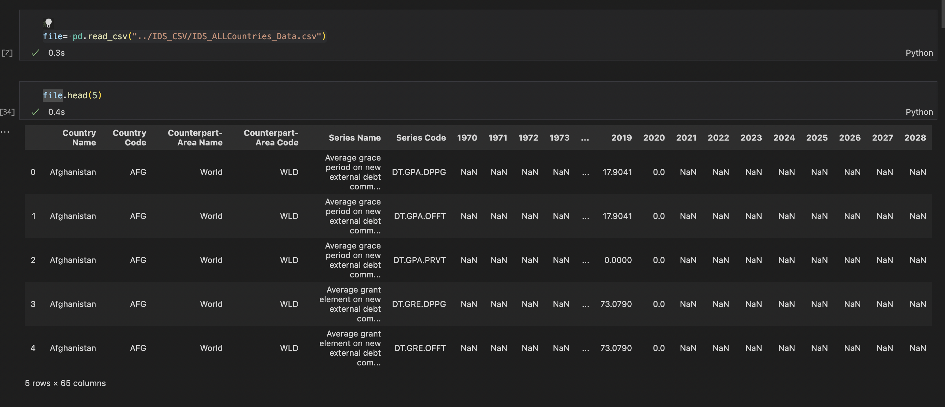

There are 5 rows and 65 columns in the dataset, which are described below.

1. **Country Name -** Display the Country Name.
2. **Country Code-** Display the Country code based on Country Name
3. **Counterpart-Area Name -** Displays the General as World
4. **Counterpart-Area Code -** Displays the Code for World as WLD
5. **Series Name -** Displays the Reason for Debt
6. **Series Code -** Displays The unique code for Different Indicator
7. **1970-2028** - Displays the debt in years
8. **Problem Statement**

Governments, like individuals, may borrow money to manage their economies, finance budget deficits or capital projects, or meet the balance of payments or cost of national emergencies. [The World Bank](https://www.linkedin.com/company/the-world-bank/) is an international financial institution that provides loans and grants to the governments of low- and middle-income countries to pursue capital projects. In this project, we are going to analyze international debt data collected by The World Bank. The dataset contains information about the amount of debt (in USD) owed by developing countries across several categories.

We are going to find the answers to questions like:

* What is the total amount of debt that is owed by the countries listed in the dataset?
* Which country owns the maximum amount of debt and what does that amount look like?
* What is the average amount of debt owed by countries across different debt Indicators?

# Architecture



Real World

Exploratory Data Analysis (EDA)

Modelling

Deployment

Data Cleaning

Data Pre- Processing

Raw Data Collection

Reporting

* 1. **Architecture Description**
     1. **Raw Data Collection-**

The dataset is taken from iNeuron’s which is provided in the introduction document of project.

[Search Page | Data Catalog (worldbank.org)](https://datacatalog.worldbank.org/search/dataset/0038015)

### Data Pre-Processing

Before building any model, it is crucial to perform data pre-processing to feed the correct data to the model to learn and predict. Model performance depends on the quality of data feed to the model to train. This Process includes-

1. Handling Null/Missing Values
2. Handling Skewed Data

### Data Cleaning

Data cleaning is the process of fixing or removing incorrect, corrupted, incorrectly formatted, duplicate, or incomplete data within a dataset.

1. Remove irrelevant observations
2. Filter unwanted outliers
3. Renaming required attributes

### Exploratory Data Analysis (EDA)

Exploratory Data Analysis refers to the critical process of performing initial investigations on data to discover patterns, spot anomalies, test hypothesis and to check assumptions with the help of summary statistics and graphical representations.

### Reporting

Reporting is a most important and underrated skill of a data analytics field. Because being a Data Analyst you should be good in easy and self-exploratory report because your model will be used by many stakeholders who are not from technical background.

1. High Level Design Document (HLD)
2. Low Level Design Document (LLD)
3. Architecture
4. Wireframe
5. Detailed Project Report
6. Power Point Presentation

### Modelling

Data Modelling is the process of analyzing the data objects and their relationship to the other objects. It is used to analyze the data requirements that are required for the business processes. The data models are created for the data to be stored in a database. The Data Model's main focus is on what data is needed and how we have to organize data rather than what operations we have to perform.

### Deployment

Below attached screenshot is a demographic view of debt across the globe using a Tableau.

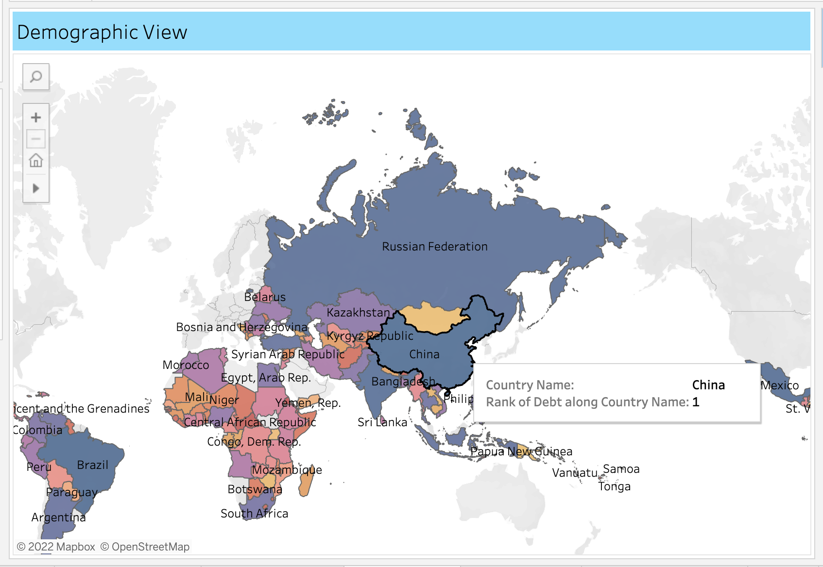

Indicator Series Code - Wise Highest Debt

