pfSense DoS Defense HomeLab

A cybersecurity homelab demonstrating network segmentation, Kali Linux DoS attack simulation on a Ubuntu VM, real-time packet capture, and firewall-based mitigation.
By Rushabh Roymon | GitHub Portfolio Project
Attack Packets Generated  1,774,472 | Wireshark Capture  377,654+ packets
Attack Packet Rate  177,000 pps | Firewall Blocking Rate  100%

Homelab Project Complete Documentation

Project Objectives

- Stand up a pfSense firewall in VirtualBox with separate WAN (bridged) and LAN (internal) segments
- Put Kali Linux on the WAN side to simulate an external attacker
- Put Ubuntu Desktop on the LAN side as the victim host
- Demonstrate DoS traffic with hping3 and show it in Wireshark
- Mitigate the attack using pfSense firewall rules and view the resulting logs

2. Lab Topology & IP Plan

Device / Segment | IP / Role
pfSense WAN | 192.168.29.241/24 (DHCP from router)
pfSense LAN | 192.168.1.1/24 (Static, DHCP Server)
Kali Linux (Attacker) | 192.168.29.7 (Bridged)
Ubuntu (Victim) | 192.168.1.100/24 (DHCP from pfSense)
Internal Network Name | intnet (VirtualBox Internal Network)

Network Flow:
Kali (192.168.29.7) → pfSense WAN (192.168.29.241) → pfSense LAN (192.168.1.1) → Ubuntu (192.168.1.100)
┌───────────────────────────────────── ──────────────┐
Host Network (192.168.0.0/24)
Physical NIC: MediaTek Wi-Fi 7
└─────────────────────────────────────────────────────┘
▼
───────────┴──────────
| |
┌────▼───────┐ ┌────────▼──────┐
KALI PFSENSE
(Attacker) (Firewall)
192.168.29.7 192.168.29.241 ← WAN (Bridged)
Bridged 192.168.1.1 ← LAN (Internal)
hping3 DHCP Server
└────────────┘ └───────┬───────┘
|
┌────── ▼────────┐
Internal Net
(intnet)
192.168.1.0/24
└───────────────┘
|
┌────────▼────────┐
UBUNTU
(Victim)
192.168.1.100/24
Wireshark
└─────────────────┘

3. Virtual Machine Setup

3.1 VM Specifications

VM | Specs
pfSense | 2 GB RAM | 2-Core CPU | 15 GB Disk
Kali Linux | Pre-built VirtualBox Image (not ISO)
Ubuntu (Victim) | 2 GB RAM | 2-Core CPU | 20 GB Disk
Host OS | Windows 11 + VirtualBox 7.x

3.2 Network Adapter Configuration on VirtualBox

pfSense Adapter 1 (WAN)
- Attached to: Bridged Adapter
- Physical NIC: MediaTek Wi-Fi 7
- Virtual Cable Connected: Enabled
pfSense Adapter 2 (LAN)
- Attached to: Internal Network
- Network Name: intnet
- Virtual Cable Connected: Enabled
Kali Adapter 1
- Attached to: Bridged Adapter
- Name: MediaTek Wi-Fi 7 MT7925 (same as pfSense WAN)
- Virtual Cable Connected
Ubuntu Adapter 1
- Attached to: Internal Network
- Name: intnet
- Virtual Cable Connected

4. pfSense Configuration

4.1 Interface Assignment
pfSense uses:
WAN = em0 (Bridged Adapter)
LAN = em1 (Internal Network - intnet)
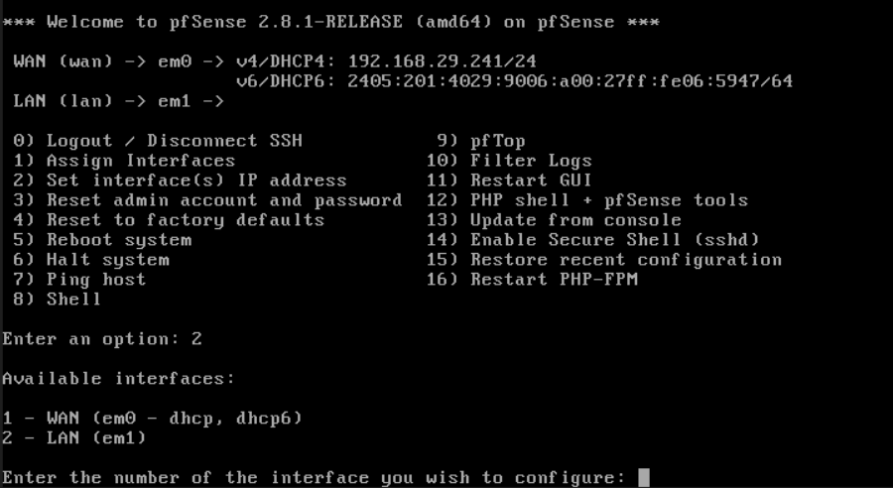
pfSense Console

4.2 LAN Static IP Configuration
Console setup via Option 2 (Set interface IP address):
- IPv4 via DHCP? → n
- IPv4 Address → 192.168.1.1
- Subnet → 24

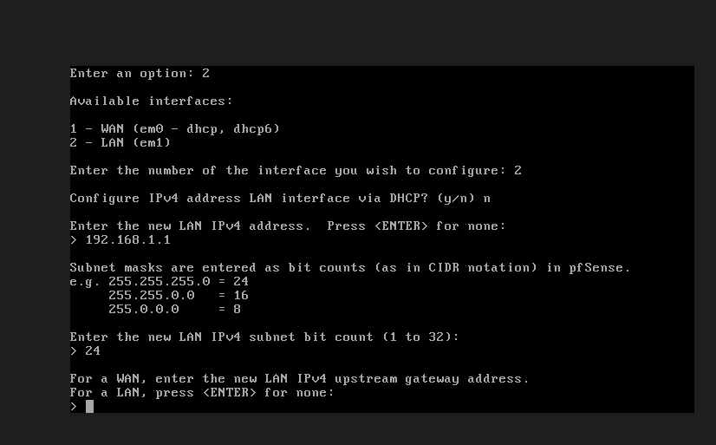

- Gateway → Enter (none - pfSense IS the gateway)
- Configure IPv6 address LAN interface via DHCP6 → n
- Enter the new LAN IPv6 address → Enter (none)
- Enable DHCP on LAN? → y

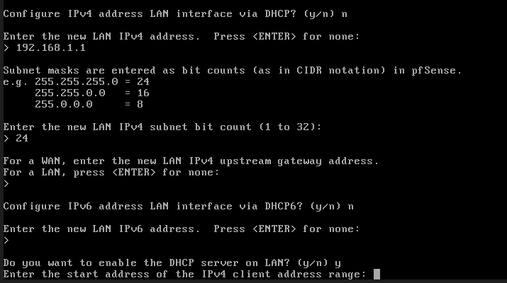

- DHCP Start: 192.168.1.100 | DHCP End: 192.168.1.199

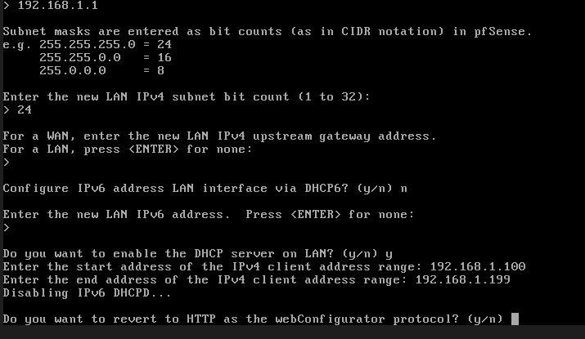

- Revert to HTTP? → n (Keep the webConfigurator protocol on HTTPS)

pfSense will finish and display the LAN address (should be 192.168.1.1).
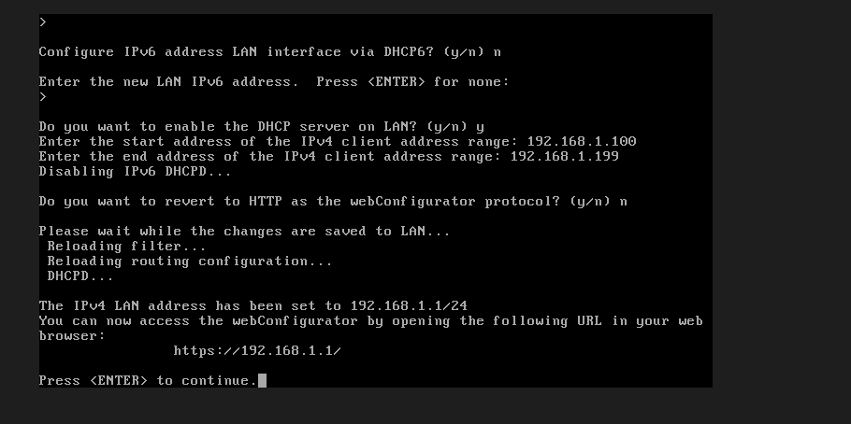\

4.3 pfSense Console - Final Status
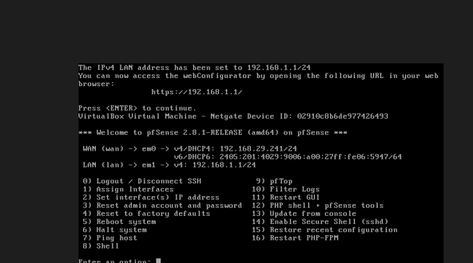

WAN IP | 192.168.29.241
LAN IP | 192.168.1.1/24
DHCP Range | 192.168.1.100 – 192.168.1.199

4.4 Web GUI Access
Accessed pfSense Web GUI via WAN IP:
https://192.168.29.241
Username: admin | Password: pfsense

Note: Used pfctl -d to disable firewall temporarily in pfSense
5. IP & Routing Configuration

5.1 Ubuntu Network (Victim)

IP Address | 192.168.1.100
Gateway | 192.168.1.1 (pfSense)
DHCP Source | pfSense LAN DHCP

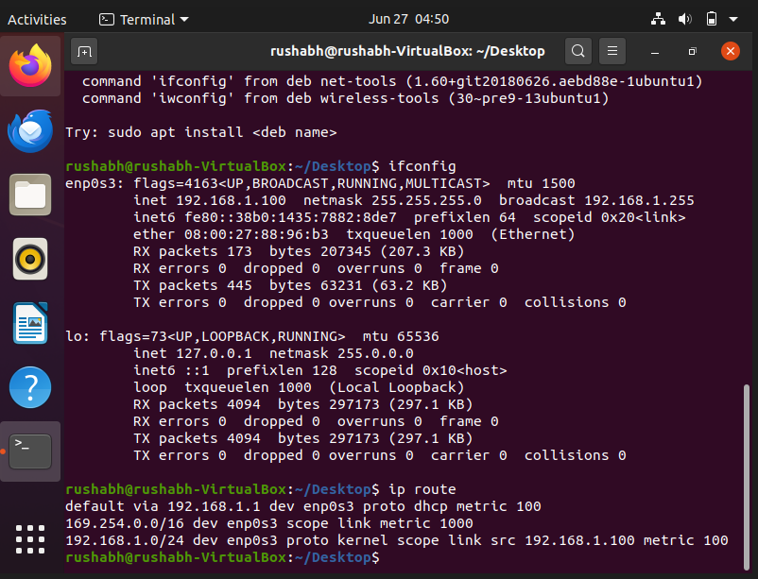

5.2 Kali Network (Attacker)

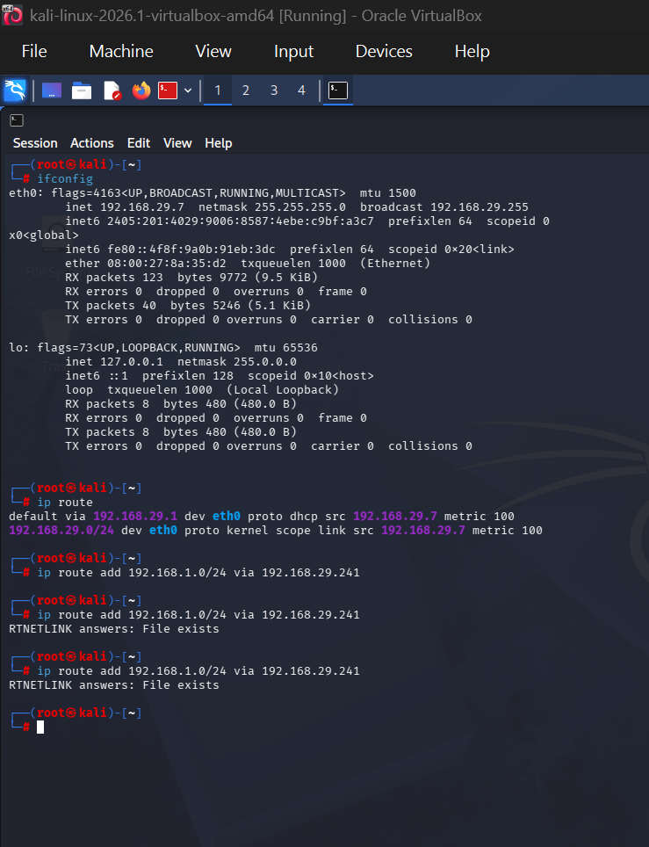

Kali (Attacker) IP Address | 192.168.29.7
pfSense WAN IP Address | 192.168.29.241
Target (Ubuntu) IP Address | 192.168.1.100

5.3 Static Route on Kali
Kali needs a route to reach the internal LAN (192.168.1.0/24) via pfSense WAN:
ip route add 192.168.1.0/24 via 192.168.29.241

Verified routing table after adding route:
default via 192.168.29.1 dev eth0 proto dhcp src 192.168.29.7 metric 100
192.168.1.0/24 via 192.168.29.241 dev eth0 ← Added
192.168.29.0/24 dev eth0 proto kernel scope link src 192.168.29.7 metric 100

Result: RTNETLINK answers: File exists
CONFIRMED via "ip route"

TEST KALI CONECTIVITY TO LAN:

From Kali:
bash
ping -c 3 192.168.1.100
100% packet loss - > the ping failed. The firewall rule isn't working yet or there's a routing issue.
Quick check on Kali, verify the static route is still there:
bash
ip route

Route is there: 192.168.1.0/24 via 192.168.29.241. The issue is pfSense isn't routing the traffic back.
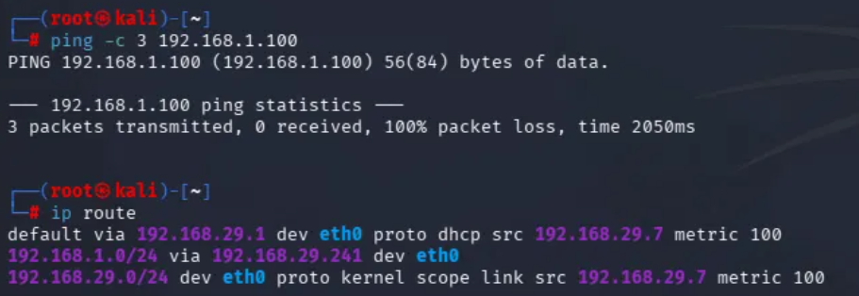
Pinging from Ubuntu to Kali to see if it's one-way or both-way:
On Ubuntu:
bashping -c 3 192.168.29.7
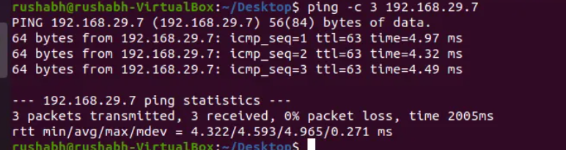
Works (0% packet loss). The issue is Kali → Ubuntu is blocked.
This means pfSense is blocking return traffic. We need to add a rule on the LAN side to allow Ubuntu to respond back to Kali
Check Ubuntu UFW: If UFW is active, it could be blocking ICMP.

On Ubuntu:

bash
sudo ufw status

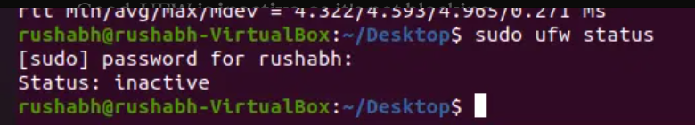

UFW is inactive, so it's not blocking.
To further diagnose the root cause
traceroute from Kali:
bash
traceroute 192.168.1.100
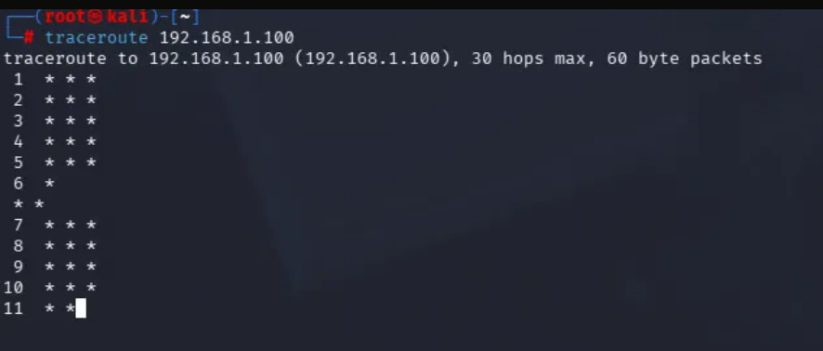
Traceroute is timing out at every hop, pfSense isn't responding or routing the traffic at all.
The issue: pfSense WAN firewall rule is blocking ICMP by default.

6. pfSense Firewall (Web GUI)

6.1 Enable DHCP Server on LAN

- Services → DHCP Server → LAN
- Range: 192.168.1.100 to 192.168.1.199
Ubuntu got 192.168.1.100 from it automatically. pfSense doesn't need DHCP from anything, it has a static IP on the LAN side (192.168.1.1). On the WAN side, pfSense gets DHCP from your home router (192.168.29.241).

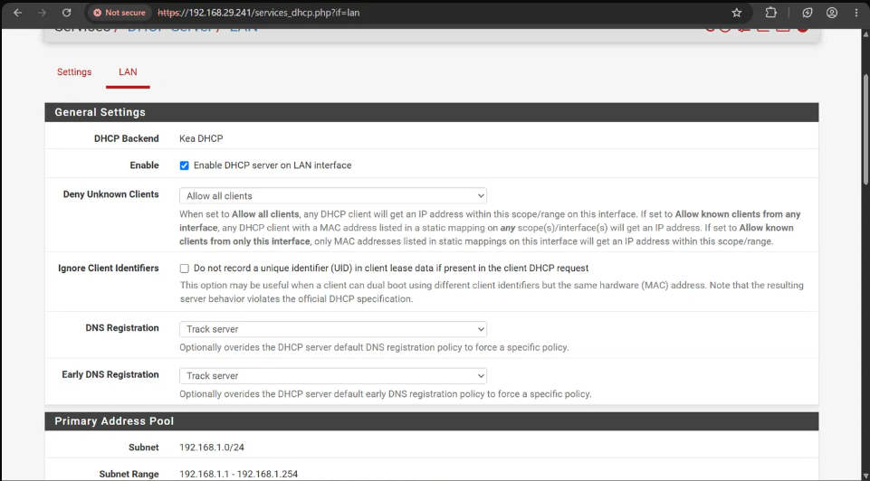

pfSense Firewall Rules

6.2 Allow Rule: Kali → Ubuntu

Added to Firewall ▸ Rules ▸ WAN to allow the initial attack traffic:

Setting | Value
Action | Pass
Interface | WAN
Address Family | IPv4
Protocol | Any
Source | 192.168.29.7 (Kali)
Destination | 192.168.1.100 (Ubuntu)
Description | Allow Kali to Ubuntu

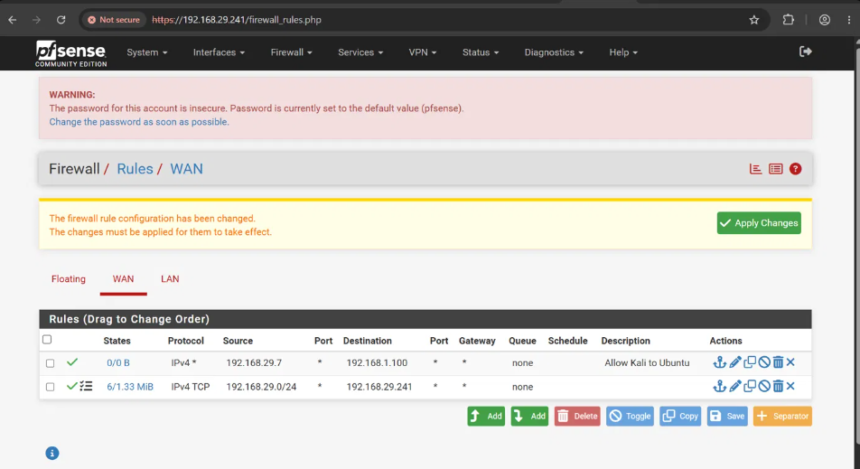

6.3 Connectivity Verification
After adding the allow rule
Ping works now -> 0% packet loss
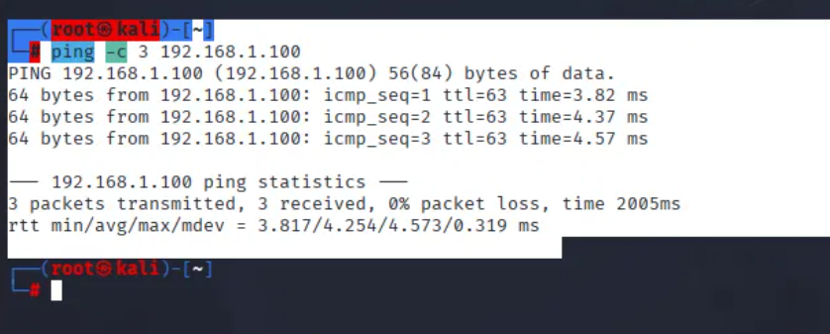

7. DoS Attack Demonstration

7.1 Wireshark Setup on Ubuntu
Installed and launched Wireshark on Ubuntu for real-time packet capture:
sudo apt install -y wireshark
sudo wireshark &

Selected interface: enp0s3 → Double-clicked to start capture
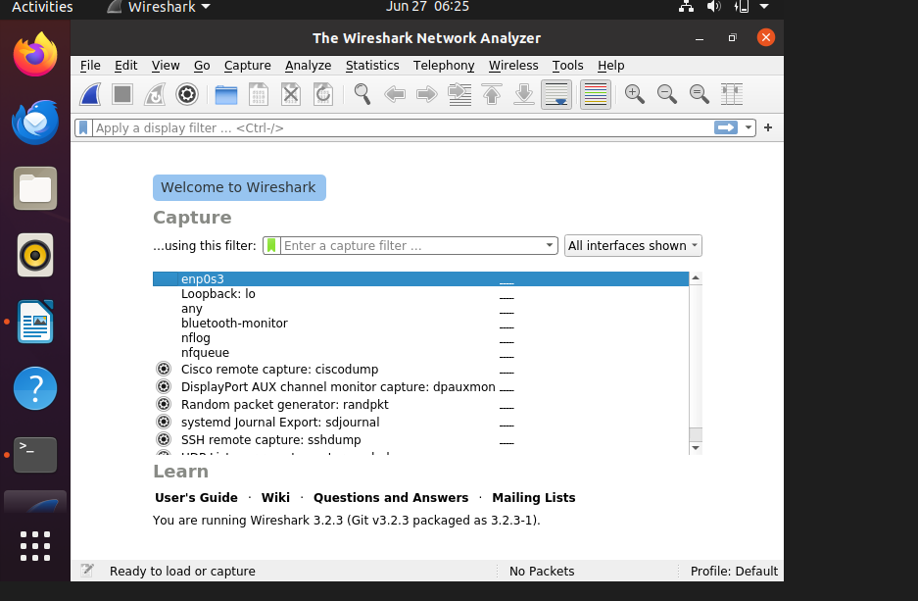

- Status: "<live capture in progress>"
- Packet table is empty (waiting for traffic)
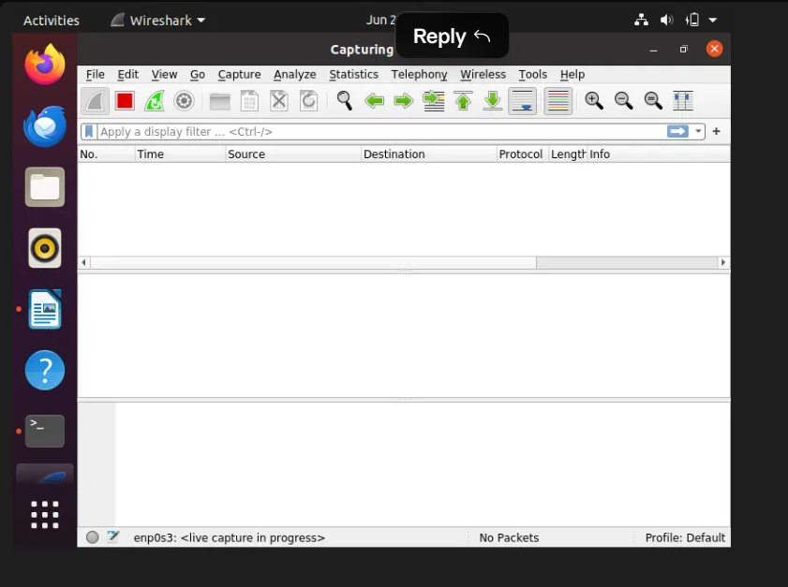

7.2 ICMP Flood Attack from Kali

Launched hping3 ICMP flood attack targeting Ubuntu:
sudo hping3 -1 --flood 192.168.1.100

Attack output:
HPING 192.168.1.100 (eth0 192.168.1.100): icmp mode set, 28 headers + 0 data bytes
hping in flood mode, no replies will be shown

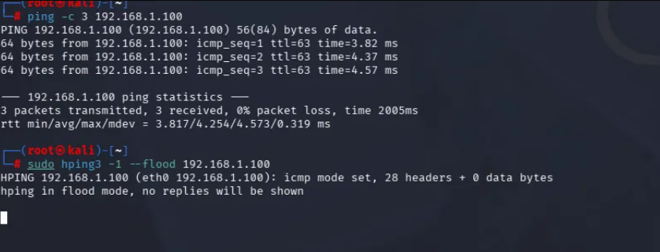
Wireshark capture evidence:
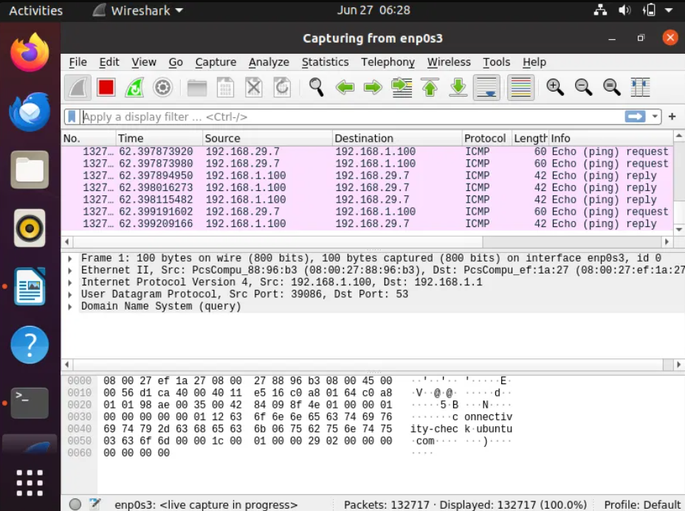

- 377,654+ packets captured in real-time
- Source: 192.168.29.7 (Kali attacker)
- Destination: 192.168.1.100 (Ubuntu victim)
- Protocol: ICMP Echo Request/Reply
- "<live capture in progress>" confirmed active attack

Stop the hping3 flood on Kali
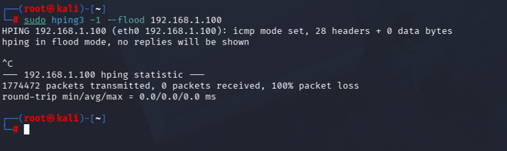

Results:
- Total packets transmitted: 1,774,472
- Packets received: 0 (flood mode - expected)
- Attack duration: ~10 seconds

8. Attack Mitigation & Blocking

8.1 Creating the Block Rule
Added blocking rule at TOP of WAN ruleset (above the allow rule):

Setting | Value
Action | Block
Interface | WAN
Address Family | IPv4
Protocol | Any
Source | 192.168.29.7 (Kali)
Destination | 192.168.1.100/24 (Ubuntu)
Logging | Enabled ✔
Description | Block Kali DoS

8.2 Rule Precedence
With the block rule at TOP, pfSense evaluates in this order:

Priority | Action | Protocol | Source | Description
❌ #1 | BLOCK | IPv4 * | 192.168.29.7 → 192.168.1.100 | Block Kali DoS ← STOPS HERE
✔ #2 | PASS | IPv4 * | 192.168.29.7 → 192.168.1.100 | Allow Kali to Ubuntu (never reached)
✔ #3 | PASS (Default) | TCP | Home Network → pfSense | Allow GUI Access

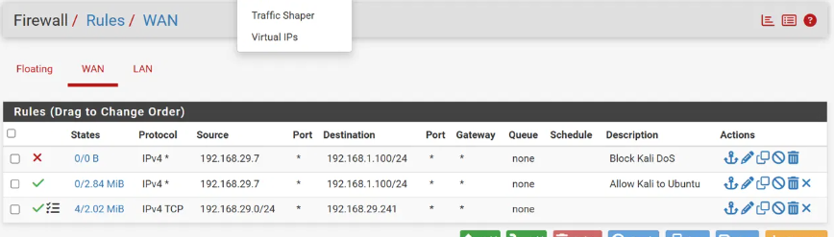
Figure 21: pfSense - All three rules applied (Block on top, Allow below)

8.3 Firewall Logs
Status ▸ System Logs ▸ Firewall ▸ Normal View showed:
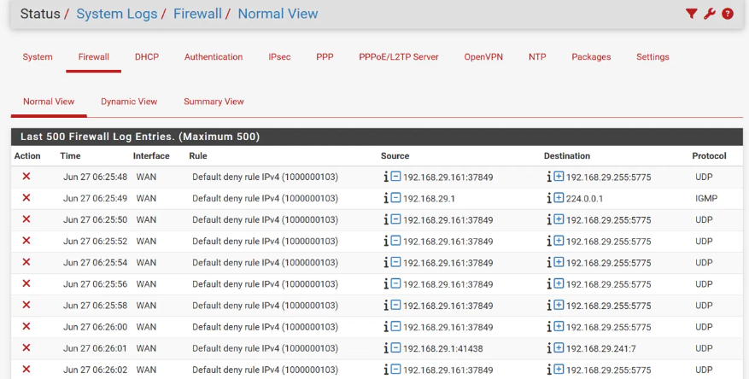

- Thousands of blocked ICMP packets blocked
- Logging confirmed attack source, destination, and protocol
- Timestamps verified attack timeline
- Rule: Block Kali DoS is not seen (Identified Logging was not Enabled)

8.4 Logging Enabled on Block Rule
Edited the block rule to enable logging for forensic evidence:
- Firewall ▸ Rules ▸ WAN ▸ Edit (Block Kali DoS rule)
- Scrolled to Extra Options
- Checked: ☑ Log packets that are handled by this rule
- Saved → Applied Changes

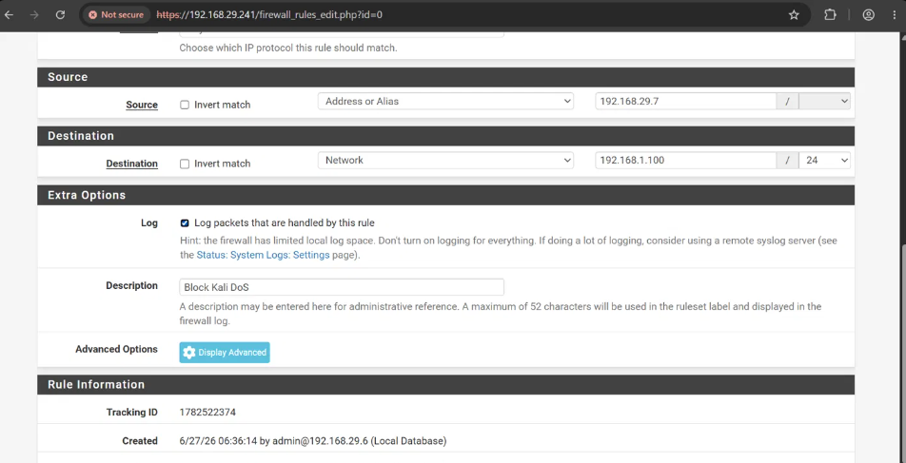
9. Verification & Results
Test | Before Block Rule | After Block Rule
ping -c 3 192.168.1.100 | 0% packet loss (attack passing) | 100% packet loss (attack BLOCKED)
Wireshark on Ubuntu | 377,654+ ICMP packets flooding in | Zero new attack packets from Kali
pfSense Logs | No block logs (rule not yet added) | Block Kali DoS entries logged

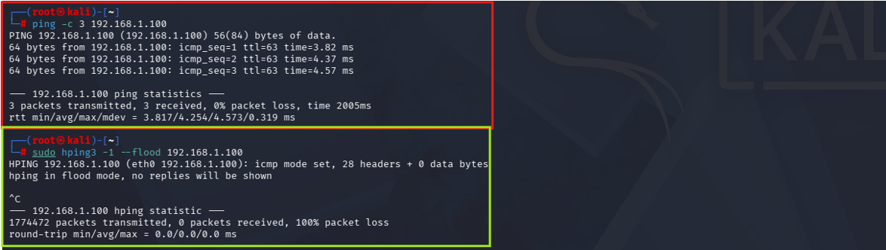

RED = Attack phase (before block rule): packets reaching Ubuntu
GREEN = Mitigated phase (after block rule): 100% packet loss = attack blocked

10. Technical Learnings & Key Takeaways

Learning | Detail
Firewall Rule Precedence | Block rule MUST be above allow rule. pfSense evaluates top-down, stops at first match.
Address Family | IPv4 addresses require IPv4-only rules. IPv4+IPv6 caused errors with specific IPs.
DHCP Server Requirement | LAN interface must have static IP before DHCP server can be enabled.
Configuring LAN adapter on pfSense | LAN adapter had to be enabled and configured on the pfSense interface also disabling IPv6.
pfSense Web GUI Access | Use pfctl -d to disable firewall for initial GUI access
Wireshark Interface | Run sudo wireshark & (not just wireshark) to capture as root on Ubuntu and selecting the correct adapter to capture is key
Logging for Forensics | Always enable logging on security rules to create forensic evidence of attacks.

11. Skills Demonstrated

Category | Skills
Firewall Admin | pfSense rule creation, rule precedence, stateful filtering, logging, DHCP
Network Architecture | Multi-zone segmentation, WAN/LAN design, DHCP, DNS, routing
Attack Simulation | hping3 ICMP flood, traffic generation, attack verification
Traffic Analysis | Wireshark live capture, packet forensics, protocol analysis
Stateful Firewall Behavior | pfSense is a stateful firewall. Return traffic from allowed connections is automatically permitted without explicit rules.
Linux Admin | Kali & Ubuntu setup, static routing, UFW, CLI networking tools
Virtualization | VirtualBox VM management, Bridged/Internal adapters, network design
Incident Response | Threat identification, rapid rule deployment, blocking verification

Summary
This lab successfully demonstrates a complete DoS defense workflow:
- pfSense firewall with WAN/LAN segmentation
- Kali Linux simulating external attacker
- Ubuntu Desktop as victim on isolated LAN
- 1.7M+ packet ICMP flood attack demonstrated
- 377,654+ packets captured with Wireshark
- Firewall block rule achieving 100% attack mitigation
- Logging and forensic evidence

