**Name: Mohd. Rushad Tanjim**

**ID: IT-15056**

**Lab Report No: 01**

**Answer to the question no: 01**

That means that all addresses in the range of 192.168.1.0 to 192.168.1.255 are in the same network. In all networks, the first address and last address is unusable, so the first usable address is 192.168.1.1 and the last is 192.168.1.254.

Since all devices in the network need to have unique addresses that means that you can have 254 devices in that network.

In the network, generally one address is the default gateway, the router that connects that subnet to the rest of the world. That can be anyone of those 254 addresses, but the most common ones are .1 and .254.

All IP addresses that do NOT start with 192.168.1 (like 123.123.123.123 and 8.8.4.4) are outside of that subnet.

All IP addresses are 4 bytes (number between 0 and 255) divided by dots.

**Answer to the question no: 02**

**Find IP address:**

1.Open command prompt.

2. Use ipconfig command.

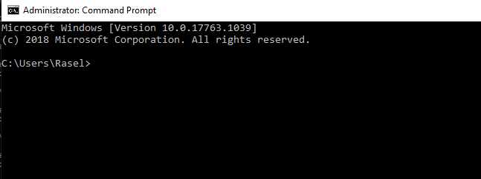

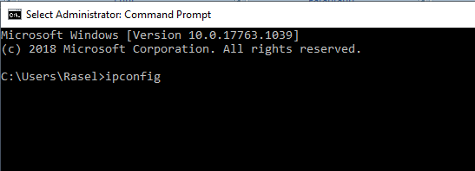

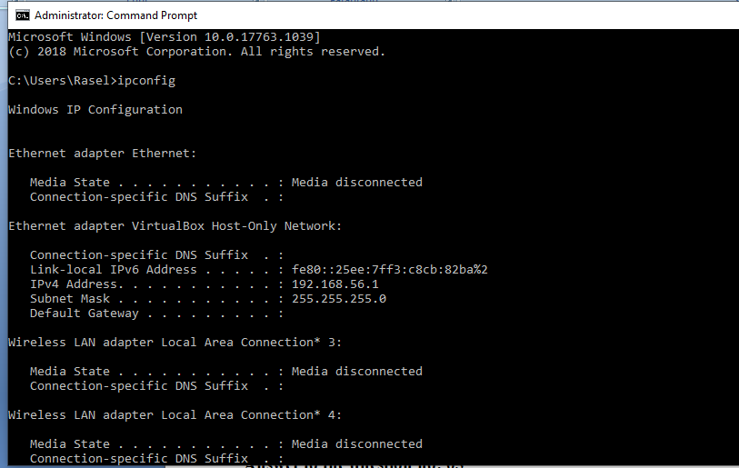

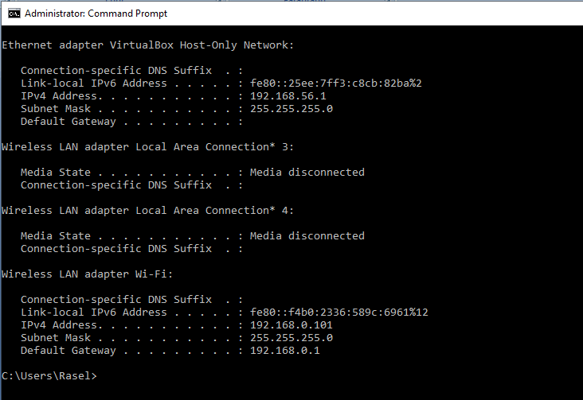

**Find MAC address:**

1.Open command prompt.

2.Use ipconfig /all command.



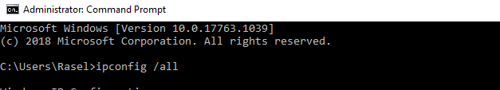

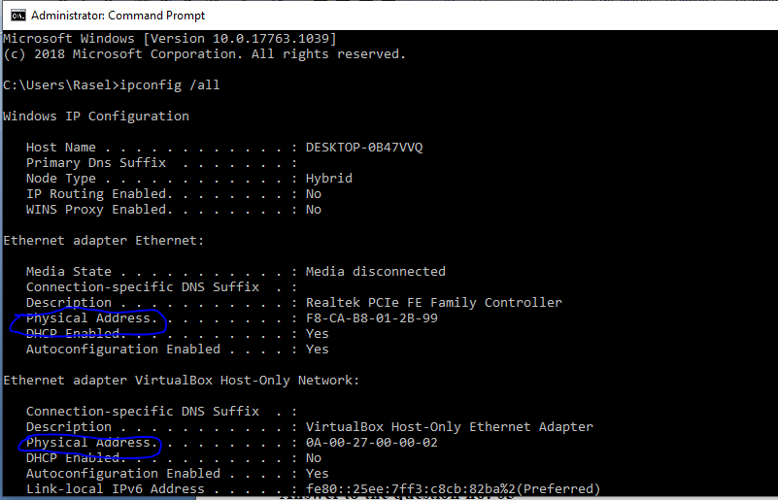

**Answer to the question no: 03**

**Routing Table:**  
A routing table is a set of rules, often viewed in table format, that is used to determine where data packets traveling over an Internet Protocol (IP) network will be directed. All IP-enabled devices, including routers and switches, use routing tables. See below a Routing Table:

Destination:

**Destination** **Subnet mask** **Interface**

128.75.43.0 255.255.255.0 Eth0

128.75.43.0 255.255.255.128 Eth1

192.12.17.5 255.255.255.255 Eth3

default Eth2

The entry corresponding to the *default* gateway configuration is a network destination of 0.0.0.0 with a network mask (netmask) of 0.0.0.0. The Subnet Mask of default route is always 255.255.255.255 .

Gateway:

A gateway is the entrance point to another network. A default gateway is the address to which packets are sent if there is no specific gateway for a given destination listed in the routing table.   
The default gateway is important because it is generally not feasible for all hosts to maintain knowledge of the routes to all other networks on the internetwork.

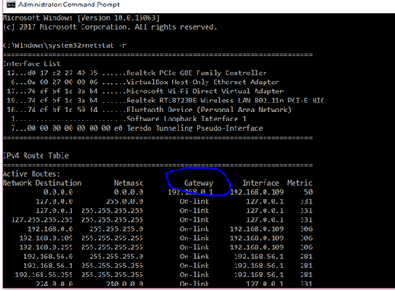

Genmask:

I am having some difficulty in understanding the 0.0.0.0 entries in the Gateway and Genmask columns.

I understand that the destination (0.0.0.0) is the least specific match meaning packets which do not match the other routes will use this route. However I do not understand the corresponding Genmask entry (0.0.0.0).. Packets which do not match the other routes will be sent to the gateway 10.0.0.138 but what is the subnet mask? 0? 10.0.0.138/0 looks a bit odd. Shouldn't it be something like /32? As in the gateway is a single address.

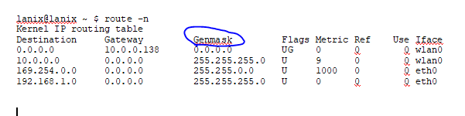

**Routing table flags**

The following table describes the Flags column in the netstat -rn output.

| **Flag** | **Description** |
| --- | --- |
| U | Up—Route is valid |
| G | Gateway—Route is to a gateway router rather than to a directly connected network or host |
| H | Host name—Route is to a host rather than to a network, where the destination address is a complete address |
| R | Reject—Set by ARP when an entry expires (for example, the IP address could not be resolved into a MAC address) |
| D | Dynamic—Route added by a route redirect or RIP (if routed is enabled) |
| M | Modified—Route modified by a route redirect |
| C | Cloning—A new route is cloned from this entry when it is used |
| L | Link—Link-level information, such as the Ethernet MAC address, is present |
| S | Static—Route added with the route command |

**MSS:**

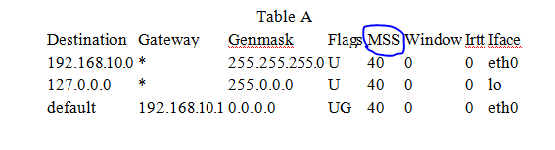

The MSS column indicates the default Maximum Segment Size for TCP connections over this route.

**WINDOW:**

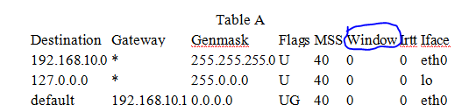

The Window column indicates the default window size for TCP connections over this route.

**IRTT:**

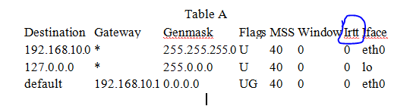

The Irtt column indicates the Initial Round Trip Time for this route.

