**Name : Mohd Rushad Tanjim**

**ID : IT-15056**

**Course Code : ICT-3208**

**Introduction**

Wireshark is a network packet analyzer. A network packet analyzer presents captured packet data in as much detail as possible.

You could think of a network packet analyzer as a measuring device for examining what’s happening inside a network cable, just like an electrician uses a voltmeter for examining what’s happening inside an electric cable (but at a higher level, of course).

In the past, such tools were either very expensive, proprietary, or both. However, with the advent of Wireshark, that has changed. Wireshark is available for free, is open source, and is one of the best packet analyzers available today.

**Purpose for using Wireshark**

* Network administrators use it to *troubleshoot network problems*
* Network security engineers use it to *examine security problems*
* QA engineers use it to *verify network applications*
* Developers use it to *debug protocol implementations*
* People use it to *learn network protocol* internals

**Getting Information about a Network:**

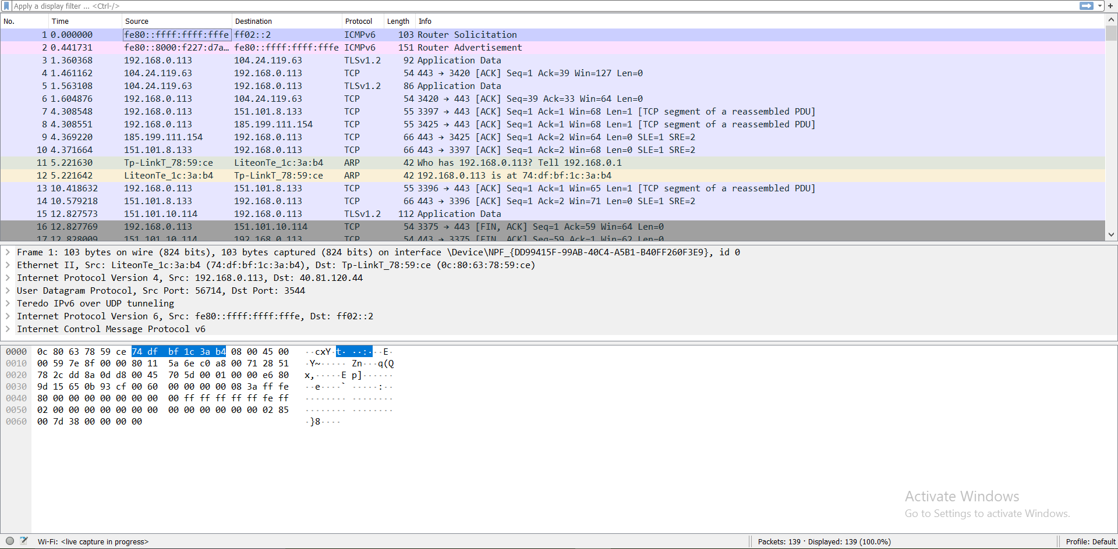

**The protocol Information :**

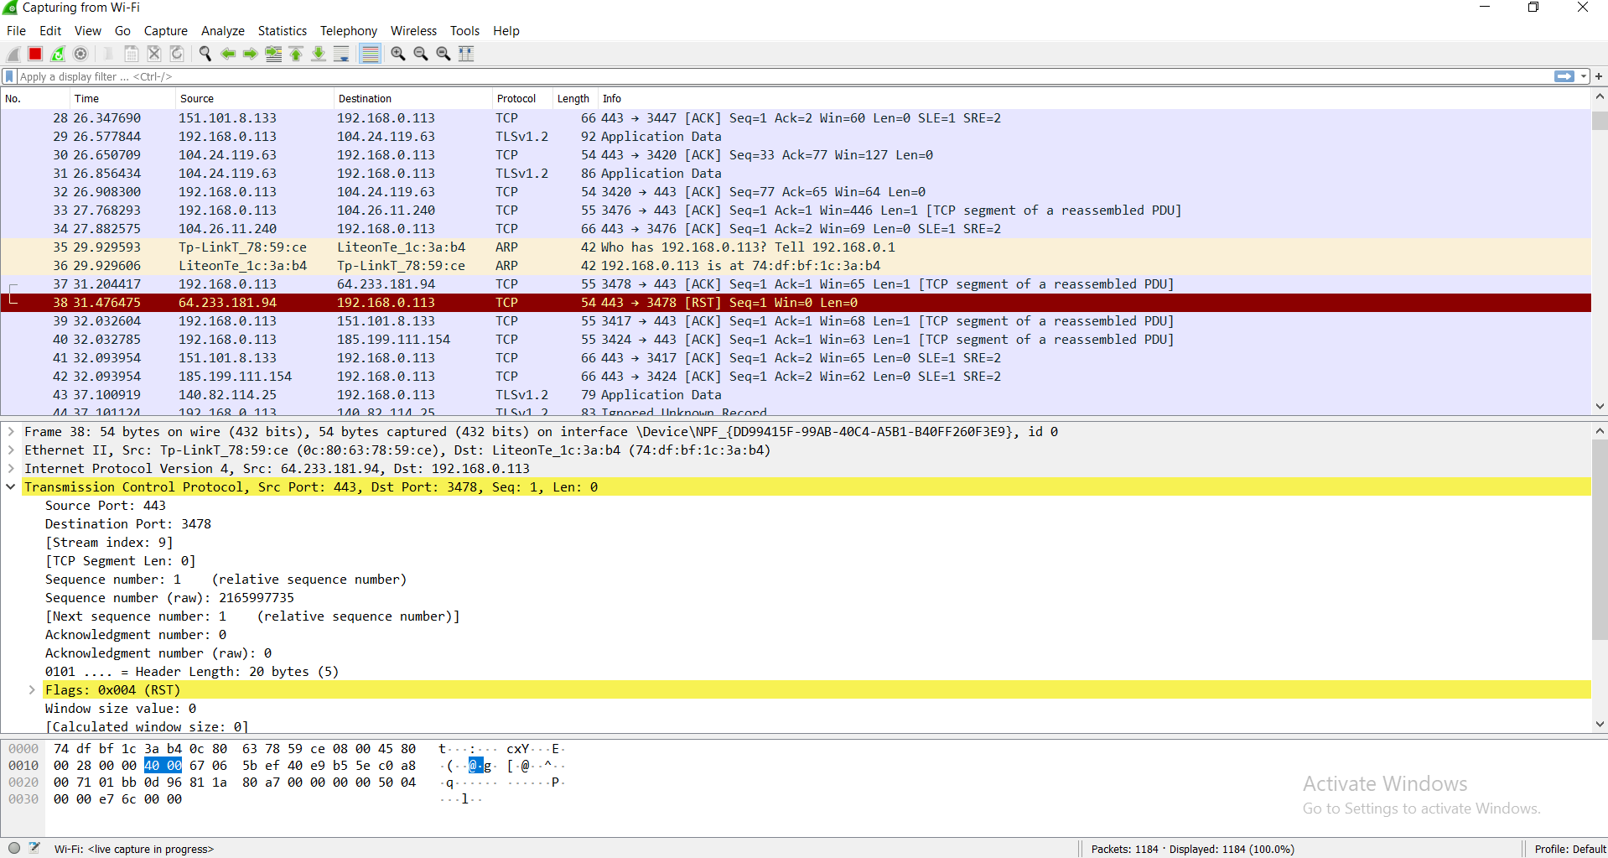

**Port Security Hashing Algorithm:**

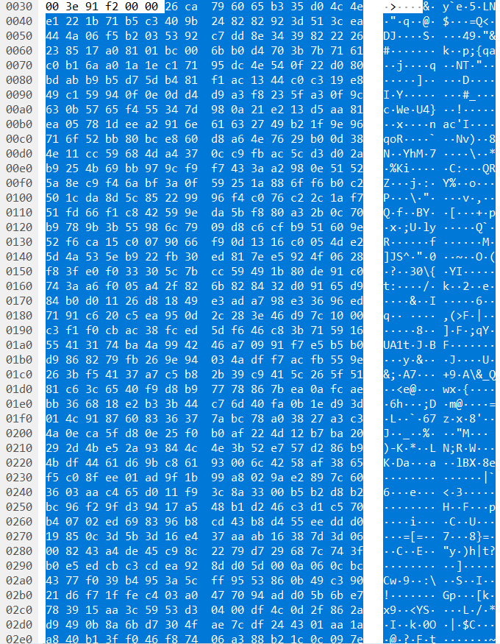

**Different Statistics:**

**Wi-Fi file capture**

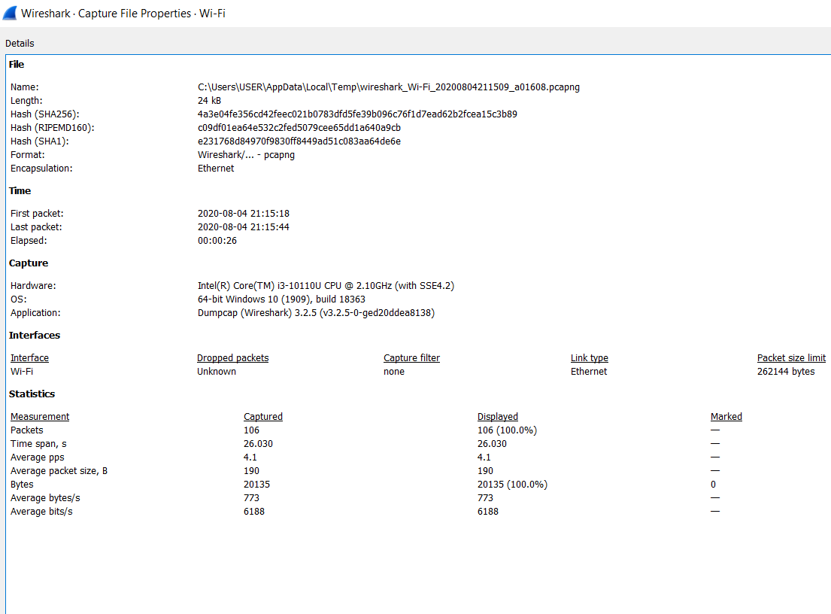

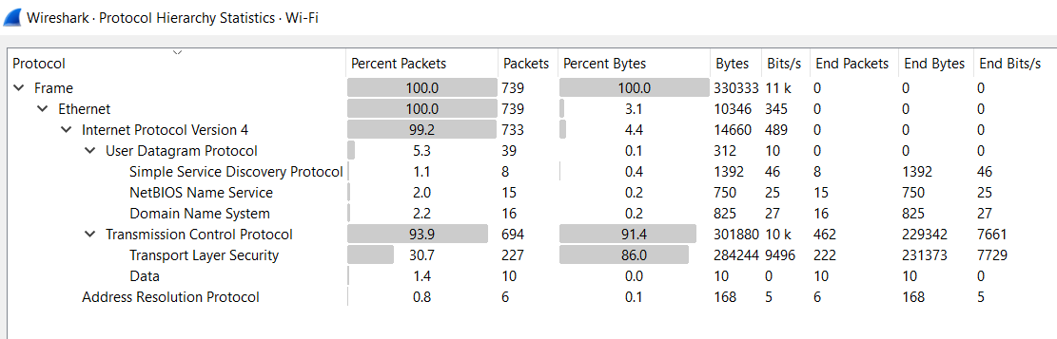

**DNS**

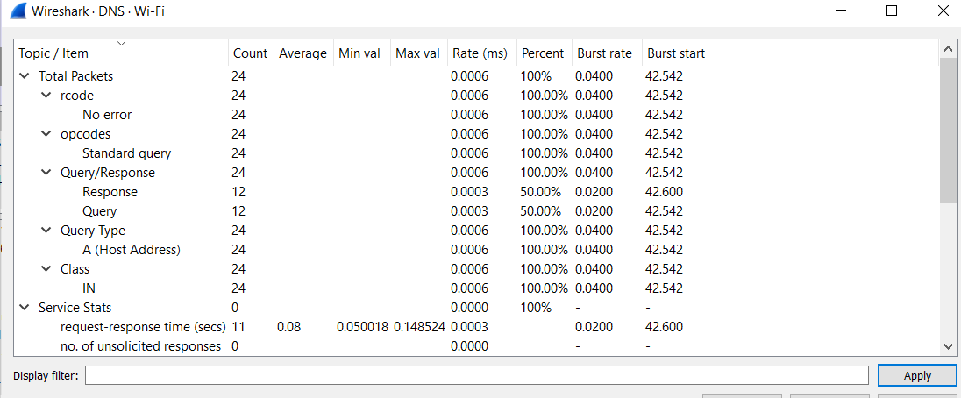

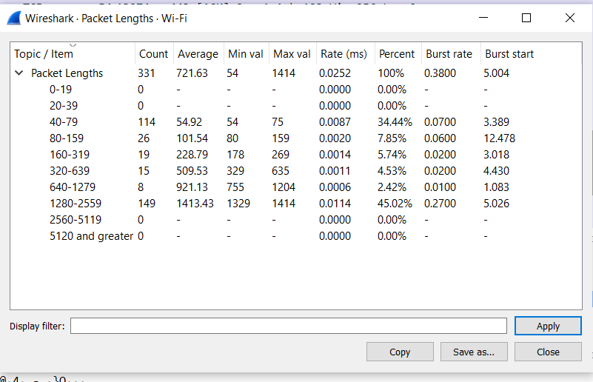

**Protocol have been used:**

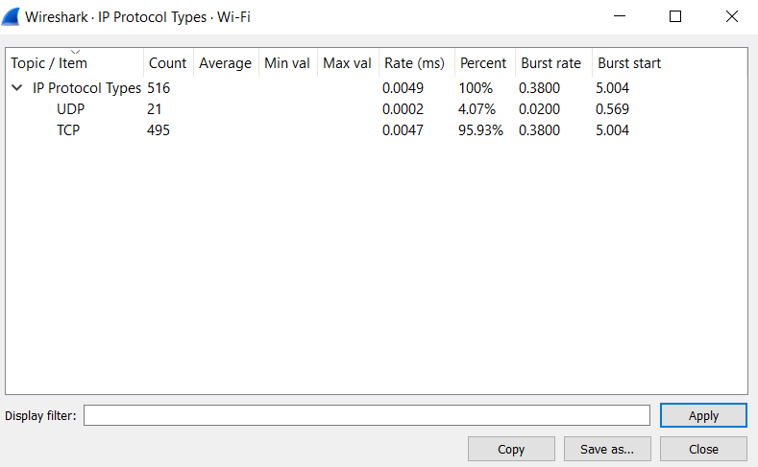

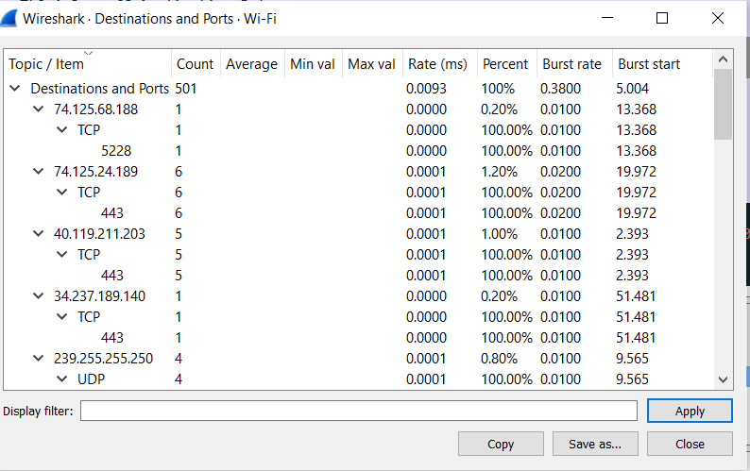

**Error & Success Rates:**

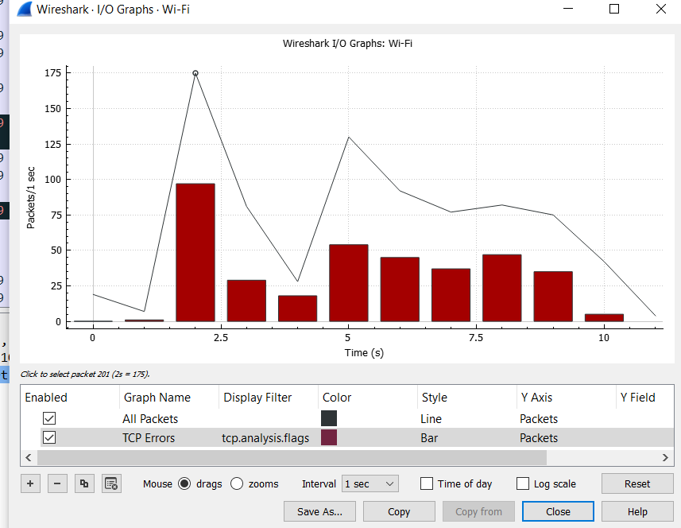

**Real time Response:**

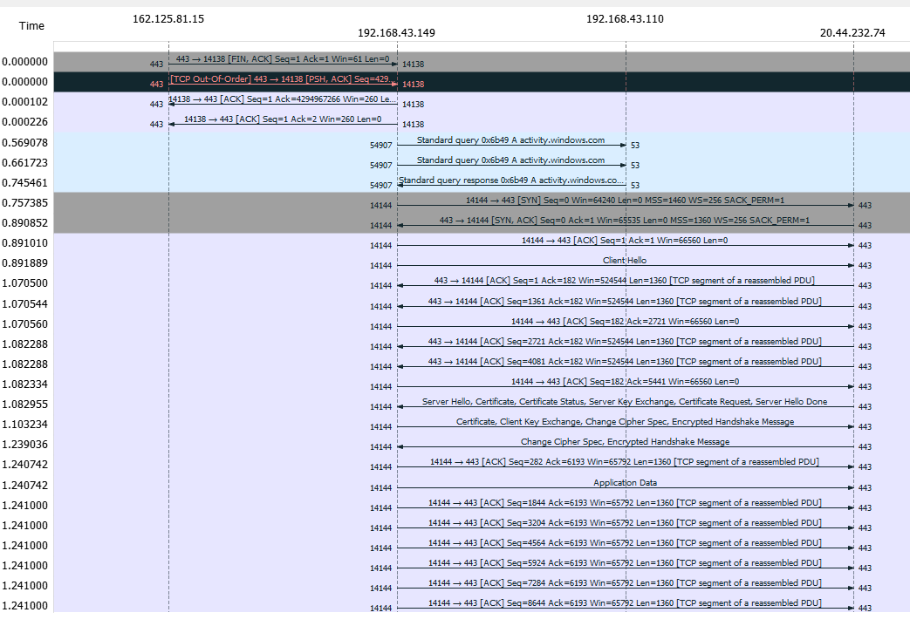

**Conclution:**

In this lab We learned the use of wireshark. We used it to analyse my personal wifi network. From this lab we were able to see some of the underlying function of internet protocol and its realtime use.