Lab Report No: 04

Lab Report on: Introduction to Mininet.
Name : Mohd Rushad Tanjim
ID : IT-15056
Objective: In this lab we will learn about installation process of Mininet in Linux. After completion of installation .Apply some mininet command from Mininet Workthrough.

- Installation process:

$ sudo apt-get install git
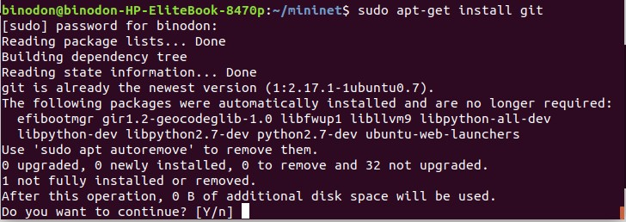

- $ sudo mn
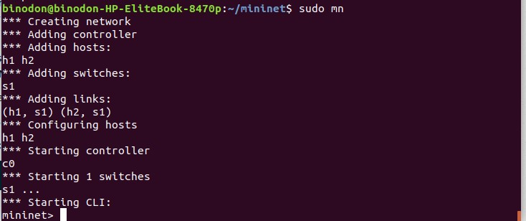

- mininet> help
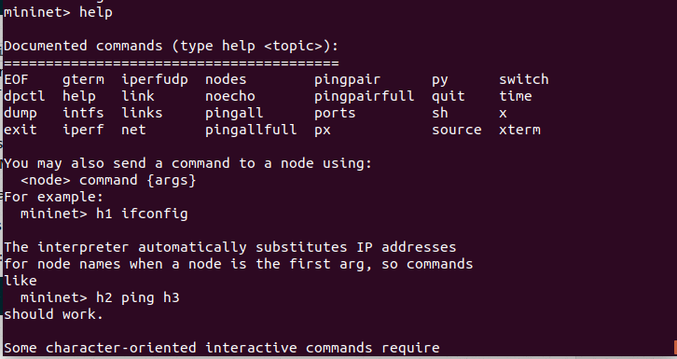

- mininet> nodes

- mininet> net
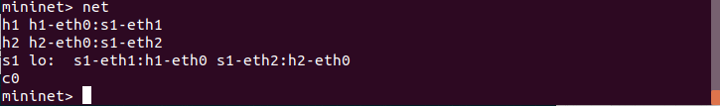

- mininet> net

- mininet> h1 ifconfig -a
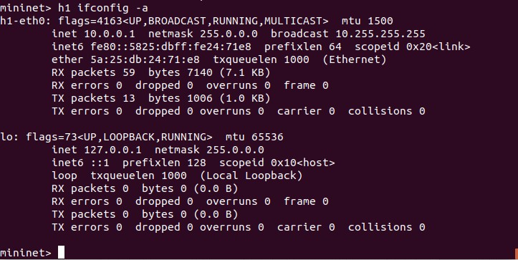

- mininet> s1 ifconfig -a
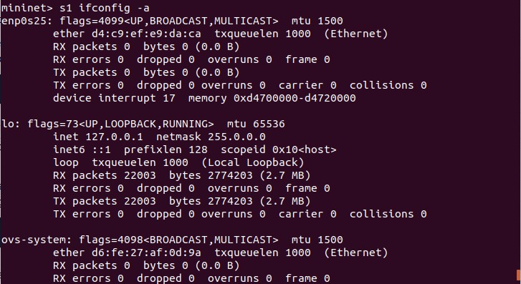

- mininet> h1 ps -a
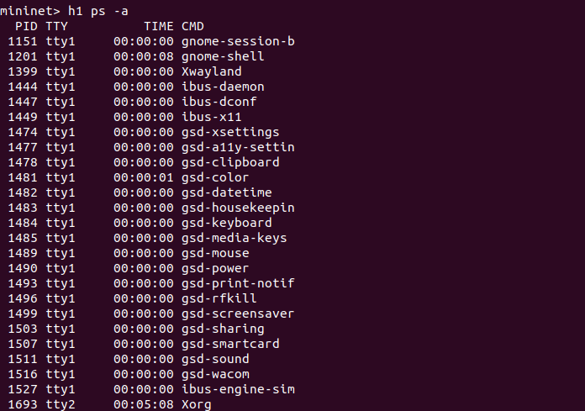

- mininet> s1 ps -a
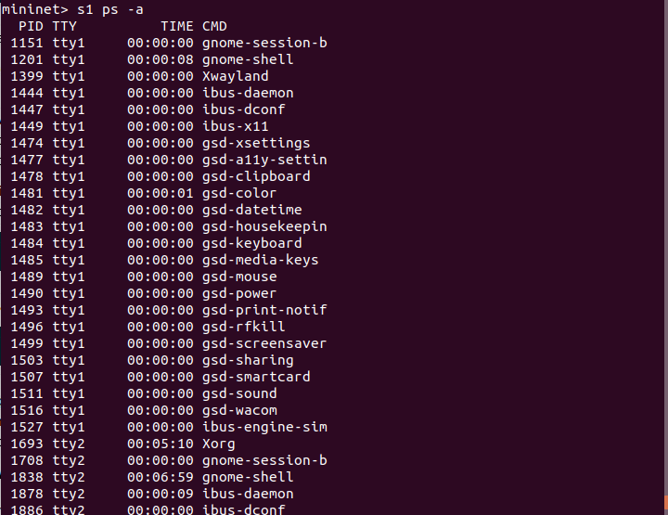

- mininet> h1 ping -c 1 h2
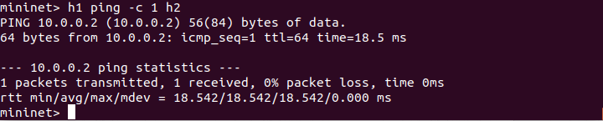

- mininet> pingall
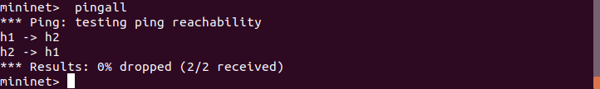

- mininet> h1 python -m SimpleHTTPServer 80 &
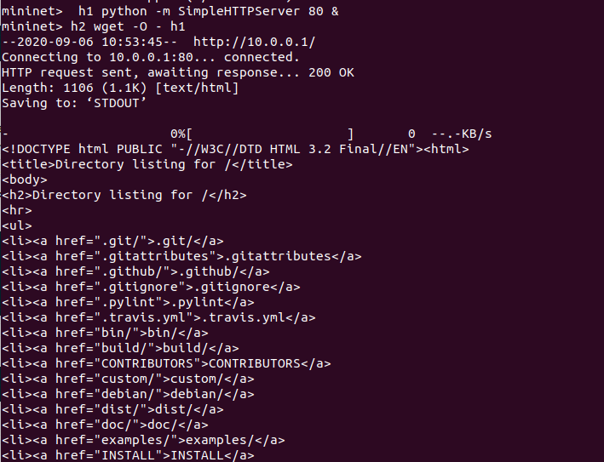
- mininet> h1 kill %python
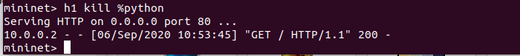

- mininet> exit
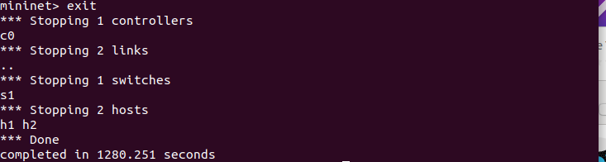

- $ sudo mn -c
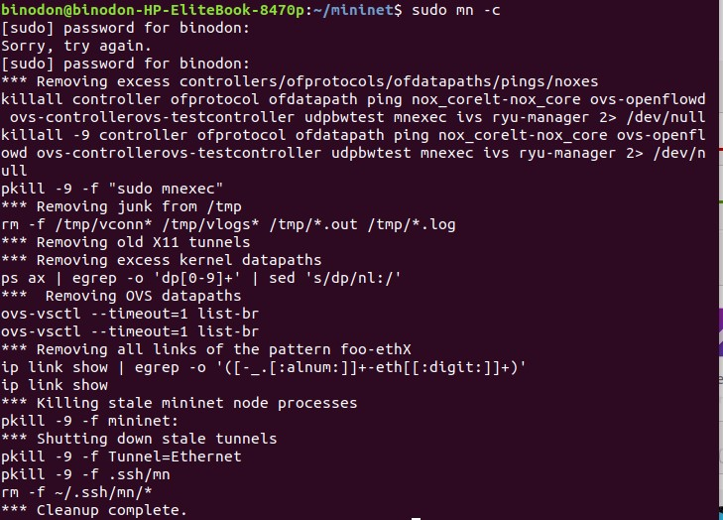
- $ sudo mn --test pingpair

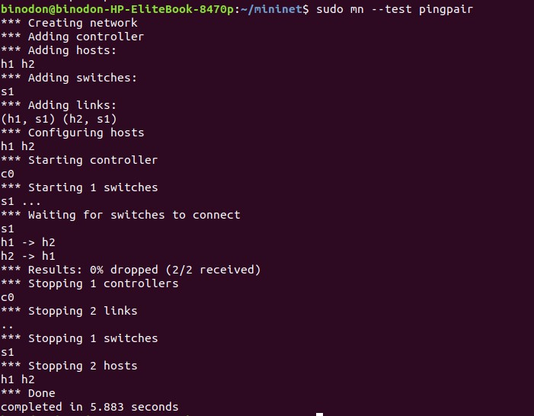

- $ sudo mn --test iperf

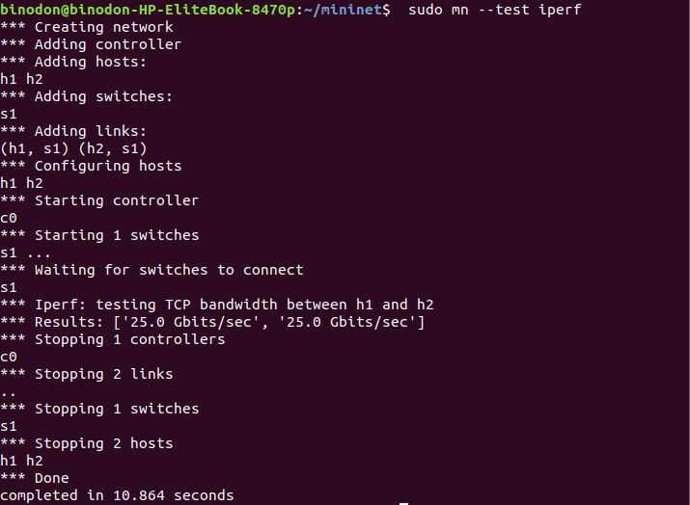
- $ sudo mn --test pingall --topo single,3

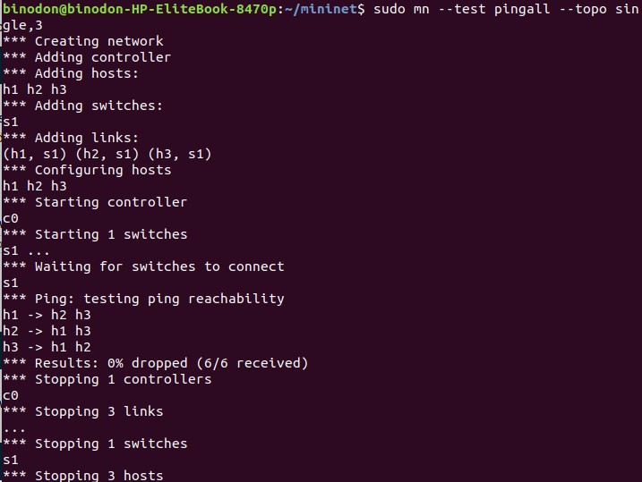

- $ sudo mn --test pingall --topo linear,4
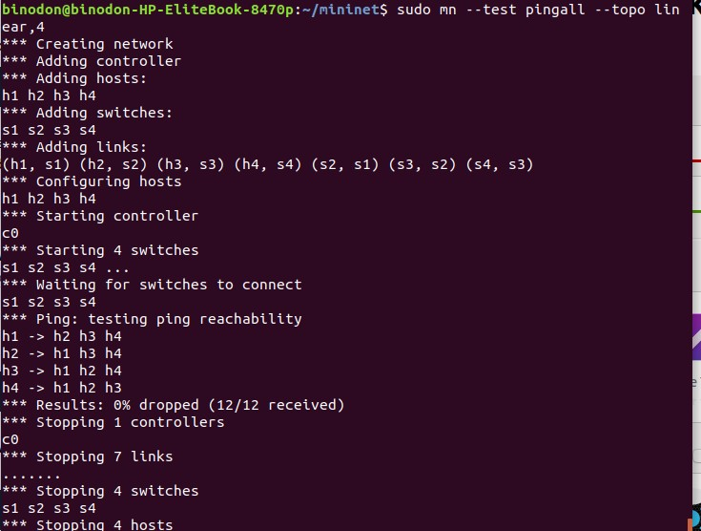
- $ sudo mn --link tc,bw=10,delay=10ms
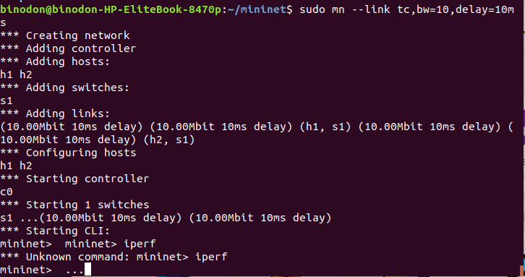
- $ sudo mn -v debug
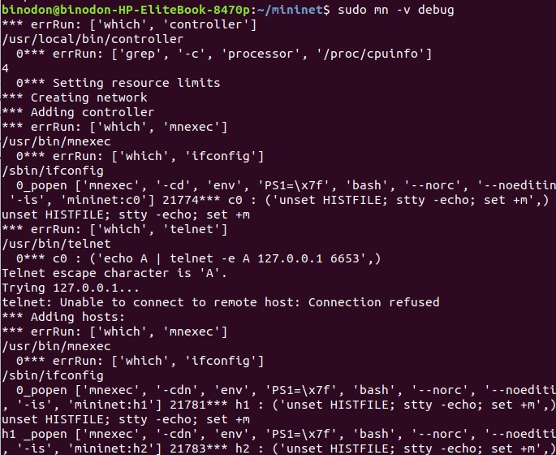
- mininet> exit
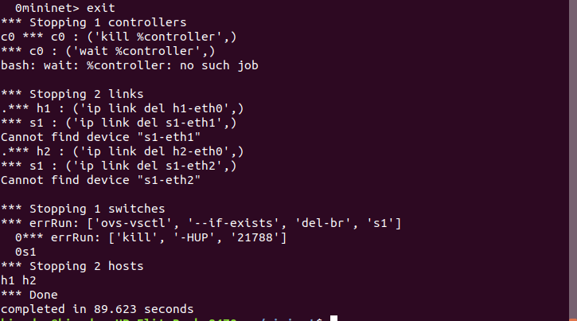

- $sudo mn --custom ~/mininet/custom/topo-2sw-2host.py --topo mytopo --test pingall
