
TRIBHUVAN UNIVERSITY
FACULTY OF HUMANITIES AND SOCIAL SCIENCE

Project Proposal
on
“KeyNest: A Password Manager with Extension”

Submitted to
Department of Computer Application
National College of Computer Studies

In partial fulfilment of the requirements of Bachelor’s Degree of Computer Application

Submitted By:
Ribesh Maharjan
(NCCSBCA101 / 2081)

Under the Supervision of
Dinesh Khadka



Tribhuvan University
Faculty of Humanities and Social Sciences
National College of Computer Studies

Supervisor’s Recommendations

I hereby recommend that this project prepared under my supervision by Ribesh Maharjan entitled “KeyNest: A Password Manager with Extension” in partial fulfillment of the requirements for a degree of Bachelors of Computer Application is recommended for the final evaluation.

______________
SIGNATURE
Dinesh Khadka
SUPERVISOR
Faculty Member
Department of Computer Application
National College of Computer

Tribhuvan University
Faculty of Humanities and Social Sciences
National College of Computer Studies

Letter of Approval

This is to certify that this project prepared by Ribesh Maharjan entitled “KeyNest: A Password Manager with Extension” in partial fulfillment of the requirements for the degree of Bachelors in Computer Application has been evaluated. In our opinion, it is satisfactory in scope and quality as a project for the required degree.

Signature of Supervisor  Dinesh Khadka  Faculty Member  Department of Computer Application  National College of Computer Studies  Paknajol, Kathmandu | Signature of HOD / Coordinator  Rajan Poudel  Faculty Member  Department of Computer Application  National College of Computer Studies  Paknajol, Kathmandu
Signature of Internal Examiner | Signature of External Examiner

Abstract
KeyNest is a secure, efficient, and user-centric web application developed to address the growing need for effective password and privacy management. It allows users to securely store, manage, and retrieve login credentials for various online accounts in one centralized location, eliminating the need to remember multiple usernames and passwords. The system implements strong AES-256 encryption to ensure the confidentiality and integrity of user data, offering features such as adding, editing, and deleting account entries. One of its standout functionalities is an integrated Google Chrome extension that can autofill login forms on behalf of the user, significantly improving ease of use and reducing login time. To further enhance user security, KeyNest includes a built-in password generator that creates strong, complex passwords that adhere to modern security standards. The platform also incorporates user authentication and session handling for added safety, and all data operations are backed by a reliable MySQL database. Designed with simplicity, performance, and security in mind, KeyNest is a practical solution for anyone looking to simplify their digital life while maintaining the password protection.

Keywords: KeyNest, secure, web application, password management, AES encryption.

Acknowledgement

We would like to extend our heartfelt gratitude to our supervisor, Mr. Dinesh Khadka, for his invaluable guidance, continuous monitoring, and unwavering motivation throughout all phases of this project. His expertise, constructive feedback, and insightful suggestions were instrumental in shaping the direction and success of this endeavour. We deeply appreciate his patience, support, and the inspiration he provided, which helped us overcome various challenges and achieve our goals. We also wish to express our sincere appreciation to all other supervisors, professors, and mentors who offered their time, knowledge, and encouragement. Their collective support and advice were crucial in refining our approach and enhancing the quality of our work. Additionally, we are grateful to our friends, peers, and family members for their constant encouragement, moral support, and willingness to assist whenever needed. This project would not have been possible without the collaborative efforts and contributions of everyone involved, and we are truly thankful for their role in making it a success.
Ribesh Maharjan

Table of Content
Abstract iv
Acknowledgement v
List of Abbreviation viii
List of Figures ix
List of Table x
Chapter 1 Introduction 1
1.1 Introduction 1
1.2 Problem Statement 1
1.3 Objective 2
1.4 Scope and Limitation 2
1.4.1 Scope 2
1.4.2 Limitation 2
1.5 Development Methodology 2
1.6 Report Organization 3
1.6.1 Introduction 3
1.6.2 Background Study and Literature Review 3
1.6.3 System Analysis and Design 3
1.6.4 Implementation and Testing 3
1.6.5 Conclusion and Future Recommendations 3
Chapter 2 Background Study and Literature Review 4
2.1 Background Study 4
2.2 Study of Existing Systems 4
2.3 Literature Review 5
Chapter 3 System Analysis and Design 7
3.1 System Analysis 7
3.1.1 Requirement Analysis 7
3.1.2 Feasibility Study 8
3.1.3 Data Modelling: Entity Relation Diagram 9
3.1.4 Data Modelling: Data Flow Diagram 10
3.2 System Design 11
3.2.1 Architecture Design 11
3.2.2 Database Schema Design 12
3.2.3 Interface Diagram 13
3.2.4 Physical DFD 14
3.2.5 Algorithm Details 14
Chapter 4 Implementation and Testing 16
4.1 Implementation 16
4.1.1 Tools used 16
4.1.2 Implementation details of modules 17
4.2 Testing 23
4.2.1 Test Cases for Unit Testing 23
4.2.2 Test Cases for System Testing 29
Chapter 5 Conclusion and Future Recommendations 31
5.1 Lesson Learnt / Outcome 31
5.2 Conclusion 31
5.3 Future Recommendations 31

List of Abbreviation
ID | Identification
MySQL | My Structured Query Language
SDLC | System Development Life Cycle
SQL | Structured Query Language
UI | User Interface

List of Figures
Figure 1.1: Waterfall Model 3
Figure 3.1: Use Case Diagram of KeyNest 7
Figure 3.2: Entity Relation Diagram of KeyNest 9
Figure 3.3: DFD Level 0 of KeyNest 10
Figure 3.4: DFD Level 1 of KeyNest 10
Figure 3.5: Three Tier Architecture 11
Figure 3.6: Database Schema of KeyNest 12
Figure 3.7: Interface Diagram of KeyNest 13
Figure 3.8: Physical DFD of KeyNest 14

List of Table
Table 4.1: Unit Testing of the Registration in KeyNest 23
Table 4.2: Unit Testing of the Login in KeyNest 24
Table 4.3: Unit Testing of the Credential Addition Feature in KeyNest 25
Table 4.4: Unit Testing of the Credential Deletion Feature in KeyNest 26
Table 4.5: Unit Testing of the Password Generator in KeyNest 27
Table 4.6: Unit Testing of the Logout Feature in KeyNest 28
Table 4.7: System Testing of the KeyNest 29

Introduction

Introduction
The popularity of online services and social media platforms has led to an increasing number of login forms, each requiring a unique username and password. As individuals sign up for more than 20 sites, keeping track of passwords can become overwhelming. This has created a need for a reliable and secure online password manager. KeyNest is an online password manager that offers a solution to these problems. The name KeyNest is derived from two words: "Key," this directly relates to passwords and access, and "Nest," a nest is a safe and secure place, often associated with protection and storage. KeyNest provides a safe and secure place to store passwords and credentials, along with chrome extension that autofill password for the user. This project proposal outlines the development of KeyNest, including its objectives, methodology, proposed work, expected outcomes, and working schedule.

Problem Statement
A survey conducted in 2020 concluded the average user has around 100 passwords. People subconsciously click on sign up with single sign-on options such as through Facebook, AppleID, or Google accounts that offer a lot of convenience. But what if those websites are hacked? Your Google or Facebook account will eventually be hacked, and you'll lose access to the website. Therefore, using a separate, traditional password management system is preferred by users. The main problem people face is that they must remember their login credentials, which results in them getting lazy and clicking to sign up with some login provider such as Google. Most individuals find it difficult to remember secure passwords; therefore, they generally choose to use simple ones instead. Choosing a safe password has become a major issue for the general public due to the rise in assaults employing password dictionaries and brute force to quickly access a user's personal account. The chance of a cross-platform data leak increases if the user uses the same password across multiple platforms. To avoid all of these, you need a secure and practical password manager with tools like data breach checking, secure password generation, and an encrypted password database.

Objective
The main objective of KeyNest is:
- To provide a secure, easy-to-use, online password database for managing the passwords for various platforms.
- To implement AES encryption for securely storing passwords.

Scope and Limitation

Scope
The study aims to develop and implement a web-based platform for securely storing passwords while minimizing system complexity and problems. The system is intended for every type of user who can save their passwords. To ensure the security of sensitive information, the system will feature AES encryption. The system is suitable for easy maintenance and locked-down environments like the management of a user's password in a business organization and its monitoring by an individual business admin for its self-hosted password database.

Limitation
The main drawback of the system is that the main site is only accessible in the presence of an internet connection. However, users with enough technical knowledge can host their own instance of the system using the source code from the project’s GitHub repository. Note that the self-hosted version can be accessed locally without an internet connection.

Development Methodology
The Waterfall Model was used as the software development methodology for this project, ensuring a structured and sequential approach to development. Following the Waterfall Model allowed for a well-structured, secure, and efficient development process. Each phase was completed before moving on to the next, reducing the risk of errors and ensuring a well-documented process.
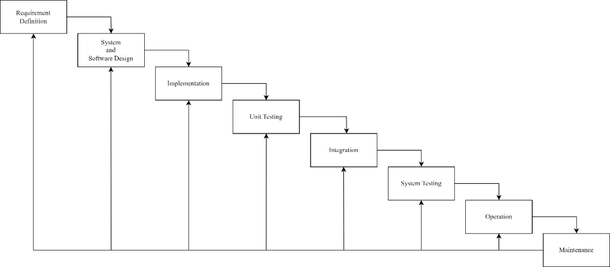
Figure 1.1: Waterfall Model

Report Organization

Introduction
This chapter provides an overview of the project, including the problem it aims to solve, the project objectives, scope and limitations, and development methodology of the project.

Background Study and Literature Review
This chapter focuses on study of existing systems and review of different articles studied.
It also explores the underlying concepts and principles that informed the development of the system.

System Analysis and Design
This chapter covers the project's requirements analysis, feasibility assessment, and design. System Models as Data Model, Process Model and Flowcharts, functionality analysis and System Designs as Architecture Design, Database Schema Design, Interface Design and Physical DFD are all included.

Implementation and Testing
This chapter provides details on the project's implementation, the software and tools used, and the types of testing conducted.

Conclusion and Future Recommendations
This chapter discusses the project's potential outcomes and summarizes the main findings. It also provides recommendations for future work

Background Study and Literature Review

Background Study
A password manager [1] is a software application designed to help users store and manage their login credentials securely. It keeps all usernames and passwords in one place, usually protected by a single master password. Password managers can also generate strong and unique passwords, reducing the risk of weak or reused passwords and helping users maintain better online security.
Cryptography is the practice of securing information by converting it into a format that cannot be easily understood by unauthorized individuals. It plays a vital role in protecting sensitive data, such as passwords, by making sure that only the intended recipients can access the original information. Cryptography can be either symmetric (using one key for both encryption and decryption) or asymmetric (using a pair of keys).
AES encryption [2] (Advanced Encryption Standard) is a widely used symmetric encryption algorithm known for its high level of security and efficiency. It transforms readable data (plaintext) into unreadable data (ciphertext) using a specific key, and only someone with the correct key can decrypt the information back to its original form. AES is commonly used in secure applications and systems around the world to protect sensitive data.

Study of Existing Systems
The community-maintained and open-source projects, KeePassXC (Windows and Linux) and KeePassDX (Android), two forks of KeePass password manager, provided offline password management on file-based databases with various encryption algorithms. Because the two are prioritized as offline password managers, they lack portability and remote access to the password database. In the study of online password managers, Mozilla Firefox’s built-in password manager [3] and Google’s online password manager [4] were used. They provided basic password management within a browser. But they are mostly integrated with the browser and cannot be accessed easily from other browsers outside the Firefox- or Chrome-based browsers. Both offline and online password managers provided similar user interfaces and functionalities. Alongside those studies, the online services "Have I Been Pwned?" and "Firefox Monitor" were used to determine if one's personal credentials had been compromised by data breaches or not.

Literature Review
We'll review some relevant literature on password management systems in this section, such as encryption algorithms like AES to secure data.
Password management solutions have become an essential part of our online lives as the number of online accounts we create and manage grows. There are numerous password management programs available, ranging from locally installed offline ones to cloud-based ones that sync login information across multiple devices.
A study by Adams and Sasse found that people tend to create weak and easily guessable passwords when they are required to create passwords frequently [5]. This highlights the importance of password managers that generate strong and unique passwords for each account. Users frequently hesitate to adopt new security technologies because they believe them to be cumbersome or challenging to use. So, password managers should be user-friendly and simpler.
There are password managers like Dashlane and LastPass that exist in the cloud-based space, while KeePass and 1Password are standalone managers. Although users tend to have more confidence in cloud-based password managers when their security measures and data management techniques are transparent. The 2015 LastPass breach, which exposed user email addresses, password reminders, and encrypted master passwords, is only one example of the numerous security issues that cloud-based password managers have faced [6].
To ensure that password managers can provide a safe and convenient password management solution, encryption algorithms like AES are often used to secure the data. AES is a symmetric encryption algorithm that is widely used in password managers due to its speed and security. It uses a substitution-permutation network that involves multiple rounds of operations to encrypt and decrypt data. The number of rounds is determined by the key length, with 10 rounds for 128-bit keys, 12 rounds for 192-bit keys, and 14 rounds for 256-bit keys. While AES encryption and decryption are closely related, the algorithms must be implemented separately to ensure the data's security [7].
Another consideration is the password manager's portability. Because the password database must be manually transferred between devices, offline password managers such as KeePass have limited portability. On the flip side, password managers that rely on cloud technology enable users to reach their login information from any device that can access the internet. This does come with apprehensions about security and privacy.
Password managers have become into an essential tool for people as maintaining several online accounts has become more and more crucial. But when picking a password manager, it's important to pay close attention to aspects like security, usability, and adaptability. The suggested password manager would offer a safe and convenient password management solution to allay these worries.

System Analysis and Design

System Analysis

Requirement Analysis
Requirements will be collected through personal evaluation of different existing systems, along with suggestions from mentors, and supervisors.

Functional Requirements
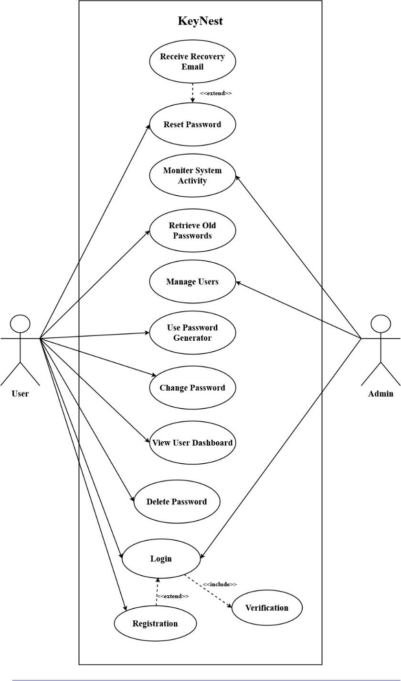
Figure 3.1: Use Case Diagram of KeyNest

The use case diagram in previous page specifies the basic operations a user can perform in the proposed system
- A new account creation feature with a master username and password is required.
- With their username and password, users must be able to access their accounts.
- Users with wrong username will neither be validated nor allowed to login.
- Users with correct credentials must be able to perform CRUD (Creation, Retrieve, Update and Delete) operation on the entries on their password database.
- The site should be able to run with most of the modern web browsers.
- The database should have AES encryption enabled by default.
- Change in a password entry must reflect in version history.
- Each entry should be given a date and time of creation.
- The site should include password generator.
- Users should be able to reset their password if they forget it.

Non-Functional Requirements
- The website should be able to handle multiple concurrent users with different credentials.
- Users would be able to add site as categories for managing their password.
- Users will have enough storage to save at least 50 password entries.
- There should be site field, username field, notes field and password field.
- Once the user has logged out, they should be brought back to the login page.
- There should be a user dashboard which allows changing of master password.
- Database exporting should be implemented.

Feasibility Study
The system is evaluated for future development with a set of constraints. The feasibility study is done regarding the available technologies, time constraints, area of application, cost of deployment and upkeep, and future possibilities of the project.

Technical Feasibility
The system meets the criteria for technical feasibility, as it will be developed with existing technologies as frontend languages: HTML, CSS, and JavaScript, and the traditional web application stack: Apache Web Server, MySQL database, and PHP scripts running on a local computer. Since the project is web-based, users can easily access it through a web browser in the presence of the internet or a connection to the server from any hardware platform. Development of the project will be done in free software and on free platforms such as Visual Studio Code, GitHub, and Mozilla Firefox and Chromium-based browsers.

Operational Feasibility
The user interface will be similar to the existing password manager with minor tweaks, so users will adapt to the system with ease. The interface will be responsible across all platforms as well as follow basic design principles.

Economic Feasibility
Most of the software used for developing this project will be open source and free. Along with it, suitable cloud hosting will be used. Most of the technology will be free.

Data Modelling: Entity Relation Diagram
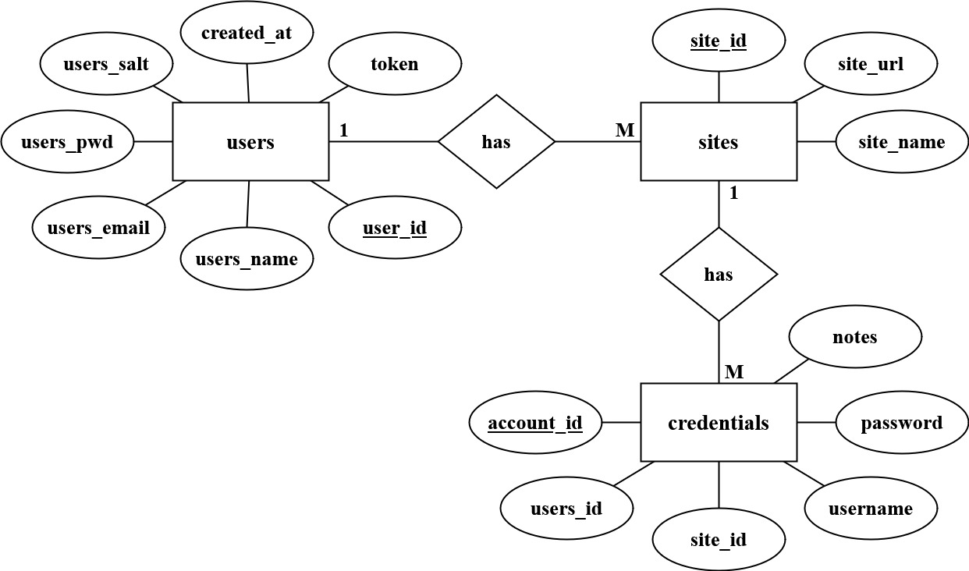
Figure 3.2: Entity Relation Diagram of KeyNest
The above table represents the following relation:
- One-to-many relationship between “Users” and “Credentials” entity where one user can have multiple social accounts.
- One-to-many relationship between “Users” and “Sites” entity where one user can have multiple login sessions.
- One-to-one relationship between “Credentials” and “Sites” entity where each credential can have only one sites.

Data Modelling: Data Flow Diagram
- DFD Level 0
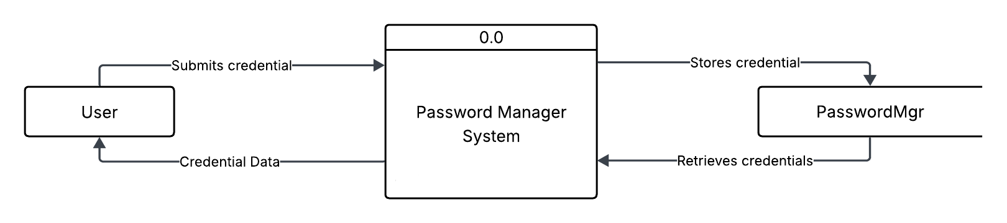
Figure 3.3: DFD Level 0 of KeyNest
- DFD Level 1
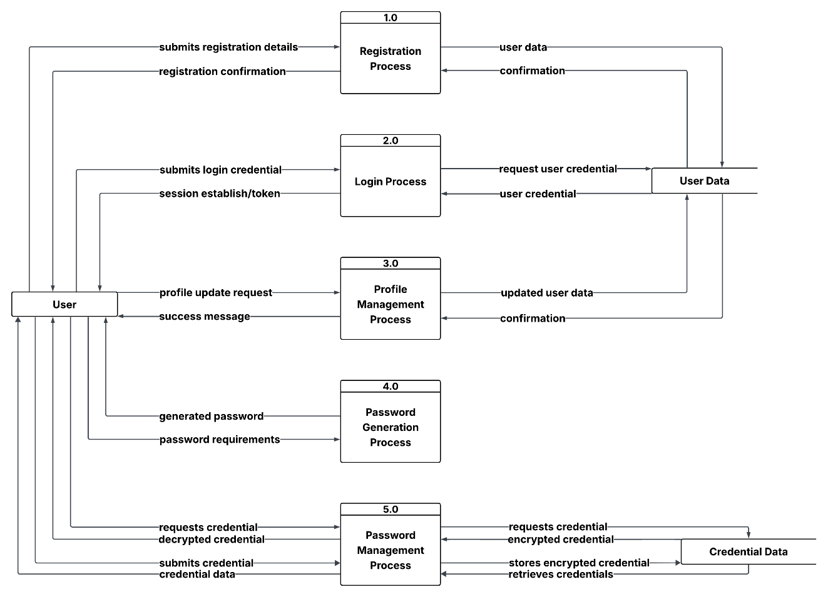
Figure 3.4: DFD Level 1 of KeyNest
The data flow in the "KeyNest" system includes registering and logging in, with their account details stored in a MySQL database. Users can view, edit, and delete their account details, view their account history, as well as mark certain accounts as favourites. Administrators can view a list of all users and remove them if necessary.

System Design

Architecture Design
The three-tier architecture has been used for this project. This architecture is a client- server architecture in which the functional process logic, data access, computer data storage and user interface are developed and maintained as independent modules on separate platforms.
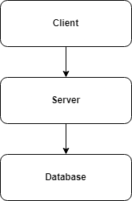
Figure 3.5: Three Tier Architecture
Three-Tier Architecture has the following layers.
- Client Layer: Occupies the top level and includes the user interface that allows users to interact with the application. This layer communicates with the other tiers by sending and receiving requests and responses.
- Server Layer: Also called the application layer or the logic tier, this layer is responsible for processing user requests and generating responses. It handles the application's functionality and communicates with the database layer to retrieve or update data. In KeyNest, this layer is handled by Apache Server running on a local machine.
- Database Layer: The bottom layer houses the database server where data is stored and retrieved. The data is kept independent of application servers or the business logic. In KeyNest, we use localhost’s MySQL database as the data store.
Following are the reasons behind choosing three tier-architecture:
- An ability to update the technology stack of one tier, without impacting other areas of the application as it creates a physical and logical separation.

Database Schema Design

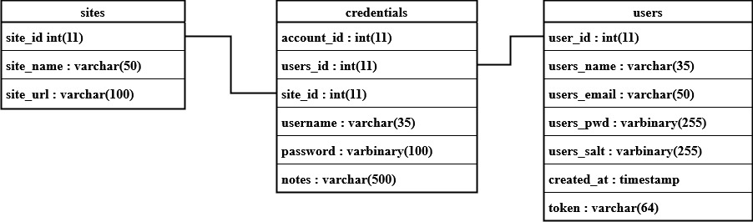
Figure 3.6: Database Schema of KeyNest
The database schema design for KeyNest includes the following tables:
- users: This table stores user information, including the `user_id`, `users_name`, `users_email`, `users_pwd`, ` users_salt` and `created_at` timestamp. The `users_name` and `users_email` fields have unique constraints.
- sites: This table store the information about sites, including the `site_id`, `site_name`, and `site_url`.
- credentials: This table stores users credential associated with each site. It includes the `account_id`, `users_id`, `site_id`, `username`, `password`, and `notes`. The `users_id` field is a foreign key referencing the `users` table.

Interface Diagram
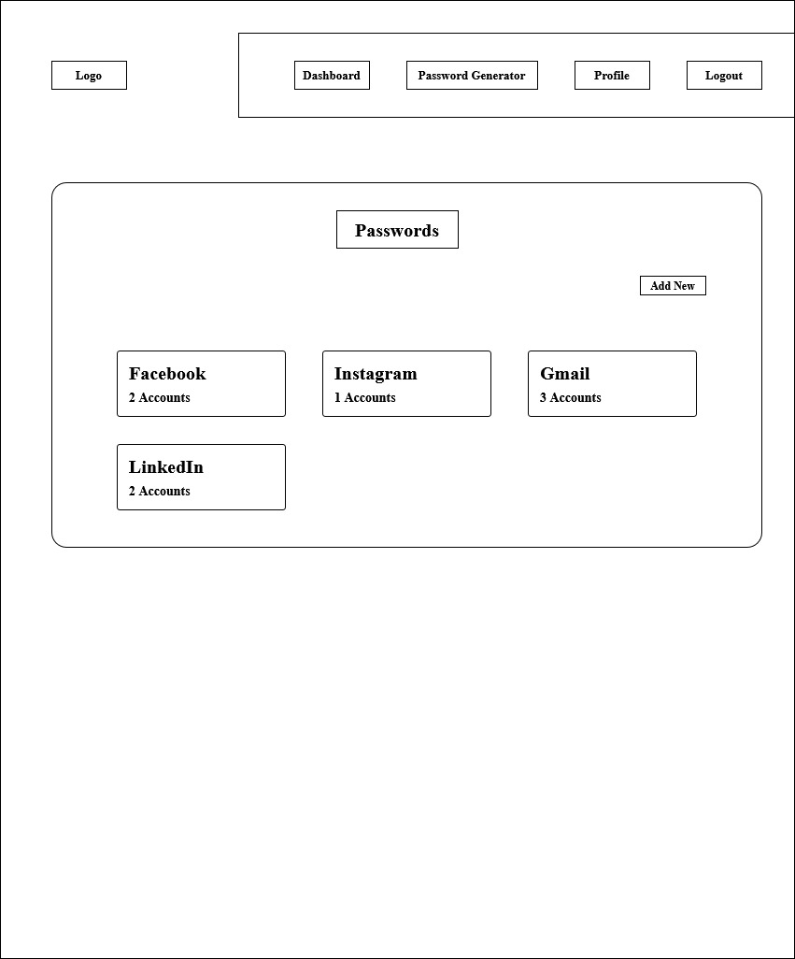
Figure 3.7: Interface Diagram of KeyNest
The interface structure design defines the basic components of the interface and how they work together to provide functionality to users. An interface structure diagram (ISD) is used to show how all the screens, forms, and reports used by the system are related and how the user moves from one to another.

Physical DFD
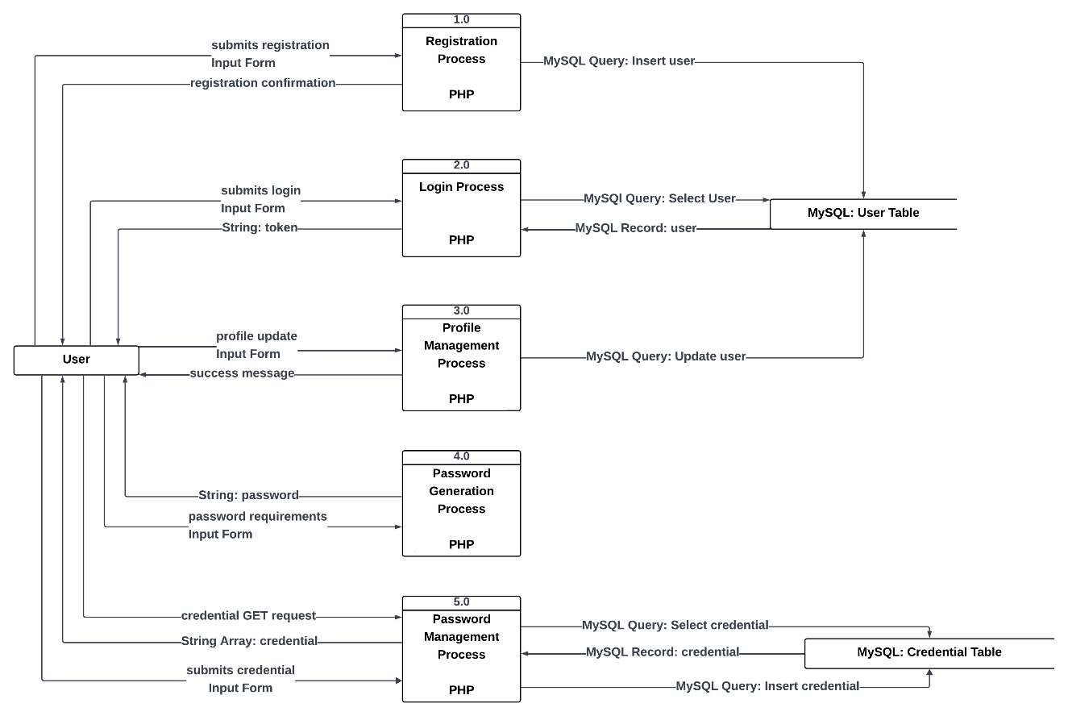
Figure 3.8: Physical DFD of KeyNest
The above figure is a Physical DFD that visualizes user’s activity, and the flow of the data between the user, and MySQL database. The user performs activities as logging in, viewing, adding, marking favourite, updating, checking history, and deleting account details.

Algorithm Details
AES (Advanced Encryption Standard) is a commonly used symmetric encryption algorithm that is considered to be highly secure. It was introduced in 2001 and has since been widely adopted as the standard encryption algorithm for various applications.
To encrypt plaintext, the AES algorithm performs a series of mathematical operations that transform it into ciphertext. The algorithm operates on plaintext blocks that are 128 bits in length and uses keys that are either 128, 192, or 256 bits long [8].
The AES algorithm comprises the following steps:
- Key Expansion: The key is expanded to create a key schedule that is used during the encryption and decryption process.
- Initial Round: The first round of AES involves adding the key to the plaintext using a bitwise XOR operation.
- Rounds: The number of rounds in AES depends on the key length. For a 128-bit key, there are 10 rounds, for a 192-bit key, there are 12 rounds, and for a 256-bit key, there are 14 rounds. Each round consists of four operations: SubBytes, ShiftRows, MixColumns, and AddRoundKey.
- SubBytes: The SubBytes operation replaces each byte of the state with a corresponding byte from a fixed substitution table called the S-box.
- ShiftRows: The ShiftRows operation shifts the rows of the state to the left by a certain number of bytes, with the first row unchanged, the second row shifted one byte to the left, the third row shifted two bytes to the left, and the fourth row shifted three bytes to the left.
- MixColumns: The MixColumns operation applies a matrix multiplication to the columns of the state to mix the data.
- AddRoundKey: The AddRoundKey operation XORs each byte of the state with a corresponding byte from the key schedule.
- Final Round: The final round of AES is similar to the rounds described above, but it omits the MixColumns operation.
- Output: The output of AES is the final state of the data after the final round of encryption or decryption.
In summary, the AES algorithm involves key expansion, an initial round, several rounds of four operations, a final round, and output. By using this process, AES provides strong encryption and is widely used for securing data in various applications [2].

Implementation and Testing

Implementation

Tools used
This project utilized various tools, including CASE tools, programming languages, and database platforms, to develop and implement the system.
For the development of the system, we used Microsoft Visual Studio Code as our CASE tool. It provided a source code editor for developing, debugging, and testing the system. We also used Git as a version control tool to manage the source code and track changes made to it.
We used PHP as the primary programming language to develop the system. It allowed us to create efficient and reliable code that was easy to maintain and modify. We also used HTML, CSS, and JavaScript alongside PHP to develop the web interface of the system.
For the database management system, we used MySQL Server. It provided us with a robust, scalable, and secure platform to store and manage data for the system. We designed the database schema using Entity Relationship Diagrams (ERDs) and implemented it using SQL scripts. We also used diagram tools as Diagram.net, and Figma for design.
Overall, these tools played a significant role in the development and implementation of the system. They enabled us to create a reliable, efficient, and user-friendly system that met the project requirements.

Implementation details of modules
In this section, we provide a detailed description of the procedures, functions, classes, and methods used in the implementation of the system modules.
Module 1: Encryption and Decryption
This module provides the core logic for AES (Advanced Encryption Standard) encryption and decryption in PHP. It transforms plaintext into ciphertext (encryption) and then back into readable text (decryption) using a symmetric key.
Encryption
public function encrypt($input, $key)
{
$this->w = $this->keyExpansion($key);
$state = array_chunk($input, 4);

$this->addRoundKey($state, 0);

for ($round = 1; $round < $this->Nr; $round++) {
$this->subBytes($state);
$this->shiftRows($state);
$this->mixColumns($state);
$this->addRoundKey($state, $round);
}

$this->subBytes($state);
$this->shiftRows($state);
$this->addRoundKey($state, $this->Nr);

$output = [];
foreach ($state as $row) {
$output = array_merge($output, $row);
}

return $output;
}
Decryption
public function decrypt($input, $key)
{
$this->w = $this->keyExpansion($key);
$state = array_chunk($input, 4);

$this->addRoundKey($state, $this->Nr);

for ($round = $this->Nr - 1; $round > 0; $round--) {
$this->invShiftRows($state);
$this->invSubBytes($state);
$this->addRoundKey($state, $round);
$this->invMixColumns($state);
}
$this->invShiftRows($state);
$this->invSubBytes($state);
$this->addRoundKey($state, 0);

$output = [];
foreach ($state as $row) {
$output = array_merge($output, $row);
}
$decrypted_str = rtrim(implode('', array_map('chr', $output)), "\0");
return $decrypted_str;
}
Module 2: Login and Register
This module handles user login in a secure way by checking if the provided username/email and password match the records in the database. It uses AES encryption for storing and verifying passwords.
When logging in the code below checks if the username is present or not.
<?php

if ($stmt->rowCount() > 0) {
$salt = $stmt->fetch(PDO::FETCH_ASSOC)["users_salt"];
$pwd = $stmt->fetch(PDO::FETCH_ASSOC)["users_pwd"];
decipher = $aes->decrypt($pwd, $salt);
$checkPwd = ($pwd == $decipher) ? true : false;

if($checkPwd) {
$stmt = $dbh->prepare('SELECT * FROM users WHERE (users_name = ? OR users_email = ?) AND users_pwd = AES_ENCRYPT(?,?);');
$stmt->execute(array($uname, $uname, $pwd, $salt));
$user = $stmt->fetch(PDO::FETCH_ASSOC);

$_SESSION['auth'] = true;
$_SESSION["userid"] = $user["user_id"];
$_SESSION["username"] = $user["users_name"];
$_SESSION["password"] = $user["users_salt"];
} else {
echo '<div class="alert alert-danger" role="alert" style="background-color: #2b5fb31f;">Wrong password.<br>Please try again.</div>';
}
} else {
echo '<div class="alert alert-danger" role="alert" style="background-color: #2b5fb31f;">User does not exits.<br>Please try again.</div>';
}
?>

When registering into the system, the code below sets new username account to the database along with the checks for any errors.
<?php
if ($_SERVER["REQUEST_METHOD"] == "POST") {
$uname = $_POST['uname'];
$email = $_POST['email'];
$pwd = $_POST['pwd'];
$pwdRepeat = $_POST['pwdRepeat'];

if (!empty($uname) && !empty($email) && !empty($pwd) &&! empty($pwdRepeat)) {
$stmt = $dbh->prepare('SELECT users_email FROM users WHERE users_name = ? OR users_email = ?;');
$stmt->execute(array($uname, $email));

if ($stmt->rowCount() == 0) {
$stmt = $dbh->prepare('INSERT INTO users (users_name, users_email, users_pwd, users_salt) VALUES (?,?,?,?);');
$key = $aes->generateSalt($pwd);
$cipher = $aes->encrypt($pwd, $key);
$stmt->execute(array($uname, $email, $cipher, $key));

echo "<meta http-equiv='refresh' content='0;url=login.php'>";
exit();
} else {
echo '<div class="alert alert-danger" role="alert" style="background-color: #2b5fb31f;">User already exist</div>';
}
} else {
echo '<div class="alert alert-danger" role="alert" style="background-color: #2b5fb31f;">Please fill all fields.</div>';
}
}
?>

Module 3: Select, Delete and Update
This module allows users to view, update, and delete their saved account details. It fetches credentials linked to a site, removes entries by account ID, and updates usernames, encrypted passwords, and notes. All actions use the user's session for security.
For Select
$salt = $_SESSION["password"];
$stmt = $dbh->prepare("SELECT credentials.account_id, credentials.username, credentials.password, credentials.notes, sites.site_name, sites.site_url FROM credentials INNER JOIN sites ON credentials.site_id = sites.site_id WHERE credentials.users_id = ? AND sites.site_id=?;");
$stmt->execute(array($_SESSION["userid"], $site_id));
$data = $stmt->fetchAll(PDO::FETCH_ASSOC);

For Delete
if ($_SERVER["REQUEST_METHOD"] == "POST") {
// Grabbing the data
$id = $_POST["id"];
$user_id = $_SESSION["userid"];

try {
$dbh->beginTransaction();
$stmt = $dbh->prepare("DELETE FROM credentials WHERE account_id = ?;");
$stmt->execute(array($id));
$dbh->commit();
} catch (PDOException $e) {
$dbh->rollBack();
echo "Error: " . $e->getMessage();
}
}

For Update
if ($_SERVER["REQUEST_METHOD"] == "POST") {
$user_id = $_SESSION["userid"];
$id = $_POST["id"];
$username = $_POST["username"];
$password = $_POST["password"];
$notes = $_POST["notes"];

$stmt = $dbh->prepare("UPDATE credentials SET notes = ?, username = ?, password = AES_ENCRYPT(?,?) WHERE account_id = ?;");
$stmt->execute(array($notes, $username, $password, $_SESSION["password"], $id));

header("location: ../single.php?site_id=");

}

Module 5: Connection Establishment
This module is responsible for establishing a secure and reusable connection between the web application and the MySQL database named passwordmgr.
$dbParams = array(
'host' => 'localhost',
'username' => 'root',
'password' => '',
'dbname' => 'passwordmgr'
);

try {
$dbh = new PDO("mysql:host=" . $dbParams['host'] . ";dbname=" . $dbParams['dbname'] . "", $dbParams['username'], $dbParams['password']);
} catch (PDOException $e) {
echo "An unknown error occurred: " . $e->getMessage();
}

Testing

Test Cases for Unit Testing
Project Name: KeyNest
- Unit Testing of the Registration in KeyNest
Test Case ID: 1
Test Title: Verify registration with valid username and password
Test Designed Date: 10 Apr, 2025
Test Summary: Conduct unit testing for the registration process within KeyNest to ensure its functionality.

Pre-conditions: User is on the registration page of the KeyNest.

Table 4.1: Unit Testing of the Registration in KeyNest
Test Steps | Test Data | Expected  Result | Actual  Result | Status  (Pass/Fail)
1. Navigate to register page  2. Fill the registration form  3. Click on the Register button | Username:  johndoe  Email:  john@gmail.com  Password: Password#123  Re-password:  Password#123 | User should be redirected to login page | User should be redirected to login page | Pass
1. Navigate to register page  2. Click on the Register button | Username:  Email:  Password:  Re-password: | Displays dialog “Please fill all the missing field” | Displays dialog “Please fill all the missing field” | Pass

Post-condition:
User should be redirected to login page

- Unit Testing of the Login in KeyNest
Test Case ID: 2
Test Title: Verify login with valid username and password
Test Designed Date: 10 Apr, 2025
Test Summary: Conduct unit testing for the login process within KeyNest to ensure its functionality.

Pre-conditions: User is on the login page of the KeyNest and has already registered with a valid username and password.

Table 4.2: Unit Testing of the Login in KeyNest
Test Steps | Test Data | Expected  Result | Actual  Result | Status  (Pass/Fail)
1. Navigate to login page  2. Fill the login form  3. Click on the Login button | Username:  johndoe  Password: Password#123 | User should be able to login | User is navigated to the dashboard with successful login | Pass
1. Navigate to login page  2. Click on the Login button | Username: 00  Password: 00 | User login invalid | User login invalid | Pass

Post-condition:
User is validated with the database and successfully logs into the dashboard.

- Unit Testing of the Credential Addition Feature in KeyNest
Test Case ID: 3
Test Title: Verify if credential is added
Test Designed Date: 10 Apr, 2025
Test Summary: Conduct unit testing for the credential addition process within KeyNest to ensure its functionality.

Pre-conditions: User should be logged in.

Table 4.3: Unit Testing of the Credential Addition Feature in KeyNest
Test Steps | Test Data | Expected  Result | Actual  Result | Status  (Pass/Fail)
1. Navigate to single page  2. Fill the credential form  3. Click on the Submit button | Site:  Example  Siteurl:  Example.com  Username: TestUser  Password: TestPass | The credential should be added to the database. | Credential is added to database | Pass
1. Navigate to single page  2. Leave the credential form empty | Site:  Siteurl:  Username:  Password: | The add entry button doesn’t allow clicking | The add entry button doesn’t allow clicking | Pass

Post-condition:
Credential shows on the dashboard.

- Unit Testing of the Credential Deletion Feature in KeyNest
Test Case ID: 4
Test Title: Delete a credential record
Test Designed Date: 11 Apr, 2025
Test Summary: Conduct unit testing for the credential deletion process within KeyNest to ensure its functionality.

Pre-conditions: Credential entry should be deleted

Table 4.4: Unit Testing of the Credential Deletion Feature in KeyNest
Test Steps | Test Data | Expected  Result | Actual  Result | Status  (Pass/Fail)
1. Click on the site.  2. Select the credential  3. Click on the Delete button  4. Click on the Confirm button | Site:  Example  Site url:  Example.com  Username: TestUser  Password: TestPass | The Credential should be deleted. | Credential is deleted from the database | Pass

Post-condition:
Credential is removed from database and dashboard successfully.

- Unit Testing of the Password Generator in KeyNest
Test Case ID: 5
Test Title: Generate password
Test Designed Date: 12 Apr, 2025
Test Summary: Conduct unit testing for the password generator within KeyNest to ensure its functionality.

Pre-conditions: User should be logged in.

Table 4.5: Unit Testing of the Password Generator in KeyNest
Test Steps | Test Data | Expected  Result | Actual  Result | Status  (Pass/Fail)
1. Navigate to single page  2. Select the password requirement.  3. Click on the Generate button | Length:  12  Lowercase:  True  Uppercase:  True  Numbers:  True  Symbols:  True | Password should be generated. | Password should be generated. | Pass

Post-condition:
Password should be generated based on user requirement.

- Unit Testing of the Logout Feature in KeyNest
Test Case ID: 6
Test Title: Verify logout
Test Designed Date: 12 Apr, 2025
Test Summary: Conduct unit testing for the logout process within KeyNest to ensure its functionality.

Pre-conditions: User has valid username and password and has logged in.

Table 4.6: Unit Testing of the Logout Feature in KeyNest
Test Steps | Test Data | Expected  Result | Actual  Result | Status  (Pass/Fail)
1. Navigate to homepage.  2. Click on the Logout Button | Simply click on logout button | Users should be able to logout. | User is logged out | Pass

Post-condition:
User is redirected to the login page.

Test Cases for System Testing
- System Testing of the KeyNest
Test Case ID: 7
Test Title: End-to-End System Testing of KeyNest Features
Test Designed Date: 12 Apr, 2025
Test Summary: Conduct system testing for KeyNest to ensure its functionality.

Pre-conditions: User has access to the KeyNest application and the system is up and running with all modules.
Table 4.7: System Testing of the KeyNest
Test Description | Test Data | Expected  Result | Actual  Result | Status  (Pass/Fail)
1. Navigate to register page  2. Fill the registration form  3. Click on the Register button | Username:  johndoe  Email:  john@gmail.com  Password: Password#123  Re-password:  Password#123 | User should be redirected to login page | User should be redirected to login page | Pass
1. Navigate to login page  2. Fill the login form  3. Click on the Login button | Username:  johndoe  Password: Password#123 | User should be able to login | User is navigated to the dashboard with successful login | Pass
1. Navigate to single page  2. Fill the credential form  3. Click on the Submit button | Site:  Example  Siteurl:  Example.com  Username: TestUser  Password: TestPass | The credential should be added to the database. | Credential is added to database | Pass
1. Click on the site.  2. Select the credential  3. Click on the Delete button  4. Click on the Confirm button | Site:  Example  Site url:  Example.com  Username: TestUser  Password: TestPass | The Credential should be deleted. | Credential is deleted from the database | Pass
1. Navigate to single page  2. Select the password requirement.  3. Click on the Generate button. | Length:  12  Lowercase:  True  Uppercase:  True  Numbers:  True  Symbols:  True | Password should be generated. | Password should be generated. | Pass
1. Navigate to homepage.  2. Click on the Logout Button | Simply click on logout button | Users should be able to logout. | User is logged out | Pass

Post-condition:
User is successfully logged out after interacting with all main features (registration, login, profile update, password generation, and credential management), confirming full system workflow operates correctly.

Conclusion and Future Recommendations

Lesson Learnt / Outcome
From this project, I learned about project management, how the coding structure is maintained and how programming is done on the projects. I also learned to build the diagrams that are needed for the system. I learned many things which can lead us to do any work related to projects further.

Conclusion
The system is designed to provide a secure platform to manage a user's password from any device with internet access and provide source code to make it self-hostable. This system will deliver a functional, attractive, and easy to use web browser-based application to manage passwords.

Future Recommendations
The project will be upgraded and extended with the following features:
- Improving the design, implementation, and documentation in such a way that the page is accessible.
- The web application will be made into Progressive Web App.
- Enhance the system with email and SMS (Short Message Service) or email notifications.
- Implement account recovery feature.
References

[1] | S. M. Kerner, “Techtarget,” [Online]. Available: https://www.techtarget.com/searchsecurity/definition/password-manager.
[2] | Computerphile, “youtube,” 2019.
[3] | “monitor firefox,” firefox, [Online]. Available: https://monitor.firefox.com .
[4] | “passwords.google,” google, [Online]. Available: https://passwords.google.com/intro .
[5] | A. S. Anne Adams, “Users Are Not the Enemy,” December 1999. [Online]. Available: https://www.researchgate.net/publication/220427273_Users_Are_Not_the_Enemy.
[6] | J. Sergrist, “archive,” 15 06 2015. [Online]. Available: https://web.archive.org/web/20160220071830/https://blog.lastpass.com/2015/06/lastpass-security-notice.html.
[7] | “tutorialspoint,” [Online]. Available: https://www.tutorialspoint.com/cryptography/advanced_encryption_standard.htm .
[8] | “geeksforgeeks,” [Online]. Available: https://www.geeksforgeeks.org/advanced-encryption-standard-aes.
[9] | “mozilla,” [Online]. Available: https://www.mozilla.org/en-US/firefox/features/password-manager.

Appendix
