**Tribhuvan University**

**Faculty of Humanities**



**A Project Proposal**

**On**

**“MovieMagic: The streaming aspect for Cinematography”**

**Submitted To:**

Department of Computer Application

National College of Computer Studies

**In partial fulfillment of the requirement for the degree of Bachelor of Computer Application (BCA)**

**Submitted By:**

Jenisha Sthapit and Rusha Manandhar

BCA 4th Semester



**Tribhuvan University**

**Faculty of Humanities and Social Sciences**

**Kathmandu College of Technology**

**Supervisor’s Recommendation**

I hereby recommend that this project prepared under my supervision by **Jenisha Sthapit** and **Rusha Manandhar** entitled **MovieMagic – “The streaming aspect for Cinematography”** in partial fulfillment of the requirements for the degree of Bachelor of Computer Application is recommended for the final evaluation.

……………………………….

**SIGNATURE**

**Dinesh Khadka**

**SUPERVISOR**

**Faculty Member**

**Department of Computer Application**

**National College of Computer Studies**



**Tribhuvan University**

**Faculty of Humanities and Social Sciences**

**Kathmandu College of Technology**

**LETTER OF APPROVAL**

This is to certify that this project prepared by Jenisha Sthapit and Rusha Manandhar entitled **MovieMagic – “The streaming aspect for Cinematography”** in partial fulfillment of the requirements for the degree of Bachelor in Computer Application has been evaluated. In our opinion it is satisfactory in the scope and quality as a project for the required degree.

|  |  |
| --- | --- |
| **SIGNATURE of Supervisor**  Dinesh Khadka  Faculty Member Department of Computer Application  National College of Computer Studies  Paknajol, Kathmandu | **SIGNATURE of HOD/ Coordinator**  Rajan Poudel  Faculty Member Department of Computer Application  National College of Computer Studies  Paknajol, Kathmandu |
| **SIGNATURE of Internal Examiner** | **SIGNATURE of External Examiner** |

**ABSTRACT**

MovieMagic is a user-friendly movie streaming platform designed to provide effortless access to a curated selection of popular films. With our interface, users can easily navigate the website and discover new movies across various genres. MovieMagic offers seamless streaming capabilities on various devices, ensuring uninterrupted viewing experiences and user’s privacy. Additionally, users can personalize their movie-watching journey by creating and managing watchlists. With basic interaction features such as user ratings and reviews, mm fosters community engagement and enhances user satisfaction.

**ACKNOWLEDGEMENT**

I would like to thank our supervisor Mr. Dinesh Khadka for his valuable guidance who gave us great encouragement for this work and helpful suggestions. I would also like to express our thanks to Mr. Radha Krishna Gajurel and Mr.Nabaraj Negi who guided us during the development of this project.I would also like to thank our Vice Principle sir, Mr. Santosh Maskey who monitored, guidedand motivated us throughout all the phases of this project. I appreciate the support from all thesupervisors, friends and family to help make this project successfully.

Jenisha Sthapit and Rusha Manandhar

# LIST OF FIGURES

Figures Page

1. Fig(3.1):Waterfall Model
2. Fig(3.5):Use case Diagram
3. Fig(3.2): ER diagram 6
4. Fig(3.3):Context Diagram 7
5. Fig(3.4):Level-1 DFD Diagram 7
6. Fig(3.6):Flowchart diagram for admin 9
7. Fig(3.7):Flowchart diagram for user 10
8. Fig(3.8):Architectural Diagram 10
9. Fig 1: Homepage 18
10. Fig 2:Homepage 18
11. Fig 3:Homepage 19
12. Fig 4:Login Page 19
13. Fig 5:Admin Dashboard 20
14. Fig 6:Admin Dashboard 20
15. Fig 7:Admin Dashboard 21
16. Fig 8:Admin Dashboard 21
17. Fig 9:Admin Dashboard 22
18. Fig 10:Admin Dashboard 22

**Chapter 1: Introduction**

**1.1 Introduction**

Movies are an enchanting escape, weaving captivating narratives and visual spectacles that transport audiences into diverse worlds. The silver screen's glow illuminates storytelling at its finest, offering a powerful medium to evoke emotions and create lasting memories. From gripping dramas to heartwarming comedies, movies captivate, entertain, and leave an indelible mark on our cinematic journey.

Introducing MovieMagic, your cinematic companion offering a unique blend of affordability and quality entertainment. Embracing a low-budget ethos, MovieMagic ensures that the magic of movies remains accessible to all. Experience the thrill of cinematic storytelling without breaking the bank. MovieMagic boasts an impressive collection of high-definition movies, ensuring a visually stunning and immersive viewing experience. This user-friendly platform not only values your budget but also your time, delivering an array of genres and timeless classics at your fingertips. With MovieMagic, enjoy the best of both worlds – low-cost accessibility and top-notch cinematic quality, redefining the way you experience movies online.

# Problem statement:

##### The movie website project faces several challenges that impact user satisfaction and engagement. One key issue is the lack of an effective content recommendation system, leading to difficulties for users in discovering films that align with their preferences. Additionally, inconsistent streaming quality undermine the overall user experience. The absence of a robust community and interactive features further hinders user engagement. To ensure the success of the project, addressing these issues is essential, necessitating the implementation of a sophisticated recommendation algorithm, improvements in streaming infrastructure, and the integration of community-building elements within the platform.

# Objectives:

* To create a streaming platform with personalized recommendations, consistent HD streaming, and community engagement through user ratings.

# Scope and Limitations:

The project scope involves developing a streaming platform with personalized recommendation features, optimized streaming quality, and community engagement functionalities. Recommendations will be based on user behavior and preferences, excluding the use of machine learning algorithms. The platform will utilize adaptive bitrate streaming technology to ensure consistent HD viewing across various internet speeds. Community engagement will be facilitated through user rating systems and interactive features.

However, limitations such as content availability constraints, technical complexities, internet connectivity issues, privacy concerns, scalability challenges, and the need for user adoption promotion remain. Addressing these limitations is crucial for the platform's success.

# 1.5 Report Organization

## 1.5.1 Introduction

This chapter introduces the concept of this project. It describes the problems that has been existing and how its objective can tackle it. It also presents the scope and limitations of the project.

## 1.5.2 Background study and literature review

This chapter focuses on the basic ideology of how this project will be build. It traces out the study of different platforms and their workings.

## 1.5.3 System analysis and design

This chapter describes the requirements gathering, feasibility study, and designing of the project. It includes diagrams, functionality analysis, requirement gathering technique and process model.

## 1.5.4 Implementation and testing

This chapter is designed to give information about how the project has been implemented, what kind of software and tools has been used and the type of testing that the project has gone through.

## 1.5.5 Conclusion and future recommendation

This chapter includes the possible outcome of this project, conclusion and future recommendations.

# Chapter 2: Background Study

## 2.1 Background Study

It is the study of history of video sharing platform, how it emerged and when did it started gaining popularity. The existing systems have been studied as the background study for this project.

### 2.1.1 Study of existing system

A comprehensive study of existing video streaming platforms, such as YouTube, Fmovies, HITV,etc., has been conducted to understand their functionalities and user experience. These platforms offer a multitude of features designed to provide seamless video streaming experiences. Users can enjoy real-time video playback with minimal latency and express their preferences through rating systems, enabling them to contribute to the platform's content discovery process.

However, one notable limitation observed across these platforms is the inability to download videos for offline viewing. This restriction may pose challenges for users with limited internet access or those seeking to watch content without an active internet connection. Despite this limitation, the platforms continue to offer valuable features and functionalities that contribute to their popularity and user engagement.

# Chapter 3: System Analysis and Design

## 3.1 System Analysis

The waterfall model has been adopted for the system development life cycle of this project. Its linear and sequential approach is well-suited for projects with stable and clearly defined requirements. By following a structured progression through distinct phases such as requirement analysis, design, implementation, testing, and maintenance, the waterfall model ensures thorough planning and documentation upfront. This methodology minimizes the need for frequent updates or changes during development, making it an efficient choice for projects with static requirements. Thus, the waterfall model provides a reliable framework for the systematic and controlled development of the project.

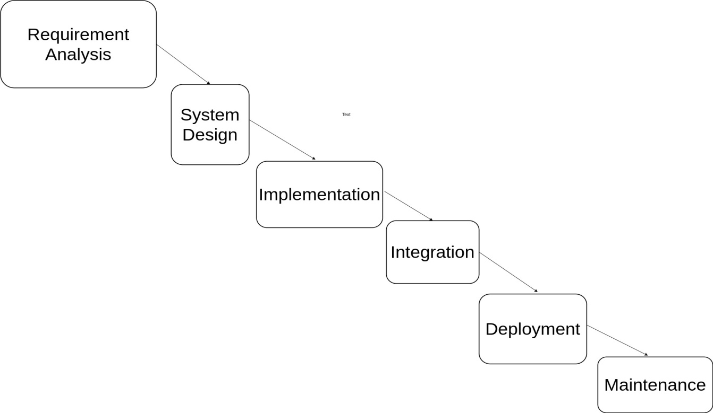

Fig (3.1): Waterfall model.

### 3.1.1 Requirement Identification

Requirement identification is the gathering of relevant requirement that will be used to develop a system. Different methods have been adopted to gather requirement for this project.

#### 3.1.1.1.1 Functional Requirements

Only admin can log in to the system. Admin can add, delete, or edit the videos. Users can watch the video online. Users can also choose the videos from different categories to watch and rate them accordingly. User can save the video in their watchlist.

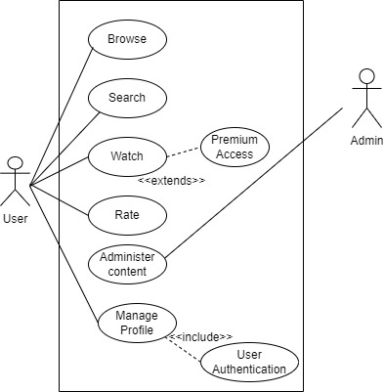

**Fig(3.2): Use case diagram of MovieMagic**

#### 3.1.1.2 Non-Functional Requirements

MovieMagic will provide high quality content with minimum latency. This website will allow multiple users to watch the video in real time.

### 3.1.2 Feasibility Study

It is the study of how well the system will function under the given constraints. It studies about how easy is it to build a system under given constraints. The constraints include operational feasibility, economic feasibility, and technical feasibility.

#### 3.1.2.1 Technical Feasibility

This system meets the technical feasibility as it will be using existing technologies like HTML, CSS, JavaScript, PHP and MYSQL etc. as well as simple hardware specifications.

#### 3.1.2.2 Operational Feasibility

Since the system promises to provide easier and understandable user interface as well as responsiveness when used in another device. Thus, the proposed system will be operationally feasible.

#### 3.1.2.3 Economic Feasibility

The system will be feasible economically as the only resources needed will be a laptop, internet connection.

3.1.3 Data Modeling

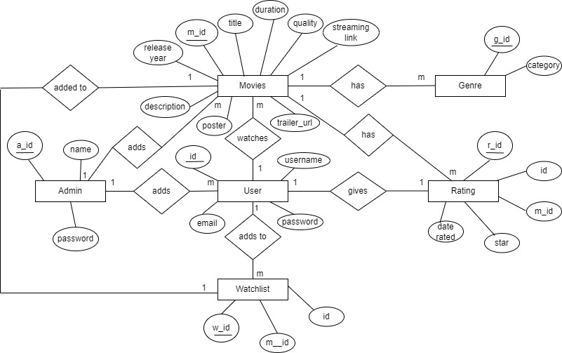

Fig: ER diagram

**Entities:**

User: Represents people who use the website to stream movies. Attributes might include user ID (primary key), name, email, and subscription details.

Movie: Represents the movies available on the streaming platform. Attributes might include movie ID (primary key), title, release date, duration, and language.

Genre: Represents the genres that movies belong to, such as action, comedy, drama, etc. Attributes might include genre ID (primary key) and name.

Subscription Plan: Represents different subscription options available to users. Attributes might include plan ID (primary key), plan name, and price.

Review: Represents user reviews for movies. Attributes might include review ID (primary key), user ID (foreign key), movie ID (foreign key), rating, and comments.

**3.1.4 Process Modeling**

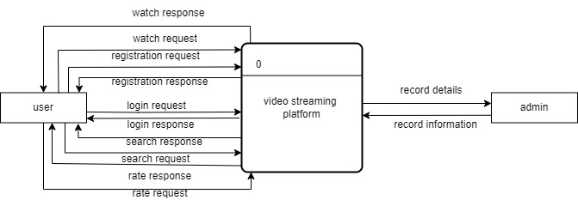

Fig: Context diagram

The context diagram provides a top-level view of how the system interacts with its environment and the data it processes. It does not go into the details of internal processes; instead, it focuses on the high-level relationships between the system and external entities. It interacts with the user as:

* From Users to System: login credentials, registration information, search queries, streaming requests.
* From System to Users: streamed content, user account information.

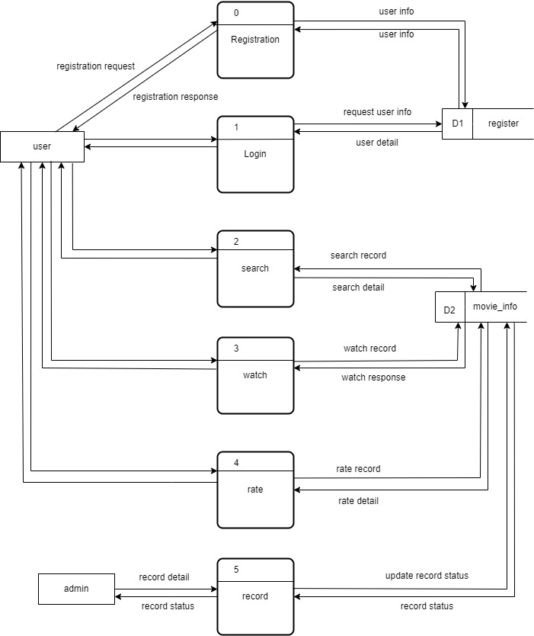

Fig: Level-1 DFD diagram

This Level 1 DFD provides an overview of how different processes interact with data stores and external entities. It outlines the flow of data within the system and the basic functionality of the various processes.

1. Process: User Management

* Register User: Collects user information (username, password, email) and saves it in the user Database.
* Login User: Authenticates user credentials from the User Database and grants access.

1. Process: Streaming Service

* Stream Movie: Streams requested movies to users.

1. Data Stores

* User Database: Stores user registration and login data.
* Movie Database: Stores movie information including titles, descriptions, genres, and streaming links.

External Entities:

* Users:
* Provide registration information, login credentials, and movie requests.
* Receive streamed movies, movie information.
* Admin:
* Provides new movie data, updated movie data, and delete requests.
* Receives success or error messages for movie creation, updates, and deletions.

**3.1.6 Flow Chart for Admin:**

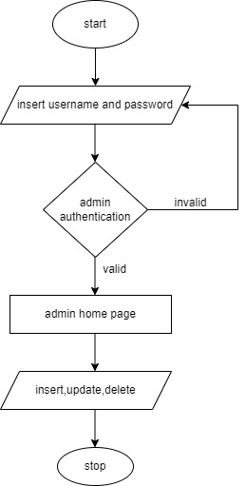

Main processes and interactions of an admin:

1. Admin Authentication:

* Admin navigates to the admin login page.
* Admin enters login credentials (username and password).
* System verifies the credentials.
* If credentials are valid, admin is granted access to the admin panel.

1. Admin Panel:

* After successful authentication, admin lands on the admin panel dashboard.

1. Manage:

In this section, admin can perform the following actions:

* Insert Movie, Tv-shows:
* Admin can add a new movie by providing details such as title, genre, cast, synopsis, release date, etc.
* Admin can upload link to the movie.
* Update Movie, Tv-shows:
* Admin can modify details such as title, genre, cast, synopsis, release date, etc.
* Admin can update the link if needed.
* Delete Movie:
* Admin can search for a specific movie by title or ID.
* Once a movie is selected, admin can delete the movie from the database.

1. Logout:

* Admin can log out of the admin panel.

### 3.1.7 Flowchart for user:

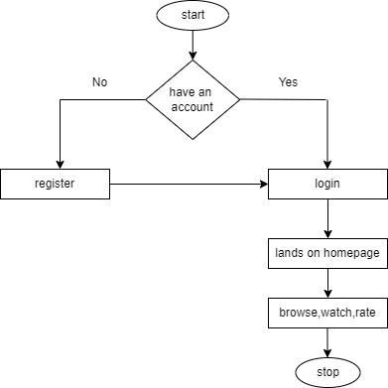

Main processes and interactions of a user:

1. User Registration/Login:
   * User navigates to the website.
   * User can either register for a new account or log in with existing credentials.
2. Homepage:

* After logging in, user lands on the homepage.
* The homepage displays featured movies, categories, and recommendations.

1. Browse Movies:

* User can browse movies by category, genre, release year, etc.
* User can also search for specific movies using the search bar.

1. Movie Details:

* When the user clicks on a movie, they are directed to the movie details page.
* This page displays information about the movie such as synopsis, cast, ratings, etc.

1. Watch Movie:

* If the user decides to watch the movie, they click on the play button.

1. Logout:

* User can log out from the website.

## 3.2 System Design

### 3.2.1 Architectural Design

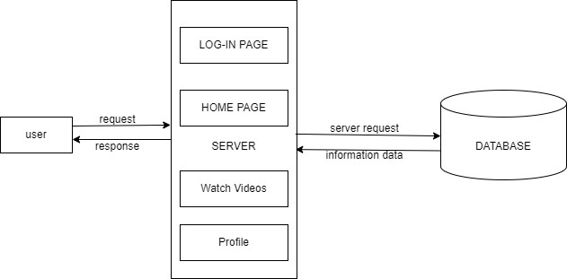

Fig:

An architectural diagram for movie streaming website provides an overview of the system's structure, including its major components, their interactions, and how data flows between them. This kind of diagram helps you understand how the different parts of the system work together to achieve the desired functionality.

Key components:

1. Client Interfaces:

* Web Interface:

A frontend application that allows users to interact with the system, such as browsing movies, registering, logging in, and streaming movies.

1. Server Components:

* Web Server:

Handles incoming HTTP requests from clients and serves static content.

* Application Server:

Hosts the backend logic of the application, handling requests from clients and interacting with databases and other external services.

1. Data Stores:

* User Database:

Stores user data, such as registration details, login credentials, and profile information.

* Movie Database:

Stores movie data, such as titles, descriptions, genres, and streaming URLs.

1. Interactions and Data Flow:

* User Interactions:

Users interact with the system through the web interface. They can browse movies, register, log in, and stream content.

* Server Interactions:

The web server and application server handle requests and responses from clients, routing requests to the appropriate backend services.

* Database Interactions:

The application server interacts with the user and movie databases to create, read, update, and delete data as required by user and admin actions.

# Chapter 4: Implementation

## 4.1 Implementation

### 4.1.1 Tools Used

Frontend:

* HTML
* CSS
* JavaScript
* Jquery
* Ajax

Backend:

* PHP

Database:

* MySql

Server:

* Apache

### Implementation details of modules

The different modules provided are:

**Module 1: Browse Movies**

It provides an interface for users to browse available movies across various genres and categories.

Features:

* Users can view movie details, including titles, descriptions, genres, and ratings.
* Allows users to sort and filter movies based on different criteria (e.g., release date, popularity, genre).
* Displays thumbnails or posters for each movie to aid in visual browsing.

**Module 2: Stream Movies**

It enables users to stream selected movies directly on their devices.

Features:

* Users can select a movie to watch from the list of available options.
* Provides playback controls such as play, pause, and volume adjustments.

**Module 3: Admin Manage Movies**

It allows the admin to manage the movie database, including adding, updating, and deleting movies.

Features:

* Admin can add new movies, including their metadata (titles, descriptions, genres, release dates, etc.).
* Admin can update existing movies, such as modifying descriptions or genres.
* Admin can delete movies from the database as needed.

## Testing

**Table 4.1: Test Cases of Unit Testing for Admin Operation**

| **Test Case(s)** | **Steps** | **Expected Results** | **Status** |
| --- | --- | --- | --- |
| 1. Login as an admin | The user logs in as an admin. | The user should be redirected to the admin dashboard. | Pass |
| 2. Add new movie | Admin fills in all required fields for a new movie. | The movie should be added to the database, and the admin redirected to the dashboard. | Pass |
| 3. View movies | Admin clicks on the "View Movies" button. | Admin should see a list of all movies in the database. | Pass |
| 4. Update a movie | Admin selects a movie to update and fills in new details. | The movie should be updated in the database. | Pass |
| 5. Delete a movie | Admin selects a movie to delete. | The movie should be removed from the database. | Pass |
| 6. View users | Admin clicks on the "View Users" button. | Admin should see a list of all users in the database. | Pass |
| 7. Update a user | Admin selects a user to update and fills in new details. | The user should be updated in the database. | Pass |
| 8. Delete a user | Admin selects a user to delete. | The user should be removed from the database. | Pass |

**Table 4.2: Test Cases of System Testing**

| **Test Case(s)** | **Steps** | **Expected Results** | **Status** |
| --- | --- | --- | --- |
| 1. Browse movies | User views the list of available movies. | User should see a list of available movies with titles, genres, and thumbnails. | Pass |
| 2. Select a movie | User selects a movie from the list. | User should be able to see detailed information about the movie (description, rating, etc.). | Pass |
| 3. Stream a movie | User chooses to stream a movie. | The movie should start streaming without buffering issues and with appropriate quality based on the user's internet speed. | Pass |
| 4. Add to watchlist | User adds a movie to their watchlist. | The movie should be added to the user's watchlist and visible there. | Pass |
| 5. View watchlist | User navigates to the "Watchlist" section. | User should see a list of movies they have added to their watchlist. | Pass |
| 6. Rate a movie | User rates a movie after watching it. | The user's rating should be saved in the database and reflected in the movie's average rating. | Pass |
| 7. Search for movies | User searches for movies by title, genre, or actor. | User should see a list of movies that match their search criteria. | Pass |
| 8. Review a movie | User writes a review for a movie they watched. | The user's review should be saved in the database and visible to other users. | Pass |

# Chapter 5: Conclusion and future recommendation

## 5.1 Lesson Learned/Outcome

The project has demonstrated the effectiveness of providing users with a straightforward movie streaming website based on simple CRUD operations. Users can efficiently browse available movies, select and stream content, manage their watchlists, and rate or review movies. The system's simplicity contributes to a smooth user experience, ensuring that users can interact with the website seamlessly and enjoy their chosen movies without complications. This approach highlights the value of focusing on essential functionalities for clear and efficient content management.

**5.2 Conclusion**

The project delivers a simple and efficient movie streaming website that offers a user-friendly experience for movie lovers. By meeting the project's objectives of streamlining the browsing and streaming process, it improves the overall service quality. The website's ease of use and focus on core functionalities result in a positive user experience and satisfaction.

**5.3 Future Recommendations**

# The movie streaming website can be improved further by incorporating advanced features such as personalized recommendations based on user viewing history and preferences. The project could benefit from implementing a social sharing feature that allows users to share movies with their friends and family. Integrating options for user-created playlists and favorites lists could enhance user engagement. Future iterations may also include more sophisticated search and filtering options, as well as improved quality control features to optimize the streaming experience.

# References

* <https://fmoviesz.to/genre/action?page=2>
* <https://vvv1.dramacool.sr/>
* <https://onetouchtv.co/>
* <https://www.gohitv.com/mkpages/#/en-US>
* <https://www.youtube.com/>
* <https://www.instagram.com/>
* [www.google.com](http://www.google.com)