Introduction

1.1. Introduction to VeloSite (The 80/20 Hybrid Architecture)
The modern digital world, the creation of the professional web presence is a requirement of the success of people, startups, and businesses. Although the software industry has been branded by constant innovations, the cost of entry in the web development of custom-built applications is high-priced. The usual model requires strong technical skills in the full-stack environments, such as markup of HTML, styling of CSS, JavaScript interactivity, and routing of the back-end server. Although the introduction of Content Management Systems (CMS) and No-Code platforms (like Wix and Squarespace) tried to democratize the process, they also came with serious trade-offs of providing the technical complexity in exchange of strict template restrictions and lock-in with vendors.
With the recent explosion of Large Language Models (LLMs) including OpenAI GPT-4 and Google Gemini, a new possible paradigm has been kicked off: Generative Web Development. These artificial intelligence systems hold the potential of being able to directly convert natural language into useful software. Using pure text-to-code models on web architecture, however, has a failure point of critical importance. Unlike deterministic logic engines, LLMs are probabilistic engines, which is, they compute the statistical probability of the next token. Therefore, given the responsibility of creating complex, hierarchical Document Object Model (DOM) structures manually, they often hallucinate incorrect syntax, code up non-CSS classes, or do not close HTML elements.
This project is designed VeloSite and is aimed at correcting this technological bottleneck. VeloSite is a modern, fault-tolerant AI Website Generator which does not use the unreliable pure generation model, but instead, it uses a Hybrid 80/20 Architecture. The system can ensure the syntactic correctness and mobile responsiveness of the structural layout by using a deterministic Python (Flask) back-end to process 80% of the structural layout using pre-compiled Jinja2 and Tailwind CSS templates. The remaining 20 percent, i.e. intent classification and content generation contextualized, are then strictly sandboxed using Google Gemini 2.5 Flash API. Such orchestration enables the users to create deploy-ready code out of a mere text prompt within less than 30 seconds, which effectively eliminates the divide between artificial creativity and the rigorous software engineering concepts.

1.2. Problem Domain
Although artificial intelligence has totally transformed the technology industry, it is a very challenging task to fully construct a functioning, professional site among people who are not techno savvy. At the present, those users who are interested in creating a site have to contend with a number of significant discontinuities that slow down the process, make it more costly or simply become extremely frustrating. The targeted issues that this project will solve are:
1. AI produces Broken Code (The Hallucination Problem):
The use of AI tools such as ChatGPT is created to forecast and compose text according to the pattern; it does not perceive the rules of strict programming. The AI often gets errors when instructed by a user to create a website (with HTML, CSS and JavaScript) on a blank slate. It may leave an HTML tag open (such as </div>), or it may create imaginary CSS classes, which do not exist. These are simple to correct to a software engineer. However to a non-technical user, a site that has been generated and appears to be broken in a mobile phone is of absolutely no use since he/she has no expertise to debug and correct the raw code.
2. The Chatbot Fatigue Issue (Hard to edit):
The majority of AI coding systems are based on a basic conversational chat window. As soon as a user creates a web page, yet he or she needs to modify a single detail, e.g. make the background a bit darker or conceal a particular image, he must enter a whole new command. Then they need to sit back as the AI rewrites the entire page afresh. This is an extremely tedious and annoying process. Worse still, the AI will tend to misinterpret the follow-up prompt and go ahead to destroy the sections of the site already liked by the user. One cannot tweak the design easily manually without having to restart.
3. "Blank Canvas" Confusion:
The non-technical user is likely to become overwhelmed when confronted with a blank text box and be told to provide a description of their web site. They are aware of their fundamental business requirements (such as "I require a web site to promote my new coffee shop), but they are unaware of web design terminology. They are not aware of how to instruct the AI on what typography to resort to, how tight the layout is to be, or what kind of color psychology would fit their brand. The AI provides them with highly generic and boring results because they do not know how to write a highly detailed prompt.
4. Crippled and Prisoner Platforms (Vendor Lock-in):
In order to escape the shattered code of AI, numerous end-users resort to the conventional No-Code systems such as Wix or Squarespace. Although these platforms are user-friendly and do not have broken code, they entrap the user. These services chain the user to high monthly subscription fees. Moreover, the user does not physically own the code of the websites; they do not have the ability to download their HTML files and transfer their websites to a cheaper, separate hosting company.

1.3. Background & Literature Review
Background and Literature Review.
The development of the web has gone through a magnificent change that has seen it move through manual code that required a lot of labor and then through the available no-code systems and then progressing to generative AI-based tools where non-technical users can now build professional websites in a short time period. This development tackles the long-term limitations of accessibility, speed and cost, but creates additional issues such as LLM hallucinations during code creation, which compromises the reliability of end-users. VeloSite is a hybrid AI web generative system that uses deterministic Python templates to ensure structural integrity and uses the Gemini 2.5 Flash API as a creative element, which reduces these concerns.

Web Development Paradigm Evolving.
The conventional web development system was based on manual coding using such languages as HTML, CSS, or JavaScript and required a strong technical background and long development cycles. This method had the drawback of being expensive and requiring expert developers and reducing access to small businesses and individuals. The democratization of the process through Content Management Systems (CMS) such as WordPress and no-code platforms such as Wix and Webflow has made it through the introduction of drag-and-drop interfaces and ready-to-use templates, likely cutting development time by up to 80 percent on simple sites.

No-code tools have since developed further with the ability to completely abstractify code, so that users can build components visually, whereas platforms automatically create the underlying markup, such as Webflow workflow integration with tools such as Figma. These platforms are however usually rigid in their templates and have integration restrictions that do not easily allow complex customization without going back to code. The most recent paradigm, Generative UI tools such as the v0.dev at Vercel uses large language models (LLMs) to generate complete user interfaces, estimated to be as fast as prototyping over ten minutes, but lacking reliability.

This trend can be seen as a direction towards intent-oriented programming: beginning with syntax-oriented programming, then moving to visual abstraction with no-code, to AI baked into generated code with GenUI, where a business logic is represented as a description.

The Issue of LLM Hallucinations in the Generation of Codes.
Pure text-to-code LLMs, on which Generative UI is based, are susceptible to hallucinations, plausible yet factually incorrect or even non-functional output, which makes them structurally unreliable, particularly when used by non-technical users. Hallucinations can occur in various forms, such as requirement conflicts (most common, which occur in intent alignment), context deviations, and knowledge gaps, with ChatGPT models less impacted by intent issues but with more context issues. Even state-of-the-art LLMs demonstrate inaccurate functionality on more than half of instances according to empirical standards such as HalluCode, and the quality of prompts is poor and the model is limited.

With marketing experts, this lack of reliability is made worse: research indicates that even with natural language explanations, marketing professionals fail to identify 60-70% of flaws in the analyzed code of the LLM data analysis, even with lack of domain knowledge. High-level results are of greater importance to end-users, but they do not consider the encoded defects such as inefficient algorithms or integrations that failed to work, since they cannot look at raw code (Vaithalingam et al., 2025). As a result, pure generative models produce fragile websites, which look attractive but can fail at any time, which increases the threats of non-experts who make 80 percent of the creators of websites.

Consistent academic reviews in 2024-2026 continue to point out the following structural weaknesses: The models are effective at generalizing patterns but fail in precision tasks, and the level of hallucinations remains constant across benchmarks even as the models are scaled.

Cross-Over Solutions: Finding the Middle Ground between Determinism and Generativity.
Hybrid AI systems overcome these traps by taking a deterministic rule (e.g. fixed templates) with generative elements, which can achieve 80-90% structural reliability with creative flexibility. An example is Retrieval-Augmented Generation (RAG) whereby deterministic knowledge retrieval is used to base LLMs, reducing factual task slashing hallucinations by 40-60%. Deterministic Python templates are also used in web generation, where skeletons of HTML/CSS/JS are required to ensure that the syntax is correct, and the content is generated by LLMs such as Gemini.

VeloSite represents this hybridity Python templates ensure no hallucinated structure (i.e. responsive grids, SEO boilerplate), and Gemini 2.5 Flash is restricted to low-risk creative fills, such as headlines or copy. This is reflected in the pattern of enterprises in which generative layers brainstorm and the deterministic layers confirm constraints such as accessibility. Such orchestration layers are suggested to send high-stakes outputs to rules-based checks to improve deployability by recent studies.

Conclusions of Non-Technical Users and VeloSite.
To non-technical users in places such as Nepal where there is a shortage of developers and hence the need to use self-service tools, pure GenUI runs the risk of spreading errors which increases the cost of maintenance. Reduced barriers In the VeloSite hybrids: Users define requirements, templates make it work, and AI polish it - professional outputs without coding skills.

To conclude, although GenUI makes innovation faster, the unreliability of the innovation using hallucinations requires hybrids. VeloSite goes further and focuses on determinism, which is in line with demands of limited deployment of LLM.

1.4. Aims and Objective

1.4.1. Aim
The main purpose behind this project is to design, develop and test VeloSite, a fault-tolerant, AI-driven web generation platform. It seeks to eliminate structural hallucinations typical of raw LLMs by using a Hybrid 80/20 Architecture, which combines a deterministic Python routing engine with generative AI content synthesis, thus offering non-technical users a "Design Studio" to quickly create, iterate, and deploy professional websites.

1.4.2. Project Objectives
In order to successfully attain this purpose, the following specific, measurable technical objectives were set and implemented:
Goal 1: To develop a Hybrid System Architecture:
To create a solid Python (Flask) application with a strict decoupling of the structural logic of the webpage (controlled by Jinja2 and Tailwind CSS) and the creative writing of the text, it is necessary to ensure that the final product is structurally correct and does not contain even the slightest elements of the HTML syntax.
Goal 2: To Design a Exploratory Taste Engine:
To code a deterministic Natural Language Processing (NLP) algorithm which mathematically ranks user prompts with contextual dictionaries (Industry, Vibe, Density) to automatically direct users to the best layout and color theme and then call the LLM engine.
Goal 3: To combine Generative AI and Fault Tolerance:
To safely bind the Google Gemini API (gemini-flash-latest) to generate structured JSON data (headlines, features, calls-to-action). This involves putting in place severe validation gates that identify malformed AI responses and automatically inject pre-written fallback data to avoid system crashes.

Goal 4: To Develop an Interactive "Studio" Workspace:
To avoid Chatbot Weakness by creating a dynamic frontend interface that produces variants of design during the initial phases. The Studio should enable users to turn on or off UI layer visual effects, apply uploaded brand assets and refine copy through conversational prompts using a persistent SQLite database to store session state.
Goal 5: To Support Instant Deployment and Code ownership:
To back-end services that enable users to either immediately publish their generated site to a live, temporary URL so they can immediately share it, or to package the raw HTML, CSS, and localized assets into a downloadable ZIP file in less than 30 seconds.

Pre-planning

2.1. Methodology (Agile Incremental Hybrid)
This project follows the complete Software Development Life Cycles (SDLC). Software engineering starts with the choice of an suitable Software Development Life Cycle (SDLC). An SDLC is a framework that is organized in a structured way with phases such as initial requirement analysis through to deployment and maintenance, which makes sure that the final product is delivered in a systematic manner, on time and within scope. Since integrating Generative Artificial Intelligence (the Google Gemini API) with a deterministic web framework (Flask/Jinja2) is highly experimental, it was essential to choose a methodology that could be used to plan the architecture strictly and also to iterate the prompt flexibly.

2.1.1 Considered Methodologies
The conventional and contemporary software engineering approaches were critically analyzed against the definite constraints of the VeloSite project before finalizing the development roadmap of the project.
2.1.1.1 The Waterfall Methodology
The waterfall methodology is a structured work approach that guides project manager on a liner path. It has five different work phases starting from requirement, design, implementation, verification and maintaince at the end with each phases having each set of task (Day, 2025).
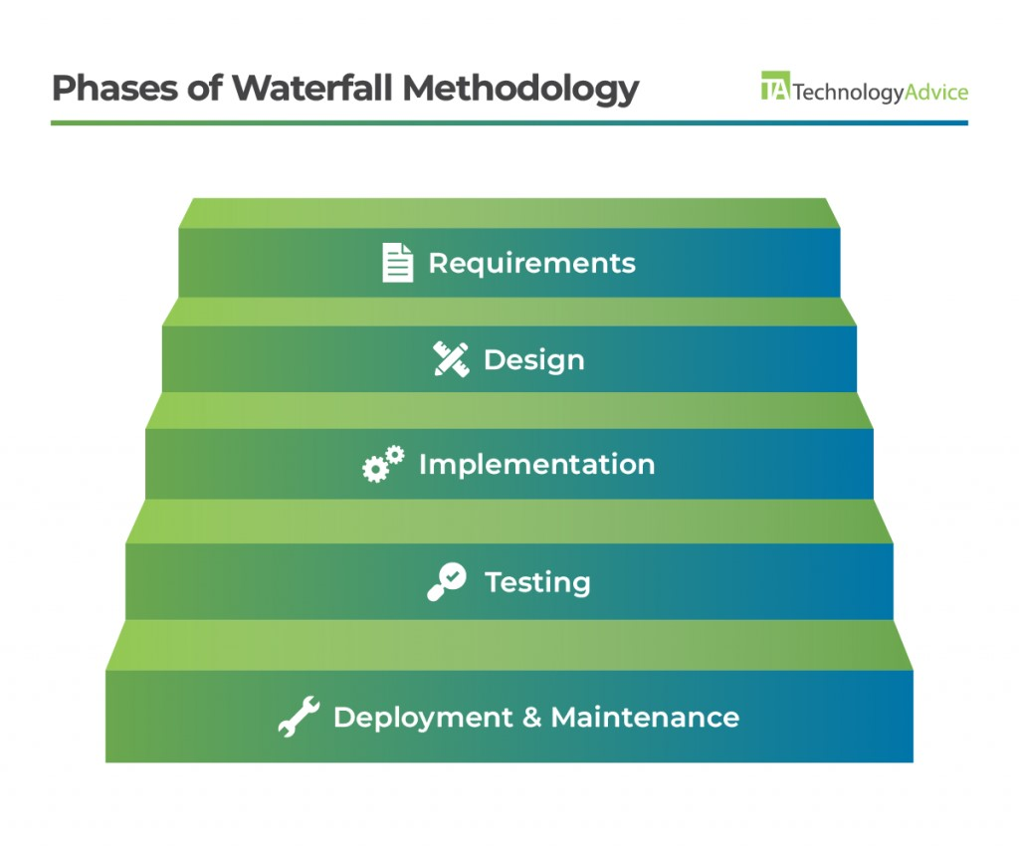
S.N. | Reason for Consideration | Reason for Not Picking
1. | It gives an academic timetable a clear, strict framework with a set of distinct milestones thus making it easy to manage | It is dogmatically fixed, once a phase has been reached, it becomes hard to revisit and amend artifacts without spending considerable time.
2. | The requirements are detailed at the beginning, which provides a yielded roadmap of the lifecycle of development. | The use of Generative AI (Gemini) creates a lot of uncertainty; trial and error is the basis of instant engineering, which the linear quality of the Waterfall model cannot allow.
3. | It is a focus on thorough documentation on each stage. | The testing will be carried out at the very end; in case the AI integration does not work in the later phases, the whole project schedule will be to fail.

2.1.1.2. Pure Agile Methodology
The Agile methodology is a collaborate way of managing the flow of the project without breaking them into smaller phases which is iteration (Paliwal, 2025).
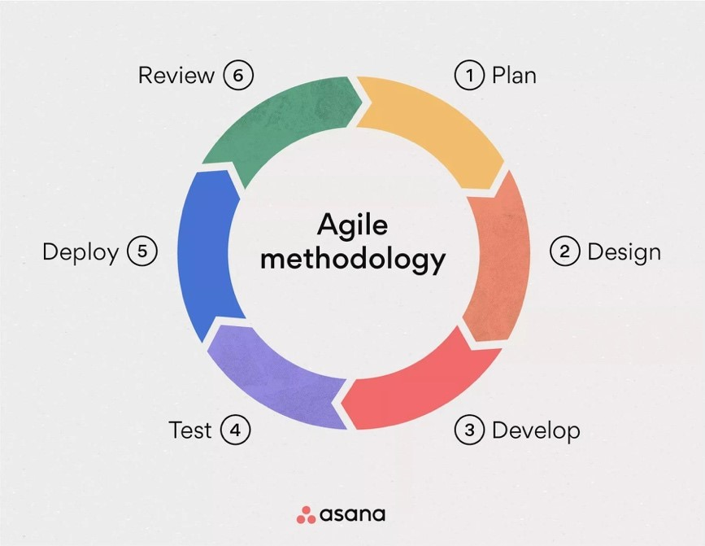
Figure 7 Pure Agile methodology
S.N. | Reason for Consideration | Reason for Not Picking
1. | It is very dynamic and embraces adaptation of necessities thus conforming to the experimental aspect of AI prompting. | In the absence of a strict architectural scheme, Agile in its pure form can lead to scope creep, allowing the project to become larger than the rigid university deadline.
2. | It enables testing to be performed constantly and thus the bugs can be detected at an early stage of the development cycle. | Agile tends to neglect detailed documentation in support of running software, and as a result, it is inconsistent with the scholarly need of a detailed technical report.
3. | It breaks the project into small manageable sprints. | The assumption that leads to using pure Agile is a necessity of continuously getting feedbacks on the stakeholders; since the project is a personal student work, it should be provided with a more detailed roadmap to be able to complete the Skeleton (Backend) first and the Brain (AI) afterwards.

2.1.2. Selected Methodology: Agile Incremental Hybrid
To balance between the organizational flow of the Waterfall/Incremental model and the flexibility in Agile, this project uses Agile Incremental Hybrid Approach. The selected methodology allows the system to be built in functional “Increments) (Modules) and refines the code by an iterative transformation of the code using the so-called “Agile Sprints.”
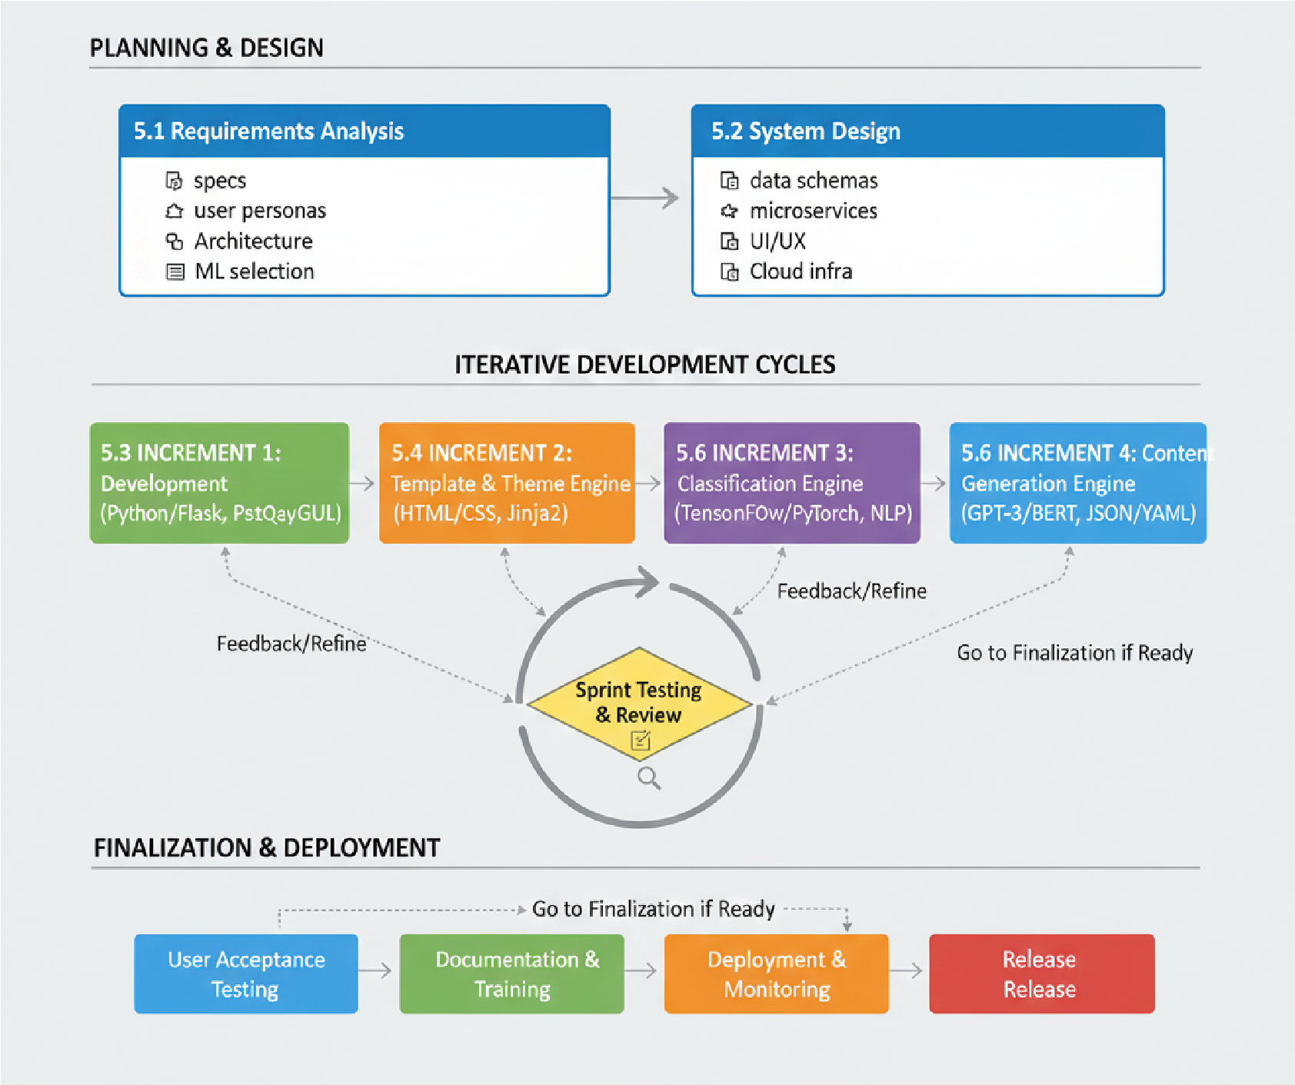
Figure 8 Agile Incremental Hybrid Methodology\
The lifecycle of development was divided into three phases:
Phase 1: Architectural Design and Planning.
The phase was linear to lay the groundwork of the project. It included the definition of the hybrid constraints (80/20), visualizing the database structure of the Studio workspace, and choosing the technology stack (Python 3.12, Flask, SQLite, Tailwind CSS).

Phase 2: Repeat Development Cycles (The Increments)
The main implementation was split into four different increments, with a Sprint Testing and Review loop in-between them:
- Increment 1 (Backend Foundation): configuring the Flask server, routing architecture, and environment.
- Increment 2 (Template Engine): Developing the deterministic site framework with HTML5, Tailwind CSS, and Jinja2 placeholders.
- Increment 3 (Heuristic & AI Logic): Developing the Taste Engine as intent identification and including the Gemini 2.5 Flash API as content generation in JSON.
- Increment 4 (Studio Workspace): Adding In-Memory/Redis state management (preview_store.py) to enable users to dynamically remix themes and edit UI layers without causing unnecessary AI calls.
Phase 3: Finalization and Deployment.
The last step was concerned with integration of the system, testing of cross-browsers, and testing of failure (emulating API failures), and implementation of the ZIP export and live-publish logic.

2.2. Project Management

2.3. Work Breakdown Structure WBS & Gantt Chart
The work within the projects was broken down in a hierarchical manner in order to make it manageable. Work Breakdown Structure (WBS) is based on the Hybrid structure but splits the project into various requirements, consisting of “Planning”, and finally, the individual increments included in the list above.

2.4. Risk Management (API rate limits & Fallback strategies)
One of the crucial elements of the pre-planning stage was to carry out a proactive risk assessment. Developing an application based on the use of external Generative AI adds special failure points. The architectural contingencies that were directly implemented in the VeloSite codebase to provide high availability and fault tolerance include:
1. API Quota Exhaustion and down time (High Probability, High Impact)
- The Threat: VeloSite will use Google Gemini API to generate content. In case the API slows down the application (HTTP 429) or the server is down (HTTP 503/504), the core generation option would crash.
- Mitigation Strategy: An effective RotatingGeminiAIProvider class was designed in the back-end. When the main API key reaches its quota, the system will automatically switch to one of the secondary keys, which are specified in the .env file. Moreover, in case of default of the default model, the system will use an automated fallback mechanism to another model (e.g. gemini-3-flash-preview) and will use exponential backoff algorithms to restart the connection gracefully.
2. Corrupted JSON and Hallucinations (High Probability, Critical Impact)
- The Threat: LLM may reply back to conversational filler (e.g., "Here is your code:), bad JSON syntax, or lack of necessary data arrays (such as the 'Features' list). Further relaying this to the frontend would be lethal to the Jinja2 rendering engine.
- Mitigation Strategy: In Python, a Python sanitization pipeline (clean_json_response) and validation gate (protect_content) were created. The system removes formatting of markdown physically using RegEx. In case the AI cannot produce the necessary parts of the site, the system invokes a slot fallback mechanism, that automatically inserts manually written, context-specific default text, so that the site will render perfectly 100% of the time.
3. Session State Loss When UI Iterating (Medium Probability, High Impact)
  - The Threat: When using a website design in the Studio, users may lose the variants they have created thus far, should the server crash or the page be reloaded, causing gross "iteration fatigue."
  - Mitigation Strategy: The architecture was revised to have an interface-agnostic caching system (preview_store.py), both with In-Memory storage and Redis compatibility. This continues user session data and ProjectManifest objects through a Time-To-Live (TTL) expiration protocol. This will enable users to use the Studio safely and switch between layout modes and ask AI to rewrite their content and preserve their underlying design condition.

Design

3.1. System Architecture Diagram (The Flask to Gemini pipeline)

3.2. Entity Relationship Diagram (ERD for Users, Conversations, Messages)

3.3. User Case Diagram (Onboarding, Brief Generation, Studio Editing)

3.4. Data Flow (DFD level 0 & 1)

3.5. Sequence Diagram (The /generate API lifecycle)

3.6. Wireframes & UI/UX Flow

Implementation
4.1. The Deterministic Engine (Python, Flask, Jinja 2, Tailwind)

4.2. The “Tase Engine” (Heuristic NLP Keyword Scoring)

4.3. The AI Provider & Key Rotation (ai_provider.py & Gemini 2.5 Flash)

4.4. State Management & Database (Preview_store.py, SQLite/Redis)

4.5. The Studio Canvas (Iframe injection and Javascript overrides)

Testing

5.1. Unit Testing (test_taste_engine.py, test_ai_provider.py)

5.2. Integration Testing (Testing the Studio JSON overrides)

5.3. Fault Tolerance Testing (Forcing Gemini to fail to test Fallbacks)

5.4. User Acceptance Testing (UAT)

Sustainability

6.1. Environmental & Compute Efficiency

6.2. Scalability (Redis caching vs In-Memory storage)

6.3. API Key Rotation (Financial sustainability and quota management)

Analysis

7.1. Evaluation of the 80/20 Architecture (Did it stop hallucinations?)

7.2. Performance Analysis (Generation speed < 30 seconds)

7.3. Limitations (Template boundaries, lack of backend generation)

Conclusion

8.1. Summary of Achievements

8.2. Future Work

