Configuration in ASP.Net Core
Configuration in ASP.Net Core provide using one or more configuration providers. Providers can be:
- File Configuration Provider(JSON,XML,INI)
- Environment Variables
- Command line arguments
- User Secrets
The Default Configuration Hierarchy:
When we run asp.net core project the Main method calls CreateDefaultBuilder of a host class you can see in following snippet:
public class Program
{
public static void Main(string[] args)
{
CreateHostBuilder(args).Build().Run();
}

public static IHostBuilder CreateHostBuilder(string[] args) =>
Host.CreateDefaultBuilder(args)
.ConfigureWebHostDefaults(webBuilder =>
{
webBuilder.UseStartup<Startup>();
});
}
The CreateDefaultBuilder load All Configuration from different configuration providers in following hierarchy (default):
- First it looks for appsettings.json file if it found then it load all it configuration
- Second it looks for appsettings.{environment}.json file if it found then it load all it configuration (environment can be Development, Staging, Production)
- Then if it is development environment then it loads the User Secrets file
- After that It loads values Environment variables
- And lastly it loads values from command line arguments
This is default hierarchy for loading the application configuration. This Configuration will loaded into IConfiguration and register it into Application Services (Dependency Injection).
Note:
- If same configuration found in multiple configuration provider then overrides according to hierarchy for example:
There is Value in Named API_URL in appsettings.json and its value http://api.google.com and if API_URL found in environment variables value of it https://api.google.com then it considers the https://api.google.com value of API_URL

Overriding Configuration Hierarchy:
We can override the default configuration hierarchy using ConfigureAppConfiguration method see example:
public class Program
{
public static void Main(string[] args)
{
CreateHostBuilder(args).Build().Run();
}

public static IHostBuilder CreateHostBuilder(string[] args)
{
return Host.CreateDefaultBuilder(args)
.ConfigureAppConfiguration((context, builder) =>
{
var env = context.HostingEnvironment;

builder.AddCommandLine(args);
builder.AddEnvironmentVariables();
builder.AddJsonFile("appsettings.json");
builder.AddJsonFile($"appsettings.{env.EnvironmentName}.json");

})
.ConfigureWebHostDefaults(webBuilder =>
{
webBuilder.UseStartup<Startup>();
});
}
}
In above example we have modified the hierarchy we have taking command line and environment variables first then we are adding appsettings file. In ConfigureAppConfiguration we have passed action with two parameters context( HostBuilderContext ) and builder( IConfigurationBuilder ). We can load any file (like XML,INI) for configuration IConfigurationBuilder has methods AddXmlFile, AddIniFile or we can add static configuration using AddInMemoryCollection method in this we need pass IEnumerable<KeyValuePair<string,string>>
for example:
ConfigureAppConfiguration((context, builder) =>
{
var env = context.HostingEnvironment;
builder.AddEnvironmentVariables();
builder.AddJsonFile("appsettings.json");
builder.AddJsonFile($"appsettings.{env}.json");

IEnumerable<KeyValuePair<string, string>> staticCollection = new List<KeyValuePair<string, string>>()
{
new KeyValuePair<string, string>("API_URL", "https://api.google.com"),
new KeyValuePair<string, string>("API_KEY", "testapikey")
};

builder.AddInMemoryCollection(staticCollection);
});

Accessing Configuration Values:
After loading all configurations from all configurations providers it will bind it to IConfiguration interface and register it into default service provider (Dependency Injection). Even in startup class it will injecting the IConfiguration Interface. We can inject IConfiguration in any method or constructor in entire application
How do we access configuration?
- Using GetValue/GetValue<T> method of IConfiguration instace:
Example:
appsettings.json:
{
“API_Details”:{
“API_URL”:https://api.paypal.com,
}
}
If we want to access API_URL in application we can access like this:
HomeCotroller.cs
public class Home : Controller{
private IConfiguration _configuration;
public Home(IConfiguration configuration) {
_configuration = configuration;
}
public IActionResult Index(){
string API_URL = _configuration.GetValue<string>("API_Details :API_URL");
return View();
}
}
The GetValue returns the object type of any value and GetValue<T> method get value and caste it to provided type in T. it returns null if API_URL is doesn’t exists. We can access sub section using colon(:) Separator.

- Using GetSection:
We can get entire section of json file and bind POJO class using this. GetSection never returns null. If a matching section isn't found, an empty IConfigurationSection is returned.
Example:
appsettings.json
{
“EmailDetails”:{
“Host”:”smtp.google.com”,
“port”:”5432”,
“Username”:”abc@gmail.com”,
“password”:”12345”
}
}
EmailDetails.cs (POJO Class):
public class EmailDetails {
public string Host { get; set; }
public int Port { get; set; }
public string Username { get; set; }
public string Password { get; set; }
}
HomeController.cs
public class Home : Controller{
private IConfiguration _configuration;
public Home(IConfiguration configuration) {
_configuration = configuration;
}
public IActionResult Index(){
EmailDetails emailDetails = new EmailDetails();
_configuration.GetSection("EmailDetails").Bind(emailDetails);
return View();
}
}
The bind methods bind values to actual properties. To see more about GetSection click here.
Configuring options and Resolving in Objects using Dependency Injection:
We can configure and resolve configuration objects in constructor. To configure we use IServiceCollection.Configure<T> method and Consume using IOptions<T>:
For Example:
appsettings.json
{
“EmailDetails”:{
“Host”:”smtp.google.com”,
“port”:”5432”,
“Username”:”abc@gmail.com”,
“password”:”12345”
}
}
Startup.cs
public void ConfigureServices(IServiceCollection services) {
services.Configure<EmailDetails>(Configuration.GetSection("EmailDetails"));
}
HomeController.cs
public class Home : Controller{
private EmailDetails _emailDetails;
public Home(IOptions<EmailDetails> emailDetails) {
_emailDetails = emailDetails.Value;
}
}
In above example we configured EmailDetails class and provided section EmailDetails. Now we don’t need to write boilerplate to get the EmailDetails from configuration we can just inject IOption<EmailDetails> to get email Configuration.

Important Notes:
- Hosting Environment decided based on environment based on launchSettings.json’s value of ASPNETCORE_ENVIRONMENT. But this file only available on the time of development. In production we need to set Environment Variable ASPNETCORE_ENVIRONMENT in System. If you ASPNETCORE_ENVIRONMENT it’ll take default value Production.
How to set Environment Variable?
In Windows System:
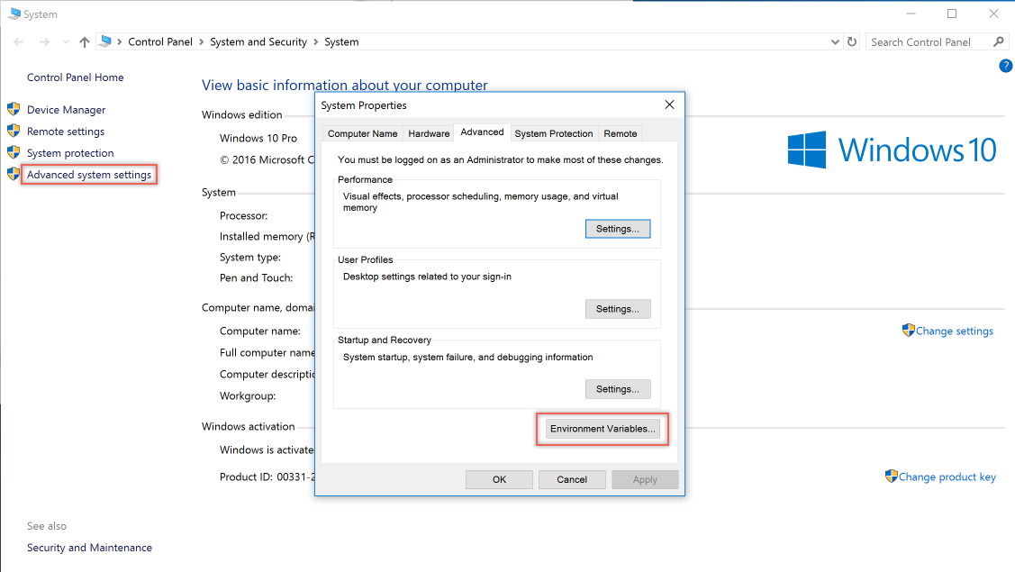

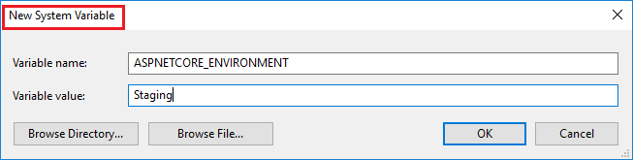
In CMD:
SET ASPNETCORE_ENVIRONMENT=Staging
dotnet {projectName}.dll or {projectName}.exe
IN Bash Shell (Linux Systems/ Mac OS):
ASPNETCORE_ENVIRONMENT=Staging
dotnet {projectName}.dll or {projectName}.exe
- In Real world Production System app configuration( like database ConnectionString, API Keys ) are provided in Environment Variables

To Provide Nested Configuration We can use separator colon (:) or triple underscore (___)
Example:
Connection String Name is TestDB
For that
ConnectionStrings__TestDB

Middlewares in ASP.Net Core

What is Middleware?

A Middleware is chain of function which are executed before the response of request being generated.
Middleware can do following:
- Handle an incoming HTTP request by generating an HTTP response.
- Process an incoming HTTP request, modify it, and pass it on to another piece of middleware.
- Process an outgoing HTTP response, modify it, and pass it on to either another piece of middleware, or the ASP.NET Core web server.

Middleware are used for user authentication, logging, and error handling, etc.

Middleware are executed in the same order in which they are configured/added see following diagrams:

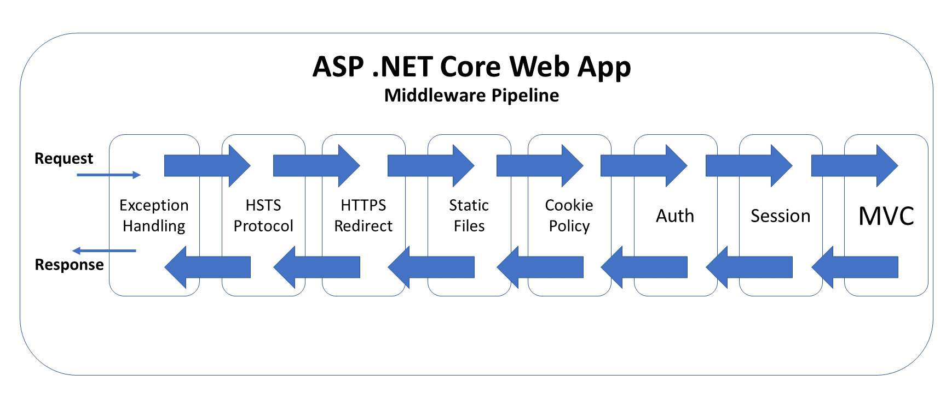

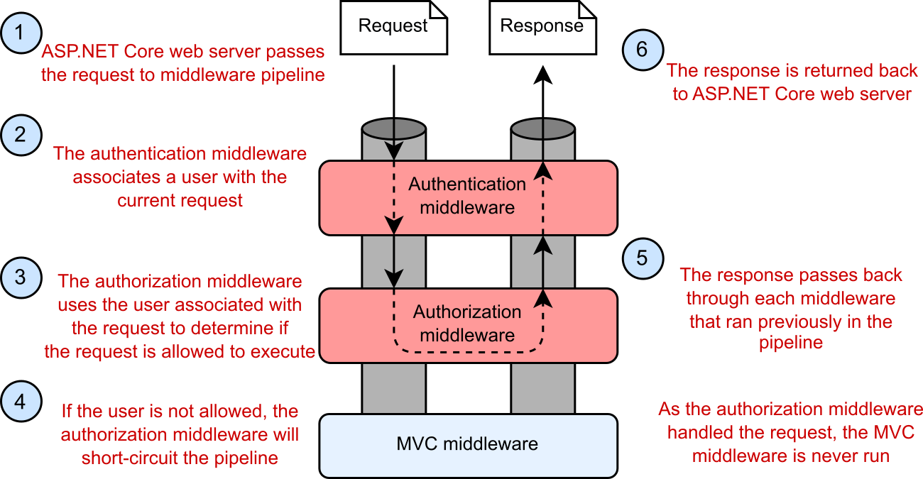

Each Middleware is responsible for passing request to then next middleware using next method if it doesn’t pass to it’ll be considered as termination of middleware hence request passes it back through the pipeline. When it reaches the ASP.NET Core web server, the response is sent to the user's browser.
Request delegates are used to build the request pipeline. The request delegates handle each HTTP request.

What is Request Delegate?
The RequestDelegate type represents any Task returning method, which has a single parameter of type HttpContext.
ASP.NET Core request handling is achieved by chaining one or more RequestDelegate instances together.
What is HttpContext Object?
The ASP.NET Core web server constructs an HttpContext, which the ASP.NET Core application uses as a sort of "storage box" for a single request. Anything which is specific to this request and the subsequent response can be associated with and stored in it. This could include properties of the request, request-specific services, data which has been loaded, or errors which have occurred.
Create a middleware pipeline with IApplicationBuilder:
The Configure method calls once the when application starts and constructs the request pipeline IApplicationBuilder has methods for creating middlewares.
Methods are:
- Use
- Map
- Run

- Use Method:
IApplicationBuilder.Use is used to allow the request delegate to pass the request to the next middleware in the pipeline.

- Map Method:
This branch the request pipeline with the mentioned URL In simpler words, this should be used in some specific cases where you want to map something to a special URL. If match found then REST of Middlewares won’t be considered in pipeline
- Run Method:
This will be used to end the pipeline registrations and acts as a final step. In simpler words, this should be used at the very last step of the pipelines when you want to start the actual application.
Examples:
- Use Example:
public void Configure(IApplicationBuilder app, IWebHostEnvironment env)
{
app.Use(async (context,next)=>{
await context.Response.WriteAsync(“Before Middleware”);
await next()
});
}
The app.Use gets two arguments. One is HttpContext and the second one is a RequestDelegate, which is basically the reference to the next middleware.
- Map Example:
public class Startup{
private static void HandleMapTest1(IApplicationBuilder app) {
app.Run(async context =>
{
await context.Response.WriteAsync("Map Test 1");
});
}

private static void HandleMapTest2(IApplicationBuilder app) {
app.Run(async context =>
{
await context.Response.WriteAsync("Map Test 2");
});
}

public void Configure(IApplicationBuilder app) {
app.Map("/map1", HandleMapTest1);

app.Map("/map2", HandleMapTest2);

app.Run(async context =>
{
await context.Response.WriteAsync("Hello from non-Map delegate. <p>");
});
}
}
Run Example:
public class Startup
{
public void Configure(IApplicationBuilder app)
{
app.Use(async (context, next) =>
{
await next.Invoke();

});

app.Run(async context =>
{
await context.Response.WriteAsync("Termination of middleware");
});
}
}
Types of middlewares:
- Built in Middlewares
- Custom Middleware
  - Conventional Middleware
  - Factory Based Middleware

- Built in Middlewares:
As name implies built in middlewares are built in and it provided by asp.net core. Following are built in middlewares:
Exception Handling:
UseDeveloperExceptionPage() & UseDatabaseErrorPage(): used in development to catch run-time exceptions
UseExceptionHandler(): used in production for run-time exceptions
Calling these methods first ensures that exceptions are caught in any of the middleware components that follow
HSTS & HTTPS Redirection:
UseHsts(): used in production to enable HSTS (HTTP Strict Transport Security Protocol) and enforce HTTPS.
UseHttpsRedirection(): forces HTTP calls to automatically redirect to equivalent HTTPS addresses.
Calling these methods next ensure that HTTPS can be enforced before resources are served from a web browser.
Static Files:
UseStaticFiles(): used to enable static files, such as HTML, JavaScript, CSS and graphics files. Called early on to avoid the need for authentication, session or MVC middleware.
Calling this before authentication ensures that static files can be served quickly without unnecessarily triggering authentication middleware.
Cookie Policy:
UseCookiePolicy(): used to enforce cookie policy and display GDPR-friendly messaging
Calling this before the next set of middleware ensures that the calls that follow can make use of cookies if consented.
Authentication, Authorization & Sessions:
UseAuthentication(): used to enable authentication and then subsequently allow authorization.
UseSession(): manually added to the Startup file to enable the Session middleware.
Calling these after cookie authentication (but before the MVC middleware) ensures that cookies can be issued as necessary and that the user can be authenticated before the MVC engine kicks in.
MVC & Routing:
UseMvc(): enables the use of MVC in your web application, with the ability to customize routes for your MVC application and set other options.
UseRouting(): adds route matching to the middleware pipeline. This middleware looks at the set of endpoints defined in the app, and selects the best match based on the request.
UseEndpoints(): adds endpoint execution to the middleware pipeline. It runs the delegate associated with the selected endpoint.

- Custom Middlewares:
We can create custom reusable middleware classes and use them using UseMiddleware method.
To define custom middleware there a class should have:
- The middleware class must declare a non-static public constructor with at least one parameter of type RequestDelegate
- The middleware class must define a public method named Invoke or InvokeAsync that takes an HttpContext and returns a Task. This is the method that gets invoked when the request arrives at the middleware

- Conventional Middleware:
Conventional middleware are like normal middleware define without implementing IMiddleware interface. But you can’t access Scoped or Transient Dependencies in the constructor or methods. The instance of conventional middleware is created only once in application lifetime.
Example:

public class ExceptionHandler : IMiddleware
{
public async Task InvokeAsync(HttpContext context, RequestDelegate next)
{
try
{
await next.Invoke(context);
}
catch (Exception e)
{
context.Response.StatusCode = 500;
await context.Response.WriteAsync(e.Message);
}
}
}
public static class ExceptionMiddleware
{
public static void UseException(this IApplicationBuilder app)
{
app.UseMiddleware<ExceptionHandler>();
}
}
In above example we have created extension method UseException() now we can import and register it in Configure method of Startup Class.
- Factory Based Middleware:
Factory based middleware are created runtime as per request and this instance of middleware are created by IMiddlewareFactory.
Advantages:
- Activation on client request
- We can inject Scoped and Transient Services in this middleware (In constructor or methods)

To create Factory based middleware a class must have to implement IMiddleware Interface and register class in ConfigureServices method of startup class
Example:
FactoryActivatedMiddleware.cs
public class FactoryActivatedMiddleware : IMiddleware{
private readonly AppDbContext _db;
public FactoryActivatedMiddleware(AppDbContext db) {
_db = db;
}
public async Task InvokeAsync(HttpContext context, RequestDelegate next) {
var keyValue = context.Request.Query["key"];
if (!string.IsNullOrWhiteSpace(keyValue))
{
_db.Add(new Request(){
DT = DateTime.UtcNow,
MiddlewareActivation = "FactoryActivatedMiddleware",
Value = keyValue
});
await _db.SaveChangesAsync();
}
await next(context);
}
}
MiddlewareExtension.cs
public static class MiddlewareExtensions
{
public static IApplicationBuilder UseFactoryActivatedMiddleware(
this IApplicationBuilder builder)
{
return builder.UseMiddleware<FactoryActivatedMiddleware>();
}
}
Startup.cs :
Public class Startup{
public void ConfigureServices(IServiceCollection services) {
services.AddDbContext<AppDbContext>(options =>
options.UseInMemoryDatabase("InMemoryDb"));

services.AddTransient<FactoryActivatedMiddleware>();

services.AddRazorPages();
}
public void Configure(IApplicationBuilder app, IWebHostEnvironment env) {
app.UseFactoryActivatedMiddleware();
app.UseStaticFiles();
app.UseRouting();
app.UseEndpoints(endpoints =>
{
endpoints.MapRazorPages();
});
}
}

Dependency Injection
What is Dependency Injection?
Dependency injection is a software design pattern that allows a choice of component to be made at run-time rather than compile time.
Or
Dependency Injection is a set of software design principles and patterns that enable us to develop loosely coupled code.

Why Loosely-Coupled Code?
Loosely-coupled code helps us in a number of areas. Here are just a few:
Extensibility
Extensibility is the ability to easily add new functionality to code. The “easily” part means that we can make updates in well-isolated areas rather than needing to update bits and pieces throughout the code base.
Late Binding
As mentioned, late binding is the ability to choose what components we use at run-time rather than compile-time. We can only do this if our code is loosely-coupled – our code only cares about abstractions rather than a particular concrete type. This lets us swap components without needing to modify our code.
Parallel Development
If our code is loosely-coupled, it makes it easier for multiple development teams to work on the same project. We can have one team working in the business layer, and a different team working in the service layer. Because the layers are independent, the teams will be in different source files that don’t directly affect each other.
Maintainability
When our components are independent, the functionality is isolated. This means that if we need to hunt down bugs or tweak functionality, we know exactly where to look.
Testability
Unit testing is a hugely important topic. The primary goal of unit tests is to test small pieces of code in isolation. When we have loosely-coupled code, we can easily put in mock or fake dependencies so that we can easily isolate the parts of the code that we actually want to test.
Also, as mentioned earlier, we will run across several of the S.O.L.I.D. principles as we look at Dependency Injection.

Look at following Example Code:
Employee.cs
public class Employee{
public int ID { get; set; }
public string Name { get; set; }
public double Salary { get; set; }
}
Database.cs
public class Database{
public IEnumerable<Employee> GetEmployees(){
var employees = new List<Employee>()
{
new Employee{ID=1,Name="Rushang",Salary=21000},
new Employee{ID=1,Name="Mihir",Salary=21000},
new Employee{ID=1,Name="Vikas",Salary=21000},
};
return employees;
}
}
EmployeeService.cs
public class EmployeeService
{
public IEnumerable<Employee> GetEmployeesData()
{
var db = new Database();
return db.GetEmployees();
}
}
Program.cs
class Program
{
static void Main(string[] args)
{
EmployeeService employeeService = new EmployeeService();
foreach (var employee in employeeService.GetEmployeesData())
{
Console.WriteLine($"ID = {employee.ID} Name = {employee.Name} Salary= {employee.Salary}");
}
}
}
In above code in Database class is tightly coupled with the employee service class in future if we want enhance functionality to multiple data provider such as SQL Server, My SQL then we have to change the logic in all places. Then we can use the dependency injection topics look at following example:
Database.cs
public interface IDatabase{
IEnumerable<Employee> GetEmployees();
}
public class Database : IDatabase{
public IEnumerable<Employee> GetEmployees(){
var employees = new List<Employee>(){
new Employee{ID=1,Name="Rushang",Salary=21000},
new Employee{ID=1,Name="Mihir",Salary=21000},
new Employee{ID=1,Name="Vikas",Salary=21000},
};
return employees;
}
}
EmployeeService.cs
public class EmployeeService{
private IDatabase _database;
public EmployeeService(IDatabase database) {
_database = database;
}
public IEnumerable<Employee> GetEmployeesData(){
return _database.GetEmployees();
}
}
Program.cs
class Program{
static void Main(string[] args) {
EmployeeService employeeService = new EmployeeService(new Database());
foreach (var employee in employeeService.GetEmployeesData()) {
Console.WriteLine($"ID = {employee.ID} Name = {employee.Name} Salary= {employee.Salary}");
}
}
}

In above example we have remove dependency of database from employee service class now if we want to enhance it to another database provider then we just need to inherit the IDatabase Interface provide it in EmployeeService. This is the basic idea behind the Dependency Injection.
How Dependency Injection Works Infernally?
DI Container:
DI Container is the object, which is responsible for creating the dependencies and pass it to the object that requests it.
Provider:
Provider is object which responsible taking the instance from DI Container and pass it to requested object.
We need to register our objects in DI Container and need to resolve dependencies using the provider look the below diagram.
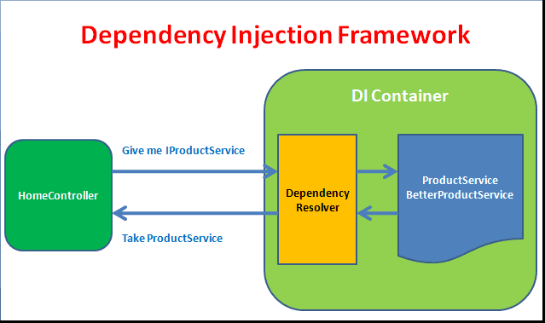
Dependency Injection in ASP.NET Core:
Prior to .Net Core, the only way to get DI in your applications was through the use of a framework such as Autofac, Ninject, StructureMap and many others.
ServiceDescriptor is class used to define service information like service type, implementation type, lifetime (Transient, Scoped, and Singleton)
IServiceCollection is the collection of the service descriptors. We can register our services in this collection with different lifestyles (Transient, scoped, singleton)
IServiceProvider is the simple built-in container that is included in ASP.NET Core that supports constructor injection by default. We are getting registered services with using service provider.
Service Lifestyle/Lifetimes
At registration time, dependencies require a lifetime definition. The service lifetime defines the conditions under which a new service instance will be created and destroyed.
Transient
This lifestyle services are created each time they are requested.
Scoped
Scoped lifestyle services are created once per request.
Singleton
A singleton service is created once at first time it is requested and this instance of service is used by every sub-requests.
Registering Services:
To register services IServiceCollection has extension methods to register services like
- AddTransient<TService,TImplementation>:
AddTransient method register an object and implementation with transient lifetime.
- AddScoped<TService,TImplementation>:

AddScoped method register an instance with scoped life time

- AddSingleton<TService,TImplementation>:

AddSingleton methods register an instance with singleton life time
We can use above methods like this:
AddTransient<IDatabase,Database>() or
AddTransient<IDatabase>(new Database()); or
Define only implementation as well without interface
AddTransient<Database>();
Examples:
Interfaces.cs
public interface IDIObject
{
string GetID();
}
public interface ISingleton : IDIObject { }
public interface IScoped : IDIObject { }
public interface ITransient : IDIObject { }
Implmentation.cs
public class DIObject : ISingleton, IScoped, ITransient{
private string _ID = string.Empty;
public DIObject() : this(Guid.NewGuid().ToString()){}
public DIObject(string ID) {
_ID = ID;
}
public string GetID(){
return _ID;
}
}
Startup.cs – ConfigureServices method
public void ConfigureServices(IServiceCollection services) {
services.AddControllersWithViews();
services.AddSingleton<ISingleton, DIObject>();
services.AddScoped<IScoped, DIObject>();
services.AddTransient<ITransient, DIObject>();
}

DependencyInjection.cs
public class DependencyInjection : Controller{
private ISingleton _singleton;
private IScoped _scoped;
private ITransient _trasient;
public DependencyInjection(ISingleton singleton, IScoped scoped, ITransient transient) {
this._singleton = singleton;
this._scoped = scoped;
this._trasient = transient;
}
public IActionResult Index([FromServices] ITransient transient) {
ViewData["SingletonID"] = _singleton.GetID();
ViewData["ScopedID"] = _scoped.GetID();
ViewData["TransientID"] = _trasient.GetID();
ViewData["AnothetTransient"] = transient.GetID();
return View();
}
}
Index.cshtml
<h5>Singleton ID - @ViewData["SingletonID"]</h5>
<h5>Scoped ID - @ViewData["ScopedID"]</h5>
<h5>Transient ID - @ViewData["TransientID"]</h5>
<h5>Controller Transient ID - @ViewData["AnothetTransient"]</h5>
Output:
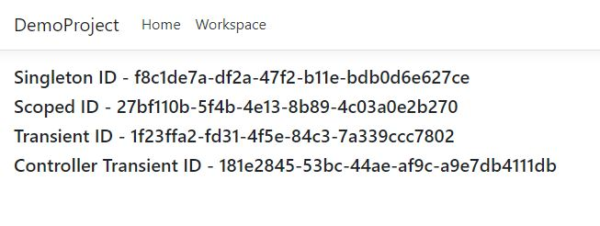
In Above example we have configured three different dependencies with different lifetime and Injected It in constructor and the transient we have injected in action/method you can see transient id is always different because it returns new instance every time.

Framework Provided Services:
When ASP.Net Core applications starts the framework registers following services by default:
Service Type | Lifetime
Microsoft.AspNetCore.Hosting.Builder.IApplicationBuilderFactory | Transient
IHostApplicationLifetime | Singleton
IWebHostEnvironment | Singleton
Microsoft.AspNetCore.Hosting.IStartup | Singleton
Microsoft.AspNetCore.Hosting.IStartupFilter | Transient
Microsoft.AspNetCore.Hosting.Server.IServer | Singleton
Microsoft.AspNetCore.Http.IHttpContextFactory | Transient
Microsoft.Extensions.Logging.ILogger<TCategoryName> | Singleton
Microsoft.Extensions.Logging.ILoggerFactory | Singleton
Microsoft.Extensions.ObjectPool.ObjectPoolProvider | Singleton
Microsoft.Extensions.Options.IConfigureOptions<TOptions> | Transient
Microsoft.Extensions.Options.IOptions<TOptions> | Singleton
System.Diagnostics.DiagnosticSource | Singleton
System.Diagnostics.DiagnosticListener | Singleton

Another way to get instance from DI Container:
When asp.net core application start under the hood it gets the instance from IServiceProvider and inject it into constructor or method. Asp.net core by default provide IServiceProvider service using this we can get instance from DI Container
See following example
public class DependencyInjection : Controller
{
private IServiceProvider _provider;
public DependencyInjection(IServiceProvider serviceProvider)
{
_provider = serviceProvider;
}
public IActionResult Index()
{
ViewData["SingletonID"] = ((ISingleton)_provider.GetService(typeof(ISingleton))).GetID();
return View();
}
}

Best articles about dependency injection
Article 1,
Microsoft official documentation

Handle errors in ASP.NET Core

ASP.NET Core provides default methods/Middleware for handling errors.

Developer Exception page:
The Developer Exception Page displays detailed information about request exceptions. It includes the following information about the exception and the request:
- Stack trace
- Query string parameters if any
- Cookies if any
- Headers
You can use like:
if (env.IsDevelopment())
{
app.UseDeveloperExceptionPage();
}
Exception Handler Page:
This middleware generally used in production environments to redirect user to specific page to show predefined error page
This exception handling middleware:
- Catches and logs exceptions.
- Re-executes the request in an alternate pipeline using the path indicated. The request isn't re-executed if the response has started. The template generated code re-executes the request using the specified path.
We can use like :
if (env.IsDevelopment()){
app.UseDeveloperExceptionPage();
}
else{
app.UseExceptionHandler("/Error");
app.UseHsts();
}

UseStatusCodePage:
By default, an ASP.NET Core app doesn't provide a status code page for HTTP error status codes, such as 404 - Not Found. When the app encounters an HTTP 400-599 error status code that doesn't have a body, it returns the status code and an empty response body. To provide status code pages, use the status code pages middleware. To enable default text-only handlers for common error status codes, call UseStatusCodePages in the Startup.Configure method:

app.UseStatusCodePages();

