Team 9: Car Rental Database

Rushan Shakya, Tahrima Mustafa and Cam Moy

In partial fulfillment of the requirements for the course project of

ISQS 6338- Database Concepts

Supervisor

Prof. Dr. Benjamin Mitchell

Rawls College of Business

December 5, 2017

1. Introduction

We are developing a Car Rental tracking system for Car Rentals, LLC. The company has two stores operating in Lubbock, TX: one being operated near the Preston Smith International Airport and the other one by University Avenue and Broadway.

The company maintains a fleet of cars at two of its stores. A customer can generally make a reservation for a car in advance or just walk into a store to rent a car that is available. The company asks for driver’s license number and credit card number from the customers to make a car reservation. A customer can rent his/her desired car for any number of days. The per day car rental charge is determined at the beginning, when the car rental booking is made. At the end of the rental period, the customer returns the car back to the company. This is when the final charges for the car rental is computed and charged to the customer if there is any due.

# 2. Objectives

The Car Rental database system is going to keep a record of all car rental transactions that goes around Car Rental, LLC and its customers. The system is also going to keep track of all the cars available in their inventories. It will also store the records of when a car was rented, to whom, and when it was returned. Besides these, the car rental company is going to have the following objectives that answers particular business use case scenarios:

1. How many cars are being rented on any given day? Which cars are available on a day for the rentals?

One of the main purposes for this Car Rental Database System is to display the car availability. A customer should be able to see which cars are available for renting on any particular day. Also, the system must display rental information (car type, number of days it was rented) when the customer returns the car. Whenever asked, the system should be able to display reports of which cars are being rented, when they will be returned and the available cars the company has for rent at a given time.

1. Some customers might have certain car preferences. Can the new system keep track of all customer preferences?

To have these answered, the database has to efficiently display the features of the cars such as: size, model, year, etc. Also, some customers might want to have cars with premium audio systems, GPS navigation systems, etc. A customer should be able to browse through available cars based on various characteristics and features the rental company offers. This will provide Car Rentals to gain customer loyalty and enhance customer experience.

1. Who rented the 2017 Chevrolet Impala?

To keep track of which customers rented which vehicles, the database system should adequately record the customer details. The database should record information like if the customer is an individual or a company, name of the customer, age, address, contact information, insurance information, driver's license and Credit Card information. These types of information is important since it allows Car Rentals to identify their customers in case of security sensitive incidents i.e. road accidents. As well as these information enables the company to keep track of their customer types, so that they can run promotional campaigns for sales in future.

1. Do people rent more vehicles during Christmas holidays?

The company should keep track of the number of car rentals made along a period of time to make forecasts with past data. The car rental database system should be able to give reports on how many cars of which type were rented at a particular time period. With this feature, the rental companies can define the peak seasons when people rents cars the most and the off-peak seasons when cars are rented the least. This information will help the rental companies in updating their inventory according to customer demand and setting price range to attract maximum number of customers.

1. Which employee handed the rental car to a customer? Which employee inspected the rented car after it was returned?

The system should record which employee delivered the rental car over to a customer. Also, the employee who inspected the car after the rental must also be captured by the system. Saving this information, car rentals can keep track of their employee workload as well as the responsible personnel if any issue occurs regarding car health or rent.

# 3. Boundaries and Environment

The company is operating in two locations inside Lubbock, TX i.e. Lubbock Preston Smith International Airport and other at University Avenue and Broadway. The customer can rent the cars they want from any of these two locations and return the car to any of the two locations.

Car Rentals, LLC wants to develop a database system which will track its car rental transactions. The company is also interested in maintaining records of its car inventory and customer details.

The company offers various types of vehicles like the Compact cars, Mid-sized cars, Premium cars, and Pick-Up cars to their customers. The company rents its cars to both individuals and organizations. It has big business ties to organizations like Texas Tech University, Covenant Health Systems, etc. inside Lubbock. A customer can rent a car from any of the two locations and can return the car to where it was rented. A customer can pre-book a car for up to 3 months ahead of the rental date.

The customer must have their own insurance for the car rental as the company does not provide any kind of car insurance for the rental. While renting out the car, the customer must present a valid driver’s license, credit card, and the proof of insurance. The driver/renter must be at least 25 years of age at the time of renting the car.

The per day car rental charge is dependent upon the car being rented, number of days it will be rented, at which time of year the car is being rented, and rental rates being offered by other car rental companies (Competitors). The car rental charge per day for each individual type of car is decided by the company’s sales team. The final rental charges can include cleaning fees, fuel charges, and damage charges charged to the customers for each rental transaction.

Since the company has special ties with businesses and other organizations around Lubbock, the company offers special offers to the car rentals made by these businesses and organizations. Special organizational customers receive a set percentage of discounts on their car rental. Individual customers receive special promotional offers that is decided by the company’s sales and marketing departments.

The company takes payments for the car rental only through credit cards. Big institutional (organizations and businesses) customers can send their employees for the car rental with their institutional credit card or any other kind of payment cards and their respective company IDs and/or authorization letters.

When the cars are handed over for the rentals to the customers, an inspection of the car is made by the customer and a company representative (employee) to attest to the condition of the car being rented. The car condition is then documented in the system and then the car is handed to the customer. Similarly, when cars are returned, a company employee will inspect the returning car for any type of damage and the car condition will be documented in the system. If the car is found to be damaged, then the customer will be billed for the damage made to the car.

# 4. Conceptual Model

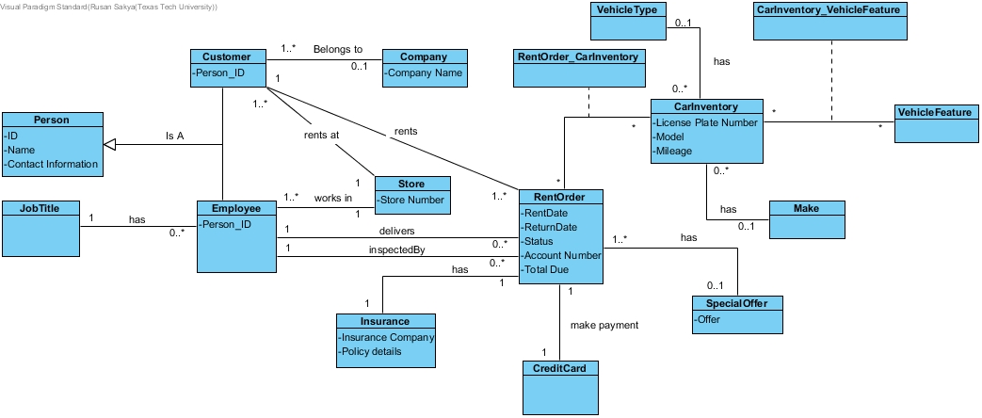

Figure 1. Conceptual Model for Car Rental, LLC

The number of cars being rented at any given day is given by tracing RentOrder object instance and CarInventory object instance, through which we get the rental date, return date, and the car information. With the information from these two object instances, we should get a clear idea of which cars are being rented out, which cars are reserved orders, and when those cars were returned to the car rental company.

The new database system is also capable of tracking personal customer preferences as they rent out the car with Car Rentals, LLC. We can easily track which features about a car is most valued by the customer when making a car rental order. We can do this by tracing Customer object instance through RentOrder, CarInventory and Vehicle Feature.

Similarly, we can track which customer rented what vehicle when by tracing Customer object instance through RentOrder and CarInventory.

We can also determine what type of car, i.e. the mid-sized, compact, etc. cars during various times of the year. Like to determine if people rent bigger cars during the holidays to go see their families. We can do this by tracing RentOrder Object Instance with CarInventory object instance. With the information from the RentOrder Object Instance (the date attribute), we can easily determine when is the peak season for car rentals and when do people tend to rent fewer cars.

Through the Employee object instance passing through RentOrder, we have two relationships. The first relationship, i.e. delivered by, is to determine which employee delivered the car to the customer and the second relationship, i.e. inspected by, is to determine which employee inspected the car after it was returned to the Car Rental company. We can trace employee, RentOrder, CarInventory, and the Customer Object instances to determine which customer rented what car, when, returned the car on what date, which employee handed the car to the customer and which employee did the post-rental inspection of the car one it was returned to the Car Rental company.

The credit card serves two purposes. The customer’s credit card can be charged for the liability purposes and so that the customer account can be charged for the rental at the end of the rental period. All the payments must be made through one single card.

Also, the special offer is applied to one rental order according to the rental promotion period.

# 5. Logical Model/Entity Relationship Diagram

The logical model for the Car Rental company is given below:

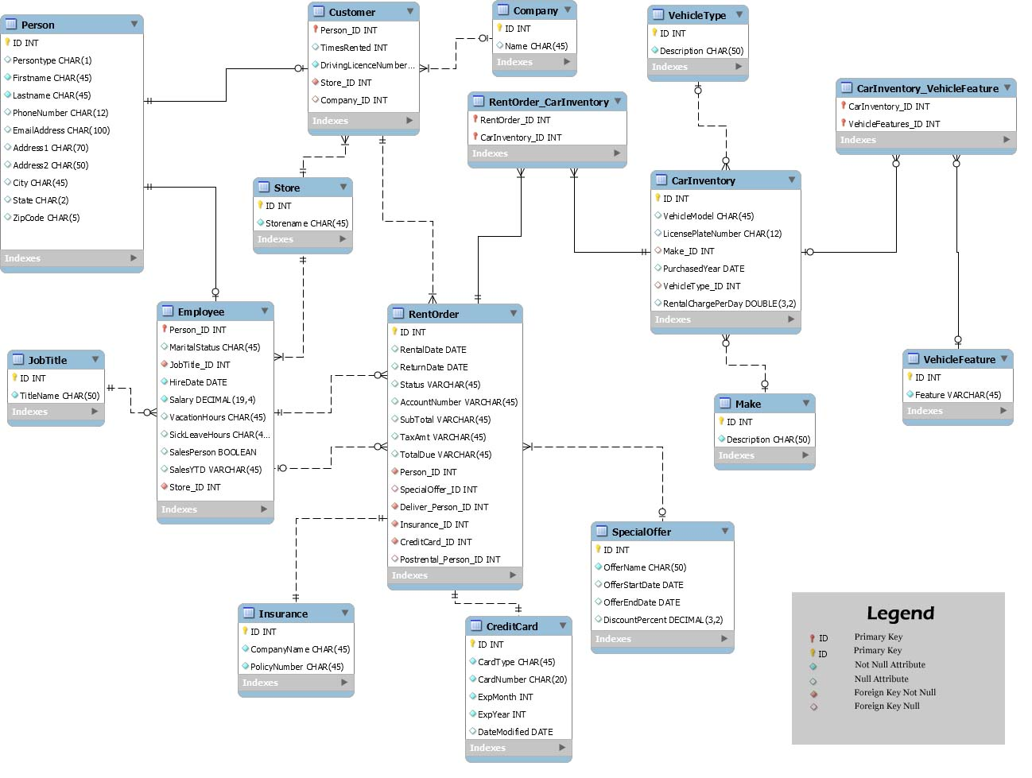

Figure 2. ER Diagram for Car Rental, LLC

# SQL Statements

The CarRental Database tables and some dummy data to test the database was created using the following SQL Statements:

## Create Table Statements

USE ISQS6338_Group_09

CREATE TABLE Person (

ID int NOT NULL,

Persontype char(1) DEFAULT NULL,

Firstname char(45) NOT NULL,

Lastname char(45) NOT NULL,

PhoneNumber char(12) DEFAULT NULL,

EmailAddress char(100) DEFAULT NULL,

Address1 char(70) DEFAULT NULL,

Address2 char(50) DEFAULT NULL,

City char(45) DEFAULT NULL,

State char(2) DEFAULT NULL,

ZipCode char(5) DEFAULT NULL,

PRIMARY KEY (ID)

)

CREATE TABLE Store (

ID int NOT NULL,

Storename char(45) NOT NULL,

PRIMARY KEY (ID)

)

CREATE TABLE JobTitle (

ID int NOT NULL,

TitleName char(50) NOT NULL,

PRIMARY KEY (ID)

)

CREATE TABLE company (

ID int NOT NULL,

Name char(45) DEFAULT NULL,

PRIMARY KEY (ID)

)

CREATE TABLE Customer (

Person_ID int NOT NULL,

TimesRented int DEFAULT NULL,

DrivingLicenceNumber char(50) NOT NULL,

Store_ID int NOT NULL,

Company_ID int DEFAULT NULL,

PRIMARY KEY (Person_ID),

CONSTRAINT fk_Customer_Person1 FOREIGN KEY (Person_ID) REFERENCES Person (ID),

CONSTRAINT fk_Customer_Store1 FOREIGN KEY (Store_ID) REFERENCES Store (ID),

CONSTRAINT fk_Customer_Company1 FOREIGN KEY (Company_ID) REFERENCES Company(ID)

)

CREATE TABLE Employee (

Person_ID int NOT NULL,

MaritalStatus char(45) DEFAULT NULL,

JobTitle_ID int NOT NULL,

HireDate date NOT NULL,

Salary decimal(19,4) NOT NULL,

VacationHours float DEFAULT NULL,

SickLeaveHours float DEFAULT NULL,

SalesPerson BIT DEFAULT NULL,

SalesYTD char(45) DEFAULT NULL,

Store_ID int NOT NULL,

PRIMARY KEY (Person_ID),

CONSTRAINT fk_Employee_JobTitle1 FOREIGN KEY (JobTitle_ID) REFERENCES JobTitle (ID),

CONSTRAINT fk_Employee_Person1 FOREIGN KEY (Person_ID) REFERENCES Person (ID),

CONSTRAINT fk_Employee_Store FOREIGN KEY (Store_ID) REFERENCES Store (ID)

)

CREATE TABLE Make (

ID int NOT NULL,

Description char(50) NOT NULL,

PRIMARY KEY (ID)

)

CREATE TABLE VehicleType (

ID int NOT NULL,

Description char(50) NOT NULL,

PRIMARY KEY (ID)

)

CREATE TABLE CarInventory (

ID int NOT NULL,

VehicleModel char(45) NULL,

LicensePlateNumber char(12) NULL,

Make_ID int NULL,

PurchasedYear CHAR(4) NULL,

VehicleType_ID int NULL,

RentalChargePerDay FLOAT NULL,

PRIMARY KEY (ID),

CONSTRAINT fk_CarInventory_Make1 FOREIGN KEY (Make_ID) REFERENCES Make (ID),

CONSTRAINT fk_CarInventory_VehicleType1 FOREIGN KEY (VehicleType_ID) REFERENCES VehicleType (ID)

)

CREATE TABLE vehiclefeature (

ID int NOT NULL,

Feature varchar(45) NOT NULL,

PRIMARY KEY (ID)

)

CREATE TABLE carinventory_vehiclefeature (

CarInventory_ID int NOT NULL,

VehicleFeatures_ID int NOT NULL,

PRIMARY KEY (CarInventory_ID,VehicleFeatures_ID),

CONSTRAINT fk_CarInventory_has_VehicleFeatures_CarInventory1 FOREIGN KEY (CarInventory_ID) REFERENCES carinventory (ID),

CONSTRAINT fk_CarInventory_has_VehicleFeatures_VehicleFeatures1 FOREIGN KEY (VehicleFeatures_ID) REFERENCES vehiclefeature (ID)

)

CREATE TABLE SpecialOffer (

ID int NOT NULL,

OfferName char(50) NOT NULL,

OfferStartDate date DEFAULT NULL,

OfferEndDate date DEFAULT NULL,

DiscountPercent decimal(3,2) DEFAULT NULL,

PRIMARY KEY (ID)

)

CREATE TABLE insurance (

ID int NOT NULL,

CompanyName char(45) NOT NULL,

PolicyNumber char(45) NOT NULL,

PRIMARY KEY (ID)

)

CREATE TABLE creditcard (

ID int NOT NULL,

CardType char(45) NOT NULL,

CardNumber char(20) NOT NULL,

ExpMonth int NOT NULL,

ExpYear int NOT NULL,

DateModified date DEFAULT NULL,

PRIMARY KEY (ID)

)

CREATE TABLE RentOrder (

ID int NOT NULL,

RentalDate date DEFAULT NULL,

ReturnDate date DEFAULT NULL,

RentalStatus char(45) DEFAULT NULL,

AccountNumber char(45) DEFAULT NULL,

SubTotal Float DEFAULT NULL,

TaxAmt Float DEFAULT NULL,

TotalDue Float DEFAULT NULL,

Person_ID int NOT NULL,

SpecialOffer_ID int DEFAULT NULL,

Deliver_Person_ID int NOT NULL,

Insurance_ID int NOT NULL,

CreditCard_ID int NOT NULL,

Postrental_Person_ID int DEFAULT NULL,

PRIMARY KEY (ID),

CONSTRAINT fk_Order_SpecialOffer1 FOREIGN KEY (SpecialOffer_ID) REFERENCES SpecialOffer (ID),

CONSTRAINT fk_RentOrder_Employee1 FOREIGN KEY (Deliver_Person_ID) REFERENCES employee (Person_ID),

CONSTRAINT fk_RentOrder_Employee2 FOREIGN KEY (Postrental_Person_ID) REFERENCES employee (Person_ID),

CONSTRAINT fk_RentalOrder_Customer1 FOREIGN KEY (Person_ID) REFERENCES Customer (Person_ID),

CONSTRAINT fk_RentOrder_CreditCard1 FOREIGN KEY (CreditCard_ID) REFERENCES creditcard (ID) ,

CONSTRAINT fk_RentOrder_Insurance1 FOREIGN KEY (Insurance_ID) REFERENCES insurance (ID)

)

CREATE TABLE RentOrder_CarInventory (

RentOrder_ID int NOT NULL,

CarInventory_ID int NOT NULL,

PRIMARY KEY (RentOrder_ID,CarInventory_ID),

CONSTRAINT fk_RentOrder_has_CarInventory_CarInventory1 FOREIGN KEY (CarInventory_ID) REFERENCES CarInventory (ID),

CONSTRAINT fk_RentOrder_has_CarInventory_RentOrder1 FOREIGN KEY (RentOrder_ID) REFERENCES RentOrder (ID)

)

## Insert Table Statements

USE ISQS6338_Group_09

--Person table data

INSERT INTO person VALUES (1001,'I','Rex','McRobb','218-256-8978','rexmcrobb@yahoo.com','1 Laurel Terrace','Apt 3358','Lubbock','TX','79415'),(1002,'I','Ailee','Baudi','314-547-8523','aileebaudi@aol.com','60906 Holmberg Hill',NULL,'Lubbock','TX','79401'),(1003,'I','Shandra','Angeli','512-678-9851','shandra@gmail.com','2271 Foster Circle',NULL,'Lubbock','TX','79403'),(2004,'E','Wilfrid','Lampitt','608-879-9845','wilfrid.lampitt@carrental.com','365 Huxley Drive',NULL,'Lubbock','TX','79405'),(2005,'E','Nevsa','Sircomb','214-806-2586','nevsa.sircomb@carrental.com','369 Indiana Avenue',NULL,'Lubbock','TX','79409'),(2006,'E','Orelle','Vankeev','325-456-7894','orelle.vankeev@carrental.com','458 Frankford Avenue','Apt 658','Lubbock','TX','79415'),(3007,'C','Abeu','Ravilus','806-321-5467','abeu.ravilus@ttu.edu','3005 Boston Avenue',NULL,'Lubbock','TX','79401'),(3008,'C','Natasha','Taedu','806-987-5641','natasha.taedu@covenant.org','1001 Hangover Drive','Apt 36','Lubbock','TX','79410');

--Store Table data

INSERT INTO store VALUES (1,'University Avenue Store'),(2,'Airport Store');

--JobTitle table data

INSERT INTO jobtitle VALUES (1,'Sales Associate'),(2,'Store Manager');

--Company Table data

INSERT INTO company VALUES (1,'Texas Tech University'),(2,'Covenant Health Systems');

--Customer table data

INSERT INTO customer VALUES (1001,2,'36521',1,NULL),(1002,1,'78521',1,NULL),(1003,1,'56985',2,NULL),(3007,2,'58971',2,1),(3008,1,'60214',2,2);

--Employee tables data

INSERT INTO employee VALUES (2004,'Single',1,'2015-10-20',36000.0000,'0','8',1,'98000',2),(2005,'Single',1,'2016-12-30',25000.0000,'0','8',1,'56000',1),(2006,'Married',2,'2015-10-20',68000.0000,'40','16',0,'256000',1);

--Make table data

INSERT INTO make VALUES (1,'Toyota'),(2,'Honda'),(3,'Ford');

--VehicleType Table data

INSERT INTO vehicletype VALUES (501,'Compact'),(502,'Mid-Sized'),(503,'Premium');

-- CarInvenory Table data

INSERT INTO carinventory VALUES (1,'Camry LE','WER-1234',1,'2015',502,9.99),(2,'Corolla LE','XDS-2536',1,'2016',501,9.99),(3,'Accord Sport','YWD-5871',2,'2015',502,9.99),(4,'Civic','CDF-7894',2,'2017',501,9.99),(5,'Element','VXY-5454',2,'2017',502,9.99),(6,'Focus','WPO-5478',3,'2017',501,9.99),(7,'Mustang GT','CYY-1237',3,'2017',503,9.99);

--VehicleFeature table data

INSERT INTO vehiclefeature VALUES (10,'Moon Roof'),(11,'Satellite Radio'),(12,'GPS Navigation System'),(13,'Leather Seats');

--CarInventory_VehicleFeature table data

INSERT INTO carinventory_vehiclefeature VALUES (1,10),(1,11),(1,12),(1,13),(2,12),(2,13),(3,10),(4,11),(5,12),(6,12),(6,13),(7,10),(7,12),(7,13);

--SpecialOffer table data

INSERT INTO specialoffer VALUES (3007,'Texas Tech Employee Discount','2015-01-01','2030-12-31',8.50),(3008,'Covenent Health System Employee Discount','2016-01-01','2031-12-31',9.99);

--Insurance table data

INSERT INTO insurance VALUES (501,'State Farm Insurance','35-TX-56-6V'),(502,'GEICO Insurance','58-68-C-TX-69'),(503,'AllState Insurance','102-586-6698'),(504,'Goosehead Insurance','25-A-203-98-TX'),(505,'General Insurance','58-69-41-TX-A');

--CreditCard Table data

INSERT INTO creditcard VALUES (1001,'VISA','2937-8162-9273-9723',1,2020,'2017-11-18'),(1002,'VISA','4428-1234-5678-9012',2,2022,NULL),(1003,'MASTERCARD','5466-1601-2345-6789',3,2022,NULL),(3007,'MASTERCARD','5425-1234-5678-8888',4,2020,'2017-11-18'),(3008,'AMEX','3579-876543-21001',5,2021,NULL);

--RentOrder Table data

INSERT INTO rentorder VALUES (1,'2015-07-05','2015-07-06','Returned','123-456-25','110','8.8','118.8',1001,NULL,2004,501,1001,2005),(2,'2016-09-20','2016-09-22','Returned','123-456-26','120','9.6','129.6',1001,NULL,2005,501,1001,2004),(3,'2015-05-26','2015-05-28','Returned','123-456-27','240','19.2','259.2',1002,NULL,2005,502,1002,2004),(4,'2017-06-01','2017-06-02','Returned','123-456-29','80','6.4','86.4',1003,NULL,2004,503,1003,2005),(5,'2016-08-20','2016-08-27','Returned','123-456-30','360','28.8','388.8',3007,3007,2006,504,3007,2006),(6,'2017-12-05',NULL,'Rented','123-456-31',NULL,NULL,NULL,3007,3007,2006,504,3007,NULL),(7,'2017-12-05',NULL,'Rented','123-456-32',NULL,NULL,NULL,3008,3008,2004,505,3008,NULL);

--RentOrder_CarInventory table value

INSERT INTO rentorder_carinventory VALUES (1,1),(2,1),(3,2),(4,2),(5,3),(6,5),(7,7);

First all the tables for the CarRental Database was created in the SQL Server. After the tables were created using our ERD, the tables were then populated with some dummy data to test our database. All the scripts for the CarRental Database has been uploaded into the SQL server.

# SQL statements to answer the Data Science Questions

From the use of our database, Car Rental, LLC will be able to find the answers to some amazing Data Science questions. Some of the questions that we talked about in our objectives could easily be answered by our model. Some answers to our question are illustrated below:

Question 1: How many cars are being rented on any given day? Which cars are available on a day for the rentals?

select LicensePlateNumber, count(*) as TimesRented from CarInventory CI

inner join RentOrder_CarInventory RC on CI.ID = RC.CarInventory_ID

inner join RentOrder R on RC.RentOrder_ID = R.ID

Group By LicensePlateNumber

Output:

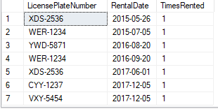

Select VehicleModel, LicensePlateNumber from CarInventory CI

left join RentOrder_CarInventory RC on CI.ID = RC.CarInventory_ID

join RentOrder R on RC.RentOrder_ID = R.ID

where RentalStatus NOT IN ('Rented')

Output:

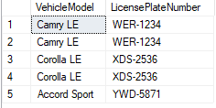

## Question 2: Some customers might have certain car preferences. Can the new system keep track of all customer preferences?

select Feature, VehicleModel, count(*) as TimesRented from vehiclefeature VF

inner join carinventory_vehiclefeature CV on VF.ID = CV.VehicleFeatures_ID

inner join CarInventory C on CV.CarInventory_ID = C.ID

inner join RentOrder_CarInventory RC on RC.CarInventory_ID = C.ID

inner join RentOrder R on R.ID = RC.RentOrder_ID

Group By Feature, VehicleModel

Output:

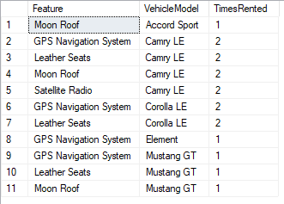

## Question 3: Who rented the 2017 Chevrolet Impala?

select rtrim(FirstName) + ' ' + rtrim(LastName) as CustName, VehicleModel, count(*) as TimesRented

from vehiclefeature VF

inner join carinventory_vehiclefeature CV on VF.ID = CV.VehicleFeatures_ID

inner join CarInventory C on CV.CarInventory_ID = C.ID

inner join RentOrder_CarInventory RC on RC.CarInventory_ID = C.ID

inner join RentOrder R on R.ID = RC.RentOrder_ID

inner join Customer Cust on Cust.Person_ID = R.Person_ID

inner join Person P on Cust.Person_ID = P.ID

Group By rtrim(FirstName) + ' ' + rtrim(LastName), VehicleModel

Output:

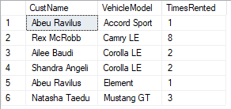

## Question 4: Do people rent more vehicles during Christmas holidays?

select RentalDate, count(*) as NumberRented from CarInventory CI

inner join RentOrder_CarInventory RC on CI.ID = RC.CarInventory_ID

inner join RentOrder R on RC.RentOrder_ID = R.ID

Group By RentalDate

Output:

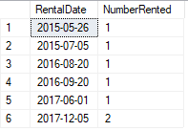

## Question 5: Which employee handed the rental car to a customer? Which employee inspected the rented car after it was returned?

select CI.LicensePlateNumber, C.DrivingLicenceNumber, R.RentalStatus,

RTRIM(Firstname) + ' ' + RTRIM(LastName) as DeliveryEmpName,

(select RTRIM(Firstname) + ' ' + RTRIM(LastName) from Person

inner join Employee on Person.ID = Employee.Person_ID

right outer join RentOrder on Employee.Person_ID = RentOrder.Postrental_Person_ID

where RentOrder.ID = R.ID) As InspectorEmpName

from Person P

inner join Employee E on P.ID = E.Person_ID

inner join RentOrder R on E.Person_ID = R.Deliver_Person_ID

inner join Customer C on C.Person_ID = R.Person_ID

inner join RentOrder_CarInventory RC on R.ID = RC.RentOrder_ID

inner join CarInventory CI on CI.ID = RC.CarInventory_ID

Output:

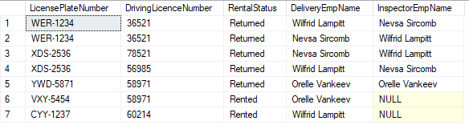

# Business use case for using the Car Rental database

The car rental database is designed to handle multiple stores at once. It includes a total package to manage Employee, Customer, and Car Rental activities. It keeps a thorough record of all the human-car rental activity within the system. It keeps track of which customer rented what car when and when did they return it back. Similarly, it keeps track of who among the company’s employees delivered the car to the customer, who performed the post rental inspection of the vehicle.

The new database also captures the payments and liability aspect of the car rental by keeping proper record of customer credit cards. It also keeps a good record of the insurance the customer is carrying while the car is being rented. Also, the database records all the features a car may have so that the rental company can better provide its customers with cars they want for their future rental activities.

The new database brings in more value for the company. With the use of the system, the company can efficiently track the use of its car fleet. The company with all the data that will reside within our database can easily track future demand of rental cars, make predictions about future customer rental needs, and can easily integrate future development needs and possibilities of the company.

# Database limitations and future improvements

Limitations of our Model:

* The customers must have their own insurance for the car rental. The database has no functionality that can provide company’s own insurance to the renters.
* The company has two types of offers for their customers: Promotional offers for individuals and institutional offers for some specific institutions like Texas Tech. But the database has been designed such that only one special offer can be applied to a rental transaction.
* Special offers are entered manually by the sales representatives. Thus, the discount amount is entered to the database, it’s not auto generated.
* Payments can be made using only one credit card. One customer cannot use multiple credit cards for transaction.
* Credit cards are also stored for liability purposes.

Future Improvements of Our Model:

* Include records of the cars' conditions in the database
* Accept multiple payment methods
* Track return location for every car rented

# Appendix

SQL questions for class exercise.

1. List the license plate number, rental date and the number of times a car was rented. Order the list by rental date.
2. List the car features, vehicle model, License Plate number, and number of times a car was rented. Group by Car Features, vehicle model, and license plate number. Order by Car Features in descending order.
3. List customer first name and last name (concatenated as CustName), Vehicle Model and Make. Group by CustName, Vehicle Model and Make to find out the number of times a car was rented.