**SmartSort: Intelligent Waste Classification for a Greener Future**



**2022-2026**

**Submitted by:**

Rushba Irshad 2022-CS-141

Fatimas Shahid 2022-CS-142

**Submitted to:**

Prof. Samyan Qayyum Wahla

Department of Computer Science

**University of Engineering and Technology**

**Lahore Pakistan**

## **Table of Contents**

1. **Project Overview**
   1. Project Title
   2. Submitted By
   3. Submitted To
   4. Institution
   5. Session
2. **Introduction**
   1. Purpose
   2. Scope
   3. Domain
3. **System Features and Functionalities**
   1. Frontend Functionalities
   2. Backend Functionalities
4. **Technical Details**
   1. Dataset Details
   2. Data Augmentation Techniques
   3. Model Used
   4. Model Training
5. **Workflow of the System**
6. **Performance Analysis**
   1. Confusion Matrix
   2. Metrics
7. **Challenges and Solutions**
8. **Applications**
9. **Future Enhancements**
10. **Conclusion**

## **Introduction**

### **Purpose:**

This report documents the development and implementation of an AI-based waste classification system designed to identify and sort waste into recyclable (R) and non-recyclable (O) categories. The purpose is to promote recycling, improve waste management, and contribute to environmental sustainability.

### **Scope:**

The system leverages image recognition using deep learning to classify waste items. It aims to automate sorting processes in waste management facilities, schools, and community centers, significantly reducing landfill waste and supporting recycling efforts.

### **Domain:**

Waste Management and Environmental Sustainability.

## **System Features and Functionalities**

### **Frontend Functionalities:**

* **User Interfaces:**
  + **Admin Dashboard:** Enables administrators to manage and monitor the waste classification system.
  + **User Dashboard:** Displays waste sorting statistics and data insights for users.
* **Real-time Data Display:**
  + Shows classification results as images are processed.
  + Provides graphical representation of recycling statistics.

### **Backend Functionalities:**

1. **Waste Image Processing:** Reads images from a designated folder.
2. **AI-based Classification:** Employs a pre-trained MobileNetV2 model for real-time waste classification.
3. **Data Analytics:** Analyzes and stores data on recyclable and non-recyclable waste.
4. **Database Management:** Maintains records of classification statistics.

## **Technical Details**

### **Dataset Details:**

* **Source:** Waste Classification Dataset from Kaggle.
* **Training Set:** 5,000 images of recyclable and non-recyclable waste.
* **Testing Set:** 2,000 images for validation.

### **Data Augmentation Techniques:**

* Resizing images to .
* Random rotations and horizontal flips to introduce variability.
* Normalization using mean and standard deviation values for RGB channels.

### **Model Used:**

***MobileNetV2***

#### **Architecture:**

* Pre-trained on ImageNet.
* Modified the final layer to classify into two categories (recyclable and non-recyclable).

#### **Hyperparameters:**

* Learning Rate: 0.0001
* Batch Size: 128
* Loss Function: CrossEntropyLoss with class weights.
* Optimizer: Adam optimizer.

### **Model Training:**

1. **Number of Epochs:**
   1. The model was trained for 20 epochs.
2. **Time Taken:**
   1. Total training duration: 41413.67 seconds (~11.5 hours).
   2. Average time per epoch: seconds (~34.5 minutes per epoch).
3. **Training Procedure:**
   1. Used GPU for accelerated training.
   2. Training loss and accuracy were monitored to ensure proper learning.

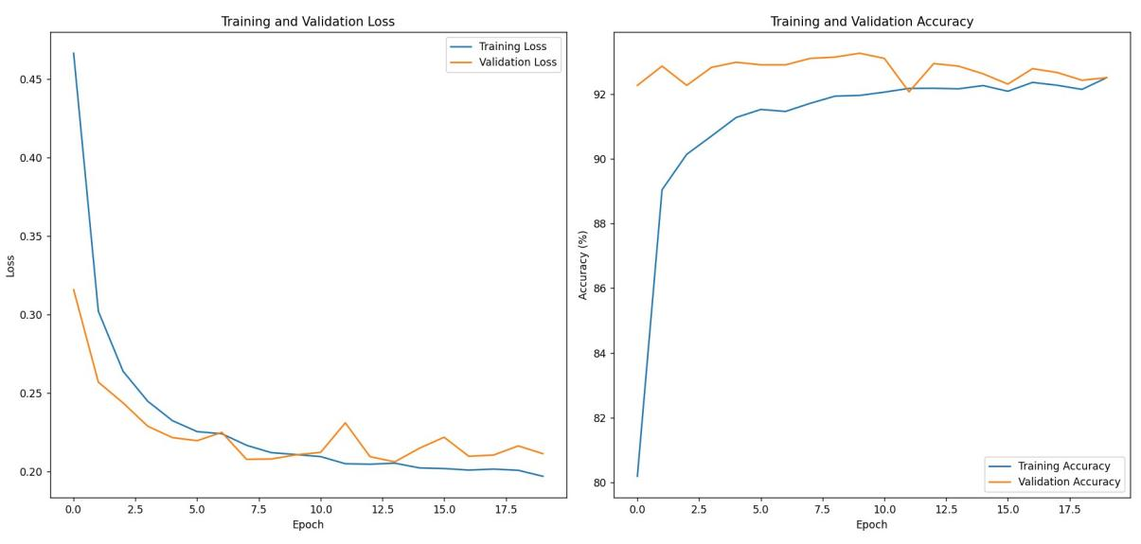

### **Final Model Performance:**

* **Best Validation Loss:** 0.2061
* **Overall Accuracy:** 92.52%

#### **Class-wise Performance:**

* **Class 'O' (Non-recyclable):**
  + Precision: 92.62%
  + Recall: 94.08%
  + F1-Score: 93.34%
* **Class 'R' (Recyclable):**
  + Precision: 92.39%
  + Recall: 90.56%
  + F1-Score: 91.46%

#### **Averages:**

* Macro Precision: 92.50%
* Macro Recall: 92.32%
* Macro F1-Score: 92.40%

## **Workflow of the System**

1. **Image Loading:**
   1. Images are directly read from folders containing labeled data for recyclable and non-recyclable waste.
2. **Preprocessing:**
   1. The images are resized, augmented, and normalized for model compatibility.
3. **AI Model Prediction:**
   1. The pre-trained MobileNetV2 model classifies the image as either recyclable (R) or non-recyclable (O).
4. **Sorting Action:**
   1. The classification results are logged and stored for statistical analysis.
5. **Data Storage:**
   1. Classification statistics are stored in a database for reporting and analysis.

## **Performance Analysis**

### **Confusion Matrix:**

|  |  |  |
| --- | --- | --- |
|  | **Predicted R** | **Predicted O** |
| Actual R | 1007 | 105 |
| Actual O | 84 | 1317 |

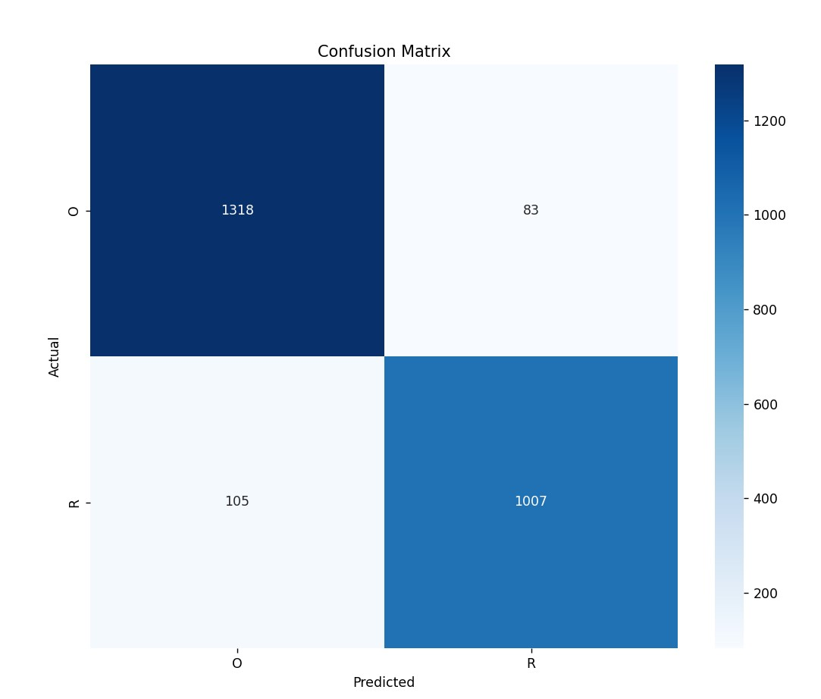

### **Metrics:**

* **ROC Curve:** Demonstrates strong separation between classes with high AUC-ROC

Scores

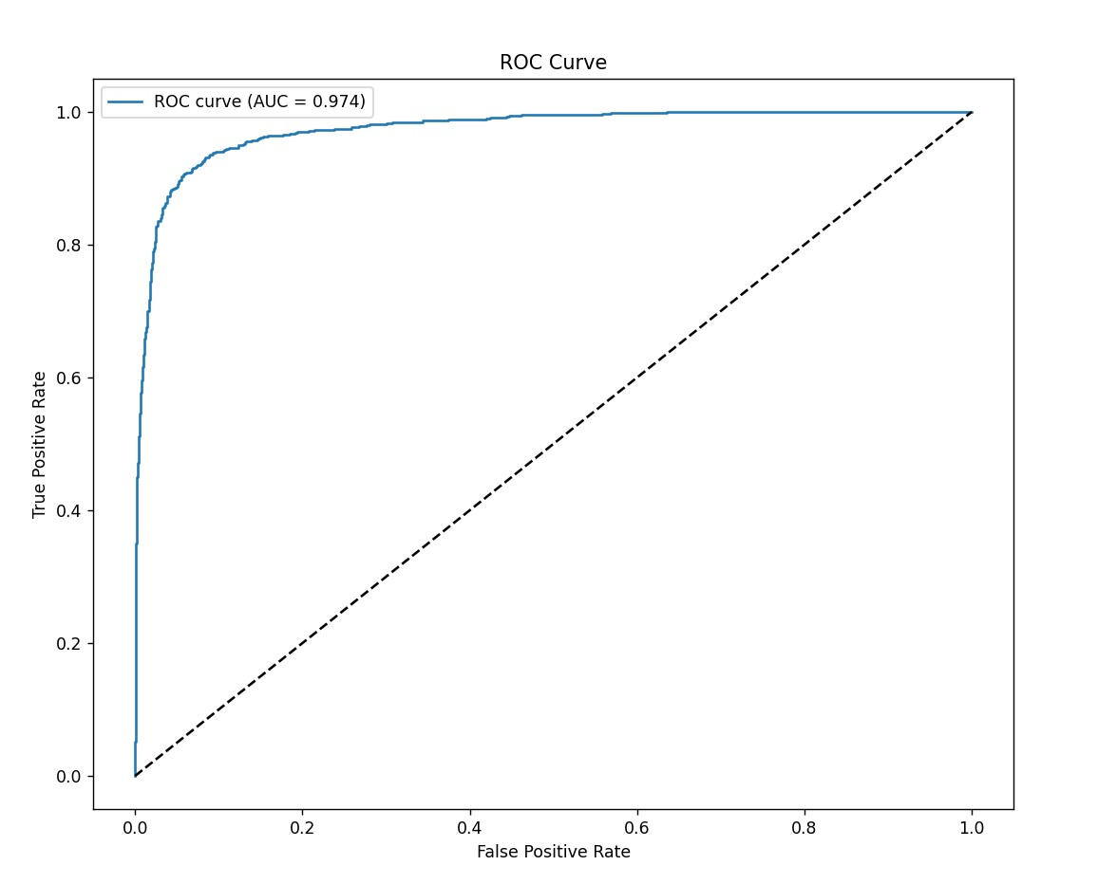.

* **Precision-Recall Curve:** Highlights the balance between precision and recall.

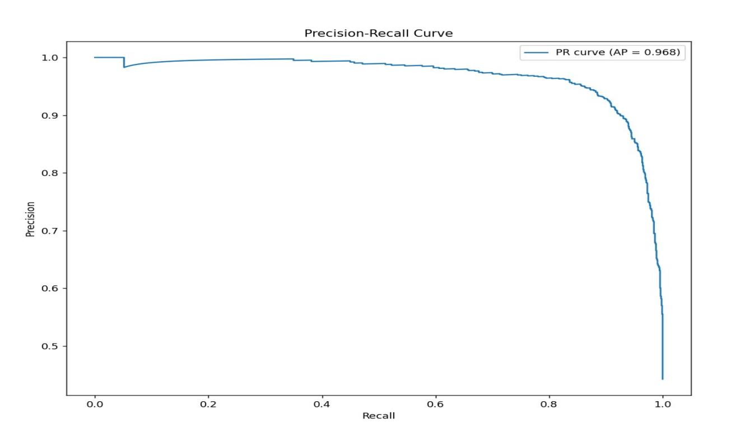

## **Challenges and Solutions**

### **Challenge 1:**

Class imbalance in the dataset.

* **Solution:** Applied class weighting during loss computation to balance the learning process.

### **Challenge 2:**

Long training time.

* **Solution:** Used a pre-trained MobileNetV2 model with frozen layers to reduce computational load.

### **Challenge 3:**

Low recall for recyclable waste (Class R).

* **Solution:**
  + Added diverse augmentation techniques.
  + Increased the number of recyclable waste samples in the training dataset.

## **Applications**

* Waste management facilities.
* Community recycling programs.
* Educational institutions to promote sustainability awareness.
* Shopping malls and public spaces for automated sorting.

## **Future Enhancements**

1. **Additional Classes:** Extend classification to other waste categories (e.g., organic, hazardous).
2. **Integration with IoT:** Use smart bins for real-time classification and disposal.
3. **Improved Hardware:** Deploy faster and more efficient GPUs for training and inference.
4. **Mobile Application:** Develop an app for users to access sorting statistics remotely.

## **Conclusion**

The SmartSort waste classification system demonstrates a significant leap towards achieving sustainable waste management. With its robust AI model, efficient classification, and real-world applications, the project provides a foundation for smarter, greener communities. Future advancements can further refine its capabilities and expand its reach globally.