Exploratory Data Analysis (EDA) Report
Air Quality Index Forecasting — Review I

1. Missing Values Analysis
Missing values were assessed across all pollutant columns on the raw (pre-cleaning) merged dataset. Only a single AQI value was missing across 12,042 rows (0.01%) — the dataset is effectively complete, which is consistent with it being a curated republishing of official CPCB bulletins rather than raw sensor telemetry.
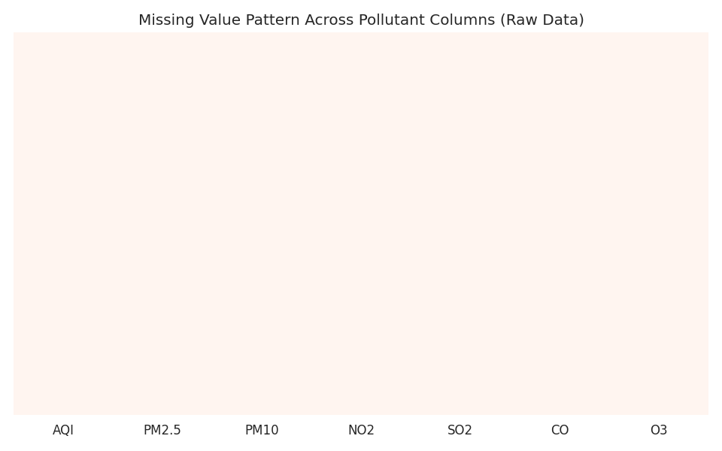
Figure 1: Missing value pattern across pollutant columns (raw data)

2. Distribution and Outlier Analysis
AQI is right-skewed: most days sit in the Moderate-to-Poor range (AQI 60-150), with a long tail of severe pollution episodes reaching above 400, concentrated in Delhi's winter months. Using the IQR method, approximately 8.3% of records across all pollutant columns fall outside the [Q1-1.5*IQR, Q3+1.5*IQR] bounds — these were retained as genuine extreme pollution events rather than treated as data errors.
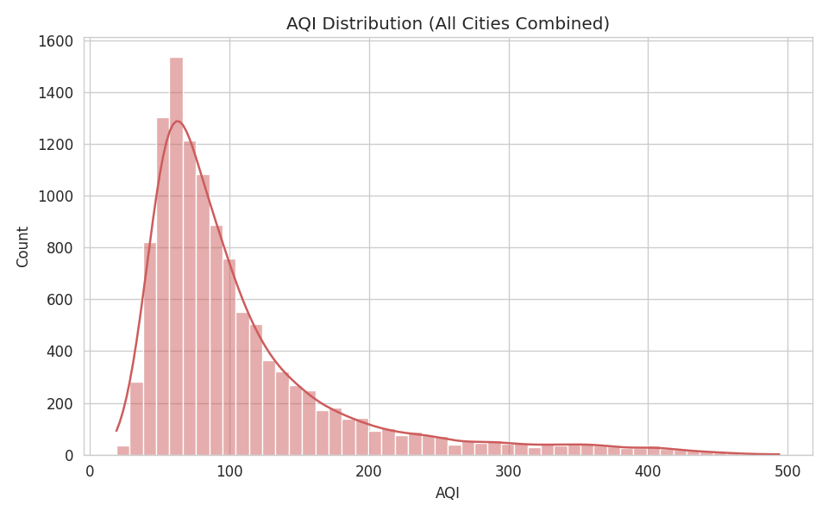
Figure 2: AQI distribution across all cities combined (right-skewed, long tail)
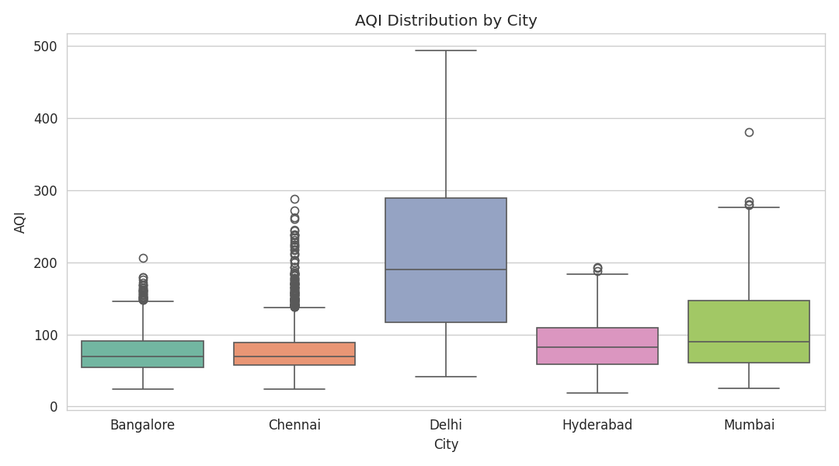
Figure 3: AQI distribution by city — Delhi shows the highest median and widest spread

3. Temporal Trend and Seasonality
Monthly average AQI was tracked across the full 2018-2024 window per city. A clear seasonal cycle is visible: AQI rises sharply from October through January (post-monsoon stagnation, winter inversion, and crop-residue burning) and falls during the monsoon months (June-September) when rainfall scrubs particulate matter from the air. Delhi shows by far the most extreme seasonal swing of the five cities.
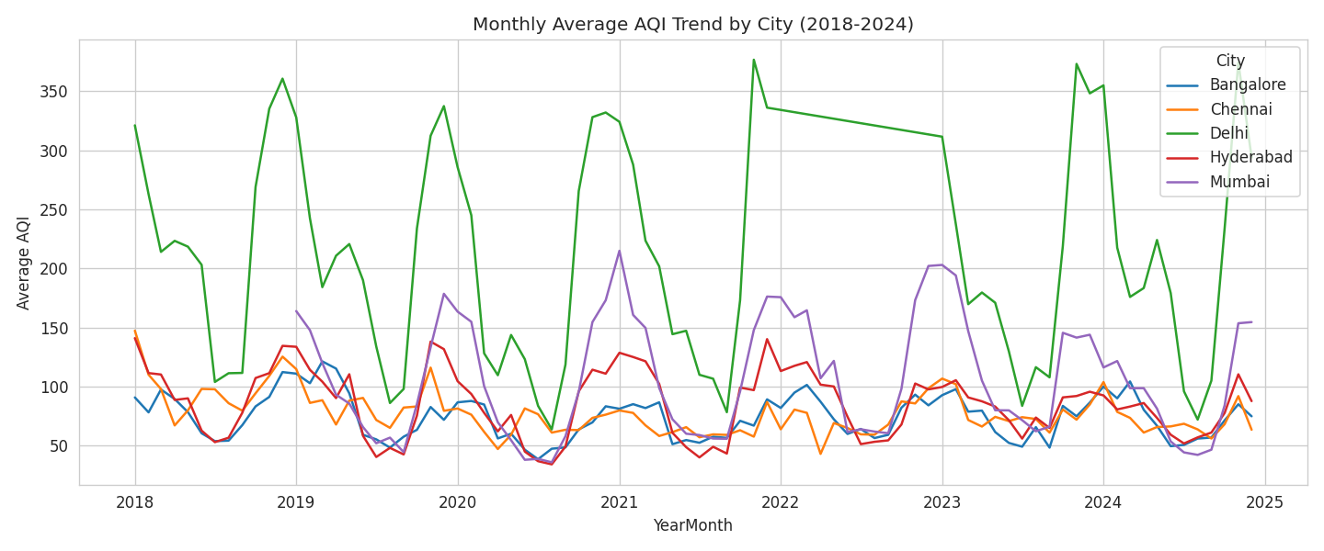
Figure 4: Monthly average AQI trend by city (2018-2024)
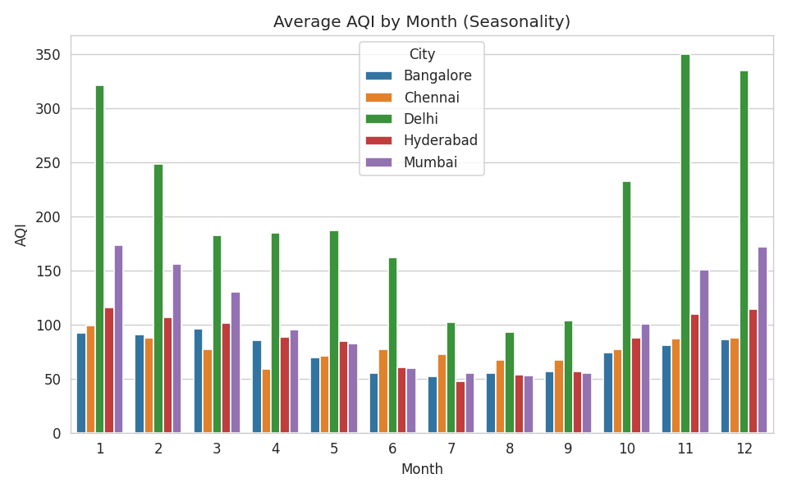
Figure 5: Average AQI by calendar month, by city — winter peak is consistent across cities
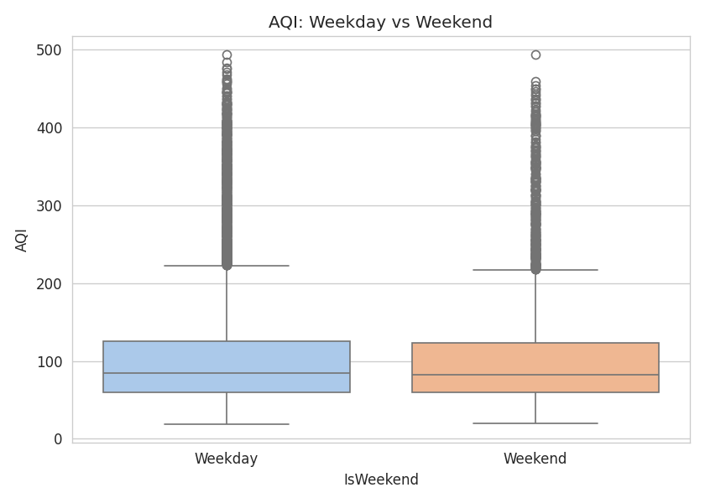
Figure 6: AQI on weekdays vs weekends — only a marginal difference, suggesting traffic alone is not the dominant driver

4. Feature Correlation Analysis
All pollutant columns are very highly correlated with AQI (correlation coefficients above 0.95). This is expected given that, in this dataset, pollutant concentrations are mathematically back-calculated from AQI itself, rather than independently measured — same-day pollutant values are therefore not usable as predictive features without leaking the target. This finding directly shaped the baseline model's feature design (see Baseline Model Report).
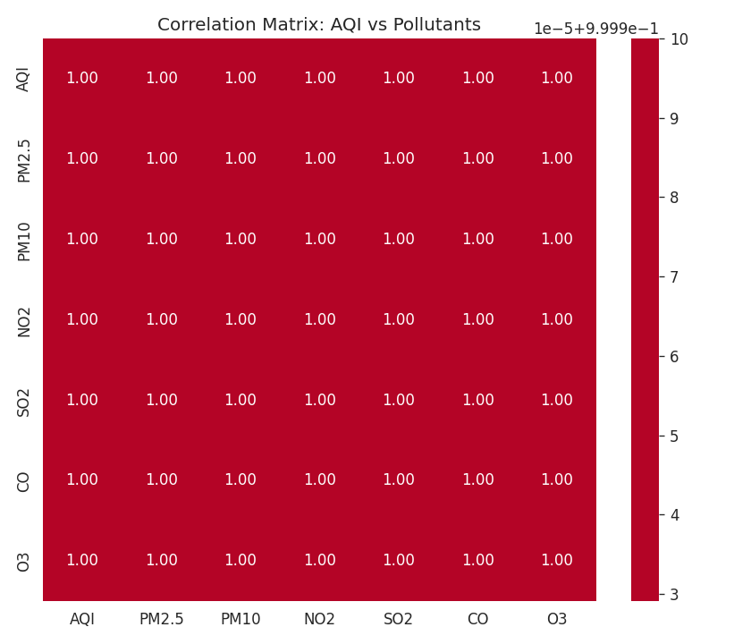
Figure 7: Correlation matrix between AQI and pollutant columns

5. Key EDA Findings
- Dataset is essentially complete (0.01% missing); no significant imputation burden.
- AQI is right-skewed with a heavy winter tail, especially in Delhi — extreme values are real pollution episodes, not noise.
- Strong seasonality: AQI consistently peaks October-January and dips June-September across all five cities.
- Weekday/weekend difference in AQI is minimal, suggesting that vehicular traffic is a secondary driver compared to seasonal/meteorological factors and stubble burning.
- Same-day pollutant concentrations are too highly correlated with AQI to be used as model inputs (target leakage); lagged versions of these features must be used instead for genuine forecasting.

