Baseline Model Report
Air Quality Index Forecasting — Review I

1. Forecasting Task Definition
The baseline task is defined as: given information available up to and including today, forecast tomorrow's city-level AQI. This framing is deliberately stricter than predicting today's AQI from today's pollutant readings, because in this dataset pollutant concentrations are mathematically derived from AQI itself (see Dataset Report, Section 5) — using same-day pollutants as inputs would let the model trivially reconstruct the target rather than genuinely forecast it. All same-day pollutant columns were therefore excluded from the feature set.

2. Features Used
- Calendar features: Month, DayOfWeek, DayOfYear, IsWeekend
- Lag features: AQI_lag1 (previous day's AQI), AQI_lag3_avg (trailing 3-day average AQI)
- Lag features: PM2.5_lag1, PM2.5_lag3_avg, PM10_lag1, PM10_lag3_avg
- City identity: one-hot encoded (City_Bangalore, City_Chennai, City_Delhi, City_Hyderabad, City_Mumbai)

3. Train/Test Split
A time-respecting 80/20 split was used rather than a random shuffle split: the dataset was sorted chronologically and the most recent 20% of records were held out as the test set (2,406 records), with the earlier 80% (9,621 records) used for training. This prevents the model from being evaluated on dates that fall before its training window, which would otherwise give an unrealistically optimistic estimate of forecasting performance.

4. Algorithms Attempted
- Linear Regression — simple linear baseline, features standardized.
- Ridge Regression (α=1.0) — L2-regularized linear baseline.
- Decision Tree Regressor (max_depth=8)
- Random Forest Regressor (200 trees, max_depth=12)
- Gradient Boosting Regressor (200 estimators, max_depth=4)
- LightGBM Regressor (300 estimators, max_depth=6, learning_rate=0.05)

5. Evaluation Results
Model | MAE | RMSE | R²
Linear Regression | 14.680 | 22.978 | 0.9196
Ridge Regression | 14.681 | 22.979 | 0.9196
Gradient Boosting | 14.718 | 23.070 | 0.9190
LightGBM | 14.965 | 23.581 | 0.9154
Random Forest | 15.147 | 23.591 | 0.9153
Decision Tree | 16.186 | 27.504 | 0.8849

Linear Regression achieved the best test-set performance (MAE = 14.68, RMSE = 22.98, R² = 0.92), narrowly ahead of Ridge Regression and Gradient Boosting. This indicates that, once same-day pollutant leakage is removed, the relationship between yesterday's AQI/pollutant history plus calendar position and tomorrow's AQI is largely linear and dominated by the autoregressive AQI_lag1 and AQI_lag3_avg terms — the more complex tree ensembles do not meaningfully outperform a simple linear model on this feature set.
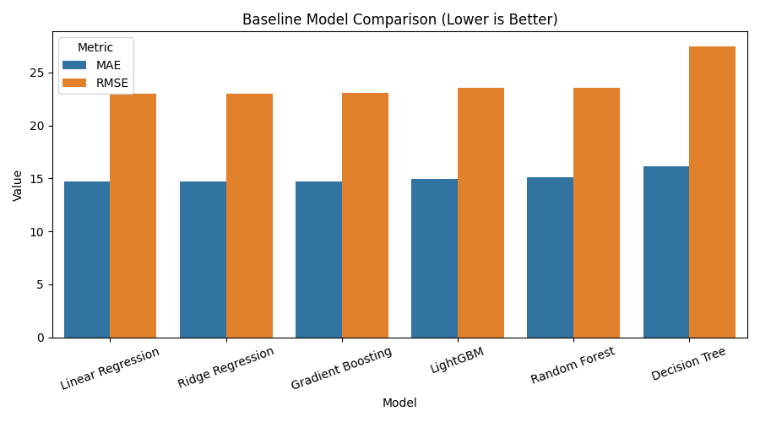
Figure 1: MAE and RMSE comparison across all six baseline models
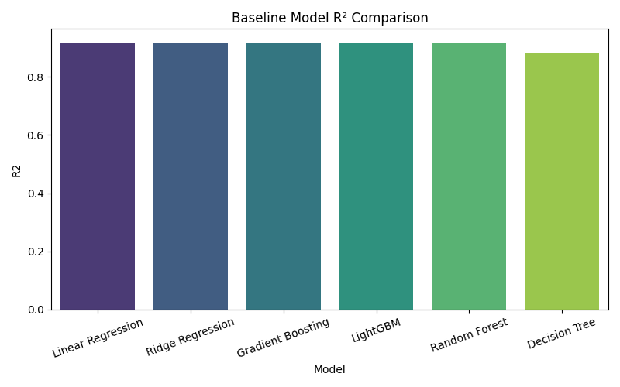
Figure 2: R² comparison across all six baseline models
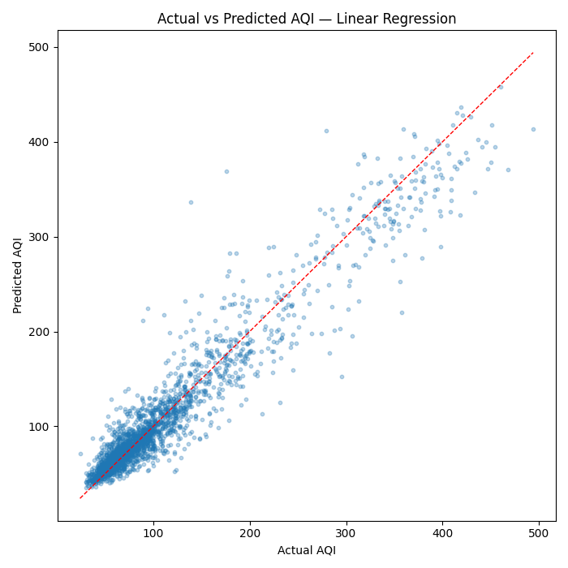
Figure 3: Actual vs. predicted AQI on the test set (best model: Linear Regression)
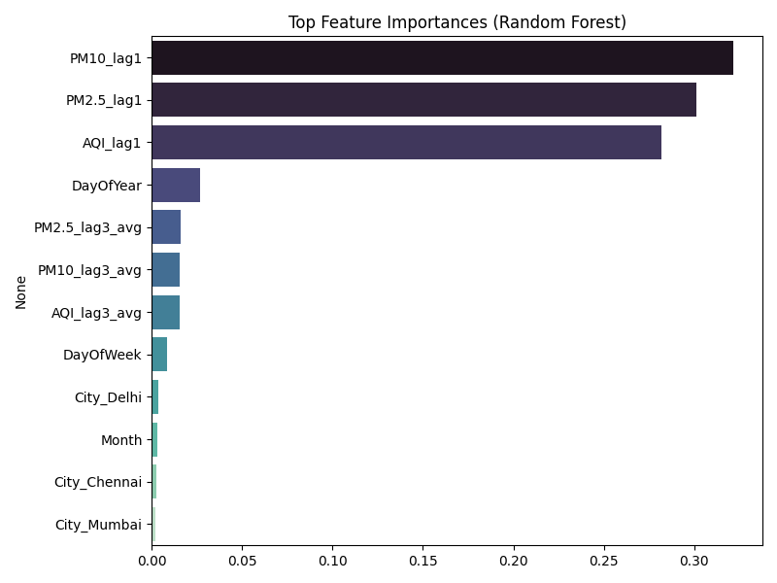
Figure 4: Top feature importances (Random Forest) — AQI_lag1 and AQI_lag3_avg dominate

6. Challenges Identified
- Target leakage risk: initial models trained with same-day pollutant features achieved a deceptive R² of 1.0, which on inspection revealed that pollutant columns in this dataset are reverse-engineered from AQI. This was corrected by restricting features to lagged values only — an important validation step before the rest of the MLOps pipeline is built on top of this baseline.
- City heterogeneity: Delhi's AQI distribution is far wider and more extreme than the other four cities, raising the question (to be explored in Review II) of whether a single shared model or per-city models will generalize better.
- Diminishing returns from model complexity: tree ensembles (Random Forest, LightGBM, Gradient Boosting) did not outperform linear baselines on this lag-feature set, suggesting that further accuracy gains will likely come from richer features (e.g. external weather data, festival/burning-season indicators) rather than more complex algorithms alone.
- Unequal city date ranges: Mumbai's data starts a year later (2019) than the other four cities (2018), which was handled by computing lag features within each city's own group rather than across the merged frame.

7. Next Steps (Review II)
- Track all experiments (features, hyperparameters, metrics) using MLflow for reproducibility.
- Version the dataset and model artifacts with DVC.
- Wrap the best-performing model behind a REST API and a basic monitoring dashboard.
- Explore enriching the feature set with external meteorological data to push beyond the current autoregressive-feature ceiling.

