System Architecture
Air Quality Index Forecasting — Review I

1. High-Level Architecture
The system is designed as a nine-stage MLOps lifecycle organized into three layers: a data layer (sourcing, versioning, and preprocessing), a modeling layer (training, experiment tracking, and a model registry), and an operations layer (CI/CD deployment, monitoring, and automated retraining). The operations layer feeds back into the modeling layer through a continuous-training loop, which is the defining characteristic that separates this system from a one-time AQI prediction model.

2. MLOps Lifecycle Diagram
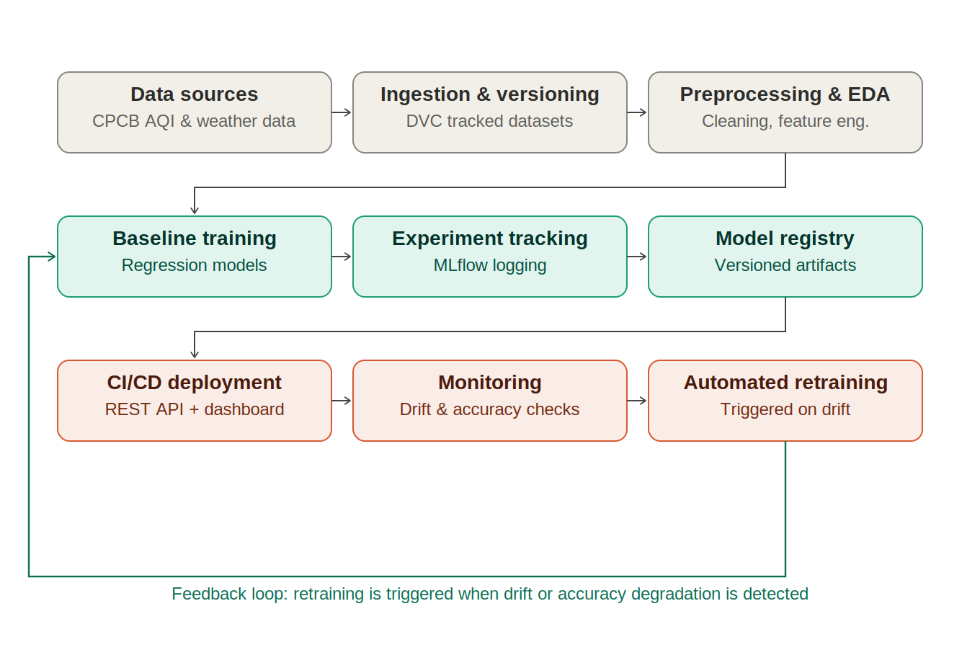
Figure 1: End-to-end MLOps lifecycle for the AQI forecasting system

3. Stage Descriptions
- Data sources — daily CPCB AQI and pollutant bulletins for 5 cities; future versions to include meteorological data.
- Ingestion & versioning — automated data pull, schema validation, and DVC-tracked dataset snapshots.
- Preprocessing & EDA — missing-value handling, outlier flagging, calendar and lag feature construction.
- Baseline training — current stage: regression models trained on lag/calendar features (Review I).
- Experiment tracking — MLflow logging of parameters, metrics, and artifacts for every training run (Review II).
- Model registry — versioned, promotable model artifacts ready for deployment (Review II).
- CI/CD deployment — automated build/test/deploy of the model behind a REST API and monitoring dashboard (Review II-III).
- Monitoring — continuous tracking of live prediction accuracy and input data drift (Review III).
- Automated retraining — triggered when drift or accuracy degradation crosses a defined threshold, closing the loop back to baseline training (Review III).

4. Technology Stack (Planned)
- Data & versioning: Pandas, DVC
- Modeling: scikit-learn, LightGBM
- Experiment tracking: MLflow
- Deployment: FastAPI / Flask REST API, Docker
- CI/CD: GitHub Actions
- Monitoring: custom drift-detection scripts (e.g. population stability index on pollutant/AQI features) with a lightweight dashboard

5. Team Role Allocation
Member | Primary responsibilities (Review I) | Planned role (Reviews II-III)
Darshan K (24AD0058) | Dataset acquisition & merging, data cleaning, feature engineering, baseline model training and evaluation, target-leakage diagnosis | MLflow experiment tracking, REST API deployment, CI/CD pipeline setup
Dharaneeswaran M (24AD0065) | Literature survey, EDA visualizations and outlier/correlation analysis, dataset & EDA documentation, SDG justification | DVC data/model versioning, drift monitoring dashboard, automated retraining trigger logic

