**Title:** Install and use NoSQL databases: 1. MongoDB 2. Cassandra

**Objective/Aim:** Write Python desktop Application to demonstrate the CRUD operation with above backend cloud databases.

**Introduction:** The assignment focuses on leveraging the benefits of most popular NoSQL databases by implementing them in a python GUI application.

**Theory/Algorithm:**

1. MongoDB: MongoDB is a source-available cross-platform document-oriented database program. Classified as a NoSQL database program, MongoDB uses JSON-like documents with optional schemas. MongoDB is developed by MongoDB Inc. and licensed under the Server Side Public License.
2. Cassandra: Apache Cassandra is a free and open-source, distributed, wide-column store, NoSQL database management system designed to handle large amounts of data across many commodity servers, providing high availability with no single point of failure. Cassandra offers support for clusters spanning multiple datacenters, with asynchronous masterless replication allowing low latency operations for all clients. Cassandra was designed to implement a combination of Amazon's Dynamo distributed storage and replication techniques combined with Google's Bigtable data and storage engine model.

**Documentation/Block Diagrams:**

1. MongoDB data storage structure:

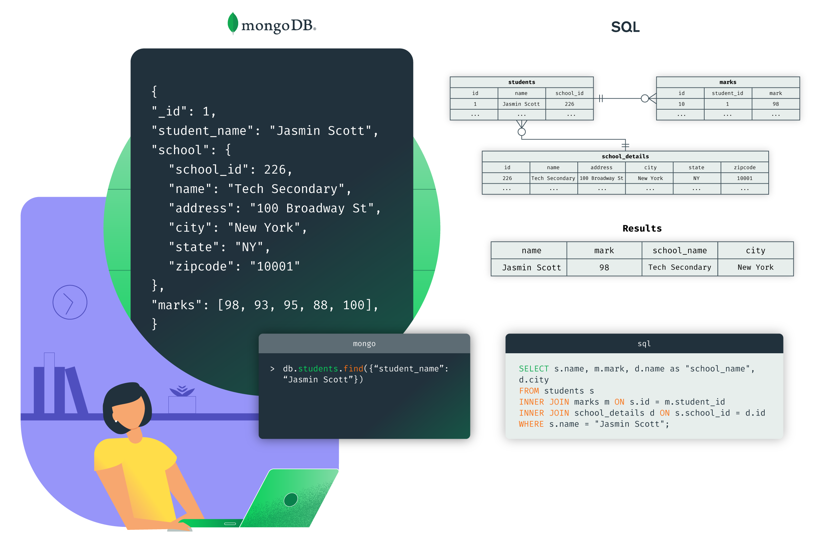

1. Cassandra Data Structure:

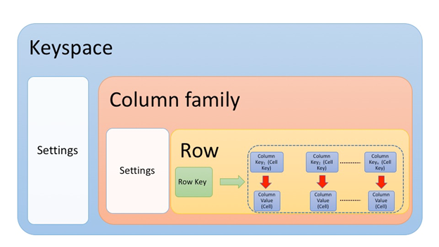

**Procedure:**

**Actual Experimentation/ simulation/ result/ Observation:**

MongoDB CRUD application gui:

1. Insert:

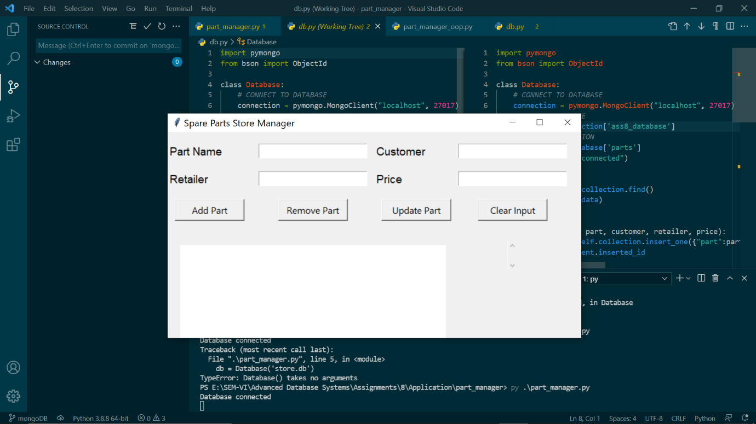

1. Update

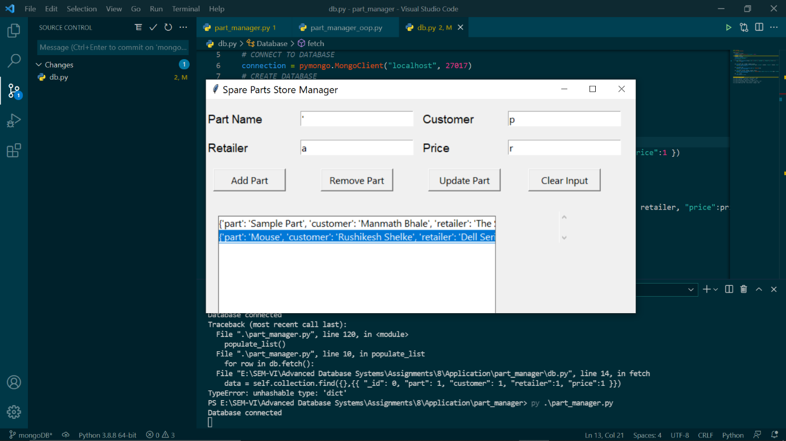

1. Delete:

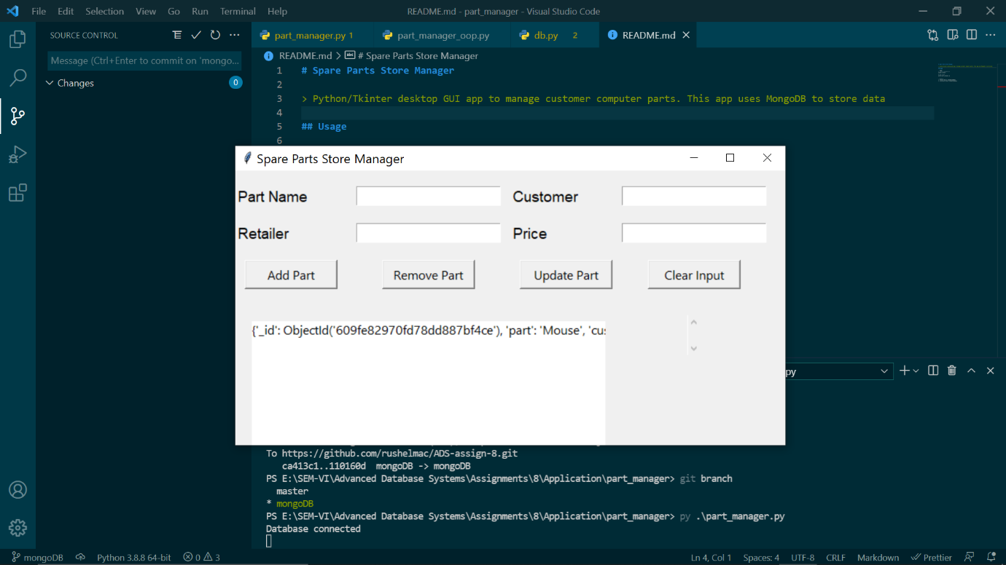

**Conclusion:** We understood the key concepts of NoSQL databases and how to implement them in a real time application.

**References:**

1. <https://en.wikipedia.org/wiki/Apache_Cassandra>
2. <https://cassandra.apache.org/quickstart/>
3. <https://en.wikipedia.org/wiki/MongoDB>
4. <https://docs.mongodb.com/>